

ATPL GROUND TRAINING SERIES

**HUMAN PERFORMANCE AND LIMITATIONS**

© CAE Oxford Aviation Academy (UK) Limited 2014

All Rights Reserved

|  |
| --- |
| **This text book is to be used only for the purpose of private study by individuals and may not be reproduced in any form or medium, copied, stored in a retrieval system, lent, hired, rented, transmitted or adapted in whole or in part without the prior written consent of CAE Oxford Aviation Academy.** |

Copyright in all documents and materials bound within these covers or attached hereto, excluding that material which is reproduced by the kind permission of third parties and acknowledged as such, belongs exclusively to CAE Oxford Aviation Academy.

Certain copyright material is reproduced with the permission of the International Civil Aviation Organisation, the United Kingdom Civil Aviation Authority and the European Aviation Safety Agency (EASA).

**This text book has been written and published as a reference work to assist students enrolled on an approved EASA Air Transport Pilot Licence (ATPL) course to prepare themselves for the EASA ATPL theoretical knowledge examinations. Nothing in the content of this book is to be interpreted as constituting instruction or advice relating to practical flying.**

Whilst every effort has been made to ensure the accuracy of the information contained within this book, neither CAE Oxford Aviation Academy nor the distributor gives any warranty as to its accuracy or otherwise. Students preparing for the EASA ATPL (A) theoretical knowledge examinations should not regard this book as a substitute for the EASA ATPL (A) theoretical knowledge training syllabus published in the current edition of ‘Part-FCL 1’ (the Syllabus). The Syllabus constitutes the sole authoritative definition of the subject matter to be studied in an EASA ATPL (A) theoretical knowledge training programme. No student should prepare for, or is currently entitled to enter himself/herself for the EASA ATPL (A) theoretical knowledge examinations without first being enrolled in a training school which has been granted approval by an EASA authorised national aviation authority to deliver EASA ATPL (A) training.

CAE Oxford Aviation Academy excludes all liability for any loss or damage incurred or suffered as a result of any reliance on all or part of this book except for any liability for death or personal injury resulting from CAE Oxford Aviation Academy’s negligence or any other liability which may not legally be excluded.

**Introduction**

Printed in Singapore by KHL Printing Co. Pte Ltd

|  |
| --- |
| **I** |

# Introduction

**Textbook Series**

**Introduction**

**I**

|  |  |  |
| --- | --- | --- |
| Book | Title | Subject |
|  |  |  |
| 1 | 010 Air Law |  |
|  |  |  |
| 2 | 020 Aircraft General Knowledge 1 | Airframes & Systems |
|  |  |  |
|  |  | Fuselage, Wings & Stabilising Surfaces |
|  |  | Landing Gear |
|  |  | Flight Controls |
|  |  | Hydraulics |
|  |  | Air Systems & Air Conditioning |
|  |  | Anti-icing & De-icing |
|  |  | Fuel Systems |
|  |  | Emergency Equipment |
|  |  |  |
| 3 | 020 Aircraft General Knowledge 2 | Electrics – Electronics |
|  |  |  |
|  |  | Direct Current |
|  |  | Alternating Current |
|  |  | Basic Radio Propagation |
|  |  |  |
| 4 | 020 Aircraft General Knowledge 3 | Powerplant |
|  |  |  |
|  |  | Piston Engines |
|  |  | Gas Turbines |
|  |  |  |
| 5 | 020 Aircraft General Knowledge 4 | Instrumentation |
|  |  |  |
|  |  | Flight Instruments |
|  |  | Warning & Recording |
|  |  | Automatic Flight Control |
|  |  | Power Plant & System Monitoring Instruments |
|  |  |  |
| 6 | 030 Flight Performance & Planning 1 | Mass & Balance |
|  |  | Performance |
|  |  |  |
| 7 | 030 Flight Performance & Planning 2 | Flight Planning & Monitoring |
|  |  |  |
| 8 | 040 Human Performance & Limitations |  |
|  |  |  |
| 9 | 050 Meteorology |  |
|  |  |  |
| 10 | 060 Navigation 1 | General Navigation |
|  |  |  |
| 11 | 060 Navigation 2 | Radio Navigation |
|  |  |  |
| 12 | 070 Operational Procedures |  |
|  |  |  |
| 13 | 080 Principles of Flight |  |
|  |  |  |
| 14 | 090 Communications | VFR Communications |
|  |  | IFR Communications |

iii

**Introduction**

|  |
| --- |
| **I** |

# Introduction

**Contents**

# ATPL Book 8 Human Performance and Limitations

1. Basic Concepts . . . . . . . . . . . . . . . . . . . . . . . . . . . . . . . . . . . . . . . . . . . . 1
2. The Circulation System. . . . . . . . . . . . . . . . . . . . . . . . . . . . . . . . . . . . . . . .17
3. Oxygen and Respiration . . . . . . . . . . . . . . . . . . . . . . . . . . . . . . . . . . . . . . .35
4. The Nervous System, Ear, Hearing and Balance . . . . . . . . . . . . . . . . . . . . . . . . . .57
5. The Eye and Vision . . . . . . . . . . . . . . . . . . . . . . . . . . . . . . . . . . . . . . . . . .73
6. Flying and Health. . . . . . . . . . . . . . . . . . . . . . . . . . . . . . . . . . . . . . . . . . .89
7. Stress . . . . . . . . . . . . . . . . . . . . . . . . . . . . . . . . . . . . . . . . . . . . . . . . 121
8. Information Processing, Human Error & the Learning Process . . . . . . . . . . . . . . . . . 145
9. Behaviour and Motivation. . . . . . . . . . . . . . . . . . . . . . . . . . . . . . . . . . . . . 167
10. Cognition in Aviation . . . . . . . . . . . . . . . . . . . . . . . . . . . . . . . . . . . . . . . 181
11. Sleep and Fatigue . . . . . . . . . . . . . . . . . . . . . . . . . . . . . . . . . . . . . . . . . 203
12. Individual Differences and Interpersonal Relationships . . . . . . . . . . . . . . . . . . . . 225
13. Communication and Cooperation . . . . . . . . . . . . . . . . . . . . . . . . . . . . . . . . 251

**Introduction**

**I**

1. Man and Machine. . . . . . . . . . . . . . . . . . . . . . . . . . . . . . . . . . . . . . . . . 271
2. Decision Making and Risk . . . . . . . . . . . . . . . . . . . . . . . . . . . . . . . . . . . . 295
3. Human Factors Incident Reporting . . . . . . . . . . . . . . . . . . . . . . . . . . . . . . . 309
4. Introduction to Crew Resource Management. . . . . . . . . . . . . . . . . . . . . . . . . . 323
5. Specimen Questions . . . . . . . . . . . . . . . . . . . . . . . . . . . . . . . . . . . . . . . 339
6. Glossary . . . . . . . . . . . . . . . . . . . . . . . . . . . . . . . . . . . . . . . . . . . . . . 437
7. Index. . . . . . . . . . . . . . . . . . . . . . . . . . . . . . . . . . . . . . . . . . . . . . . . 449

v

**Introduction**

Chapter

## **1** Basic Concepts

The History of Human Performance . . . . . . . . . . . . . . . . . . . . . . . . . . . . . . . . . 3

The Relevance of Human Performance in Aviation. . . . . . . . . . . . . . . . . . . . . . . . . 5

The Pilot and Pilot Training. . . . . . . . . . . . . . . . . . . . . . . . . . . . . . . . . . . . . . 6

Aircraft Accident Statistics . . . . . . . . . . . . . . . . . . . . . . . . . . . . . . . . . . . . . . 7

Flight Safety . . . . . . . . . . . . . . . . . . . . . . . . . . . . . . . . . . . . . . . . . . . . . . 9

The Most Significant Flight Safety Equipment . . . . . . . . . . . . . . . . . . . . . . . . . . 10

Safety Culture . . . . . . . . . . . . . . . . . . . . . . . . . . . . . . . . . . . . . . . . . . . . 10

Reason’s Swiss Cheese Model . . . . . . . . . . . . . . . . . . . . . . . . . . . . . . . . . . . 11

The Five Elements of Safety Culture . . . . . . . . . . . . . . . . . . . . . . . . . . . . . . . . 12

Flight Safety/Threat and Error Management . . . . . . . . . . . . . . . . . . . . . . . . . . . 12

Threats. . . . . . . . . . . . . . . . . . . . . . . . . . . . . . . . . . . . . . . . . . . . . . . . 12

Errors. . . . . . . . . . . . . . . . . . . . . . . . . . . . . . . . . . . . . . . . . . . . . . . . . 12

Undesired Aircraft States . . . . . . . . . . . . . . . . . . . . . . . . . . . . . . . . . . . . . . 13

Duties of Flight Crew . . . . . . . . . . . . . . . . . . . . . . . . . . . . . . . . . . . . . . . . 13 Human Factors is about people: it is about people in their working and living environments, and it is about their relationship with equipment, procedures and the environment. Just as important, it is about their relationship with other people. It involves the overall performance of human beings within the aviation system. Human Factors seeks to optimize the performance of people by the systematic application of the human sciences, often integrated within the framework of system engineering. Its twin objectives can be seen as safety and efficiency.

**Basic Concepts**

*ICAO Human Factors Digest Number 1, 1989*

### The History of Human Performance

In November 1783 the first manned balloon voyage took place. Two men took off from the grounds of the Chateau de la Muette in Paris in a Montgolfier hot air balloon and landed 25 minutes later, having drifted five miles and reached a height of 3000 feet. The trouble was, and still is, that balloons are non-steerable and are dependent on the wind to provide their horizontal motive power.

To overcome the non-steerability of balloons, it became obvious that a motive unit of some sort was needed to allow them to become a useful form of transport and the concept of the airship was formulated. It was not until 1852 that Henri Giffard was able to fly the first practical airship. Even at this early stage it was realized that the future of aviation lay not with balloons and airships but with heavier than air machines.

The first powered aeroplane to fly was a model steam powered aircraft designed and built by John Stringfellow in 1848. The first manned flight of a heavier than air machine, and the beginning of modern aviation, took place at Kittyhawk in 1903 when Orville Wright made a flight of 12 seconds in the aptly named ‘Wright Flyer’. This short duration flight ushered in an era which has probably seen a greater number of scientific advances than any other period in history.

With the aircraft came aircraft accidents. In the early decades of this century a great number of these accidents, indeed the majority, were caused by equipment failure or other factors outside the control of the operators. Over the last 30 to 40 years however the major cause of aircraft accidents has been human factors.

**Basic Concepts**

Airframes have become more reliable, modern engines and associated equipment seldom fail, navigational equipment (both in the aircraft and on the ground) has improved in leaps and bounds, giving a degree of accuracy undreamt of by the early pioneers of flying.

The improvement in the equipment available, allied with the advances in meteorological forecasting should have virtually eliminated aviation accidents except for the most freak conditions, but these accidents have not reduced at the rate one would expect from the advances of technology. The factor that has not changed is the human being. It is often seen in reports of aircraft accidents that the cause was **‘Pilot Error’** but, of course, a more correct reason would be **‘Human Error’.**

It is unfortunate that errors occur at all stages of an aircraft’s life. Designers may make small arithmetical slips which may not be picked up, servicing personnel can put the wrong fuel and lubricants into engines or fit components incorrectly, operations and loading staff do get the weights wrong but the major contributions to flight safety can be achieved by educating the operating crew.

This publication is written to enable you, the future pilot, to appreciate the limitations of the human being in the aviation environment. Our bodies are designed to exist on the surface of the earth and a stable gravitational force. In aviation it is subject to new factors, among which are altitude, large changes in pressure, changes of gravitational forces, radiation and shortage of oxygen.

In the purely physical sense you will need to learn how to recognize the symptoms of oxygen deficiency and the effects of high g-forces or large changes of temperature. You should gain an appreciation of the problems brought about by stress and time zone changes as well as trying to organize sleep patterns which may be out of synchronisation with your internal body clock.

In addition to the physical problems associated with aviation you will need an appreciation of the psychological aspects of flying such as receiving information, assessing data, making decisions and carrying out the necessary actions to ensure the safe progress of your flight in all conditions. You will learn some of the ways in which mistakes occur and be able to reduce your personal errors to a minimum.

As a crew member, you will be flying with many contrasting personalities some of whom may be from very different cultural backgrounds from yourself. If you are a member of a large airline, you will be meeting your fellow crew members mostly for the first time. It is vital that you become adept in recognizing these different personalties and be able to work with them as a successful member of the group. A continuing study of both CRM and Human Performance will be your basic tool but the development of successful interpersonal skills must be an ongoing personal aim.

**Basic Concepts**

It is to be hoped that you will not have to face many emergencies in your flying career, except in the simulator, but to be forewarned is to be forearmed. Knowledge brings confidence and the following chapters are designed to increase your knowledge of yourself and your limitations.

The layout of these notes is designed to match the syllabus as taught at CAE Oxford Aviation Academy. These notes should be used as a reference and a revision aid. They do not necessarily contain all the material which you will receive during the course. Students are urged to complete the revision questions at the end of each chapter as well as the multi-choice papers found at the end of these notes.

Whereas every effort has been made to ‘compartmentalize’ the subject into different chapter headings, there is inevitable interchapter overlap. In these cases, repetition is used to highlight the common ground.

### The Relevance of Human Performance in Aviation

***Aviation in itself is not inherently dangerous but, like the sea, it is inordinately unforgiving of any carelessness, incapacity or neglect.***

**Human Performance** (sometimes referred to as Human Factors) is relevant wherever and whenever the human being is involved in aviation. Thus it plays a fundamental and vital role to promote efficiency and - above all else - safety in every facet of the aviation industry. It promotes:

* Safety and efficiency.
* Health, fitness and well-being.
* Operating skills.
* Awareness of the common areas of human error.
* Judgement and decision making.
* Leadership qualities.
* Crew coordination.
* Efficient design of:
* Aircraft, cockpit, instrument and control layouts.
* Operating procedures.
* Checklists.

**Basic Concepts**

* Charts.
* Training procedures.
* Efficient and comfortable working environments.
* Efficient personnel selection.
* Efficient communications.

These can be summarized as the: Safety and efficiency of the operation

and

Well-being of the individual

**ICAO Requirement for the Study of Human Factors**

Since the inclusion of Amendment 159 of Annex 1 to the Chicago Convention, which came into force on 16th November 1989, ICAO has made the study of Human Factors a mandatory part of obtaining a professional pilot’s licence.

### The Pilot and Pilot Training

#### Introduction

The most flexible but the most error-prone component within aviation is the aircrew. Thus selection, training, maintenance of morale and monitoring of aircrews make the largest contribution to flight safety. ***The Competent Pilot***

When assessing the competency of a pilot a number of qualities are sought. Among the qualities that go towards making a safe, effective and competent pilot are:

* A high sense of responsibility
* Ability (academic and flight handling)
* Motivation
* A good communicator
* Flexibility
* Physical fitness
* Reliability
* A balanced personality
* A team player
* Calmness under stress
* An eye for detail
* Competency in Risk Assessment
* Competency in the skills of Stress and Crew Managements

**Basic Concepts**

#### Training

There is a myriad of pilot training methods and techniques : Flight Simulator, Crew Resource Management (CRM), Line Oriented Flying Training (LOFT), Self-development, Leadership, Flight Safety, Survival and Correspondence courses are all available to aircrew. To ensure the future competency of pilots, courses should designed to be:

* Relevant
* Regular
* Clear and concise
* Time-efficient
* Participational
* Include course reading and revision material

#### Self-training

Self-training is a process aimed at developing specific skills, knowledge or attitudes. As pilots you will, throughout your careers, be subject to continuous and regular training. It is of fundamental importance that you do not rely solely on the formal training to maintain your aviation expertise. Every opportunity should be taken to increase your competency, knowledge and professionalism. Always self-debrief after every flight. Read, research, discuss and discover as much as you can of this enormous and fascinating field.

As your competence and expertise increase so will your self-confidence. This, in turn, will arm you to tackle new aspects of your profession with enthusiasm and conviction.

### Aircraft Accident Statistics

#### General

Statistics play a fundamental role in accident analysis. It is only by the production of comprehensive and wide-ranging statistics that the root cause of accidents can be established. The Safety Data Department of the CAA regularly distribute a number of publications in this field of which Aviation Safety Review, Data Plus and Global Accident Review are but three.

When compared with other forms of transportation, aviation has the best safety record (the risk of death per person per year in a car accident is 1 in 10 000 in the UK and 1 in 4000 in the USA).

As can be seen from the graphs below – which we publish with the kind permission of Flight International - the aviation fatal accident rate over the last 10 years is approximately 1 per 1.2 million flights.

**Basic Concepts**

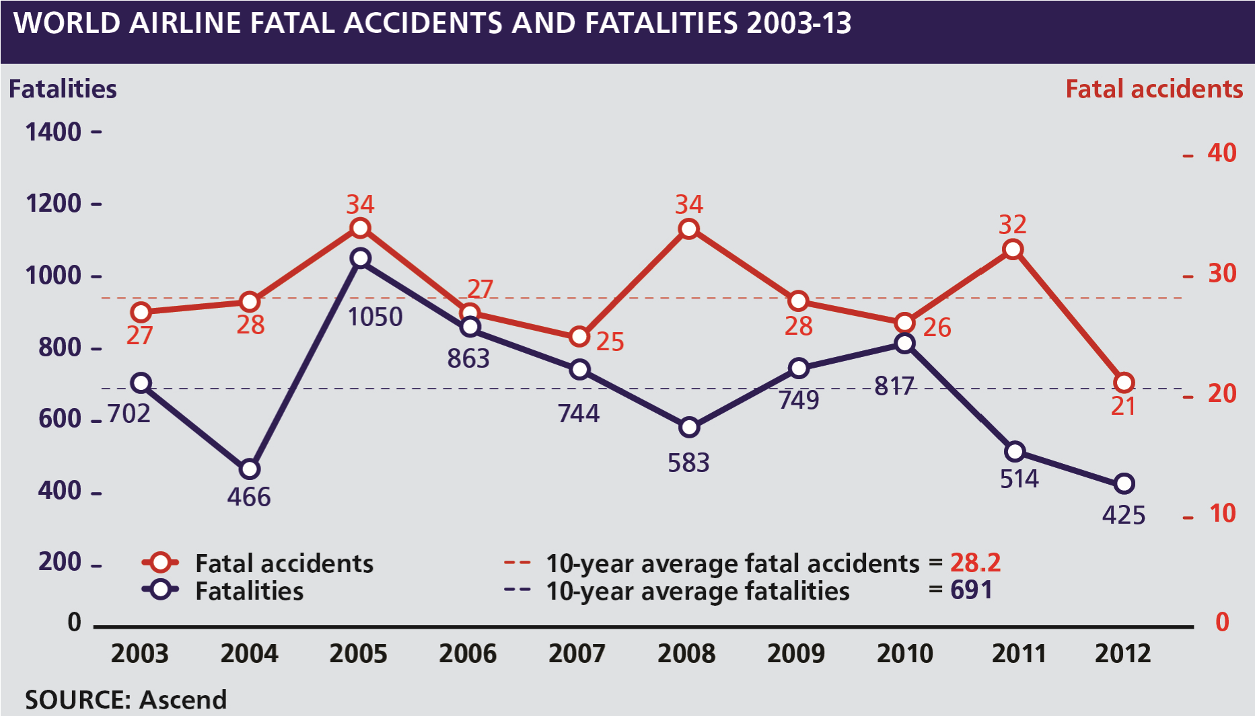

*Figure 1.1 By kind permission of Flight International*

2012 was an exceptional year and has been dubbed as “the safest year yet” in which the rate dropped to 1 per 2.3 million flights. Unfortunately experts, at the time of printing, are generally of the opinion that it is expected that the rate will return to approximately the norm of 1 per 1.2 million flights in future years. It is of note that in 2012 almost all of the accidents were precipitated by pilot misjudgment or mismanagement.

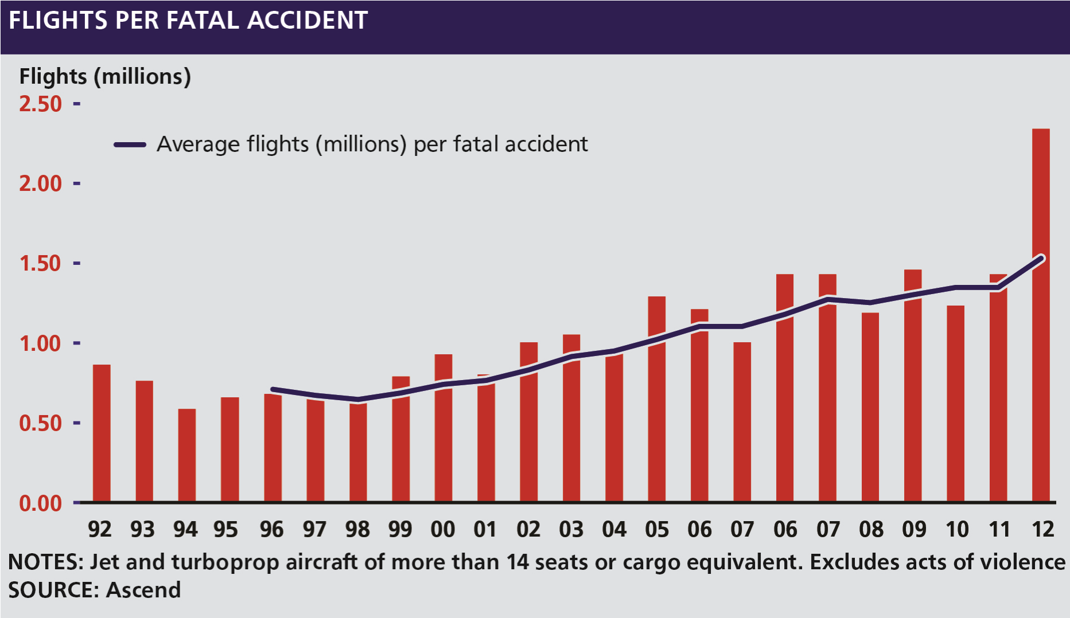

*Figure 1.2*

The sad fact is that accidents are still occurring. This is in spite of enormous technical advances in:

* Aircrew training and selection
* Aircraft manufacture and design
* Weather tracking and prediction
* Mechanical reliability
* Systems monitoring equipment
* Communications
* Accuracy and range of navigational equipment
* Cockpit and cabin layout
* Safety equipment
* Air Traffic Control expertise and capabilities
* Control and weather radar equipment

**Basic Concepts**

* Airfield lighting and facilities

Even with all the above technical successes, and the overall standards of safety that have been achieved, the art and science of advanced aeronautics in all types of flying conditions are not yet fully perfected. Nor has the complex relationship between technological progress on the one hand, and human frailty on the other, been fully resolved. In aviation, perhaps more than in other fields of human endeavour, mankind remains as much a victim of himself as of the elements around him.

#### Causes of Accidents - General

Approximately 73% of all accidents are caused by Human factors. Historically this figure has not changed since the 1950’s. **CFIT** (Controlled Flight into Terrain) remains the most common general form of accident.

#### Causes of Accidents - Pilot Induced

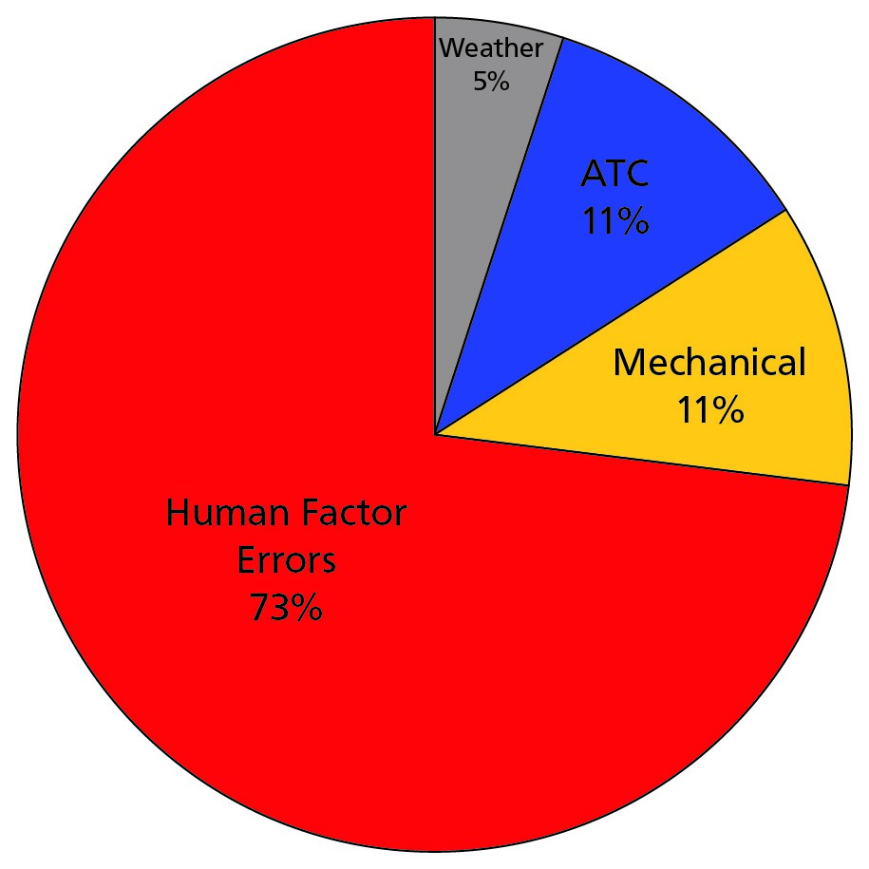

The five most common specific causes of pilotinduced accidents, in order of frequency, are:

* Loss of directional control
* Poor judgement
* Airspeed not maintained
* Poor preflight planning and preflight decision making
* Not maintaining ground clearance

The phases of flight most prone to accidents are, in order of precedence:

* Intermediate and Final Approach
* Landing
* Take-off
* Descent *Figure 1.3 Causes of accidents*

### Flight Safety

#### Roles Played by the Various Aviation Participants in Flight Safety

Air transport is a huge system employing millions of people in thousands of different capacities. Those having a direct influence on flight safety are noted below together with their possible limitations:

**Basic Concepts**

#### National and International Authorities (ICAO, IATA, EASA, CAA, FAA etc.)

These organizations have, among their responsibilities those of setting , implementing and monitoring flight safety standards. They are also charged with developing the aviation industry within their field of influence. The two requirements sometimes conflict and, on many occasions, responsible compromises have to be found. This conflict necessitates limitations which, in many cases, are based on either financial or political considerations.

#### Commercial Organizations

Commercial organizations can suffer from a similar dilemma. The financial position of the organization may drive flight safety parameters. Smaller companies can be particularly vulnerable to cash problems.

The outward signs could include:

* Stretched crew duty times
* Poor rostering
* Unserviceabilities carried
* Weaknesses and short-cutting in maintenance and operational procedures
* Poor communications
* Lip service to minimum equipment lists
* Shortcomings and non-standardization of cockpit layouts
* Lack of passengers and aviation facilities
* Absenteeism
* Poor industrial relations
* Rise in accident rate

#### Management

A minor change of policy may have far-reaching effects. For example a change in the utilization of an aircraft may effect workload, servicing schedules, rostering and render procedures invalid. The ripple effect is normally felt throughout the organisation and can have a direct influence on flight safety. In-depth consultation is a prerequisite to effective aviation management.

#### Training Staff

Training staff are at the coal face of flight safety. The interface and feedback between management and technical/flight personnel often takes place at this level. The professionalism, motivation, flexibility and communication abilities of training personnel are all fundamental to the augmentation of flight safety standards.

#### Technical/Flight Personnel

At the end of the line are the technical/flight personnel. On their shoulders lie the ultimate conflict. Should job security be put at risk because of flight safety considerations? Should a pilot, for example, agree to fly after extended duty times in order to satisfy a valued contract? Equally should an engineer submit to managerial pressures in order to satisfy serviceability demands? Sadly, this quandary has been faced many times in the past and will continue to be confronted in the future.

### The Most Significant Flight Safety Equipment

It is generally considered that the most significant item of technical equipment that has been introduced in the 1980s and 1990s which has contributed most to the reduction of accidents is the Ground Proximity Warning System **(GPWS)** and later the Enhanced Ground Proximity Warning System **(EGPWS).**

**Basic Concepts**

### Safety Culture

An active safety culture is considered to be the heart of and vital to the continuing success of a safety management system.

It has been described as “The safety culture of an organization is the product of individual and group values, attitudes, perceptions, competencies and patterns of behaviour that determine the commitment to, and the style and proficiency of, an organization’s health and safety management.” ***Definition***

Safety culture is defined as the enduring value and prioritization of worker and public safety by each member of each group and in every level of an organization.

It refers to the extent to which individuals and groups will commit to personal responsibility for safety and to:

* act to preserve
* enhance and communicate safety concerns
* strive to actively learn
* adapt and modify (both individual and organizational) behaviour based on lessons learned from mistakes

and

* strive to be honoured in association with these values

#### Open Culture

Where all levels of an organization play an active part in the improvement of the safety culture. ***Closed Culture***

Where an organization is reluctant to release information on threats, errors or undesired aircraft states to other agencies.

#### National Culture

Both government and ethnic factors influence attitudes towards safety culture.

**Factors that Promote a Good Safety Culture**

* Leadership
* Commitment
* Good example

### Reason’s Swiss Cheese Model

Likens human systems to multiple slices of Swiss cheese, stacked together, side by side.

An organization’s defences against failure are modelled as a series of barriers (the Swiss cheese slices). The holes in the cheese slices represent individual weaknesses in each part of the system and are continually varying in position and size in each slice.

**Basic Concepts**

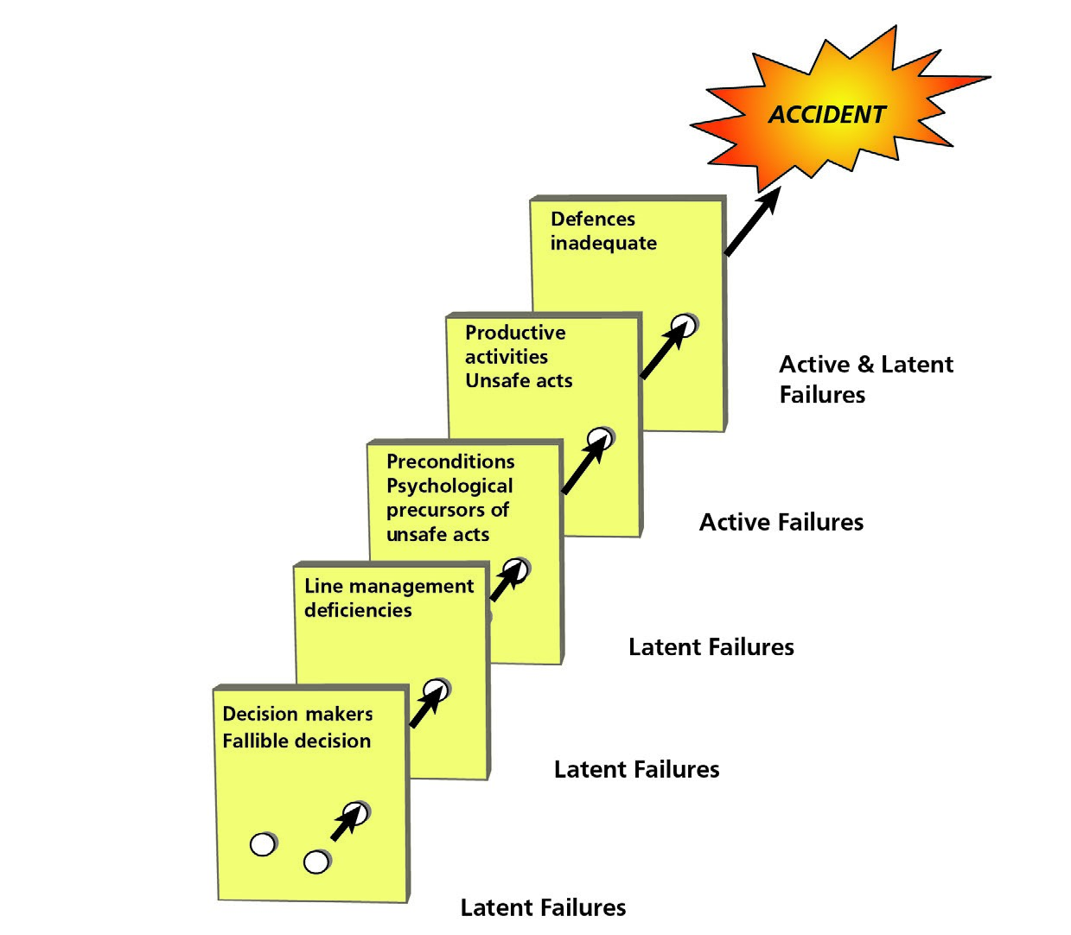

*Figure 1.4*

*The Swiss Cheese Model - by James Reason*

The system as a whole will produce failures when all of the holes in each slice momentarily align. A hazard will pass through all of the holes in all of the defences leading to a failure.

### The Five Elements of Safety Culture

1. An informed culture
2. A reporting culture
3. A learning culture
4. A just culture
5. A flexible culture

#### Just Culture

Errors and unsafe acts will not be punished if the error was unintentional. Those who act recklessly or take deliberate and unjustifiable risks will be subject to disciplinary action.

#### Non Punitive Culture

Errors and unsafe acts will not be punished thus encouraging an atmosphere where people have the confidence to report safety concerns.

### Flight Safety/Threat and Error Management

The three components of threat and error management (TEM) are:

1. Threats
2. Errors
3. Undesired aircraft states

### Threats

**Basic Concepts**

#### Latent Threats

Not immediately obvious to, or observable by flight crews, e.g. poor equipment design, visual illusions or quick turn-around schedules.

***Environmental Threats***

Those occurring during actual operations, e.g. weather, terrain, ATC, airport.

#### Organizational Threats

Operational pressure, aircraft type, cabin design, maintenance, dispatch, documentation. **Errors**

Defined as:

Actions or lack of actions by the flight crew that lead to deviations from organisational or flight crew intentions or expectations. ***Aircraft Handling Errors***

Manual handling, automatic systems, ground navigation.

***Procedural Errors***

SOPs, checklists, briefing documentation.

***Communication Errors***

Crew to external, pilot to pilot.

### Undesired Aircraft States

Defined as:

Flight crew induced aircraft speed or position deviations, misapplication of flight controls, incorrect system configurations, associated with a reduction in safety margins.

1. Aircraft handling
2. Ground navigation
3. Incorrect configuration

#### Counter Measures

All flight crew MUST employ counter measures in order to keep threats, errors and undesired aircraft states from reducing safety margins in flight operations.

#### Hard Resources

Examples of hard resources are:

Airborne Collision Avoidance Systems (ACAS)

Ground Proximity Warning Systems (GPWS)

Standard Operation Procedures (SOPs)

Checklists

Briefings Training

#### Human Resources

**Basic Concepts**

*Avoid Trap Mitigate* **(ATM)**

**Avoid:** An attempt to foresee potential problems. Best achieved at times of low workload.

**Trap:** Deal with threats and hazards as they occur.

**Mitigate:** Deal with the consequences of an error that has occurred.

***Mitigation feels like failure but is, in fact, success - it is the safe option.***

### Duties of Flight Crew

Flight crew duties and responsibilities of a commercial company normally include the following: ***All Flight Crew***

* To be conversant and uphold both the laws/regulation of the country and the rules of the company. Ignorance not an acceptable excuse for any contravention.
* Shall obey all lawful commands which the Commander of the aircraft may give for the purpose of securing the safety of the aircraft and of persons or property carried therein, or to the safety, efficiency or regularity of air navigation.

#### The Commander

* Maintain familiarity with relevant air legislation, practices and procedures together with provisions of the company Operations Manual.
* Be responsible for the safe operation of the aircraft and the safety of its occupants and cargo. This responsibility starts when he/she enters the aircraft with the intention of flying or when he/she first signs the flight documents and ends when the post-flight documents are completed and signed.
* Subject only to the above, act to the benefit of the company’s commercial advantage.
* Have the authority to give all commands he/she deems necessary for the purpose of securing the safety of the aircraft and the persons or property therein.
* Have the authority to disembark any person, or any part of the cargo, which in his/her opinion, may represent a potential hazard to the safety of the aircraft or its occupants.
* Not allow a person to be carried in the aircraft who appears to be under the influence of alcohol or drugs to the extent that the safety of the aircraft or its occupants are likely to be endangered.
* Have the right to refuse transportation of inadmissible passengers, deportees or persons in custody, if their carriage poses any risk to the safety of the aircraft or its occupants.
* Ensure that all passengers are briefed on the location of emergency exits and the use of relevant safety and emergency equipment.
* Ensure that all operational procedures and checklists are complied with, in accordance with the company’s Operations Manual.

**Basic Concepts**

* Ensure that flight duration or duty times do not exceed the company maximum.
* Decide whether or not to accept the aircraft with unserviceabilities allowed by the company Minimum Equipment List (MEL).
* Ensure that the aircraft and any required equipment is serviceable.
* Ensure that the aircraft refuelling is supervised with particular attention to:
* the correct grade and amount of fuel fuel water checks
* fire safety precautions
* checking filler caps are correctly replaced after refuelling
* Ensure that the aircraft mass and balance is within the calculated limits for the operating conditions.
* Confirm that the aircraft’s performance will enable it to safely complete the proposed flights.
* Not permit any crew member to perform any activity during take-off, initial climb, final approach and landing except those duties required for the safe operation of the aircraft.
* Ensure that whenever the aircraft is taxiing, taking-off or landing, or whenever he/she considers it advisable (e.g. during turbulent conditions), all passengers are properly secured in their seats, and all cabin baggage is stowed in the approved stowage.
* Ensure that the required documents and manuals are carried and will remain valid throughout the flight or series of flights.
* Ensure that the preflight inspection has been carried out.
* Maintain a high standard of discipline, conduct and appearance.
* Shall not permit the Flight Data Recorder (FDR) to be disabled, switched off or erased during flight. Nor will he/she permit data to be erased after flight in the event of an accident or an incident subject to mandatory reporting.
* Shall not permit a Cockpit Voice Recorder (CVR) to be disabled or switched off during flight unless he/she believes that the recorded data, which otherwise would be erased automatically, should be preserved for incident or accident investigation. Nor may he/she permit recorded data to be manually erased during or after flight in the event of an accident or incident subject to mandatory reporting.
* Take any action he/she considers necessary, in the event of an emergency that requires an immediate decision. In such cases he/she may deviate from rules, operational procedures and methods in the interests of safety.
* Has the authority to apply greater safety margins, including aerodrome operating minima, if deemed necessary.
* Ensure that a continuous listening watch is maintained on the appropriate radio frequencies at all times whenever the flight crew is manning the aircraft for the purpose of commencing and/or conducting a flight and when taxiing.

**Basic Concepts**

* Ensure the welfare of the passengers and crew.

#### The First Officer/Co-pilot

* Is responsible to the Commander to assist in the safe and efficient conduct of the flight. He/ she will report to the Commander any incident that has, or may have, endangered safety.
* In the event of incapacitation of the Commander the First Officer/Co-pilot will assume command.
* Maintain familiarity with relevant air legislation, practices and procedures together with provisions of the company Operations Manual.
* Assist the Commander as requested, concerning operational and administrative duties in relation to the flight.
* Support the Commander in the maintenance of a proper standard of crew discipline, conduct and personal appearance.
* To carry out such duties, as are allocated to him/her by the Commander, concerning the flight in accordance to the company Standard Operating Procedures (SOPs). These may include procedures, limitations and performance of the specific aircraft type.
* Confirm the safe navigation of the aircraft, maintaining a continuous and independent check upon both the geographical position of the aircraft and its safe terrain clearance.
* To volunteer such advice, information and assistance to the Commander, as may contribute favourably towards the safe and efficient conduct of the flight.
* To support the Commander, by active example, in the development and maintenance of a high standard of professional expertise and morale amongst the crew.

#### Flight Engineer

Where there is no Flight Engineer, these duties would be carried out by the Commander or First Officer.

* Advise the Commander of aircraft serviceability and any acceptable deferred defects.
* Carry out external, internal engineering checks and complete all necessary documentation.
* Complete all checklists in the manner specified in the Operations Manual.
* Maintain fuel and instrument logs and any other records required.
* Monitor R/T communications and assist in obtaining met reports and conduct company communications as required.
* Operate power plants and systems ensuring limitations are not exceeded and advise the Commander of any malfunction.

**Basic Concepts**

* Assist in monitoring all flight indications, especially attitude, altitude/height, speed and heading together with all warning lights and flags.
* Assist in monitoring the navigational displays.
* Maintain a lookout whenever possible.
* Carry out any duties consistent with his/her training and qualifications which may be delegated by the Commander. ***Other Members of the Crew***
* To assist the Commander in the safe and efficient conduct of the flight and to report to the Commander any incident that has endangered or may endanger safety.
* Shall carry out any lawful instructions of the Commander and to assist him/her concerning operational and administrative duties in relation to the flight.
* To support the Commander in the maintenance of a proper standard of crew discipline, conduct and personal appearance.
* Maintain familiarity with relevant air legislation, practices and procedures together with provisions of the company Operations Manual as are necessary to fulfil his/her function.

Chapter

## **2** The Circulation System

Blood Circulation . . . . . . . . . . . . . . . . . . . . . . . . . . . . . . . . . . . . . . . . . . 19

The Blood . . . . . . . . . . . . . . . . . . . . . . . . . . . . . . . . . . . . . . . . . . . . . . 19

Composition of the Blood . . . . . . . . . . . . . . . . . . . . . . . . . . . . . . . . . . . . . 19

The Heart . . . . . . . . . . . . . . . . . . . . . . . . . . . . . . . . . . . . . . . . . . . . . . 20

Oxygen Carriage . . . . . . . . . . . . . . . . . . . . . . . . . . . . . . . . . . . . . . . . . . 20

Carriage of Carbon Dioxide . . . . . . . . . . . . . . . . . . . . . . . . . . . . . . . . . . . . 21

The Circulation System . . . . . . . . . . . . . . . . . . . . . . . . . . . . . . . . . . . . . . . 21

What Can Go Wrong . . . . . . . . . . . . . . . . . . . . . . . . . . . . . . . . . . . . . . . . 23

System Failures . . . . . . . . . . . . . . . . . . . . . . . . . . . . . . . . . . . . . . . . . . . 23

Factors Predisposing to Heart Attack . . . . . . . . . . . . . . . . . . . . . . . . . . . . . . . 24

Insufficient Oxygen Carried . . . . . . . . . . . . . . . . . . . . . . . . . . . . . . . . . . . . 24

Carbon Monoxide. . . . . . . . . . . . . . . . . . . . . . . . . . . . . . . . . . . . . . . . . . 25

Smoking . . . . . . . . . . . . . . . . . . . . . . . . . . . . . . . . . . . . . . . . . . . . . . . 26

Blood Pressure. . . . . . . . . . . . . . . . . . . . . . . . . . . . . . . . . . . . . . . . . . . . 26

Pressoreceptors and their Function Maintaining Blood Pressure . . . . . . . . . . . . . . . . 28

Function . . . . . . . . . . . . . . . . . . . . . . . . . . . . . . . . . . . . . . . . . . . . . . . 28

Donating Blood and Aircrew. . . . . . . . . . . . . . . . . . . . . . . . . . . . . . . . . . . . 29

Pulmonary Embolism . . . . . . . . . . . . . . . . . . . . . . . . . . . . . . . . . . . . . . . . 29

Questions . . . . . . . . . . . . . . . . . . . . . . . . . . . . . . . . . . . . . . . . . . . . . . 30

Answers . . . . . . . . . . . . . . . . . . . . . . . . . . . . . . . . . . . . . . . . . . . . . . . 34

**The Circulation System**

### Blood Circulation

The circulatory system of the human body consists of two parts. The **pulmonary system** takes de-oxygenated blood from the heart to the lungs for gaseous exchange and returns oxygenated blood to the heart. From there the **systemic system** delivers oxygen rich blood to all tissues of the body to allow metabolization to occur and returns the de-oxygenated blood to the heart.

### The Blood

Blood consists of a liquid, the **plasma**, and a number of different types of **cells** which are necessary for the healthy functioning of the human body. The functions of the circulatory system and the blood contained therein are to:

* carry oxygen to, and carbon dioxide from, the various tissues and organs of the body.
* carry nutrients to tissues and remove waste products from these tissues.
* carry chemical messengers, such as **hormones** including **adrenaline**, to regulate the actions and secretions of various organs.
* transport certain cells which can attack and destroy invading micro-organisms, **bacteria**, enabling the body to resist disease.

**The Circulation System**

* assist in temperature control of the body. Vasoconstriction of the exterior blood vessels will take place if the body is subjected to cold and vasodilation will take place if the body is subjected to heat.

### Composition of the Blood

The plasma, a pale straw coloured medium, is the liquid part of the blood. As well as carrying the various blood cells it delivers digested food products such as glucose and amino acids, dissolved proteins, various hormones and enzymes. The plasma contains sodium chloride.

The blood cells are of three types:

* **Red** blood cells contain **haemoglobin** and carry oxygen to the cells and tissues of the body. The red cells do not have nuclei and thereby make more room for haemoglobin.
* **White** blood cells are of various types; they resemble amoebae and have large nuclei to engulf and destroy invading bacteria. Their main function is the defence against disease. They produce antibodies to fight bacteria and antitoxins to **neutralize** the toxins produced by bacteria.
* **Platelets** are the smallest of the blood cells and assist in the blood clotting process.

### The Heart

At the centre of the circulatory system is a muscular pump, the heart, which is located in the chest cavity. A section through a human heart is shown in *Figure 2.1* The heart has four chambers, two **ventricles** which are the most powerful parts of the heart and two **auricles or atria**,(**atrium** is the singular of atria), which are the upper chambers of the organ.

**Functions of the Ventricles** The ventricles supply the main force that propels the blood through the lungs and the circulatory system.

The right ventricle pumps deoxygenated blood to the

lungs and the left ventricle pumps the oxygenated blood around the body.

**Functions of the Atria**  The atria act principally as entryways to the ventricles but they also pump weakly to help move the blood on through the atria into the ventricles. Thereby they increase the effectiveness of the ventricles as pumps.

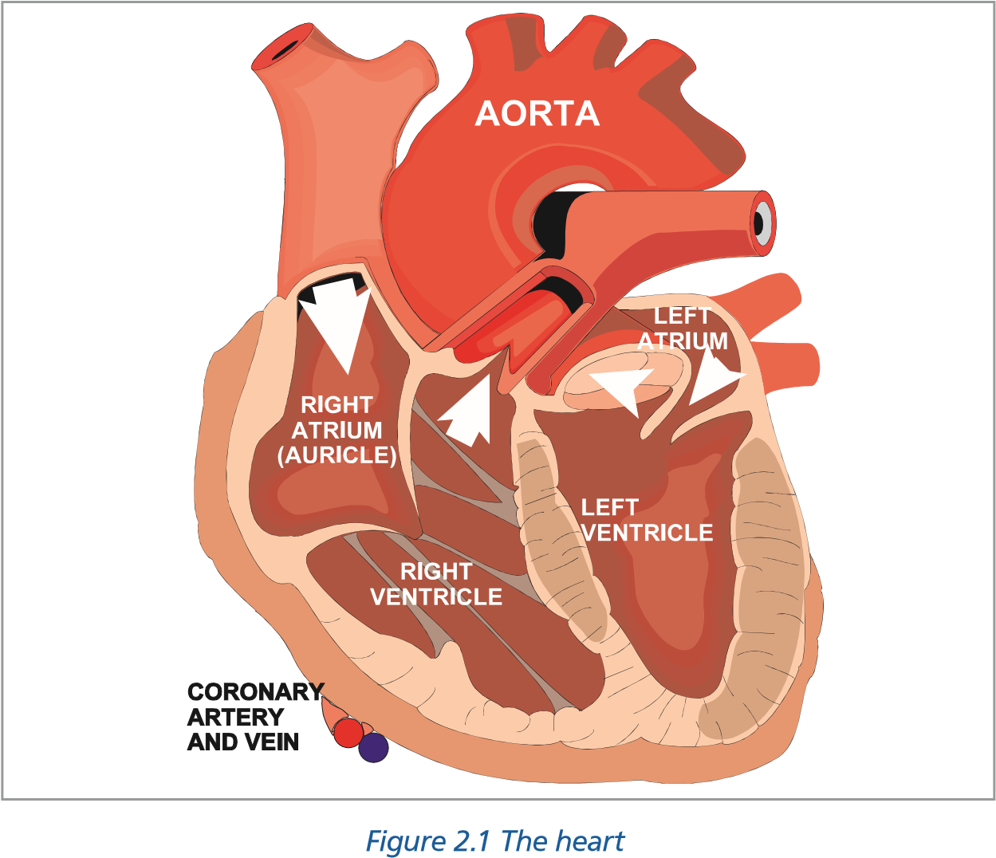Leading into and out of the heart are various blood vessels, the **arteries** which carry blood from the heart at high pressure and the **veins** which return blood to the heart at low pressure. As the heart itself is a muscle it requires its own blood supply system which is provided by the **coronary** arteries and veins.

**The Circulation System**

A narrowing or blockage of the **coronary** arteries or veins are the cause of one of the major diseases which may affect the heart.

### Oxygen Carriage

A small amount of oxygen is dissolved in the blood plasma but the major vehicle for oxygen carriage is **haemoglobin** which is contained in the red blood cells.

Like all cells in the body, the red blood cells die and are replaced in a regular cycle. Red blood cells contain no nuclei and have an average life in man of about 108 days. New red blood cells and their haemoglobin are made mainly in the **bone marrow**, but some are also produced in the liver and spleen.

Oxygen from the lungs combines with the haemoglobin in the red blood cells to form **oxyhaemoglobin** which will release the oxygen to tissues which require it. Blood containing a large amount of oxygen is a red colour whilst blood with a shortage of oxygen is of a bluer tinge. If an artery is cut bright red blood spurts out, if a vein is cut then dark blood oozes out.

### Carriage of Carbon Dioxide

A small amount of the carbon dioxide may be dissolved in the plasma but the majority is carried in chemical combination with water in the form of **carbonic acid**.

**CO2 + H2O** ➔ **H2CO3**

Our blood is naturally acidic because of the presence of this carbonic acid. An acidic basis is required to allow the easy release of oxygen from oxyhaemoglobin to tissues. A reduction in the acidity of the blood which can occur when there is insufficient carbon dioxide in the blood, as when **hyperventilating** (see Chapter 3 - Oxygen and Respiration), interferes with the release of oxygen to the tissues.

### The Circulation System

The function of the circulatory system, which particularly concerns the aviator, is the carriage of oxygen to the tissues and the removal of carbon dioxide. Oxygen is required by the tissues for oxidation of food. Whereas the major source of energy for the body is **carbohydrates** which are a component of our food, energy can also be derived from **proteins and fats.** Thus those on hunger strike inevitably utilize proteins for energy.

**The Circulation System**

Carbohydrates are composed only of the elements carbon, hydrogen and oxygen and in the tissues these foodstuffs combine with Oxygen to give energy:

**Carbohydrates + Oxygen** ➔ **Energy + CO2 + H2O**

This process whereby energy is released from food, takes place in the cells and is called **Internal Respiration.**

Oxygen is obtained from the atmosphere and the blood picks up the oxygen from the lungs for transport around the body. Follow the path of the circulatory system as shown in *Figure 2.2*. The largest and most muscular part of the heart is the left ventricle. Blood containing oxygen is sent around the body from the left ventricle when it contracts. A system of one-way valves in the heart prevents blood going the wrong way.

The oxygenated blood passes through the **aorta** into the major arteries which divide into the smaller arteries before arriving at the smallest vessels of the system - the **capillaries**. The capillaries have very thin walls (only one cell thick) which allow the passage of oxygen from the blood into the tissues by **diffusion (Fick’s Law).** They also allow **carbon dioxide and water vapour** to diffuse in the reverse direction.

*Figure 2.2 The circulation system*

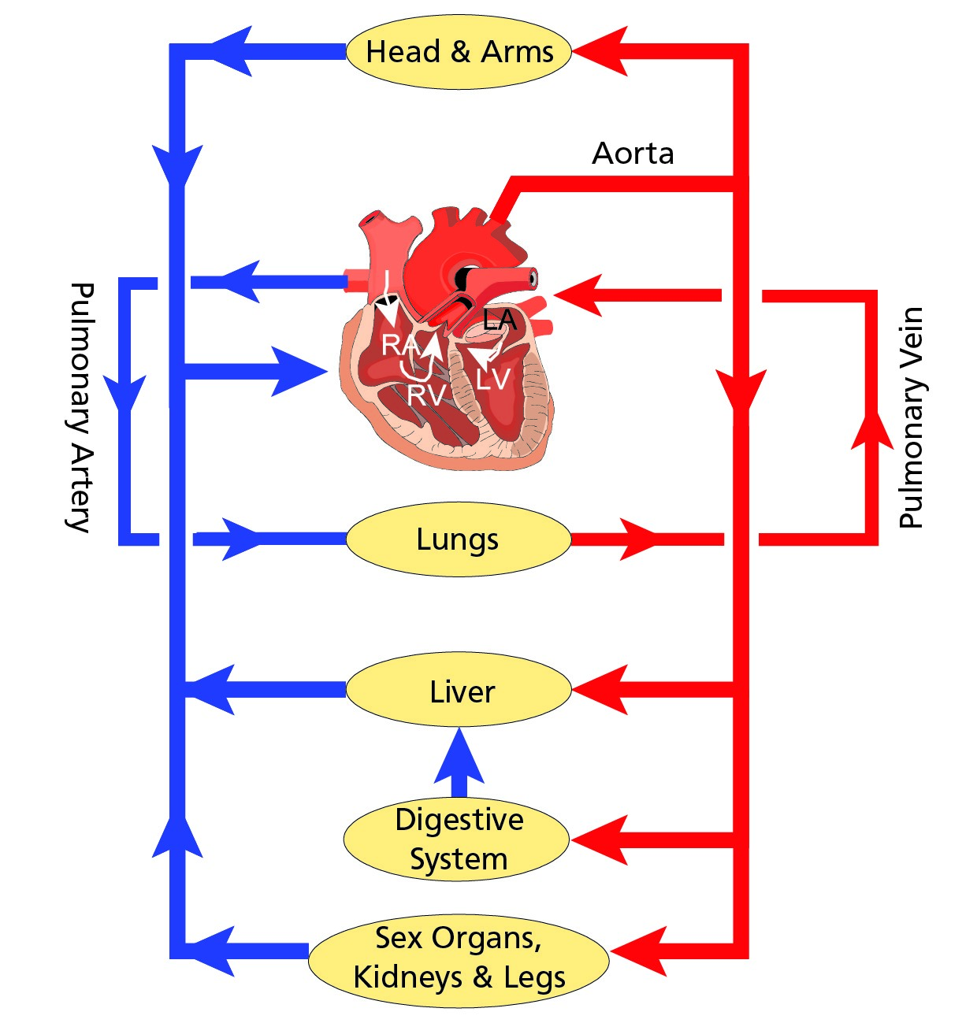

It is emphasized that this exchange can only take place at the capillaries. Even the smallest arteries and veins have walls too thick to allow the exchange of gases.

De-oxygenated blood passes from the venous capillaries to veins which progressively increase in size and returns eventually to the **right atrium**. It then passes to the **right ventricle** which pumps the blood via the **pulmonary artery** to the lungs. The carbon dioxide and water in the blood are released to the lungs and, at the same time, the blood is re-oxygenated. The blood then returns to the heart via the  **pulmonary vein** and left auricle. It is then pumped back into the aorta by the left ventricle.

**The Circulation System**

#### Cardiac Output

Cardiac output is the quantity of blood pumped by the left ventricle into the aorta each minute. It is the product of the stroke volume and the heart rate (or pulse rate). The normal pulse rate for a healthy average individual is 70 beats a minute. The stroke volume of a healthy heart remains constant and thus cardiac output will increase linearly with an increase in pulse rate. The limit of effective heart rate in man is about 180 beats a minutes. Above this, the heart cannot fill up quickly enough and cardiac output will decrease.

The cardiac output for the average human being at rest is 5.0 to 5.5 litres a minute.

#### Factors Determining Pulse Rate

The pulse rate will increase or decrease resulting from a number of factors as the demand for oxygen varies. Among the principal factors are:

* Exercise.
* Altitude.
* Temperature.

The pulse rate can also vary as a result of the sympathetic/parasympathetic control of the heart. This is discussed in Chapter 6. Among these factors are:

* Fight or Flight (GAS) Syndrome.
* Shock.
* Emotion (fear, anxiety and anger).

### What Can Go Wrong

The efficient distribution of oxygen may be disturbed in two ways:

* The system (heart, arteries, veins etc.) can develop a fault.
* The blood is unable to carry enough oxygen for the needs of the tissue cells.

### System Failures

The heart (pump) can be damaged. Heart tissue is muscle which responds to electrical impulses from the brain to contract or relax systematically. Sometimes this controlling system does not carry the impulses in a coordinated way. The heart beat may become irregular or even fail altogether.

**The Circulation System**

In modern surgery a mechanical device **(pacemaker)** may be implanted to produce the regular electrical impulses to cause the heart to beat at a regular rate. These electrical impulses and their synchronisation with the heart’s pulse rate can be measured, by an **electrocardiogram (ECG).** An ECG test is incorporated in aircrew medical examinations.

The heart muscles require oxygen to continue working. This oxygen is carried to the heart by the **coronary arteries***.* If a narrowing of these vessels should occur then insufficient blood may reach the heart muscle. This lack of oxygen, particularly when the heart is beating faster due to exercise or stress, will give rise to the symptoms of **angina**, with pain in the chest and sometimes the arms.

If the blood supply is cut off completely then a portion of the heart muscle may die (an infarct). The dead tissue is unable to carry the electrical impulses and the heart beat may become irregular or even fail completely **(a heart attack)**. ***Heart Attack (Myocardial Infarction).***

Angina is often a precursor to the development of a heart attack. Approximately half of those who have a myocardial infarction die immediately. A proportion go on to develop an associated abnormality of the heart rhythm which can completely interrupt the co-ordinated muscular contractions of the heart **(cardiac arrest).**

The most common of these disturbances is called **ventricular fibrillation**. If this can be treated promptly with an application of DC shock via a Defibrillator, then the heart may revert to its normal rhythm and the patient may survive. If the patient’s essential circulation can be supported by cardiac massage and assisted ventilation, he/she may survive while waiting for a defibrillator to be available. Without treatment cardiac arrest is fatal within 4 minutes.

Those who survive the first 24 hours post myocardial infarction will have a good chance of recovery however the retrieval of a flying licence will not be possible without extensive investigation and - in any case - a **restriction to multi-crew operations will always be imposed.**

### Factors Predisposing to Heart Attack

The factors predisposing to a heart attack, in order of importance, are:

* Family History (heredity).
* Age.
* Previous history of cardiovascular problems.
* Raised blood pressure (hypertension).
* Smoking.
* Raised blood cholesterol.
* Lack of exercise.
* Diabetes.

Other factors such as stress, obesity, alcohol and certain dietary considerations are less clearly understood. It is noteworthy that coronary disease is responsible for 70% of pilot deaths during their careers. ***Incapacitation in Flight***

**The Circulation System**

The dramatic and sudden incapacitation of a pilot during flight is uncommon and very rarely the cause of an accident. An aircraft accident at Staines was one of the very few major accidents in civil aviation due to the pilot suffering a heart attack. Rigorous medical selection and periodic health checks minimize the risk of total incapacitation due to heart disease, epilepsy etc. As the pilot grows older the frequency of medical checks increases. **ECG (electrocardiogram)** and **EEG (electroencephalogram)** recordings are used more and more to spot those at risk. **Insufficient Oxygen Carried**

The cells of the various tissues may be deprived of the oxygen they need because of:

* Insufficient haemoglobin or red blood cells **(anaemia).** This can be primarily caused by the breakdown of the production process of haemoglobin in the bone marrow or by excessive bleeding.
* Insufficient pressure of oxygen in the air. The pressure of oxygen in the air (partial pressure) reduces with altitude and people who live at high altitude for a prolonged period produce more red blood cells than those who live at sea level. In other cases it will be necessary to add oxygen to the air breathed. This topic is treated fully in the next chapter.
* A lack of iron.

### Carbon Monoxide

Carbon monoxide is produced by incomplete combustion of carbon. Jet exhausts contain less than 1% carbon monoxide whereas exhaust gases from reciprocating engines can consist of as much as 9%. It may be introduced into the air from leaking exhausts and heater fumes.

**The dangers of a presence of carbon monoxide cannot be emphasized too strongly.**

Haemoglobin has a much greater affinity for carbon monoxide molecules than for oxygen (up to 210-50 times) and will transport them in preference to oxygen. Carbon monoxide combines with haemoglobin to form **carboxyhaemoglobin** which gives the blood a bright pink colour. Carbon monoxide is odourless which adds significantly to its dangers.

The first symptom of carbon monoxide poisoning is a headache (or tightness across the forehead) nausea and dizziness. **Thus the peril will probably not be immediately recognized** by an individual thereby increasing the danger. As a precaution, fresh air should always be used in conjunction with cabin heat to minimize the effects of possible carbon monoxide poisoning.

The mild hypoxia associated with flying at cabin altitudes of 8 to 10 thousand feet accentuates the effects of carbon monoxide.

Finally it is an important fact that the effects of carbon monoxide are **cumulative**. Thus a pilot who flies several times in the same day or on successive days in an aircraft with carbon monoxide concentrations, can eventually suffer serious effects.

#### Symptoms of Carbon Monoxide Poisoning

**The Circulation System**

* Headache, tightness across the forehead, dizziness and nausea.
* Impaired vision.
* General feeling of lethargy or weakness.
* Impaired judgement.
* Personality change.
* Impaired memory.
* Slower breathing rate and weakening pulse rate.
* Loss of muscular power.
* Flushed cheeks and cherry-red lips.
* Convulsions.
* Death.

#### Treatment of Carbon Monoxide Poisoning

* Turn off cabin heat.
* Stop all smoking.
* If oxygen available, it should be inhaled by those effected.
* Increase the supply of fresh air through vents and windows.
* Land as soon as possible.

#### Susceptibility to Carbon Monoxide Poisoning

* Altitude.
* Smoking.
* Age.
* Obesity.
* General state of health.

Many aircraft are equipped with carbon monoxide detectors. They should be checked regularly by the pilot in flight and correctly maintained by engineering.

### Smoking

Apart from the addictive properties of **nicotine** which are thought to increase the risk of cardiovascular disease and tar which is carcinogenic (known to increase the risk of cancer), smoking tobacco produces carbon monoxide which links with the haemoglobin in the blood to deny oxygen carriage. A person smoking 20 cigarettes a day will have a raised carboxyhaemoglobin level by about 7%. This equates to a reduction in oxygen carrying capacity of 4000 to 5000 ft. Add this to a cockpit altitude of 6000 to 8000 ft and the smoker would react as if at an altitude up to 12 000 ft with resulting **anaemic hypoxia** leading to reduced performance and slower reactions.

Individuals suffering from ‘passive’ smoking will also be affected and there is a tendency for modern airlines to move more and more towards a non-smoking policy on board aircraft.

Smoking also leads to:

* Lung cancer.
* Breathing problems.

**The Circulation System**

* Circulatory problems.
* Reduced tolerance to g-forces.
* Increased risk of heart attack.
* A stimulation of the secretion of adrenaline and an increase of vigilance caused by the nicotine - but as stated above, this substance is the one which causes addiction.
* Degradation of night vision.

Some airlines may not accept into their training programmes pilots who smoke. So:

**IF YOU SMOKE - STOP**

**IF YOU DON’T SMOKE - DON’T START**

### Blood Pressure

As part of any medical examination the doctor will measure your blood pressure. The result will be given as two numbers e.g. 120/80. The higher figure is the **systolic** pressure, that is the pressure exerted by the heart when it contracts to send blood around the body. The lower figure is the **diastolic** pressure which is the permanent pressure within the arterial system. The pressures are measured in mm of mercury.

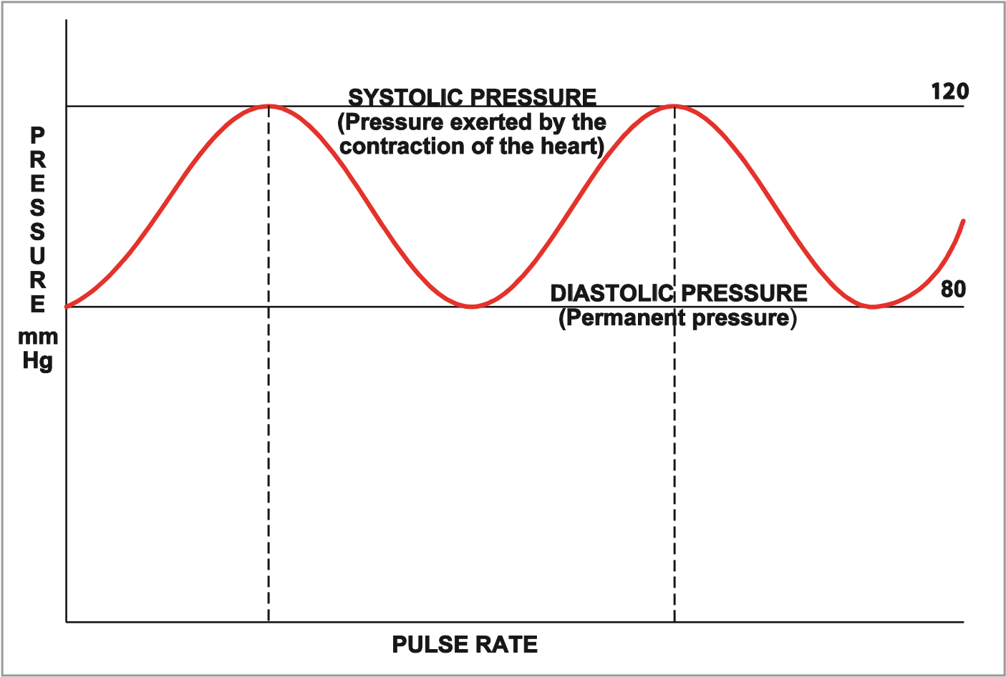

*Figure 2.3 Diastolic and systolic pressure*

Too high a blood pressure can be a factor in cardiovascular failure. High blood pressure **(hypertension)** is the major factor in **strokes.** A blood pressure of **160/95 or over** is assessed by JAR-FCL3 as unfit.

Hypertension can be caused by:

* Stress.
* Smoking.
* Dietary factors (among which is excessive fat and/or salt intake).
* Age.
* Obesity.
* Lack of exercise.
* Narrowing and/or hardening of the arteries.

**The Circulation System**

High blood pressure may give no symptoms at all and needs to be detected by routine flight crew screening. The primary symptoms of hypertension are:

* Heart palpitations.
* Shortness of breath.
* Angina (chest pains).
* Headaches.
* Nose bleeds.

Hypertension can be controlled by drugs, surgery or a change in life style.

**Note:** The average pilot’s blood pressure will rise slightly with age as the arteries lose their elasticity. This natural change will be taken into consideration by your aviation medical examiner in progressive medical tests.

Low blood pressure **(hypotension)** normally does not constitute a danger. However if the pressure decreases too much, leading to a shortage of oxygen to the tissues, it can lead to:

* Lethargy/tiredness.
* Reduced resistance to the effects of shock (faints or collapse).
* Congestion of the respiratory system.
* Stagnation in the blood supply.
* Reduced capability to withstand positive g-forces.

**The normal range** of blood pressure varies with age, but a healthy young adult will typically have a systolic pressure of about 120 mm Hg and a diastolic pressure of about 80 mm Hg **(120/80).**

Both hypertension and hypotension may disqualify a pilot from obtaining a medical clearance to fly.

### Pressoreceptors and their Function Maintaining Blood Pressure

#### General

Pressoreceptors are located in the wall of the carotid sinus in the neck and upstream of the brain. They are part of the pressure regulating system of the blood supply to the brain.

#### Function Hypertension

**The Circulation System**

Should the Pressoreceptors detect an increase of blood pressure, impulses are sent to the brain which will cause a reduction of the heart rate and a relaxation of the blood vessels effecting a reduction of blood pressure.

#### Hypotension

Should the Pressoreceptors detect a decrease of blood pressure, impulses are sent to the brain which will cause an increase of the heart rate and a tightening of the blood vessels effecting an increase of blood pressure.

It can be seen from the above that the primary function of the pressoreceptors **is that of maintaining homeostasis.**

#### The Effect of G-forces and Blood Pressure

Should a pilot experience positive g, the blood pressure will decrease in the area of the brain and the pressoreceptors will attempt to protect the brain by increasing the pressure. At high g-forces the pressoreceptors can no longer cope and the pilot may suffer from grey or blackout. In the case of negative g, the reverse process will take place except that the pilot will experience redout - negative g (see Chapter 6).

Not only can the blood vessels in the eye and face burst with large negative g-forces but the lower eyelids are pushed upwards obscuring vision.

Positive g-forces will also **increase the hydrostatic variation** of the circulatory blood system.

This is explained in detail in Chapter 6 (Flying and Health).

### Donating Blood and Aircrew

Many aircrew express the wish to donate blood either in support of the National Blood Transfusion Service or for personal reasons. In order to prevent the very slight risk of post transfusion faintness **(syncope)** it is recommended that, having given blood, aircrew should drink plenty of fluids and rest supine for a short time (15 - 20 minutes). They must refrain from flying duties for a **minimum of 24 hours.** It is also advisable to seek advice from an aviation specialist prior to blood donation.

### Pulmonary Embolism

**The Circulation System**

The blood supply to the lungs may be interrupted by a blockage to the Pulmonary artery. This not only causes death of lung tissue but also prevents oxygenation of the blood. The most common cause of this condition is known as a pulmonary embolism which results from a blood clot from the leg **(thrombus)** becoming detached and travelling to the lungs where it becomes lodged causing the blockage.

The immobility associated **with long haul flights may predispose the formation of blood clots in the lower limbs**. Exercising the legs help reduce the risk and both crews and passenger should be encouraged to walk around the cabin from time to time throughout the flight.

### *Questions*

#### Questions

1. **How is oxygen transported around the body?**
   1. By red blood cells combined with carbon dioxide
   2. By red blood cells combined with nitrogen and water vapour
   3. By red blood cells combined with haemoglobin
   4. By red blood cells combined with nitrogen, hormones and plasma
2. **How is the rate and depth of breathing controlled?**
   1. By the amount of oxyhaemoglobin in the blood and lungs
   2. By the amount of haemoglobin in the blood and the lungs
   3. By the amount of carbon monoxide and oxygen in the blood
   4. By the amount of carbonic acid in the blood
3. **What is the function of the left and right ventricle?**
   1. Left: Pumps deoxygenated blood to the lungs Right: Pumps oxygenated blood around the body b. Left: Pumps oxygenated blood around the body Right: Pumps deoxygenated blood to the lungs c. Left: Pumps oxygenated blood to the lungs Right: Pumps deoxygenated blood around the body d. Left: Pumps oxygenated blood to the lungs

**Questions**

Right: Pumps oxygenated blood around the body

1. **The factor which most increases the risk of coronary heart disease is:**
   1. family history
   2. lack of exercise
   3. obesity
   4. smoking
2. **What is the carcinogenic content of a cigarette?**
   1. Nicotine
   2. Tar
   3. The type of tobacco
   4. The wrapping
3. **Angina is a pain associated with the heart which is felt only across the chest. This statement is:**
   1. true
   2. untrue
4. **List the symptoms of carbon monoxide poisoning:**
   1. ruddy complexion, headache, stomach cramps, nausea, lethargy
   2. difficulty in breathing, ruddy complexion, headache, stomach cramps, nausea, lethargy
   3. ruddy complexion, headache, nausea, giddiness, stomach cramps
   4. ruddy complexion, headache, tightness across the forehead, impaired judgement

### *Questions*

1. **Why is it essential to ensure that the combustion heaters are serviceable?**
   1. To prevent carbon dioxide poisoning and possible fire
   2. To prevent carbon dioxide poisoning, possible fire or explosion
   3. To prevent carbon monoxide poisoning
   4. To prevent carbon dioxide poisoning and possible fire
2. **The effects of smoking, particularly in relation to aviation are:**
   1. an early onset of hypoxia due to an apparent increase in altitude and a degradation of night vision
   2. an early onset of hypoxia due to an apparent increase in altitude
   3. an early onset of hypoxia due to an apparent increase in altitude up to a maximum of 40 000 ft
   4. an early onset of hypoxia due to an apparent increase in altitude with a resulting risk of anaemia
3. **Will smokers experience hypoxia at a lower or higher cabin altitude than nonsmokers?**
   1. At a higher cabin altitude
   2. At a lower cabin altitude
   3. Both will experience hypoxia at approximately the same cabin altitude
   4. Smoking, although harmful in other ways, lessens the effects of hypoxia

**Questions**

1. **A pilot must wait at least 24 hours before flying after donating blood.**
   1. True
   2. False
2. **Where does the exchange of oxygen and carbon dioxide + water vapour take place:**
   1. the arteries
   2. the veins
   3. the capillaries
   4. the pulmonary veins and arteries
3. **The normal range of blood pressure is:**
   1. systolic 120 mm Hg and diastolic 80 mm Hg
   2. systolic 80 mm Hg and diastolic 120 mm Hg
   3. systolic 120 mm Hg and diastolic 120 mm Hg
   4. systolic 80 mm Hg and diastolic 80 mm Hg
4. **Pressoreceptors affect the:**
   1. ECG readings
   2. tightening and relaxation of the blood vessels only
   3. EEG readings
   4. tightening and relaxation of the blood vessels and the pulse rate

### *Questions*

1. **Hypotension is:**
   1. high blood pressure
   2. high pulse rate
   3. low blood pressure
   4. low pulse rate
2. **Haemoglobin has a preference to carbon monoxide over oxygen by a factor of:**
   1. 100 – 120
   2. 210 - 250
   3. 200
   4. 10 - 20
3. **Treatment of carbon monoxide poisoning should include:**
   1. immediate descent to MSA
   2. turn up cabin heat
   3. keep the patient’s body temperature as low as possible

**Questions**

* 1. stop all smoking

1. **Low blood pressure can lead to:**
   1. low body temperature
   2. reduced tolerance to g-forces
   3. infarct
   4. angina
2. **Cardiac output (the quantity of blood pumped by the heart per unit time), is the product of:**
   1. stroke volume and the heart rate (pulse rate)
   2. stroke volume and viscosity of the blood
   3. pulse rate and strength of the ventricle muscle
   4. pulse rate only
3. **Internal Respiration is:**
   1. the brain’s control of the pulse rate
   2. the exchange of oxygen with carbon dioxide and water in the cells
   3. sighing
   4. the retention of breath

***Questions***

**Questions**

### *Answers*

**Answers**

#### Answers

|  |  |  |  |  |  |  |  |  |  |  |  |  |  |  |  |  |  |  |  |
| --- | --- | --- | --- | --- | --- | --- | --- | --- | --- | --- | --- | --- | --- | --- | --- | --- | --- | --- | --- |
| 1 | | 2 | | 3 | | 4 | | 5 | | 6 | | 7 | | 8 | | 9 | 10 | 11 | 12 |
| c | | d | | b | | a | | b | | b | | d | | c | | a | b | a | c |
| 13 | 14 | | 15 | | 16 | | 17 | | 18 | | 19 | | 20 | |
| a | d | | c | | b | | d | | b | | a | | b | |

Chapter

## **3** Oxygen and Respiration

Oxygen Intake. . . . . . . . . . . . . . . . . . . . . . . . . . . . . . . . . . . . . . . . . . . . 37

Composition of the Standard Atmosphere - Humidity, Gas Laws and Partial Pressure. . . . . 39

Thresholds of Oxygen Requirements Summary . . . . . . . . . . . . . . . . . . . . . . . . . . 43

Hypoxic Hypoxia . . . . . . . . . . . . . . . . . . . . . . . . . . . . . . . . . . . . . . . . . . 43

Hypoxic Hypoxia Symptoms . . . . . . . . . . . . . . . . . . . . . . . . . . . . . . . . . . . . 43

Stages/Zones of Hypoxia . . . . . . . . . . . . . . . . . . . . . . . . . . . . . . . . . . . . . . 44

Factors Determining the Severity of and the Susceptibility to Hypoxic Hypoxia . . . . . . . . 45

Anaemic Hypoxia . . . . . . . . . . . . . . . . . . . . . . . . . . . . . . . . . . . . . . . . . . 46

Time of Useful Consciousness (TUC) . . . . . . . . . . . . . . . . . . . . . . . . . . . . . . . . 47

Times of Useful Consciousness at Various Altitudes . . . . . . . . . . . . . . . . . . . . . . . 47

Effective Performance Time (EPT) . . . . . . . . . . . . . . . . . . . . . . . . . . . . . . . . . 47

Hyperventilation . . . . . . . . . . . . . . . . . . . . . . . . . . . . . . . . . . . . . . . . . . 47

Symptoms of Hyperventilation. . . . . . . . . . . . . . . . . . . . . . . . . . . . . . . . . . . 48

Hypoxia or Hyperventilation? . . . . . . . . . . . . . . . . . . . . . . . . . . . . . . . . . . . 48

Cabin Pressurization . . . . . . . . . . . . . . . . . . . . . . . . . . . . . . . . . . . . . . . . 49

Cabin Decompression. . . . . . . . . . . . . . . . . . . . . . . . . . . . . . . . . . . . . . . . 49

Decompression Sickness (DCS) . . . . . . . . . . . . . . . . . . . . . . . . . . . . . . . . . . . 49

DCS in Flight and Treatment . . . . . . . . . . . . . . . . . . . . . . . . . . . . . . . . . . . . 50

Questions . . . . . . . . . . . . . . . . . . . . . . . . . . . . . . . . . . . . . . . . . . . . . . 52

Answers . . . . . . . . . . . . . . . . . . . . . . . . . . . . . . . . . . . . . . . . . . . . . . . 56

**3**

**Oxygen and Respiration**

### Oxygen Intake

We have seen from the previous chapter that oxygen is required by all the cells and tissues of the body. Certain cells are much more sensitive to a lack of oxygen than others. Brain cells for example will die if they are deprived of oxygen for as little as two minutes. The oxygen required by the body is obtained from the air we breathe. Whereas the brain only constitutes approximately 2% of body weight, it consumes 20% of the total required oxygen for the normal functioning of the body. Nitrogen is also dissolved into the blood to a small extent but plays no part in the bodily processes. However the importance of this nitrogen content and its role in decompression sickness (DCS) is discussed in this chapter.

The level of carbon dioxide in the bloodstream has been referred to in the previous chapter. It is this that triggers the brain to increase or decrease breathing. The higher the carbon dioxide level the more the brain is stimulated to increase breathing and thus increase the oxygen content. This, in turn, reduces the carbon dioxide content. Once the brain senses that the level is normal, the breathing rate is reduced. Certain cells in the brain also detect shortage of oxygen in the blood and will again trigger an increase in respiration.

Air is drawn into the lungs during inspiration, when the **intercostal muscles** between the ribs acting in unison with the **diaphragm** increase the volume of the chest cavity thereby reducing the internal pressure. Expiration is the reverse process, achieved in normal breathing by relaxation of the above muscles. This mechanism is sometimes referred to as **external respiration**. Under normal conditions, external respiration is a subconscious process that occurs at a rate of 12 to 20 breaths/minute, averaging 16 breaths/minute.

**Oxygen and Respiration**

**3**

Normal breathing is a purely automatic process. In some diseases such as poliomyelitis the automatic system fails and an artificial respirator is required to maintain respiration.

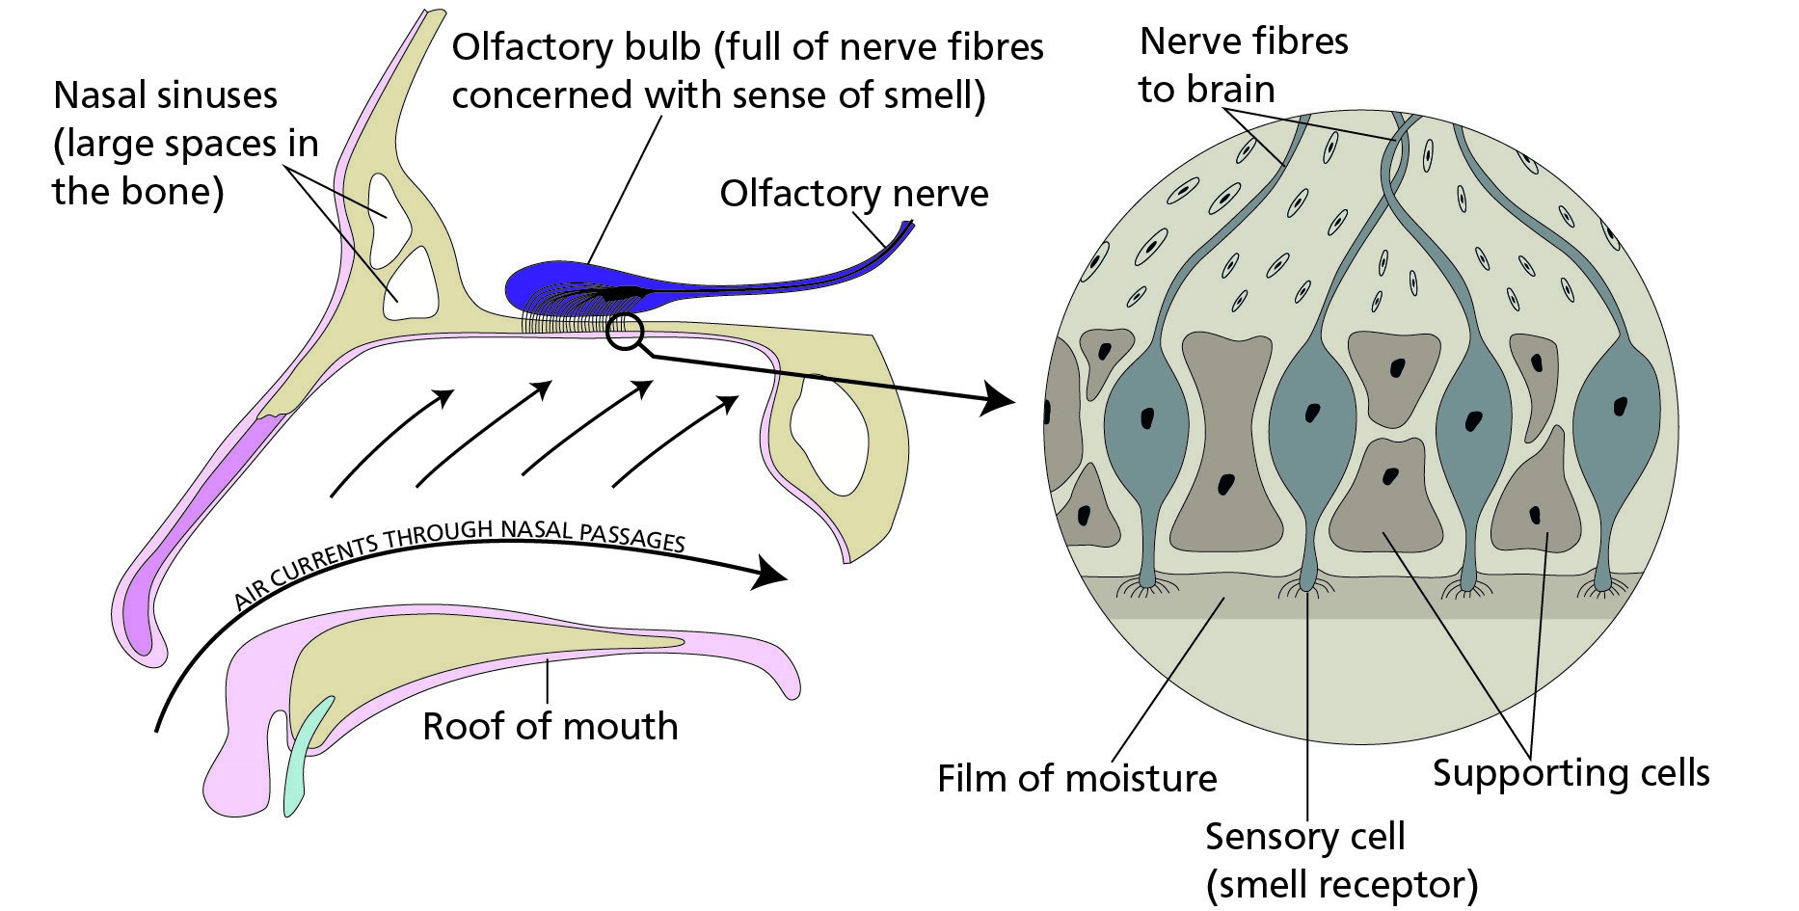

*Figure 3.1*

Air entering the nose (where it is warmed, moistened and filtered) and mouth passes into the **trachea**, which is a tube reinforced with cartilage rings. The trachea divides into the left and right **bronchi** which take the air to the two lungs. Within the lungs the airways become progressively smaller until they end in tiny sacs, the **alveoli.** These sacs are very small but the normal lung contains thousands of them giving a total area of some hundreds of square metres.

The walls of the alveoli are very thin and are covered by fine capillaries which themselves have only a thin wall. Oxygen from the alveoli diffuses into the blood and carbon dioxide and water pass into the lungs to be exhaled in expiration. Effective gas exchange only takes place between the alveoli and the capillaries; the walls of the larger passages in the lung are too thick to allow the diffusion.  *Figure 3.2* shows the main divisions of the respiratory system.

#### Pulmonary Volumes and Capacities

Pulmonary means “of the lungs”. It is required that you are familiar with the following definitions and capacities:

* **Tidal Volume** is the volume of air inhaled and exhaled with each normal breath. It amounts to about 500 ml in the normal male adult.

**3**

**Oxygen and Respiration**

* **Inspiratory Reserve Volume** is the extra volume of air that can be inhaled over and beyond the normal tidal volume.
* It amounts to about 3000 ml in the normal male adult.
* **Expiratory Reserve Volume** is the amount of air that can be still exhaled by forceful expiration after the end of the normal tidal expiration. It amounts to about 1100 ml in the normal male adult.
* **Residual Volume** is the volume of air remaining in the lungs even after the most forceful expiration. It amounts to about 1200 ml in the normal male adult.

***Note:***  *All pulmonary volumes and capacities are about 20% - 25% less in the female.*

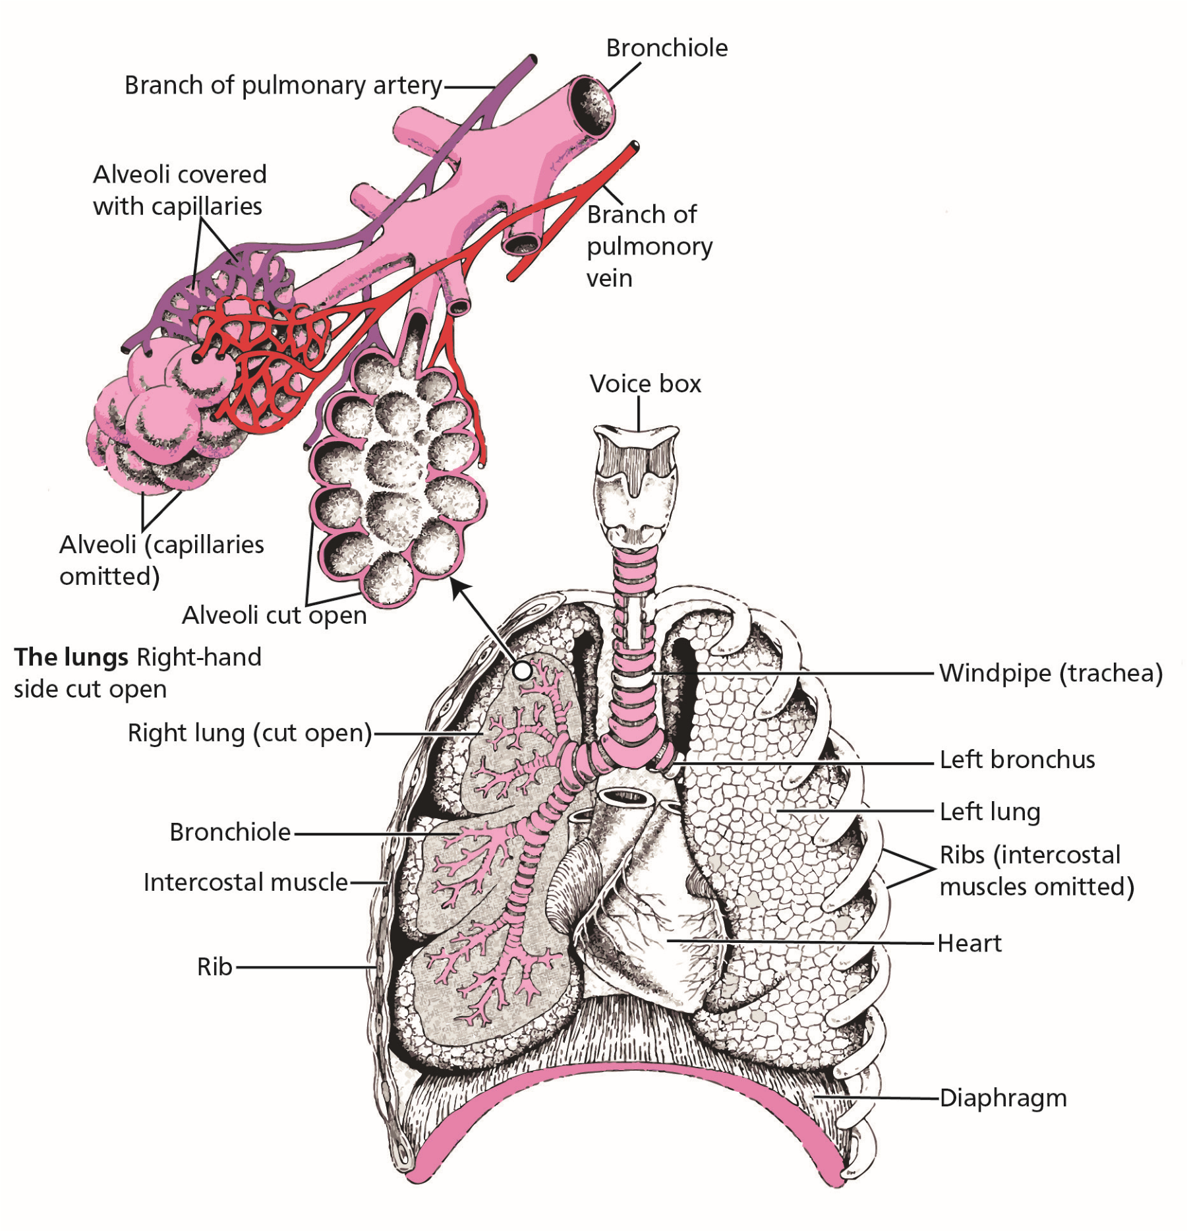

*Figure 3.2 Air passages in the lungs*

### Composition of the Standard Atmosphere - Humidity, Gas Laws and Partial Pressure *The Standard Atmosphere*

The ICAO Standard atmosphere is defined as follows:

* MSL temperature of +15°C.

**Oxygen and Respiration**

**3**

* MSL pressure of 1013.25 hPa (760 mm Hg).
* MSL density of 1225 g/m3
* A lapse rate of 1.98°C/1000 ft (6.5°/km) up to 36 090 ft (11 km) thereafter the temperature remains constant at -56.5°C up to 65 617 ft (20 km).

The altitudes in the standard atmosphere that pressure will be ¼, ½ and ¾ of MSL pressure is approximately:

¼ MSL - 36 000 ft

½ MSL - 18 000 ft

¾ MSL - 8000 ft

**Note :** Atmospheric pressure decreases at a faster rate at low altitudes than at higher altitudes

***Composition of the Atmosphere*** The atmosphere is made up of:

21.0% oxygen

78.0% nitrogen

0.93% argon

0.03% carbon dioxide

0.04% rare gases

These volume percentages for each of the gasses remain constant to about 70 000 ft - well within the altitudes at which conventional aircraft operate. For the pilot oxygen is the most important of these gases.

**3**

**Oxygen and Respiration**

#### Humidity and Relative Humidity - Definitions

**Absolute Humidity.** The weight of water vapour in unit volume of air which is usually expressed in g/m³.

**Relative Humidity.**  The amount of water vapour present in a volume of air divided by the maximum amount of water vapour which that volume could hold at that temperature expressed as a percentage. ***A Summary of the Gas Laws* BOYLE’S LAW** states that:

“Providing the temperature is constant the volume of gas is inversely proportional to its pressure”. (**Otic and gastrointestinal tract barotrauma, aerodontalgia**).

Expressed mathematically:

*P*1 *V*2

*P*2 = *V*1

where *P*1 = initial pressure *P*2 = final pressure

*V*1 = initial volume *V*2 = final volume

**DALTON’S LAW** states that:

“The total pressure of the gas mixture is equal to the sum of its partial pressure”. **(Hypoxia and night vision).**

Expressed mathematically: *P*t = *P*1 + *P*2 +  *P*3 ............ *P*n

Where: *P*t = total pressure of the mixture

*P*1, *P*2 ............ *P*n = partial pressure of each of the constituent gases **HENRY’S LAW** states that:

“At equilibrium the amount of gas dissolved in a liquid is proportional to the gas pressure”. **(Decompression sickness and “bends”).**

**FICK’S LAW**  states that:

“The rate of gas transfer is proportional to the area of the tissue and the difference between the partial pressures of the gas on the two sides and inversely proportional to the thickness of the tissue”. **(Diffusion of gas at the lungs and cells).**

**CHARLES’ LAW** states that:

“The volume of a fixed mass of gas held at a constant pressure varies directly with the absolute temperature”.

**Oxygen and Respiration**

**3**

Expressed mathematically: *V*1 *T*1 (*t*1 + 273)

*V*2 = *T*2 (= *t*2 + 273)

Where: *V*1 = initial volume

*V*2 = final volume

*T*1 = initial absolute temperature = initial temperature t1°C + 273

*T*2 = final absolute temperature = final temperature t2°C + 273 **THE COMBINED GAS LAW** states that:

“The product of the pressure and the volume of a quantity of gas divided by its absolute temperature is a constant”.

Expressed mathematically: *PVT* = *K*

**Partial Pressure.** Looking closer at Dalton’s Law with regards to the atmosphere, it is well- known that the total pressure decreases as altitude increases. As the proportion of oxygen remains constant it follows that the **partial pressure** of oxygen must also reduce. In dealing with the pressures at various altitudes instead of hectopascals/millibars used in other subjects such as Meteorology or Instruments, the unit of measurement is the millimetre of mercury (mm Hg). At sea level the standard pressure is **760 mm Hg**. As oxygen is 21% of the total then the partial pressure of oxygen is twenty one hundredths of **760 - 160 mm Hg.**

Humans operate best at sea level but they are perfectly capable of operating at higher altitudes where the partial pressure of oxygen is lower. People who live permanently at high altitudes can adapt to the reduced amount of oxygen by producing extra red blood cells to enable more oxygen to be carried. Healthy people without these extra cells can function normally up to about 10 000 -12 000 ft provided no strenuous exercise is undertaken.

As altitude increases the overall pressure decreases as does the partial pressures of the various gases in the atmosphere.

The partial pressure of oxygen in the air is not, however, the governing factor. The reason being that the body takes its oxygen from the alveoli of the lungs where the partial pressure is less. The body produces carbon dioxide and water vapour which is passed into the alveoli.

As the total pressure both inside and outside the lungs remains the same then the **partial** pressure of oxygen must reduce. The table following shows the partial pressures of the various gases in the atmosphere and in the alveoli at various altitudes.

**AT SEA LEVEL**

**3**

**Oxygen and Respiration**

|  |  |  |  |  |
| --- | --- | --- | --- | --- |
|  | **P** | **artial Pressures (mm Hg)** | |  |
| Constituents | Oxygen | Nitrogen | Water Vapour | Carbon Dioxide |
| Atmospheric Air | 160 (21%) | 600 | - | - |
| Alveolar Air | 103 (14%) | 570 | 47 | 40 (5.3%) |

**AT 10 000 FEET**

|  |  |  |  |  |
| --- | --- | --- | --- | --- |
| Alveolar Air | 55 | 381 | 47 | 40 |

As a partial pressure of 55 mm Hg is considered the minimum for normal operations, then above cabin heights of above 10 000 ft oxygen needs to be added to the pilot’s air supply. The oxygen added is sufficient to maintain an alveolar partial pressure of 103 mm Hg which is equivalent to breathing air at sea level.

At lower levels, less oxygen needs to be added and as the altitude increases more oxygen is added. A stage will be reached when one hundred per cent oxygen is required to maintain the 103 mm Hg partial pressure (the equivalent to breathing air at sea level). This stage is reached at:

**33 700 ft**

This does not, however, limit us to flying only to 33 700 ft when breathing 100% oxygen. We can continue to operate normally with alveolar partial pressure of 55 mm Hg. (equivalent to breathing air at 10 000 ft). This partial pressure is reached at: **40 000 ft**

Above this level, 100% oxygen must be supplied at an increased pressure (pressure breathing) but this is more relevant to military crews who fly at high altitudes. Pressure breathing for long periods is tiring and it requires practice to perfect the technique.

### Thresholds of Oxygen Requirements Summary

|  |  |
| --- | --- |
| Up to 10 000 ft | Air only |
| 10 000 - 33 700 ft | Oxygen/Air mixture |
| 33 700 - 40 000 ft | 100% Oxygen |
| Above 40 000 ft  **Hypoxic Hypoxia** | 100% Oxygen under pressure |

The term for the effects of a shortage of oxygen is **hypoxic hypoxia.** This can result from a number of reasons such as extreme anaemia, asthma and meningitis. But the most important reason, as far as pilots are concerned, is altitude. Haemoglobin at sea level is approximately **97.5%** saturated with oxygen. At 10 000 ft this falls to **87%** and thereafter falls off rapidly so that, at 20 000 ft, the haemoglobin is only **65%** saturated with oxygen. The symptoms of hypoxia may develop slowly at lower levels or very rapidly at high altitudes.

### Hypoxic Hypoxia Symptoms

Hypoxic hypoxia is a shortage of oxygen to the body which can be caused by, for example, altitude, pneumonia or strangulation.

The symptoms of hypoxic hypoxia are:

**Oxygen and Respiration**

**3**

* **Apparent personality change.** A change in outlook and behaviour with euphoria or aggression and lack of inhibitions. The very real danger of this was graphically described in 1875 by G. Tissandier after his balloon flight to 25 000 ft, which proved fatal to both his companions. The words still ring true today:

***“But soon I was keeping absolutely motionless, without suspecting that perhaps I had lost use of my movements. Towards 7500 m (24 606 ft) the numbness one experiences is extraordinary. The body and the mind weaken little by little, gradually, unconsciously, without one’s knowledge. One does not suffer at all; on the contrary. One experiences an inner joy, as if it were an effect of the inundating flood of light. One becomes indifferent; one no longer thinks of the perilous situation; one rises and is happy to rise”.***

* **Impaired judgement.** Loss of self-criticism and individuals are unaware of their reduced performance. Short-term memory loss exacerbates this condition and can occur at approximately 12 000 ft.
* **Headache** (particularly if mildly hypoxic for a long period).
* **Tingling** in hands and feet.
* **Increased rate of breathing - hyperventilation.**
* **Muscular impairment.** Finely co-ordinated movements become difficult through slow decision making and poor fine muscular control. Handwriting becomes more and more illegible. In the late stages of hypoxia, muscular spasms and convulsions may occur.
* **Memory impairment.** Short-term memory is lost making drills difficult to complete. This starts at approximately 12 000 ft.
* **Visual sensory loss.** Vision is affected early. Colour perception is reduced and peripheral vision is gradually lost. The light-sensitive cells of the eye are particularly oxygen “hungry” and a deterioration of night vision can occur at altitudes as low as 5000 ft.
* **Tunnel vision** develops making it necessary to make larger head movements to scan the instruments and the external environment.
* **Impairment of consciousness.** As hypoxia progresses the individual’s level of consciousness drops until he/she becomes confused, then semi-conscious, and unconscious.
* **Cyanosis.** An individual who has become hypoxic at altitude is likely to be **Cyanosed**, that is the lips and fingertips under the nails will develop a blue tinge, due to much of the blood haemoglobin being in the deoxygenated state.
* **Formication.** The hypoxic individual may experience formication, a creeping sensation on the skin, as of ants crawling over the body.
* **Unconsciousness.**
* **Death.**

**3**

**Oxygen and Respiration**

**UNLESS HE OR SHE RECEIVES OXYGEN THE INDIVIDUAL WILL DIE AND AT HIGH ALTITUDES** **DEATH CAN OCCUR WITHIN A FEW MINUTES. Stages/Zones of Hypoxia**

Hypoxia can be classified by stages/zones of performance decrement. The 4 stages are:

1. **The Indifferent Stage/Zone GL - 10 000 ft (3048 m)**

Dark adaption is adversely affected (can be as low as 5000 ft).

Performance of new tasks may be impaired.

Slight increase in heart and breathing rates occurs.

1. **The Compensatory Stage/Zone 10 000 ft - 15 000 ft (3048 - 4572 m)**

In this stage the physiological automatic responses provide some protection against hypoxia **trying to maintain homeostasis.**  These include:

An increase in the respiratory volume.

An increase in cardiac output and blood pressure.

However after a short time the effects of hypoxia on the CNS are perceptible causing: drowsiness.

decreased judgement and memory. difficulty in performing tasks requiring mental alertness or very small movements.

1. **The Disturbance Stage/Zone 15 000 ft - 20 000 ft (4572 - 6092 m)**

In the Disturbance Stage/Zone, the physiological compensatory mechanisms are no longer capable of providing for adequate oxygenation of the tissues.

The symptoms include:

Euphoria

Dizziness

Sleepiness

Headache

Fatigue

Intellectual impairment and slow thought processes

Memory impairment

Motor performance is severely impaired

Loss of judgement

‘Grey-out’ and tunnelled vision

**4. The Critical Stage/Zone 20 000 ft - 23 000 ft (6092 - 7010 m)**

Mental performance deteriorates rapidly.

Confusion and dizziness occurs within a few minutes.

Total incapacitation with loss of consciousness follows with little or no warning.

**Note:** A healthy person is normally able to compensate for altitudes up to approximately 10 000 - 12 000 ft.

**Oxygen and Respiration**

**3**

### Factors Determining the Severity of and the Susceptibility to Hypoxic Hypoxia

The most important factors in determining an individual’s likelihood of becoming hypoxic are:

* **Altitude.** The greater the altitude the greater the degree of hypoxia and the more rapid the onset and progression.
* **Time.** The longer the time exposed to high altitude the greater will be the effect.
* **Exercise (workload).** Exercise increases the demand for oxygen and hence increases the degree of hypoxia. Even the smallest of physical exertion will significantly reduce the time of useful consciousness.
* **Extremes of temperature.** Extremes of heat or cold place a heavy demand upon the circulatory adjustments which the body has to make, and thus lower the tolerance to hypoxia. At low temperatures we shiver in order to maintain body temperature, thus increasing the demand for oxygen and so increasing the state of hypoxia.
* **Illness and fatigue.** Both increase the energy demands of the body and lower the threshold for hypoxia symptoms.
* **Alcohol/drugs.**  Alcohol affects metabolization and causes histotoxic hypoxia, thus reducing the tolerance to hypoxic hypoxia. Many other drugs have adverse effects on the brain function which may lead to hypoxia as altitude tolerance decreases.

### Anaemic Hypoxia

Anaemic Hypoxia is caused by the inability of the blood to carry oxygen and may be due to a medical condition (anaemia) or to carbon monoxide poisoning both of which have been discussed in Chapter 2. ***Smoking and Anaemic Hypoxia***

Smoking produces **carbon monoxide** which is inhaled. As the haemoglobin in the red blood cells has a much greater affinity to this carbon monoxide than to oxygen it reduces the availability of haemoglobin to transport oxygen. Heavy smoking produces 8% - 10% carboxyhaemoglobin in the blood. A regular smoker will start to suffer from hypoxia approximately 4000 ft - 5000 ft below that of a non-smoker.

**The importance of aircrew being able to recognize hypoxia cannot be overstated. It is of particular danger to inexperienced aircrew who may not recognize the onset of the initial symptoms.**

#### Treatment of Hypoxia

Knowledge of the signs and symptoms and early identification of the problem will allow the correct drills to be carried out before anyone is placed in jeopardy but it is important that these drills are well learnt and easily accomplished.

Principally:

**3**

**Oxygen and Respiration**

* Provide oxygen.
* Descend to a level where atmospheric oxygen is present in sufficient quantities to meet the body’s needs or to Minimum Safe Altitude (MSA), whichever is the higher.

Aircrew must familiarize themselves with the appropriate oxygen drills for the aircraft they are flying before venturing above an altitude at which hypoxia can occur (above 10 000 ft).

#### Prevention of Hypoxia

Some of the factors predisposing to hypoxia are unavoidable risks of flying; others can be reduced by good personal habits and forethought. Some pointers are:

* When anticipating flying above 10 000 ft ensure that a serviceable supplementary supply of oxygen is available and that the correct method of use is known.
* Ensure that passengers are correctly briefed.
* If you smoke - stop.
* Fly only if you are 100% fit and you are not taking any medication or drugs.
* Ensure that cabin heaters are thoroughly checked and serviceable. If used, ensure that fresh air is also brought into the cabin.

### Time of Useful Consciousness (TUC)

This is the time available for the development of hypoxia and the pilot to do something about it, i.e. it is the time of **useful** consciousness. It is not the time to unconsciousness but the shorter time from a reduction in adequate oxygen until a specific degree of impairment, generally taken to be the point when the individual can no longer take steps to help him/herself.

The time will depend on the individual, and will be affected by any or all of the following:

* Individual fitness
* Workload
* Smoking
* Overweight or obesity
* Decompression is progressive or explosive

The average times of useful consciousness at various altitudes are set out in the following table.

### Times of Useful Consciousness at Various Altitudes

**Oxygen and Respiration**

**3**

|  |  |  |
| --- | --- | --- |
| **Altitude** | **Person seated or at rest** | **Moderate activity** |
| **20 000 ft** | **30 minutes** | **5 minutes** |
| **30 000 ft** | **1 – 2 minutes** |  |
| **35 000 ft** | **30 – 90 seconds** |  |
| **40 000 ft** | **15 – 20 seconds** |  |

### Effective Performance Time (EPT)

Effective Performance Time is always within and shorter than TUC. Its quantification, however, is not possible since it will depend upon the individual, the task in hand, physiological and mental stress, altitude and the circumstances involved. It is highly variable and individualistic. Above 40 000 ft the EPT is approximately 5-6 seconds.

### Hyperventilation

Hyperventilation can be defined as lung ventilation in excess of the body’s needs and denotes an overriding of the normal automatic control of breathing by the brain. Simply, hyperventilation is overbreathing. That is breathing in excess of the ventilation required to remove carbon dioxide. Overbreathing induces a reduction in the carbon dioxide and thus decreases the carbonic acid balance of the blood. This disturbance of the acid balance has a number of effects, the major one being that haemoglobin gives up its oxygen readily only in an acid medium.

Hypoxia does cause hyperventilation but it is far from the only cause. **Anxiety, motion sickness, shock, vibration, heat, high g-forces, pressure breathing** can all bring on the symptoms of hyperventilation. A high standard of training breeds confidence and decreases the chances of confronting unusual and stressful situations and is, without doubt, the best means of preventing hyperventilation in aircrew.

An anxious passenger boarding an aircraft must be closely watched since hyperventilation may take place even whilst still on the ground.

### Symptoms of Hyperventilation

* **Dizziness** and a **feeling of unreality.**
* **Tingling.** Especially in the extremities and lips.
* **Visual disturbances.** Blurred, tunnelling and clouding vision.
* **Hot or cold sensations.** These may alternate in time and vary as to parts of the body affected.
* **Anxiety.**  Thus establishing a vicious circle.
* **Loss of muscular coordination and impaired performance.**
* **Increased heart rate.**
* **Spasms.**  Just prior to unconsciousness, the muscles of the hands, fingers and feet may go into spasm.
* **Loss of consciousness.** Hyperventilation can lead to collapse but thereafter the body’s automatic system will restore the normal respiration rate and the individual will recover.

#### Treatment of Hyperventilation

The classic way to treat a patient suffering from hyperventilation is to make him/her breathe into a **paper bag.** The sufferer is then forced to inhale the carbon dioxide that has been exhaled. The immediate effect of this is to increase the carbonic acid level to its norm and the brain consequently reduces the breathing rate.

**3**

**Oxygen and Respiration**

The symptoms can, in themselves, be alarming. In all cases try to calm the patient and encourage her/him to slow down the rate of breathing.

**Hypoxia or Hyperventilation?**

The natural reaction to a shortage of oxygen is for the body to try to obtain more air by breathing faster and deeper. The hypoxic individual may **hyperventilate** in an effort to get more oxygen, but this is of little value when in an environment of low ambient pressure.

In flight it can be difficult to distinguish the symptoms of hypoxia and hyperventilation. The appropriate response of pilots must be **to assume the worst** and if they are at an altitude where hypoxia is a possibility they **must** take that to be the cause and carry out their hypoxia drills. If symptoms occur at an altitude at which hypoxia is not a consideration (below 10 000 ft) they should regulate the rate and depth of breathing to restore the normal acid/base balance of the blood and alleviate the symptoms. When flying below 10 000 ft significant symptoms of hypoxia are unlikely and hyperventilation may be assumed.

**DO NOT ASSUME HYPERVENTILATION IF IT COULD BE HYPOXIA**

**HYPERVENTILATION - AFTER UNCONSCIOUSNESS - RECOVERY**

**HYPOXIA - AFTER UNCONSCIOUSNESS - DEATH**

### Cabin Pressurization

Cabin pressurisation systems ensure that the effective altitude to which the occupants are actually exposed is much lower than the altitude at which the aircraft is flying. Ideally the cabin should be maintained at sea level but this is impractical because of aircraft weight and fuselage strength limitations.

The pressurization of a commercial airliner flying at 30 000 ft produces an internal cabin pressure equivalent to about 6000 ft with a maximum of 8000 ft. The pressure differential across the aircraft skin is normally designed not to exceed 8-9 psi The rate of change of cabin pressure is restricted to 500 ft/min in the ascent and 300 ft/min in the descent to minimize passenger discomfort due to the pressure equalization limitations of the middle ear.

### Cabin Decompression

Loss of cabin pressurization can occur in flight. The rate of loss may be slow, with the crew recognizing the problem and making appropriate height reductions before the passengers are aware of anything amiss. Very occasionally there is rapid decompression perhaps due to the loss of a window or door, or a failure in the fuselage.

Occupants, crew and passengers, will rapidly be exposed to the full rigours of high altitude: **hypoxia, cold, decompression sickness.**  Oxygen can be supplied to all occupants but for only a limited period.

**THE AIRCRAFT MUST RAPIDLY DESCEND**

**Oxygen and Respiration**

**3**

**TO 10 000 ft OR MSA WHICHEVER IS THE HIGHER**

In cases of rapid decompression the altitude of the cabin may actually rise to above the pressure altitude. The **Venturi effect** of air passing over the fuselage can suck air out of the cabin; this can make up to 5000 ft difference in pressure terms.

Another effect of decompression at height is that, due to the sudden drop in temperature within the aircraft, windows and cockpit windshields will be prone to misting or fogging.

***It is most important to emphasize that crew protection must be the highest of priorities. Should decompression take place it is critical for the crew to individually don oxygen masks and check flow as quickly as possible. Any delay caused by helping other members of the crew or passengers could have catastrophic results for all the occupants of the aircraft.***

### Decompression Sickness (DCS)

As we have seen, the gas making up the major part of the air - nitrogen - is dissolved in the blood to a small extent but plays no part in the normal bodily processes. It may however cause severe problems if the nitrogen should come out of solution as small bubbles. It can be likened to the bubble formation in fizzy drinks when the top of the bottle is opened and the pressure allowed to drop. If this occurs in the human body and nitrogen bubbles are formed in the blood, the process leads directly to DCS.

Body exposure to reduced pressure can lead to DCS since the body is normally saturated with nitrogen. When ambient pressure is abruptly reduced some of this nitrogen comes out of solution as bubbles. Any ascent to altitudes over 25 000 ft is normally associated with DCS however it is more likely the higher and longer the exposure to altitudes above 18 000 ft. It is unlikely to occur below 14 000 ft.

Ultimately the individual may collapse and in rare cases DCS may occur or persist after descent and go on to cause **DEATH**. Hypoxia and cold increase the risk as does age and excess body mass/obesity.

**The primary symptoms** are:

**Joints** . Bubbles in the joints (shoulders, elbows, wrists, knees and ankles) cause rheumatic-like pains called the **bends.** In aviation the shoulder, wrist, knee and ankles are most commonly affected. Movement or rubbing the affected parts only aggravates the pain but descent usually resolves the problem.

**Skin.** Nitrogen bubbles released under the skin causes the **creeps** when the sufferer feels that a small compact colony of ants are crawling over, or just under, the skin.

**Respiratory system.**  This is known as the **chokes.** Nitrogen bubbles may get caught in the capillaries of the lungs blocking the pulmonary blood flow. This leads to serious shortness of breath accompanied by a burning, gnawing and sometimes piercing pain.

**Brain.** The bubbles affect the blood supply to the brain and the nervous system. This effect is known as the **staggers.** The sufferer will lose some mental functions and control of movement. In extreme cases chronic paralysis or even permanent mental disturbances may result.

**The secondary symptom** is:

**3**

**Oxygen and Respiration**

**Post descent collapse** . This may occur up to four hours after the primary symptoms when nitrogen bubbles have combined and therefore not gone back into solution and have reached the heart.

DCS can be avoided by preoxygenation before exposure to high altitudes, thus reducing the body store of nitrogen as much as possible.

### DCS in Flight and Treatment

If the symptoms of DCS appear in any passenger or crew member, the pilot should commence an immediate descent to a level at which the symptoms are relieved. The aircraft should land as soon as possible. Meanwhile the sufferer should be kept warm and rested and put onto a 100% oxygen supply. Urgent medical assistance must be sought on landing even if the patient appears to have recovered. ***Flying and Diving***

DCS is rare but the incidence is greatly increased for individuals who have been diving, using compressed air, shortly before a flight. The pressure that a 30 ft column of sea water exerts is the same as that exerted by the atmosphere at sea level (i.e. 760 mm Hg). Therefore a person at a depth of 30 ft is exposed to a pressure of 2 atmospheres (1 atmosphere caused by the air above the water and the other by the water itself).

In scuba diving, air under pressure is used and this increases the amount of nitrogen in the body. On subsequent ascent this may come out of solution giving rise to DCS. The following rules must be strictly observed by both crew and passengers. Failure to adhere to these rules results in incidents each year in which individuals develop DCS in flight at altitudes as low as 6000 ft.

**DO NOT FLY WITHIN 12 HOURS OF SWIMMING USING COMPRESSED AIR**

**Oxygen and Respiration**

**3**

**AND**

**AVOID FLYING FOR 24 HOURS IF A DEPTH OF 30 FEET HAS BEEN EXCEEDED.**

### *Questions*

#### Questions

1. **With an alveolar partial pressure of oxygen of 55 mm Hg, what is the maximum altitude to breathe 100% oxygen without pressure?**
   1. 33 700 ft
   2. 44 000 ft
   3. 10 000 ft
   4. 40 000 ft
2. **What are the constituents of the atmosphere?**
   1. Oxygen 22% Nitrogen 77% Other gases 1%
   2. Oxygen 22% Nitrogen 78% Other gases 2%
   3. Oxygen 21% Nitrogen 78% Other gases 1%
   4. Oxygen 22% Nitrogen 77% Other gases 1%
3. **What is the % of oxygen and carbon dioxide in the alveoli at sea level?**
   1. 15.5% and 6.6% respectively
   2. 16.5% and 7.6% respectively
   3. 14.0% and 5.3% respectively
   4. 21.0% and 0.5% respectively

**3**

**Questions**

1. **On 100% oxygen at 40 000 feet, what height in the atmosphere does the partial pressure of oxygen in the alveoli equate to?**
   1. The same as at 20 000 ft
   2. The same as at 10 000 ft
   3. The same as at 25 000 ft
   4. The same as at 30 000 ft
2. **At what height is the partial pressure of oxygen in the lungs approximately half that at sea level?**
   1. 10 000 ft
   2. 25 000 ft
   3. 30 000 ft
   4. 18 000 ft
3. **What is the percentage of oxygen in the atmosphere at 35 000 ft?**
   1. 25%
   2. 21%
   3. 32%
   4. Approximately 30%
4. **What is one of the initial indications of hypoxia?**
   1. Blue tinge in the lips
   2. Stomach cramps
   3. Pain in the joints
   4. Impaired judgement

### *Questions*

1. **Why does cold make you more susceptible to hypoxia?**
   1. Heart beats faster which uses up more oxygen
   2. More energy is required when shivering therefore more oxygen used
   3. Lowers temperature of the body which makes it less efficient
   4. Lowers temperature of the body and especially the head which has a debilitating effect on the brain
2. **What is the first action that should be taken by the pilot in the event of a cabin decompression above 10 000 ft?**
   1. Descend as soon as possible
   2. Don oxygen mask and check oxygen flow
   3. Warn the passengers
   4. Descend and check passengers
3. **In flight someone complains of feeling alternately hot and cold, anxious, dizzy, tingling at the fingertips and is breathing rapidly. What may they be suffering from?**
   1. Hypoxic hypoxia
   2. Formication
   3. Cyanosis
   4. Hyperventilation

**Questions**

**3**

1. **The carbon dioxide level of the blood level is higher than normal. The brain:**
   1. increases the rate of breathing and pulse rate
   2. decreases the rate of breathing and pulse rate
   3. increases the pulse rate and decreases rate of breathing
   4. decreases the pulse rate and increases rate of breathing
2. **What are the times of useful consciousness at 20 000 ft (moderate activity):**
   1. 5 minutes
   2. 1 minute
   3. 10 minutes
   4. 30 seconds
3. **If the symptoms of hyperventilation occur at an altitude where hypoxia is not a consideration, what is the correct remedial action?**
   1. Descend to MSL
   2. Decrease rate and depth of breathing
   3. Increase rate of breathing
   4. If possible lay flat and help to calm sufferer
4. **What increases the risk of DCS occurring in flight?**
   1. Scuba diving shortly before flight
   2. Snorkel diving shortly before flight
   3. Alcohol
   4. Smoking

### *Questions*

1. **What are the restrictions to flying after scuba diving?**
   1. No flying within 48 hours if a depth of 40 ft has been exceeded, otherwise the limit is 12 hours
   2. No flying within 48 hours if a depth of 30 ft has been exceeded, otherwise the limit is 24 hours
   3. No flying within 12 hours if a depth of 30 ft has been reached, otherwise the limit is 24 hours
   4. No flying within 24 hours if a depth of 30 ft has been exceeded, otherwise the limit is 12 hours
2. **A pilot has been snorkelling and has exceeded a depth of 30 ft. Are there any restrictions to him/her flying?**
   1. No flying within 12 hours
   2. No flying for 12 hours plus 30 minutes for every 10 feet deeper than 30 ft
   3. No
   4. No flying within 6 hours
3. **Tidal volume is:**
   1. the volume of air inhaled with each normal breath
   2. the volume of air exhaled with each normal breath

**3**

**Questions**

* 1. the volume of air breathed when diving
  2. the volume of air inhaled and exhaled with each normal breath

1. **The altitude that pressure will be half that of MSL in the standard atmosphere is:**
   1. 8000 ft
   2. 18 000 ft
   3. 34 000 ft
   4. 33 700 ft
2. **Henry’s Law has application in Human Performance to:**
   1. otic barotrauma
   2. DCS
   3. carbon monoxide poisoning
   4. partial pressure in the alveoli
3. **Hypoxic hypoxia affects night vision.**
   1. True
   2. False
4. **Anaemic hypoxia can be:**
   1. brought on by altitude
   2. caused by decompression
   3. caused by smoking
   4. brought on by fatigue

### *Questions*

1. **In commercial aircraft cabin pressure is normally maintained at:**
   1. sea level
   2. 6000 - 8000 ft
   3. 10 000 ft
   4. below 5000 ft
2. **In the event of a passenger showing symptoms of DCS, the aircraft must:**
   1. descend to MSL
   2. descend to 10 000 ft
   3. land as soon as possible
   4. descend to below 10 000 ft
3. **The “chokes” are associated with:**

**Questions**

**3**

* 1. NIHL
  2. DCS
  3. blockage of the alveoli
  4. oxygen loss

1. **Breathing 100% oxygen at 40 000 ft is equivalent of breathing normally at:**
   1. sea level
   2. 20 000 ft
   3. 40 000 ft d 10 000 ft
2. **What are the times of useful consciousness at 35 000 ft (at rest):** 
   1. 5 minutes
   2. 15 - 20 seconds
   3. 2 minutes
   4. 30 - 90 seconds

### *Answers*

**3**

**Answers**

#### Answers

|  |  |  |  |  |  |  |  |  |  |  |  |
| --- | --- | --- | --- | --- | --- | --- | --- | --- | --- | --- | --- |
| 1 | 2 | 3 | 4 | 5 | 6 | 7 | 8 | 9 | 10 | 11 | 12 |
| d | c | c | b | a | b | d | b | b | d | a | a |
|  |  |  |  |  |  |  |  |  |  |  |  |
| 13 | 14 | 15 | 16 | 17 | 18 | 19 | 20 | 21 | 22 | 23 | 24 |
| b | a | d | c | d | b | b | a | c | b | c | b |
| 25 | 26 |
| d | d |

Chapter

## **4** The Nervous System, Ear, Hearing and Balance

Introduction . . . . . . . . . . . . . . . . . . . . . . . . . . . . . . . . . . . . . . . . . . . . . 59

The Nervous System . . . . . . . . . . . . . . . . . . . . . . . . . . . . . . . . . . . . . . . . 59

The Sense Organs . . . . . . . . . . . . . . . . . . . . . . . . . . . . . . . . . . . . . . . . . . 60

Audible Range of the Human Ear and Measurement of Sound . . . . . . . . . . . . . . . . . 62

Hearing Impairment . . . . . . . . . . . . . . . . . . . . . . . . . . . . . . . . . . . . . . . . 62

The Ear and Balance . . . . . . . . . . . . . . . . . . . . . . . . . . . . . . . . . . . . . . . . 63

Problems of Balance and Disorientation . . . . . . . . . . . . . . . . . . . . . . . . . . . . . 65

Somatogyral and Somatogravic Illusions . . . . . . . . . . . . . . . . . . . . . . . . . . . . . 66

Alcohol and Flying . . . . . . . . . . . . . . . . . . . . . . . . . . . . . . . . . . . . . . . . . 67

Motion Sickness . . . . . . . . . . . . . . . . . . . . . . . . . . . . . . . . . . . . . . . . . . . 67

Coping with Motion Sickness . . . . . . . . . . . . . . . . . . . . . . . . . . . . . . . . . . . 68

Questions . . . . . . . . . . . . . . . . . . . . . . . . . . . . . . . . . . . . . . . . . . . . . . 69

Answers . . . . . . . . . . . . . . . . . . . . . . . . . . . . . . . . . . . . . . . . . . . . . . . 72

**4**

**The Nervous System, Ear, Hearing and Balance**

### Introduction

Before considering the ear and the eye it is first necessary to consider the nervous system. Our knowledge of the outside world is gained through our sense organs. Information from our eyes and ears provide the majority of information but there are other sources.

Our senses of taste and smell both give information to our brain and special nerve cells in our skin can inform us of touch sensations, temperature changes and also detect pain. Within our muscles are pressure sensitive cells that can assist our appreciation of the relative position of our limbs and can detect the effects of gravity.

### The Nervous System

#### General

As the most complex of the systems in the human body, the nervous system is responsible for sending, receiving and processing nerve impulses. It serves as the body control centre and its electrical-chemical communications network. It integrates countless pieces of information and generates reactions by sending these electrochemical impulses through the nerves to trigger organs such as muscles or glands. All of the body’s muscles and organs rely upon the nervous impulses to function.

The nerve cells are called **neurons** and the connection between two neurons is the **synapse**. When a nerve impulse (**electrical**) travels across a neuron to the synapse, it causes a release of **chemicals** which carry the signal to the next neuron. Thus messages are sent through the nervous system by both **electrical and chemical** means (electrochemical).

**The Nervous System, Ear, Hearing and Balance**

**4**

Three systems work together to carry out the mission of the nervous system:

#### Central Nervous System (CNS)

Encased in bone, the CNS is responsible for issuing nerve impulses and analysing sensory data. It consists of the brain and the spinal cord. The brain weighs an average of 1.4 kg and comprises 97% of the entire nervous system. Nerve pathways extend from the brain to virtually every tissue and structure of the body. ***Peripheral Nervous System (PNS)***

The PNS is made up of a series of specialised cells that both pass information received from the body organs and muscles back to the CNS through **sensory nerves**. It also is responsible for passing information from the CNS directly to the organs and muscles themselves through **motor nerves**. Thus it is not always necessary for the brain to be involved in the reaction to stimulus. Reflex actions, such as quickly withdrawing one’s hand from a painful stimulus, will only involve a loop between the hand and the spinal cord. Because fewer neurones are involved, reflexes are rapid.

#### Autonomic (Vegetative) Nervous System (ANS)

A special autonomic (independent) nervous system manages the glands of the body and the involuntary muscles of the internal organs and blood vessels. Although the autonomous nerves have connections with the CNS, we are not aware of the autonomic system working and have no conscious control over it.

As we have seen, breathing is regulated by the autonomic system and other functions include:

* Arterial pressure.
* Gastrointestinal motions.
* Urinary output.
* Sweating.
* Body temperature.
* General Adaption Syndrome (GAS).

*This is sometimes known as the Fight or Flight Response. The GAS Syndrome is reliant upon the Sympathetic and Parasympathetic Systems which are part of the ANS. This Syndrome is discussed in Chapter 7 - Stress).*

The ANS is a biological control system which is neurohormonal and, like others, is highly self- regulating in normal circumstances or environments.

### The Sense Organs

The two most important of our senses in aviation are sight and hearing. In this and the following chapter we shall be considering the ear and the eye which provide us with the majority of the information essential to the appreciation of our position in space and our sense of balance. They are of particular concern to the aviator as, in an environment for which evolution has not adapted us, they may present incorrect or misleading information.

**4**

**The Nervous System, Ear, Hearing and Balance**

#### The Ear - Purpose

The ear performs two quite separate functions. Firstly it is used to receive vibrations in the air (sounds), and secondly it acts as a balance organ and acceleration detector. See *Figure 4.1* for the construction of the ear.

The ear is divided into three sections, the outer, middle, and inner ear.

#### Outer Ear

The outer ear directs sounds, which are collected by the **pinna**, through the **auditory canal** **(Meatus)** and onto the eardrum. The sound waves will cause the ear drum to vibrate.

#### The Middle Ear

The ear drum - or **tympanum** - separates the outer and middle ear. Connected to the ear drum is a linkage of three small bones the **ossicles** (the malleus, incus and stapes) which transmit the vibrations across the middle ear, (filled with air) to the inner ear which is filled with liquid. The last of the bones (the stapes) is attached to the oval window of the inner ear where a diaphragm sets in motion the fluid of the cochlea of the inner ear. The eustachian tube vents to the mouth and nose allowing pressure to equalize across the ear drum. The phenomena of otic barotrauma which is associated with the eustachian tube is discussed in detail in Chapter 6 (Health and Flying).

#### The Inner Ear

The diaphragm attached to the stapes causes the fluid in the **cochlea** to vibrate. Inside the cochlea there is a fine membrane covered with tiny hair-like cells. The movement of these small cells will be dependent on the volume and pitch of the original sound. The amount and frequency of displacement is detected by the auditory nerve which leads directly to the **cortex** of the brain where the tiny electrical currents are decoded into sound patterns. It is possible for hearing also to bypass the ear drum and ossicular system and for the transmission of sound to pass through the bone. This is because the cochlea is embedded in a bony cavity within the temporal bone. Vibrations of the entire skull can cause fluid vibrations in the cochlea itself. Therefore, under certain conditions, a tuning fork or vibration device placed on the skull causes the person to hear the note/sound.

**The Nervous System, Ear, Hearing and Balance**

**4**

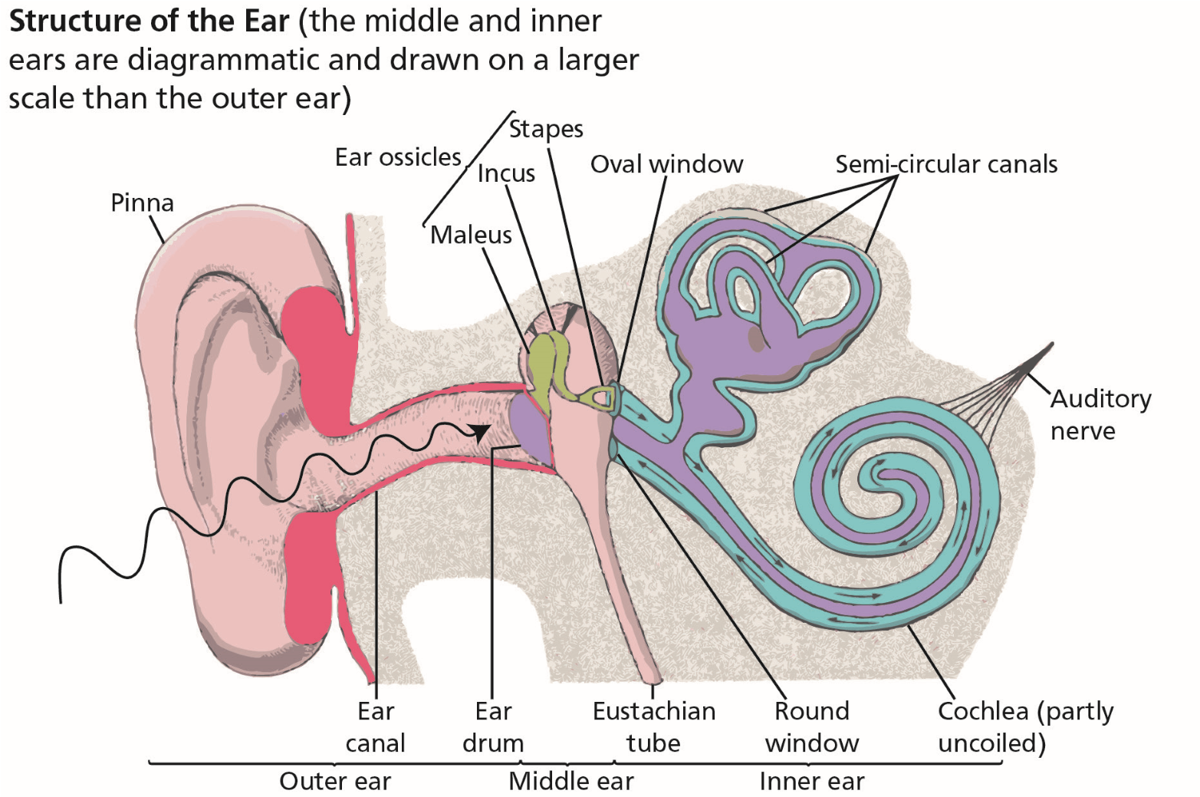

*Figure 4.1 The structure of the human ear*

### Audible Range of the Human Ear and Measurement of Sound

The frequency of sounds that a young person can hear is generally stated to be between 20 and 20 000 Hertz. However the sound range depends, to a great extent, on intensity (which is measured in decibels). The human voice uses the frequency range of 500 Hz to 3000 Hz.

Sound intensities are expressed in terms of the logarithm of the actual intensities. Below is a table of typical noise levels.

**Noise levels for various sounds and locations**

**4**

**The Nervous System, Ear, Hearing and Balance**

|  |  |
| --- | --- |
| **Sound** | **Noise Level (dB)** |
| Threshold of hearing | 0 |
| Rustle of leaves in gentle breeze | 10 |
| Average whisper (at 4 ft) | 20 |
| Quiet conversation | 30 |
| Office noise | 40 |
| Conversation in noisy factory | 50 |
| Loud street noises (trucks etc.) | 60 |
| Standing close to heavy machinery | 80 |
| Maximum recommended for 8 hours exposure | 87 |
| Maximum recommended for 2 hours exposure | 100 |
| Maximum recommended for 30 minutes exposure | 110 |
| Standing near a piston engine aircraft (noise becoming uncomfortable) | 120 |
| Standing near a jet aircraft (threshold of pain) | 140 |

### Hearing Impairment

Hearing difficulties are broadly classified into three categories:

#### Conductive Deafness

Any damage to the conducting system, the ossicles or the ear drum, will result in a degradation of hearing. It is possible that perforations of the ear drum will result in scarring of the tissue thus reducing its ability to vibrate freely. A blow to the ear may cause damage to the small bones in the middle ear again limiting the transfer of vibrations. Modern surgery may help in some circumstances.

**Excessive wax** or a **tumour** in the ear canal can also cause conductive deafness.

#### Noise Induced Hearing Loss (NIHL)

Loud noises can damage the very sensitive membrane in the cochlea and the fine structures on this membrane. The loss of hearing may at first be temporary but continued exposure to loud noise in excess of **90 decibels (dB)** will result in permanent loss of hearing. The early symptoms are an inability to hear high pitched notes as these notes are normally detected by the finer cells which suffer the greatest damage. Helicopter pilots and military jet pilots tend to suffer from NIHL and, with the advent of personal stereos, there has been an alarming increase of this impairment appearing in youth.

Environmental noise pollution is now a significant factor in the prevalence of NIHL. NIHL is an occupational hazard for those of us in the aviation industry and it is strongly recommended that ear plugs are used conscientiously whenever possible. The most dangerous to the ear is noise of high frequency.

#### Presbycusis (Loss through Ageing)

Hearing deteriorates with advancing age. In old age, the frequency falls to between 50 and 8000 cycles per second or less. The loss of some hearing is natural as one grows older but if combined with NIHL there may be sufficient impairment to lead to a loss of a flying licence.

It is worth noting that aircraft engineers are warned always to use hearing protection when exposed to noise in excess of 115 dB. As a rough guide such levels occur when normal speech cannot be clearly heard at 2 metres.

**The Nervous System, Ear, Hearing and Balance**

**4**

Intermittent and sudden noise is generally considered to be more disruptive than continuous noise. In addition, high frequency noise generally has a more adverse effect on performance than lower frequency.

### The Ear and Balance

As well as distinguishing sound, the ear is used to detect both angular/linear movement and accelerations. Our primary source of spatial orientation is sight but the ear provides a secondary system, particularly if vision is restricted.

#### Semicircular Canals

Within the inner ear are three **semicircular canals** filled with liquid and arranged in three planes at 90º to each other. They detect angular accelerations greater than 0.5°/sec². Within the semicircular canals are fine hair-like cells which bend as the liquid in the canals moves in relation to the walls of the canals. The movement of these hairs generates small electric currents which are passed to the **cerebellum** (the second smaller division of the brain).

In fact the cerebellum has the ability to predict the loss of balance and compensate. For example as you step onto an escalator muscles will work to push the body forward instinctively to avoid losing balance. Thus the cerebellum has a major part to play in both balance and coordination.

*Figure 4.2 Vestibular apparatus*

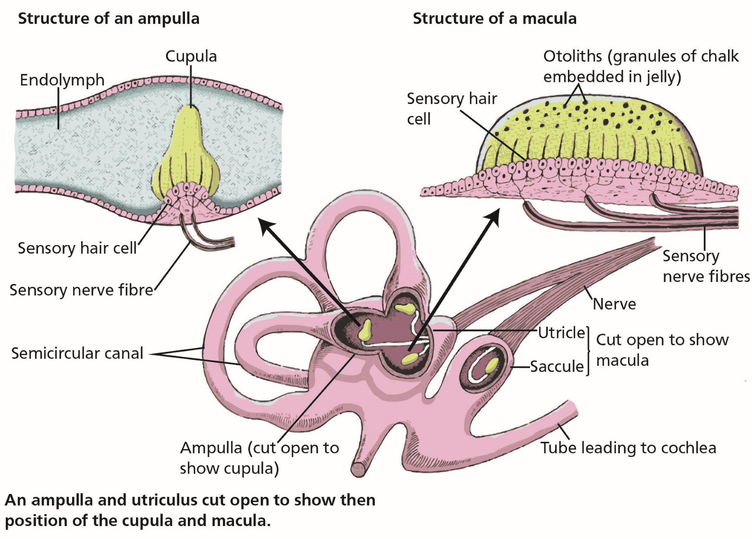

*Figure 4.3 Operation of the otoliths & semicircular canals*

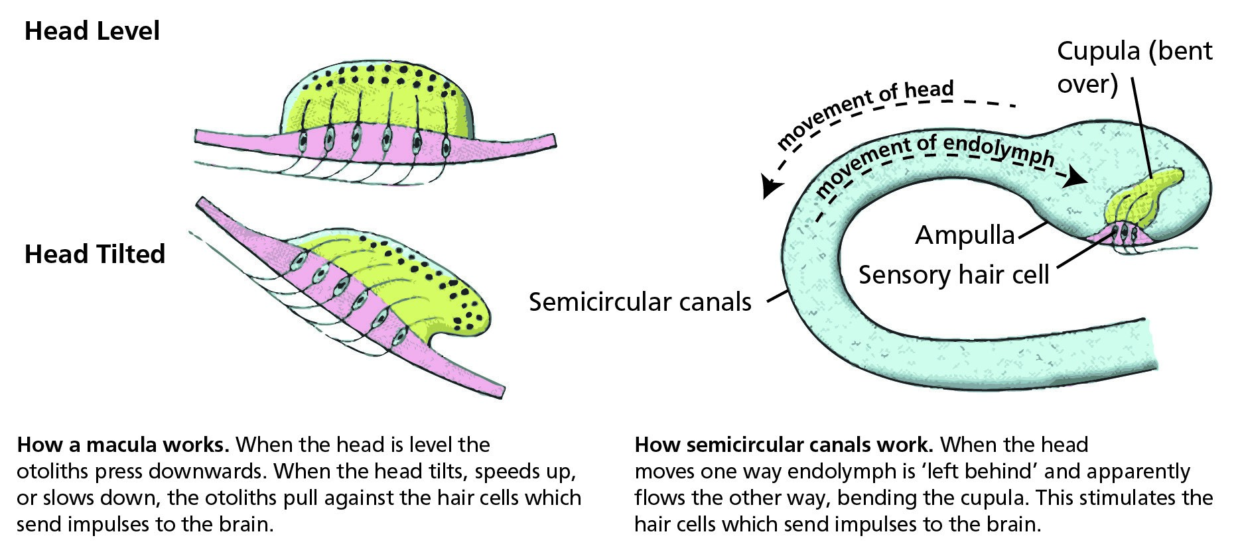

#### Otoliths

The otoliths, literally ‘stones in the ears’ are small grains of chalk embedded in a fleshy medium containing hair cells, located at the base of the semicircular canals. **Otoliths** detect tilting of the head and linear acceleration and are contained within chambers known as **utricles and saccules.**

**4**

**The Nervous System, Ear, Hearing and Balance**

Acceleration greater than 0.1 m/s² causes the hair cells to bend and this bending is interpreted by the brain to determine the new position of the head.

This gives rise to a problem when a pilot experiences linear acceleration/deceleration. As acceleration takes place the otoliths are moved backwards giving the signals to the brain that the head is tilting backwards. Thus the pilot feels that he/she is climbing. The reverse takes place during deceleration, giving the pilot the false impression of pitching down. This is known as the **somatogravic effect or somatogravic illusion.**

The somatogravic effect can be reinforced by information received from the nerve cells in the muscles of the body from pressures due to gravity. This is discussed in more detail in Chapter 10 (Cognition in Aviation). The result of these two *quite separate* effects combine to lead to an almost overpowering illusion of climb or descent and has led to catastrophic results.

It is worth noting that, should an air driven artificial horizon be fitted to the aircraft, this false feeling of pitch up will be reinforced by the indication of a climb on the instrument resulting from one of the two acceleration errors (the artificial horizon will show a climbing turn to the right having been subjected to a linear acceleration). If the aircraft decelerates, the reverse will apply and the reading from the instrument will reinforce the feeling of an apparent descent.

The semicircular canals and the otoliths together make up the **vestibular apparatus** which helps to maintain spatial orientation and controls other functions. For example eye movement to maintain a stable picture of the world on the retina when the head is moved.

### Problems of Balance and Disorientation

Statistics have shown that spatial disorientation has been a contributory factor in 37% of accidents in general aviation and 12% in commercial transport operations. It is the most dangerous of conditions and over 80% of accidents resulting *directly* from disorientation are fatal. The most well known example of disorientation among pilots is “The Leans”. ***Leans or Somatogyral Illusion.***

**The Nervous System, Ear, Hearing and Balance**

**4**

The vestibular apparatus is not always sufficiently reliable to maintain an accurate model of orientation. This condition is known as the **leans or somatogyral illusion.** It can occur in all conditions of flight, and can persist for up to an hour after the event causing it.

The two most common circumstances under which the ‘leans’ may be experienced are:

* The pilot commences a very gentle slow turn, so gentle that the movement of the liquid is not enough to cause a detectable bending of the hair cells. Therefore, although in a turn, the balance mechanism senses no change has been made. A subsequent normal return to straight and level flight, will be detected as a turn from the straight and level by the balance mechanism. The aircraft is now, in reality straight and level, but the pilot feels that he is still turning.
* The pilot executes a prolonged turn to such an extent as to allow the hairs to erect in the canals while still in the turn. This gives the pilot the erroneous feeling that he/she is straight and level. As the pilot rolls out, the ends of the hairs move again to give a false impression of a turn when - in fact - the aircraft is level. This condition is illustrated in *Figure 4.4* .

In both the above, the pilot will be subjected to two conflicting signals. The visual sense will tell him that he/she is level whereas the vestibular apparatus will tell him he/she is turning.

**If in IMC**

**BELIEVE YOUR INSTRUMENTS**

**If in VMC**

**LOOK OUT AT THE HORIZON**

### Somatogyral and Somatogravic Illusions

Whereas there are various differing definitions of these two illusions, it has been confirmed that the following (extracted from “*Fundamentals of Aerospace Medicine*” by R.L. Dehart), are accepted:

#### Somatogyral Illusion

The somatogyral illusion results from the inability of the semicircular canals to register accurately a prolonged rotation (sustained angular velocity). If a turn is prolonged the sensation of turning is gradually diminished as the hairs in the semicircular canals straighten. If the turn is then either decreased or the aircraft levelled, the pilot has the **sensation of turning in the opposite direction** as the hairs are again displaced. Thus a somatogyral illusion is the sensation of turning in the opposite direction that occurs whenever the body undergoes angular deceleration from a condition of sustained angular velocity.

**“The Graveyard Spin”** is a term used to describe the result of an incorrect recovery from a spin caused by the **Somatogyral Illusion** and which may lead to disaster.

During a prolonged spin, the fluid *(endolymph)* within the semicircular canals settles, thereby allowing the sensing hairs to erect. When a recovery from the spin is initiated (as in the case of a prolonged turn), the hairs of semicircular canals again are moved, giving the pilot a strong sensation of entering in a spin in the opposite direction. If he/she succumbs and reacts to this incorrect information, **the pilot will re-enter the spin in the original direction. *Somatogravic Illusion.***

**4**

**The Nervous System, Ear, Hearing and Balance**

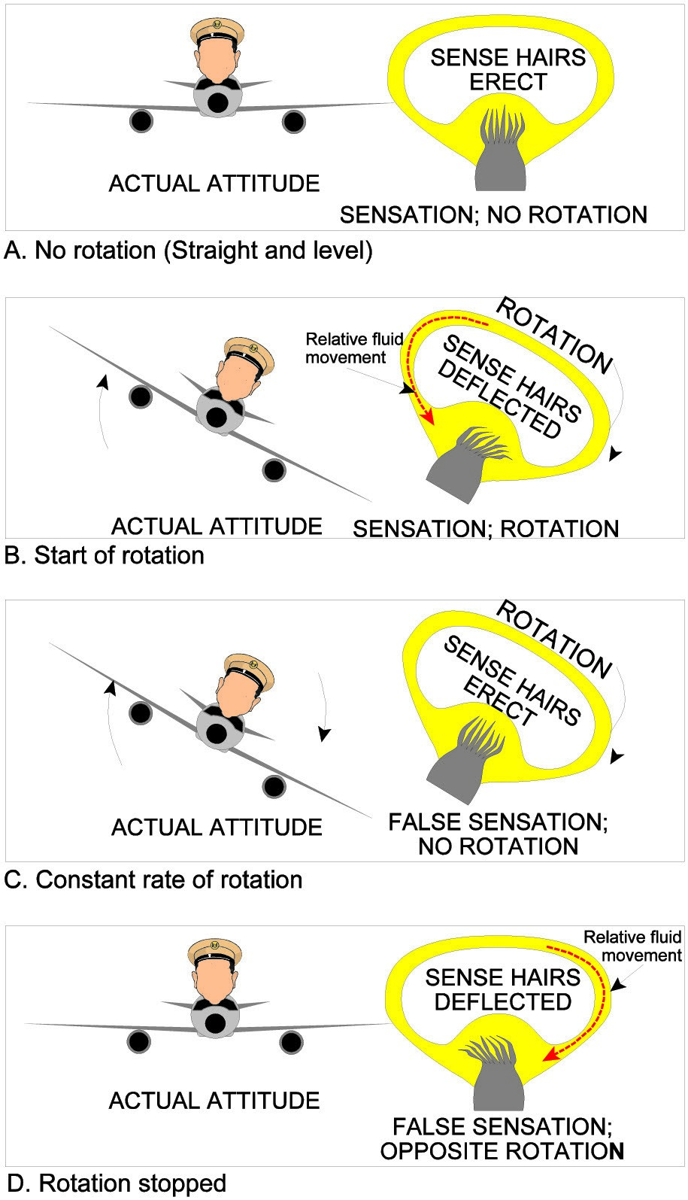

The illusion of **pitching up or down** as a result of the movement of the Otoliths due to linear acceleration. On take-off this is exacerbated by the resultant vector of the g-forces acting on the pilot and aircraft (*see Figure 10.10*).

Another illusion associated with the vestibular apparatus is vertigo, a loss of spatial awareness, in which the individual experiences a rotating, tumbling or turning sensation. This may be caused by disease in the inner ear but can occur in the healthy individual in certain circumstances which include:

* Blocked eustachian tubes.
* Sudden pressure changes in the inner ear (sneezing or strong blowing of the nose).
* Accelerations or high g-loadings.
* Drug-induced. *Figure 4.4*

Alcohol intoxication provokes vertigo.

#### Coriolis Effect

If a steady turn is being maintained then a sudden movement (greater than about 3° a second) of the head will be detected as a change in the turn rate. This phenomenon is referred to as a cross-coupled stimulation of the semicircular canals **(coriolis effect).**

It cannot be overemphasized that where there is a conflict between the two senses, **the visual reference will provide the more accurate picture of orientation.** Pilots are urged to always remember that the most important sense for spatial orientation is sight.

### Alcohol and Flying

Alcohol has a lower specific gravity than water. Alcohol in the fluid of the inner ear will change the specific gravity and cause erroneous results for certain movements, leading to disorientation. Alcohol in the fleshy stalk of the otoliths may persist for days after all traces of alcohol have vanished from the blood. It is not unusual for even small movements of the head to cause disorientation or motion sickness up to three days after alcohol was last consumed.

### Motion Sickness

Motion sickness is a misnomer since it is a normal and direct manifestation of sensory functions. It is probable that no one with a normal vestibular apparatus is completely immune and motion sickness has been referred to since the times of Hippocrates. It arises when man is exposed to real or apparent motion of an unfamiliar kind. It occurs not only in normal flying but also in space or at sea. Some individuals experience it in a car or on a train. Motion sickness is caused by a mismatch between the visual and vestibular signals. The symptoms of motion sickness are:

**The Nervous System, Ear, Hearing and Balance**

**4**

* Nausea.
* Hyperventilation.
* Vomiting.
* Pallor.
* Cold sweating.
* Headache.
* Depression.

It can be severely incapacitating but is a normal response to perceived stimuli.

**Anyone** with a normal sense of balance will suffer motion sickness if stimulated enough. Its symptoms are observed in up to 8% of passengers on board modern aircraft. Motion sickness can be generated without any real motion even, for example, in a simulator when an expected movement does not occur. Motion sickness can cause problems with flying training programmes and, to avoid the problem, all progress should be gradual. For example gradual progress from gentle to steep turns and avoidance of aerobatics during early training. Any prolonged break from training may lead to a recurrence of the problem.

Many pilots experience motion sickness when they fly but most can adjust or be conditioned to avoid symptoms. For a pilot suffering from chronic motion sickness it is most important that his/her organization’s aviation specialist is consulted.

### Coping with Motion Sickness

If motion sickness is experienced there are a number of strategies to give relief:

* Keep the head still if possible, as movement aggravates the vestibular system.
* Visual mismatching can be reduced by closing the eyes but this is obviously not acceptable for aircrew. Being relieved of lookout duty, with its continuous head movements will help, as will concentrating on flying the aircraft.

**4**

**The Nervous System, Ear, Hearing and Balance**

* Go for steady progress in aircraft manoeuvres. Opening the air vents will help in the majority of cases.
* Medication may help but always consult an aviation doctor before taking any drugs before flying. **Hyoscine** is the normal drug prescribed for air sickness.

### *Questions*

#### Questions

1. **The outer, middle and inner ear are filled with:** 
   1. Air Air Liquid
   2. Air Liquid Liquid
   3. Liquid Air Air
   4. Liquid Liquid Air
2. **What is the purpose of the Eustachian tube?**
   1. To pass sound waves across the middle ear to the auditory nerve
   2. To allow ambient pressure to equalize on both sides of the ear drum
   3. To allow ambient pressure to equalize on the middle ear side of the ear drum
   4. To allow ambient pressure to equalize on both sides of the vestibular apparatus
3. **What causes conductive deafness?**
   1. Damage to the outer ear
   2. Damage to the pinna
   3. Damage to the ossicles or the eardrum
   4. Damage to the middle ear
4. **What is noise induced hearing loss (NIHL)?**

**Questions**

**4**

* 1. Loss of hearing due to damage to the ossicles
  2. Loss of hearing due to damage to the vestibular apparatus
  3. Loss of hearing due to damage to the middle ear
  4. Loss of hearing due to damage to the cochlea

1. **On what does NIHL depend?**
   1. Both the intensity and duration of the noise above 100 dB
   2. The duration of the noise above 100 dB
   3. The duration of the noise above 110 dB
   4. Both the intensity and duration of the noise above 90 dB
2. **What is the most important sense for spatial orientation?**
   1. Hearing and balance
   2. Sight
   3. “Seat of the pants”
   4. All senses play their part in situation awareness
3. **If an aircraft accelerates, what do the otoliths indicate to the brain?**
   1. That the aircraft nose is pitching down; this feeling will be reinforced by an air driven artificial horizon
   2. That the aircraft is turning; this feeling will be reinforced by an air driven artificial horizon
   3. That the aircraft is climbing and turning; this feeling will be reinforced by an air driven artificial horizon
   4. That the aircraft is pitching up; this feeling will be reinforced by an air driven

artificial horizon

### *Questions*

1. **When can a pilot experience the “leans”?**
   1. In all flight conditions
   2. In the climb
   3. In the descent
   4. In the climb or the descent
2. **Which part of the ear senses linear accelerations and decelerations?**
   1. The ossicles in the middle ear
   2. The otoliths in the middle ear
   3. The ossicles in the middle ear
   4. The otoliths in the saccules canals
3. **What should a pilot rely on if disorientated in IMC?**
   1. Vision
   2. Turning head to recover from disorientation
   3. Sense of balance
   4. Instruments
4. **The conductive system consists of:**
   1. the ear drum and ossicles
   2. the semicircular canals and otoliths

**4**

**Questions**

* 1. the cochlea and eustachian tube
  2. the cochlea and the mitus

1. **The frequency band that a healthy young person can hear is:**
   1. 70 - 15 000 cycles per second
   2. 80 - 20 000 cycles per second
   3. 500 - 15 000 cycles per second
   4. 20 - 20 000 cycles per second
2. **Decibels increase:**
   1. linearly
   2. in terms of a logarithm
   3. in terms of increments
   4. in terms of integrals
3. **Presbycusis is an impairment of hearing due to:**
   1. damage to the cochlea
   2. damage to the semicircular canals
   3. age
   4. smoking
4. **The vegetative system is another name for the:**
   1. CNS
   2. NILH
   3. sense receptors
   4. ANS

### *Questions*

1. **The vestibular apparatus detects .................. acceleration:**
   1. linear
   2. angular
   3. angular and linear
   4. +g
2. **Messages are sent through the nervous system by the following means:**
   1. electrical
   2. chemical
   3. biological
   4. electrical and chemical
3. **The otoliths detect an acceleration greater than:**
   1. 0.001 m/s2
   2. 0.01 m/s2
   3. 0.1 m/s2
   4. 1.0 m/s2
4. **If a steady turn is being maintained, then a sudden movement (greater than about ................) may cause a phenomena known as the coriolis effect:**

**Questions**

**4**

* 1. 4° a second
  2. 5° a second
  3. 3° a second
  4. 2° a second

1. **Another name for “the leans” is:** 
   1. the oculogravic effect
   2. the somatogyral illusion
   3. the somatogravic illusion
   4. ocular disorientation
2. **Vertigo can be caused by a blocked eustachian tube.**
   1. True
   2. False
3. **The PNS comprises:**
   1. the sensory and motor nerves
   2. sensory and reaction nerves
   3. reaction and motor nerves
   4. only reaction nerves
4. **The ANS is a biological control system which is neurohormonal and, like others, is not self-regulating in normal circumstances.**
   1. True
   2. False

### *Answers*

**4**

**Answers**

#### Answers

|  |  |  |  |  |  |  |  |  |  |  |  |
| --- | --- | --- | --- | --- | --- | --- | --- | --- | --- | --- | --- |
| 1 | 2 | 3 | 4 | 5 | 6 | 7 | 8 | 9 | 10 | 11 | 12 |
| a | b | c | d | d | b | d | a | d | d | a | d |
| 13 | 14 | 15 | 16 | 17 | 18 | 19 | 20 | 21 | 22 | 23 |
| b | c | d | c | d | c | c | b | a | a | b |

Chapter

## **5** The Eye and Vision

Function and Structure . . . . . . . . . . . . . . . . . . . . . . . . . . . . . . . . . . . . . . . 75

The Cornea . . . . . . . . . . . . . . . . . . . . . . . . . . . . . . . . . . . . . . . . . . . . . 75

The Iris and Pupil . . . . . . . . . . . . . . . . . . . . . . . . . . . . . . . . . . . . . . . . . . 75

The Lens . . . . . . . . . . . . . . . . . . . . . . . . . . . . . . . . . . . . . . . . . . . . . . . 76

The Retina . . . . . . . . . . . . . . . . . . . . . . . . . . . . . . . . . . . . . . . . . . . . . . 76

The Fovea and Visual Acuity . . . . . . . . . . . . . . . . . . . . . . . . . . . . . . . . . . . . 77

Light and Dark Adaptation. . . . . . . . . . . . . . . . . . . . . . . . . . . . . . . . . . . . . 78

Night Vision . . . . . . . . . . . . . . . . . . . . . . . . . . . . . . . . . . . . . . . . . . . . . 78

The Blind Spot. . . . . . . . . . . . . . . . . . . . . . . . . . . . . . . . . . . . . . . . . . . . 79

Stereopsis (Stereoscopic Vision) . . . . . . . . . . . . . . . . . . . . . . . . . . . . . . . . . . 80

Empty Visual Field Myopia . . . . . . . . . . . . . . . . . . . . . . . . . . . . . . . . . . . . . 80

High Light Levels . . . . . . . . . . . . . . . . . . . . . . . . . . . . . . . . . . . . . . . . . . 80

Sunglasses . . . . . . . . . . . . . . . . . . . . . . . . . . . . . . . . . . . . . . . . . . . . . . 80

Eye Movement . . . . . . . . . . . . . . . . . . . . . . . . . . . . . . . . . . . . . . . . . . . 81

Visual Defects . . . . . . . . . . . . . . . . . . . . . . . . . . . . . . . . . . . . . . . . . . . . 81

Use of Contact Lenses . . . . . . . . . . . . . . . . . . . . . . . . . . . . . . . . . . . . . . . 83

Colour Vision . . . . . . . . . . . . . . . . . . . . . . . . . . . . . . . . . . . . . . . . . . . . 84

Colour Blindness . . . . . . . . . . . . . . . . . . . . . . . . . . . . . . . . . . . . . . . . . . 84

Vision and Speed . . . . . . . . . . . . . . . . . . . . . . . . . . . . . . . . . . . . . . . . . . 84

Monocular and Binocular Vision . . . . . . . . . . . . . . . . . . . . . . . . . . . . . . . . . . 84

Questions . . . . . . . . . . . . . . . . . . . . . . . . . . . . . . . . . . . . . . . . . . . . . . 85

Answers . . . . . . . . . . . . . . . . . . . . . . . . . . . . . . . . . . . . . . . . . . . . . . . 88

**5**

**The Eye and Vision**

### Function and Structure

The eye is the organ which receives electromagnetic waves within the visual spectrum from the external world and passes them to the brain for interpretation into an image. The basic structure is similar to a simple camera with an aperture, a lens, and a light sensitive screen called the **retina.**

To be able to keep tracking a moving object, the eyes need to act in harmony with one another which means coordinated control of the muscles of the two eyes by the brain. In a fatigued person, this coordination sometimes fails and the result is that quite differing images are transmitted from each eye. Subsequently double vision occurs.

**The Eye and Vision**

**5**

*Figure 5.1 The structure of the human eye*

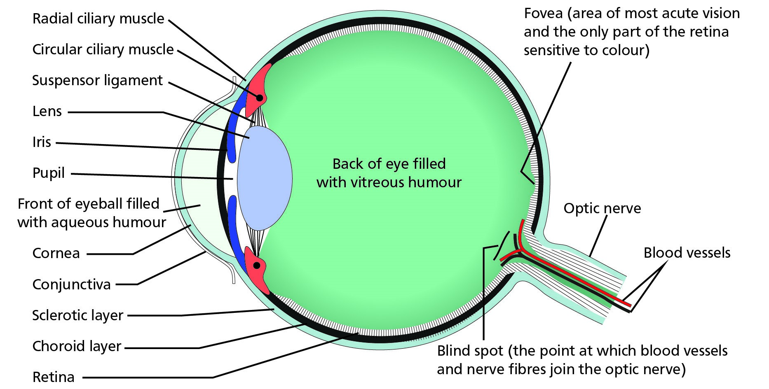

### The Cornea

Light enters the eye through the **Cornea,** a clear window at the front of the eyeball. The cornea acts as a fixed focusing device and is responsible for between 70% and 80% of the total focusing ability of the eye. The focusing is achieved by the shape of the cornea bending the incoming light rays.

### The Iris and Pupil

The amount of light allowed to enter the eye is controlled by the **iris,** the coloured part of the eye, which acts as a diaphragm. It does this by controlling the size of the **pupil,** the clear centre of the iris. The size of the pupil can change rapidly to cater for changing light levels.

If the eye observes a close object the pupil becomes smaller and, if the object is at a distance, the pupil becomes larger.

The amount of light can be adjusted by a factor of 5:1. But this factor is not sufficient to cope with the different light levels experienced between full daylight and a dark night and a further mechanism is required. In reduced light levels a chemical change takes place in the light sensitive cells on the retina which enable them to react to much lower light levels.

### The Lens

After passing through the pupil the light passes through a clear **lens**. Its shape is changed by the muscles (**ciliary muscles**) surrounding it which allow the final focusing onto the fovea. This change of shape is known as **accommodation.** The power of accommodation can be affected by the aging process or fatigue. When a person is tired, accommodation is diminished, resulting in blurred images.

In order to focus clearly on a near object, the lens is thickened. To focus on a distant point, the lens is flattened.

The image is inverted and reversed by the lens onto the retina. However the brain perceives the object in the upright position because it considers the inverted image as normal.

### The Retina

The retina is a light sensitive screen lining the inside of the eyeball. On this screen are light- sensitive cells which, when light falls on them, generate a small electrical charge which is passed to the **visual cortex** of the brain by nerve fibres (neurones) which combine to form the **optic nerve.** The optic nerve enters the back of the eyeball along with the small blood vessels needed to bring oxygen to the cells of the eye.

The light sensitive cell receptors of the retina are of two types - **rods and cones.** The centre of the retina is called the **fovea** (see below) and the receptors in this area are all cones. Moving outwards, the cones become less dense and are gradually replaced by rods, so that in the periphery there are no cones.

**5**

**The Eye and Vision**

Vision through the functioning of the rods is called **scotopic vision** whereas vision through the operation of the cones is known as **photopic vision.**

**Mesopic vision** is when both the rods and cones are in operation.

#### Cones

The cones are used for direct vision in good light and are **colour sensitive**. Each cone has its own neurone and thus can detect very fine detail. The human eye is capable of distinguishing approximately 1000 different shades of colour.

#### Rods

The maximum density of rods is found about 10° from the fovea. Several rods are connected to the brain by a single neurone. The rods can only detect **black and white** but are much more sensitive at lower light levels. As light decreases, the sensing task is passed over from the cones to the rods. This means that in poor light levels we see only in black or white or varying shades of grey.

Rods are responsible for our **peripheral vision.** At night time, with a dimly lit flight deck, the colour of instruments must be bright enough for cone vision to be used.

Rods are also sensitive to movement and the movement of an object to the side of us is quickly picked up.

Rods and cones are the nerve endings of the optic nerve. Thus, as an extension of the brain, they are very much affected by a shortage of oxygen, excess of alcohol, drugs or medication.

It is worth noting that the human eye has approximately 1.2 million neurones leading from the retina to the visual cortex of the brain, while there are only about 50 000 from the inner ears.

The eye is about 24 times more sensitive than the ear.

### The Fovea and Visual Acuity

#### Fovea

The central part of the retina, the **fovea,** is composed only of cone cells. Anything that needs to be examined in detail is automatically brought to focus on the fovea. The rest of the retina fulfils the function of attracting our attention to movement and change. Only at the fovea is vision 20/20 or 6/6. This is termed as **central vision.**

The **visual field** comprises both the central and peripheral vision.

**Note:** Alphanumeric information is limited to the foveal area of the retina.

#### Visual Acuity

This is a measure of central vision and the figures above are a means of measuring **visual acuity**. It is the ability to discriminate at varying distances. An individual with an acuity of 20/20 vision should be able to see at 20 feet that which the so-called normal person is capable of seeing at this range. It is sometimes expressed in metres (6/6). The figures 20/40 (or 6/12) mean that the observer can read at 20 feet what a normal person can read at 40 feet (6 /12 metres).

**The Eye and Vision**

**5**

Any resolving power at the fovea drops rapidly as the angular distance from the fovea increases. At as little as 5° from the fovea the acuity drops to 20/40 that is half as good as at the fovea. At approximately 25° acuity decreases to a tenth (20/200). See *Figure 5.2* below.

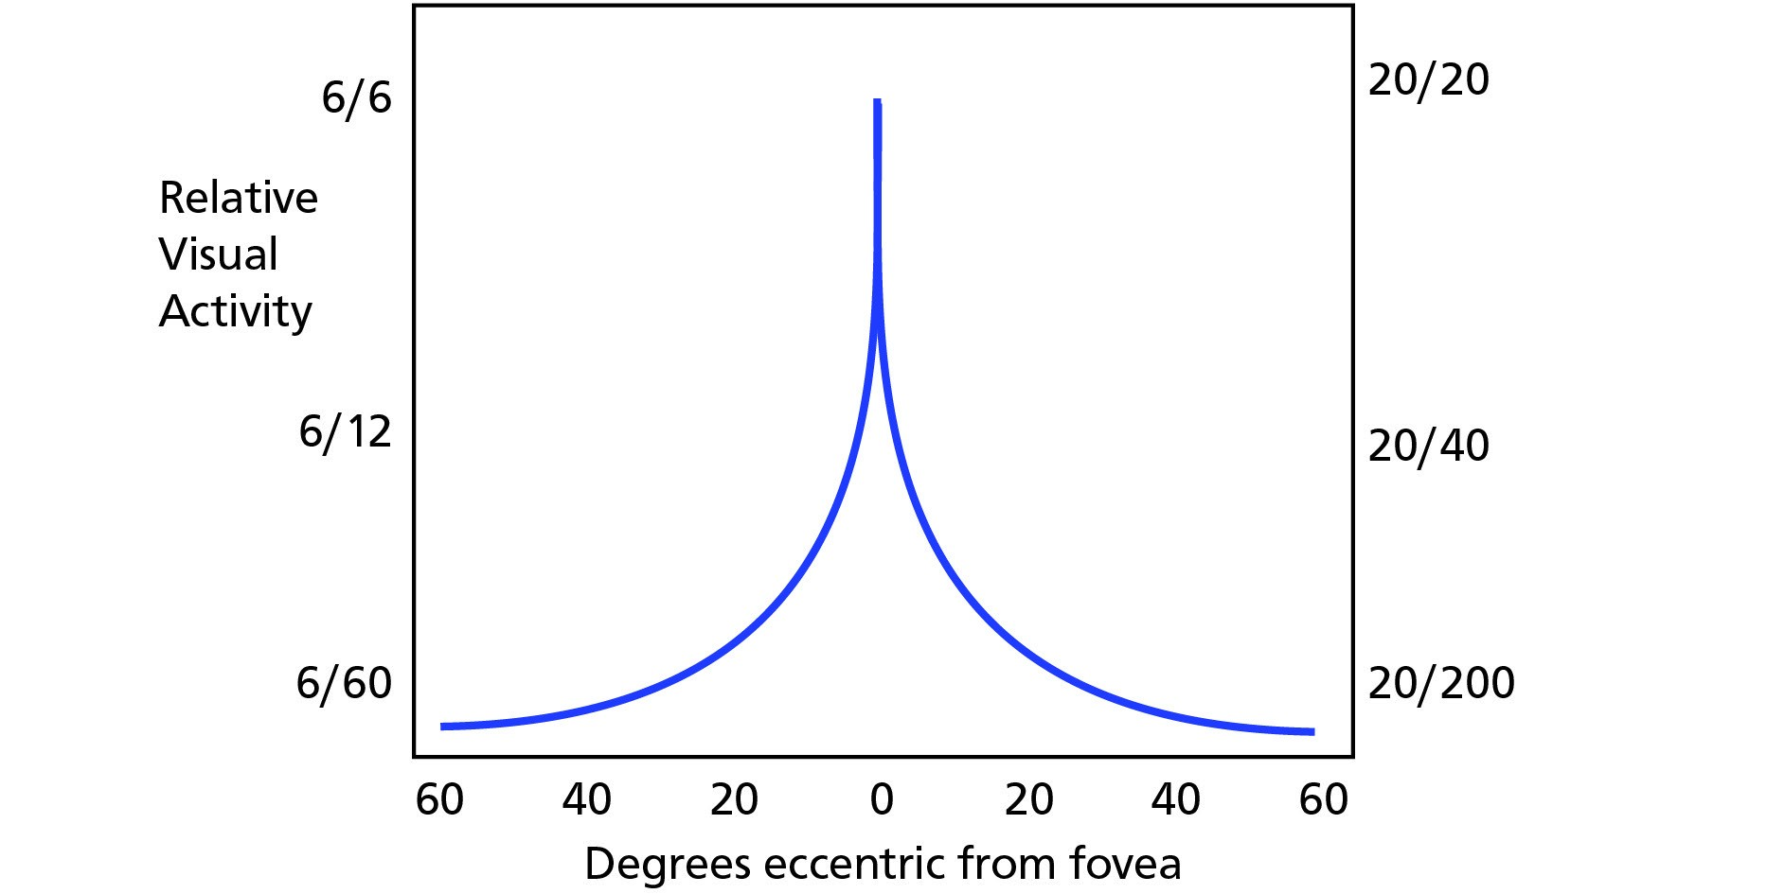

*Figure 5.2 The change in acuity across the retina*

#### Limitations of Acuity

In effect acuity will be limited by many factors among which are:

* Angular distance from the fovea.
* Physical imperfections within the visual system.
* Age.
* Hypoxia.
* Smoking.
* Alcohol.
* Visibility (dust,mist etc.).
* Amount of light available
* Size and contours of an object.
* Distance of the object from the viewer.
* Contrast of an object with its surroundings
* Relative motion of a moving object.
* Drugs or medication.

### Light and Dark Adaptation

#### Light Adaptation

When experiencing sudden high levels of illumination the eye quickly adjusts (approximately **10 seconds**). However, if a person has been in bright light for a long time, large proportions of the photochemicals in both the cones and rods are reduced thereby reducing the sensitivity of the eye to light. Thus going quickly from outside on a sunny day into a darkened room has the effect of vision being severely reduced until dark adaptation takes place.

**5**

**The Eye and Vision**

#### Dark Adaptation

On the other hand, if the person remains in darkness for a long time the reverse takes place and both the cones and rods gradually become supersensitive to light so that even the minutest amount of light causes excitement of the receptors.

### Night Vision

You may have noticed that in dim light it is easier to focus on an object if you look slightly away from it. As the fovea contains no rods, which would be required for vision in very low brightness levels, the centre part of the eye becomes blind to dim light. It is then necessary to look away from the visual target so that the peripherally located rods can perform their sensing task. This is most noticeable when night flying.

You can demonstrate this to yourself by looking at dim stars on a clear night. Some of them will be invisible with direct viewing but will be discernible if you look 10° to 15° off to one side.

It takes time for our eyes to adapt to darkness. This adaptation does take time - **about 7 minutes for the cones and 30 minutes for the rods.** However even a brief exposure to bright light will require a further period of adaptation to recover effective night vision.

It is good airmanship to avoid bright lights about 30 minutes prior to a night flight. It is also advisable to turn up cockpit lights when approaching a weather pattern which might produce the possibility of lightning. It is possible that fatigue may also necessitate the increase of instrument lighting.

From sea level to 3000 m is known as the **“indifferent zone”** because ordinary daytime vision is unaffected up to this altitude. There is, however, a slight impairment of night vision. Without supplemental oxygen, the average percent decrease in night vision capability is:

5% at 1100 metres

18% at 2800 metres

35% at 4000 metres

50% at 5000 metres

The most common factors affecting night vision are:

* Age (see **presbyopia** later in this chapter).
* Mild hypoxia.
* Cabin altitudes above 5000 ft (but not detrimental below approximately 12 000 ft).
* Smoking (a consumption of 20 cigarettes a day results in a night vision degradation of approximately 20%).
* Alcohol.
* Minor illnesses.
* Deficiency of vitamin ‘A’.

### The Blind Spot

The point on the retina where the optic nerve enters the eyeball has no covering of lightdetecting cells. Any image falling on this point will not be detected. This has great significance when considering the detection of objects which are on a constant bearing from the observer. If the eye remains looking straight ahead it is possible for a closing aircraft to remain in the blind spot until a very short time before impact. Safe visual scanning demands frequent eye movement with minimal time spent looking in any direction.

**The Eye and Vision**

**5**

Use *Figure 5.3* to demonstrate to yourself the existence of the blind spot. Hold the drawing at arm’s length, close the left eye and keep the right eye open. Now move the picture towards the face keeping the right eye focused on the cross. The aircraft will disappear, then reappear as it gets close.

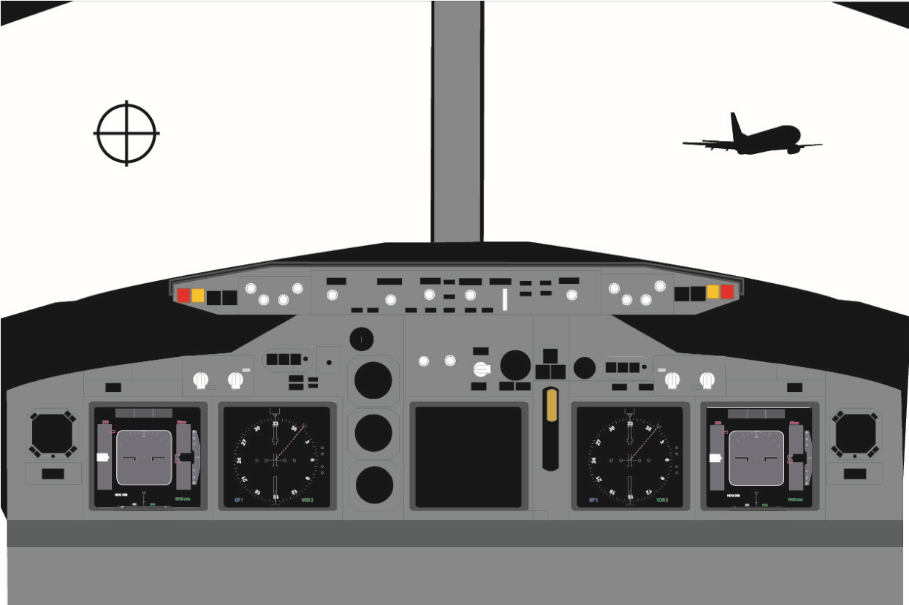

*Figure 5.3 The blind spot*

If both eyes of the observer are open and unobscured the blind spot is not a problem as each eye is able to see the detail in the other eye’s blind spot. However there is a very real possibility that an approaching aircraft on a constant bearing will not be seen since it remains in the blind spot of one eye and an object/person within the cockpit is obscuring the aircraft from the pilot’s other eye.

### Stereopsis (Stereoscopic Vision)

Some of the optic nerve fibres cross over in the brain. Because one eye is a little more than 2 inches (5 cm) to one side of the other eye, the images on the two retina are different from one another. This enables the brain to compare the slight differences seen by each eye. The brain interprets this as depth/distance perception. Thus a person with two eyes has a far greater ability to judge relative distances when objects are *nearby* than a person who only has one eye. However stereopsis is virtually useless for depth perception at distances beyond 200 ft/60 m.

### Empty Visual Field Myopia

In the absence of anything to focus on **(empty field**) the natural focus point of the eye is not at infinity, as was long assumed, but on average at a distance of between just under 1 metre and 1.5 metres, although there are wide variations between individuals.

This is very significant in searching for distant targets when visual cues are weak, as the eye will not be adjusted to detect them. The condition is aggravated when there are other objects close to the empty field range, rain spots on the windscreen for example, as the eye will naturally be drawn to them.

**5**

**The Eye and Vision**

This phenomena can occur in cloudless skies at high altitudes, in total darkness, under a uniformly overcast sky or when resting the eyes.

Aircrew should minimize the risks associated with empty visual field by periodically and deliberately focusing on objects thus exercising the eyes.

### High Light Levels

It is possible for too much light to fall on the eye. Pilots are exposed to much higher light levels than most people. Very high light levels occur at altitude where light may be reflected from cloud and more importantly, where there is less scattering of the light rays by atmospheric pollution.

Normal sunlight contains all the colours of the spectrum but at high altitudes pilots are exposed to light that contains more of the high energy blue and ultra violet wavelengths than is experienced at sea level. The **higher energy blue light** can cause cumulative damage to the **retina** over a long period. **Ultra violet** wavelengths can also cause damage, mainly to the **lens** of the eye, but most are filtered out by the cockpit windows.

### Sunglasses

Wearing appropriate sunglasses can provide complete protection against the above problems. When purchasing sunglasses always consult a knowledgeable supplier. Sunglasses should have the following characteristics:

* Be impact resistant.
* Have thin metal frames (minimum obstruction of the visual field).
* Be coated with polycarbonate for strength.
* Be of good optical quality.
* Have a luminance transmittance of 10-15%.
* Have appropriate filtration characteristics.

Pilots are strongly advised to avoid using cheap sunglasses as they can allow the light to be over diffused across the eye thus causing perceptional problems in flight. The use of Polaroid sunglasses should be avoided since problems can occur when used with laminated aircraft windscreens.

Light sensitive lenses (photochromic) are also generally forbidden for use in flight due to the time taken for the lens to clear when moving from a bright situation to one of low light. This delay may significantly reduce visual acuity at a critical time.

**Polarised lenses** reduce the amount of light passing through the lens by selective filtering of certain electromagnetic spectral planes. These lenses can cause distortion patterns from certain laminated cockpit windshields. They can also alter cloud appearance and reduce ground reflections useful for VFR pilots. The use of these sunglasses is therefore discouraged.

### Eye Movement

Movement of the eye is achieved by 6 extraocular muscles that allow movement in two planes; up/down and left/right. Normally both eyes move together to view an object. The surface of the eye is lubricated by a liquid secreted by the lacrimal glands. Tears are drained by the tear ducts into the nose. At low humidity levels the eyes can become dry and may feel painful. Tears also have a slight antiseptic property.

**The Eye and Vision**

**5**

### Visual Defects

Hypermetropia (long-sightedness) and myopia (short-sightedness) are caused by the distorted shape of the eyeball.

#### Hypermetropia

In long sightedness, hypermetropia, a shorter than normal eyeball along the visual axis results in the image being formed behind the retina and, unless the combined refractive index of the cornea and the lens can combine to focus the image in the correct plane, a blurring of the vision will result when looking at close objects. A **convex** lens will overcome this refractive error by bending the light inwards before it meets the cornea.

#### Myopia

In short-sightedness, Myopia, the problem is that the eyeball is longer than normal and the image forms in front of the retina. If accommodation cannot overcome this, then distant objects are out of focus whilst close up vision may be satisfactory. A **concave** lens will correct the situation by bending the light outwards before it hits the cornea. Pilots with either hypermetropia or myopia may usually retain their licences provided that their **corrected** vision allows them to read normal small print in good lighting at a distance of 30 cm and have at least 6/9 vision in each eye, but with 6/6 vision with both eyes. This is equivalent to reading a car number plate at about 40 metres, as compared to the driving test requirement of 23 metres. Bifocal spectacles may be used when flying.

#### Presbyopia

The ability of the lens to change its shape and therefore focal length (**accommodation**) depends on its elasticity and normally this is gradually lost with age. After the age of 40 to 50 the lens is usually unable to accommodate fully and a form of long-sightedness known as presbyopia occurs. The effects start with difficulty in reading small print in poor light. The condition normally requires a minor correction with a weak convex lens. Half lenses or lookover spectacles will suffice.

#### Astigmatism

The surface of a healthy cornea is spheroidal in shape. Astigmatism is usually caused by a misshapen or oblong cornea and objects will appear irregularly shaped. Although astigmatism can be cured by the use of cylindrical (toric) lenses, modern surgical techniques can reshape the cornea with a scalpel or, more easily, with laser techniques.

**5**

**The Eye and Vision**

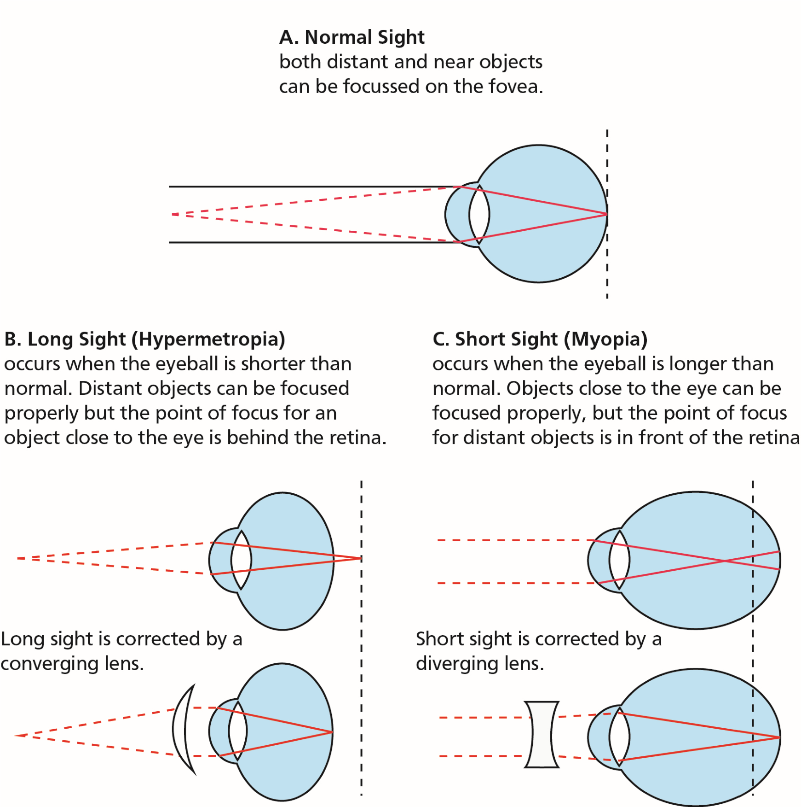

*Figure 5.4 Correction of myopia with a concave lens & correction of hypermetropia with a convex lens*

**It is a requirement that aircrew who have to wear correcting spectacles, in order to exercise the privileges of their licence, are to carry a spare (easily accessible) pair during flight.**

#### Cataracts

Cataracts are normally associated with the ageing process though some diseases can cause cataracts at any age. With time, the lens can become cloudy causing a marked loss of vision. For severe cases, traditional surgery is carried out in which a section of the lens is removed and replaced with an artificial substitute. Surgery utilizes local anaesthesia on an outpatient basis and, following successful treatment, pilots will normally be allowed to return to flying.

#### Glaucoma

Glaucoma is a disease of the eye which causes a pressure rise of the liquid in the eye (aqueous humour). The fluid protects the lens and nourishes the cornea. It passes through a small shutter which can either be flawed or can become jammed causing a rise in pressure of the eye. The normal pressure range is 10 - 20 mm Hg. Glaucoma damages the optic nerve and may cause severe pain and if left untreated, blindness. Part of the JAA medical examination is a test for glaucoma. The symptoms can be treated either be by eye drops (timitol) or by an operation in which a hole is made in the shutter. Glaucoma can be inherited or may result from the ageing process.

The main symptoms of Glaucoma are:

* Acute pain in the eye - in extreme cases.
* Blurred vision.
* Sensitivity to high light levels.

**The Eye and Vision**

**5**

* Visual field deterioration.
* Red discolouration of the eye.

### Use of Contact Lenses

Contact lenses provide better peripheral vision and are not subject to misting. Therefore many pilots are attracted to the idea of wearing them instead of spectacles. But there are a number of problems:

* As the cornea does not have its own blood supply, it obtains its oxygen from the ambient air. Mild hypoxia and dehydration, caused by low humidity on the flight deck, increase the potential for corneal damage when using contact lenses.
* Cabin decompression may result in bubble formation under the contact lens.
* The lens may be dislodged by careless rubbing of the eyes (for example when the humidity is low), an accidental knock or increased g-forces.

Whereas the use of contact lenses by aircrew is permitted, under authorised medical supervision, **bifocal contact lenses are prohibited.**

**Note:** Should a pilot be cleared by the authorities to use contact lenses for flying it will be on the **proviso that a pair of ordinary spectacles is carried at all times while practising the privileges of his/her licence.**

### Colour Vision

Good colour vision is essential for flight crew because of use of colour associated with the following:

* Navigation lights of aircraft.
* Runways and airfields.
* Ground obstructions.
* Cockpit displays and instruments.
* Maps and charts.
* Emergency flares.
* Light signals.

### Colour Blindness

Total colour blindness is a bar to the issue of a flying licence. It is caused by a defect in the structure of the colour sensitive cones in the retina - normally when a single group is missing. Whereas total colour blindness is extremely rare, many people suffer from this defect to a degree (colour defective). The most common form is red/green blindness. These colours are seen in shades of yellow, brown or grey. **It does not affect acuity** and many people go through their lives with no knowledge that they suffer from this imperfection.

Colour blindness is rare in women**,** however they do act as carriers of this incurable and congenital flaw.

**5**

**The Eye and Vision**

### Vision and Speed

In high speed flight (greater than approximately 450 knots), particularly at very low altitudes of below 500 ft, the principle problem is extension of the total reaction time (visual input, brain reaction, perception, recognition, evaluation, decision, action and response). In the ideal circumstances this takes about 5 - 7 seconds. Although many factors - including workload and fatigue - may prolong this period, it is the initial triggering of visual input, brain reaction, perception and recognition (or the “**visual perception cascade)**” that is especially important. In perfect conditions the visual perception cascade takes approximately 1 second however the following factors may extend this time period:

* Poor atmospheric conditions.
* Darkness.
* Size and contrast of object.
* Angular approach. An aircraft, for example, approaching head-on will stimulate the retina less than one tracking tangentially across the visual field.

### Monocular and Binocular Vision

Binocular vision is not essential for flying and there are many one-eyed (monocular) pilots, currently flying with a class II medical certificate. However should a pilot lose an eye it normally takes some time for the brain to learn to compensate for the loss of binocular vision and for the individual to regain his/her medical certificate. However, a person with vision in only one eye cannot be accepted under EASA as fit to fly.

### *Questions*

#### Questions

1. **What part of the eye bends the most light?**
   1. The cornea
   2. The lens
   3. The pupil
   4. The retina
2. **Which part of the eye has the best visual acuity?**
   1. The retina
   2. The fovea
   3. The lens
   4. The cornea
3. **The resolving power of the fovea decreases rapidly at only ..................... from its centre.**
   1. 5°
   2. 13° to 16°
   3. 3°
   4. 2° to 3°
4. **What is “empty field myopia”?**

**Questions**

**5**

* 1. It is a term used when the eye, if it has nothing on which to focus will tend to focus at infinity
  2. It is a term used when the eye, if it has nothing on which to focus will tend to focus between 4 to 6 metres
  3. It is a term used when the eye, if it has nothing on which to focus will tend to focus between 10 to 12 metres
  4. It is a term used when the eye, if it has nothing on which to focus will tend to focus between just under 1 to 1.5 metres

1. **What causes long or short sightedness?**
   1. Presbyopia
   2. Astigmatism
   3. Distortion of the eyeball
   4. Distortion of the cornea
2. **Is a pilot allowed to fly wearing bifocal contact lenses?**
   1. Yes
   2. Yes, if cleared to do so by a qualified aviation specialist
   3. Yes, if cleared to do so by the authority
   4. No
3. **What part of the spectrum should sunglasses filter out?**
   1. The red and UV end of the spectrum
   2. The blue and UV end of the spectrum
   3. All high intensity light
   4. UV only

### *Questions*

1. **What four factors affect night vision?**
   1. Age, alcohol, altitude and smoking
   2. Age, altitude, instrument lights and smoking
   3. Instrument lights, alcohol, altitude and smoking
   4. Age, alcohol, altitude and instrument lights
2. **Cones detect .................... and are mostly concentrated at the .....................**
   1. black and white fovea
   2. colour fovea
   3. black and white retina
   4. colour entry point
3. **What is the recommended course of action if encountering an electrical storm during flight?**
   1. Pull the visors down
   2. Turn the cockpit lights down
   3. Turn the cockpit lights to full
   4. Put on sunglasses if available
4. **Where is the “blind spot”?**
   1. On the iris
   2. On the fovea

**5**

**Questions**

* 1. On the edge of the lens
  2. At the entrance to the optic nerve

1. **Peripheral vision is looked after by the:**
   1. rods
   2. cones
   3. rods and cones
   4. fovea
2. **Does lack of oxygen affect sight?**
   1. Yes
   2. No
   3. Sometimes
   4. It depends on the health of the individual
3. **The amount of light allowed to enter the eye is controlled by the:**
   1. cornea
   2. retina
   3. iris
   4. fovea
4. **Accommodation is controlled by the:**
   1. ciliary muscles
   2. iris
   3. lens
   4. cornea

### *Questions*

1. **The maximum number of rods are found ..................... from the fovea.**
   1. 10°
   2. 20°
   3. 15°
   4. 30°
2. **Dark adaption takes about ..................... for the rods and .................... for the cones.**
   1. 30 minutes 7 minutes
   2. 7 minutes 30 minutes
   3. 15 minutes 20 minutes
   4. 25 minutes 45 minutes
3. **Stereopsis is associated with:**
   1. night flying
   2. depth perception
   3. acuity
   4. colour blindness
4. **Hypermetropia is caused by a ...................... eyeball and is corrected by a**

**.................... lens.**

* 1. elongated convex

**Questions**

**5**

* 1. shortened concave
  2. shortened convex
  3. elongated concave

1. **Astigmatism is normally associated with the:**
   1. retina
   2. fovea
   3. iris
   4. cornea
2. **Glaucoma is caused by:**
   1. an increase in the pressure of the eye
   2. a decrease in the pressure of the eye
   3. a defect of the cornea
   4. a defect of the retina.
3. **Cataracts are associated with the:**
   1. retina
   2. tear ducts
   3. iris
   4. lens
4. **Does colour blindness affect acuity?**
   1. Yes
   2. No

### *Answers*

**5**

**Answers**

#### Answers

|  |  |  |  |  |  |  |  |  |  |  |  |
| --- | --- | --- | --- | --- | --- | --- | --- | --- | --- | --- | --- |
| 1 | 2 | 3 | 4 | 5 | 6 | 7 | 8 | 9 | 10 | 11 | 12 |
| a | b | a | d | c | d | b | a | b | c | d | a |
| 13 | 14 | 15 | 16 | 17 | 18 | 19 | 20 | 21 | 22 | 23 |
| a | c | a | a | a | b | c | d | a | d | b |

Chapter

## **6** Flying and Health

Flying and Health . . . . . . . . . . . . . . . . . . . . . . . . . . . . . . . . . . . . . . . . . . 91

Acceleration . . . . . . . . . . . . . . . . . . . . . . . . . . . . . . . . . . . . . . . . . . . . . 91

G-forces . . . . . . . . . . . . . . . . . . . . . . . . . . . . . . . . . . . . . . . . . . . . . . . 91

Effects of Positive G-force on the Human Body . . . . . . . . . . . . . . . . . . . . . . . . . . 91

Long Duration Negative G . . . . . . . . . . . . . . . . . . . . . . . . . . . . . . . . . . . . . 92

Short Duration G-forces . . . . . . . . . . . . . . . . . . . . . . . . . . . . . . . . . . . . . . 92

Susceptibility and Tolerance to G-forces. . . . . . . . . . . . . . . . . . . . . . . . . . . . . . 92

Summary of G Tolerances. . . . . . . . . . . . . . . . . . . . . . . . . . . . . . . . . . . . . . 94

Barotrauma . . . . . . . . . . . . . . . . . . . . . . . . . . . . . . . . . . . . . . . . . . . . . 94

Toxic Hazards . . . . . . . . . . . . . . . . . . . . . . . . . . . . . . . . . . . . . . . . . . . . 97

Body Mass Index (BMI) . . . . . . . . . . . . . . . . . . . . . . . . . . . . . . . . . . . . . . . 98

Obesity. . . . . . . . . . . . . . . . . . . . . . . . . . . . . . . . . . . . . . . . . . . . . . . . 99

Losing Weight . . . . . . . . . . . . . . . . . . . . . . . . . . . . . . . . . . . . . . . . . . . . 99

Exercise . . . . . . . . . . . . . . . . . . . . . . . . . . . . . . . . . . . . . . . . . . . . . . . 99

Nutrition and Food Hygiene . . . . . . . . . . . . . . . . . . . . . . . . . . . . . . . . . . . .100

Fits . . . . . . . . . . . . . . . . . . . . . . . . . . . . . . . . . . . . . . . . . . . . . . . . . .102

Faints. . . . . . . . . . . . . . . . . . . . . . . . . . . . . . . . . . . . . . . . . . . . . . . . .102

Alcohol and Alcoholism. . . . . . . . . . . . . . . . . . . . . . . . . . . . . . . . . . . . . . .103

Alcohol and Flying . . . . . . . . . . . . . . . . . . . . . . . . . . . . . . . . . . . . . . . . .105

Drugs and Flying . . . . . . . . . . . . . . . . . . . . . . . . . . . . . . . . . . . . . . . . . .105

Psychiatric Illnesses . . . . . . . . . . . . . . . . . . . . . . . . . . . . . . . . . . . . . . . . .106

Tropical Diseases and Medical Hazards (including Hepatitis and Diabetes). . . . . . . . . . .107

Diseases Spread by Animals and Insects. . . . . . . . . . . . . . . . . . . . . . . . . . . . . .110

Sexually Transmitted Diseases . . . . . . . . . . . . . . . . . . . . . . . . . . . . . . . . . . .110

Personal Hygiene . . . . . . . . . . . . . . . . . . . . . . . . . . . . . . . . . . . . . . . . . .111

Stroboscopic Effect . . . . . . . . . . . . . . . . . . . . . . . . . . . . . . . . . . . . . . . . .111

Radiation . . . . . . . . . . . . . . . . . . . . . . . . . . . . . . . . . . . . . . . . . . . . . .111

Common Ailments and Fitness to Fly . . . . . . . . . . . . . . . . . . . . . . . . . . . . . . .112

Continued Overleaf

Drugs and Self-medication . . . . . . . . . . . . . . . . . . . . . . . . . . . . . . . . . . . .112

Anaesthetics and Analgesics . . . . . . . . . . . . . . . . . . . . . . . . . . . . . . . . . . .113

Symptoms in the Air . . . . . . . . . . . . . . . . . . . . . . . . . . . . . . . . . . . . . . .114

**6**

**Flying and Health**

Questions . . . . . . . . . . . . . . . . . . . . . . . . . . . . . . . . . . . . . . . . . . . . .115

Answers . . . . . . . . . . . . . . . . . . . . . . . . . . . . . . . . . . . . . . . . . . . . . .120

### Flying and Health

A career in aviation brings the individual into situations not usually met in other professions. These situations are discussed below.

### Acceleration

Acceleration is the rate of change in velocity, either as regards to speed or direction or both. Man is exposed to the forces of acceleration in one form or the other almost constantly throughout flight. Acceleration is referred to in aviation medicine as:

* Linear.
* Radial (centripetal).
* Angular.

#### Difference between Radial and Angular Acceleration

Angular acceleration involves rotation about an axis which passes through the pilot’s body whereas radial (centripetal) is where the axis is external to the pilot. Thus, when a very gentle turn is initiated, the body will initially experience angular acceleration but, as the turn develops, both angular and radial accelerations are experienced.

The effects of acceleration on the human body may be classified into long or short duration accelerations. In long duration acceleration the force will act for longer than one second. In the case of short acceleration, which lasts for one second or less, we are mainly concerned with impact forces.

**Flying and Health**

**6**

### G-forces

The human body has adapted to live under the force of gravity on the earth (the pull of the earth’s gravity giving the body weight). Acceleration in an aircraft can subject the body to forces much greater than this. For convenience, the forces are measured as multiples of our 1g terrestrial environment.

Acceleration in the fore and aft (the horizontal) plane is referred to as **Gx**, whereas acceleration in the lateral plane (side to side) is known as **Gy**. However the usual g-force encountered in aviation is that in the vertical plane which is termed as **Gz**.

### Effects of Positive G-force on the Human Body

In long-term positive acceleration, the changes in g-force are perceived as:

* An increase in body weight so that limbs become harder to move, the head becomes heavy (2g and above). Mobility is impaired, for example, if the head is lowered it may be impossible to raise it again. At 2.5g it is impossible to rise from the sitting position.
* Internal organs are displaced downwards from their normal positions and the lower facial area feels “pulled down” (3-4g and above).
* An increase in **hydrostatic variation** of the blood pressure. Normally the blood pressure in the legs and lower body is greater than that at the heart. As the positive g-forces increase so the hydrostatic variation increases. The result is a pooling of blood in the lower body with a reduced venous return to the heart. There is a consequent reduction of blood pressure in the head and blood supply to the brain, heart and eyes with an increased blood pressure at the feet.
* The photosensitive cells of the eyes (rods and cones) need a disproportionate amount of oxygen from the blood. Positive g-forces reduces the amount of oxygen available, thus causing a **‘greying out’** (3-4g) as vision is affected. It also induces a tunnelling of vision as the eye cells at the edge of the retina, being furthest from the blood supply, suffer first. Eventually (above 5g) the individual will lose consciousness **“blackout”** - now more commonly referred to as G-LOC. The effects of blacking out disappear almost as soon as the g level is reduced, although the individual will be confused for a few seconds and may have difficulty in focusing his/her eyes.
* Inspiration difficulties due to the lowering of the diaphragm (4-5g).
* Loss of sensory functions (above about 8g).
* Cramping of the calf muscles. At very high g-forces haemorrhages can occur about the legs and feet.
* At extreme g-forces, fracture of the vertebrae and death will occur due to lack of venous return to the heart.

### Long Duration Negative G

In negative g situations, such as inverted flight, outside loops, and some forms of spinning, the symptoms can be more uncomfortable than those caused by positive g.

**6**

**Flying and Health**

Organs are forced upwards and blood is forced into the region of the head thus affecting the hydrostatic variation. The individual will experience respiration difficulties, facial pain and lower eyelid will be pushed up giving rise to **‘redout’** vision. Additionally the upward flow of blood causes a slowing of the heart. With high negative g, the small blood vessels in the face and eye may burst.

### Short Duration G-forces

Short duration g-forces are concerned with impact forces. The maximum tolerable levels are determined by the strength of various parts of the body. The human body can stand shortterm g-forces of surprising magnitudes.

### Susceptibility and Tolerance to G-forces

#### Susceptibility

The ability to withstand even moderate g-forces is reduced by the following factors:

* Hypoxia.
* Hyperventilation.
* Hypotension.
* Stress.
* Fatigue.
* Heat.
* Low blood sugar.
* Smoking.
* Obesity. • Alcohol.

#### Factors That Increase Tolerance to Long Duration G-forces

The normal relaxed individual will usually be able to withstand or tolerate about +3.5g without serious effects such as greying out, other visual disturbances, or unconsciousness. The factors that can increase tolerance are:

**Body Position**

It has been found that, while in the sitting position, by raising the knees and feet and bending the trunk forward from the hips has a small benefit in delaying the effect of blackout. Firstly it decreases the vertical distance between the lower limbs and the heart, and secondly, it causes the acceleration force to drive the blood in the thighs towards the heart instead of away from it. Certainly lying in the prone or supine positions go a long way to eliminate the hydrostatic variation and it has been known for the human being to tolerate up to 12G in this position before blacking out.

**Voluntary Manoeuvres**

It is possible to raise the g tolerance by about 1-1.5g by taking a number of physical actions. The principle underlying the first three of the following manoeuvres is to raise the pressure in the abdominal cavity, so as to maintain the level of the diaphragm and facilitate the return of the venous blood. This can be done by:

* Straining.
* Shouting.

**Flying and Health**

**6**

* Tensing leg muscles

It is essential that these measures are kept short and intermittent since they cause fatigue and will have a negative effect if prolonged.

**Anti-g Straining Manoeuvre**

This is now widely accepted as a means of combining the beneficial effects of the manoeuvres listed above. It is a combination of muscle tensing and the valsalva manoeuvre performed rhythmically every 3 to 4 seconds.

**Anti-g Suits**

The object of the suit is to provide more counter-pressure to the lower limbs and help to maintain the level of the diaphragm. The operation is automatic and varying pressures are delivered to the suit according to the g level experienced.

Combined with the anti-g straining technique, the tolerance level can be increased by 1.5 to 2g, however these techniques are normally confined to military flying.

The tolerance for negative g-forces is much lower being only -3g. This level can only be tolerated for a few seconds.

**Short Duration Positive (Impact) g-Forces**

The body can tolerate at most **25g** in the vertical axis and **45g** in the fore and aft axis. Forces above these levels will cause serious injury and death.

The **lap strap**, as worn by airline passengers, is the simplest form of restraint. Although tolerance is increased when correctly fitted, the body may jackknife over the belt causing injury as the head strikes a forward structure. Knees can be severely damaged and compression of internal organs may also result The **five point harness** with the anti-g or crutch strap, offers the best protection as the **lap and diagonal** and **four point harnesses** found in most general aviation and some commercial aircraft do not give complete protection against **submarining** (sliding under the harness that can occur in some impact situations).

### Summary of G Tolerances

**Long duration (More than 1 second)**

* + 3.5g in relaxed subject.
* + 7 to +8g using anti-g straining techniques.
* - 3g but only for short periods.

**Short duration (Impact forces)**

* 25g in vertical axis.
* 45g in fore/aft axis.

**Remember: The effects of acceleration are mainly cardiovascular and pulmonary but it can also produce perceptual disorders and neurosensory illusions.**

### Barotrauma

#### Introduction

**Barotrauma** is pain caused by the expansion and contraction, due to outside pressure changes, of air trapped in the cavities of the body, notably within the intestines, middle ear, sinuses or teeth. Barotrauma can cause discomfort or extreme pain sufficient to interfere with the pilot’s ability to operate the aircraft. ***Otic (Middle Ear) Barotrauma***

**6**

**Flying and Health**

Pressure is normally equalized across the eardrum by the **eustachian tube** leading from the middle ear to the back of the mouth/nose. There is seldom any problem in the climb when air passes from the middle ear to atmosphere.

Most problems occur in the descent when air is attempting to return to the middle ear. The end of the eustachian tube acts as a flap valve which allows air to escape with relative ease (required in the ascent) but can restrict air entering the middle ear (required in the descent). With a reduced pressure in the middle ear the increasing pressure outside will cause a distortion of the ear drum and sometimes extreme pain. The severity of otic barotrauma depends upon the rate of climb or descent. It occurs mainly at lower levels where pressure changes are the greatest.

The problem is increased if the person has a cold or any other condition which has caused the mucous membrane lining the eustachian tube to become inflamed and swell. One or both ears can be affected and will cause:

* Pain (gradual or sudden), which can radiate to the temples.
* Temporary deafness.
* Pressure Vertigo.
* Tinnitus (a ringing in the ears).
* Rupture and bleeding of the ear drum in extreme cases. This may cause deafness.

It is most important that pilots ensure that, having suffered from otic barotrauma, they are in a perfect state of health before returning to flying. If the resumption of flying takes place prior to a complete recovery, this can lead to further damage to the system which may result in a chronic state and the risk of infection.

#### “Clearing the Ears”

Care also must be used when “clearing the ears” by blowing down a held nose with the mouth closed **(Valsalva Manoeuvre**). A violent usage of this method may cause **pressure vertigo**. Less severe methods include:

* The Frenzel Manoeuvre (similar to stifling a sneeze).
* Swallowing with the nose held.
* Yawning.
* Moving the lower jaw from side to side.

These methods should only be used for equalizing pressure in the middle ear during the **descent.**

Should all these methods fail, a landing should be made as soon as practicable and medical assistance sought from an aviation medical specialist.

#### Sinus Barotrauma

Sinuses are cavities within the skull which are air-filled and their function is to make the skull lighter and the voice resonant. They are situated above the eyes, in the cheeks and at the back of the nose and are connected to the nasal cavity by narrow ducts. These tiny ducts can become swollen or obstructed allowing air to become trapped within the sinuses. As with the ears, the sinuses can vent air more easily in the ascent than they allow gas to re-enter in the descent. Thus the painful results normally occur in the descent if the sinuses are infected by a cold or influenza.

**Flying and Health**

**6**

The pain, which normally starts around the eyes spreading to the temples, can be so severe as to render the pilot quite incapable of maintaining control of the aircraft. Fainting due to such pain is not unknown. Associated with the pain is a watering of the eyes making vision difficult and, in addition, bleeding from the nose may occur.

The immediate treatment is to return to the altitude where the pain first became apparent. The flight should then be terminated with a return to ground level at as slow a rate as possible.

***Note:*** *Unlike otic barotrauma, the pain suffered due to sinus barotrauma may be equally as acute in the climb or the descent.*

#### Barotrauma of the Teeth (Aerodontalgia)

Healthy teeth do not contain air but gas pockets can form in old or poor fillings or abscesses. Aerodontalgia is most common in the ascent as the gas expands, perhaps pressing on a nerve, and can cause severe tooth pain. Good dental care and hygiene can prevent any problem.

#### Gastrointestinal Barotrauma

The Gastro-intestinal tract is, in effect a tube from the mouth to the anus. Air can be swallowed along with food and the digestive processes produce gas. Gas collecting in the stomach can easily escape through the mouth whereas at the other end of the system, gas in the large intestine, mostly caused by the action of bacteria, can readily be vented to the outside (known as “passing flattus”).

**6**

**Flying and Health**

*Figure 6.1 Gastro-intestinal tract*

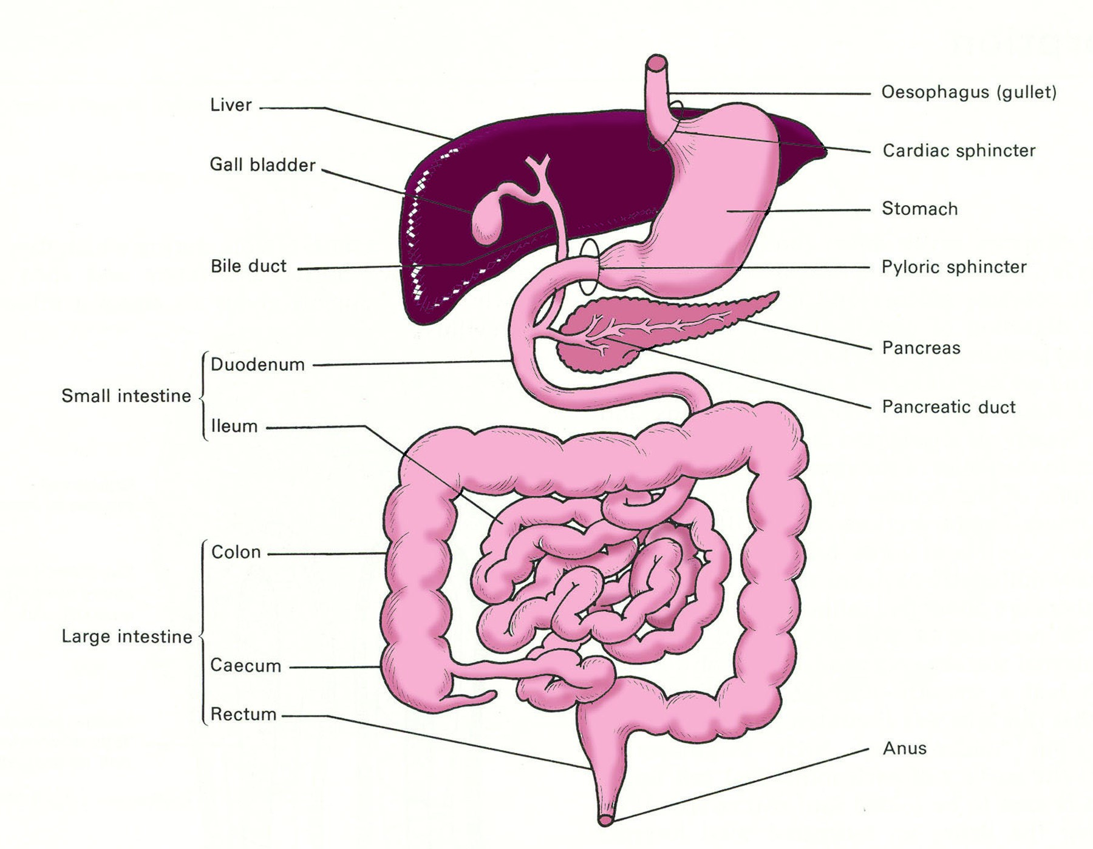

The main problem is gas in the small intestine. It has no easy exit from the system at either end and will expand causing discomfort and sometimes pain sufficiently severe to cause fainting. Very occasionally the wall of the intestine may tear.

There is no easy way to relieve the symptoms during flight except by descending but the effects may be greatly reduced by:

* Avoiding foods which are high gas producers (raw apples, cabbage, cauliflower, celery, cucumber, beer, beans, any highly spiced foods such as curries) before flight.
* Eating slowly and not rushing meals, especially just before flight.
* Eating smaller portions (less swallowed air).
* Not using chewing gum (less swallowed air).

#### Lungs

The lungs contain a large volume of gas but there is easy communication to the outside air so that pressure changes are rapidly dealt with. The only potential risk is from a very rapid decompression but, provided the individual breathes out during this stage, lung damage is extremely rare. ***Plaster Casts***

It is worth noting that air trapped within plaster casts will expand and can cause acute distress to the wearer. If in doubt, passengers’ casts should be split prior to take-off especially if the flight is to be lengthy.

### Toxic Hazards

Aviation involves the use of many substances that are themselves toxic or have the potential to become so in a fire, releasing dangerous fumes which may be inhaled. In some cases, raised temperature and lowered atmospheric pressure are significant factors in producing or aggravating toxic effects.

Even mild toxic effects can lower an individual’s performance which can result in an aircraft accident.

**Fuels, lubricants and propellants** can release vapours which may cause drowsiness or irritation to the respiratory system, together with skin damage. Hydrocarbon and lead tetra ethyl can effect the nervous system causing a loss of sensation. If the sense of smell is affected, an individual’s awareness of continued exposure may be reduced.

**Flying and Health**

**6**

**Anti-icing fluid** gives off fumes which, if allowed to enter the fuselage, can be harmful. Ethylene glycol, which is often used, can cause kidney damage.

**Fire Extinguishing agents,** (particularly Halon 1211 or BCF) may cause suffocation, lung irritation, dizziness, confusion and coma.

**Agricultural chemicals**, although not normally carried by commercial aircraft, can cause health problems. Some insecticides can be as poisonous to people as they are to pests and even at low trace levels can result in vomiting, diarrhoea, tremors and coma.

**Mercury** is exceedingly corrosive and poisonous and, in addition, its vapour is highly toxic. Mercury is still used in instruments and gyroerection systems of a number of old aircraft. It may be found in the thermometer carried as part of the first aid kit in modern aircraft. In the event of contact with mercury, you should at once wash in quantities of hot water followed by soap and hot water. Should the vapour be inhaled immediate and urgent medical treatment must be sought.

**Mercury spillage** in an aircraft can lead to catastrophic results. It attacks aluminium by a chemical reaction known as amalgamation. In this process, the mercury attacks the grain of the alloy and, in an exceedingly short time, will completely destroy it. Mercury will flow through minute cracks to get to the lowest part of the structure where it will cause extensive damage. Extreme care must be exercised when removing spillages and on no account should an attempt be made to blow it with compressed air as this will only scatter it and increase the risk of further damage. Vacuuming is the best method.

**Batteries**, if fitted incorrectly, can leak corrosive liquid and dangerous vapours.

**Ozone**, a variant of oxygen, is highly toxic when inhaled, even in small quantities. It is an irritant to the lungs and can cause severe headaches. It also impairs night vision. The amount of ozone in the air increases above 40 000 ft but during the winter months the low tropopause may mean that there are significant amounts at much lower levels. Fortunately most aircraft effectively break down excess ozone at the compressor stage of cabin air supply through catalytic converters before it enters the cabin. Although present mainly in the stratosphere, ozone is not considered a component in the composition of the atmosphere. Ozone is a very corrosive gas which is toxic to living organisms.

**Furnishings and baggage**. In case of fire on board an aircraft, some cabin furnishings and plastic or foam upholstery give off poisonous fumes as they are heated. There is also the risk that luggage may contain lethal items which may not have been detected during routine screening. The tragic Saudia Tristar aircraft accident, which killed over 300 people as a result of toxic fumes, is a prime example of this very real danger.

**Plastic coated electric wires** can be a source of highly toxic fumes when burnt. If the concentration is high enough damage to the central nervous system can occur.

**Exhaust gases** must be avoided at all times as they contain carbon monoxide. Be especially aware of this when on the apron and while carrying out preflight inspections. The effects and dangers of carbon monoxide have already been discussed.

**Acetone and Turpentine,** which are both used in aviation, can damage mucous membranes and eyes.

**Individuals who have been exposed to any toxic hazard should seek medical assistance as soon as possible from an aviation specialist.**

**6**

**Flying and Health**

### Body Mass Index (BMI)

Body Mass Index is the measure of a person’s weight in relation to a normal standard. The following formula is used to calculate the BMI of an individual.

BMI = Weight in Kilograms

(Height in Metres)²

A BMI of:

Up to 20 for males or up to 19 for females = Underweight.

Between 20 and 25 for males or between 19 and 24 for females = Normal.

Over 25 - 30 inclusive for males and over 24 - 29 for females = Overweight.

**Over 30 for males or 29 for females = OBESE.**

Thus a male with a height of 1.80 metres and weighing 85 kilograms has a BMI of 26.23 indicating that he is overweight. BMI is also known as The Quetelet Index.

#### Backache

There are a number of back complaints from which flight crew can suffer. These can range from unspecific back pains to a slipped disk.

Aircrew should be aware of the importance of a good sitting position in flight and the correct setting of the seat lumber support provided. In-flight exercise can help if and most problems can be cured by physiotherapy treatment.

### Obesity

Obesity, which tends to be genetic, is the term for an excess of fatty tissue in the body. An individual who is obese is susceptible to:

* Heart attack.
* Hypertension (high blood pressure) with the higher risk of a stroke.
* Hypoxia at lower altitudes than normal.
* General circulation problems.
* Gout (painful inflammation of the joints due to an excess of uric acid).
* Osteoarthritis (wear and tear on the joints).
* Diabetes.
* G-forces.
* Problems with joints and limbs due to weight.
* Decompression sickness (DCS).
* Heavy sweating.
* Chest infections.
* Varicose veins.
* A reduced life expectancy.

### Losing Weight

**Flying and Health**

**6**

If an individual is overweight or obese there are obvious advantages in losing weight. There is no magic formula or secret dietary method to reduce weight. Any food taken in has to be balanced by the energy output. Any excess is stored in the body as fat. The only practical way to lose weight is to **eat less** from a balanced diet containing the right mix of carbohydrates, protein and fat.

The use of “crash diets” must be avoided. They are normally ineffective in the long term and may cause dangerous physical and emotional symptoms. The overall objective must be to introduce new habits of eating, with a change in frequency, size and content of meals. On no account should **appetite suppressants** be taken unless under the direct supervision of an aviation medical specialist.

### Exercise

Exercise promotes both mental and physical fitness and a sense of well-being but the amount of exercise required to burn off excess weight is so high that it is not a practical solution to obesity. Those who do take regular exercise can cope with fatigue much better and their resistance to stress is improved. As pilots are required to sit for long periods of time, regular exercise is of particular importance.

**To be effective in reducing coronary artery disease, exercise must be regular and sufficient to raise the resting pulse rate by 100% for at least 20 minutes, three times a week.**

Playing squash or tennis, swimming, jogging and cycling provide good exercise. Playing a round of golf or walking the dog may be pleasant but provide insufficient exercise to benefit the individual physically.

### Nutrition and Food Hygiene

#### Healthy Diets

A balanced diet is the foundation of good health. A high-carbohydrate/fibre and low-fat diet can reduce the risk of coronary heart disease, stroke, diabetes and certain forms of cancer. Sources of carbohydrates include grains, vegetables, nuts, potatoes and fruits and should make up more than 50% of the calories consumed. The rest should come from lean meats and poultry, fish and low-fat dairy products.

**Never miss breakfast - it is the most important meal of the day.** Medical authorities state that breakfast should supply about 25% of the daily calorie intake. Never wait until you get on board the aircraft to eat.

Not eating regular meals or fasting can result in low blood sugar **(hypoglycaemia)** (below about 50 mg per 100 ml of blood).

Its symptoms are:

* Headache.

**6**

**Flying and Health**

* Stomach pains.
* Lack of energy.
* Nervousness.
* Shaking.
* Sleepiness.
* Lack of concentration.
* Fainting.

Hypoglycaemia can be relieved in the short term by eating a snack.

**REMEMBER: NEVER FLY ON AN EMPTY STOMACH**

#### Vitamins

Vitamins are organic substances your body needs to function properly. They help process other nutrients and form blood cells.

Vitamin pills should not be taken without first seeking an aviation specialist’s advice.

The major sources of vitamins are:

|  |  |
| --- | --- |
| A | Fish oils, butter, eggs, margarine, cheese, milk, carrots, tomatoes and fruits. |
| B1 | Wheatgerm, wholegrain cereals, lentils, pork, nuts, yeast and potatoes. |
| B2 | Brewer’s yeast, liver, meat extract, cheese, eggs, peanuts, beef, wholemeal bread, milk and fish. |
| B3 | Bran, wholegrain cereals, lentils, liver, kidney, meat, fish and yeast extract. |
| B6 | Meat, liver, vegetables, wholegrain cereals, and bran. |
| B12 | Meat, liver, eggs and milk. |
| C | Citrus fruits, currants, green vegetables, new potatoes and berries. |

1. Sunlight, oily fish, butter, eggs and margarine.
2. Wholemeal flour, nuts, wheatgerm, eggs and unrefined vegetable oils.

K Vegetables, peas and cereals.

#### Principal Minerals

Minerals are essential to many vital body processes. The three principle minerals which are critical to the body’s functions are **calcium, phosphorus and iron.**

**Calcium** is the most abundant mineral in the body. It helps with the building and maintaining of bones and teeth. Its sources are milk, milk products, dark green leafy vegetables and shellfish.

**Phosphorus**, the second most abundant mineral, performs more functions than any other mineral and plays a part in nearly every chemical reaction in the body. Its sources are grains, cheese and milk, nuts, meats, poultry, fish, dried peas and beans and egg yolks.

**Iron** is necessary for the formation of haemoglobin. Its sources are meats, beans, green leafy vegetables, grain products, nuts and shellfish.

#### Trace Elements

A few elements are present in the body in such small quantities that they are called “trace” elements. However they are essential to health. The most important of these trace elements are iodine, copper, zinc, cobalt, manganese and fluorine.

Trace elements will be obtained from a healthy and balanced diet and supplementary pills should not be taken unless under the direct supervision of an Aviation Medical Specialist.

**Flying and Health**

**6**

#### Incapacitation Due to Food Poisoning

The most common cause of in flight incapacitation is acute **Gastroenteritis** due to food poisoning or drinking contaminated water. Gastrointestinal disorders represent almost half the causes of incapacitation in flight. The onset of the disorder is usually abrupt and violent. Symptoms include nausea, vomiting, abdominal pain, loss of appetite and diarrhoea which can cause a rapid loss of fluids and lead to dehydration.

An **insidious** onset is the most dangerous form of this incapacitation. With no obvious symptoms, the pilot is slow to become aware of the critical state into which he/she has entered. ***Major Sources of Contaminated Foodstuffs***

The major sources of food contamination are from unhygienic food preparation and poor storage methods, undercooked or rancid meats, unwashed salads (or washed in contaminated water), unpeeled fruit and vegetables, seafood and locally made ice cream and mayonnaise.

#### Actions to Be Taken to Avoid Food or Liquid Contamination

It is prudent for aircrew to take the following precautions when travelling on duty:

* Always eat in a clean environment.
* Avoid eating raw vegetables and fruit unless you can peel them yourself.
* Avoid seafoods - these can harbour powerful poisons without impairing the taste.
* Only eat properly cooked foods.
* Drink water only from capped bottles or cans.
* Avoid ice cubes made from local water supplies. If in doubt - avoid these altogether.
* When eating together - either on the ground or in flight - each member of the crew should choose a different meal from the menu.
* Allow about a **90 minutes interval** between eating and flying. This should be sufficient time for the first symptoms of food poisoning to appear. In addition, some airlines insist that this interval applies to meals of aircrew while in flight.
* Avoid local mayonnaise and ice cream.

The simulator can be of great benefit when training aircrew to recognize and react promptly to incapacitation on the flight deck.

### Fits

A **fit** or seizure is usually referred to as **epilepsy**. This is not a specific disease but a set of signs or symptoms in response to a disturbance of **electrical activity in the brain.** Fits are often described as **major** or **minor** although the distinction is not always clear.

**6**

**Flying and Health**

In a major fit the sufferer may experience convulsions or uncontrolled movements. In a minor fit there may only be a short period of ‘absence’ or loss of attention, similar to daydreaming. Many patients with epilepsy have an abnormal EEG tracing with characteristic signs. An EEG may be used in the initial medical assessment of pilots or applied to pilots who may have had a disturbance of consciousness.

Any fit, major or minor, is associated with an unpredictable loss of consciousness and is therefore an absolute bar to the holding of a flying licence.

### Faints

A faint is a common cause of loss of consciousness in adults. The basic reason is a sudden reduction in the blood supply to the brain, commonly caused by:

* Standing up quickly after prolonged sitting, especially when hot or dehydrated.
* A sudden shock or other physiological stressors.
* Loss of blood after an accident.
* Lack of food.

This form of attack has no sinister significance so far as future flying is concerned, **as long as the cause is clearly understood.**

### Alcohol and Alcoholism

#### Alcohol

Alcohol (ethyl alcohol or ethanol) is not digested in the human body. It is absorbed directly from the stomach (20%) and intestines (80%) into the bloodstream. From there it is carried to every portion of the body. The liver is responsible for eliminating the alcohol and does this by changing the alcohol into water and carbon dioxide. Drunkenness occurs when the individual drinks alcohol faster than the liver can dispose of it.

Alcohol is broken down by the body at a rate of approximately one unit per hour, though there are many individual differences. (1 unit is approximately half a pint of beer or an imperial glass of wine, or a tot of spirits).

A more accurate measurement is that alcohol is removed from the blood at a rate of approximately 15 milligrams per 100 millilitres per hour. The consumption of 1½ pints of beer or three whiskies will result in a blood/alcohol level of about 45-50 mg/100 ml, and so it can take up to 4 hours for the blood level to return to normal.

The absorption rate into the blood varies, depending on the type of drink (alcohol with fizzy mixes is absorbed much quicker than straight alcohol), body weight, amount of food in the digestive tract and individual metabolic differences. The most important of these is body weight.

Contrary to popular belief, a person cannot speed up the rate at which alcohol is eliminated from the body. The use of black coffee, steam baths or fresh air will not change the rate of oxidation and sleeping off the effects will actually cause the rate of oxidation to be prolonged because body functions and metabolic rates are slowed during sleep. Eating during drinking will only slow the **rate** at which alcohol is absorbed into the blood, not the amount. It in no way affects the rate at which oxidation occurs.

**Flying and Health**

**6**

Once in the bloodstream, alcohol acts as a central nervous system depressant, with some critical areas of the brain (the inhibition centre) being especially vulnerable. Even small amounts of alcohol can, to some degree, produce the following effects:

* Impaired judgement.
* Impaired ability to reason.
* Degraded muscular coordination.
* Lack of inhibition and self-control resulting in increased recklessness.
* Degraded vision.
* Balance and sensory illusions.
* Disrupted sleep patterns (alcohol degrades REM sleep and causes early waking).
* Heightened susceptibility to hypoxia.
* Physical damage to the liver, heart, brain and blood cells.
* Disrupted short and long-term memory.
* Slowed reaction times.
* A false perception that performance has improved.

**High altitude, where oxygen is less, worsens these effects.**

Any consumption above the following levels can cause **permanent** damage to the body:

**Men - Five units daily**

**21 units per week**

**Women - Three units daily**

**14 units per week**

#### Alcoholism

Alcoholism is not easily recognized or defined. The World Health Organization definition is:

***“When the excessive use of alcohol repeatedly damages a person’s physical, mental, or social life.”***

The single most important characteristic of the alcoholic’s use of drink is a loss of control with a continuing progression to more and heavier drinking or regular binges lasting days or even weeks. The alcoholic does not necessarily present the classic picture of a derelict existing on cheap wine or methylated spirits. Most are supposedly sober citizens with responsible jobs as doctors, lawyers, managers, or even clergy.

No profession is exempt from the illness but some, aircrew in particular, have a higher than average risk because in their occupation they are exposed to factors known to be associated with its development. These include social isolation, boredom, high income, and an easy access to cheap alcohol. Aircrew tend to live in a ‘drinking culture’ with a need to conform and often erroneously use alcohol to unwind and as an aid to sleep.

**6**

**Flying and Health**

Signs that may indicate problems with alcohol control are:

* Drinking alone.
* Gulping the first drink.
* Preoccupation with the next drink.
* Becoming defensive and angry when criticized about his/her drinking habits.
* Protection of the alcohol supply.
* Use of alcohol as a tranquilliser.
* Loss of memory of events when drunk.
* Requirement to increase the intake to feel good.
* Morning shakes.
* High tolerance to alcohol.
* Loss of control (binge) drinking.

The alcoholic is a danger to himself/herself and other people. The first essential in the treatment of alcoholism is the admission that he or she is an alcoholic and a willingness to accept treatment.

Total abstinence is the only realistic goal as there is no hope of a return to controlled drinking. Given suitable treatment a pilot can return to flying duties. A high level of social drinking can be damaging, even without alcohol dependence.

Should the suspicion arise that a crew member is suffering from alcoholism, a prompt, frank and positive approach is required with the knowledge that help is available. However, if the direct approach is felt not to be possible, the organization’s aviation medical specialist or fleet manager should be informed.

### Alcohol and Flying

Pilots, in particular, may be exposed to alcohol since during travel alcohol is : a. always available

1. cheap (duty free)
2. looked upon as a “relaxer” after a long and demanding duty period
3. the tradition of the crew meeting after a flight at the hotel bar

Recent in-flight research has confirmed that even in a small and uncomplicated aircraft, blood/ alcohol concentrations of 40 mg/100 ml (half the legal driving limit) are associated with significant increases in errors by pilots.

**EU-OPS specifies a maximum blood alcohol limit for pilots of 20 milligrams per 100 millilitres of blood.**

The British authorities have strongly advised that pilots should not fly for at least 8 hours after taking small amounts of alcohol and proportionally longer if larger amounts are consumed. They go on to say that it would be prudent for a pilot to abstain from alcohol for at least 24 hours before flying.

Mixing the consumption of alcohol and drugs is absolutely prohibited as this can lead to disastrous and unpredictable consequences.

### Drugs and Flying

**Flying and Health**

**6**

Any use of recreational drugs, like alcohol, is incompatible with flight safety. The short-term effects alone are disastrous to intellectual and motor performance. Pilots should also be aware of the dangers of medicinal drugs, particularly the non-prescription “over the counter” type available in chemists and supermarkets.

#### Caffeine

Caffeine - a central nervous system stimulant - has had a long history in human cultures, yet is one of the drugs which receives relatively little attention. It is, however, the most widely used drug in the world. Because of the lifestyle, aircrews tend to have a comparatively high intake of caffeine compared with other professionals and they should be aware of the dangers.

Its effects on the body, both physiological and psychological, make it evident that caffeine is one of the drugs which may be abused and can lead to addiction. Caffeine is present in coffee, tea, cocoa, chocolate and many fizzy soft drinks such as Coca Cola. Caffeine pills are also available and are sold as an aid to keeping awake and alert. It is also found in medications for dieting, the treatment of colds, allergies and migraines.

A consumption of 6-8 cups of normal strength tea or coffee a day will usually lead to dependence and **as little as 200 mg may reduce performance**. An average coffee drinker consumes 3.5 cups per day (360 - 440 mg).

For caffeine to be fatal, 10 g or approximately 100 cups of coffee need to be consumed. An intake of 25-30 cups a day is sufficient for the individual to hear odd noises, see flashes of light, exhibit withdrawal symptoms, suffer from extreme nervousness and have an increased heart rate and elevated blood pressure.

Caffeine is a diuretic and can increase the risk of dehydration, particularly when relative humidity is low. Caffeine is found in the blood only 10 minutes after ingestion and has a halflife of approximately 4 hours.

Regular intakes of caffeine over a long period can lead to:

* Ulcers and other digestive disorders.
* Increased risk of cardiac arrest.
* Hypertension.
* Personality disorders.
* Chronic muscle tension.
* Insomnia.
* Disorientation.
* Hyperactiveness (especially in children).

The withdrawal symptoms (normally 12 - 16 hours after last dose) are:

* Irritability.
* Sluggishness.
* Headaches.
* Depression.
* Drowsiness.
* Lethargy.
* Occasional nausea and vomiting (in the more serious case).

The approximate contents of caffeine sources are shown below:

**6**

**Flying and Health**

|  |  |
| --- | --- |
|  | **Caffeine content (mg)** |
| Cup of brewed coffee | 80 - 135 |
| Cup of instant coffee | 65 - 100 |
| Cup of decaffeinated coffee | 3 - 4 |
| Cup of espresso coffee | 100 |
| Cup of black tea | 30 - 70 |
| Average 12 oz can of Cola | 30 - 60 |
| Bar of dark chocolate | 30 |
| Average cold relief tablet | 30 |
| Can of 7Up | 0 |

**It is recommended that the absolute maximum caffeine limit of approximately 250 - 300 mg (2 - 3 cups of coffee) a day should be rigorously respected by aircrew.**

### Psychiatric Illnesses

Serious forms of psychiatric illness associated with loss of insight or contact with reality - a **psychosis** such as **bipolar disorder (manic depression)** or **schizophrenia** - will always result in the permanent loss of a flying licence.

There are less serious mental states of the neurotic type - anxiety states, phobic states, depression, or obsessional disorders which are treatable by drugs or counselling. Whilst these disorders are active or under treatment they, too, will be a bar to flying.

After successful treatment, however, when in good health and off all drug treatment most pilots will be able to return to flying duties.

### Tropical Diseases and Medical Hazards (including Hepatitis and Diabetes)

Aircrew are responsible for arranging their own vaccinations against the communicable diseases. If travelling for the first time to areas where these may be found, a medical brief should be arranged prior to travel. Although the list below covers the most important medical hazards which may be encountered, it is far from complete.

***Note:*** *Approximately two thirds of the cabin air in modern airliners is recirculated which can in itself cause health problems such as Legionnaires disease and be associated with the spread of other infections/diseases.*

#### Malaria

Malaria is still considered as one of the world’s biggest killers. It is responsible for the death of about 1 million infants and children every year in Africa.

The symptoms include recurrent cyclic fever, uncontrolled shivering and delirium and must be treated in hospital.

Over the years, too much reliance has been placed on antimalarial tablets which are providing less and less protection. The only sure way to stop catching malaria is to avoid being bitten by the mosquitoes which carry the protozoa responsible for the disease. The individual should wear long trousers and long sleeves in the evening, when the insects are active. When in air conditioned rooms, avoid opening the windows and always spray the room before retiring. If mosquito nets are provided - use them.

**Flying and Health**

**6**

Should antimalarial prophylaxis be taken, the treatment should generally start a **week before departure** to an area where malaria is endemic and continue throughout the stay and for **4 weeks after leaving.** Advice from an aviation medical specialist should be sought as to the choice of prophylactic drugs to be taken.

#### Tuberculosis

Tuberculosis (an airborne contagion) has made a dramatic return. This potentially fatal disease was virtually extinct in the developed world and was believed to be under control in other countries. However, in recent years there has been a great upsurge in the disease in many parts of Africa and other developing areas and it now compares with Malaria as a killer disease.

It is passed by airborne water droplets (normally through coughing or sneezing). The organism may lie dormant for several years before symptoms appear. These include a hacking cough, anorexia, chest pain, shortness of breath, fever and sweating. Hospitalization is necessary.

#### Smallpox

Smallpox is an acute viral infection. Although the World Health Organization confirmed in May 1980 that the disease had been eradicated, cases have reappeared.

#### Cholera

Cholera is contracted through food or water which has been contaminated by the faeces of infected persons. Outbreaks thus reflect poor sanitary and hygiene conditions.

Symptoms include vomiting, cramps and diarrhoea resulting in dangerous loss of body fluids. Liquid loss may be as much as 19 litres a day. Once fluids have been replaced, antibiotics may be given to stop the bacteria. A vaccine is available but is of questionable benefit.

Drinking only boiled or bottled water and eating only cooked food are the best preventative measures. It is noteworthy that aircrew should always check that the seal is intact before drinking from a bottle of water at hotels or restaurants. In many developing countries bottles are refilled and thus may contain contaminated water.

#### Yellow Fever

Yellow fever is an acute destructive disease usually found in tropical regions and is caused by a virus transmitted by infected mosquitos. The virus has an incubation period of 3 to 8 days. Symptoms include fever, liver damage (with accompanying jaundice) and intestinal disorders. Treatment consists of maintaining the blood volume and transfusions may be necessary. Vaccination confers immunity for 10 years.

#### Tetanus

Tetanus is an infection which is transmitted through spores via a puncture of the skin and attacks the central nervous system. The most characteristic symptom of tetanus is lockjaw. After the initial vaccination (3 over a 12 month period) revaccination every ten years is necessary.

#### Typhoid Fever

**6**

**Flying and Health**

Typhoid is contacted through infected milk, water or food and affects the large intestine. Symptoms include high fever, headache, constipation which soon changes to diarrhoea and a rash which usually appears on the chest and abdomen. The disease is serious and can be fatal. The vaccine does not provide complete protection and a booster is required after two years.

#### Hepatitis

Hepatitis is a virus that affects the liver, causing its enlargement and can sometimes result in liver failure. Symptoms include fever, chills, headache, decreased appetite, tenderness in the upper right abdomen, dark urine, light-coloured faeces and yellow skin or eyes. Left untreated, the victim can fall into a coma and die. Of the six forms, the three most common are discussed briefly below. ***Hepatitis A***

Hepatitis A is primarily spread **through food and water contamination.** Undercooked or raw shellfish and seafood, along with raw vegetables are likely sources. Symptoms develop about one month after exposure to the virus.

It has been reported that Hepatitis A can also be transmitted through sexual contact and drug use (needle exchange).

Gamma globulin is used as a vaccine but can be of limited protection and short-lived.

#### Hepatitis B

Hepatitis B is more serious than Hepatitis A, resulting in chronic liver disease. It is spread through **blood transfer** rather than by eating. It is transmitted primarily via intravenous drug use (needle exchange), sexual contact and blood transfusion. Tattooing and immunisation with improperly sterilised syringes are also common causes. Vaccination is possible.

#### Hepatitis C

Hepatitis C is transmitted primarily through intravenous drug use and shared needles, maternal transmission and possibly some forms of sexual contact. Vaccines exist.

#### Diabetes

There are two types of Diabetes : types 1 and 2

**Type 1**

Often referred to as juvenile diabetes, this type is normally found in the young. Either there is a deficiency of insulin or a lack of production of insulin by the pancreas. People with type 1 diabetes therefore require regular insulin injections to manage their glucose/sugar levels.

**Type 2**

Usually effects adults and pilots are not immune to this condition. It is caused by either the pancreas not producing enough insulin to maintain a normal blood glucose level or, more usually, when the body is unable to effectively use the insulin (insulin resistant). Research is continuing to look more closely into how insulin resistance develops. It is thought that the principle causes of insulin resistance is obesity, poor diet and sedentary lifestyles.

Both types can be as a result of family history.

**Symptoms**

These include :

**Flying and Health**

**6**

* Thirst
* Frequent urination
* Blurry vision
* Irritability
* Tingling or numbness in the hands or feet
* Frequent skin, bladder or gum infections
* Wounds that do not heal
* Extreme unexplained fatigue

In most cases of type 2 diabetes, there are no symptoms. In such cases, people can live for months, even years, without knowing they have the disease. This form of diabetes comes on so gradually that symptoms may not even be recognized.

Type 2 diabetes can potentially be avoided through diet and exercise and treatment includes diet modification and control, regular exercise, home blood glucose testing and, in some cases, oral medication and/or insulin injections

**Complications**

Complications may be numerous and include :

* Hypertension
* Tearing of the retina of the eyes which can lead to blindness
* Neuropathy (loss of feeling or numbness – especially of the lower limbs and feet)
* Blocked arteries with associated chances of heart attacks and strokes • Kidney failure
* Hypoglycaemia caused by taking too much insulin and possible coma

**Ability to hold a flying licence**

At the time of writing both EASA and the UK CAA are in the process of revising their policy with regards to diabetes.

It would seem that pilots suffering from diabetes will be allowed to follow their flying profession as long as they are stringently monitored and each case is looked upon on an individual basis. This monitoring will demand a demonstrated stability of the condition, and regular blood sample self-testing during flight/duty. This is to ensure that an individual does not begin a flight or shift with too high or too low a sugar level, and that a safe level is maintained.

### Diseases Spread by Animals and Insects

#### Rabies (Hydrophobia)

Rabies is a viral infection which affects the neural tissues. It is transmitted by the saliva of infected dogs and other animals. Madness, foaming at the mouth and death often follow if urgent treatment is not forthcoming. The early symptoms include fever, headache, restlessness and painful spasms of the larynx when attempting to drink. The incubation period in humans can vary between ten days and a year. Immunisation consists of 5 inter-muscular injections of the vaccine.

Aircrew must always pay strict regard to the law concerning the carriage of animals in aircraft and to the dangers associated with physical contact.

#### Insects, Worms and Parasites

Some **insects** are carriers of disease. The use of insecticides should be used in aircraft prior to take-off from an area where this possibility might occur. On landing from such areas, airport authorities normally insist that further use is made of insecticides. A number of health authorities insist on the production of the discharged aerosols on arrival as proof of use. Fumigation of aircraft on a regular basis is also mandatory.

**6**

**Flying and Health**

Travellers in developing counties should be warned of the dangers of the **parasitic diseases** transmitted from one host species to another. For example certain parasites are passed from snails to human or other mammal hosts. Avoid wading through muddy or damp areas in bare feet as small cuts or breaks in the skin can allow the entrance of the parasites. Avoid swimming in rivers or lakes since they are a host to many forms of parasites.

Some of the more important carriers are listed below:

* **Lice, fleas and mites**

These can cause typhus, plague, scabies and ascending paralysis and infection.

* **Worms**

Worms can live in the human body and gain nourishment from their host. They include ringworm, roundworm, tapeworm, flukes and hookworm. These can usually be successfully treated by drugs under qualified medical supervision.

Conscientious personal hygiene is the best preventative against both insects and parasites.

### Sexually Transmitted Diseases

All travellers should be aware of the higher incidence of sexually transmitted diseases in developing countries. AIDS has, in recent years, received most publicity but there are countless other sexually transmitted diseases. Some of them are now proving extremely difficult to treat, as over the years they have mutated into specific drug-resistant strains. Some varieties of syphilis for example, once thought easily cured by penicillin, now require a cocktail of drugs over a long period of time.

The means of catching these diseases is self-evident, and likewise the means of avoiding them.

### Personal Hygiene

A high standard of hygiene is essential if the body is to remain healthy and free from infection. Some of the elementary precautions are listed:

* Careful and daily cleansing of the body including scalp, gums and teeth.
* Washing and drying hands after the use of the toilet.
* Ensure that eating utensils are scrupulously clean.
* Minor cuts and abrasions are promptly treated and covered.
* Regular exercise.
* Balanced diet.

### Stroboscopic Effect

In helicopter operations it has been found that a limited number of people are affected by the stroboscopic effect of sunlight reaching the observer through the rotor blades. Problems are normally caused by ‘flash frequencies’ between 5 and 20 Hz. This can lead to feelings of nausea, giddiness and, in extreme cases, cause an epileptic-type fit.

**Flying and Health**

**6**

Should either a member of the crew or passengers display symptoms, the preventative actions are:

* Turn the aircraft out of sun.
* Move the person affected to a seat in the shade, if possible.
* Make the individual close his/her eyes, or cover the window.
* The wearing of sun glasses may help reduce the effects.

### Radiation

#### Introduction

We are all exposed to radiation which can, it is believed, increase the risk of cancers and may affect fertility. This is an area of a great deal of current research. It is worth noting that international air law stipulates that records must be kept of all flights above 49 000 ft and the levels of radiation exposure incurred by both aircraft and crew.

#### Types of Radiation

We are all exposed to two types of radiation:

* Galactic Radiation.
* Solar Radiation.

#### Galactic Radiation

Galactic radiation originates from outside the solar system and produces a steady and reasonably predicable low intensity flux of high energy particles. The earth’s magnetic field deflects most of these particles and, additionally, stratospheric absorption gives considerable protection in equatorial regions but this effect declines to zero as the polar regions are approached. Thus the effects of galactic radiation are worst at the poles. The effects of galactic radiation also increase with altitude.

Concorde was exposed to a galactic radiation dose of about twice that to which subsonic aircraft are exposed.

The International Committee on Radiation Protection recommends that the maximum annual permissible dose for the general public is 5 millisieverts (0.5 rem). If Concorde were still in service, this would equate to about 60 return trips across the Atlantic per year.

#### Solar Radiation

Solar Radiation is of a lower energy than galactic radiation and emanates from the sun via solar flares. This radiation is of a lower energy than galactic radiation but can be intense and unpredictable. Adequate shielding on aircraft would impose uneconomic weight penalties so Concorde had detectors to record exposure, which were mounted on the forward passenger cabin.

#### Reducing the Effects of Radiation

Designers and manufacturers are paying much more attention to the effects of radiation as the tendency for flights to operate at higher altitudes increases. Little can be done by passengers to avoid the effects other than keeping high altitude travel to a minimum. Responsible operators will monitor crew exposure and will enforce appropriate rostering.

#### Effects of Radiation

**6**

**Flying and Health**

Excess exposure to radiation will affect the central nervous system and damage organs. It can also cause cancer - especially of the skin.

### Common Ailments and Fitness to Fly

Minor ailments, such as a slight cold, or mild food poisoning, can cause a deterioration of flying performance. The decision whether or not to fly requires careful consideration by a pilot. If there is any doubt whatsoever with regard to personal fitness, a pilot should not fly.

### Drugs and Self-medication

Apart from the primary purpose for which drugs are intended, it is generally true to say that most of them have some unwanted side effects. Individuals will also vary in the way that the primary drug affects them. In some cases, due to a personal idiosyncrasy, a drug may have an adverse effect and the taker may rapidly become very ill.

For these reasons it is absolutely essential that aircrew only take medication which has been specifically prescribed by a medical aviation specialist who is aware of their profession.

Self-medication is particularly dangerous. It not only carries the risk of suffering side effects but also the hazards associated with the underlying illness.

The possible dangers of side effects may not be obvious, particularly when a mixture of drugs is contained in an apparently innocuous compound on sale to the general public in the local chemist.

The precautionary advice contained on the packaging will not take into consideration the unique problems of reduced performance associated with flying.

Below are some examples of groups of drugs and some of their ingredients. The list is by no means complete but suffices to underline the hazards involved.

* **Cold,**  **Hay Fever and Influenza Cures:** Many of these contain antihistamines, often in a slow release form, which cause drowsiness and dizziness. The drowsiness can be particularly hazardous because it may not be recognized by the individual and may recur after a period of alertness.
* **Anti-spasmodic:** drugs are often included in these compounds and they can cause visual disturbances. Quinine can also be present; this can adversely effect hearing and cause dizziness.
* **Allergy Treatments:** Most of these contain anti-histamines - see above.
* **Nasal Decongestants:** Whether in drop or inhaler form, these contain stimulants.
* **Antacids:** Not only do these contain atropine, causing visual problems, but also sodium bicarbonate which liberates carbon dioxide. At altitude the carbon dioxide may cause acute stomach pain due to barotrauma.
* **Diarrhoea Controllers:** Contain opiates which cause both nausea and depression.
* **Weight Controllers:** Most of these contain stimulants such as benzedrine or dexedrine which not only cause wakefulness but also nervousness and impaired judgement.

**Flying and Health**

**6**

* **Stimulants and Tranquillisers** can cause:
* Sleepiness.
* Nausea.
* Depression.
* Visual disturbances.
* Mental disturbances.
* Intolerance to alcohol.
* Impaired mental and physical activity.
* Impaired judgement.
* Dizziness.
* **Aspirin:** Excessive intake can cause gastric bleeding.

Particularly dangerous is the mixing of drugs/medicines. If two are taken at the same time it may render both more potent or cause side effects not experienced with each individual medicine.

### Anaesthetics and Analgesics

Following local and general dental and other anaesthetics, a period of time should elapse before air crew return to flying. The period will vary considerably from individual to individual, **but a pilot should not fly for at least 12 hours after a local anaesthetic and 48 hours following a general anaesthetic.**

The more potent forms of analgesics (pain killers) may produce a significant decrement in performance. If such analgesics are required, the pain for which they are being taken generally indicates a condition which **precludes flying.**

### Symptoms in the Air

Accidents and incidents have occurred as a result of aircrew flying whilst medically unfit and some have been associated with relatively trivial ailments. Although symptoms of colds, sore throats and abdominal upsets may cause little or no problem while on the ground, these may become a problem in the air by distracting the sufferer and degrading his/her performance.

**6**

**Flying and Health**

**The in-flight environment may also increase the severity of symptoms which may be minor when on the ground.**

**REMEMBER:**

**IF A PILOT IS SO UNWELL THAT MEDICATION IS REQUIRED, THEN HE/SHE MUST CONSIDER HIMSELF/HERSELF UNFIT TO FLY.**

### Questions

1. **A pilot is 2 metres tall and weighs 80 kg, his BMI is:**
   1. 22
   2. 24
   3. 18
   4. 20
2. **A pilot has a BMI of 26 and is 1.75 metres tall, his/her weight is:**
   1. 92 kg
   2. 78.5 kg
   3. 85 kg
   4. 79.5 kg
3. **Using the BMI formula, when will pilots be considered overweight?**
   1. When they score over 30 for males and 29 for females
   2. When they score over 26 for males and 22 for females
   3. When they score 30 for males and 29 for females
   4. When they score over 25 for males and 24 for females
4. **Using the BMI formula, when will a pilot be obese?**
   1. When they score over 30 for males and 28 for females
   2. When they score over 26 for males and 29 for females
   3. When they score over 30 for males and 29 for females

**Questions**

**6**

* 1. When they score over 32 for males and 26 for females

1. **What is the weekly level of alcohol consumption that will cause physical damage?**
   1. Consuming 22 units for men and 14 units for women
   2. Consuming 21 units for men and 15 units for women
   3. Consuming 24 units for men and 14 units for women
   4. Consuming 21 units for men and 14 units for women
2. **What is the World Health Organization’s definition of alcoholism?**

**Answer:** “When the excessive use of alcohol repeatedly damages a person’s physical, mental or social life”

1. **At what rate does the body remove alcohol from the system?**
   1. Approximately 1.5 units an hour
   2. Approximately 2 units an hour
   3. Approximately 2.5 units an hour
   4. Approximately 1 unit an hour
2. **What is the absolute minimum time a pilot should stop drinking before flying?**
   1. 6 hours but it depends upon the amount of alcohol that has been consumed
   2. 24 hours but it depends upon the amount of alcohol that has been consumed
   3. 12 hours but it depends upon the amount of alcohol that has been consumed
   4. 8 hours but it depends upon the amount of alcohol that has been consumed

### *Questions*

1. **Which of the following diseases is considered to be the world’s biggest killer?**
   * 1. Typhoid
     2. Malaria
     3. Yellow Fever
     4. Influenza
2. **How much exercise is sufficient to reduce the risk of coronary disease?**
   * 1. Regular and raise the pulse by 100% for at least 20 minutes 2 times a week
     2. Raise the pulse by 100% for at least 20 minutes 3 times a week
     3. Raise the pulse by 100% for at least 30 minutes 3 times a week
     4. Regular and raise the pulse by 100% for at least 20 minutes 3 times a week
3. **What causes otic barotrauma and when is it likely to occur?**
   * 1. Blockage in the eustachian tube which is most likely to occur in the descent
     2. Blockage in the eustachian tube which is most likely to occur in the climb
     3. Blockage in the eustachian tube and around the eardrum which is most likely to occur in the descent
     4. Blockage in the eustachian tube and around the eardrum which is most likely to occur in the climb
4. **A prudent pilot should avoid flying for ..................... hours having consumed small amounts of alcohol.**

**6**

**Questions**

* + 1. 12 hours
    2. 8 hours
    3. 24 hours
    4. 6 hours

1. **The human body can tolerate a maximum short duration g-force of ............. in the**

**.............. axis.**

* + 1. 25g vertical
    2. 45g vertical
    3. 25g fore/aft
    4. -3g fore/aft

1. **The most common cause of in-flight incapacitation is:**
   * 1. heart attack
     2. influenza
     3. the common cold
     4. gastroenteritis
2. **If a passenger of a helicopter is feeling unwell due to the rotation of the rotors causing a stroboscopic effect, what is the best course of action?**
   * 1. Move the passenger away from the window
     2. Give the passenger oxygen as soon as possible
     3. Land as soon as possible and seek medical assistance
     4. No action is necessary as the effect is not dangerous
3. **The two types of radiation are:** 
   1. galactic and sun spots
   2. galactic and solar
   3. high frequency and low frequency
   4. solar flares and galactic
4. **If, having tried all normal methods, the ears cannot be cleared in flight, the following action should be taken:**
   1. ignore and it will go away
   2. descend to 10 000 ft, or MSA - whichever is the higher
   3. seek medical advice as soon as possible
   4. descend as quickly as possible to minimize pain
5. **To remove mercury spillage ...................... must not be used:**
   1. water
   2. white spirits
   3. acid
   4. compressed air
6. **The best method for losing weight is:**
   1. the use of appetite suppressants
   2. to take plenty of exercise

**Questions**

**6**

* 1. to go on a crash diet
  2. to eat less

1. **Hypoglycaemia can be caused by:**
   1. not eating regularly or fasting
   2. too much sugar in the blood
   3. excessive g-forces
   4. stress
2. **Trace Elements should be obtained from:**
   1. a healthy and balanced daily diet
   2. the use of supplementary pills
   3. a high-fibre diet
   4. a high-fibre and very low-fat diet
3. **Food poisoning normally takes effect within .................... of eating contaminated food.**
   1. 30 minutes
   2. 60 minutes
   3. 90 minutes
   4. 120 minutes

### *Questions*

1. **Alcohol is removed from the body at the rate of .......... milligrams per ..........**

**millilitres per hour.**

* 1. 10 50
  2. 10 100
  3. 10 120
  4. 15 100

1. **Permanent damage to the body of a man may occur if the consumption of alcohol**

**level is ...........units daily and .......... units weekly.**

* 1. 5 20
  2. 5 21

**6**

**Questions**

* 1. 5 22
  2. 3 14

1. **A pilot’s performance can be affected by an intake of caffeine above ............. mg and should limit him/herself to a daily intake of approximately ............ mg.**
   1. 100 100 - 500
   2. 100 100 - 900
   3. 200 250 - 300
   4. 200 200 - 600
2. **Galactic or cosmic radiation :**
   1. decreases with altitude
   2. increases as latitude increases
   3. increases as latitude decreases
   4. increases as longitude increases

**Questions**

**6**

### *Answers*

**6**

**Answers**

#### Answers

|  |  |  |  |  |  |  |  |  |  |  |  |  |  |
| --- | --- | --- | --- | --- | --- | --- | --- | --- | --- | --- | --- | --- | --- |
| 1 | | 2 | | 3 | 4 | 5 | 6 | 7 | 8 | 9 | 10 | 11 | 12 |
| d | | d | | d | c | d | -- | d | d | b | d | a | c |
|  | |  | |  |  |  |  |  |  |  |  |  |  |
| 13 | | 14 | | 15 | 16 | 17 | 18 | 19 | 20 | 21 | 22 | 23 | 24 |
| a | | d | | a | b | c | d | d | a | a | c | d | b |
| 25 | 26 | |
| c | c | |

Chapter

## **7** Stress

An Introduction to Stress. . . . . . . . . . . . . . . . . . . . . . . . . . . . . . . . . . . . . .123

The Stress Model . . . . . . . . . . . . . . . . . . . . . . . . . . . . . . . . . . . . . . . . . .124

Arousal and Performance . . . . . . . . . . . . . . . . . . . . . . . . . . . . . . . . . . . . .124

Stress Reaction and the General Adaption Syndrome (GAS). . . . . . . . . . . . . . . . . . .125

Stress Factors (Stressors) . . . . . . . . . . . . . . . . . . . . . . . . . . . . . . . . . . . . . .127

Physiological Stress Factors . . . . . . . . . . . . . . . . . . . . . . . . . . . . . . . . . . . . .128

External Physiological Factors . . . . . . . . . . . . . . . . . . . . . . . . . . . . . . . . . . .128

Internal Physiological Factors. . . . . . . . . . . . . . . . . . . . . . . . . . . . . . . . . . . .131

Cognitive Stress Factors/Stressors . . . . . . . . . . . . . . . . . . . . . . . . . . . . . . . . .132

Non-professional Personal Factors/Stressors . . . . . . . . . . . . . . . . . . . . . . . . . . .132

Stress Table . . . . . . . . . . . . . . . . . . . . . . . . . . . . . . . . . . . . . . . . . . . . .133

Imaginary Stress (Anxiety) . . . . . . . . . . . . . . . . . . . . . . . . . . . . . . . . . . . . .134

Organizational Stress . . . . . . . . . . . . . . . . . . . . . . . . . . . . . . . . . . . . . . . .134

Stress Effects. . . . . . . . . . . . . . . . . . . . . . . . . . . . . . . . . . . . . . . . . . . . .135

Coping with Stress on the Flight Deck . . . . . . . . . . . . . . . . . . . . . . . . . . . . . . .137

Stress Management Away from the Flight Deck . . . . . . . . . . . . . . . . . . . . . . . . .138

Stress Summary . . . . . . . . . . . . . . . . . . . . . . . . . . . . . . . . . . . . . . . . . . .139

Questions . . . . . . . . . . . . . . . . . . . . . . . . . . . . . . . . . . . . . . . . . . . . . .140

Answers . . . . . . . . . . . . . . . . . . . . . . . . . . . . . . . . . . . . . . . . . . . . . . .144

**7**

**Stress**

### An Introduction to Stress

Stress is commonly defined as the body’s responses to the demands placed upon it. Perception plays a very large role in the degree of stress suffered and this is discussed in detail later in this chapter (The Stress Model). Anything that causes stress is known as a **stress factor** or **stressor.**

It is hard to measure stress in biological terms, though the strain produced by many physical and mental stressors can be measured in terms of alteration in blood pressure, pulse rate, weight, change in efficiency and so on.

The body constantly strives to maintain physiological equilibrium **(homeostasis)** in spite of varying external conditions and it contains numerous mechanisms to keep the status quo. For example, as body heat increases, sweat is produced which, by the cooling effect of evaporation, cools the body in an attempt to return it to its normal temperature. **As soon as outside conditions either put strain upon these homeostatic mechanisms or are so extreme as to nullify them, physical stress takes place.**

Mental stress, however, is much harder to measure, except in special laboratory experiments. **Whereas stress is a natural requirement of life,** too much stress is harmful. Animals are designed to cope with their environment and if all forms of external stimulation are removed they tend to pine away and even die. Experiments on volunteers kept for a considerable period of time in a stimulus-free environment have shown that they tend to regress to an infantile stage and may not return to normal for a considerable time. Thus it can be said that a certain amount of stress is of fundamental importance in keeping us aware and vigilant, whereas too much stress will degrade the performance of both body and mind.

**Stress**

**7**

We are all different and the stress level caused by a particular stressor will differ from one individual to another. The level will largely depend on the person’s inborn and learnt characteristics.

Stress is **cumulative**. If a pilot is experiencing a minor irritation or stress, his/her stress level will increase disproportionately if another stressor is added, even though the original situation may have been resolved. Thus if a pilot, having had an argument with a colleague on the ground, then flies and encounters a problem on the flight deck, his/her stress level will rise to a higher level than that if the argument had not taken place.

Experience helps ward off stress. The successful completion of a stressful task will reduce the amount of stress experienced when a similar situation arises in the future.

In everyday life too little stimulation may lead to mental unrest. The active man, who retires from work, frequently becomes bored and irritable; in some cases he may fail to adjust and so develop a chronic illness.

A reasonable level of stress in our life is **beneficial** but a high stress level is associated with unpleasant psychological and physiological responses such as:

* Sweating.
* Dry mouth.
* Difficulty in breathing.
* Increased heart rate.
* Anxiety/apprehension.
* Fatigue.
* Fear.

### The Stress Model

Stress arises from the evaluation individuals make of **the demands which they perceive** to be placed upon them and **the ability they perceive they have to cope** with the demand. It is the person’s **evaluation** of the demands imposed rather than the **actual** demands which will be used in his evaluation of the difficulty of the task. Equally it is the **perception** of ability rather than **actual** ability that determines the amount of stress.

**7**

**Stress**

*Figure 7.1 A model of stress and coping*

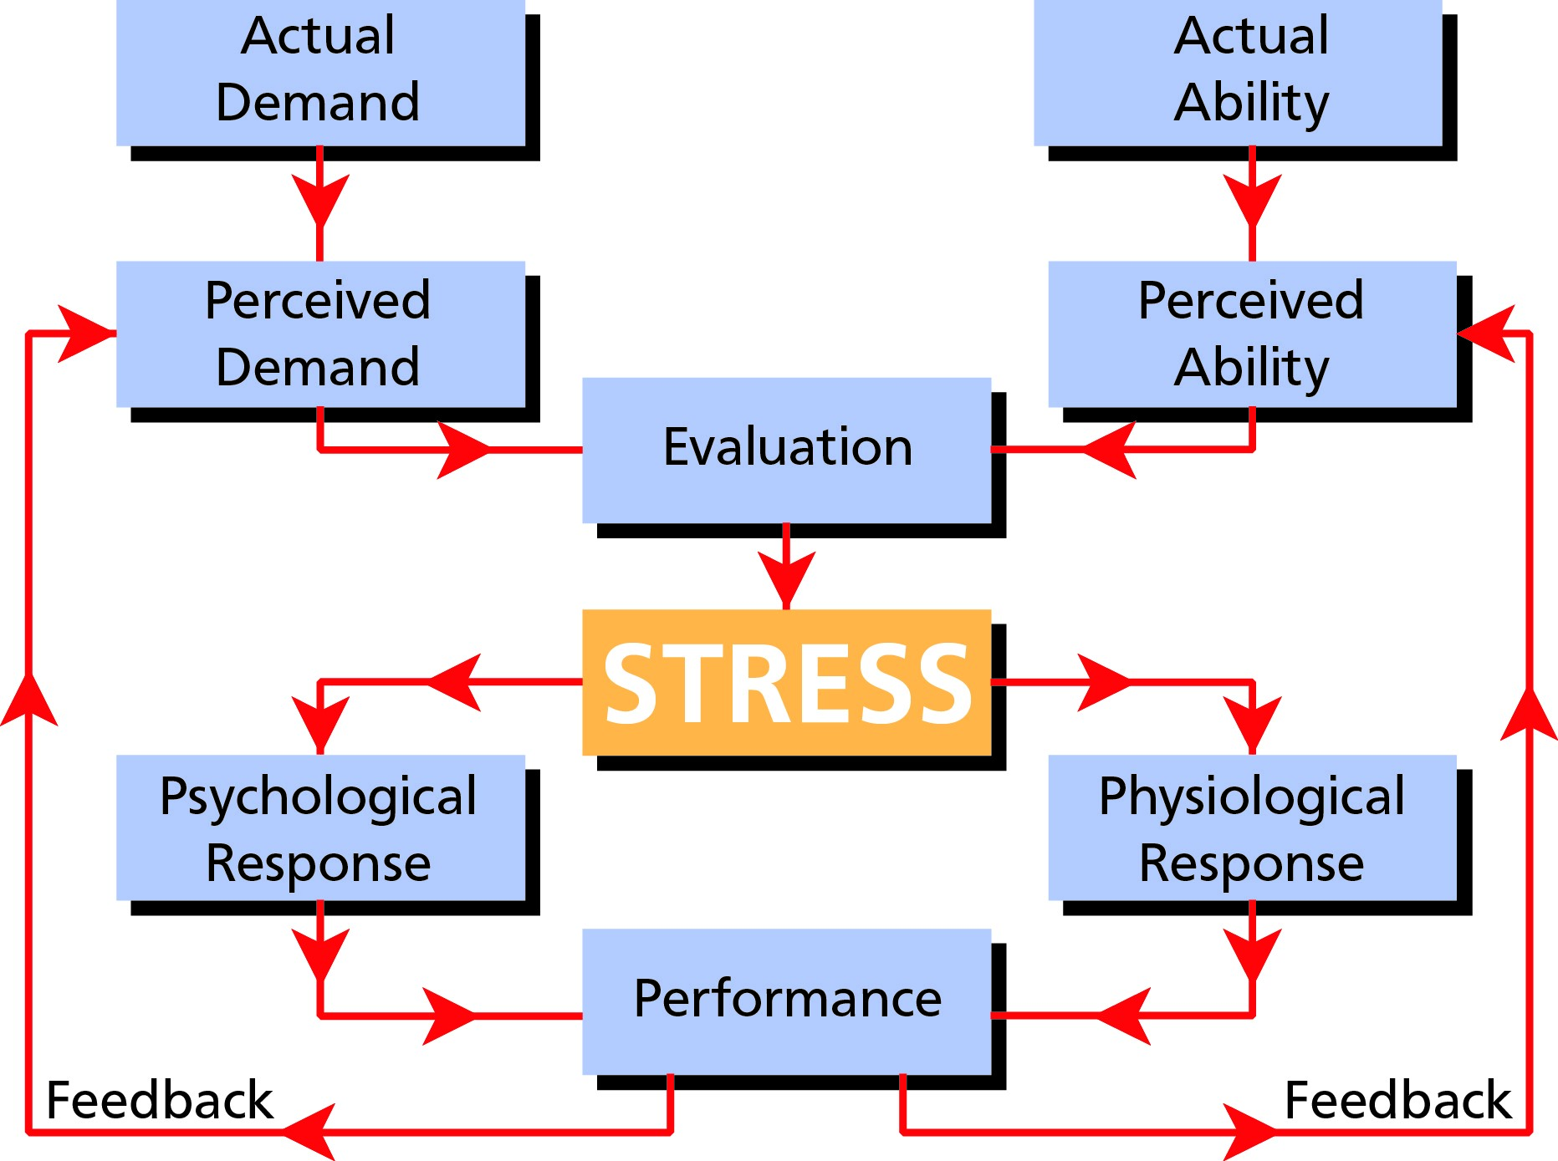

From *Figure 7.1* it will be appreciated that the feedback mechanism is of great importance in determining the amount of stress experienced on subsequent performances of the task. Successful completion of a perceived difficult task will both reduce the perceived demand and increase the perceived ability thus changing the original evaluation and reducing the stress and vice versa.

One of the features of stress is that an event which causes high stress in one individual may not have the same effect on another. It is also a fact that something which is stressful for an individual on one occasion may not be stressful at another time. **Stress is subjective.**

### Arousal and Performance

Arousal can be defined as “the measure of the human being’s readiness to respond”. The relationship between arousal and performance is shown in *Figure 7.2.*

At **low arousal** levels, such as just after waking or during extreme fatigue, the attentional mechanism is not very active, processing of sensory information is slow and the nervous system is not fully functioning. The individual will have a slow environmental scan and may miss information. Thus performance is low.

At the **optimal arousal level** we are at our most efficient - we have enough demands to keep our attention and the capability to deal with complex tasks.

At **high arousal** levels our performance starts to deteriorate, errors are made and information may be missed. We will suffer from a narrowing of attention as we tend to focus on a limited source of data. At very high arousal levels we experience overload as we reach a limit of processing capacity and/or our ability to complete all the tasks. This funnels our attention to events which we perceive as being relevant to the perceived primary task. Thus information may be missed from important, but more peripheral and non-attended sources.

At these high levels the attention mechanism can reject vital information solely due to overload.

**Stress**

**7**

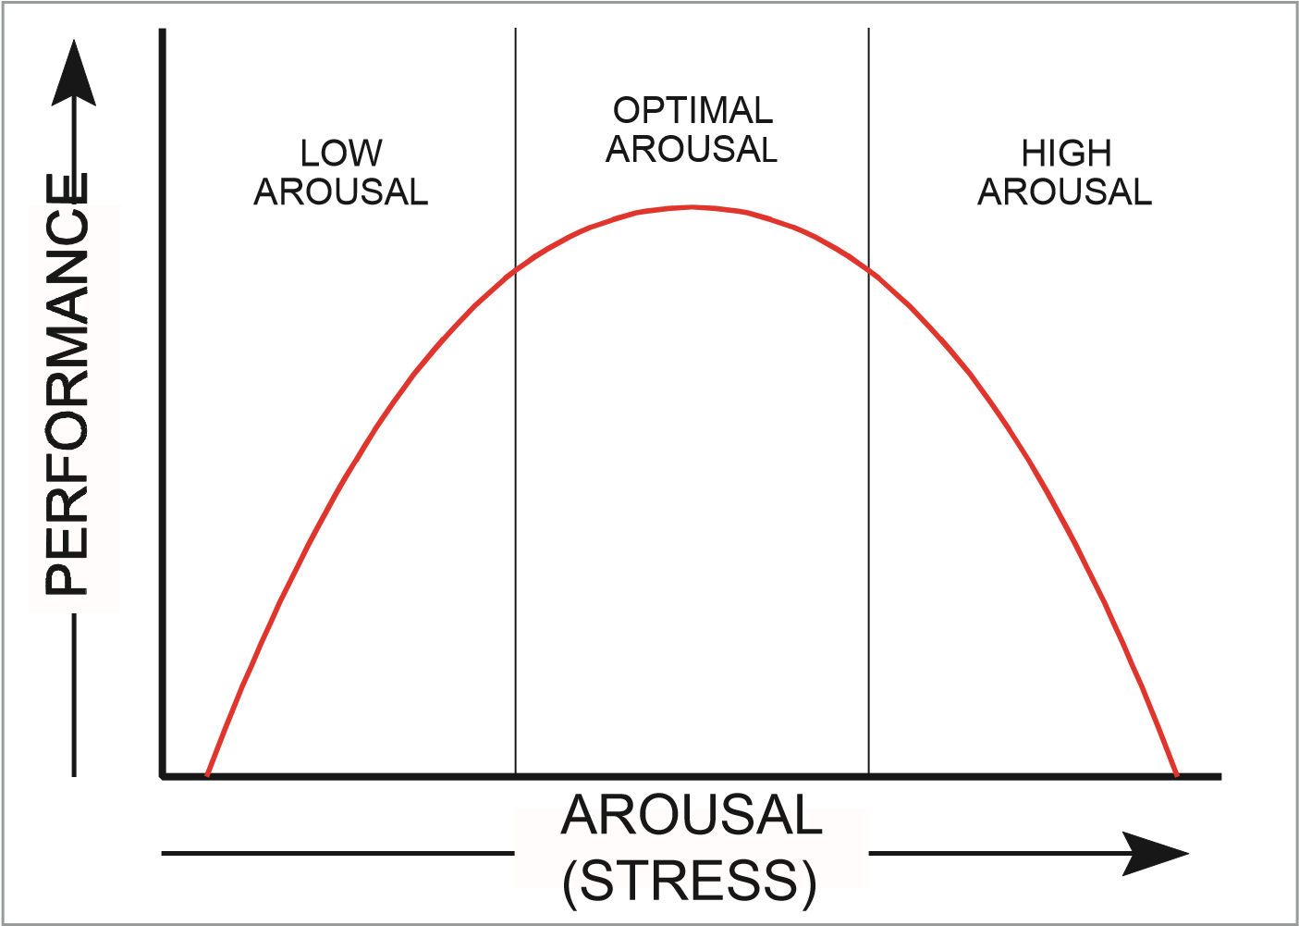

*Figure 7.2 The relationship between arousal and performance (Yerkes Dodson)*

### Stress Reaction and the General Adaption Syndrome (GAS)

The General Adaptation Syndrome **(GAS)** is the term used to describe the mechanism by which the individual reacts to an outside **real, perceived or anticipated threat.**

#### The ANS and the GAS Trigger

The syndrome is triggered by the arousal mechanism which operates through the **Autonomic Nervous System (ANS).** As has been discussed, this controls many of the body’s essential functions: respiration, circulation, digestion, etc. over which we have normally no conscious control. The state of homeostasis is maintained by this system. The ANS is divided into two branches:

* The Sympathetic branch.
* The Parasympathetic branch.

These control systems are neurohormonal in their makeup and are highly self-regulated under normal circumstances.

#### Sympathetic Branch

This provides the body with the resources to cope with a new and sudden source of stress, known as the **FIGHT OR FLIGHT RESPONSE** and its purpose is to prepare the body and mind for immediate physical activity. ***Parasympathetic Branch***

This prolongs the body’s mobilisation, to give it time to find a solution to the stressful situation, and restores the body to normal functioning when the perceived danger has passed.

#### The Three Phases of the General Adaption Syndrome

* Alarm reaction.
* Resistance.
* Exhaustion.

#### Phase 1 - Alarm Reaction

In this, the **alarm** phase, the brain will start a reaction - depending on past experience - to the stimulus. The brain will adapt and colour (pleasure or displeasure) the perceived event. The sympathetic branch is triggered to mobilise the body and allow it to react. The suprarenal (adrenal) glands play an important part in the process as they secrete the stress hormone - **adrenaline.**

This causes a massive release of sugar reserves from the liver and also brings about the following bodily reactions:

* The pupils of the eye dilate.
* The flow of saliva is inhibited.

**7**

**Stress**

* The heart rate increases.
* The rate and depth of breathing increases.
* The bronchi dilate to allow a greater volume of air (oxygen) to the alveoli.
* Peristalsis (the movement of food along the digestive system) is inhibited.
* Bladder contraction is inhibited.
* Blood pressure increases.
* Blood flow to the muscles increases.
* Muscles are tensed.
* The senses are sharpened.

Adrenaline causes all of the above to increase the body’s resources by increasing the energy available. This initial defence mechanism, common to all animals, is relatively primitive - it allows one to react physically and has only indirect effects on the brain. These are:

* Acceleration of the activities of the brain.
* Improved quality of immediate decisions.
* A speeding up of the decision-making process.
* Memory improvement.
* Improved alertness.

#### Phase 2 - Resistance

This is when the parasympathetic system takes over and attempts to prolong the mobilization of the body’s resources to give time to find a solution. A different stress hormone cortisol (cortisone) is released which assists the body to quickly convert fats to sugar to maintain the supply of energy to the muscles.

This hormone also acts on the brain to improve the memory of stress situations, which is why we remember these events particularly intensely. If, however, an individual is exposed to stress for too long, his/her energy resources become depleted.

#### Phase 3 - Exhaustion

Occurs over a variable period and will normally affect only specific parts of the body. With rest, this exhaustion stage is temporary but, if allowed to continue without respite, it can result in death as the defence mechanism completely shuts down.

The stress hormones, adrenaline and cortisol generate waste matter which must be eliminated. This is not an easy process and some secondary effects may occur. If the stress situation is coped with successfully or the stressors are removed, the body will gradually return to its normal (homeostatic) state.

It is of note that stress may be “good” or “bad” and that most stressors increase the arousal level.

#### The Three Reactions of the General Adaption Syndrome

* **Psychological Reaction:** where the brain registers fear, alarm or crisis.
* **Psychosomatic Reaction:** during which the brain triggers the release of hormones, adrenaline and sugars into the blood.
* **Somatic Reaction:** the responses of the various organs of the body to the hormonal and chemical releases.

### Stress Factors (Stressors)

**Stress**

**7**

The figure below illustrates, in general terms, some of the possible stress factors (stressors) to which we may be exposed.

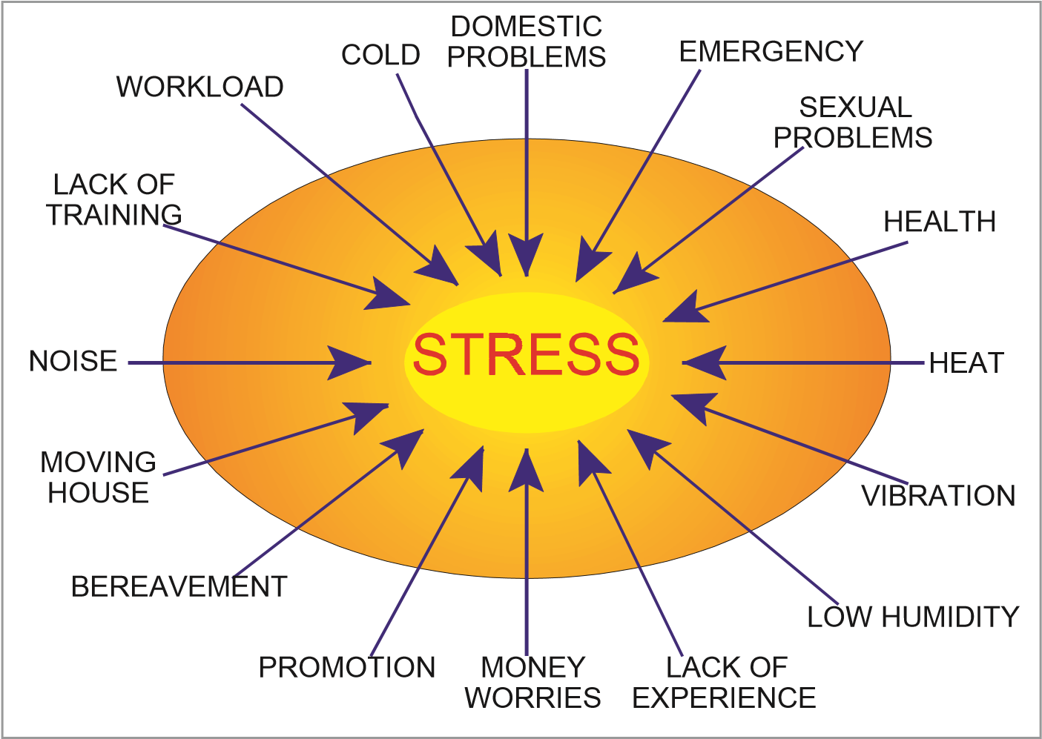

*Figure 7.3 Possible stressors*

#### Categories of Stress Factors

The stressors above can be broadly subdivided into:

* Physiological.
* Cognitive.
* Non-professional.
* Imaginary.
* Organizational.

### Physiological Stress Factors

This category can be broken down into two parts:

* External physiological factors (noise, temperature, vibrations etc.), sometimes known as **environmental stress.**
* Internal physiological factors (hunger, fatigue, lack of sleep etc.).

**7**

**Stress**

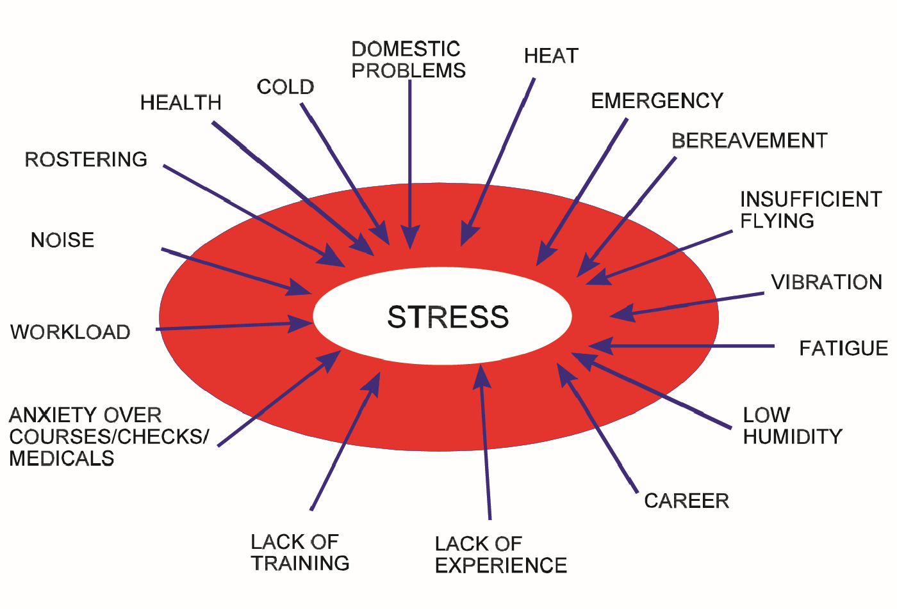

*Figure 7.4 Some flight deck stress factors*

### External Physiological Factors

Discussion will be limited to those stressors associated with aviation.

#### Flight Deck External Physiological Factors

There are a number of possible physical sources of stress; heat, vibration, noise etc. As we have seen, the effects of stress are cumulative and the negative consequences of one source are likely to lower an individual’s resistance to other forms of stress.

#### Heat and Cold

A comfortable temperature for most people in normal clothing is around 20°C.

Above 30°C, heart rate, blood pressure and sweating increase.

Below 15°C the individual becomes uncomfortable and may lose feeling and some control in the hands, especially for fine muscle movement.

The body’s reaction to extreme heat is discussed later in this chapter.

#### Noise

When bored or fatigued, some noise can raise arousal levels and increase performance.

Excessive noise (above about 90 dB) will disrupt performance and cause:

* Disrupted concentration.
* Degradation of information being received in the working memory, leading to an increase in workload.
* An increased number of crew errors.

**In designing aircraft warnings for system failures, care must be taken to ensure that the aural warnings should attract attention but not startle the crew.**

#### Vibration

Vibration may affect the whole body, or specific parts thereof. Any vibration will cause fatigue and can affect both visual and motor performance, leading to uncomfortable symptoms.

The frequency of the vibration will determine which parts are affected and the magnitude of the vibration will determine the severity of the symptoms.

**Stress**

**7**

|  |  |
| --- | --- |
| **Frequency** | **Effects/Symptoms** |
| 1 to 4 Hz | Interferes with breathing. |
| 4 to 10 Hz | Chest and abdominal pains. |
| 8 to 12 Hz | Backache. |
| 10 to 20 Hz | Headache, eyestrain, pains in the throat, speech difficulties and muscular tension plus degradation of visual acuity. |

**Resonances of 30 - 40 Hz** applied to the whole body will interfere with the human responses. If applied to the head, although no physical damage is done to the eye, there is a possibility that visual acuity may be degraded.

**Resonance of the skull** itself occurs at a frequency of approximately **1 - 4 Hz**. This may also affect vision.

Crew seats with anti-vibration mountings help to reduce the levels.

Helicopters can vibrate in all three axes at frequencies related mainly to rotor, gearbox and engine speeds. Helicopter pilots will, therefore, be particularly susceptible to this stress factor.

#### Low Humidity

The air conditioning system of a modern aircraft draws air from outside the aircraft via the engine’s compressor. At airline operating altitudes the temperature may be as low as -30°C to -55°C. At these temperatures the air is very dry, with a relative humidity as low as 5%. For comfort man requires a relative humidity of 40% to 60%. At low humidity the individual becomes uncomfortable due to drying out of the mucous membranes of the nose and throat. Eyes become sore as the tears evaporate rapidly and the tear ducts dry. Water vapour is added to the cabin environment during respiration, but as the air is continually replaced this will have a limited effect in increasing the cabin humidity. It would be possible to add water to the cabin air but the weight penalty of extra water to be carried is not considered commercially viable. It is not advisable to take on a lot of extra fluids in these circumstances but drink only enough to maintain comfort.

***Note:*** *Humidity in the cockpit typically varies between 5% and 15%. Thus flight crew should drink sufficient fluids in flight to avoid dehydration. During flight, the relative humidity in the cabin is similar to a dry summer climate or to being indoors in the wintertime.*

*Caffeine and alcoholic beverages actually contribute to dehydration.*

*Dry air may cause irritation of the eyes especially if contact lenses are worn and these may have to be removed.*

*Dry air can also aggravate allergies or asthma.*

*The humidity control system within some aircraft may alleviate this problem.*

In general, human performance is poor in an environment which is humid, regardless of the ambient temperature. Surroundings which are both dry and warm are most conducive to high performance.

**7**

**Stress**

#### Extreme Temperature Stress Factors

The human body is extremely sensitive to heat and cold and functions efficiently only over a remarkably small temperature range. The normal oral temperature is considered to be between 36.1°C (97°F) and 37.2° (99°F). Physical and mental performance starts to become significantly impaired at an internal body temperature of about **38°C**. Apart from the skin and fat, which both act as insulators, the body has mechanisms, controlled by the ANS, which endeavour to cope with the change of body temperature and maintain equilibrium (sweating and shivering for example). When the body, however, is exposed to extreme temperatures with which these internal homeostatic mechanisms cannot cope, it reacts violently.

#### Extreme Heat Stress

Once the blood temperature rises to approximately 41°C (106°F), the self-regulatory systems of the body can no longer cope and the effects of extreme heat are:

* Excessive sweating leading to fast depletion of body fluids and electrolytes.
* This dehydration leads to a further rise in body temperature, thus exacerbating the situation. Typical symptoms are: muscle cramps, giddiness, and fatigue.
* Rapid increase of the heart rate and an associated need for more oxygen.
* Thirst.
* Cell damage - especially within the brain.
* Heat stroke.
* Coma.
* **The body loses water through the skin, lungs and kidneys**.

Should the blood temperature rise to approximately 43°C (110°F), death will result.

***Note:*** *Generally speaking the mind and body need an average of 2 weeks to acclimatise to a hot and humid environment.* ***Extreme Cold Stress***

If the core temperature drops to approximately 35°C shivering declines and eventually ceases.

The effects of extreme cold are:

* Uncontrollable shivering and an associated need for more oxygen. Around 34.5°C, the shivering that will have started earlier will tend to cease.
* Cell damage - especially of the brain.
* Sleepiness associated with a feeling of contentment or apathy.
* Circulatory impairment and degradation of the sensory nerves.

**Stress**

**7**

* Severe damage to the skin and tissues (frostbite).
* Coma.
* Death.

It is important to stress that the effects of exposure to extreme temperatures are not restricted to the more dramatic conditions described above. Smaller temperature variations within these limits can have a detrimental effect on a person’s ability to perform a task.

### Internal Physiological Factors

The most important of these factors are:

* Hunger.
* Thirst.
* Fatigue.
* Lack of sleep.
* Pain.

With the exception of pain, these factors are normally within the control of aircrew. It is of fundamental importance that crews ensure they never start a period of duty with any of these internal physiological stressors.

#### The Brain’s Ability to Adapt to Physiological Stressors

Repeated exposure to moderate levels of stress from the environment will cause the body to adapt to the stress in order to reduce its impact. For example if an individual lives close to a busy airport the sounds may not be noticed after a time, whereas a visitor might well comment on the noise levels. This ability is limited and varies from person to person.

### Cognitive Stress Factors/Stressors

These differ from physiological stressors since they depend on the operator’s professional knowledge, experience and skill.

They can occur in the cockpit under the following conditions:

* When the situation facing the pilot is unexpected and no procedure exists to resolve it.
* When the solution to the unexpected problem is realized but the pilot has insufficient time, or is unable to apply the solution. This can occur when the pilot is “overloaded”.
* When the solution is applied but the results are not as expected and the problem remains unsolved.

***Level of Cognitive Stress*** This will depend upon:

* The individual’s inborn and learnt characteristics. A pilot may be easily stressed in such a situation either because of his personal character traits and sensitivity to stress or the realisation that he/she possess insufficient knowledge to solve the new problem.

**7**

**Stress**

* The time available to solve the problem. In a dynamic situation, **a lack of time is, in itself, an additional source of stress** and will often lead to risk taking.

### Non-professional Personal Factors/Stressors

In our modern, complex lives we are subjected to a plethora of life stresses and often find that we are unable to ‘switch off’ so that, inevitably, we carry these stresses from home to the workplace and vice versa.

#### Bereavement

The loss of a spouse, partner or child has been found to lead to higher levels of stress than any other event. Some airlines will ensure that a pilot suffering such a loss is removed from flying duties for a time as they are aware that the pilot’s stress level will be so high that his/her performance and reactions could be severely degraded.

#### Domestic Stress

Stress at home can affect the pilot at work and equally stress at work can affect the pilot’s home life. Pilots suffering from domestic stress should be aware that this can affect their concentration and performance when at the controls of an aircraft. Aircrew must try and use all available facilities to ensure that they are not being affected by this form of stress.

#### Non-professional Personal Factors/Stressor Table

Evidence indicates there is a relationship between stress and health and some evidence for a correlation between non-professional stress and the risk of an accident.

Although the stress level caused by a particular stressor will differ from one individual to another, it is possible to make a general assessment of stress levels.

The table below gives a suggested weighting for various incidents in an average westerner’s life. When applying such weighting to other cultures there will be some marked differences. Aircrew must remain sensitive to these **cultural differences.**

As stress is cumulative, all of the events experienced should be added to give an indication of the total stress acting on any one person.

### Stress Table

**Stress**

**7**

|  |  |  |
| --- | --- | --- |
| Death of a spouse, partner, or child | | 100 |
| Divorce |  | 73 |
| Marital separation |  | 65 |
| Death of a close family member |  | 63 |
| Personal injury or illness |  | 53 |
| Marriage |  | 50 |
| Loss of job |  | 47 |
| Retirement |  | 45 |
| Pregnancy |  | 40 |
| Sexual problems |  | 40 |
| Birth |  | 39 |
| Change of financial situation |  | 38 |
| Son or daughter leaving home |  | 29 |
| Change of eating habits |  | 25 |
| Change of residence |  | 20 |
| Taking on a bank loan or HP debt |  | 17 |
| Vacations |  | 13 |
| Minor violations of the law |  | 11 |

This list is not a complete catalogue of all events which may cause stress and the weighting given will vary according to the personal background and cultural system in which the individual was raised. **As a guide only**, to indicate your own stress level, add together the marks for each event occurring in your life in the last **six months.**

**Scoring:**

|  |  |
| --- | --- |
| Below 60 marks: | a life unusually free of stress. |
| 60 - 80 marks: | normal amount of stress. |
| 80 - 100 marks: | stress in life is rather high. |
| 100+ marks: | under serious amount of stress. |

### Imaginary Stress (Anxiety)

Both human beings and animals can suffer from stress without there being a stressor present. It is the **anxiety** that a future risk exists together with the feeling of an inability to cope or lack of self-confidence. An example of this natural response is when a dog is taken to the vet, having experienced pain during a previous visit. The animal shows signs of anxiety even though no stressor exists. Some of us have similar feelings about a visit to the dentist. Inevitably anxiety will affect our performance.

Unpleasant events in life may be apparently completely forgotten but the anxiety associated with them can be brought to the surface by one of the senses (a scene, noise, smell) and distort perception. This anxious apprehension can be strong enough so as to trigger the GAS response.

### Organizational Stress *The Organization*

In the aviation industry today, financial pressures on companies can cause pilots to work under considerable pressure. Small unserviceabilities may be carried, duty hours stretched to the limit, checks rushed to make a slot time, and there are many other examples. As an extreme example of stress generated by poor management, the president of an airline which was in financial difficulties, instructed pilots to fly below the legal minima in bad weather. They were also instructed to ignore maximum take-off weights and reduce minimum fuel reserves. As a direct result of these decisions the airline suffered three serious accidents in a short period.

If management continually exerts pressure on its employees to operate in ways that are more consistent with short-term monetary concerns than with safety and good practice, then the whole company will develop ‘organizational stress’.

**7**

**Stress**

The symptoms will manifest themselves as:

* Poor industrial relations.
* Absenteeism.
* An increased accident/incident rate.

#### Aircrew and the Organization

Work stress may be caused by a sudden high work load such as an emergency. The stress experienced will be increased if the pilot is unsure how to react or feels inadequately trained for the specific situation. Realistic simulator training is essential to reduce the impact of any emergency.

Stress may also arise from a long-term high work load. Airlines operate in a competitive world and must make maximum use of staff and equipment. An aircraft and crew standing idle are not producing revenue. Even with the advances of modern ATC there will be times when airspace and airports become overcrowded. Add to this technical delays and additional stress is created.

Rostering of crews can also lead to stress problems. A particular pilot may have to perform an excessive number of night flights and suffer undue disruption to his home life. This, in turn, leads to further cumulative stress.

Poor relationships and/or communications with management and colleagues, both on and off the flight deck, leads to stress. Some cockpit voice recordings, listened to after accidents, have detected crew members arguing on the flight deck just prior to the accident.

#### Organizational Stress Sources in Pilots

A survey of commercial pilots showed some of the main sources of stress to be:

* A lack of control or disruption of events in their lives.
* Scheduling and rostering.
* Insufficient hands-on flying.
* Anxiety over courses/checks.
* Home to work interface.
* Career prospects and achievements.
* Lack of responsibility and decision making.
* Fatigue and flying patterns.

Of significance in the above list is insufficient flying. The modern airliner is most efficiently and economically operated by automatic control, indeed it is the policy of many airlines that the flight management system should operate the aircraft for more than 96% of its flight time. Whilst modern systems and their back-ups are undoubtedly extremely reliable, many pilots are worried that the systems may fail and are unsure of their ability to manage the aircraft themselves. A pilot flying the maximum allowable duty hours may have very little actual handson time per month.

### Stress Effects

Stress has effects on the body, the mind, and the health and thus the performance of the individual. The short-term effects of a sudden source of stress will be caused by the ‘fight or flight’ response.

#### Performance

**Stress**

**7**

*Figure 7.5* shows the relationship between stress and performance. Like the arousal/ performance graph it is an inverted U curve, however, there is a **“break point”.**

When there is little or no stress, there is a drop in vigilance and performance is poor. As stress increases performance increases up to the optimum - the “break point”- after which, if stress continues to rise, performance is degraded.

BREAKPOINT

PERFORMANCE

STRESS LEVEL

NO

STRESS

MEDIUM

STRESS

MOTIVATION

INTENSE

STRESS

*Figure 7.5 Comparison of performance and stress levels*

#### Health Effects

The long-term effects of **chronic stress** damage a person’s health. The effects are usually seen earliest in the gastrointestinal system, and symptoms include nausea, indigestion, diarrhoea and, after an extended period of time, ulcers. There is evidence of a connection between stress and coronary heart disease and high blood pressure. Those who suffer stress have a higher than normal risk of getting of asthma, headaches, sleep disorders and neuroses. They also are much more likely to have allergies, skin diseases and tend to suffer more from colds and influenza.

#### Behavioural Effects

When under stress the individual will exhibit restlessness, trembling, or may have a nervous laugh. There will be a tendency to take longer over tasks and there may well be excessive changes in appetite and an increase in smoking or drinking.

Moods swings are also a common symptom of stress. Some individuals become aggressive in the cockpit towards other members of the crew and/or outside agencies (ATC). On the other hand, others submit to the situation with an air of resentfulness and frustration. Either way there is a loss of flexibility. Alternatively, there are some individuals who react to stress by a tendency to rush into decisions. Fewer parameters are taken into account and, therefore, **the risk of errors is increased. *Cognitive Effects***

Stress has a major effect on the thought process with forgetfulness being an early symptom. The ability to think and to concentrate is reduced and there is an inability to determine priorities or make decisions. Correct actions are forgotten and procedures learnt in the past are substituted. This is known as regression.

**7**

**Stress**

Fixation or “**mental block**,” is another symptom, where it becomes impossible to review what has been done and consider other solutions.

A further cognitive effect is **confirmation bias**, which is discussed further in Chapter 8. This is a compulsive and repeated search for information to confirm a decision reached.

Stress causes the mind to limit its attention to only those factors it feels it can cope with and to ignore additional inputs which may be vital in assessing a situation accurately. This **loss of situational awareness** and “not being able to see the wood for the trees” has been the root cause of many accidents.

In one case, when debriefed after escaping successfully from a burning aircraft, passengers reported how quiet everything around them seemed to be. It was stress that caused them to concentrate only on their escape, the screams around them were never registered.

It is commonly accepted that auditory information is the first to be discarded under extreme stress.

### Coping with Stress *Stress Awareness*

In order to cope with stress it is fundamental that there is an awareness that the problem exists. An individual who recognizes the fact that he/she is suffering from stress is a long way along the road to identifying the source(s) and overcoming the problem. Once recognized, the object is to change our attitudes or our environment in order to re-establish harmony between the two.

Among any population there is a wide variation in how stress is perceived. At one extreme, individuals suppress knowledge of problems and thereby appear not to perceive them or require stress coping strategies. At the other extreme are those who are highly sensitive to problems and will anticipate difficulties not perceived by others and employ coping strategies to avoid the stress experience.

Coping strategies may be classified into three categories:

* Action Coping.
* Cognitive Coping.
* Symptom Directed Coping.

#### Action Coping

In **action coping** the individual attempts to reduce stress by taking some action. He reduces the level of demand by either removing the problem or changes the situation so that it becomes less demanding. For example a pilot asked to fly in marginal conditions could refuse, thus removing the immediate stressor. However, this action could lead to another stressor - loss of employment.

The demand could be changed, however, by delaying take-off for a few hours when the weather is forecast to improve. In this case, reducing the perceived demand of the original task, without substituting another stressor. The individual may also hand over some tasks, either to other crew members, or to Air Traffic Control by asking for, as an example, assistance in navigation.

The individual may remove himself from the stress situation by changing his job, or in the case of domestic stress, by divorce. These methods may, however, only substitute one source of stress for another. Clearly in many cases it is impossible to undertake this kind of solution.

**Stress**

**7**

#### Cognitive Coping

As action coping cannot change some situations, **cognitive coping** involves reducing the impact of stress on the individual. Our brain can employ ‘defence mechanisms’ which operate outside our conscious awareness; a system of repression or denial to prevent the conscious brain from even becoming aware of the stressor.

Other strategies involve rationalization or detachment which may change the perceived magnitude of the problem. “Pretend it’s a simulator detail the same as the one you did last week” will enable the conscious mind to perceive the problem as having a solution.

#### Symptom Directed Coping

Some of the symptoms of stress may be relieved by the use of drugs. In this context the drugs may be relatively simple such as coffee or tea. Other cases may be eased by the use of alcohol or tobacco.

It must be emphasized that only the symptoms are treated by this form of coping and that the stressor(s) will remain until addressed separately.

### Coping with Stress on the Flight Deck

Coping is the process whereby the individual either adjusts to the perceived demand of the situation or changes the situation itself. Some coping changes appear to be carried out unconsciously; it is only if they are unsuccessful that we consciously take note of the stressor. To reduce the effect of stress in flight involves mainly psychological mechanisms and includes behavioural patterns which can be learned.

**Individually** one must learn and acquire experience to develop automatic responses which cost little in energy and strongly resist stress:

* A thoroughly professional approach to training will increase the range of responses available to the individual and will reduce the chances of meeting unknown situations. Hence the emphasis on regular simulator flights when any emergency can be practised in a safe environment.
* One should learn from the past, including the experience of others.
* Thorough preflight briefing and preparation will allow the individual to anticipate events. The pilot must be prepared for all incidents which could, plausibly, arise during the flight.

**Crew Resource Management (CRM)** will teach techniques for sharing and allocating tasks to prevent any one individual becoming overloaded and will highlight the effective use of all members’ knowledge to increase the range of possible responses. It should improve everyone’s awareness of the situation, and, by combined efforts, allow for the creation of new ideas.

A good atmosphere on the flight deck is a great help in a stressful situation and humour can be an effective antidote to stress.

There are five major guidelines to prevent stress affecting safety:

* Keep it simple and basic - fly the aircraft.
* Accept the situation - do not attempt to conceal the facts or danger.
* Use all crew resources (group support).

**7**

**Stress**

* The captain (unless incapacitated) must make the decisions and control the situation.
* Never give up: there is always a suitable response.

### Stress Management Away from the Flight Deck

The success of any stress management programme will be determined by the individual’s **willingness to recognize** the source of his/her stress and the determination to **do something about it**. A good stress management programme should be both:

* Preventative (finding ways to keep stress levels to a minimum)

and

* Curative (providing ways of reducing existing levels of stress)

Helpful techniques can include:

* **Health and Fitness Programmes**

Regular physical exercise reduces tension and anxiety and makes it much easier to withstand fatigue. Physical fitness also improves cognitive function and improves reaction times.

* **Relaxation Techniques**

Meditation, self-hypnosis, yoga, and biofeedback can all help to reduce tension by mental and physical (muscle) relaxation or control of heart rate and blood pressure.

* **Religious Practice**

For many people some form of religious practice will help to cope with stress, particularly if it is a major life event such as bereavement, accident or chronic illness. There are, however, some possible dangers if the particular belief is of a fatalistic nature. “It is in the hands of God” may prevent some individuals from trying to resolve their own problems.

* **Counselling Techniques**

Many individuals will benefit not only from professional counselling but also from just talking to their friends or colleagues. It will help to reduce feelings of inadequacy if they know that others find a particular task difficult.

The basic principle behind counselling is that, since stress is caused by an individual’s perception of a situation, the stress will be reduced if the individual can be made to change the way he/ she perceives or reacts to the situation by changing or modifying his/her beliefs or assumptions about the event (cognitive coping). Counselling may also assist an individual to see that some behavioural change may be necessary (action coping), and help bring about that change.

An individual, such as a pilot, who must demonstrate authority and control in his work may show some reluctance to ‘admit’ that he is experiencing problems with stress. He may fear that the admission of being under stress might be interpreted as weakness or a lack of competence. All pilots should be aware that stress can influence performance on the flight deck, particularly in an emergency, and take positive steps to deal with the stress if they feel they are affected by it.

***Note:*** *Evidence that people under stress often smoke more, overeat or increase alcohol/caffeine consumption has led to the theory that apparent self-abusive behaviours may actually be forms of stress management.*

**Stress**

**7**

### Stress Summary

Stress is simply a fact of life. We all require some stress to activate our nervous system, to stimulate us and allow us to adapt. It is only when the stress is high or sudden that it can become destructive and may exceed our abilities to adapt. Stress encountered in our daily lives is cumulative and depletes our reserves. However, a lack of stimuli may be just as bad since this encourages anxiety.

Although it is extremely difficult to eliminate stress, we can, through training and other techniques, increase our resistance to it. Stress coping can be either **short-term** (action coping) or **long-term Stress Management** (a change of lifestyle or counselling) depending on the situation. The first step is, however, to recognize and admit to oneself that the condition exists.

Although the stress mechanism is mainly physiological and triggered as a defence mechanism to help us survive, coping strategies to deal with stress are mainly psychological.

To increase stress tolerance the chief weapons in your armoury are:

* **Experience** (fewer unexpected situations).
* **Learning** (reflex responses are performed correctly, even under stress).
* **CRM** (using all resources available).

### *Questions*

#### Questions

1. **Having successfully overcome a stressful situation once, how will the person react if placed in the same or similar situation a second time?**
   1. There will be little difference
   2. He/she will know what is ahead and be already in a stressful condition thus stress will increase
   3. He/she will feel more confident and therefore stress will reduce
   4. It will depend on the individual
2. **How is performance affected by over and under arousal?**
   1. It is improved
   2. There is little difference
   3. It is degraded
   4. It will depend on the individual
3. **What is the purpose of the “sympathetic” nervous system?**
   1. To control the emotional response under stressful conditions
   2. To control the effects of adrenalin
   3. To return the body to homeostasis after the “fight or flee” syndrome
   4. To prepare the body for “fight or flight”

**7**

**Questions**

1. **What is the purpose of the “parasympathetic” nervous system?**
   1. To prolong the body’s mobilisation and return the body to normal after the

“fight or flight” syndrome

* 1. To prepare the body for “fight or flee”
  2. To direct the adrenalin to the correct organs of the body
  3. To return the body to normal after an emotional response under stressful conditions

1. **What part of the body is affected with the vibration in the 4 to 10 Hz frequency range?**
   1. The brain plus there will be a headache
   2. The chest plus there will be an abdominal pain
   3. The respiration plus pains in the chest
   4. The pulse rate
2. **Which graph shows the relationship between arousal and performance?**
   1. A U-shaped graph
   2. An inverted U-shaped graph
   3. A straight line graph
   4. An M-shaped graph
3. **The three phases of the GAS Syndrome are:**
   1. alarm, fear, resistance
   2. alarm, resistance, exhaustion
   3. alarm, fear, exhaustion
   4. fear, resistance, exhaustion

### *Questions*

1. **Which life stressor is said to cause the most stress?**
   1. Home/work interface
   2. Divorce
   3. Death of a family member
   4. Death of a spouse, partner or child
2. **During the resistance phase of the GAS Syndrome ............... is released to assist the body to convert fats to sugar.**
   1. Adrenaline
   2. Glucose
   3. White blood cells
   4. Cortisol
3. **Broadly speaking the GAS Syndrome consists of three categories of reactions. These are:**
   1. somatic, psychosomatic, physiological
   2. physiological, psychosomatic, psychological
   3. somatic, physiological, psychological
   4. somatic, psychosomatic, psychological

**Questions**

**7**

1. **Stress factors are:**
   1. non-cumulative
   2. cumulative
   3. stress reactions
   4. stress coactions
2. **A comfortable temperature for most people in normal clothing is:**
   1. 25°C
   2. 15°C
   3. 20°C
   4. 30°C
3. **The autonomic nervous system comprises:**
   1. sympathetic, neo-sympathetic and parasympathetic systems
   2. sympathetic and parasympathetic systems
   3. neo-sympathetic and parasympathetic systems
   4. none of the above
4. **Define three methods of coping with stress:**
   1. action coping, forced coping, symptom directed coping
   2. action coping, cognitive coping, symptom directed coping
   3. slip coping, cognitive coping, symptom directed coping
   4. slip coping, action coping, symptom directed coping

### *Questions*

1. **Which of the following statements, with regard to the five major guidelines to prevent stress in the cockpit from affecting safety, are correct:**
   1. planned sleep patterns and use all crew resources
   2. planned sleep patterns and keep it simple
   3. use all crew resources and keep a good flight deck atmosphere
   4. never give up - there is always a suitable response
2. **The best strategies to increase stress tolerance are:**
   1. planning, experience and self-control (fewer unexpected situations)
   2. learning, experience and anticipation
   3. learning, experience and CRM
   4. planning, experience and CRM
3. **Once the blood temperature rises above ..............., the homeostatic mechanisms within the body can no longer cope.**
   1. 40°C
   2. 35°C

**7**

**Questions**

* 1. 50°C
  2. 41°C

1. **A comfortable humidity for most people in normal clothing is:**
   1. 40% - 50%
   2. 30% - 40%
   3. 20% - 50%
   4. 40% - 60%
2. **In a dynamic situation, an additional stress factor (stressor) can be:**
   1. a lack of time
   2. homeostasis
   3. a moderate amount of noise
   4. the operation of the parasympathetic system
3. **The “break point” is:**
   1. when the pilot “overloads” due to stress
   2. the point in time when the pilot is unable to think positively
   3. the point in time when the pilot is unable to think rationally
   4. the point of optimum performance after which, if stress continues, performance will be degraded

***Questions***

**Questions**

**7**

### *Answers*

**7**

**Answers**

#### Answers

|  |  |  |  |  |  |  |  |  |  |  |  |
| --- | --- | --- | --- | --- | --- | --- | --- | --- | --- | --- | --- |
| 1 | 2 | 3 | 4 | 5 | 6 | 7 | 8 | 9 | 10 | 11 | 12 |
| c | c | d | a | b | b | b | d | d | d | b | c |
| 13 | 14 | 15 | 16 | 17 | 18 | 19 | 20 |
| b | b | d | c | d | d | a | d |

Chapter **8**

## Information Processing, Human Error and the Learning Process

Introduction. . . . . . . . . . . . . . . . . . . . . . . . . . . . . . . . . . . . . . . . . . . . .147

Basic Information Processing. . . . . . . . . . . . . . . . . . . . . . . . . . . . . . . . . . . .147

Stimuli . . . . . . . . . . . . . . . . . . . . . . . . . . . . . . . . . . . . . . . . . . . . . . . .149

Receptors and Sensory Memories/Stores . . . . . . . . . . . . . . . . . . . . . . . . . . . . .149

Attention . . . . . . . . . . . . . . . . . . . . . . . . . . . . . . . . . . . . . . . . . . . . . .150

Perception . . . . . . . . . . . . . . . . . . . . . . . . . . . . . . . . . . . . . . . . . . . . . .152

Perceived Mental Models. . . . . . . . . . . . . . . . . . . . . . . . . . . . . . . . . . . . . .152

Three Dimensional Models . . . . . . . . . . . . . . . . . . . . . . . . . . . . . . . . . . . . .153

Short-term Memory (Working Memory) . . . . . . . . . . . . . . . . . . . . . . . . . . . . .153

Long-term Memory . . . . . . . . . . . . . . . . . . . . . . . . . . . . . . . . . . . . . . . . .154

Central Decision Maker and Response Selection . . . . . . . . . . . . . . . . . . . . . . . . .156

Motor Programmes (Skills) . . . . . . . . . . . . . . . . . . . . . . . . . . . . . . . . . . . . .156

Actions - Response and Feedback . . . . . . . . . . . . . . . . . . . . . . . . . . . . . . . . .158

Human Reliability, Errors and Their Generation . . . . . . . . . . . . . . . . . . . . . . . . .159

The Learning Process . . . . . . . . . . . . . . . . . . . . . . . . . . . . . . . . . . . . . . . .161

Mental Schema . . . . . . . . . . . . . . . . . . . . . . . . . . . . . . . . . . . . . . . . . . .162

Questions . . . . . . . . . . . . . . . . . . . . . . . . . . . . . . . . . . . . . . . . . . . . . .163

Answers . . . . . . . . . . . . . . . . . . . . . . . . . . . . . . . . . . . . . . . . . . . . . . .166

**8**

**Information Processing, Human Error and the Learning Process**

### Introduction

We receive information from the world around us through our senses: sight, hearing, touch, smell and taste. When flying an aircraft the pilot must observe and react to events both in the cockpit and in the environment outside the aircraft. The information from our senses must be interpreted in order to make decisions and take actions to ensure the safe path of the aircraft at all times.

In this chapter we will lay out the basic system by which we receive and process information in order to make decisions and recognize where errors in the system may be the cause of accidents. At the end of this chapter the **learning process** is briefly discussed.

### Basic Information Processing

We know that the process of thought and decision making is achieved by electrochemical currents within the brain, but it is not possible to precisely relate each stage of the processes to a particular anatomical structure in the brain. We need to build a functional model of the various stages of our reasoning. These are:

**Information Processing, Human Error and the Learning Process**

**8**

* Detection (information is received).
* Perception.
* Decisions are taken.
* Action (responses are selected and executed).
* Feedback.

This model is of great importance when errors are considered. We can determine if the errors result from a failure of perception, a failure of memory, or in spite of having correctly interpreted the information, we have failed to take the correct action. The functional model also helps in understanding other factors, such as stress, that may influence our performance. The model is based on a series of stages that occur between receiving information and a response being made.

*Figure 8.1*, on the next page, shows a typical functional model. The various sections of the model will be discussed both individually and as part of the full mechanism.

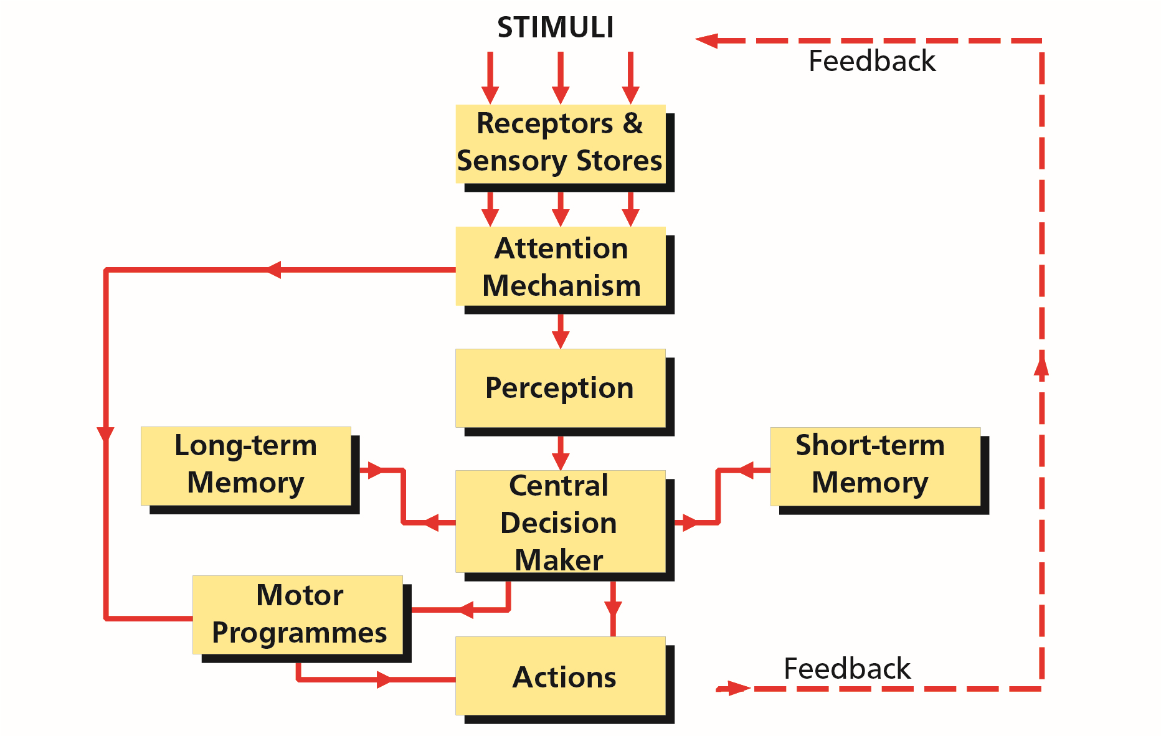

*Figure 8.1 A functional model of information processing*

#### “Bottom-up” and “Top-down” Processing

An important concept of information processing is “bottom-up/top-down” doctrine. Very many mental activities like remembering, perceiving and problem solving involve a combination of information from two sources:

* Incoming information from the outside world (i.e. the input received by the sense organs)

and

* The information already stored in memory (i.e. prior knowledge derived from past experience).

The analysis of the sensory information coming in from the outside is known as **“bottom-up”**or **data-driven processing** because it relies on the data received via the senses.

**8**

**Information Processing, Human Error and the Learning Process**

The sensory information is often incomplete or ambiguous, but the information already stored in the memory in the form of prior knowledge influences our expectations and helps us to interpret the current input. This influence of prior knowledge is known as **“top-down”** or **conceptually-driven processing.**

In practice, the two sorts of processing operate in combination. For example, “bottom-up” processes may yield sensory information about a moving black shape of medium size and having a smooth texture. “Top-down” processes based on already stored knowledge enable this to be identified as a Labrador dog. The “top-down” processes interact with the information provided by the “bottom-up” processes. This is sometimes known as **interactive processing.**

### Stimuli

The senses, sight, hearing, taste, smell and touch provide inputs (stimuli) to our brain. Most stimuli are stored for a brief time after the input has finished. The ability to retain these stimuli for a short time is essential, as when they first arrive we may not have the processing capacity to deal with them.

Stimuli must be of a certain strength for the sensory receptors to pick them up. In other words, a sound must be of sufficient strength to be received or light level strong enough to perceive. This minimum strength is known as the **sensory threshold.**

There are three types of memory:

* Sensory memories (sometimes referred to as ultra short-term memories).
* Short-term (working) memory.
* Long-term Memory.

### Receptors and Sensory Memories/Stores

The key features of the sensory memories/stores are:

* There is a separate memory store for each sensory system.
* The input decays rapidly.

The sensory stores for touch, taste and smell are of little significance in aviation however those of sight and sound have importance and knowledge of these is necessary. Both of these are discussed.

**Information Processing, Human Error and the Learning Process**

**8**

#### Sensory Memory for Sound - The Echoic Memory

The longest lasting sensory store is the **echoic** memory which can last for between **2 and 8 seconds.** The echoic memory retains sounds and, for example, it is possible to recall the chimes of a clock that have struck, when realising you want to know the time, but only after the third or fourth stroke.

In these circumstances echoic memory can be interrogated or ‘replayed’ to enable the strokes to be counted consciously. The echoic memory needs to last long enough for input to be scanned for relevance. If an input is of interest then it is called into the short-term memory.

#### Sensory Memory for Sight - The Iconic Memory

The **iconic** memory is the visual sensory store and only lasts for between **0.5 and 1 second.** 80% of information processed by man enters the visual channel.

#### Sensory Adaption (Habituation)

A special characteristic of all sensory receptors is that they **adapt** either partially or completely to their stimuli after a period of time. That is, when a continuous stimulus is first applied, the receptors respond at a very high impulse rate at first, then progressively less rapidly until finally many of them no longer respond at all. This is why, once you get dressed, you do not continue to feel your clothes against the skin.

The classic example of this when, having moved into a house close to an railway line or airport, the noise of passing trains or departing aircraft can cause extreme stress. However, having lived for a month or so under these conditions, the noise may be hardly sensed - if at all. Sensory Adaption is sometimes referred to as **habituation.**

#### Attention Introduction

Attention is the deliberate devotion of the cognitive resources to a specific item. Man must be alert to be attentive. But being alert is not sufficient guarantee that attention will be paid to the right item at the right time.

#### Choice of Item

Due to the limitations of the central processor, we are generally unable to pay attention to a number of different items at any given time. Although attention can move very quickly from item to item, it can only deal with one at a time and thus the need for the pilot to consciously prioritize.

#### Attention Mechanisms

The reason for the attention mechanisms is because of the two potentially limiting stages in processing information:

* The limit to the number of items held or maintained in **short-term memory** (sometimes known as **working memory**).
* Our channel capacity is limited. We cannot devote conscious thought or ‘attend to’ all the stimuli entering our senses. ***The Cocktail Party Effect***

The limited channel capacity means that there must be a system at an early stage of the whole process to allow us to select those stimuli which will be perceived consciously and used as a basis for our consideration and decisions.

**8**

**Information Processing, Human Error and the Learning Process**

Some stimuli are extremely efficient for getting our attention, for example the cocktail party effect which relates to hearing our own name in a background of many conversations. In aviation this may be hearing our RT callsign among a lot of radio chatter, or detecting a smell of burning on the flight deck. Each will focus our attention in an attempt to get more information.

#### Types of Attention

Attention is the process of directing and focusing psychological resources to enhance perception, performance and mental experience. It has three characteristics:

* improves mental processing.
* requires effort.
* is limited.

There are two types of attention:

* **Selective Attention** in which inputs are sampled continually to decide their relevance to the present task at hand, our names or callsigns being particularly attention getting.
* **Divided Attention** in which our central decision making channel can time-share between a number of tasks. The pilot flying a visual approach will be dividing his attention between looking out to maintain his approach and checking instruments for air speed, height, engines etc. Whereas it would appear that he/she is working on a number of tasks at the same time, in reality, the central processor is spending a fraction of every second on any number of different problems in turn.

Another example of divided attention is Cherry’s experiment (1950). He arranged for two voices, each carrying different information, to be heard by the subject in either ear at the same time. The subject was unable to process information from both ears at the same time and able only to switch from one voice to the other in turn.

#### Lack of Attention

It is important to remember that the mind always pays attention to something - except during sleep. Therefore the major danger for pilots is the **poor management** of attention, that is to say paying attention to the wrong item at any given time.

#### Stress and Attention

As we have seen in Chapter 7, stress can have a significant effect on attention especially during times of low and high arousal. Our limited ability to process information has implications for the level of performance we are able to achieve.

#### Low Arousal

At times, such as in the cruise, our attention can wander with the result that information is either missed or misinterpreted. Generating artificial flight deck work loads is a method of addressing this problem. ***Optimum Arousal***

At this level the central processor is at its most efficient.

#### High Arousal Overload

At times of high arousal, because of the limited channel capacity of the central processor, there is a real danger of attention becoming narrowed so that important information is disregarded. Indeed, if overloaded, the attention mechanism may even reject additional information. This overload can be of two types:

**Information Processing, Human Error and the Learning Process**

**8**

* **Qualitative Overload**

The information is perceived to be beyond our attentional capacity and the task too difficult.

* **Quantitative Overload**

There are just too many responses to be made in the time available.

As we have seen the relationship between workload and performance can be represented as an inverted ‘u’ curve.

#### Symptoms of Overload

As discussed in the previous chapter when considering stress, the symptoms of overload will vary from individual to individual. Among the most common are:

* A sharp degradation of performance.
* Funnelling of attention or focus.
* Regression.
* Mental “blocks”.
* Mood swings.
* Restlessness.
* Trembling.
* Panic.

### Perception

Perception involves the conversion of the sensory information received into a meaningful structure. For example, a pattern of vibrations in the air becomes recognized as a particular message. The **percept** (what we perceive) is not a complete representation of the information in the sensory store but an immediate interpretation of it.

Read the following notice:

Most people on reading the notice will read it incorrectly the first time and perhaps for few more times. The reason in this case is simple. It is the beginning of a well known phrase and, having read the first three lines the reader believes he knows what is coming next and may automatically pass on to the last word to confirm his belief, missing out the extra ‘THE’.

It is true that we can **‘perceive’** only that which we can

**‘conceive’**. It is also true that we perceive only a fraction of *Figure 8.2*the information reaching our senses at any moment. Therein lies the importance of the attention mechanism in our model.

The process of perception is greatly assisted by our ability to form mental and three dimensional visual models. ***Funnelled Perception***

Perception of a situation can differ depending upon the starting point of an observer.

**8**

**Information Processing, Human Error and the Learning Process**

Imagine two men are walking through some woods and they see a family group having a picnic. The first may perceive the overall picture of a family enjoying themselves together in the open air, whereas his companion may first perceive details of the image - the contrast of the colours of the girl’s dress with those of the rug on which she is sitting or, perhaps, the uniqueness of the picnic basket that the family is using.

It is possible, of course, that with time both observers will eventually arrive at the same conclusion; the first narrowing his overall perception to include the details of the scene and the second expanding his perception to include the overall picture. However the initial perception of the two men will be quite different of exactly the same situation.

### Perceived Mental Models

#### Mental Models

We generate a mental model on the basis of **past experience** and **learning,** sometimes referred to as the **‘filters of perception’**. However, since models are based on our experience which, naturally, differ from person to person, it is true to say that perception is **subjective.**

We then run that model in a particular situation. The value of these models is that they can reduce the need to attend to all inputs. For example, aircraft RT conversation may be very difficult to understand by the layman. The experienced aviator, with his/her mental model of the order of information in the message and his expectation of the potential content, will have far fewer problems understanding the information.

However in this lies the danger of **expectation**. When beginning to hear a familiar message we tend to assume that the end of the message will contain the same information to which we have become familiar. Thus we forecast/assume what is to come and our concentration tails off the further we get into the transmission message. These kind of assumptions have caused many an aircraft accident.

Information from our senses is compared to the model as part of our control process. If we detect a mismatch, then we have a problem to resolve. Often we try to shape the data to the model and errors occur. But when perception matches reality one is **situationally aware.**

An inherent danger in this system is that, having built a mental model, we will tend to seek only information that confirms our model **(confirmation bias)** and ignore other information that may cast doubt on its accuracy.

A good example of confirmation bias is a pilot, when temporarily unsure of his/her position but hopes that the aircraft is where it is meant to be, tries to fit the map to the ground. As discussed in CRM, this loss of situational awareness is the time when leading questions start to appear. “That was Witney, wasn’t it ?” The phenomenon tends to be brought on by stress.

### Three Dimensional Models

Our visual system has many cues to provide us with a three dimensional model. These include:

* **Convergency** - the amount that our eyes converge to bring an object into focus onto each fovea.

**Information Processing, Human Error and the Learning Process**

**8**

* **Stereopsis**  - objects at close range provide a **different** picture on each retina than distant objects.
* **Obscuration** - near objects occlude far objects.
* **Atmospheric Perspective** - objects at a distance lose their colour and clarity.
* **Retinal Size** - the angle subtended at the retina becomes smaller with increasing distance. Retinal size is of particular importance to the pilot. For example, in the final stages of an approach, the pilot is likely to judge his height above the ground from the retinal size of the runway. To make this judgement, however he must have a stored expectation of the likely size of the runway. If the runway is wider or narrower than he expects it to be he may over or underestimate his height.

### Short-term Memory (Working Memory)

#### Introduction

The attention mechanism will select what information is passed to the short-term memory. This memory enables information to be retained for a short period of time and will be lost in **10 to 20 seconds** unless it is actively **rehearsed** and deliberately placed in our long-term memory. Unless rehearsed these items are lost by interference from new information or even from information previously stored.

Acoustic information is considered easier to retain than visual information as it is easier to rehearse sounds than data in a visual form.

#### Limitations of Short-term Memory

The **capacity** of our short-term memory is limited. The maximum number of unrelated items which can be maintained is about **7 ± 2.** Once this limit is exceeded one or more of the items are likely to be lost or transposed. This is of importance when designing checklists or deciding on the contents of an RT message. As anyone who has received a complicated departure clearance is aware, much of the information cannot be memorised but must be written down.

Short-term memory is also highly sensitive to **interruption.** For example, if a frequency is passed to a pilot and very soon after reception an interruption takes place, instant retention is possible but is immediately lost and the pilot has to request that the information is re-transmitted.

#### Methods of Increasing Short-term Memory

The two main tools to increase short-term memory are:

* **Chunking**

We can expand the number of items retained in our short-term memory by a system of **‘chunking’** any related material. Chunking works best when the individual is familiar with the information (mental model). A long telephone number may contain ten or more digits e.g. 012357176204 but can be chunked to 0123 5717 6204; only three items to be held. An example of this is the French telephone directory in which numbers are printed in separated blocks making good use of this tool. When asked for a telephone number a Frenchman will sometimes pass it in chunks, each chunk consisting of three figures.

* **Association**

This technique is used by many when remembering spoken lists of items. A wild and bizarre association is imagined and attached to each item on the list. Many politicians make use of this method when putting faces to names.

**8**

**Information Processing, Human Error and the Learning Process**

* **Mnemonics**

The use of mnemonics, the art of making up a word, phrase or sentence in order to remember many points, is useful.

Typical examples of items stored in the short-term memory in flight are : radio frequencies, heights and pressure settings prior to selection, short ATC instructions and verbal responses to checklists prior to execution.

### Long-term Memory

#### Introduction

If the information in the short term memory is rehearsed, it will be transferred into the longterm memory. It is believed that information is stored in the long-term memory for an unlimited time period although frequently there are retrieval problems. One major disadvantage is the time it takes to access.

The long term memory contains information which can be classified into three types:

* **Semantic** memory.
* **Episodic** memory.
* **Procedural** memory(motor programmes).

#### Semantic Memory

Semantic memory stores general knowledge of the world, storing information to such questions as: Are fish minerals? Do birds fly? Do cars have legs? It is believed that semantic memory holds concepts that are represented in a dense network of associations. Language is also held in semantic memory. It is generally thought that once information has entered semantic memory it is never lost. It is certainly more accurate than episodic memory. When we are unable to remember a word it is because we are unable to find where the item is stored, not because it has been lost from the store.

#### Episodic Memory

Episodic Memory is a memory of events or ‘episodes’ in our life; a particular flight, meeting, or incident.

#### Motor Programmes

Although most experts in the field of information processing agree that long term memory consists of episodic and semantic memories only, there are those that include motor programmes within the make-up of the long term memory and thereby include these as a third constituent of the LTM. It would appear that EASA concur with the latter viewpoint, thus these notes have included procedural memory as part of the long-term memory. ***Factors Affecting Long-term Memory***

* **Expectation**

One of the features of episodic memory is that the information does not remain static but is heavily influenced by our expectation of what **should have happened.**  This tendency to remember what should have happened, rather than the actual series of events, causes problems to investigators of accidents or even to police investigations. For example, an experienced pilot witnessing an aviation accident will have a much stronger expectation of a likely set of events than a lay observer, and his recollection may be more biased to his interpretation of his observations than the non-expert’s recollection of the events themselves.

**Information Processing, Human Error and the Learning Process**

**8**

* **Suggestion**

It should also be noted that our recollection of events will be modified by the circumstances of **suggestion** and recall. Two observers having witnessed the same event may recall different ‘facts’ depending on the questions asked. Ask one his estimate of a vehicle’s speed as it ‘came’ around the bend and he will invariably give a lower figure than the second witness who is asked to judge the speed as it ‘screeched’ around the corner. Subconsciously the responder may give a reply that he thinks the questioner wants.

Suggestion can be *inferred* as was shown by an experiment in 1981. Some undergraduates were asked to wait for several minutes in a small cluttered office of a graduate student. When later asked to recall everything that was in the office, most students mistakenly “remembered” that books were present, even though there were none.

* **Repetition**

A third factor affecting long-term memory recall is that of **repetition.** For example, a person telling friends of a very amusing episode he experienced, may over the years of repetition add small embellishments to make the story even more amusing. Eventually the narrator will be unable to distinguish from what were the exact facts of what took place and the embellishments.

* **Amnesia**

Amnesia, or loss of memory, commonly affects only episodic memory. The sufferer may be unable to recall events in his life; is he married? - what is his job? - where does he live? However, if asked to ‘take the third door on the left and sit in the blue chair’ he will remember the meanings of words and numbers which are held in his semantic memory.

### Central Decision Maker and Response Selection

Once information has been perceived a decision must be made as to the response. For example on hearing a warning sound the operator may switch off the system (a selected response) or hold the information in memory whilst a search is made for the problem which has triggered the warning.

Information is continuously entered into and withdrawn from both the long and short memories to assist the decision process. For example ATC may require a change to a new frequency. The frequency required will be stored in the short-term memory whilst how to select a frequency will be stored in the long-term memory.

We sometimes feel that we can make several decisions at the same time. This is strictly untrue since the central decision maker can only process one decision at a time and this is its chief limitation. This is known as **single channelled processing**. If the human being was limited to single channelled processing, multi-tasks (such as flying an aircraft and holding a conversation) would not be possible. To satisfy this fundamental requirement of life we are able to learn skills through motor programmes.

### Motor Programmes (Skills)

**8**

**Information Processing, Human Error and the Learning Process**

#### Introduction

Motor Programmes, or “skills”(sometimes referred to as **procedural memory**), are **behavioural sub-routines** which are learnt by practice and/or repetition and are held within the long term memory and can be carried out without conscious thought. For clarity, the information processing model *(Figure 8.1)* shows them separated from the long term memory.

A skill is an organized and coordinated pattern of activity. It may be physical, social, linguistic or intellectual.

#### Developing Motor Programmes

To develop a motor programme or skill, there are three distinct phases:

* The **cognitive phase** in which the learner thinks consciously about each individual action.
* The **associative phase** in which the separate components of the overall action become integrated.
* The **automatic phase** when the total manoeuvre can be executed smoothly without conscious control.

These skills, or motor programmes, are essential in many tasks. It is only the ability to fly the aircraft using these skills that enables the pilot to send and receive RT messages without losing control of the aircraft. The motor programmes fly the aircraft, the central processing unit deals with the communication. If however flying the aircraft becomes non-routine, then the central decision maker is required to fly the aircraft and the transmission must stop (see next paragraph).

#### Transition between the Phases

Motor programmes help to offload the central decision maker and thus increase a pilot’s capacity. For example, a pilot in the cognitive phase of learning has no surplus capacity as the central decision maker is working to maximum capacity.

Once the pilot has achieved the automatic phase, he/she can fly without conscious thought thus freeing the central decision maker for the many other vital activities that have to be looked after in the cockpit. However, when the process of flying the aircraft becomes nonroutine (an emergency or turbulence), the pilot must concentrate on his/her flying and may slip back into the associative stage until conditions return to normal and a return is made to the automatic phase once again. It can be said that **stress** and **lack of practice** are the two most common causes of this temporary transition.

***Note:***  *A good example of the use of all three parts of long-term memory occurs in tennis. Knowing the rules of the game or how many sets are needed to win a match involves semantic memory. Remembering which side served last requires episodic memory and knowing how to lob or volley involves procedural memory/motor programmes.*

#### Non-declarative Knowledge

Motor programmes are normally held as **‘non-declarative knowledge’,** that is the possessor of the skill may not be able to explain the components of the skill, causing difficulty if he wishes to pass the skill on to others. Further, if he wishes to modify the skill, he may find that thinking about his actions spoils the execution of the skill and he may have to go back almost to the beginning to bring about change.

**Information Processing, Human Error and the Learning Process**

**8**

#### Errors Associated with Motor Programmes

There are two errors associated with motor programmes:

* **Action Slip.**  Action slips usually occur at the selection stage. For example, an ‘engine failure’ drill may be executed perfectly when a ‘loss of hydraulic pressure’ drill is required. One of the most common examples of an action slip is selecting flaps instead of lowering the landing gear. Another might be a student who knows the correct answer to a multi-choice question but marks an erroneous option on the answer sheet.
* **Environmental Capture (** **Habituation).**  Environmental capture is made when an action is frequently made in the same environment such as confirming “three greens” on final approach without selecting the landing gear down while practising a number of circuits. When questioned after making this error pilots are convinced that they saw three green lights whereas the landing gear was never selected down.

The only way to avoid these two errors, (which are the major disadvantages of motor programmes), is for pilots to **constantly monitor** both their own and each others motor actions and lastly to carry out drills and checks diligently - never automatically.

*Note: Action slip and environmental capture are sometimes referred to as* ***routine errors*** *i.e. routine errors are any errors immediately associated with a motor programme (skill).*

### Actions - Response and Feedback

#### Actions

Actions can be taken as a result of information emanating from:

* Motor Programmes via the Attention Mechanism - a skilled pilot flying straight and level.
* Motor Programmes via the Central Decision Maker - when carrying out a fire drill.
* Directly from the Central Decision Maker - when solving a non-routine or unfamiliar problem.

*Note: The above are respectively examples of Skill Based, Rule-based and Knowledge Based Behaviour which are dealt with in the next chapter.*

#### Feedback

The feedback mechanism is continually in use. Even when motor programmes are being used to fly the aircraft in straight and level flight and in visual conditions, the senses continually scan the environment to maintain the desired configuration.

#### Response

Any action undertaken will cause a detectable change which, in turn, will be noted by the senses. This **feedback** may alter the action being taken. As an example, a pilot banking the aircraft will receive feedback from the visual or artificial horizon. From the rate of bank detected the pilot may increase or decrease the control forces, and when the desired angle of bank is reached the feedback will cause the pilot to return the controls to the neutral position.

**8**

**Information Processing, Human Error and the Learning Process**

When there is pressure to make a rapid response, perhaps in an emergency, there are a number of factors to be borne in mind which include:

* There will frequently be a trade off between **speed** and **accuracy**. A delay in some situations could be dangerous (engine failure after take-off). There will also be pressure to make a response before sufficient information has been processed.
* High arousal level leads to faster but less accurate responses.
* Auditory stimuli (noises) are more likely to attract attention than visual stimuli but they are also more likely to be responded to in error.
* An increase in age between 20 and 60 years tends to lead to slower but more accurate responses.

#### Response Error (Error of Commission)

If we expect a stimulus and prepare a response, we will respond more quickly if the expected stimulus occurs. If however, an unexpected stimulus occurs we will be more likely, under pressure, to make the prepared response (an error of commission).

For example: a pilot may have noticed engine instrument variations showing parameters approaching out of limits. He/she will mentally prepare the engine shut down drills if the limits are exceeded and any stimulus, perhaps as simple as the noise of a tray falling, may be sufficient for the pilot to shut down the engine.

#### Response Times

Response or **reaction time** is the time interval between the onset of a given signal and the production of a response to that signal.

In the simplest case, such as pushing a button when a light illuminates, the reaction time is about **0.2** seconds. If we complicate the task by having two lights and two buttons the reaction time will increase, the increase being due to the increase in loading on the central decision maker. In aviation the reaction times will be even longer since the decision element of the task is likely to be more complex.

In an incident at Manchester a bang was heard before V1 (Decision Speed) and the brakes were applied within one second. In a case at Sumburgh airport when the aircraft ran off the end of the runway it took 5 seconds after the perceived emergency before the brakes were applied. Why the difference?

At Manchester the stimulus occurred before V1. Hours of training in simulators have stressed that with any emergency before V1 the aircraft should be halted and the emergency dealt with. It becomes a reflex action to stop the aircraft on the ground for any emergency before V1.

In the Sumburgh case the emergency occurred after V1. Training stresses that for any emergency after V1, the take-off run should be continued and the problem dealt with in the air. In this incident however, the emergency was that the aircraft could not get airborne (due to the elevator locks becoming engaged). The central decision maker took some time to override the ingrained desire to get the aircraft off the ground.

**Reaction times are important but in general:**

**Information Processing, Human Error and the Learning Process**

**8**

**It is of paramount importance to make the correct response rather than a fast response.**

### Human Reliability, Errors and Their Generation

“It is in the nature of man to err” - Cicero.

#### Human Reliability

Human reliability can be defined as an individual functioning in the manner in which he/she is supposed to function. Studies of human error rates during the performance of a simple and repetitive task can normally be expected to occur about once in 100 times. This error rate is built into the human system and can increase rapidly when stress, fatigue or low morale is an added factor. It has been demonstrated that with practice human reliability can be improved by several orders of magnitude. Frank Hawkins quotes that an error rate of 1 in 1,000 might be thought of as “pretty good” in most circumstances. ***Factors Affecting Human Reliability*** Among the factors affecting human reliability are:

* Length of time of exposure to risk.
* Degree of risk
* Mental and physical health.
* Innate psychological characteristics.
* Innate physiological characteristics.
* Personality deficiencies.
* Stress factors.
* Experience.
* Motivation.
* Skill level.

#### Errors General

“Error” is a generic term which describes all those occasions in which a series of mental or physical activities do not achieve their intended effect.

Human error ranges from a slip of the tongue to those that caused the terrible cost to human life in disasters such as the Tenerife runway collision in 1977, the Bhopal methyl isocyanate tragedy in 1984 and the Challenger and Chernobyl catastrophes in 1986.

The aviation industry is currently investing large amounts of funding in human error research and national authorities have all included the study of human error in Human Performance syllabi.

#### Error Generation

Although it is possible to have isolated errors that have neither consequence nor influence on any further elements, errors, in general tend to be **cumulative** (one error leads to a second which, in turn, can lead to a third and so on). This is commonly known as **the error chain.**

A simple example of an isolated error would be to take out a young plant from a flower bed mistaking it for a weed. A cumulative error would be, for example, to issue an incorrect aircraft maintenance procedure which results in a series of accidents.

Broadly speaking error generation can be caused either by **internal** or **external** factors.

**8**

**Information Processing, Human Error and the Learning Process**

* **Internal Factors**

Among the internal sources can be:

* Mistaken perception.
* Misinterpretation of information.
* Preconceived assumptions.
* Experimentation.
* Faulty memory.
* Fatigue.
* Lack of practice. This is sometimes known as **‘deterioration effect’**.
* **External Factors** Some external sources are:
* Stressors.
* Ergonomics (bad design or layout of instruments).
* Economics (company or organisational pressures).
* Social environment (cultural misunderstandings).

#### Types of Errors

Different types of errors are discussed in their relevant chapters (and, in particular, Chapter 9 of these notes) however, in general, errors can be classified into three main groups:

* **Faults.**  The action satisfies the operator’s intent, but the intent itself was incorrect. For example: the execution of a drill was 100% accurate but it was the incorrect drill for the task/emergency.
* **Slips.** Slips do not satisfy the operator’s intent although the intent was correct. For example: the correct drill for the task/emergency was carried out but wrongly. The term “slips” can also be referred to as lapses.
* **Omissions.** An omission is simply missing out a process or step that should have been included. In well-practised, highly automatic tasks (reading checklists would be one example), unexpected interruptions are frequently associated with omissions.
* **Violations.** Sometimes appear to be human errors but they differ from slips and lapses in so far as they are deliberate “illegal” actions. They are conscious actions in violation of the rules, regulations or procedures.

### The Learning Process

#### Introduction

We have, in this chapter, discussed the learning process in acquiring **skills and skill development** however the learning process also allows us to gain intellectual advance. In its simplest form, learning is an internal process which allows the mental acquisition and retention of data.

#### Types of Learning

Below is listed the types of learning and brief examples:

* **Classical/Operant Conditioning.**  This is the behaviouristic approach of Pavlov where the recipient is taught through, principally, physiological responses. For example: An experienced pilot’s reaction to a fire warning.

**Information Processing, Human Error and the Learning Process**

**8**

* **Insight.**  The data is intellectually and cognitively understood and is retained. For example: A pilot setting up the on-board navigation equipment.
* **Observational Learning/Imitation.** The data from an outside source is replicated. For example: A student pilot following-through on the controls during an approach and then executing the approach on his/her own shortly afterwards.
* **Experience.** Learning from our mistakes.
* **Skill Learning.**  Observational learning, along with practice, plays an important role in the learning of skills (motor programmes). It involves motivation, attention, observation, much practice and corrective feedback.

#### Quality of Learning

Some of the factors affecting the quality of learning are:

* Intellectual capacity of the recipient.
* Quality of communication between transmitter and recipient.
* Applicability of the data.
* Motivation of both the transmitter and the recipient.
* Overlearning. This means simply carrying the training process beyond what is required to perform to the minimum acceptable level. Overlearning not only improves the chances of recall but makes the performance of the task more resistant to stress.

#### Retention of Information

Information retention can be increased by the use of:

* **Mnemonics**

(“HASELL”, “FEFL” or “FREDA”).

* **Memory Training**

Among the methods commonly used are:

* Word/phrase or object association.
* Chunking.
* Repetition.
* Revision.
* Research.

#### Motivation

Whereas it is possible to learn without motivation, attention is essential. However, having said this, the learning process is vastly improved with motivation and high performance rarely comes without it. However, motivation is always enhanced by reinforcing successful endeavours. This topic is discussed in detail in Chapter 9 (Behaviour).

**8**

**Information Processing, Human Error and the Learning Process**

#### Experience

We all have the ability to learn from our experiences and mistakes and from those of others. An interesting reality is that in spite of the fact that age not only severely affects pilots’ learning abilities but slows both mental and physical reactions, their performance decreases by a very small amount, if at all, with advancing years.

Studies have come to the conclusion that these deficiencies are compensated for by experience.

### Mental Schema

Mental schemas are mental representations of categories of objects, events and people. For example, most Englishmen have a mental schema for football so that simply hearing these words is likely to activate whole clusters of information in the long-term memory, including the rules of the game, images or players, goal posts, balls, vests, stadiums, green playing fields, winter days and perhaps even hotdogs.

In the example of the students in a graduate student’s office, their mental schemas of such an office led them to “remember” erroneously.

### *Questions*

#### Questions

1. **Where are visual and auditory stimuli initially stored?**
   1. They are stored in the short-term/working memory for a period of time
   2. They are stored in the short-term memory for a short time
   3. They are stored in the echoic and iconic memory
   4. They are stored in the semantic and episodic memory
2. **How long will the iconic memory store information?**
   1. 1 - 2 seconds
   2. 2 - 3 seconds
   3. 0.5 - 1 second
   4. 7 seconds ±2 seconds maximum
3. **How long will the Echoic memory store information?**
   1. 2 - 8 seconds
   2. 10 - 15 minutes
   3. 10 - 20 seconds
   4. Normally up to 15 minutes

**Questions**

**8**

1. **In sensory memory/stores there is a separate store for each sensory system.**
   1. True
   2. False
2. **What is the “cocktail party” effect?**
   1. The ability to divide attention when surrounded by many different stimuli
   2. The ability to hear, for example, your own name or call sign, whilst concentrating on something else
   3. The ability to divide attention when surrounded by a number of stressors
   4. The ability to divide attention when surrounded by noise
3. **On what is our mental model of the world based?**
   1. Our perception of the environment surrounding us
   2. Our experiences and our sensitivities
   3. Our experiences and learning
   4. Each of us are different and each models the world individually
4. **Having created a mental model, what is the danger?**
   1. To only seek information which supports it (confirmation bias)
   2. Other clues outside do not tie up (environmental bias)
   3. We need confirmation (confirmation bias)
   4. We are easily swayed by outside influences (environmental bias)

### *Questions*

1. **How many separate items can be held in the short-term memory?**
   1. 8 ± 2
   2. 9 ± 2
   3. 7 ± 2
   4. 6 ± 2
2. **What is the main feature of a fully developed motor programme?**
   1. Skilled based behaviour not easily explained to other people
   2. Skilled based behaviour not requiring conscious thought
   3. Skilled based behaviour slowly learned
   4. Skilled based behaviour quickly learned
3. **What is the relationship between arousal and performance?**
   1. Performance is increased at high levels of arousal
   2. Performance is increased by both low and high arousal levels
   3. Performance is degraded by both low and high arousal levels
   4. Performance is increased at low levels of arousal
4. **Define “episodic” memory:**

**8**

**Questions**

* 1. it is the memory of events which are held in the long-term memory and is influenced by experience
  2. it is the memory of events which are held in the short-term memory and is influenced by experience
  3. it is the memory of events which are held in the long-term memory and is influenced by meaning
  4. it is the memory of events which are held in the short-term memory and is influenced by meaning

1. **Define “semantic” memory:**
   1. it is the meaning of words and lasts shorter than episodic memory and is less accurate
   2. it is the memory of events which are held in the short-term memory and is influenced by experience
   3. it is the meaning of words and lasts longer than episodic memory as well as being more accurate
   4. it is the memory of events which are held in the short-term memory and is influenced by meaning
2. **Environmental capture is associated with:**
   1. long-term memory
   2. working memory
   3. short-term memory
   4. motor programmes

### *Questions*

1. **With reference to human information processing, why is the attention mechanism required?**
   1. Because the number of stimuli around us are too many
   2. Because the stimuli around us all happen at the same time and we need a filter mechanism of some kind
   3. Because the capacity of the short-term memory and the rate of information processing are limited
   4. Because the brain needs to prioritize
2. **What is qualitative overload?**
   1. When there are too many responses to be made in the time available
   2. When the amount of information is perceived to be beyond the attentional capacity and the task is too difficult
   3. When too many responses are required
   4. When responses get transposed due to overload of work
3. **What are the two types of attention?**
   1. Cognitive and intuitive
   2. Intuitive and behavioural
   3. Divided and intuitive
   4. Selective and divided

**Questions**

**8**

1. **Two of the factors affecting long-term memory are:**
   1. expectation and suggestion
   2. repetition and echoism
   3. amnesia and anxiety
   4. anxiety and concentration
2. **Generally human error can be split into two categories:**
   1. faults and static errors
   2. static errors and faults
   3. dynamic and static errors
   4. faults and slips
3. **Information retention can be increased by the use of:**
   1. study and rote learning
   2. instinct
   3. mnemonics and memory training
   4. tertiary education
4. **An experienced pilot reacting to an engine failure is demonstrating?**
   1. Imitation learning
   2. Operant conditioning learning
   3. Skill learning
   4. Insight learning

### *Answers*

**8**

**Answers**

#### Answers

|  |  |  |  |  |  |  |  |  |  |  |  |
| --- | --- | --- | --- | --- | --- | --- | --- | --- | --- | --- | --- |
| 1 | 2 | 3 | 4 | 5 | 6 | 7 | 8 | 9 | 10 | 11 | 12 |
| c | c | a | a | b | c | a | c | b | c | a | c |
| 13 | 14 | 15 | 16 | 17 | 18 | 19 | 20 |
| d | b | b | d | a | d | c | b |

Chapter

## **9** Behaviour and Motivation

An Introduction to Behaviour . . . . . . . . . . . . . . . . . . . . . . . . . . . . . . . . . . .169

Categories of Behaviour . . . . . . . . . . . . . . . . . . . . . . . . . . . . . . . . . . . . . .169

Evaluating Data . . . . . . . . . . . . . . . . . . . . . . . . . . . . . . . . . . . . . . . . . . .171

Situational Awareness . . . . . . . . . . . . . . . . . . . . . . . . . . . . . . . . . . . . . . .172

Motivation. . . . . . . . . . . . . . . . . . . . . . . . . . . . . . . . . . . . . . . . . . . . . .173

Questions . . . . . . . . . . . . . . . . . . . . . . . . . . . . . . . . . . . . . . . . . . . . . .177

Answers . . . . . . . . . . . . . . . . . . . . . . . . . . . . . . . . . . . . . . . . . . . . . . .180

**9**

**Behaviour and Motivation**

### An Introduction to Behaviour

**Jens Rasmussen**, a Danish ergonomics author, introduced a three level activity control model in the 1980s. This model, the ’SRK’ model, is particularly suitable for explaining pilots’ learning techniques and their actions.

S = SKILL-BASED BEHAVIOUR

R = RULE-BASED BEHAVIOUR

K = KNOWLEDGE-BASED BEHAVIOUR

### Categories of Behaviour *Skill-based Behaviour*

Skill-based behaviour is that which is based on stored routines or motor programmes that have been learned by practice and repetition and which may be executed without conscious thought. This category of behaviour, and the possibilities of errors (**Action Slip** and **Environmental Capture - sometimes known as Routine Errors**) has been covered in Chapter 8.

It is important to note that errors in skill do not occur in novices since they normally have to think about each action. Skill-based errors only occur in those with experience.

Errors of this sort are more likely when he/she is preoccupied, tired or when good conditions may have led to relaxation. ***Rule-based Behaviour***

**Behaviour and Motivation**

**9**

Rule-based behaviour is that for which a routine or procedure has been learned. Unlike skills it always requires a conscious decision to initiate the behaviour. Consider the case of being asked to fly from Oxford to Amsterdam. One cannot say “I’ve never done that before, I can’t go”.

The rule-based behaviours would be to follow the set procedures for correct preparation of the flight. References will be made to the correct maps and documents to obtain the required information of the route, the relevant NOTAMS will be checked, weather information collated, details of the destination aerodrome will be looked up and noted, customs and immigration regulations may be needed and so on.

Two other examples of rule-based behaviour would be following a Terminal Approach Chart prior to landing and calling out Search and Rescue agencies.

In short, there are a set of rules that have been learned that should cover any normal flight. Rule-based behaviours are not only written down, most are stored in our long-term memory, such as emergency drills, instrument procedures, collision avoidance action, and many more. Short-term memory is also clearly involved to maintain an appreciation of the current situation. It is in the field of procedural training that simulation is used most thoroughly since pilots cannot practise many emergencies whilst actually flying.

Some procedures are too complicated to be reliably memorized and thus must be kept in some documentary form such as checklists. Even in these cases, the pilot must retain a basic memory of how to access the correct information, and this must be practised. Thus the general practice is to learn the **immediate** actions for an emergency, and complete subsequent actions from the check list.

Generally speaking, procedures should be committed to documentation unless they will need to be exercised under circumstances that might prohibit document consultation - perhaps because of restricted time (for example a rejected take-off).

Rule-based behaviours are generally robust in practice and have many strengths. Standardised procedures enable each crew member to know what other crew members should do in a selected situation, thereby acting as monitors of each others actions.

#### Errors of Rule-based Behaviour

**Error of Commission**

Error of commission is probably the most common error associated with rule-based behaviour. This is caused by the initial misidentification of a problem and engaging the wrong procedure entirely. For example an auditory warning may cause the crew to action depressurisation drills when the action required is for propeller overspeed. Even when the identification of the problem is correct, it is still possible to apply an inappropriate rule.

**Departure from the Rules**

Errors may also arise when the pilot believes it is safe to depart from the procedure. For example, aircraft have been flown into the ground when a GPWS warning has been ignored even though many airlines make it mandatory to apply maximum pitch up and full power on receipt of this warning on all occasions.

Once a set of circumstances have been reliably identified, it is almost invariably advisable to complete the standard procedure if one is available.

#### Knowledge-based Behaviour

**9**

**Behaviour and Motivation**

Knowledge based behaviour is that for which no procedure has been learned. It requires the pilot to evaluate information, then use his knowledge and experience (airmanship) to design a plan for dealing with the situation.

Decision making is carried out by the central decision maker shown in *Figure 8.1* and requires all the information available to the pilot from his environment and memory. Automated controls for all stages of flight have now reached the stage where they perform better than the pilot under normal procedural conditions, but the pilot must remain, for the foreseeable future, to think, reason and evaluate the unexpected.

Knowledge-based behaviour requires an individual to draw on data stored in long-term memory to derive a course of action. It is affected by such factors as the completeness and accuracy of mental models. Knowledge-based behaviour enables a pilot to **deal with non-routine or unfamiliar situations/problems. *Errors of Knowledge-based Behaviour***

Errors can take a wide variety of forms, none of which are necessarily predictable on the basis of the individual’s experience and knowledge level.

However, some factors that may have a profound effect are:

* Incomplete or inaccurate mental models. This can be due either to ambiguous data or an incorrect association with incidents experienced in the past.
* Overconfidence.
* Lack of situational awareness.
* Confirmation bias.
* Frequency bias (the tendency to call to mind frequently encountered experiences or scenarios and applying these to an inappropriate situation).
* Inference in accord with wishes, hopes or desires. In other words, deducing that a problem is one that is known and its solution is within the capabilities of the pilot - because that is what it is hoped to be.

**The ability of the pilot to evaluate evidence and come to conclusions will, in future, be the only reason for keeping him on the flight deck.**

### Evaluating Data

A decision taken requires the use of mental models utilising all of the information available to the pilot from his environment. Evaluation of evidence is, however, not a straightforward process and the weight placed on individual items will be biased by a number of factors.

* The pilot will be heavily influenced by the **probability** of an occurrence. For example, a bang heard on take-off could be a tyre burst, a bird strike, or an engine failure. A burst tyre is the most probable cause of a loud noise at this stage. Thus pilots may carry out the initial drills for that event.
* The pilot will also be influenced by his/her **previous experience**. Therefore, if he/she has had a certain component failure recently, he/she may look immediately to that equipment for a source of warning.

**Behaviour and Motivation**

**9**

* The incoming data may be **ambiguous**. The red light in the sky could be the setting sun reflecting off cirrus but it could also be the beginning of a volcanic eruption with the consequent danger of flying through volcanic ash.
* People are keen to structure information and to make inferences from it. Once a person has formed a theory as to what is happening he is **reluctant** to move away from this interpretation and start again with a new theory.
* Even if an individual is presented with contrary evidence he/she will tend to ignore that evidence, but will seize with alacrity any small detail which reinforces his original idea (**Confirmation Bias**). If an individual tries to test his hypothesis he will tend to try only those instances which may reinforce his original thoughts and not try negative instances.
* If we **expect a stimulus and prepare** a response, we will respond more quickly if the expected stimulus occurs. If, however, an unexpected stimulus occurs, we will be more likely under pressure to carry out the prepared response. For example, a pilot may have noticed engine instrument variations showing parameters approaching out of limits. He/she will mentally prepare the engine shut-down drills if the limits are exceeded. Any stimulus, perhaps as simple as the noise of a tray falling, may be sufficient for the pilot to shut down the engine. The error is known as **error of commission** and is also sometimes referred to as **response error.**
* Perhaps most importantly, people tend to make inferences in accordance with their **wishes, hopes, and desires.** Everyone is happy if a reasonable, non-threatening explanation can be given. In an incident in Malaysia a Boeing 747 flew through the tops of rubber trees on the approach and the noise of the strike was interpreted as an engine surge by the pilots (a clearly less blameworthy event than the too low an approach). Only the subsequent demonstration of foliage in the undercarriage was accepted as proof that they may have been a little low.

### Situational Awareness

#### Introduction

The last few pages have been concerned with trying to ensure that the pilot maintains an accurate mental model of his/her environment (perception matches reality) and this process is sometimes referred to as maintaining situational awareness. The degree of situational awareness depends upon the vigilance, alertness, communications, overall comprehension and briefing of the crew.

It is important to point out that situational awareness is not only the state whereby the crew are aware of the real situation both inside and outside the aircraft but also alert as to their own personal performance state.

Perception is very powerful whether correct or flawed. Cases have been documented where situational awareness was incorrect but was so overwhelming that pilots have actually ignored aircraft warnings informing them that their actions were wrong. ***Factors Which Might Interfere with Situational Awareness***

**9**

**Behaviour and Motivation**

Among the most important factors which can interfere with situation awareness are:

* Stress.
* Interruptions to the thought process.
* Fatigue.
* Hopes, wishes and desires.
* Poor communications.
* Boredom.

#### Loss of Situational Awareness

Some of the cues indicating the loss of situational awareness are:

* Confusion.
* Fixed concentration on a single item or factor.
* Hurried speech or actions.
* Rushing checks or procedures.
* Straying from approved procedures.
* Taking short cuts.
* Abnormal impatience or mood swings.
* Sudden decline in flying skills.
* Tendency to ask leading questions of other members of the crew.
* Unexplained discrepancies between instruments.
* Unusual timing (20 minutes in advance of a waypoint).
* Unexpected results to actions.
* Small and unexplainable events seem to be incomprehensible.
* A sensation that “something feels strange” and a sense of unexplained concern or disquiet.

#### Good Situational Awareness

The following are guidelines to ensure the best possible situational awareness is regained and maintained:

* Gather as much information as possible from every possible source before making up your mind.
* Take as much time as practicable to make up your mind. Rapid decisions are seldom necessary and are often erroneous.
* Consider all possible interpretations of the data, not just those which fit your ideas.
* Once started on a course of action, stop occasionally to take stock (feedback).
* Check your hypothesis still fits the data as events progress.
* Consider ways to test your actions to check the accuracy of your theory.
* If incoming data does not fit in with your thoughts, do not just disregard it but take time to reconsider the situation, if necessary going back to the first symptoms of the problem.
* Try to ensure that you interpret the world as it is, not as you would like it to be.

By all means:

**HOPE FOR THE BEST**

**Behaviour and Motivation**

**9**

**BUT**

**PLAN FOR THE WORST**

#### Motivation Introduction

The Oxford Dictionary defines motivation as “to cause (a person) to act in a particular way”. It can come in many guises. A painter may live in poverty, working long hours for the love of art. A politician will tolerate public attack and personal abuse in the quest for power. A business executive may forgo all family life in the pursuit of financial reward. Murder may be committed in order to survive or life lost in the attempt to save another’s life. We are all different and each of us are driven by individual motivational forces.

Frank Hawkins summed it up when he wrote: “motivation reflects the difference between what a person can do and what he will do”. In other words, an airline may spend millions on selection, training and checking of aircrew to ensure they have the capacity to perform at the highest level of expertise but it is motivation that will determine whether they will do so.

#### Concepts of Motivation

At its most basic level motivation is driven by **physiological needs**. These may be hunger, thirst, pain or the need to survive. We are also driven by **psychological or social needs**. *(see Figure 9.1).*

However the situation is rarely quite so clearly defined. For example, a woman’s hunger drive may be modified by a conflicting motivation to remain attractively slim. This, in turn, may be modified - if dining out as a guest - by a desire not to offend the hostess by rejecting part of the meal. Thus it is important to understand that a single behavioural pattern may be governed by several, perhaps conflicting, motives.

We normally tend to associate motivation with the desire to achieve a certain goal or aspiration **(goal-directed behaviour)**. A pilot may have an ambition to become a Check Captain and he/she will channel their efforts to achieve this goal which, in turn, will be reflected on behavioural patterns both at and away from the working environment. Technically this drive is known as “achievement motivation” however there are infinitely more. Power over others, competitiveness, gaining a reward, mastering a skill, self-edification are all part of an endless list.

Most people will possess many drives, depending on the situation, but the strength of any particular drive will vary with each individual so that the total combination of motive strength represents something of a personal signature.

Extreme “achievement motivation” may have spectacular results but, along the way, there may be many casualties. A commander who is determined to land at the destination airport, regardless of weather conditions, is the ultimate example.

An added danger is that if an individual is driven by extreme achievement motivation but meets an obstruction which prevents him/her from achieving the objective normally a whole range of emotions will be released (anger, frustration, stress etc.) - this is known as the “aggressive impulse”.

Finally it is important to point out that any case of excessive motivation may lead to stress in an individual which, in turn, normally has an adverse effect on performance.

**9**

**Behaviour and Motivation**

#### Model of Human Needs

Maslow (1943) attempts to qualify motivation as the satisfaction of human needs which exists in a hierarchical form *(Figure 9.1)*.

At the base of the needs are those that need to be satisfied first. From these the hierarchy rises to those needs related to the ego. Once a lower level of needs is satisfied, the needs of the next higher level assume priority. Self-fulfillment is the final stage of the motivational drive.

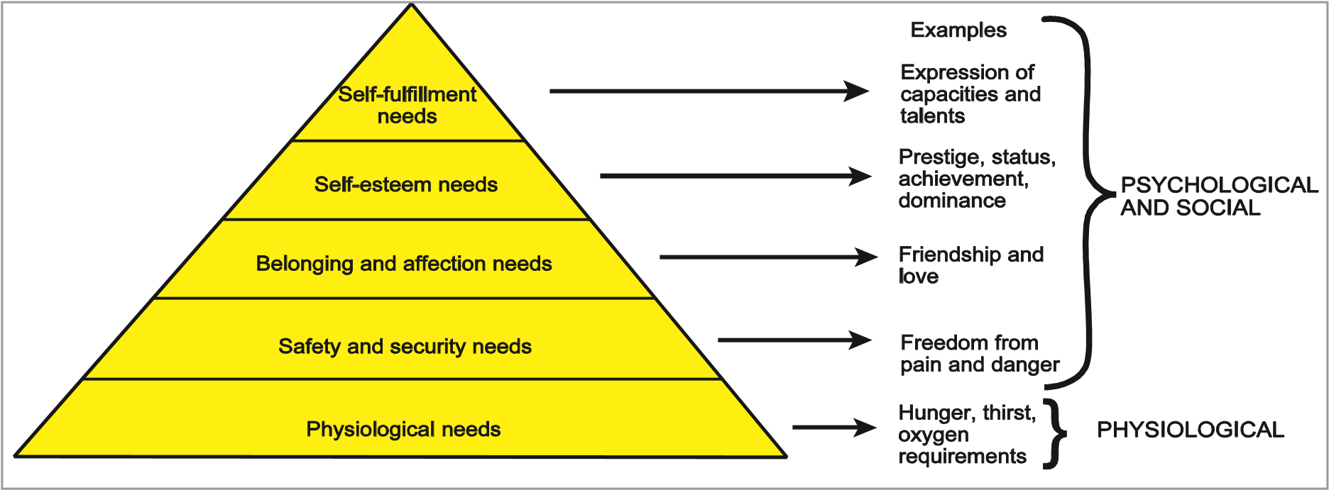

*Figure 9.1 Maslow’s Hierarchy of Needs*

At each stage in the hierarchy we can associate the relevance to flight safety. A mentally and physically satisfied pilot, who is confidently working as a member of a highly skilled team to achieve trouble-free and safe flight is one of the fundamental aims of flight safety.

The difficulty of the task and the arousal of the individual will both have an influence on a person’s motivation.

#### The Influence of Human Needs on Flight Safety

The goal of most airlines is to achieve a profit from the carriage of cargo and/or passengers safely. In order to do this, one of the many facets of the operation is the understanding of human needs in the realm of flight safety.

Passengers want to know that they will arrive safely on time at their destination with their baggage. In order to guarantee the ability to meet this requirement, the airline must provide a fully serviceable and correctly equipped aircraft.

The only way to do this is by having a well organized servicing schedule, crew rostering operation and good passenger/cargo facilities. All these factors should have an influence on meeting the human needs and, at the same time, providing greater flight safety. ***Basic Model Showing Two Independent Sources of Motivation***

The model can be used to illustrate the two independent sources of motivation. It also shows the relationship between motivational elements in a work situation and performance.

**Behaviour and Motivation**

**9**

The two sources are:

* **The perceived value of a reward**
* **The probability of its attainment**

As already discussed, people place very different values on rewards. However if a person expects that his/her efforts for attaining a reward will pass unnoticed, then he/she may feel that the reward has little usefulness even though it is highly valued.

Two other variables have also to be included here. These are **natural abilities and learned skills.**

From performance we can see rewards emerging. These can be **intrinsic** (feeling of pride or achievement) or **extrinsic** (pay or promotion).

If rewards are tied to performance and are seen to be, higher job satisfaction will be achieved resulting in higher performance. Many people feel more content if they have clear targets to meet and, providing these are realistic, they too can contribute to job satisfaction.

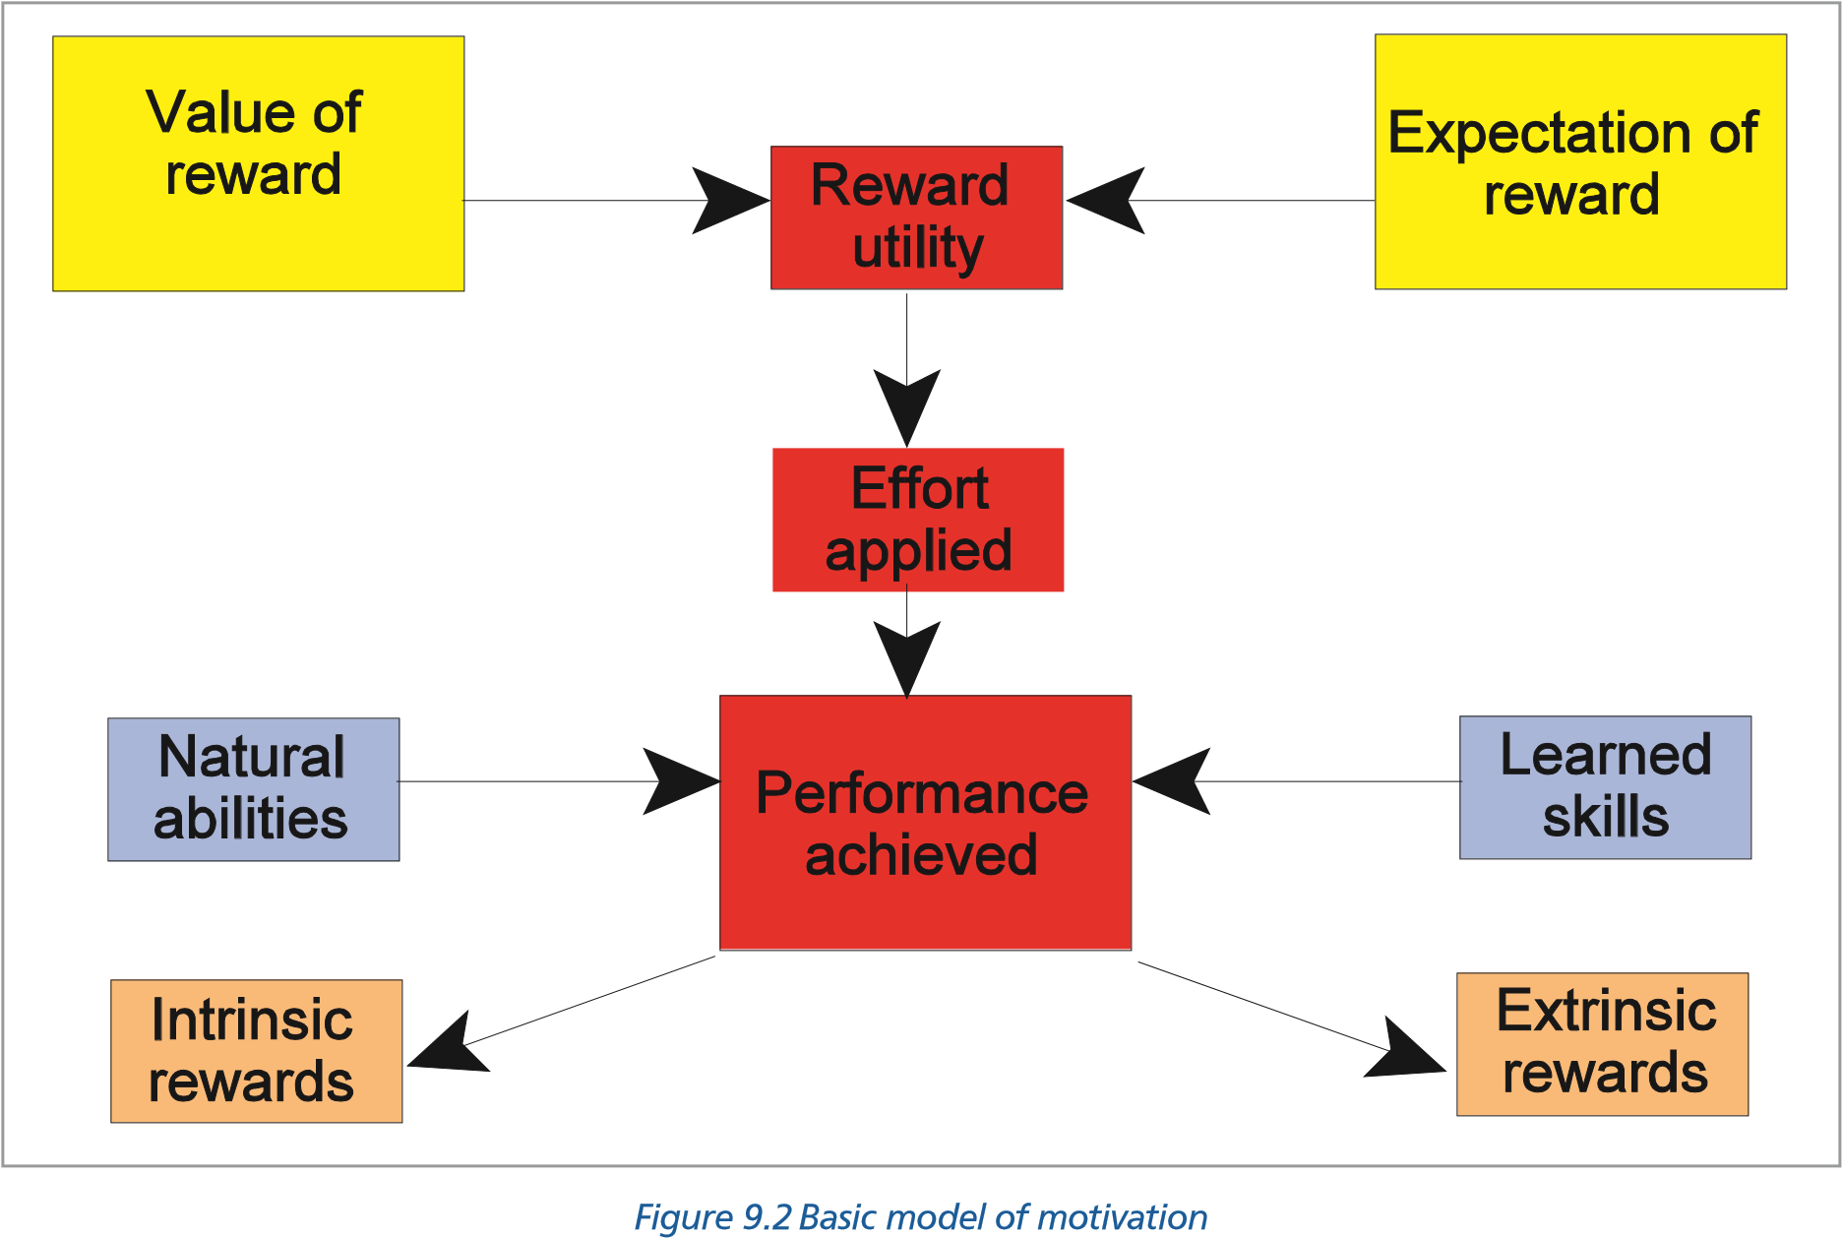

#### Motivation and Job Satisfaction

Job satisfaction is measurable through specially designed questionnaires and interviews and it is recognized that there are many factors which may influence an individual’s overall attitude to the job. These include, among others, financial rewards, management policies, colleagues, the working environment, the nature of the task etc.

#### Increasing Job Satisfaction

The two main tools used to increase job satisfaction are:

**Job enrichment**

This mainly involves active participation of staff in policy and the decision-making process concerning their work. Thus airline cabin crew are involved in decisions as to the timing of meals and menus served on board company aircraft or flight crews take an active part in the layout of flight instruments used on aircraft in the fleet.

**9**

**Behaviour and Motivation**

**Job enlargement**

Job enlargement increases the number and variety of tasks **(horizontal enlargement**) or increases an employee’s control of the routine planning of his/her task **(vertical enlargement)**. A good example of “horizontal” enlargement is the delegation by a Commander of an aircraft of some of his/her tasks to the First Officer. Aircrew actively involved in their own rostering would be an example of “vertical” enlargement.

### *Questions*

#### Questions

1. **What behaviour is used to carry out a fire drill?**
   1. Skill-based
   2. Rule-based
   3. Knowledge-based
   4. A combination of rule-based and knowledge-based
2. **Skill-based errors only occur:**
   1. in those with little or no experience
   2. in those who are in the learning process
   3. in those who have only part-learned a procedure/system
   4. in those with experience **3. Rule-based behaviour involves:**
   5. short-term and long-term memory
   6. short-term and iconic memory
   7. long-term and episodic-memory
   8. short-term, long term and episodic-memory
3. **With regards to procedures you are advised to:**

**Questions**

**9**

* 1. memorise all procedures as carefully as possible
  2. memorise immediate actions and subsequent actions
  3. memorise immediate actions and refer to check list for subsequent actions
  4. rely on the checklist for all procedures

1. **Knowledge-based behaviour enables people to:**
   1. deal smoothly and quickly with procedures
   2. deal with situations involving other people and especially with the flight and cabin crews
   3. deal with known situations
   4. deal with unfamiliar and novel situations
2. **In evaluating data pilots are influenced by:**
   1. their technical knowledge
   2. their previous experience
   3. situational awareness
   4. their state of health
3. **The reluctance to move away from a theory once formed in spite of evidence to the contrary is called:**
   1. mind set
   2. mind bias
   3. confirmation bias
   4. decision set

### *Questions*

1. **Situational awareness is:**
   1. the process that ensures the pilot maintains an accurate model of his/her environment
   2. the process that ensures the pilot maintains an accurate model of the situation within the cockpit
   3. the process that ensures the pilot maintains an accurate model of the situation outside the cockpit
   4. the process that ensures the pilot maintains an accurate model of the situation on and around the landing point
2. **Errors may occur when a pilot believes it is safe to depart from the procedure laid down. This statement is:**
   1. true
   2. false
   3. true in some circumstances
   4. false in some circumstances
3. **Once started on a course of action, it is better to:**
   1. have the courage of your convictions and carry them through
   2. confirm it with your co-pilot or most senior member of the crew
   3. ensure ATC are in the picture from the very start
   4. stop occasionally to take stock

**9**

**Questions**

1. **What is the Jens Rasmussen’s Model?**
   1. “KRS”
   2. “SKR”
   3. “SRK”
   4. “KSR”
2. **Among the most important factors which might interfere with situational awareness are:**
   1. weather patterns
   2. interpersonal differences
   3. hopes, wishes and desires
   4. poor instrument layouts
3. **We are driven by .................. needs and ................... needs.**
   1. social basic
   2. physical basic
   3. physiological social
   4. physiological basic
4. **The lowest tier of Maslow’s pyramid of needs is:**
   1. physiological needs
   2. safety and security needs
   3. belonging and affection needs
   4. self-esteem needs

### *Questions*

1. **Job satisfaction is measurable.**
   1. True
   2. False
2. **The two main tools in improving job satisfaction are:**
   1. job enrichment job enlargement
   2. job enrichment financial considerations
   3. financial considerations good industrial relations
   4. good management good industrial relations
3. **Job enlargement can be split into:**
   1. vertical slant
   2. slant horizontal
   3. slant vertical
   4. vertical horizontal

**Questions**

**9**

1. **A tendency to ask leading questions is a symptom of:**
   1. increased awareness
   2. decreased awareness
   3. increased situational awareness
   4. decreased situational awareness
2. **Action slip is an error of:**
   1. skilled-based behaviour
   2. knowledge-based behaviour
   3. rule-based behaviour
   4. none of the above
3. **The tendency to call to mind common experiences or scenarios from the past and link them incorrectly to a perceived mental model is called:**
   1. confirmation bias
   2. action slip
   3. environmental capture
   4. frequency bias

### *Answers*

**9**

**Answers**

#### Answers

|  |  |  |  |  |  |  |  |  |  |  |  |
| --- | --- | --- | --- | --- | --- | --- | --- | --- | --- | --- | --- |
| 1 | 2 | 3 | 4 | 5 | 6 | 7 | 8 | 9 | 10 | 11 | 12 |
| b | d | a | c | d | b | c | a | a | d | c | c |
| 13 | 14 | 15 | 16 | 17 | 18 | 19 | 20 |
| c | a | a | a | d | d | a | d |

Chapter

## **10** Cognition in Aviation

Cognition in Aviation . . . . . . . . . . . . . . . . . . . . . . . . . . . . . . . . . . . . . . . .183

Visual Illusions. . . . . . . . . . . . . . . . . . . . . . . . . . . . . . . . . . . . . . . . . . . .183

An Illusion of Movement . . . . . . . . . . . . . . . . . . . . . . . . . . . . . . . . . . . . . .185

Other Sources of Illusions. . . . . . . . . . . . . . . . . . . . . . . . . . . . . . . . . . . . . .186

Illusions When Taxiing . . . . . . . . . . . . . . . . . . . . . . . . . . . . . . . . . . . . . . .186

Illusions on Take-off. . . . . . . . . . . . . . . . . . . . . . . . . . . . . . . . . . . . . . . . .187

Illusions in the Cruise . . . . . . . . . . . . . . . . . . . . . . . . . . . . . . . . . . . . . . . .188

Approach and Landing . . . . . . . . . . . . . . . . . . . . . . . . . . . . . . . . . . . . . . .189

Initial Judgement of Appropriate Glideslope . . . . . . . . . . . . . . . . . . . . . . . . . . .189

Maintenance of the Glideslope . . . . . . . . . . . . . . . . . . . . . . . . . . . . . . . . . .191

Ground Proximity Judgements. . . . . . . . . . . . . . . . . . . . . . . . . . . . . . . . . . .192

Missed Approach - Somatogravic Illusion . . . . . . . . . . . . . . . . . . . . . . . . . . . . .192

Protective Measures against Illusions . . . . . . . . . . . . . . . . . . . . . . . . . . . . . . .193

Collision and the Retinal Image . . . . . . . . . . . . . . . . . . . . . . . . . . . . . . . . . .194

Human Performance Cognition in Aviation . . . . . . . . . . . . . . . . . . . . . . . . . . . .195

Special Situations . . . . . . . . . . . . . . . . . . . . . . . . . . . . . . . . . . . . . . . . . .196

Spatial Orientation in Flight and the “Seat-of-the-pants” . . . . . . . . . . . . . . . . . . . .197

Oculogravic and Oculogyral Illusions . . . . . . . . . . . . . . . . . . . . . . . . . . . . . . .198

Questions . . . . . . . . . . . . . . . . . . . . . . . . . . . . . . . . . . . . . . . . . . . . . .199

Answers . . . . . . . . . . . . . . . . . . . . . . . . . . . . . . . . . . . . . . . . . . . . . . .202

**10**

**Cognition in Aviation**

### Cognition in Aviation

#### Introduction

Human beings have evolved to function at sea level and at speeds achievable on two legs. Flight puts the pilot into an environment which can distort sense organs. In addition the changed perspective experienced in flight can result in information being presented which is outside the individual’s expectations. ***Illusions - General***

We use mental models as frameworks to make sense of the world and guide our actions. Mental models can be incomplete and thus faulty. In aviation the mismatch between what we sense and what we expect is an **illusion**. In other words the difference between perception and reality.

Objects seen from the air look quite different than when viewed on the ground. Because of the lack of stable visual references and the erroneous mental models that may be produced, the pilot is at a disadvantage. In addition, in flight, the pilot’s cognitive and sensory orientation mechanisms have to try and cope with a third dimension to which they have not been designed. This will lead to both mental and physical illusions.

Illusions may occur during all stages of the flight and to pilots of every experience and skill level. The pilot, therefore, should be aware of the possibility of misinterpreting the information received. Illusions can affect all of our senses but those of particular concern in aviation are those which affect our visual sense and those affecting the balance organs in the middle ear. We also possess a position sensing system derived from nerve endings in the skin, muscles and joints which can be a source of incorrect information passed to the brain.

**Cognition in Aviation**

**10**

**Visual illusions are particularly dangerous in aviation as we normally consider our visual input to be the most reliable of our senses.**

### Visual Illusions

**A**

**B**

**C**

**D**

*Figure 10.1 Some geometrical illusions*

Most people are familiar with the two dimensional figures in *Figure 10.1*.

In **A** the figure with the out-going fins appears to contain a longer line than the other, although both are exactly the same length. We are not often going to see large finned lines on our airfields but the natural scenery, the junction of two roads or railways, the alignment of valleys, even a small runway running into the corner of a field where hedges meet can give a false impression of runway length.

In **B** the upper of the two horizontal lines appears the longer, but they are the same size.

In **C** the vertical straight lines appear curved, but they are straight.

In **D** which line passes through the two vertical parallel lines? Try it with a straight edge.

Other visual illusions involve a perceived depth appreciation.

Both of the illustrations in *Figure 10.2*  and *Figure 10.3* can obviously be visualised as a model but neither could exist in real life.

**10**

**Cognition in Aviation**

*Figure 10.2*

*Illusion in depth*

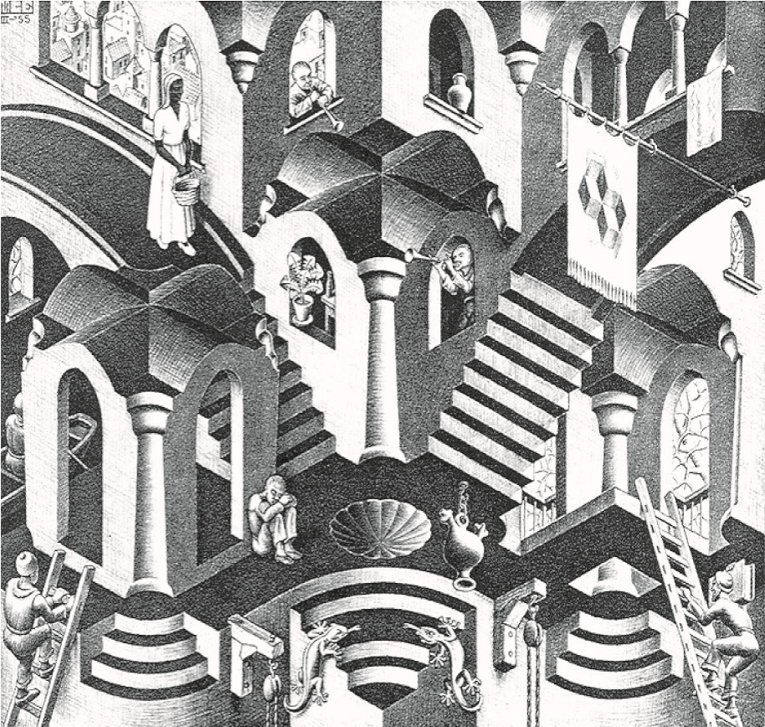

*Figure 10.3**Concave & convex*

### An Illusion of Movement

Move the page slowly away then towards the face while concentrating on the central dot.

**Cognition in Aviation**

**10**



***Atmospheric Perspective***

Visual illusions in flying are often associated with inappropriate experiences. For example the pilot who has done most of his flying in relatively polluted air may have learned to use ‘atmospheric perspective’ as a good cue to range. If the pilot then operates in a very clear atmosphere he/she may believe distant objects, because of their clarity, to be much closer than they actually are, or mistake the distant object for a similar, smaller, object he/she was expecting to see close by - both the expected and actual object will give the same angular size on the retina.

A number of accidents have occurred in the polar regions in VMC when the pilots have miscalculated the distance to a landing spot situated close to a landmark with the result that the aircraft has run out of fuel.

### Other Sources of Illusions

#### The Gestalt Theory

Our senses - sight, hearing, touch etc. - do not account for all the sensory illusions. Sometimes the perception is correct, but comprehension and identification may be in question. The human brain is continually working on the construction of mental models. The **Gestalt Theory** (from the German word gestalt = shape) of learning proposes that any individual’s understanding of the world results from sorting out and combining multiple cues perceived in the environment until a ‘coherent whole’ appears that is acceptable according to the individual’s standards as regards the world.

Gestalt psychologists propose that perception, rather than being a simple repeated association between a stimulus and a response, is an active construction of an object by the brain.

#### Laws of Perceptual Organization

To reach this ‘coherent whole’ the brain has developed a set of rules about the combination of all the cues available. These rules are the **laws of perceptual organization** of the Gestalt Theory and deal with factors such as proximity, continuity, similarity, symmetry, simplicity and closure. In many cases an individual will add cues which are not in the environment, and which the brain thinks are hidden or not visible in what has been perceived.

Basically, Gestalt laws formulate basic principles governing how objects are organized and perceived.

As an example of the application of the Gestalt laws it is possible to make sense out of a number of words where half of the letters have been removed. The brain of the observer will ‘fill in’ the missing portions of the text to match what he believes is correct. The danger in this is that what the individual fills in will depend greatly on that individual’s previous experience and expectation.

**10**

**Cognition in Aviation**

Consider the following **...... P y ol g st.** A psychology student would probably read it as - Psychologist whereas a biology student could read Physiologist.

One must use extreme caution to ensure that we do not construct our mental model according to our wishes or desires.

### Illusions When Taxiing *Relative Movement*

Even on the ground we are not free of illusions. A loading bridge moving away from the aircraft may give an illusion that it is the aircraft that is moving. When arriving at a gate which itself may be moving the pilot may believe that the aircraft is stationary and apply the parking brake, perhaps causing cabin staff to be thrown forward with the danger of injury.

Blowing snow may give a false impression of relative speed. When an aircraft is taxiing with a tailwind, the snow may appear to be falling vertically, giving the impression that the aircraft has stopped, when in fact it may still have a relatively fast taxiing speed. Application of the parking brake in these circumstances again could have serious consequences. Alternatively the aircraft could creep forward, colliding with an obstacle, when it was thought to be stationary. When taxiing into a headwind the blowing snow will give the illusion that the aircraft is taxiing faster than is the fact. In either case the pilot must look out of the side cockpit windows to gain an accurate assessment of taxi speed.

#### Cockpit Height above the Ground

Pilot eye height from the ground may be the source of misjudged speed. Pilots converting to an aircraft with an eye position that is higher than on their previous type (8.66 m above the ground on a 747 compared with 3.48 m on a DC9) will have their normal visual references at a greater distance, which will give the illusion of slower relative motion, and in the initial stages of training they may well taxi at excessive speeds as a result.

#### Illusions on Take-off Somatogravic Illusion

In commercial flying the major accelerations in the longitudinal and rotational planes occur on the take-off and go-around. An acceleration gives the pilot an impression of the nose of the aircraft pitching up and this encourages the pilot to push forward the stick with the resultant danger of flying into the ground.

The effect is due to the brain resolving the weight, acting vertically downwards, and acceleration into a single resultant force. The fact that this phenomena is exacerbated by the information supplied by the otoliths of the inner ear makes it particularly dangerous (*Figure 10.9*.)

**Cognition in Aviation**

**10**

#### Outside References

Outside references (**vectional false horizons**) may give false impressions within the cockpit.

Among these are:

* Immediately after take-off - a false horizon may be perceived when surface lights are confused with stars.
* Over water - the lights of fishing boats have been mistaken for stars and the flight path adjusted inappropriately.
* In hilly terrain - it is possible that, emerging from low cloud or mist on take-off, lights on the ground will be mistaken for stars and the flight path adjusted to a lower and dangerous profile.
* Gently sloping terrain - may create an illusion at any time when flying visually at low level.

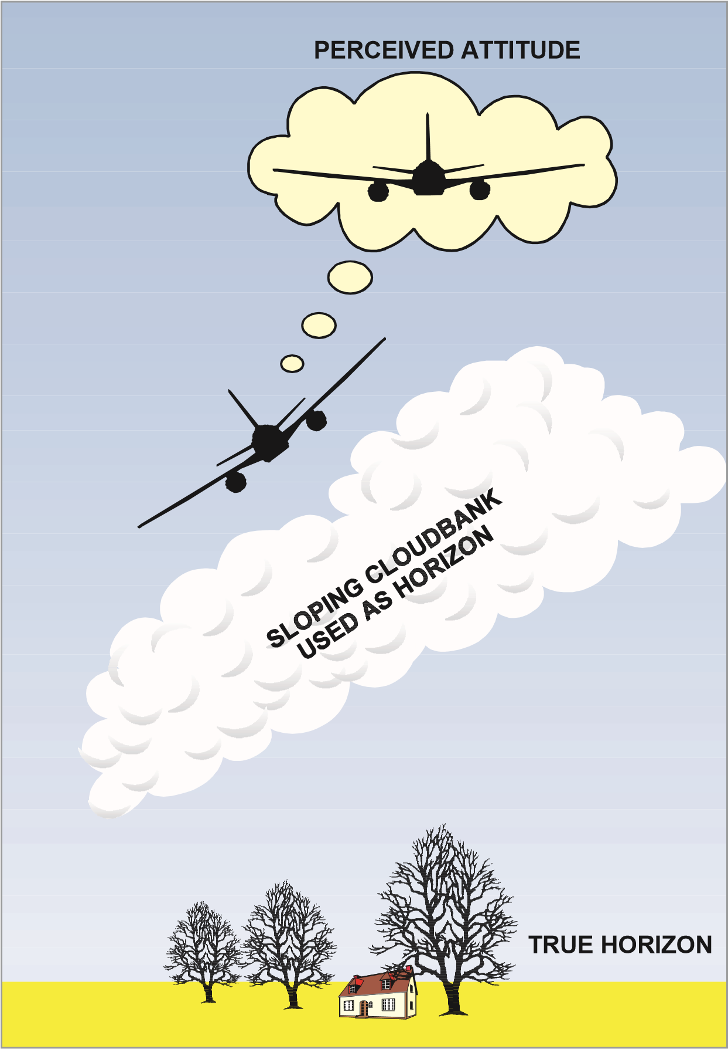

*Figure 10.4 Example of vectional false horizon*

* A bank of sloping cloud - across the horizon will give the impression of a wing low. (See *Figure 10.4* above.)
* After take-off or on approach - if the ground slopes down an illusion of excessive height may be created, and vice versa.

### Illusions in the Cruise

**10**

**Cognition in Aviation**

#### Autokinesis

Staring at an isolated and stationary light when other visual references are inadequate or absent, may cause autokinetic movements of the eyes. This gives the illusion that the light is moving and can lead the pilot to believe that a single star is another aircraft. Numerous cases have been reported of mistaken identity of lights. These illusions can be avoided by shifting the gaze to eliminate staring. The illusion is created by small movements of the eye ignored by the brain and interpreted as motion of the object.

#### Vertical Separation

A common problem in flight is the evaluation of the relative altitude of approaching aircraft and the assessment of a potential collision risk. At a distance an aircraft may appear to be at a higher level but may eventually pass below the observer. Mountains or clouds at a distance tend to appear to be above the aircraft but often pass below.

#### Holding

In civilian transport flying the normal manoeuvres are unlikely to create significant vestibular illusions. However, prolonged turning as in a holding pattern can create an illusion if the head is moved while still turning (**vertigo** - sometimes referred to as the **somatogyral illusion - or coriolis effect**).

### Approach and Landing

50% of all airline accidents occur on the approach and landing and, of all the phases of flight, this is the one most prone to human error (73%). In the final stages of a flight the pilot has to cope with the most critical visual tasks, and these may be divided into 3 stages:

* Initial judgement of glideslope.
* Maintenance of the glideslope.
* Ground proximity judgements.

### Initial Judgement of Appropriate Glideslope

#### Visual Angle

**Cognition in Aviation**

**10**

The judgement of the glideslope can be made easier by the use of VASIs or PAPIs at the airfield, or by positioning the aircraft at a predetermined height above known ground features. However, the judgement must frequently be made without such aids. To judge the approach path, normally 3°, the pilot is attempting to establish an angle. This angle is the **visual angle**, (*see Figure 10.5*) and is measured at the pilot’s eye down from the horizon to the visual aiming point on the runway. This, of course, is equal to the approach angle.

**HORIZON**

**PILOT'S**

**EYE**

**VISUAL AIMING**

**POINT**

*Figure 10.5 The visual angle*

#### Sloping Ground

A sloping terrain approach or a sloping runway may produce an incorrect estimate of horizon location and an incorrect approach slope judgement may be made *(see Figure 10.6)*. The length of a sloping runway may also be misjudged.

#### Upsloping Runways

If the runway slopes **up**, the pilot will be encouraged by the threshold visual cues to descend. This leads to an approach which will tend to be too **low**. With a lower than normal approach, if continued, the aircraft wheels will contact the runway at an increased distance behind the visual aiming point with the possibility of touching down in the undershoot area. A sloping **up** runway will appear to be **shorter** than its actual distance, making it appear closer and creating a mistaken belief of a need to descend.

#### Downsloping Runways

If the runway slopes **down**, the pilot will be encouraged by the threshold visual cues to climb. This leads to an approach which will tend to be too **high**. If the approach is too high then the aircraft may land further into the runway than planned giving a reduced runway landing and breaking distances available. A **down** sloping runway will appear to be **longer** than its actual distance, making it appear to look further away and creating a mistaken belief of not needing to descend yet.

**10**

**Cognition in Aviation**

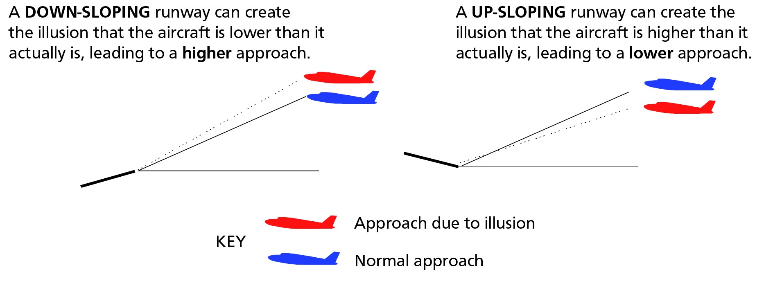

*Figure 10.6*

#### Width of Runways

The width of the runway may also cause incorrect height judgements on the final approach. A pilot used to a standard width runway 150 ft (**46 m**) may, when approaching an unfamiliar airfield with a **narrow** runway, judge he is too high and therefore round out on too **low** an approach. At an airfield with a **wider** runway than the pilot is used to the tendency will be to roundout too **high** on an approach to match the visual scene to the pilot’s expectation.

This phenomenon will be particularly noticeable for students from Kidlington when landing for the first time at Filton. They will be accustomed to the narrow runway width at Kidlington 75 ft (23 m) and will tend to flare much too high on their first landing at Filton where the runway width is 300 ft (**92 m**).

#### The Black Hole Effect (The Kraft Illusion)

When approaching an airfield at night over water, jungle or desert the only lights visible may be the distant runway or airfield lights, with a black hole intervening. This absence of visual cue leads to an illusion that the aircraft is too high and as a result the approach path may be flown at too shallow an angle - the aircraft touching down short of the runway. This phenomenon is also important to consider when designing simulator visual presentations to ensure that enough intermediate texture is available on the screen to allow correct height judgement.

*Figure 10.7 The Kraft illusion*

### Maintenance of the Glideslope

#### Aiming Point and Aircraft Attitude Pitch Angle

Once the aircraft is established on the glidepath and is in the landing configuration, it is relatively easy to visually maintain the glidepath by keeping the aiming point at a fixed position on the windscreen. ***Inadvertent Speed Loss***

A situation can arise on the approach that with an inadvertent speed loss and a gradual loss of altitude, the runway could remain in the same position on the windshield, giving the impression of a safe, stabilized approach until touching down some distance before the threshold. In particular this should be remembered when visual flying at night around airports where the surrounding terrain is without lights.

**Cognition in Aviation**

**10**

Clearly this technique (using visual angle) will only work providing the speed and configuration are maintained. If the speed decreases, the nose-up attitude of the aircraft will increase and the selected spot on the windscreen will move towards the overshoot end of the runway. The danger is to descend to regain its position on the windscreen whilst maintaining the lower speed and visa versa. ***Texture and Texture Flow***

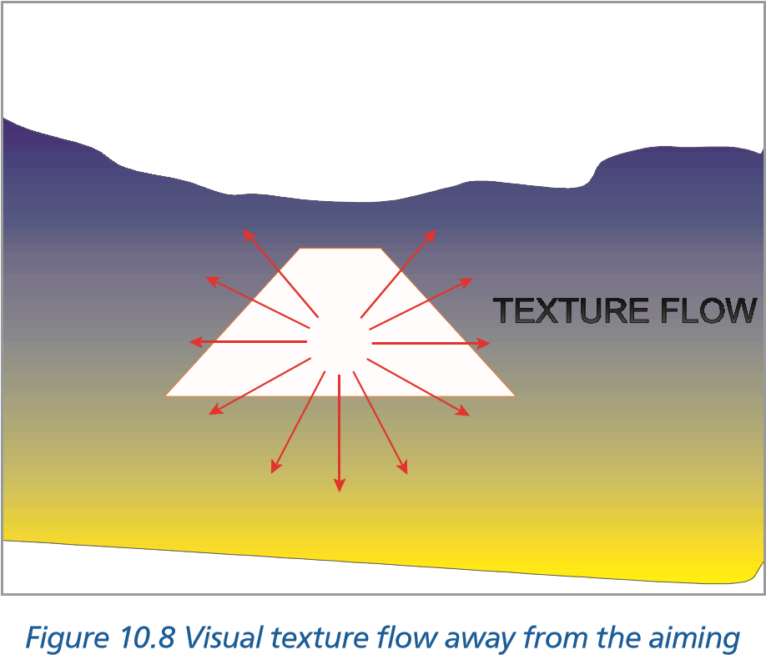The approach is progressing normally as long as visual texture flows away from the aiming point and the visual angle between this point and the horizon remains constant. The texture change is particularly important when landing on a grass field .

*point*

### Ground Proximity Judgements

In the final stage of the approach the pilot will be required to make an assessment of his height above the ground to initiate the flare or power reduction. The pilot will use a number of cues in this height assessment among which will be the:

* Apparent speed of objects on the ground will increase as the height reduces.
* Size of objects, such as runway lights etc. will increase with decreasing distance. (Both height and range of the aircraft).
* Apparent width of the runway will increase.
* Texture of the ground will change. At height, grass will appear only as a green surface, only at low level does it look like grass. There are recorded cases where pilots have mistaken the green jungle canopy for a flat green field and attempted to land with engine out.

#### Wheels and Touchdown Point

Because most large aircraft have their main undercarriage a long way below and behind the pilot’s eye level, it is self-evident that the wheels will not touch down at the visual aiming point but some way short. See *Figure 10.9.*

**10**

**Cognition in Aviation**

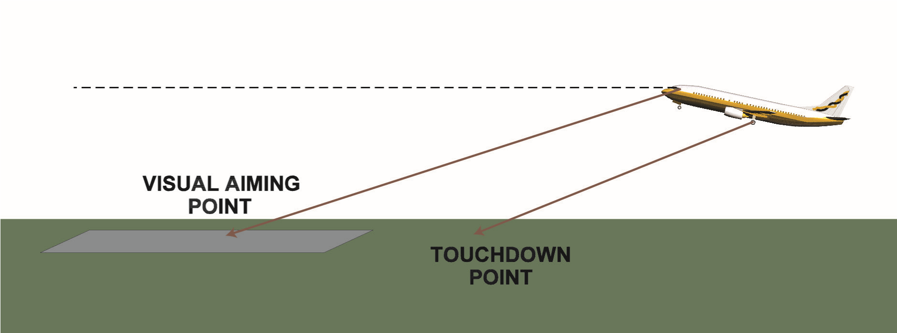

*Figure 10.9 Wheels & touchdown point*

The shallower the approach path then the greater the distance between the aiming point and the actual touchdown. If a pilot has been misled by sloping terrain or runway to fly a lower than normal approach, and accurate height cues are missing, there is a danger of the aircraft touching down before the prepared surface. This is one of the reasons for the recommended approach for large aircraft being with automatic ILS coupled to radio altimeter input of wheelheight above touchdown whenever possible.

### Missed Approach - Somatogravic Illusion

A missed approach in poor visual conditions involves linear acceleration and this causes an illusion of pitch up or climb. This is due to the inputs from the otoliths and has been discussed in Chapter 4.

In addition - and quite separate from the above - is another factor called the **Kinaesthetic Effect**. This also gives an illusion of climb with linear acceleration and descent as a result of linear deceleration. However, it is caused by the resultant of the forces of gravity acting on the aircraft and the body. These gravitational forces are picked up by the proprioceptors in the muscles and joints giving the sensation of climbing or descending. See *Figure 10.9.*

It is important to stress that the result of these two quite different effects combine, under the right circumstances, to lead to an almost irresistible illusion of climb or descent and which has led to many accidents over the years.

**Cognition in Aviation**

**10**

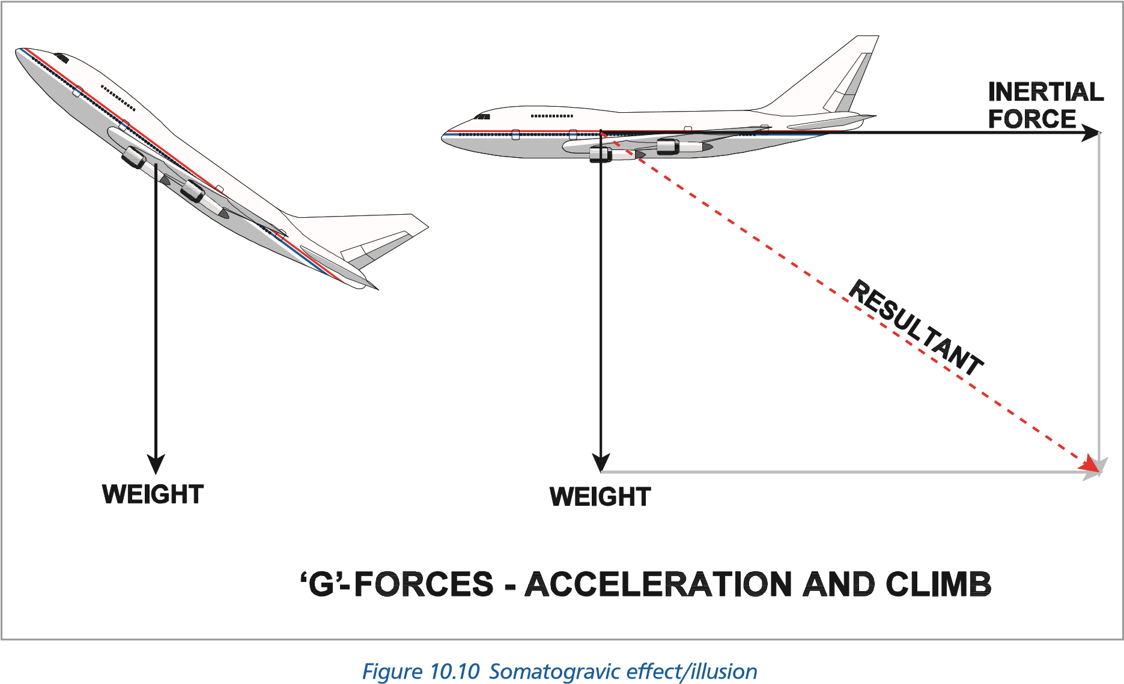

### Protective Measures against Illusions

It is sometimes said that, as visual illusions result from an unconscious process within the brain, there is nothing that can be done about providing protection against them. This is not true. Effective steps can be taken to substantially reduce the risks associated with visual illusions. **Organized and formal training** is the best protective measure and it has been recommended that this should be used to educate flight crew to recognize:

* That illusions are natural phenomena.
* The different types of illusions and their effects.
* That the supplementation of other visual cues with information from other sources is the most effective counter to the effects of illusions.
* The need for comprehensive flight briefing should the occurrence of illusions be known to exist or anticipated at particular geographic locations.
* That special care must be taken by crew during accelerations and particularly when instrument flying.
* That head movements, fatigue, night and conditions of reduced visibility are all factors that can promote visual illusions.
* That manufacturers and certifying authorities also have a role in providing protection.

### Collision and the Retinal Image

If a closing aircraft remains on the same spot on the windscreen then it is maintaining a **Line of Constant Bearing (LCB)**, and a collision risk exists. If it appears to move across the windscreen, vertically or horizontally, then no collision risk exists while both aircraft maintain their current tracks. The blind spot is of special significance when flying visually in VMC as it is possible that conflicting traffic will remain permanently on this area and undetected.

High speed traffic on a converging track from ahead may produce a very small angular picture on the retina until it is very close. Typically with two aircraft flying at 800 knots closing speed, approaching head on, each aircraft will only subtend a retinal angle of 0.5° with 3 seconds to impact and only 1° at 1.5 seconds to collision. Because of the aircraft’s small retinal size, it is quite possible that the pilot will not notice it at all if there is no relative movement across the windscreen. In the last 1.4 seconds the image of the converging aircraft will grow very large indeed, but by this time it will be far too late to take avoiding action.

**10**

**Cognition in Aviation**

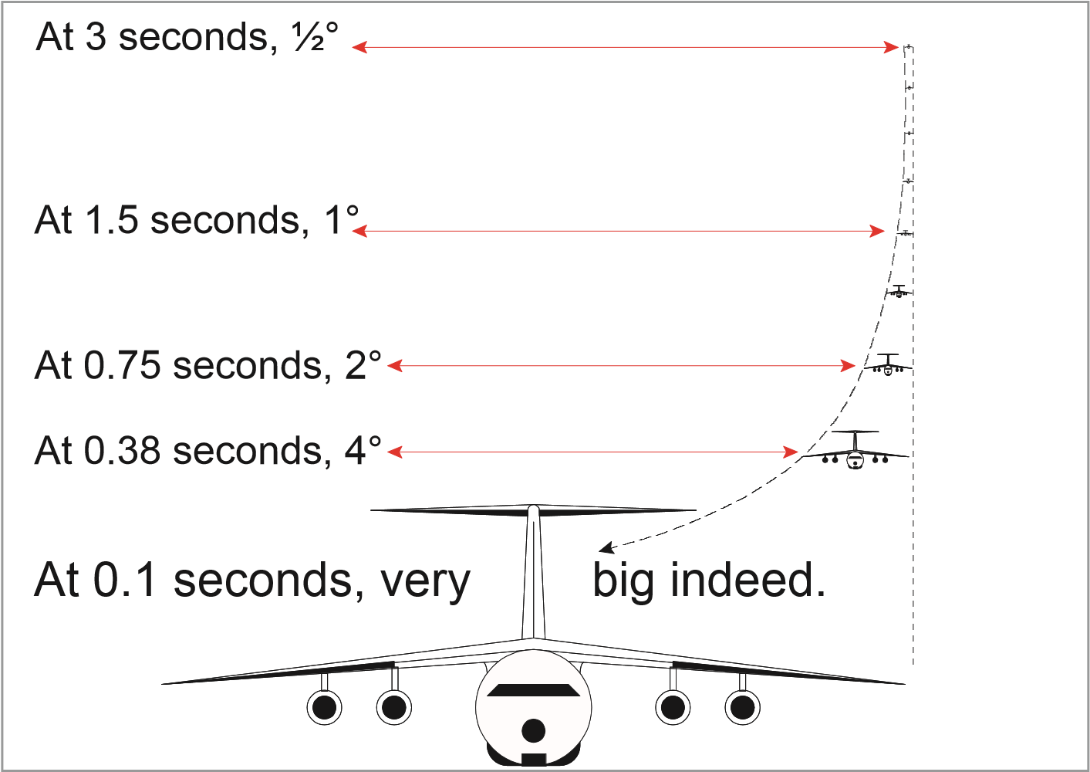

*Figure 10.11 The retinal size of an approaching aircraft before impact*

*Figure 10.11* shows the rate of increase for an aircraft approaching at a closing speed of 800 knots. It can be seen that the image of the aircraft remains very small until just before impact.

At any stage of flight there is a risk of a mid air collision. With the sophistication of modern radar and air traffic control systems the risk is greatly reduced when operating in controlled airspace, but it can never be completely eliminated. It is essential that all pilots maintain a good scan of the world outside as well as of the cockpit instruments.

However conscientiously the pilot maintains a lookout it is probably true that detection of all possible collision risks cannot be guaranteed with purely visual scanning. In an experiment in the USA with aircraft flying in good VMC conditions, pilots were warned of aircraft on collision headings from ahead. Even with almost perfect visibility, and with prewarning, only 50% of the pilots were able to detect the approaching aircraft in sufficient time that would have enabled them to take avoiding action.

### Human Performance Cognition in Aviation

**To summarize:**

The two problems facing the pilot in recognizing the immediate danger are:

* **Retinal Size**

As the aircraft presenting the hazard approaches, its retinal size increases. The rate of such increase has been plotted in *Figure 10.11* above for an aircraft with a closing speed of 800 kt. It can be seen that the image remains very small until very shortly before impact.

* **LCB**

If the conflicting aircraft remains on a constant relative bearing danger is at a maximum because there will be no movement cue aiding detection. The situation is worsened if the other aircraft is positioned, from the pilot’s perspective of view, behind a windscreen support or in his/her blind spot.

**Cognition in Aviation**

**10**

#### Saccade

There are problems associated with the way that the eye moves and how it takes in information. Unless following a moving object the eye does not move smoothly but in a series of jerks. Each movement is known as a **saccade** and is followed by a rest period when the eye samples its new field. Smooth vision is achieved by the **visual cortex** of the brain so that the observer is never conscious of saccade.

The average saccade and rest period takes about **one third of a second**. As the area within which we have good visual acuity is small, it means that eye movements must be frequent and small, and the rest periods of short duration to ensure that the sky is covered.

#### Scanning Technique

Recommendations for a successful scanning technique are:

* Each movement should be of 10° at the most and each area should be observed for at least 2 seconds to allow detection.
* Airspace above and below the aircraft must be covered.
* The sky should be covered in overlapping sectors of about 10°.
* Peripheral vision can be vital in spotting collision threats. Each time the scan is stopped and the eyes refocused, the peripheral vision takes on more importance, because it is through this that movement is best detected - this is particularly important by night. In fact, by night it may not be possible to identify an object by looking directly at it and it may only be spotted by looking slightly to one side of the object thus utilising the rods and peripheral vision for detection.
* It is best to move the body as well as the head to see around physical obstructions in the cockpit (doors and windscreen posts). Together these can cover a considerable amount of the sky and a small head or body movement may uncover an area that is concealing a threat.
* Particular care must been taken prior to take-off, landing, ascent or descent and a meticulous scan must be carried out even though clearance may have been received from ATC.
* If another aircraft shows no lateral or vertical movement, but is increasing in size, ***immediate*** evasion action must be taken.

### Special Situations *Introduction*

There are several special situations which are mainly caused by environmental factors which mislead our perception. These have resulted in a number of major accidents. Among these are: ***Rain on the windscreen***

**10**

**Cognition in Aviation**

* **Refraction**

Due to the refraction of the raindrops collecting on the cockpit windscreen the eye sees the runway lower than it is. This tends to make the pilot carry out a shallower than normal approach. This is true both by day and night.

* **Rain on the windscreen**

Rain on the windscreen at **night** can also make runway lights bloom and, as a result, the runway appears closer than it really is; subsequently the pilot has the impression that the aircraft’s closing speed is faster than it is in reality. The pilot may subsequently adjust the approach resulting in an adoption of a too shallow approach angle.

* **Weather**

A heavy rain storm between the aircraft and the airfield will make the field seem more distant.

#### Water and Height Judgment

Flying over a smooth water surface makes it extremely difficult to judge height due to the lack of visual cues. This has the effect of the aircraft flying too low - especially over smooth water.

There have been a number of instances of helicopters flying into the sea during night approaches onto offshore rigs. Multi-engine aircraft have hit the water with their propellers when attempting to fly at fifty feet over a calm sea or lake.

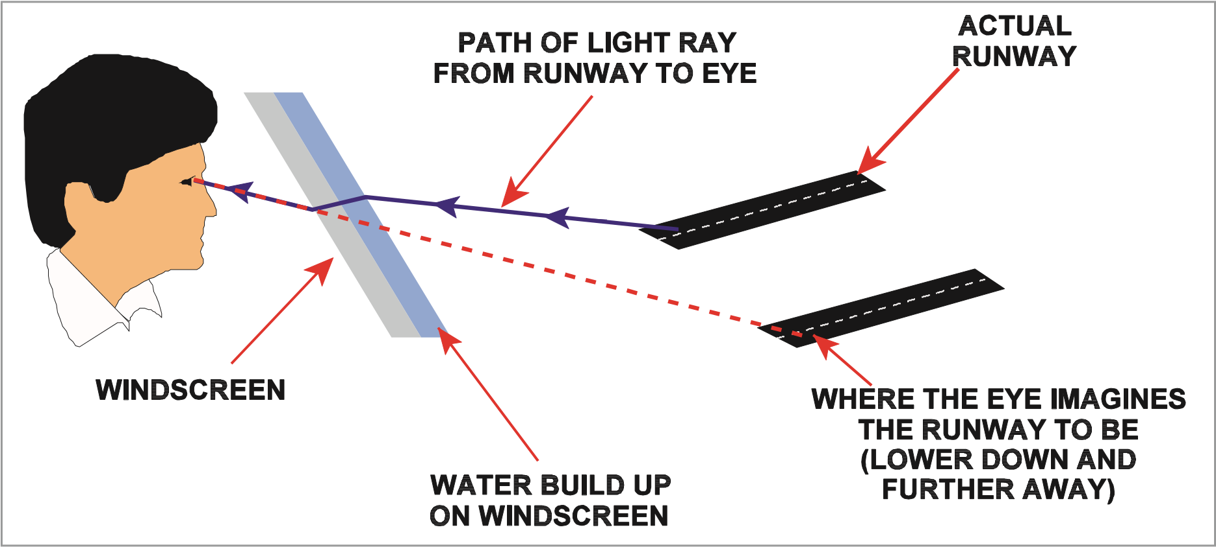

*Figure 10.12 A visual illusion caused by a layer of water on the windscreen*

#### Snow Coverage

Not only does snow lead to false height judgements it is often difficult to decide where the surface ends and the sky begins due to the absence of visual and focal clues. It is easy to mistake snow-covered mountains for clouds with catastrophic results.

**Whiteout** can be caused either by blowing snow, when visibility is reduced to zero and even taxiing is impossible or by extended exposure to the reflected glare of snow. The second cause can be most alarming since it manifests itself in the inability to distinguish ground features. The landscape appears to be a flat, smooth plane of white and accurate height assessment is rendered impossible. There is the added danger that snow may not reflect radar pulses so the high ground will not appear on the weather radar screen.

#### Fog, Haze, Pollution and Low Visibility

As a result of fog, haze or pollution, runway lights appear dim giving the impression that the runway is further away than it is which gives rise to steeper approaches than normal.

#### Runway Lights

**Cognition in Aviation**

**10**

The intensity of runway lights will also lead to errors. Their brightness or dimness will either give the false impression of the runway being either closer or more distant than it is. Thus incorrect approach angles and judgement of closing speeds are likely.

### Spatial Orientation in Flight and the “Seat-of-the-pants”

As we saw in Chapter 4, the vestibular apparatus detects the orientation and movements *only of the head*. It is therefore essential that the nervous centres also receive information depicting the spatial orientation of the head with respect to the body as well as the spatial orientation of the different parts of the body with respect to each other. This information is transmitted by the **proprioceptors** which are components of the nervous system and are located under the skin (subcutaneous) in the neck and the major parts of the body. A pilot relying on these inputs is sometimes referred to as flying by the “seat-of-the-pants”.

The most important sense with regards to spatial orientation is sight. Even without the inputs from the vestibular apparatus, a person can still use his/her visual images of the outside world to maintain spatial orientation.

Under instrument conditions a pilot loses this vital visual input. For example, if the aircraft goes into a descent it will accelerate and this acceleration, via the otoliths, will inform the pilot that the aircraft is in the climb. The proprioceptors will also detect a climb because of the g-forces resulting from the somatogravic effect.

**Thus these proprioceptive stimuli are completely unreliable when visual contact with the ground is lost or when flying IMC and must be ignored.**

**CROSS CHECK AND BELIEVE THE INSTRUMENTS**

### Oculogravic and Oculogyral Illusions

Whereas there are various differing definitions of these two illusions, it has been confirmed that the following (extracted from *Fundamentals of Aerospace Medicine* by R.L. Dehart), are accepted:

**Oculogyral Illusion**

Whereas a somatogyral illusion is a false sensation, or lack of sensation, experienced by a pilot undergoing angular motion, an oculogyral illusion is a false sensation of visual movement of an object viewed by a pilot. It is the visual sister to the somatogyral illusion. Thus the pilot experiencing an oculogyral illusion will see **objects in front of him/her to be moving in the opposite direction.** A very real danger is created when the somatogyral illusion is combined with the oculogyral illusion. In this case the pilot not only has the sensation of turning in the opposite direction due to the somatogravic illusion but this feeling is confirmed by his/her visual inputs - the very human sense that is known to be the most important as far as spatial orientation is concerned and therefore to be trusted.

**10**

**Cognition in Aviation**

**Oculogravic Illusion**

The oculogravic illusion occurs under the same conditions as the somatogravic illusion and is the direct **visual** result of linear acceleration. For example, a pilot subjected to deceleration experiences a nose-down pitch sensation because of the somatogravic illusion. Simultaneously, he/she observes the instrument panel to move downwards, confirming his/her sensation of tilting forward. Thus the oculogravic illusion is the **visually apparent movement of an object** in front of the observer that is actually in a fixed position relative to him/her.

### *Questions*

#### Questions

1. **If a runway slopes downwards, how does this affect the pilots’ approach?**
   1. It is likely to be too high
   2. It is likely to be too low
   3. It is likely to be too fast
   4. It is likely to be too slow
2. **If a runway slopes upwards, how does this affect the pilots’ approach?**
   1. It is likely to be too high
   2. It is likely to be too low
   3. It is likely to be too fast
   4. It is likely to be too slow
3. **What is the likely effect of a runway which is wider than expected?**
   1. Flaring too late and damaging the aircraft
   2. Flaring too soon and causing a heavy landing
   3. Approach speed much too high
   4. Approach speed higher than usual

**Questions**

**10**

1. **What approach conditions cause the “black hole effect”?**
   1. Landing at night in sleet or heavy rain
   2. Landing at night with a partially lit runway
   3. Landing at night with the cockpit instruments turned up too high
   4. Landing at night when there are no lights between the aircraft and the runway
2. **How does the “black hole effect” alter the pilots’ judgement of the approach?**
   1. Overestimation of height
   2. Underestimation of height
   3. Tends to make the approach much too fast
   4. Tends to make the approach faster than normal
3. **What are the main visual cues for rounding out?**
   1. Round out height and speed
   2. Confirmation of decision height and closing speed
   3. Closing speed and height check
   4. Apparent speed of ground objects increases and texture of ground changes.
4. **How do misty/foggy conditions affect the pilots judgement on the approach?** 
   1. Underestimating range due to illusionary effect through cockpit glass
   2. Underestimating range due to the lights appearing dim
   3. Underestimating range due to illusionary effect through cockpit glass
   4. Overestimating range due to the lights appearing dim

### *Questions*

1. **If two aircraft are on a line of constant bearing, what is the likely outcome?**
   1. Depends whether by day or by night
   2. They will collide
   3. There will be a near miss
   4. It is quite safe and they will pass well clear of each other
2. **How will an oncoming aircraft on a line of constant bearing appear visually?**
   1. There will be no relative movement and it will appear to be very small until seconds before the collision
   2. There will be no relative movement and it will appear to be very small until seconds before the aircraft passes close by
   3. There will be no relative movement and it will appear to be very small until seconds before the aircraft passes above
   4. There will be no relative movement and it will appear to be very small until seconds before the aircraft passes well clear
3. **What is the duration of a saccade and rest period?**
   1. 0.3 seconds
   2. 0.5 seconds
   3. 0.013 seconds

**10**

**Questions**

* 1. 1 second

1. **What visual technique should be used when searching for an aircraft?**
   1. Sweep from side to side with the eyes covering the whole field of vision
   2. Search the sky portion by portion starting on the left
   3. Pinpoint 10° segments of the sky and confirm before passing onto another
   4. Use a succession of small and rapid eye movements
2. **Refraction, due to rain on the windscreen, makes the approach:**
   1. steeper
   2. shallower
   3. faster
   4. slower
3. **Expectation can affect perception.**
   1. True
   2. False
4. **The blooming effect of rain makes:**
   1. the runway appear closer
   2. the runway appear further away
   3. does not effect runway perception
   4. the instruments difficult to read

### *Questions*

1. **What are the laws that the Gestalt Theory propose?**
   1. The laws of Perception
   2. The laws of Perceptual Illusions
   3. The laws of Perceptual Reception
   4. The laws of Perceptual Organization
2. **A visual scan should cover the sky in overlapping sections of:**
   1. 5°
   2. 10°
   3. 15°
   4. 20°
3. **The scanning technique should differ by day and night.**
   1. True
   2. False

**Questions**

**10**

1. **A distant aircraft is identified and remains on a constant relative bearing. You should:**
   1. wait until the aircraft appears to grow larger before taking avoiding action
   2. take avoiding action if you do not have right of way
   3. take immediate avoiding action
   4. wait two seconds to reidentify and then take avoiding action
2. **Another name for the illusion associated with acceleration is:**
   1. the somatogyral illusion
   2. the somatogravic illusion
   3. motion sickness
   4. air sickness
3. **If an illusion is known to be possible at a particular aerodrome, as Captain of the aircraft, you should:**
   1. say nothing as it might frighten the crew
   2. ensure you brief the crew
   3. report the fact to operations so that other crews are aware of the danger
   4. report the fact to your operator so that other crews are aware of the danger

### *Answers*

**10**

**Answers**

#### Answers

|  |  |  |  |  |  |  |  |  |  |  |  |
| --- | --- | --- | --- | --- | --- | --- | --- | --- | --- | --- | --- |
| 1 | 2 | 3 | 4 | 5 | 6 | 7 | 8 | 9 | 10 | 11 | 12 |
| a | b | b | d | a | d | d | b | a | a | c | b |
| 13 | 14 | 15 | 16 | 17 | 18 | 19 | 20 |
| a | a | d | b | b | c | b | b |

Chapter

## **11** Sleep and Fatigue

General . . . . . . . . . . . . . . . . . . . . . . . . . . . . . . . . . . . . . . . . . . . . . . .205

Biological Rhythms and Clocks . . . . . . . . . . . . . . . . . . . . . . . . . . . . . . . . . . .205

Body Temperature . . . . . . . . . . . . . . . . . . . . . . . . . . . . . . . . . . . . . . . . .206

Time of Day and Performance . . . . . . . . . . . . . . . . . . . . . . . . . . . . . . . . . . .207

Credit/Debit Systems . . . . . . . . . . . . . . . . . . . . . . . . . . . . . . . . . . . . . . . .207

Measurement and Phases of Sleep . . . . . . . . . . . . . . . . . . . . . . . . . . . . . . . .208

Age and Sleep. . . . . . . . . . . . . . . . . . . . . . . . . . . . . . . . . . . . . . . . . . . .210

Naps and Microsleeps. . . . . . . . . . . . . . . . . . . . . . . . . . . . . . . . . . . . . . . .211

Shift Work . . . . . . . . . . . . . . . . . . . . . . . . . . . . . . . . . . . . . . . . . . . . . .211

Time Zone Crossing . . . . . . . . . . . . . . . . . . . . . . . . . . . . . . . . . . . . . . . . .212

Sleep Planning. . . . . . . . . . . . . . . . . . . . . . . . . . . . . . . . . . . . . . . . . . . .214

Sleep Hygiene . . . . . . . . . . . . . . . . . . . . . . . . . . . . . . . . . . . . . . . . . . . .215

Sleep and Alcohol. . . . . . . . . . . . . . . . . . . . . . . . . . . . . . . . . . . . . . . . . .216

Sleep Disorders . . . . . . . . . . . . . . . . . . . . . . . . . . . . . . . . . . . . . . . . . . .216

Drugs and Sleep Management. . . . . . . . . . . . . . . . . . . . . . . . . . . . . . . . . . .217

Fatigue. . . . . . . . . . . . . . . . . . . . . . . . . . . . . . . . . . . . . . . . . . . . . . . .217

Vigilance and Hypovigilance . . . . . . . . . . . . . . . . . . . . . . . . . . . . . . . . . . . .218

Questions . . . . . . . . . . . . . . . . . . . . . . . . . . . . . . . . . . . . . . . . . . . . . .220

Answers . . . . . . . . . . . . . . . . . . . . . . . . . . . . . . . . . . . . . . . . . . . . . . .224

**11**

**Sleep and Fatigue**

### General

#### Introduction

Sleep is essential to human well-being. During a sleep period the body is not only recuperating from the physical activity of the day but it is also carrying out essential organization of the mental processes. The amount of sleep required varies according to age, amount of physical and mental energy used prior to sleep and individual differences. Sleep exhibits particular cycles during each sleep period, varying from light dozing to very deep sleep, with intervals of a unique type of sleep in which vivid dreams occur. The duration of sleep and its quality depends to a large extent on our internal body rhythms, and it is well to consider these rhythms before looking at sleep itself. ***Aircrew’s Attitude to Sleep***

Aircrew must not regard sleep as merely a mechanism for recuperation from the previous day’s activity. It is of fundamental importance that aircrews’ attitude towards sleep is **proactive** and that sleep is actively planned in order that flights are conducted at maximum physical and mental efficiency.

### Biological Rhythms and Clocks

#### Introduction

Many physiological processes in the body undergo rhythmic fluctuations (through the **hypothalamus** in the brain), and these occur whether the person is awake or asleep. These rhythms are controlled internally and are not simply reaction to our environment. The rhythms are not necessarily synchronized and these fluctuations or cycles can vary from about 90 minutes to as much as 28 days. The discipline of studying rhythms is called **chronobiology.**

**Sleep and Fatigue**

**11**

#### Circadian Rhythms

The most common rhythms exhibited by man and most other animals have periodicities of about 24 hours and are known as **circadian rhythms.** These rhythms are seen as measurable and regular daily fluctuations - sometimes greater than 50% of the daily mean - in variables such as:

* Body temperature.
* Blood pressure.
* Heart rate.
* Sensory acuity.
* Adrenal gland output.
* Brain neurotransmission levels.

In normal conditions our circadian rhythms are locked to 24 hours by external time cues (Zeitgebers). ***Zeitgebers***

These cues are provided by clock times and other external events, such as the sun rising, light and darkness, the increase in traffic noise at certain times, regular mealtimes, and work schedules all of which assist in the regulation of our internal biological clock. These cues are known as **zeitgebers** (German for ‘time givers’). In fact, cognitive awareness of the clock time is, in itself, an example of a zeitgeber.

If an individual is isolated from these zeitgebers, without clocks, set meal times, or any way of detecting light changes, the circadian rhythms will **‘free run’** to a periodicity of about 25 hours. This means that an average individual, if isolated from these cues, instead of working to an average 16 hours awake and 8 hours sleep, will extend his/her day to 17 hours awake, 8 hours sleep.

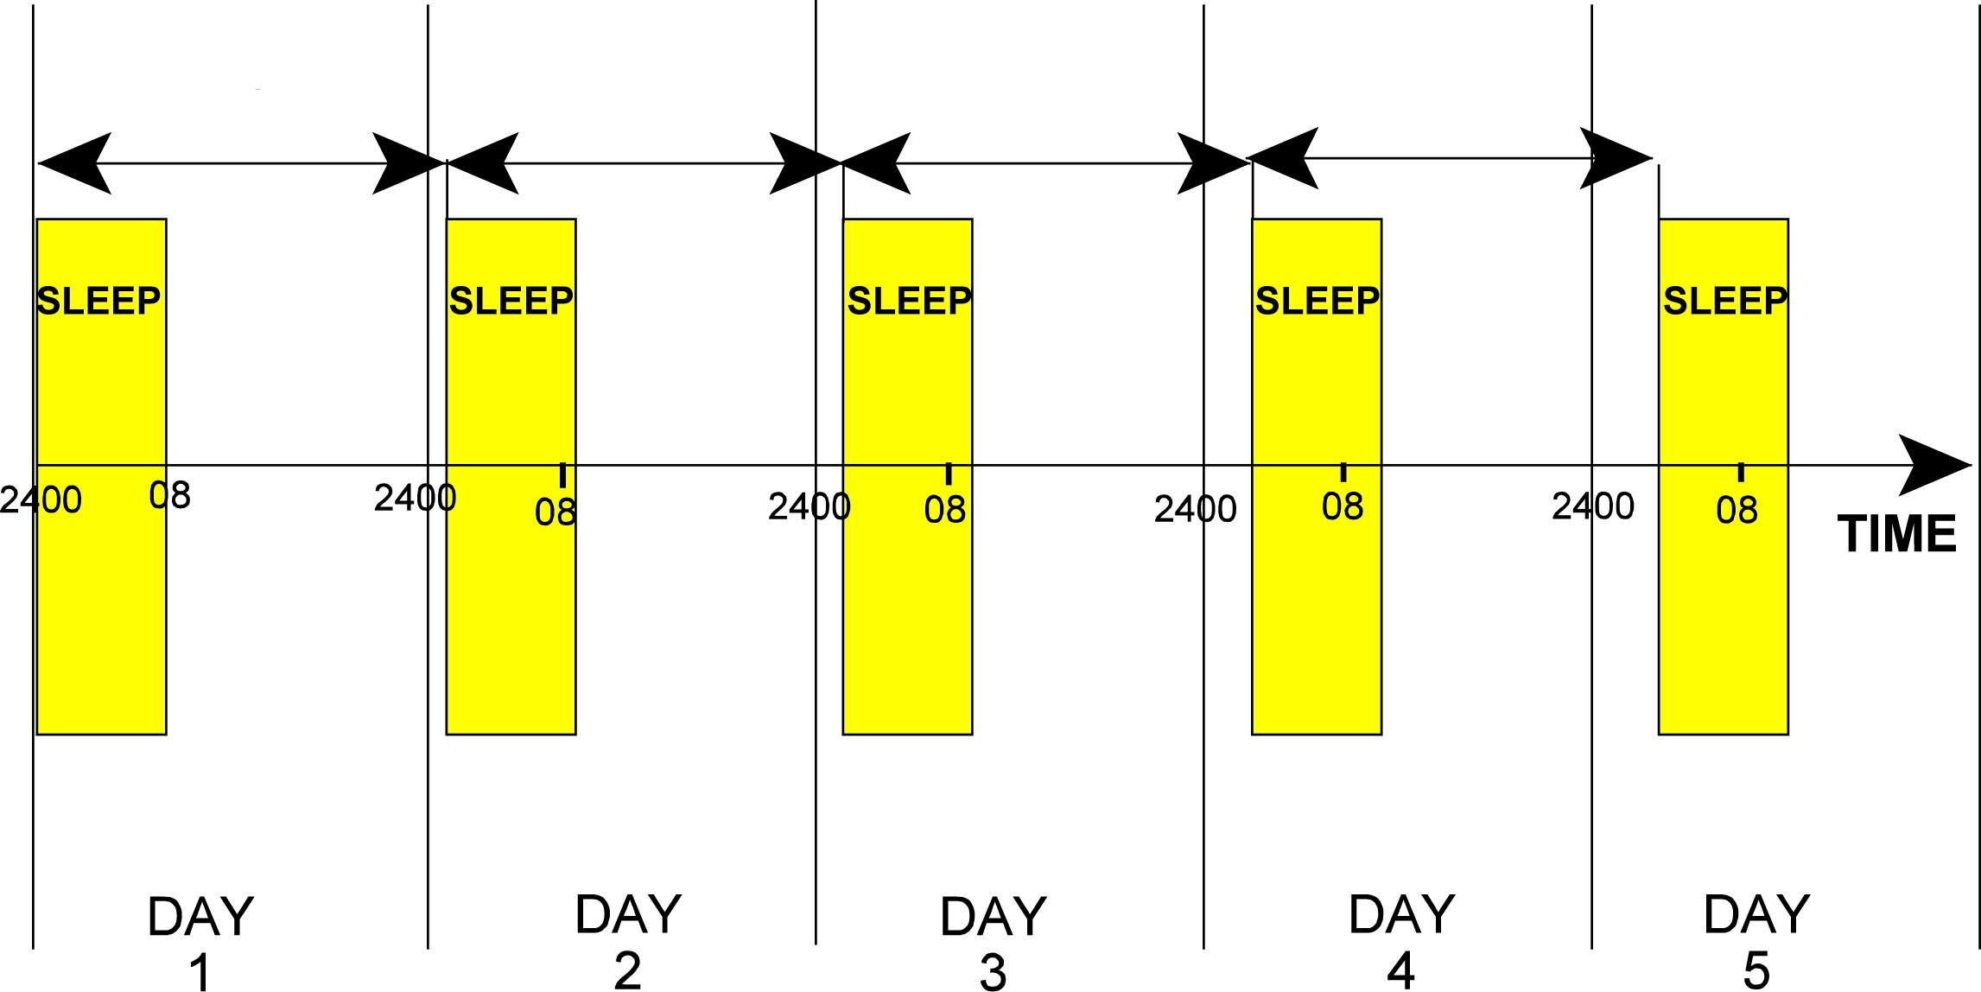

*Figure 11.1 A sleep pattern on successive days without zeitgeber cues to time*

#### Body Temperature Body Temperature and Sleep

**11**

**Sleep and Fatigue**

There is a direct relationship between our body temperature and sleep cycle. At the time of lowest body temperature we find it hardest to stay awake. We will start to feel sleepy at a time when the temperature is falling and be at our most wide awake when the temperature is rising. This relationship explains the difficulty we may have of sleeping well for a few days after time zone crossings. This is one of the symptoms of ‘jet lag’.

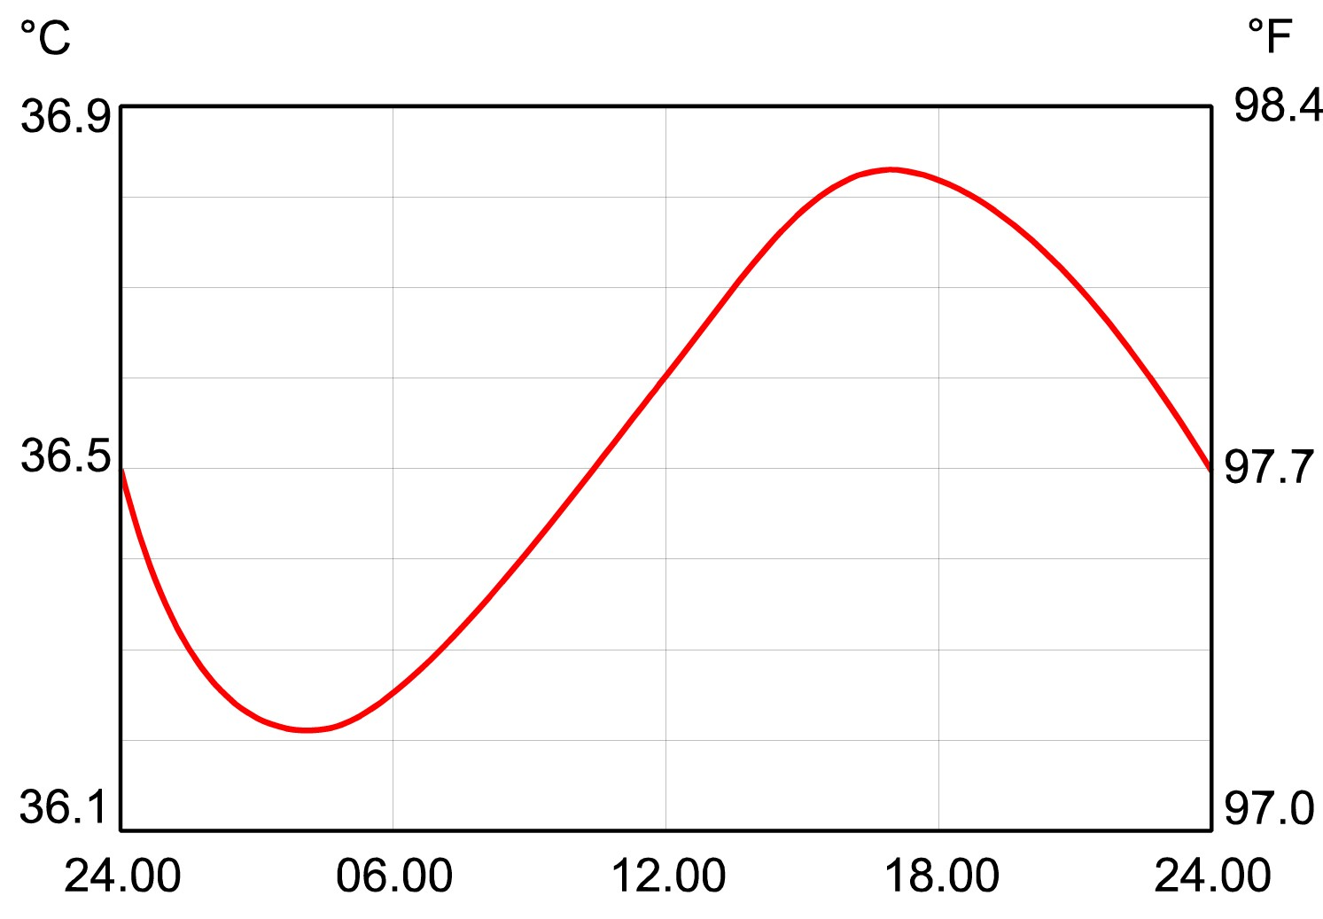

*Figure 11.2 The circadian rhythm of body temperature*

Body temperature variations throughout the day follow a regular cycle. The highest temperature occurs around 1700 hours and the lowest at about 0500 hours, at which time we are least efficient and the desire for sleep is at its peak.

#### Timing Planned Sleep

Time spent awake is important in determining readiness for sleep but there is also a circadian rhythm of sleep. This means that at certain times of the day even the sleep-deprived individual may have difficulty in falling asleep. It is the **timing** of sleep not the amount of time awake that is the **critical** factor in determining sleep duration. As indicated earlier, the duration of sleep is linked to the body temperature cycle.

Sleep taken at times near the temperature peak or when the temperature is falling will be longer and more refreshing than sleep taken when body temperature is rising. Aircrew attempting to sleep when the body temperature is on the rise will have considerably more difficulty getting to sleep, and if successful, will usually awaken within a relatively short period of time.

### Time of Day and Performance

As well as the circadian rhythms of temperature and other basic physiological processes, there are rhythms for more complex behaviours. Performance of different tasks is affected by the time of day. Simple tasks, requiring little short-term memory input, follow the pattern of body temperature. Performance improves as temperature increases and declines as the temperature decreases. Performance using short-term memory tasks declines throughout the day. Verbal reasoning and mental arithmetic skills peak around midday.

**Sleep and Fatigue**

**11**

Accident statistics have been examined to detect a correlation between time of day and accidents. It has been found that driving accidents peak at certain times of the day, for example 1500 hours, but other factors, such as traffic density and road conditions will also affect the results.

With regards to aviation accidents, the time of day has been noted as a causal factor in a number of incidents.

### Credit/Debit Systems

#### General

The sleep/wake cycle can be thought of as a credit and debit system. In this system the individual is given two points for every hour spent asleep and has one point deducted for every hour spent awake. This is only a rough measure, as individuals vary considerably in the amount of sleep they require. ***Sleep Credit Limit***

The maximum credit available is **16 points.** You cannot store credit points above 16 in anticipation of a long period of awake. A sleep of 10 to 12 hours after a long period of strenuous activity will only give the 16 credits and the individual will feel sleepy again after 16 hours, not after 20 to 24 hours.

However, if a period of wakefulness is significantly foreshortened (the individual is still in a state of sleep credit) then a good sleep is unlikely.

#### Sleep Debit

The fewer points you have the readier you are to sleep. Normally the person will sleep when he/she has little or no credit and will sleep for about eight hours, followed by a wakeful period of about sixteen hours when the sleep credit will be exhausted. A gradual reduction in level of credit may build up over a period of time as a **‘cumulative sleep debt’**. It is important to realize performance reduction, resulting from sleep deprivation, increases with altitude.

### Measurement and Phases of Sleep

*(see Figure 11.3)*

#### Measurement

Laboratory experiments have revealed a great deal about the various sleep phases. Volunteers have undergone a number of measurements and observations whilst they are asleep. The devices used include:

* **Electroencephalogram** (EEG) - to record the electrical activity of the brain
* **Electrooculogram** (EOG) - to measure eye movement within the eye socket
* **Electromyogram** (EMG) - to measure muscle tension or relaxation

#### Sleep Stages

*(see Figure 11.3)* The stages of sleep are classified into 4 stages:

**11**

**Sleep and Fatigue**

**Stage 1**

The sleeper is in a very light sleep. It is a transitional phase between waking and sleeping; if woken at this stage the volunteer may claim that he has not even been asleep. In early sleep we pass through about 10 minutes of stage 1 before moving to the deeper stage 2.

**Stage 2**

In early sleep we spend about 20 minutes in stage 2 before moving on to the deeper stages 3 & 4. About 50% of a normal sleep is spent in stage 2.

**Stages 3 & 4**

During Stages 3 & 4 sleep:

* The brain is semiactive emitting long slow waves measured by EEG tracings and thus it is commonly referred to as **‘slow wave’** or **orthodox** sleep.
* The eyes are stationary behind the eyelids.
* The muscles are relaxed.
* Choking or crushing dreams.

*Figure 11.3 Sleep profile for a typical night’s sleep*

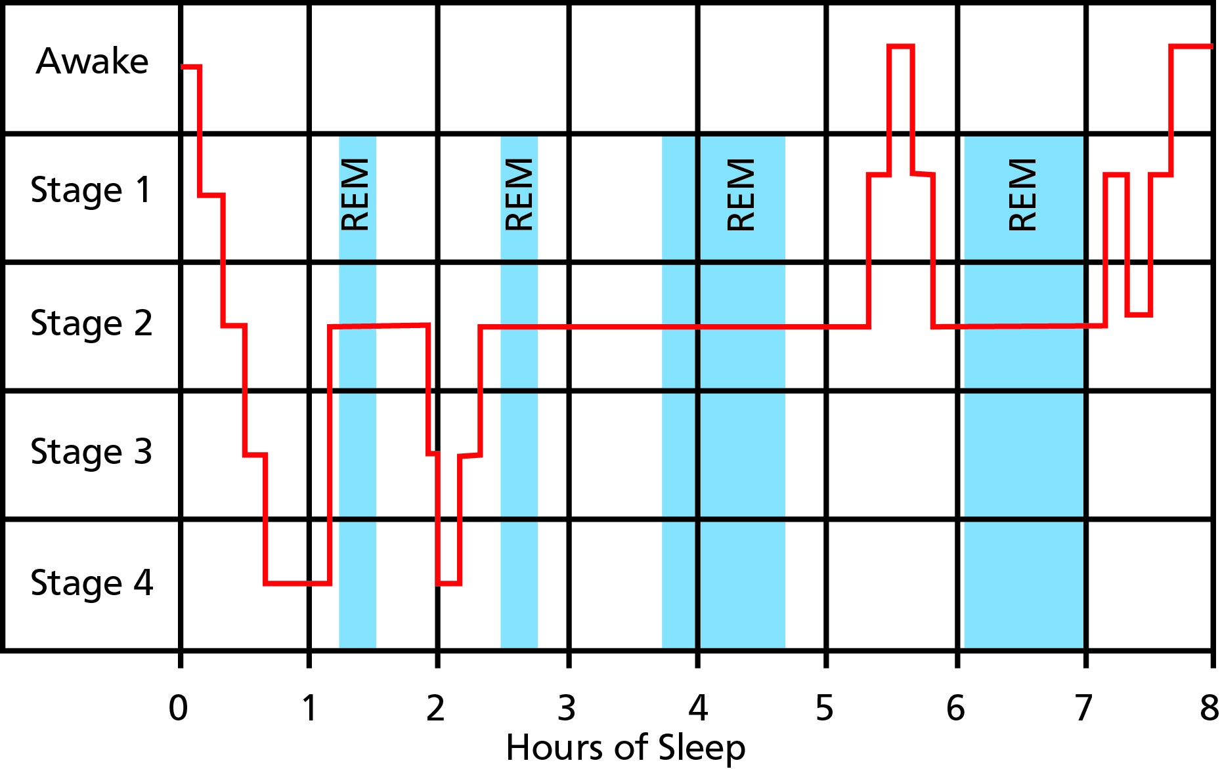

#### Function of Slow Wave Sleep (Orthodox Sleep)

Slow wave sleep refreshes the body and is necessary for tissue restoration. After strenuous physical activity the body will require more slow wave sleep.

#### Rapid Eye Movement (REM) Sleep

Superimposed on the above 4 stages is REM (sometimes referred to as **paradoxical sleep**) which is quite different from orthodox sleep. In this phase:

* The brain is active and the EEG trace is similar to that of an individual who is fully awake whilst the other measurements show the person to be asleep.
* Rapid eye movement behind the eyelids are detected.

**Sleep and Fatigue**

**11**

* Whereas there is near total muscle paralysis (thought to prevent the sleeper acting out dreams), there is frantic movement of the muscles of the eye. This motor activation occasionally breaks through resulting in twitching of the limbs.
* Complex, bizarre, and emotionally-coloured dreams take place.

#### Function of REM Sleep

REM sleep refreshes the brain. It strengthens and organizes the memory. After a period of learning new tasks or procedures REM sleep will increase. In addition, REM sleep contributes significantly to emotional equilibrium and good humour. Thus, irritability normally follows a period of disrupted sleep.

#### Characteristics of Orthodox and Paradoxical Sleep

Some characteristics of orthodox and paradoxical sleep are:

|  |  |  |
| --- | --- | --- |
| **Characteristic** | **Orthodox Sleep** | **Paradoxical Sleep** |
| EEG (brain waves) | Large slow waves | High frequency |
| EOG (eyes) | Still | Rapid eye movements |
| EMG (throat) | Relaxed muscles | Tensed muscles |
| ECG (heart) | Regular | Irregular |
| Dreaming | Normally no recall | Recall |
| Sleep walking | Yes | No |
| Body movements | Less frequent | More frequent |
| Stomach acids | Steady | Increase |
| Function | Tissue restoration | Memory organization |

#### Sleep Cycles

During any normal night’s sleep the pattern operates on an approximately 90 minute cycle. Towards the end of the first 90 minutes of falling asleep the first REM stage occurs but this first REM experience lasts only 10 to 20 minutes before the person passes back into slow wave sleep.

**11**

**Sleep and Fatigue**

At the end of the second cycle of 90 minutes the duration of REM sleep periods increases.

#### Sleep Profile

A sleep profile for a typical night’s sleep is shown in *Figure 11.3*. The individual stages will vary depending on the activities prior to sleep. If a great deal of strenuous physical activity has taken place then the sleep stages 3 and 4 will be extended. Alternatively, if a lot of mental work has been undertaken, such as learning new information or procedures, then REM sleep will be increased. ***Rebound Effect***

Sleep deprivation experiments have shown that if a person is deprived of either slow wave or REM sleep there will be a **‘rebound’** effect in the next sleep period. That is the individual will make up the deficit in either case. For example if one is woken after 3 hours of a normal sleep period then the body will have had all its required slow wave sleep, but be deficient in REM sleep. In the next sleep period it is found that REM sleep will occur earlier and last longer than normal.

### Age and Sleep

Individuals differ in the amount of sleep they require. In a survey of one million people the most frequently reported sleep duration was between 8 and 9 hours. Some people seem able to do with much less sleep and can manage quite well on 3 to 4 hours per night.

Ageing brings major changes in sleep requirements. New born babies may sleep for up to 23 hours per day (of which the majority is REM) and even as they grow older will require much more sleep than adults. However as people get older they sleep less but at the same time, become less flexible about when sleep is taken. Shift work becomes more difficult with age as it is much harder to reprogramme the body clock. Women tend to sleep longer than men but report more sleep problems.

### Naps and Microsleeps

#### Naps

A nap is a short period of sleep taken at any hour. The time of day, the duration of the nap and the sleep credit/deficit of the individual will determine through which sleep stages the individual will pass. The restorative properties of naps will vary from one individual to another. Those who habitually take naps appear to gain more benefit than non-habitual nappers, who sometimes perform at a reduced level for some time after awakening from the nap.

With the increase in extended flight times there is debate about allowing a crew member to take 20 to 30 minute naps in the seat in an effort to keep him/her fresh. There would appear to be some benefit but pilots should be aware of the pitfalls. It is not unknown for one of the pilots to be taking a nap and the other pilot to fall asleep.

Pilots should also be aware that after napping it may take some minutes to collect one’s thoughts and they will have slow responses and reactions for up to 5 minutes after being roused. The minimum duration for a nap to be restorative appears to be **not less than** 10 minutes (Hawkins). It is strongly recommended that pilots should plan to be fully awake at least 1 hour before descent.

#### Microsleeps

**Sleep and Fatigue**

**11**

Microsleeps are very short periods of sleep lasting from a fraction of a second to two to three seconds. Although their existence can be confirmed by EEG readings, the individual may be unaware of their occurrence which makes them particularly dangerous. They occur most often in conditions of fatigue but are of no assistance in reducing sleepiness.

### Shift Work *General*

Sleep loss or partial sleep is an occupational hazard of commercial aviation. There will be times when the pilot has to work when he would rather be asleep, and other times when he has to sleep when he would rather be awake. At these times sleep problems may be aggravated by circadian rhythms.

The sleep/wake cycle affects readiness for sleep, and the **timing** of sleep relative to the body cycle of temperature is critical in determining the duration of the sleep.

#### Planning Shift Work Sleep

As an example it is assumed that one is rostered for night duty. The pilot will attempt to get some sleep during the afternoon prior to reporting for duty. However, it will be difficult to get any satisfactory sleep due to having a good sleep credit assuming a normal night’s sleep had been achieved the night before, plus an increasing body temperature does not facilitate sleep.

There are basically two options in this case:

Firstly, one could go to bed early the previous night and set the alarm for an early call so that, by the afternoon, the body will be approaching sleep deficit and be ready for sleep. The second alternative would be to go to bed late the previous night, sleep late, relax in the afternoon and still have a good sleep credit for the night duty.

Both solutions have limitations. In the first case, having gone to bed in the afternoon, sleep may be impossible due to outside noise, daylight entering the room or, if in a hotel, construction work or domestic work in the corridors, in which case one may go on duty with an even greater sleep deficit. The second solution will prove useless if, having prepared oneself for five to six hours duty, the trip is delayed for a few hours for technical, weather, or air traffic reasons.

Generally, it is now accepted that shift rotation should be to later shifts (early shift to late shift to night shift and so on).

### Time Zone Crossing

#### General

Crossing time zones is a way of life for long haul aircrew, and time zone shifts can lead to cumulative sleep deprivation. Although such sleep deficits can build up, it is unlikely to go to extreme levels as the body will sleep when it needs to. Long haul pilots have constantly to adjust and readjust their circadian rhythms, and it is possible that continual disruption may incur some health penalties, particularly associated with stomach and bowel disorders. The disturbance to the normal body functions is commonly known as **jet lag** or **circadian dysrhythmia.**

#### Circadian Dysrhythmia (Transmeridian Desynchronisation)

The internal body rhythms become of great significance in the modern age of rapid air travel. This leads to a large discrepancy between the local time at destination and the body clock of the traveller.

**11**

**Sleep and Fatigue**

For example it may be local noon for the traveller arriving in Los Angeles, but his body clock will still be based on a UK time of 2000 hours, possibly leading to an internal conflict. After a sleep the internal body clock will indicate a time to wake up when the local time is 0100 hours.

These factors are of great significance to the pilot who may have to sleep during local day hours or operate a long flight at a time when his body clock is indicating a time for sleep. In addition to this, normal rhythms of the alimentary canal (the passage along which food passes during digestion) and urinary system can cause disruption to sleep in the new time zone.

#### Recovery

The shifting of zeitgebers will help to resynchronize to the new local time but it is a slow process, averaging a shift of **about 90 minutes for each day in the new time zone.** A shift of 9 hours in local time, for example, on a flight direct from London to Los Angeles, will require about 6 days for the body to adjust to the local time. The pilot may only have 2 or 3 days before return to London and when he does return his body clock is now out of synchronisation again.

Another factor to be considered is that body systems shift their phase at different rates, so while they are shifting, they are not only out-of-phase with the local time, but out-of-phase with each other. ***Effects of Direction on Recovery - East or West, which is Best?***

The effects of jet lag and its recovery will also be dependent on the direction of travel. The following two examples illustrate this phenomena.

**Travelling Westwards**

(London - New York)

New York is 5 hours behind London so noon occurs 5 hours later. This means that an aircrew will experience a 29 hour day. However, our free-running body clock is 25 hours which means that the crew will suffer from **4 hours jet lag.**

**Travelling Eastwards**

(New York - London)

London is 5 hours ahead of New York so noon occurs 5 hours earlier. This means that an aircrew will experience a 19 hour day. However, our free-running body clock is 25 hours which means that the crew will suffer from **6 hours jet lag.**

**Sleep and Fatigue**

**11**

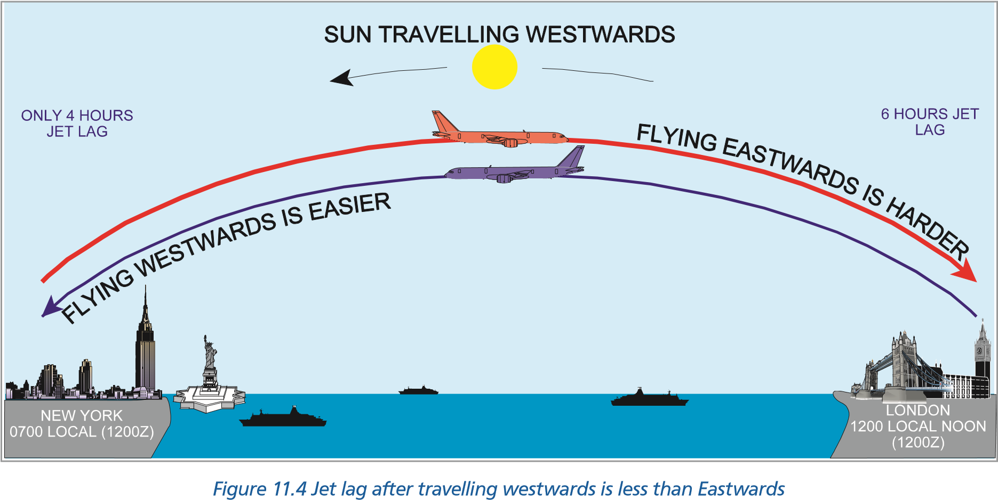

#### Recovery Techniques

The method of dealing with circadian dysrhythmia is a major research area in aviation. With the differences in individual pilots’ reaction to time zone changes and rates of resynchronisation there cannot be any hard and fast rules. Each individual must work out his/her own methods for dealing with the problem but there are some generally accepted techniques. See examples below.

#### Short Stopover - Less Than 24 Hours

If the stopover is of short duration with a rapid return to base, it may be advisable to try to maintain home time in one’s activities. For example eating breakfast at home base time rather than conforming to local time and sleeping at normal home time hours.

#### 24 Hours - the Most Difficult Stopover

One of the worst time intervals to spend on a stopover is 24 hours. This does not allow time for two good sleep periods but is too long a period to cover with only a single sleep session. This may involve taking a limited rest period on arrival so that at a later time the body will be more ready to sleep for a longer period before call for duty. As will be seen in the example below, the options open are not easy. ***Stopover - More Than 24 Hours***

For longer stops it is recommended that you plan to readjust to the new local time as soon as possible.

### Sleep Planning

To ensure that you have the maximum amount of beneficial sleep before arriving at work to fly it is recommended that you base your calculations on three simple rules:

#### Basic Rules

To calculate the required sleep pattern there are three simple rules:

**Rule 1** 1 hour’s sleep = 2 hours awake.

**Rule 2**  The required sleep must be taken immediately prior to the wake-up call for duty.

**Rule 3** Use the “3 in 1 Rule”. (Rule 1 gives units of three hours which we can use to calculate the required amount of sleep needed.

#### Example

A pilot flies from London to New York (5 hours behind UTC for a 24 hour stopover. He/she arrives at the hotel room at 2100 hours local time with no sleep credits. The following duty day is scheduled to be 16 hours.

#### Solution 1

The pilot requires 8 hours sleep (Rule 1) for the duty day ahead and this must be taken immediately prior to the wake-up call (Rule 2). The problem is how best to organize his/her sleep pattern.

The pilot has 16 hours before he/she **must** go to sleep to ensure the maximum amount of credit. Using Rule 3, divide 16 hours by 3 and we find that 5 hours 20 minutes of sleep is required. This sleep could be taken as:

**11**

**Sleep and Fatigue**

|  |  |  |  |
| --- | --- | --- | --- |
| **State** | **Local Time** | **Body Clock Time** | **Sleep Credits** |
| Sleep | 2100 - 0220 | 0200 - 0720 | 10 hours 40 minutes |
| Awake | 0220 - 1300 | 0720 - 1800 | 0 |
| Sleep | 1300 - 2100 | 1800 - 0200 | 16 hours |

#### Advantages

* The second sleep will be of good quality as sleep credit is 0 and the body temperature is decreasing for much of the time.
* Only one disruption of sleep.

#### Disadvantages

* First sleep period will be of mixed quality as although there is 0 credit the body temperature is on the rise for part of the time.
* Unsociable time to be awake and the temptation to sleep again prior to 1300 hours will be strong.

Another possible way to organise the 5 hour 20 minutes of sleep prior to the time when he/ she **must** sleep is:

#### Solution 2

The pilot has a short sleep (1 hour 20 minutes) and then enjoys the local nightlife. He/she has a further period of sleep to give sufficient credits before the third and final sleep period immediately prior to duty day.

|  |  |  |  |
| --- | --- | --- | --- |
| **State** | **Local Time** | **Body Clock Time** | **Sleep Credits** |
| Sleep | 2100 - 2220 | 0200 - 0320 | 2 hours 40 minutes |
| Awake | 2220 - 0100 | 0320 - 0600 | 0 |
| Sleep | 0100 - 0500 | 0600 - 1000 | 8 hours |
| Awake | 0500 - 1300 | 1000 - 1800 | 0 |
| Sleep | 1300 - 2100 | 1800 - 0200 | 16 hours |

#### Advantages

* More sociable times to be awake.
* Both first and last sleep periods will be of good quality as credits are 0 and body temperature is on the decrease.

#### Disadvantages

* Very disrupted sleep pattern and it will be hard to stick to the schedule.

**Sleep and Fatigue**

**11**

* Middle sleep period will be or poor quality as body temperature will be rising.

### Sleep Hygiene

If your body really needs sleep it will sleep under almost any condition. If one is attempting to sleep whilst still in sleep credit or at a time of low circadian sleepiness then:

* Avoid drinks containing caffeine near bedtime (coffee, tea, cola and a number of fizzy soft drinks). Caffeine affects both Stage 4 and REM sleep. When caffeine is removed from a drink, the sleep-disturbing effect is also removed. (Aspirin also contains caffeine).
* Avoid napping during the day.
* Make sure the room and bed are comfortable, with any daylight excluded, air conditioning working, and ensure insects (especially the biting or stinging variety) are not able to enter the room.
* Avoid excessive mental stimulation, emotional stress.
* A warm milky drink, light reading, or simple progressive relaxation techniques will all help to promote sleep.
* Avoid alcohol and heavy meals.

### Sleep and Alcohol

Alcohol is widely used by aircrew as an aid to sleep. It is however a non-selective central nervous depressant. It may induce sleep but the sleep pattern will not be normal as **REM sleep will be reduced considerably** and early waking is likely.

### Sleep Disorders *Narcolepsy*

An inability to stop falling asleep even when in sleep credit. Specialists believe that this is associated with the inability of the brain to distinguish between wakefulness and REM sleep. This condition is clearly undesirable in aircrew as the sufferer may go to sleep at any time, even in a dangerous situation.

#### Apnoea

A cessation of breathing whilst asleep. This is quite a common condition and the subject will normally either wake up or restart breathing after a short time.

It becomes a more serious problem when the breathing stoppage lasts for up to a minute and the frequency of stoppages increases. The frequent awakenings will disturb the normal sleep pattern and the individual may experience excessive daytime sleepiness. Other clinical problems may be involved and medical advice should be sought.

#### Sleepwalking (Somnambulism)

**11**

**Sleep and Fatigue**

This condition, as well as talking in one’s sleep, is more common in childhood, but does occur later in life. It may happen more frequently in those operating irregular hours or those under some stress. The condition should not cause difficulty in healthy adults unless the sleep walker is involved in an accident whilst away from his bed. Sleepwalking, as night terrors, happens during non-REM sleep.

#### Insomnia

This is simply the term for difficulty in sleeping. It may be divided into:

**Clinical Insomnia**

This describes the condition when a person has difficulty in sleeping under normal, regular conditions in phase with the body rhythms. In other words, an inability to sleep when the body’s systems are calling for sleep.

It must be understood that clinical insomnia is rarely a disorder within itself. It is normally a symptom of another disorder. For this reason the common and symptomatic treatment with sleeping drugs or tranquillisers is inappropriate unless treatment for the underlying cause is also undertaken.

**Situational Insomnia**

There is an inability to sleep due to disrupted work/rest patterns, or circadian dysrhythmia. This often occurs when one is required to sleep but the brain and body are not in the sleeping phase. This condition is the one most frequently reported by aircrew.

### Drugs and Sleep Management

People’s tolerance to sleep disturbance varies and some individuals may require the assistance of drugs to obtain sleep or to stay awake. The commonest drug used to delay sleepiness is caffeine, contained in tea or coffee, and this will assist the user to stay awake.

Wide publicity has been given to melatonin as a cure of jet lag. Aircrew should not take this drug or any other drug or medicine without first seeking advice from his/her aviation medical specialist.

Barbiturates and benzodiazepines (valium, mogadon, librium and normison) must be rigorously avoided. Barbiturates are not only addictive but fatal if taken in overdose. Contrary to common belief, benzodiazepines can be addictive and all have an adverse effect on performance - especially if taken with alcohol. There is no place in aviation for such drugs except under the strict supervision of an aviation medical specialist.

#### Fatigue Introduction

Fatigue is deep tiredness and, similar to stress, it is **cumulative** and can be caused by:

* A lack of restful sleep.
* A lack of physical or mental fitness.

**Sleep and Fatigue**

**11**

* Excessive physical or mental stress and anxiety.
* Desychronisation of the body cycles (jet lag).

Whereas tiredness is instantly recognisable by the sufferer and is an acceptable social admission, fatigue is more insidious. A pilot suffering from fatigue can be unaware of his/her condition for a long period of time until a crisis forces realisation. Even if aware that fatigue is a problem, a pilot will be hesitant to admit the fact openly. It appears to be akin to an admission that he/she is not up to the job. It is critical to be able to recognize the symptoms of fatigue both in yourself and, just as importantly, in other members of your crew.

Fatigue can be subdivided into short and long-term (chronic) fatigue.

#### Short-term Fatigue

As implied, this type of fatigue is akin to tiredness. It is usually due to a lack of sleep, hard physical or mental exertion, crew scheduling, a long duty period, lack of food or jet lag. Short- term fatigue is easily recognized and remedied by not flying and sufficient rest.

#### Long-term (Chronic Fatigue)

Long-term fatigue is much more difficult to recognize and admit. It can come from a number of different causes which may include a lack of physical or mental fitness, a stressful marriage coupled with problems at work, financial worries and a high workload. It also can be subjective, one pilot being able to tolerate more than the next before chronic fatigue sets in. Anyone who suspects that they are suffering from chronic fatigue must take themselves off flying.

#### Symptoms of Fatigue

The symptoms of fatigue can be:

* Lack of awareness.
* Diminished motor skills.
* Obvious tiredness.
* Diminished vision.
* Increased reaction time.
* Short-term memory problems.
* Channelled concentration.
* Easily distracted.
* Poor instrument flying.
* Increased mistakes.
* Irritability and/or abnormal mood swings.
* Reduced scan.
* Reversion to ‘old’ habits.
* Decrease in communication.

#### Delaying the Onset of Fatigue

Some of the actions that may be considered to avoid fatigue:

**11**

**Sleep and Fatigue**

* Accept that fatigue is a potential problem.
* Plan sleep strategies proactively (plan sleep ahead of the next day’s activities).
* Use exercise as part of the relaxation period and ensure you are fit.
* Avoid alcohol.
* Eat a regular and balanced diet.
* Have your emotional and psychological life under control.
* Ensure cockpit comfort.
* Ensure that food and drink are available for long flights.
* Ensure your seat is properly adjusted.

### Vigilance and Hypovigilance

#### State of Vigilance

The scientific definition of vigilance differs from what we normally understand by the term. The state of vigilance is the degree of activation of the central nervous system. This can vary from deep sleep to extreme alertness and is controlled by the circadian cycle. A vigilant man is an alert man and so, in normal circumstances, as workload increases so does vigilance.

***Note:*** *Vigilance is a very different mechanism to that of attention (see Chapter 7).*

#### Hypovigilance

This occurs when sleep patterns begin to show on an EEG during activity. It is akin to a microsleep which can occur during periods of:

* Monotony.
* Reduction of workload.
* During simple or repetitive tasks.
* Constant and monotonous noise.
* Low lighting.
* High temperature.
* Isolation.
* Sleep debit.
* Fatigue.

It can also occur shortly after a meal. ***Forestalling Hypovigilance in Flight***

It is not possible to totally eliminate hypovigilance during flight and, indeed, there is a theory that hypovigilance helps to control energy consumption. However, it is prudent to endeavour to forestall this phenomenon as far as is possible. Precautions should include:

* Ensure that you have sufficient sleep credit.

**Sleep and Fatigue**

**11**

* Be aware of the physical danger signs which may include:
* Drowsiness, head dropping forward and a vague but persistent sensation of discomfort causing you to constantly shift your sitting position.
* Slower sensory perception (having to look at an instrument for a longer time than normal before digesting its information).
* Preoccupation with a problem completely outside of the current situation.
* Moodiness and a reluctance to talk.
* Move your position regularly every so often and, if possible, get up and walk a few steps in the aircraft.
* Maintain social contact with the rest of the crew.
* Vigilance decreases with lack of stimuli so keep mentally and physically active.
* Members of the crew should take their meals at different times. This goes a long way to ensuring that, if hypovigilance is to be a problem amongst the crew, its occurrence will probably be staggered. As has already been discussed, this precaution also avoids food poisoning striking more than one member of the crew at a time.

**In general there is no absolute amount of sleep that must be achieved**

**You should sleep as much as you need**

### *Questions*

#### Questions

1. **How long is a free running circadian rhythm?**
   1. 24 hours
   2. 48 hours
   3. 25 hours
   4. 29 hours
2. **When is the circadian cycle of temperature at its lowest?**
   1. At about 0500 hrs
   2. At about 0100 hrs
   3. At about 0300 hrs
   4. Varies from day to day
3. **What does the duration of sleep depend on?**
   1. The mental and physical exercise taken prior to sleep
   2. The number of hours awake prior to sleep
   3. Timing i.e. when the body temperature is falling
   4. The quality of the REM sleep
4. **What is the maximum number of “sleep credits” that can be accumulated and what is the minimum time to accumulate them?**

**11**

**Questions**

* 1. 24 credits and it will take 12 hours
  2. 8 credits and it will take 16 hours
  3. 16 credits and it will take 12 hours
  4. 16 credits and it will take 8 hours

1. **When does orthodox (slow wave sleep) occur and what does it restore?**
   1. It occurs early in the sleep cycle - stages 3 & 4 and it restores the body
   2. It occurs early in the sleep cycle - stages 3 & 4 and it restores the brain
   3. It occurs early in the sleep cycle - stages 1 & 2 and it restores the body
   4. It occurs late in the sleep cycle - stages 3 & 4 and it restores the brain
2. **If the sleeper awakes early, how does this affect the next sleep pattern?**
   1. The sleeper goes into a “sleep deficit” and will need more sleep
   2. The sleeper goes into a “sleep deficit” and will need twice the amount of sleep lost to catch up
   3. They will “rebound” so that the current sleep pattern will make up those stages lost in the previous spell of sleep
   4. The sleeper goes into a “sleep deficit” which is carried forward
3. **How many stages are there in a sleep cycle?**
   1. 3 stages plus REM
   2. 4 stages plus REM
   3. 3 stages including REM
   4. 4 stages including REM

### *Questions*

1. **How long is a sleep cycle?**
   1. 90 minutes
   2. 120 minutes
   3. 60 minutes
   4. 30 minutes
2. **What will an EOG trace during REM sleep?**
   1. Little activity
   2. A lot of activity
   3. Intermittent activity
   4. No activity
3. **What is the function of REM sleep?**
   1. To refresh the body after exercise
   2. To refresh the body and brain following physical and mental activity
   3. To assist in the organization of memory and helping to coordinate and assimilate new information learned
   4. To exercise the brain so it is prepared for the next day

**Questions**

**11**

1. **As a general rule, if a pilot is rostered for a flight which returns within 24 hours, should he adjust his/her sleep pattern?**
   1. Yes
   2. Yes - as soon as possible
   3. Yes - over the next 48 hours
   4. No - stay on UK time
2. **As a general rule, if a pilot is rostered for a flight which has 24 hours or more in a country where there is a time zone difference, should he adjust his/her sleep pattern?**
   1. Yes and try and arrange it so that the sleep pattern allows 8 hours sleep before wake- up call
   2. Yes and try and arrange it so that the sleep pattern allows 10 hours sleep before wake- up call
   3. No - stay on UK time
   4. No - not necessary unless he/she stays for over 48 hours
3. **How long does it take for the circadian rhythm to resynchronize to local time after crossing time zones?**
   1. Approximately 2 days per 1 to 2 hours of time change
   2. Approximately 1 day per 1 to 2 hours of time change
   3. Approximately 2 days per 1 to 1½ hours of time change
   4. Approximately 1 day per 1 to 1½ hours of time change

### *Questions*

1. **Does it make any difference to the circadian rhythm adjusting to time zone changes if the flight is to the East or West?**
   1. Yes, due to the free running of the circadian rhythm tends to adjust more quickly to West bound flights
   2. Yes, due to the free running of the circadian rhythm tends to adjust more quickly to East bound flights
   3. No - it make no difference. West or East have the same effect
   4. Yes, due to the free running of the circadian rhythm tends to adjust more slowly to West bound flights
2. **What effect does drinking alcohol before sleep have to the sleep pattern?**
   1. A small amount (one beer or a small whisky) is of help to relax the body prior to sleep and thus enhances the sleep pattern
   2. It lengthens REM sleep and the length of sleep
   3. It shortens REM sleep and the length of sleep
   4. It has no significant effect on the sleep pattern itself but does affect other systems of the body adversely
3. **When suffering from sleep deprivation, will performance be further decreased by altitude?**
   1. No

**11**

**Questions**

* 1. Yes
  2. Sometimes
  3. Under certain circumstances

1. **Hypovigilance is akin to a microsleep.**
   1. True
   2. False
2. **The two forms of fatigue are:**
   1. mental and physical
   2. short-term and chronic
   3. mental and body
   4. psychological and physiological
3. **Insomnia is divided into:**
   1. psychological and physiological
   2. mental and physical
   3. clinical and situational
   4. clinical and physiological
4. **Can you fly suffering from narcolepsy?**
   1. Under the strict supervision of an aviation medical specialist
   2. Sometimes - it depends on the degree
   3. Never
   4. By day only

***Questions***

**Questions**

**11**

### *Answers*

**11**

**Answers**

#### Answers

|  |  |  |  |  |  |  |  |  |  |  |  |
| --- | --- | --- | --- | --- | --- | --- | --- | --- | --- | --- | --- |
| 1 | 2 | 3 | 4 | 5 | 6 | 7 | 8 | 9 | 10 | 11 | 12 |
| c | a | c | d | a | c | b | a | b | c | d | a |
| 13 | 14 | 15 | 16 | 17 | 18 | 19 | 20 |
| d | a | c | b | a | b | c | c |

Chapter

## **12** Individual Differences and Interpersonal Relationships

Introduction. . . . . . . . . . . . . . . . . . . . . . . . . . . . . . . . . . . . . . . . . . . . .227

Personality. . . . . . . . . . . . . . . . . . . . . . . . . . . . . . . . . . . . . . . . . . . . . .227

Interactive Style . . . . . . . . . . . . . . . . . . . . . . . . . . . . . . . . . . . . . . . . . . .231

The Individual’s Contribution within a Group. . . . . . . . . . . . . . . . . . . . . . . . . . .232

Cohesion. . . . . . . . . . . . . . . . . . . . . . . . . . . . . . . . . . . . . . . . . . . . . . .234

Group Decision Making. . . . . . . . . . . . . . . . . . . . . . . . . . . . . . . . . . . . . . .234

Improving Group Decision Making . . . . . . . . . . . . . . . . . . . . . . . . . . . . . . . .237

Leadership. . . . . . . . . . . . . . . . . . . . . . . . . . . . . . . . . . . . . . . . . . . . . .238

The Authority Gradient and Leadership Styles . . . . . . . . . . . . . . . . . . . . . . . . . .243

Interacting with Other Agencies. . . . . . . . . . . . . . . . . . . . . . . . . . . . . . . . . .246

Questions . . . . . . . . . . . . . . . . . . . . . . . . . . . . . . . . . . . . . . . . . . . . . .247

Answers . . . . . . . . . . . . . . . . . . . . . . . . . . . . . . . . . . . . . . . . . . . . . . .250

**12**

**Individual Differences and Interpersonal Relationships**

### Introduction

This chapter should be read in conjunction with Chapter 13 (Communication and Co-operation) since both are part of the bigger picture of individual differences, communications and intercrew cooperation.

#### Personality Introduction

People differ from one another in many respects such as size, skin colour, gender, intelligence and personal characteristics. Some of these differences are irrelevant in aviation, but many are not. The size of an individual may limit the type of aircraft flown, and the personality and intelligence of an individual will determine the way that he or she interacts both with other crew members and people in general.

Personality traits are initially innate - inherited through genes - and acquired very early in life. They are deep-seated characteristics which constitute the essence of a person. They are stable and very resistant to change. However, over time, personality can be influenced and developed by outside factors and thereby undergo a degree of change. These changes can occur at any stage in a person’s life.

One of the greatest challenges in psychology is to understand how much people bring into the world - their biological/genetic nature - and how much the environmental conditions and events affect them after they arrive (nurture). It is generally accepted today that the two intertwine to shape personality and mental processes. Thus heredity, upbringing and experience all tend to contribute to a greater or lesser degree.

**Individual Differences and Interpersonal Relationships**

**12**

One useful way of thinking about the relative contributions of nature and nurture is to think of genetics as roughly defining a fairly broad potential of range of abilities and nurture as pushing a child up or down within this range.

#### Self Concept

A child first develops an awareness of himself/herself as an entity separate and distinct from the environment surrounding him because other people respond to him as a separate and autonomous object.

As he/she (referred to as he for the rest of this chapter) develops a concept of “self”, he becomes aware of himself as an object of his own perception. Furthermore his own evaluation of himself arises *as a reflection of others’ evaluation*. As he grows his personality is gradually developed by social interaction with other people.

Thus it is possible to say that:

* Self-concept is crucial to any change or adjustment in personality.
* Self-evaluation changes in response to changes in other’s evaluations of oneself.

To amplify the two statements, a gradual change in personality will only take place if either the individual is unhappy about the person he sees himself to be or this realization is triggered by the reaction of others to him. For example, a spoilt and only child is sent to school and, from the reaction of other children to his selfishness, realizes the kind of personality he has and may deliberately set about to change it.

Many outside sources may also influence personality. Success is one of these. An under- confident co-pilot is promoted to Captain and, with the realisation of his own capabilities, becomes assured when dealing both with his work and others around him. Other factors influencing personality are social origins, education and past experience.

#### Defining Personality

Personality is the term used to embrace all those stable behavioural characteristics that are associated with an individual and it is extremely important when determining relationships with others. It refers to the total organization of the individual’s motives, attitudes, beliefs, ways of perceiving and of behaving.

We are all used to the common descriptive words and phrases used to describe individuals - ‘a daredevil’, ‘a good sport’, ‘a sour faced skinflint’ or ‘a good listener’ for example. These terms, however, are unscientific and too general for use in assessing personality with any degree of accuracy.

#### Personality, Attitude and Behaviour

Attitude and behaviour differ from personality in that **attitude** is a way of believing and feeling about an object or class of objects. Attitudes are learnt and they may be general or specific. They represent predispositions to respond, favourably or unfavourably, towards the “target” of the attitude. Unlike personality, there seems to be no real evidence that attitudes are genetic. ***Behaviour***

**12**

**Individual Differences and Interpersonal Relationships**

Is the outward result of both personality and attitude. However, behaviour is not always the *natural* outcome since behaviour may be controlled if the individual is so motivated. We are all able to adapt our behaviour to the circumstances or, indeed, the person with whom we are associating at the time. This ability is particularly important in a pilot who has to fly with many differing and diverse personalities. ***Assessing Personality***

We all make assessments of personality in any social encounter. We even make quick decisions on a stranger’s personality by their appearance or dress. To illustrate this, study *Figure 12.1* in which individuals are classified into three groups: **endomorphic, mesomorphic,** or **ectomorphic.**

The endomorph is soft and round in physical appearance and we tend to think of him as easy going, sociable and self-indulgent. The mesomorph appears physically hard, muscular, and rectangular, and is considered to be psychologically restless, energetic, and insensitive. Finally the ectomorph is physically tall, thin and fragile and is looked upon as introspective, sensitive and nervous.

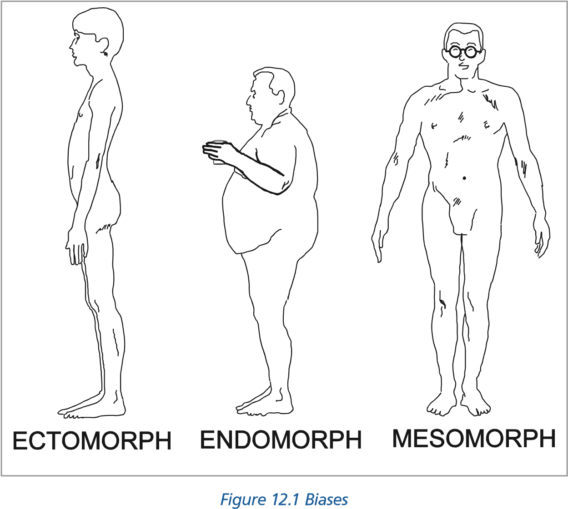

#### Personality Questionnaires and Interviewing Techniques

Although we do make judgements of personality from a person’s appearance, our assessments are often wrong. Irrespective of the number of times that we have been proved incorrect in our initial assessment we still tend to stick to these preconceived images when meeting a stranger.

Personality may be assessed by various techniques such as single or panel interviews, projective tests, and even role play. However, it has been proved that the written questionnaire is, on the whole, the most reliable form of personality assessment.

#### Dimensions of Personality

Personality, attitudes and beliefs are intangible in as much as they cannot be isolated or studied directly but only inferred from what a person says or does. Personality may be classified in a number of dimensions. The major dimensions may be said to be extraversion and anxiety but other major traits such as warmth and sociability, impulsiveness, tough-mindedness, dominance, stability and boldness will all contribute to the overall personality of the individual. ***Extroversion and Anxiety***

**Individual Differences and Interpersonal Relationships**

**12**

At the very basic level extroversion may be associated with boldness, impulsive behaviour and sociability.

Anxiety is normally linked to emotional instability, tension and suspiciousness. As extroversion and anxiety are not related to one another, some people may be anxious and extroverted, others anxious and introverted.

The results from a series of tests or questionnaires may be plotted on a simple two dimensional graph of personality with axes of extroversion and anxiety, see *Figure 12.2*. Most people will be about the average in both dimensions.

As deviation from the average increases so the characteristics of that personality become more pronounced, for example:

* The anxious extrovert will be regarded as aggressive and changeable.
* The stable introvert will be regarded as thoughtful and controlled.
* An anxious introvert will seem sober and pessimistic.
* Stable extroverts will be seen as responsive and easy going.

**12**

**Individual Differences and Interpersonal Relationships**

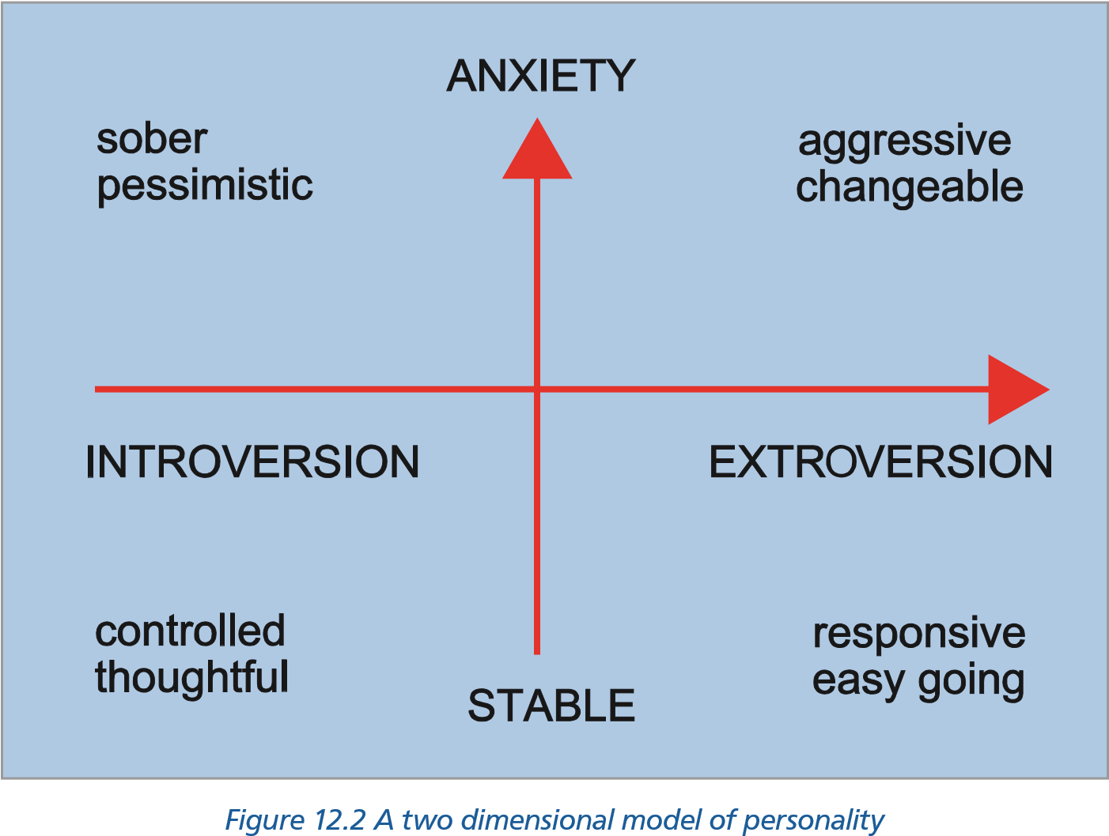

#### Personality and Aircraft Accidents

Personality is a factor in many aviation accidents. The anxious extroverts tend to have more flying accidents in which risk taking is involved. The anxious introverts tend to have a different sort of accident when their rigid and sober approach may lead them to underperform when confronted with an emergency and to mismanage their task when under pressure.

Risk taking and risk assessment represent the biggest problem in many accidents, especially in single pilot operations. Some of the risks may be taken for personal reasons, showing off for example, but other risks may be taken due to commercial pressure. To reduce these possible risks pilots should be aware of their own personality type and, if they recognize impulsive and thrill-seeking elements in that personality, should take steps to satisfy these characteristics away from the flight deck. ***Preferred Personality***

The preferred average pilot should be stable and extroverted but whether this represents the ideal personality type for flying is arguable. Certainly military flying, with its requirements to fly to extended limits or take greater risks, may require different characteristics than those required in commercial operations. With the ever-increasing advance in cockpit automation, associated with long periods of boredom, this is perhaps pushing the ideal pilot “position” more to the left of the chart towards - but not into - the introvert sector.

A pilot must also be self-disciplined and have the ability to control his/her internal emotions and external actions. This personality trait is essential in the “ideal” pilot.

#### Hans Eysenck and Personality

Hans Eysenck’s major contribution to psychology is his theory of personality. He confirmed the model as illustrated in *Figure 12.2*. However he described **“Anxiety”** as **“Neuroticism”.**

Thus in Eysenck’s PEN (Psychoticism, Extroversion-Introversion, Neuroticism) Model, Personality is divided into:

* Extroversion
* Introversion
* Stability
* Neuroticism

He defines neuroticism as a tendency of the sympathetic system (autonomic arousal) to act too quickly. **This special definition needs to be noted** as it is not a meaning that is generally associated with the word.

His research proved that perfectly “normal” people can score high on the neurotic scale. This individual usually has a lot of “drive”. The only problem that comes about is when the person who scores high on the neurotic scale is subjected to a great deal of stress. He/she is then likely to suffer from a neurotic disorder.

Furthermore he presented the hypothesis that a Stable Introvert possessed “Ego Control” whereas a Neurotic Extrovert tended towards Psychoticism.

**He confirmed the view that personality is largely innate and genetically determined.**

### Interactive Style *Introduction*

**Individual Differences and Interpersonal Relationships**

**12**

When individuals are working as a team towards a common goal it is helpful to consider the individual’s team or interactive style. The way they interact may be classified in a number of ways. The authoritarian individuals are dogmatic, and will not easily tolerate dissent from their subordinates but when confronted by someone they perceive as having a higher status become submissive. This kind of personality often has a clear and defined perception of hierarchy, rank and status.

Other styles are the paternalistic and democratic. Any individual’s style may change with time. The submissive first officer can become an authoritarian captain.

Circumstances may change the style required. A democratic approach to problems on the flight deck is desirable as long as time is available and the democratic approach is directed to reaching the goal, but a more autocratic approach may be necessary in an emergency situation. ***Goal/Person Directed Styles.***

There are two main factors that characterise interactive style. The first concerns the achievement of the task (**goal directed style: G**), and the second is concern to keep the team members happy (**person directed style: P**).

On a two dimensional model the individual may be classified as P + G-, P + G+, P - G+ or P - G-. In general the G+ individuals will have a keen desire to complete the designated task, whilst the G- will care little for the job and will not exert themselves unduly. The P+ persons will have a concern for the other team members and will consult them as needed. The P- individuals couldn’t care less about other team members.

The ideal pilot should have a P + G+ interactive style. They will be as concerned for the morale and well-being of the other team members as they are for the efficient operation of the flight.

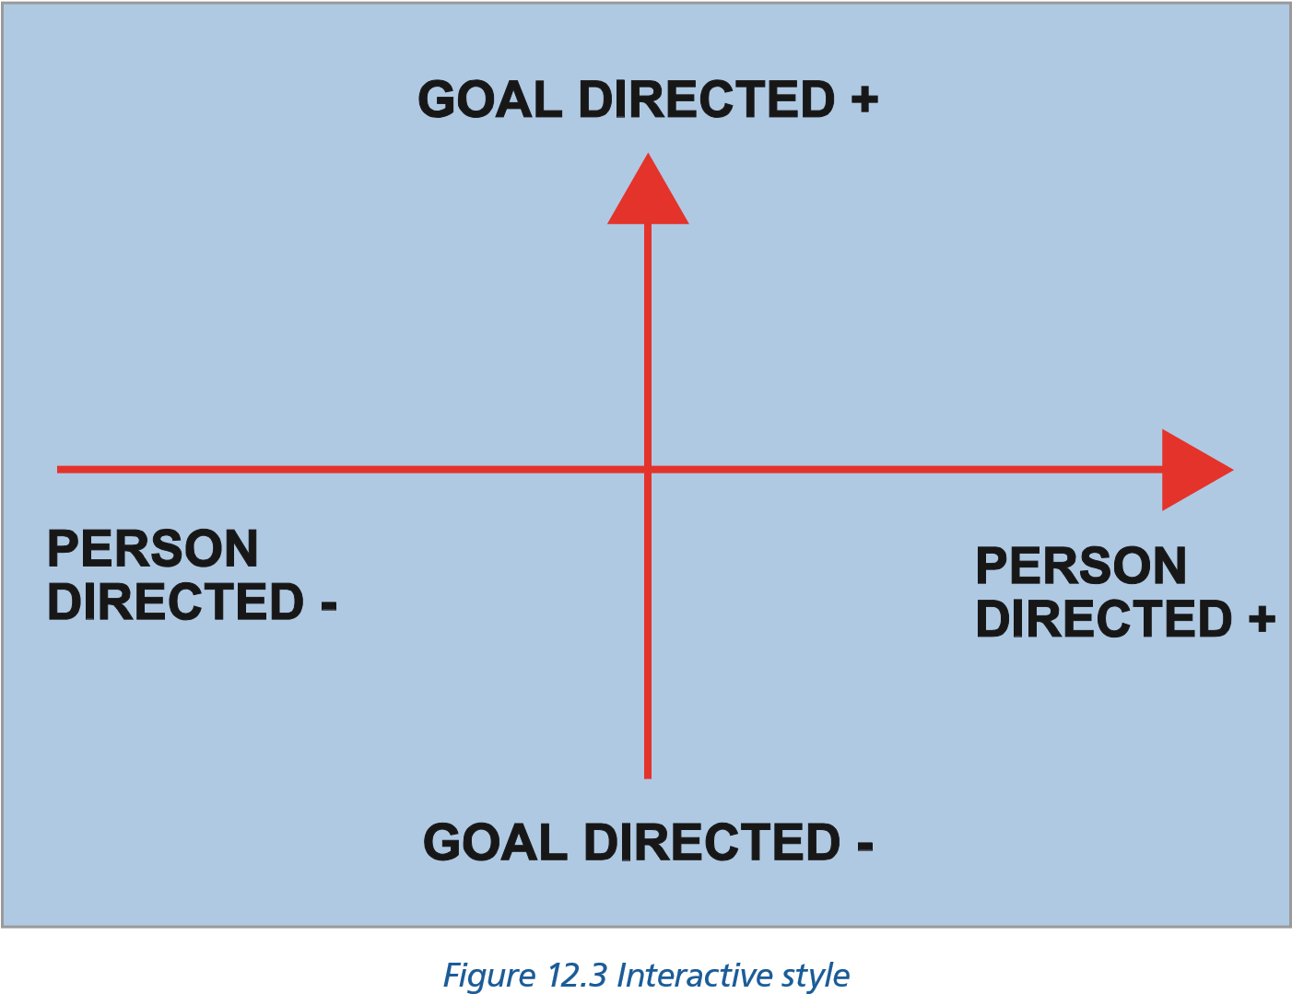

### The Individual’s Contribution within a Group

#### Introduction

**12**

**Individual Differences and Interpersonal Relationships**

The Group or Team implies that there are certain characteristics shared amongst those present which set them aside from others and which give them a sense of belonging. It also implies that there are shared goals, values, interests and motives amongst the group members.

It is relatively easy to work and make decisions on ones own. However, to work effectively within a group is something quite different. A reorientation of attitudes is required (sometimes called **“Groupthink”**) in which flexibility of thought, an ability to listen and an appreciation of the mutual interdependence of each other are among the factors which go towards the making of an effective group member. However, **Groupthink** can have very negative results when there is too much cohesion within the group. This phenomenon has been illustrated, for example, in the massive foreign policy fiascos such as Britain’s appeasement towards Hitler prior to the outbreak of WWII and the Bay of Pigs invasion during J.F. Kennedy’s presidency. In both cases close-knit groups developed a clubby feeling of “we-ness” which prohibited group members from introducing or entertaining unsettling information for fear of upsetting the group.

The effectiveness of a team, and the effectiveness of any individual’s contribution to the common task is determined by a number of factors. Among these factors are: **Ability, Status** and **Role**. ***Ability***

The competence of any individual in a team will play a significant part in his/her effectiveness. Perceived competence will, in conjunction with his interactive style, determine what other team members think of him/her. People will more readily accept deficiencies in personality and interactive style if they perceive that the individual is good at his/her job.

Perceived high ability does have a negative side. It is possible for a P+ G- team member to allow a colleague, whom he perceives as competent, to proceed much further on an inappropriate course of action because he feels the operator ‘probably knows what he is doing’.

The autocratic leader who is competent will obtain a better result than the autocrat with low ability, who may be regarded with distaste and derision by his team members. There is a serious risk that other crew members may allow the low ability autocrat to proceed on an incorrect course of action hoping he will end up in trouble just to ‘bring him down a peg’. This behaviour on a flight deck is obviously unacceptable.

#### Status

On the flight deck status is normally determined by the number of rings on one’s uniform. The status of the individual, combined with perceived ability and interactive style, will play a significant part in decision making on the flight deck. A dominant captain will readily question the actions of a junior first officer, but the opposite will not be so. A junior first officer will need to be absolutely sure that the captain is getting it wrong before he airs his anxieties.

The effect of status in decision making is significantly different within differing cultures. In some Middle and Far Eastern cultures the thought of questioning a senior’s course of action would be unthinkable in any circumstances. In West European and North American cultures junior colleagues will much more readily question the senior individual’s actions. A study has shown the least status affected pilots to be Australian nationals, who place much greater emphasis on perceived ability than any other factor.

#### Role

The third factor that is instrumental in determining interpersonal behaviour in the cockpit, is role. The roles of pilots change, depending on whether they are the handling or non-handling pilot.

**Individual Differences and Interpersonal Relationships**

**12**

It is clear from a number of accident reports that it is very difficult for one pilot to take control away from another, since doing so may be perceived as a lack of faith in the other’s ability. This reluctance to interfere is *particularly evident when both pilots are of the same status*, i.e. two captains on a training detail. An example of the importance of the interaction of these factors is given:

**The twin prop commuter aircraft was commanded by a pilot who was also a senior manager in the airline and known to be somewhat irascible. The first officer was junior in the company and still in his probationary period. At the end of a long day the captain was plainly annoyed when company operations asked for a further flight, but he reluctantly undertook it. During the approach at the end of this leg, the first officer completed the approach checks without receiving any responses from the captain. Rather than question or challenge the captain, the first officer sat tight and let the captain get on with it. The aircraft flew into the ground short of the runway because the first officer did nothing to intervene. It transpired that the captain had failed to respond to the checks not because he was in a bad mood, but because he had died during the approach.**

#### Status/Role

Some high-status individuals find it difficult or are uncomfortable to move to a perceived “lower” role. An example of this might be when a senior commander finds himself/herself carrying out co-pilot duties to a captain who is perceived as being of lower status. This situation may lead to escalating conflict unless handled professionally.

### Cohesion

Cohesion can be defined as the sum of the forces which bind crew members together. It generally goes hand-in-hand with a shared attitude towards problems and is based upon:

* The mutual motivation of the crew towards the job.
* Inter-appreciation of the members of the crew one to another.

Individual acceptance of standards and roles depends upon how tightly or loosely knit are the links between the members of the group. Group cohesion is a major advantage in times of difficulty or danger and crews tends to draw personal strength from their relationships with other crew members.

### Group Decision Making

#### Introduction

In a multi-crew aircraft any decision may be improved by consultation among the crew members. It is generally true that the decision reached by a **group will be better than the average decision made by individuals within the group.**

The group decision will, however, seldom improve on the problem-solving ability of the ablest member of the group. From this point of view there may be valid reasons to increase crew complements to improve the chances of having an able member. The tendency with modern aircraft is, however, to reduce crew members thereby reducing operating costs.

**12**

**Individual Differences and Interpersonal Relationships**

#### Factors Affecting the Group/Team

A number of factors (and, in some cases, disadvantages) will affect the group’s deliberations in reaching a correct solution and agreement on that decision. The factors involved are: **Conformity, Compliance, Status and Obedience, Persuasion, Risky Shift, Group Duration, Role/Norm, and Coordination and Cooperation.**

**Conformity**

People like to conform since non-conformity is stress-inducing. To conform with a group is a strategy for minimizing stress and people do not normally wish to be seen as the ‘odd one out’. An experiment can be conducted in which a group of subjects are asked to judge comparative lengths of coloured blocks of wood. Before the experiment four stooges are briefed to give the wrong answer. It will be found that the fifth member will often go along with the group against the evidence of his senses. His response is what he sees as the **social expectation** (what other people expect of him) rather than giving the correct response. The effect is maximised when the group holding the opposing opinion is just four. It has been found, however, that if the single subject is provided with a partner, his conformity dramatically decreases.

Such conformity is not confined merely to judgements of length. Individuals will accept group opinions and attitudes on many subjects. Readiness to conform appears to differ between races, sexes and nationalities.

**Compliance**

This is the term used to describe an individual’s likelihood of complying with a request. If a large and unreasonable request is made, there is a greater likelihood of it being complied with if it has been preceded either by an even more outrageous request that has been denied, or if a smaller more reasonable request has already been accepted.

For example, a householder whose house is on a dangerous bend in the road may refuse a request to have a large warning notice on his property. However, if he had allowed a very small notice to be on the site, he would more readily accept a larger warning notice when told that the small notice was not readable at a reasonable distance. A succession of seemingly small increases in the sign size could eventually reach the stage where the originally requested size of sign is in position. Alternatively if the original request was for a massive sign, he could well accept a large sign, having turned down the first request.

**Status and Obedience**

The role of status in group decision making is of major importance. People will be more ready to listen to, and believe and obey, those whom they perceive to be of a higher status. This can be demonstrated by giving a problem to groups of varying status. Although the high status individuals may achieve the correct answer only as often as those of medium or low status, those of high status who do get the correct answer are able to persuade a higher percentage of their group to accept their answer.

Those of lower status, although getting the correct answer, will be less successful in persuading their group to accept their answer.

**Individual Differences and Interpersonal Relationships**

**12**

**Persuasion**

This should rarely be used in the cockpit. If differences of opinion cannot be solved by airing the problem and coming to a logical conclusion, the group cannot be said to be working effectively. Occasionally, if a fact has been overlooked by the rest of the group, persuasion has its role however it normally has negative connotations within a team.

**Risky Shift**

If a group is asked to consider a problem they will usually come to a decision that **is more risky than the average made by individual group members**. This tendency is known as Risky Shift and can obviously create problems on the flight deck. Many pilots like to be thought of as bold or daring individuals and combining such individuals into a crew can make for an unduly bold outcome.

Two possible reasons may explain “risky shift”:

* The spread or diffusion of responsibility for any adverse consequences of a decision-involving risk. In other words, blame is shared amongst all members of the group.
* Individuals who hold high risk attitudes tend to be more dominant and persuasive in the group assuming a leadership role. They thus have a disproportionate influence over their fellow members.

Many incidents have had, as a contributing factor, an element of risky shift, and an example is given below.

**A large military transport was carrying out an approach to a Canadian airfield in winter. Conditions were strictly below limits but the alternative to a night stop at this location was a diversion to an airfield some 40 minutes flying time away where night stopping facilities (and allowances) were much worse.**

**On the first approach no lights were seen at decision height and the captain overshot. During the overshoot the engineer reported that he had seen the runway lights as they passed over the threshold. In the following discussion the captain briefed for a split approach, in which the co-pilot would fly on instruments whilst the captain would take over for the landing. As part of the briefing the captain told the other pilot not to start the missed approach at decision height but to level out until told to climb. This decision whilst strictly illegal was supported by the navigator who told the rest of the crew that the ground was level at this stage with no obstructions. With the captain, engineer and navigator looking out the co-pilot flew to decision height. At this stage one crew member called ‘lights’ and a few seconds later the captain saw the runway lights below. He took control and executed a rapid descent and a firm landing.**

**Only by the use of full reverse thrust was the aircraft halted before the end of the runway, and whilst taxiing back the crew were able to see by the tyre marks in the snow that the aircraft had touched down halfway along the runway, with far less landing distance available than the aircraft required.**

**Group Duration**

**12**

**Individual Differences and Interpersonal Relationships**

Military aircrews often fly together as a ‘constituted crew’. This has certain advantages as the crew come to know each other’s habits as well as their strengths and weaknesses. The constituted crew is not a practical option in civil aviation and in a large airline it is quite possible for crew members to be flying together for the first time. This reinforces the need for standardized procedures for all aspects of the flight as they enable each of the strangers to know what other crew members will do.

There are benefits in constituted crews but without great care they may introduce particular risks. If one crew member is ill and temporarily replaced the new crew member will be unaware of the adopted procedures of the rest of the crew. He/she will not be aware of any hand signals or shortened procedures that the constituted crew has adopted. A thumbs-up sign on finals may have been an understood signal for selecting landing flap position but the new co-pilot may merely take it as an appreciation of his flying skills. There is always the danger that, if a crew has remained together for a long time, any bad habits will not be noticed but absorbed into the crew operating procedures.

Because of the above a constituted crew policy is not considered a good policy in modern aviation crewing policy.

**Role and Norm**

Behaviour within a group may very well depend upon the social expectation of the role played within a group. For example, an individual who finds himself/herself “Chairman” of a committee will tend to behave in a different manner to that shown when he or she was a normal member. Thus a newly promoted Commander of an aircraft may show a distinct behavioural and attitude change once in the Captain’s seat.

**Coordination and Cooperation**

The purpose of having a crew is to reduce workload by enabling tasks to be shared. **Efficient crew coordination** will depend on effective **communications** and **cooperation.** Members must be sensitive to individual needs as well as the needs of the group.

Coordination generally differs between the flight training phase and the commercial flight operations. During *training* there is an expectation of errors as skills are developed, whereas in *commercial flight operations* the monitoring and cross-checking function is a confirmation of expected and mutually understood actions.

### Improving Group Decision Making

#### General Guidelines

Guidelines can be given to improve decision making. Some of these are given below:

* Avoid arguing for your personal judgements. Approach the task on the basis of logic.
* Avoid changing your mind only in order to reach agreement or avoid conflict. Support only solutions with which you are able to agree.
* Avoid conflict-reducing techniques such as a majority vote or a middle course strategy.

**Individual Differences and Interpersonal Relationships**

**12**

* View differences of opinion as helpful rather than a hindrance in decision making. When these guidelines are used a group will produce a better performance than another group not utilizing the guidelines. ***The Role of CRM and LOFT***

Line-Oriented Flying Training **(LOFT)**, and Crew Resource Management **(CRM)** training seeks to improve the quality of crew performances rather than individual achievement. The use of video tapes to record realistic simulation exercises provides crew members with ‘behavioural feedback’. This enables them to observe themselves, and perhaps realise that the way they present themselves to other people may be different from the way intended. In this way their self-image becomes more consistent with the image that others have of them. In these exercises it can be helpful if the participants ‘role play’ or act in a certain way.

This may require the timid first officer to be more assertive in a benign environment so he will realise that he is capable of behaving in that way and to show him that most captains will respond favourably to being given a clear statement of his ideas. It may also be useful to require the authoritarian captain to actively solicit advice and ideas from other crew members. This will demonstrate to him/her that doing so will not be interpreted as a sign of weakness, but help in consolidation of the crew and lead to better decision making.

### Leadership

#### A Definition

A definition of leadership is the ability to get work done with and through others, while at the same time winning their confidence, respect, loyalty and willing cooperation.

#### Introduction

Contrary to popular belief, no one is born a leader but some people do have certain abilities that predispose them to developing into a leader. Like many other skills, leadership can be learned and developed. While there is no agreed list of qualities that make a good leader, it is generally agreed that leaders tend to have the following characteristics:

* Social maturity.
* Self-motivation.
* Achievement orientation.
* Self-confidence.
* Communication skills.

Leadership influences many aspects of work. A leader:

* is the chief communicator of the group.
* affects motivation by his/her behaviour.
* is responsible for the group’s objectives being understood and achieved.

#### Principles for Leaders

The most important principles for the leader to follow, both to reach the best decision and to maintain the morale of the team are:

**12**

**Individual Differences and Interpersonal Relationships**

* Avoid giving any indication of your own opinion or ideas at the outset. A team member with a different idea may be reluctant to air it if it seems to contradict the captain.
* Do make a point of soliciting the ideas of other crew members openly. In particular encourage them to express any doubts or objections to a particular course of action. Always ensure that the potential problems or dangers are fully aired.
* When the leader has made a decision, the reasons for arriving at that decision should be explained if there is time. Failure to do so will make the crew members feel that their ideas have been ignored, with the result that in the future they will not be at all keen to put forward proposals. ***Leaders and Followers***

There are other guidelines that are appropriate for both leader and follower:

* Do not delay airing uncertainties or anxieties because you think you might appear foolish or weak. Other crew members may well have the same doubts and will welcome some candour.
* When asked, give your point of view fully and clearly. Do not worry about whether you are saying what the other person wants to hear.
* Do not give opinions in an emotionally or dominant way (e.g. ‘Any fool can see that ....’).
* Do not become ‘ego involved’ with your own point of view and simply try to get your own way. If a group decision has been made, accept it unless you feel it contains some hazard not appreciated by the other group members.
* Do not let others progress down wrong paths of action and into trouble just to make yourself look clever.
* Do not compete, do not get angry, do not shout and do not sulk on the flight deck. Do not let your own bad mood show. Try to maintain a pleasant working atmosphere even if you do not like the other crew members.

**“Tell me and I’ll forget;**

**show me and I may remember;**

**involve me and I’ll understand”.**

#### Chinese proverb Blake and Mouton (1964) Leadership/Managerial Grid Theory

Blake and Mouton integrated the ideas of task and relationship orientations into a grid with five main styles (similar to the interactive styles).

It is based on the concept that leaders vary from 1 to 9 in their concern for people **(relationships)** and their concern for getting things done **(tasks or goals)**. The five main styles are:

* **Authoritarian - Obedience Style (9.1.)**

The leader’s maximum concern is for task completion and is combined with a minimum concern for people (i.e. dictating to followers what they should do and how they should do it). The leader concentrates on maximizing the tasks to get done. This type of leader tends to regard colleagues as a means of production and seeks to motivate by encouraging competition between people. If challenged, this is looked upon as non-cooperation. (similar to G+ P-)

**Individual Differences and Interpersonal Relationships**

**12**

* **“Country Club” Management Style (1.9.)**

The leader shows a minimum concern for the completion of tasks but a maximum concern for people. Fostering good feelings gets primary attention even at the expense of achieving results. Production is secondary to the avoidance of conflict and the maintenance of harmony. These managers will always seeks to find compromises and to arrive at solutions acceptable to everyone. (Similar to G- P+)

* **Impoverished Management Style (1.1.)**

The leader has a minimum concern for both production and people and makes only the least effort required to remain in the organization. (Similar to G- P-)

* **Organization Man Style or Middle of the Road Style (5.5.)**

The leader goes along to get along. This results in a conformity to the status quo. An attitude of “live and let live” is typified together with a tendency to avoid real issues.

* **Team Management Style (9.9.)** The leader:
* integrates the concern for production and the concern for people.
* seeks results through the participation, involvement and commitment of all those who can contribute.
* believes in creating situations in which people can satisfy their own needs through commitment to the tasks of the organization.
* handles difficulties in working relationships by confronting colleagues directly and attempting to work out solutions with those concerned.

***Note:*** *Opportunistic leaders use several styles interchangeably. For example he/she may begin a meeting in a casual, but friendly way (1.9), but quickly become tough and demanding (9.1) which is his/her dominant style.*

|  |  |  |  |  |  |  |  |  |
| --- | --- | --- | --- | --- | --- | --- | --- | --- |
| **Countr** | **y Club** |  |  |  |  |  | **Team** | |
|  |  |  |  |  |  |  |  |  |
|  |  |  |  |  |  |  |  |  |
|  |  |  |  |  |  |  |  |  |
|  |  |  | **Middle of the Road** | | |  |  |  |
|  |  |  |  |  |  |  |  |  |
|  |  |  |  |  |  |  |  |  |
|  |  |  |  |  |  |  |  |  |
| **Impov** | **erished** |  |  |  |  | **Authoritarian** | | |

**9**

**P 8**

**E 7**

* 1. **6**
  2. **5**

**L 4**

**E 3**

**2**

**1**

**12**

**Individual Differences and Interpersonal Relationships**

**1 2 3 4 5 6 7 8 9 T A S K**

Should the reader like to make a self-analysis of his/her leadership style, (which the author definitely does not recommend as he received deep personal disillusionment when he did so), the instructions are as follows:

* Complete the questionnaire being as truthful as possible.
* Transfer the answers to the columns provided in the scoring section.
* Total the scores in each column and **multiply each total by 0.2** • Plot the two scores along the appropriate Task and People axis.
* Draw two lines from each until the lines intersect.
* The area of intersection is the leadership dimension from which you naturally operate (Authoritarian, Impoverished, Team, Organization/Middle of the Road or Country Club leadership style).

#### Grid Questionnaire

Read each statement carefully, then using the scale below, decide the extent to which it actually applies to you. Allow yourself a maximum of 45 minutes.

#### Scoring

_________________________________________________________________________________

never sometimes always

0 1 2 3 4 5

_________________________________________________________________________________

1. I encourage my team to participate when it comes to decision making and I try to implement their ideas and suggestions.
2. Nothing is more important than accomplishing a goal or task.
3. I closely monitor the schedule to ensure a task or project will be completed in time.
4. I enjoy coaching people on new tasks and procedures.
5. The more challenging the task is, the more I enjoy it.
6. I encourage my employees to be creative about their job.
7. When seeing a complex task through to completion, I ensure that every detail is accounted for.

**Individual Differences and Interpersonal Relationships**

**12**

1. I find it easy to carry out several complicated tasks at the same time.
2. I enjoy reading articles, books and magazines about training, leadership and psychology and then putting what I have read into action.
3. When correcting mistakes, I do not worry about jeopardizing relationships.
4. I manage my time very efficiently.
5. I enjoy explaining the intricacies and details of a complex task or project to others.
6. Breaking large projects into small manageable tasks is second nature to me.
7. Nothing is more important than building a great team.
8. I enjoy analysing problems.
9. I honour other people’s boundaries
10. Counselling others to improve their performance or behaviour is second nature to me.
11. I enjoy reading articles, books and magazines about my profession and then implementing the new procedures I have learned.

#### Scoring

After completing the questions, write your answer in the spaces below:

**12**

**Individual Differences and Interpersonal Relationships**

|  |  |  |  |  |  |
| --- | --- | --- | --- | --- | --- |
| Question **(People)** | |  |  | Question **(Task)** | |
| 1. | _____ |  |  | 2. | _____ |
| 4. | _____ |  |  | 3. | _____ |
| 6. | _____ |  |  | 5. | _____ |
| 9. | _____ |  |  | 7. | _____ |
| 10. | _____ |  |  | 8. | _____ |
| 12. | _____ |  |  | 11. | _____ |
| 14. | _____ |  |  | 13. | _____ |
| 16. | _____ |  |  | 15. | _____ |
| 17. | _____ |  |  | 18. | _____ |
| **Total** | **_____** |  |  | **Total _____** | |
| × 0.2 | _____ |  |  | × 0.2 _____ | |
|  | (multiply by 0.2 for final score) | | | | |

Plot your 2 final scores on the axis of the grid on *page 240*. Then draw two lines from each until the lines intersect. The area of intersection is the leadership dimension from which you naturally operate.

A perfect score is 9.9. You should review the statements in the survey and reflect on the low scores by asking yourself “If I score higher in that area, would I be a more effective leader?”. If the answer is “yes”, then it should become a personal action item.

***Note:***  *Some may ask “in order to get a perfect score I would have to obtain maximum marks on both question 2 and 14. Is this not a paradox?”. One of the better known mottos of the US Army is: “People and Mission first”. That is, nothing is more important than accomplishing the task and nothing is more important than looking after the welfare of the people. A good leader can do both.*

**Question 10 is a “People” question. How can this be?**

If a leader really cared about the person, would the relationship or would guiding that person onto greater achievement be the more important? Good leaders do what it takes to build and develop people around them. The “relationship” is not what makes them tick .... guiding others onto greatness is what a “people” leader is all about.

### The Authority Gradient and Leadership Styles

#### Introduction

Leadership should not be confused with authority. Authority is normally assigned, while leadership is acquired and suggests a voluntary following.

*Figure 12.4* shows what is termed the Cockpit Authority Gradient. It illustrates the three types found in the air:

* The Autocratic Cockpit.
* The Laissez-faire Cockpit.
* The Synergistic Cockpit (the ideal).

The Captain’s task is to maintain a compromise which maintains the authority gradient without losing the support of the crew members.

**Individual Differences and Interpersonal Relationships**

**12**

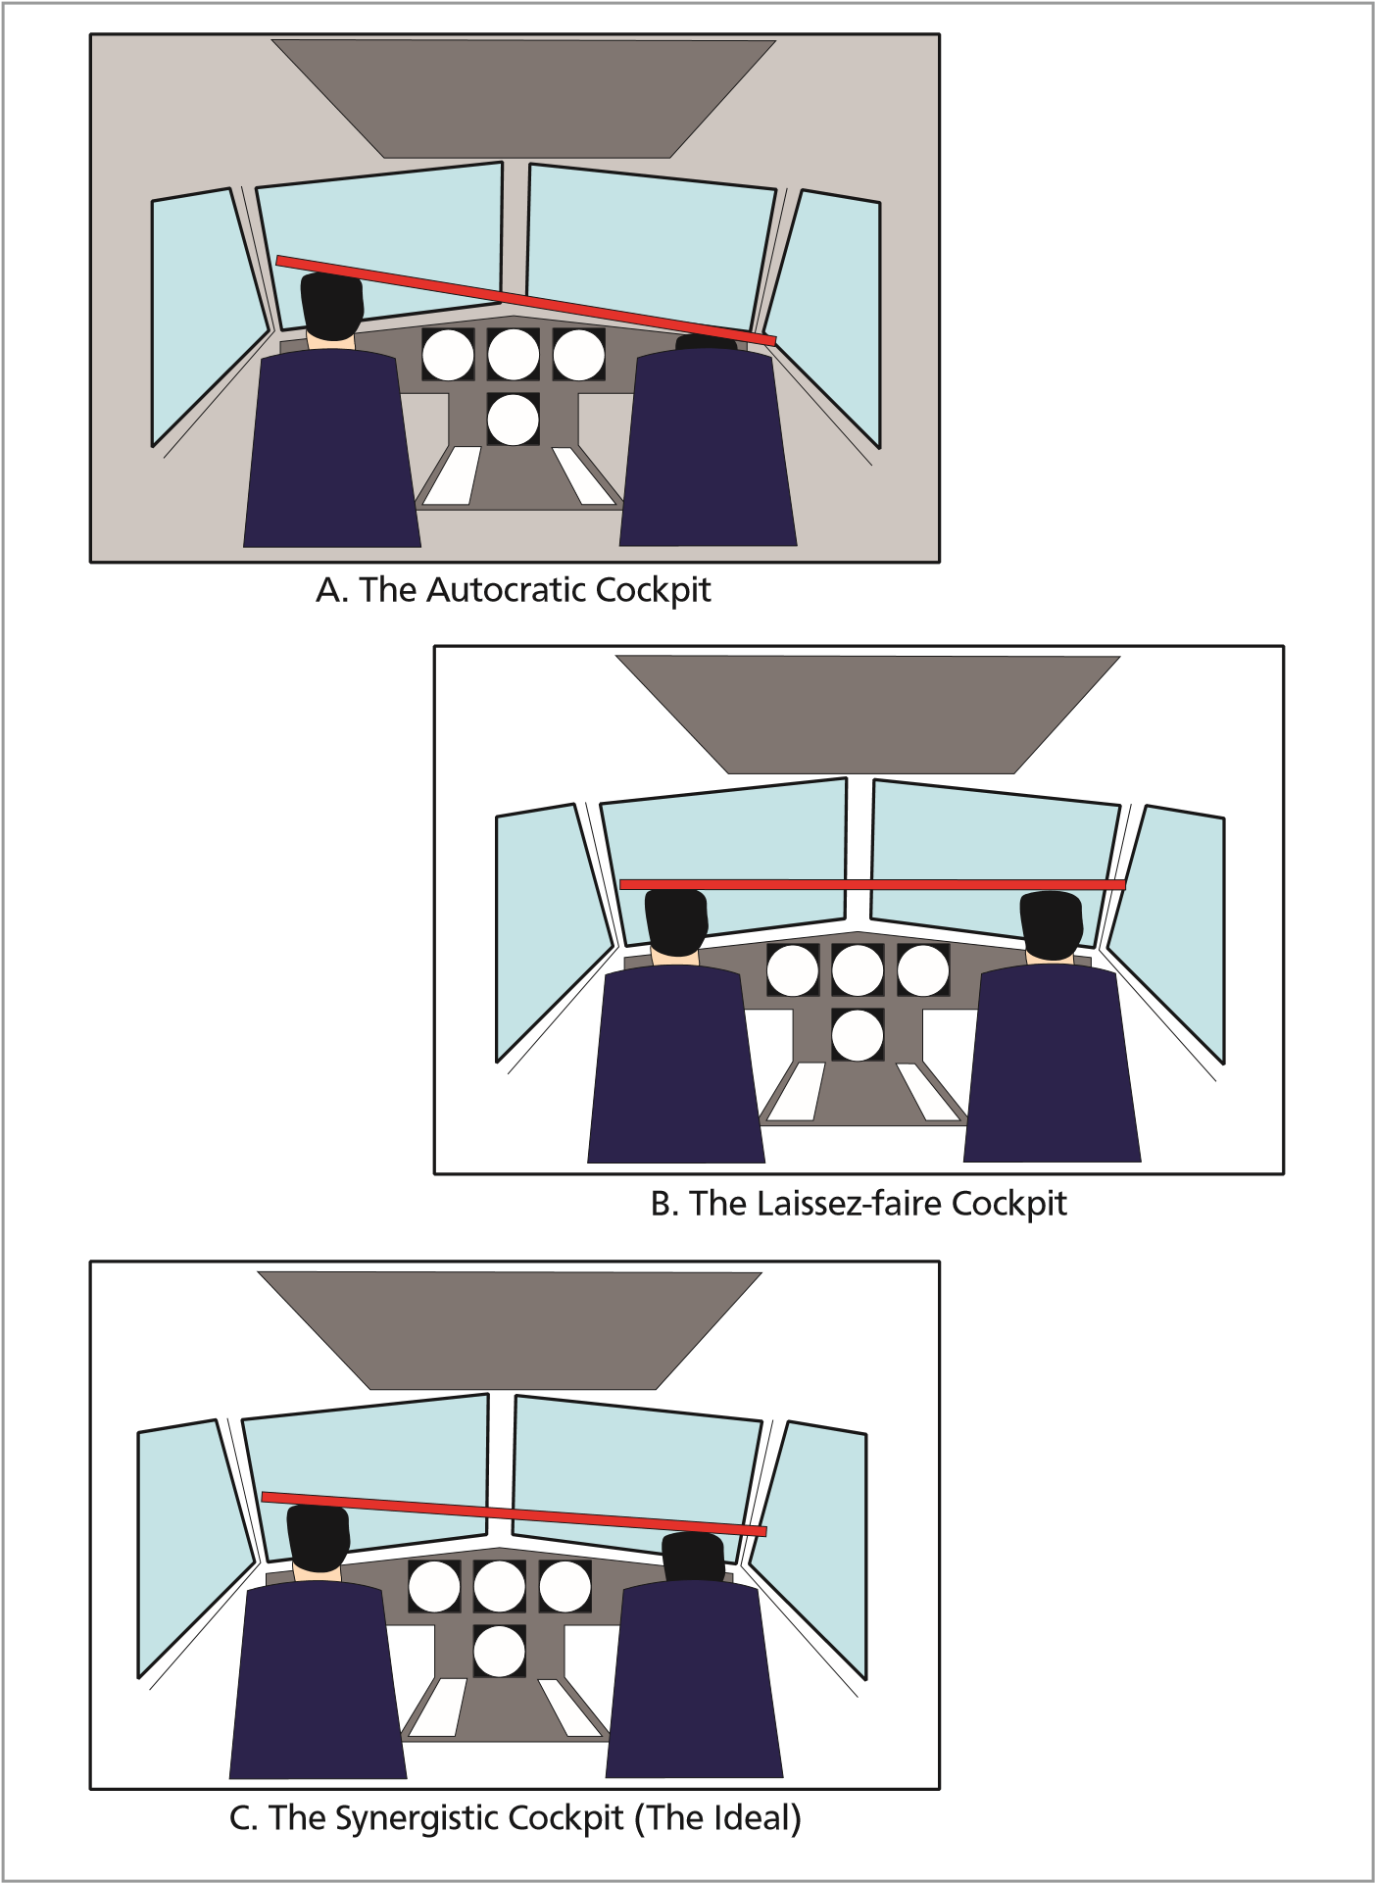

*Figure 12.4**The Authority Gradient*

#### The Autocratic Cockpit

The autocratic cockpit is one in which the Captain:

* Decides and imposes his/her decisions without consultation.
* Takes no account of the opinions of the other members of the crew.
* Rarely delegates.
* Makes general comments which teach nothing.
* Does not listen and is isolated from the rest of the crew.
* Considers forcefully made suggestions as either criticism or insubordination.
* Encourages a tense and non-communicative atmosphere in the cockpit.

By the very nature of the way the cockpit is run, the Captain is normally overloaded in the event of a problem.

This nightmare scenario can occur when:

* The under-confident Captain uses his/her authority to hide inherent weaknesses.
* There is a large gap in both the seniority and technical ability/knowledge between the Captain and the remaining members of the crew. For example, a very senior Captain flying with a new co-pilot.
* The Captain has a very strong character and the co-pilot has a personality which is weak and self-effacing.

Faced with a Captain whose manner is too authoritarian, crews tend to react in a stereotyped manner. In a three-seat cockpit there tends to be collusion between the co-pilot and flight engineer thus somewhat redressing the situation.

**12**

**Individual Differences and Interpersonal Relationships**

However in a two-seat cockpit this is not possible and the co-pilot is forced to handle the situation alone. In this case, the classic reactions of the co-pilot can be any of the following:

* Aggression is met with aggression and, with this confrontational attitude, the tension in the cockpit is increased.
* An apparent submission and withdrawal coupled with the decision “to say nothing more”.
* The unexpressed aggression is turned against a third person (or scapegoat). This is normally ATC or cabin staff.
* The aggression is delayed, contained and “mulled-over”. Not only will this preoccupation deprive the co-pilot of his/her situation awareness but the aggression will be suddenly and unexpectedly released - possibly in just the situation which demands careful and analytical reasoning and in which emotion has no part to play.

Crews meeting such situations must be aware of the potential dangers and approach the flight with as positive attitude as possible. The presentation of cooperation can be made in a conciliatory form but the contents of this cooperation must be firm.

**This not to say that there is no place at all for authoritarianism in the air. In an emergency situation and when pressed for time, the Captain must give crisp, clear orders needed for immediate reactions and responses.**

#### The Laissez-faire Cockpit

At the other end of the spectrum is the laissez-faire cockpit. In this situation the Captain:

* Remains passive.
* Allows other members of the crew freedom in decision making.
* Makes few suggestions.
* Makes neither positive or negative judgements.
* Encourages a relaxed and laid-back atmosphere in the cockpit with communications leaning towards non-professional subjects.
* Has a primary aim to please the rest of the crew.

This situation tends to arise when the Captain is working with competent pilots and flight engineers, particularly during the “co-pilot’s leg”.

The consequences of the laissez-faire cockpit are apparent. Either the vacuum is filled by another member of the crew who takes over the leadership role or members of the crew work on their own, preoccupied on different plans of their own, and without keeping each other informed. A **“self-centred”** cockpit is thus created which offers the least synergy and is the **most dangerous** of the cockpit situations. ***The Synergistic Cockpit - the Ideal***

**Individual Differences and Interpersonal Relationships**

**12**

The Synergistic Cockpit is one where the Captain:

* Leads by example.
* Motivates the crew.
* Develops the skills of the crew.
* Supports team working.
* Clearly communicates intentions and required standards.
* Monitors the crew performance and gives constructive advice to the crew members.
* Coordinates interrelated activities concerning the flight.
* Listens to the rest of the crew and looks upon their suggestions as helpful.
* Makes decisions with the help and active participation of the other crew members.
* Makes a plan of action defined by the group.
* Delegates responsibilities and actions.
* Shares information and explains decisions.
* Tries not to over-participate leaving each member of the crew to show their worth and capabilities.
* Works to maintain a positive, cordial and professional cockpit atmosphere throughout the flight.
* Openly shows appreciation for work well done.
* Debriefs the crew and encourages ideas for improvements.

### Interacting with Other Agencies

People are very good at identifying themselves with a group but the pilot is a member of a number of groups at the same time. He/she is obviously a member of the flight deck group and it is with this group that he/she has the most identity of purpose and common interests.

The pilot, is of course, also a member of the whole crew, including the cabin crew. In many circumstances the whole crew must act together against what is seen as a threat to them all such as a plane-load of drunken passengers or in the case of an emergency.

**12**

**Individual Differences and Interpersonal Relationships**

The pilot is also a member of a larger organization; the company or airline. In this group the pilot interacts with dispatch clerks, ticket agents, technical services etc. To resolve certain problems the pilot must interact with all of them.

Perhaps the largest group to which the pilot belongs is the Aviation Group. The common purpose of this group including ATC agencies and controllers is to maintain a safe and expeditious flow of traffic across the world, combining together to overcome weather conditions, health problems, or in some circumstances political considerations.

### *Questions*

#### Questions

1. **What is the most effective way of analysing personality?**
   1. Group therapy
   2. Written questionnaires
   3. Personal interviews
   4. Two dimensional model analysis
2. **How would a person who is aggressive and changeable be described?**
   1. Aggressive extrovert
   2. Unpredictable extrovert
   3. Unreliable extrovert
   4. Anxious extrovert
3. **What are the personality traits of a good pilot?**
   1. Reliable and stable
   2. Stable and extroverted
   3. Reliable and extroverted
   4. Reliable, calm and extroverted
4. **What characteristics will authoritarian pilots display?**

**Questions**

**12**

* 1. Are autocratic on most occasions
  2. Are autocratic with the crew of the aircraft but submissive when dealing with an emergency or when under stress
  3. Are autocratic when in command and submissive when confronted by someone of higher perceived status
  4. Tend to be authoritarian when dressed in uniform and when dealing with both air and cabin crew

1. **What “P” and “G” qualities should a pilot have?**
   1. G + P +
   2. G + P +
   3. G ++ P +
   4. P + P +
2. **How will a person tend to react if they are confronted with a decision from someone they perceive as having a higher status?**
   1. Listen to, believe, and comply with the decision
   2. Avoid confrontation
   3. Become introverted
   4. Question the decision
3. **If an average ability group make a decision, is it likely to be better or worse than one made by the individual members?**
   1. Worse
   2. Tends to be either
   3. 75% of the time better
   4. Better

### *Questions*

1. **If a group - with someone who has above average ability - makes a decision, is the decision likely to be better or worse than one made by the above average person on their own?**
   1. Unlikely to be better
   2. Likely to be better
   3. Likely to be worse
   4. It depends on the number of the members of the group
2. **Is a group decision likely to be more or less risky than one made by the individual members?**
   1. Less risky
   2. Sometimes more risky
   3. Sometimes less risky
   4. More risky
3. **What should a Captain do before making a non-urgent decision?**
   1. Put his own view forward and then ask for the opinions of other members of the crew
   2. Consider all the implications
   3. Encourage ideas from the crew before stating his own opinion
   4. Monitor his motor programme (flying)

**12**

**Questions**

1. **Body Language is:**
   1. non-verbal communication
   2. sign Language
   3. aggression
   4. verbal communication which is open to cultural problems
2. **Self-discipline is an essential quality of the “ideal” pilot.**
   1. True
   2. False
3. **Is a constituted crew an advantage in commercial aviation?**
   1. Always
   2. Sometimes
   3. Depends on the task
   4. None of the above
4. **What are the three types of Cockpit Authority Gradient (see p243)?:**
   1. autocratic, subjective, synergistic
   2. autocratic, submissive, synergistic
   3. laissez-faire, subjective, synergistic
   4. autocratic, laissez-faire, synergistic
5. **There is no place at all for authoritarianism in the air.**
   1. True
   2. False

### *Questions*

1. **The Laissez-faire cockpit may arise when:** 
   1. the Captain is suffering from stress
   2. the Captain is preoccupied
   3. on a competent co-pilot’s leg

**Questions**

**12**

* 1. on an incompetent co-pilot’s leg

1. **To counteract an authoritarian cockpit crews should:**
   1. ensure that they ensure that their opinions are heard in spite of possible confrontation
   2. remain silent and sort it all out on the ground
   3. cooperate in a conciliatory form but the contents of this cooperation is firm
   4. obtain support from another crew member

### *Answers*

**12**

**Answers**

#### Answers

|  |  |  |  |  |  |  |  |  |  |  |  |
| --- | --- | --- | --- | --- | --- | --- | --- | --- | --- | --- | --- |
| 1 | 2 | 3 | 4 | 5 | 6 | 7 | 8 | 9 | 10 | 11 | 12 |
| b | d | b | c | b | a | d | a | d | c | a | a |
| 13 | 14 | 15 | 16 | 17 |
| d | d | b | c | c |

Chapter

## **13** Communication and Cooperation

Introduction. . . . . . . . . . . . . . . . . . . . . . . . . . . . . . . . . . . . . . . . . . . . .253

A Simple Communications Model . . . . . . . . . . . . . . . . . . . . . . . . . . . . . . . . .253

Types of Questions . . . . . . . . . . . . . . . . . . . . . . . . . . . . . . . . . . . . . . . . .255

Communications Concepts . . . . . . . . . . . . . . . . . . . . . . . . . . . . . . . . . . . . .257

Good Communications . . . . . . . . . . . . . . . . . . . . . . . . . . . . . . . . . . . . . . .257

Personal Communications . . . . . . . . . . . . . . . . . . . . . . . . . . . . . . . . . . . . .258

Cockpit Communications . . . . . . . . . . . . . . . . . . . . . . . . . . . . . . . . . . . . . .259

Professional Languages. . . . . . . . . . . . . . . . . . . . . . . . . . . . . . . . . . . . . . .262

Metacommunications. . . . . . . . . . . . . . . . . . . . . . . . . . . . . . . . . . . . . . . .263

Briefings . . . . . . . . . . . . . . . . . . . . . . . . . . . . . . . . . . . . . . . . . . . . . . .263

Communications to Achieve Coordination . . . . . . . . . . . . . . . . . . . . . . . . . . . .263

Synchronization . . . . . . . . . . . . . . . . . . . . . . . . . . . . . . . . . . . . . . . . . . .264

Synergy in Joint Actions . . . . . . . . . . . . . . . . . . . . . . . . . . . . . . . . . . . . . .264

Barriers to Crew Cooperation and Teamwork. . . . . . . . . . . . . . . . . . . . . . . . . . .265

Good Team Work . . . . . . . . . . . . . . . . . . . . . . . . . . . . . . . . . . . . . . . . . .265

Summary. . . . . . . . . . . . . . . . . . . . . . . . . . . . . . . . . . . . . . . . . . . . . . .266

Miscommunication . . . . . . . . . . . . . . . . . . . . . . . . . . . . . . . . . . . . . . . . .266

Questions . . . . . . . . . . . . . . . . . . . . . . . . . . . . . . . . . . . . . . . . . . . . . .267

Answers . . . . . . . . . . . . . . . . . . . . . . . . . . . . . . . . . . . . . . . . . . . . . . .270

**13**

**Communication and Cooperation**

### Introduction

**Communication can be defined as “the effective transmission of a message”.**

The majority of all civilian aircraft accidents are caused by human error. In 1997 over 70% of all civilian aircraft accidents in which fatalities occurred involved a perfectly serviceable aircraft being flown into the ground - Controlled Flight Into Terrain (CFIT). There appears to be no significant improvement in recent years.

With the tendency for the modern airliner to reduce the flight deck crew complement to just two operating pilots, and the increasing use of computers to take over the functions previously undertaken by crew members, there is an ever-increasing emphasis on crew cooperation and communication to ensure the safe operation of all flights.

### A Simple Communications Model

#### Introduction

Paul Watzlawick’s first axiom of communication states that “one cannot not communicate”. Thus, no matter how one may try, one must communicate. Activity or inactivity, words or silence all have message value. They influence others who, in turn cannot not respond to these communications and are thus themselves communicating. Mere absence of talking or taking notice is no exception.

The man at a crowded lunch counter who looks straight ahead, or the aircraft passenger who sits with his/her eyes closed, are both communicating that they do not wish to speak to anyone or to be spoken to. Their neighbours normally “get the message” and response appropriately by leaving them alone. This, obviously, is just as much an interchange of communication as an animated discussion.

**Communication and Cooperation**

**13**

The simplest model to represent communication would consist only of a transmitter sending a message to a receiver. This model would, however, be far too simple to represent the wealth and variety of interhuman communications. ***Basic Requirements***

For any meaningful information to be passed:

* The transmitter and receiver must speak the **same language;** even the same native language would not necessarily suffice in cases where an expert in one field is attempting to pass information to an individual who has no knowledge of the subject.
* Sentences should be correctly formed and, where possible, unambiguous.
* Gestures and attitudes should duplicate the spoken word and either strengthen or weaken the contents.
* Interference/noise levels are such that clear communication is possible.

The message to be decoded by the receiver is the sum of all verbal and non-verbal expressions.

With radio communications the non-verbal aspects are lost (see Metacommunications).

#### Context

The meaning of what is said does not depend on the language alone. It depends on the context for both the transmitter and receiver. With different contexts the same message can have very different meanings. A simple phrase term such as ‘landing gear down’ could be an executive order to lower the undercarriage or, if said in a different tone, could be a question. ‘Is the undercarriage down?’ Yet another tone could be a simple statement that the undercarriage is down at a stage when it should have been raised.

Another well-known example where meaning is totally changed by context is:

“Woman without her man is useless” whereas

“Woman: without her, man is useless”

#### Basic Components of Interpersonal Communication

Berlo (one of the foremost exponents of the science of communications) proposed six basic components of interpersonal communications which are widely accepted. These are:

**Source**

* All human communication has some source, some person or group of persons with a purpose, a reason for engaging in communication. Given a source, with ideas, needs, intentions, information and a purpose for communicating, a second ingredient is necessary. The purpose of the source has to be expressed in the form of a message.

**Message**

**13**

**Communication and Cooperation**

* In human communication, a message is behaviour in physical form - the translation of ideas, purposes and intentions into a code - a systematic set of symbols.

**Encoder**

* How do the source’s purposes get translated into a code or language? This requires the third communications ingredient - an encoder. This is responsible for taking the ideas of the source and putting them in a code. The most common encoders are:
* Vocal mechanisms (words, cries, musical notes)
* Muscles of the hand (written words, pictures, diagrams)
* Other muscle systems of the body (gestures, facial expressions, posture)

**Channel**

* This is amplified later in this chapter. Briefly, a channel is a medium, a carrier of messages (for example speech, gestures, writing).
* It is worth noting that in spite of the fact that we have introduced a source, a message, an encoder and a channel, no communication has yet taken place. For this we require someone else at the other end of the channel. When we talk, someone must listen or when we write, someone must be there to read.

**Receiver**

* The person or persons at the other end of the channel are referred to as the receiver or the target of communication.

**Decoder**

* Just as the source requires an encoder to translate the purpose into a message, the receiver needs a *decoder* to retranslate the message and put it into a form that the receiver can use. We can look at the decoder as a set of sensory skills of the receiver.

*Note: Should only the four most basic components be asked of students, these are:*

* Source
* Message
* Channel
* Receiver

### Types of Questions *Introduction*

Questions not only beg information but can be used as a tool to confirm information. Questions, of course, can be moulded or loaded to anticipate an answer that is either desired or expected. For example: “do you find our newly redesigned seating comfortable?” invites an answer that is pleasing to the questioner. On the other hand “When you are smoking, do you always try and avoid causing discomfort to others?” places the weight of social expectation upon the responder. There are also ambiguous, imprecise or complex questions all of which have no place in good crew communications. Fundamentally there are three types of questions: leading, implicit and explicit questions.

**Leading Questions**

**Communication and Cooperation**

**13**

* These are questions where the required answer is in the question. The words “isn’t it” are often present - the classic student leading question during “mutual” flying......”That is Witney down there, isn’t it?” This type of question normally indicates a loss of situational awareness.

**Implicit Questions (Open Questions)**

* These require either a single or multiple deductions from the responder prior to his/her answer. For example a captain turns to his/her co-pilot and asks, “in view of the weather, what is the best course of action?” Before an answer is possible a number of factors must be considered by the co-pilot among which might be the:
* type, position and configuration of the aircraft.
* type and proximity of the weather.
* dangers that such weather might pose.
* aircraft fuel state.
* availability of ATC or airport facilities.
* qualifications of the aircrew etc.

The advantages of these type of questions are:

* A “second opinion” or group decision is brought into play thus probably improving the quality of the eventual conclusion.
* Normally more factors are investigated thereby reducing the chances of important considerations being overlooked.
* The deductions of the questioner are checked.
* Knowledge is extracted from the responder which can be assessed by the questioner. Because of this advantage the implicit question is widely utilized in teaching and instructing techniques.

The disadvantages are:

* The responder may not fully understand the implications of the question and consider irrelevant or, indeed, completely incorrect factors.
* Discussion may follow and thereby delay a conclusion.
* Discussion may divert attention from remaining focused on the main problem.
* They are prone to misunderstandings which may not be identified. i.e. sender and receiver may be talking at cross purposes.
* They are prone to diversions which may not be detected.

**Explicit Questions (Closed Questions)**

**13**

**Communication and Cooperation**

Explicit questions pose no such restrictions. They are straightforward and, if they do not require further clarification, assume that either the responder has (or can quickly obtain) all the information necessary to answer the question or that the question itself contains all the information essential for an informed response.

An example of an explicit question might be: “Are we maintaining the correct track?”

The advantages of explicit questions are:

* Question and response is normally quicker.
* The meaning of the question is usually clear.
* Both questioner and responder are on the “same wavelength”.
* Misunderstandings are quickly identified and clarified.

The disadvantages are:

* Important factors may be overlooked and therefore not discussed.
* The assumption that the question contains enough information for an informed answer may be incorrect.

### Communications Concepts

#### Communication Bits

Communications may be said to exist when information is passed from one individual, the transmitter, to another individual or group, the receiver(s). Information can only be considered to have been passed when the receiver’s uncertainty is reduced. Communications specialists measure information in **bits, one bit being the quantity of information which reduces uncertainty in the receiver by 50%. *Communication Channels***

Communication is the establishment of a relationship aimed at achieving an objective. It can, and does, consist of a number of different modes or **‘channels’** (for example: speech, gestures, writing). Although communication generally involves transmitting information, there will be circumstances when it may not necessarily pass information but simply serve to keep the channel open (to assure the receiver of a human presence).

#### Dialogue

A **dialogue** is a series of communications on the same subject between a transmitter and a receiver. It can be considered as a form of negotiation which progressively converges towards a common aim. ***Hypertext***

Hypertext is the set of implicit information contained in a written text or spoken message. For example the phrase ‘I would like to find a pub’ includes in the hypertext the ideas that the individual may be hungry or thirsty or, if out walking in cold rainy weather, that shelter and warmth would be welcome. If crawling along in a traffic jam the hypertext for the same phrase could include the need to find a telephone. It can be seen that hypertext for the same phrase can vary depending on the situation in which the phrase is used.

**Communication and Cooperation**

**13**

### Good Communications

#### Confirmation of Information

Numerous experiments have been carried out in simulators to determine the effectiveness of air to ground communications. In summary the findings were that crews who reacted best to events were those who not only communicated among themselves but systematically **confirmed reception** of messages from ATC and other crew members. The crews which met with most problems were those which failed to communicate adequately, omitted to confirm messages received and allowed themselves to be interrupted without taking any special precautions. As an outcome to these experiments it has been proved that the non-confirmation of messages received can be the major cause of gradual deterioration in the pilot’s situational awareness. ***Perceived Ability of the Receptor***

The contents of the transmitter’s message will depend, to a great extent, on his image of the receiver. If the transmitter considers the receiver to be incompetent he will give much more detail, repeat messages and use many more gestures to facilitate understanding. This is similar to the way an adult would behave with a child who does not understand. If the transmitter considers his receiver to be competent he will shorten his phrases and go directly to the point, assuming that the other can easily understand any omissions.

When speaking to a foreign receiver the transmitter tends to repeat himself, reduce the rate of speech, simplify the language and use a restricted vocabulary. As a note of caution if one attempts to reply with an excellent accent in a foreign country, this will immediately increase the complexity of the other party’s language and rate of speech.

In the cockpit, when one crew member does not seem to understand, the transmitter rarely re- transmits the message in the same form. He/she may say it in another form and include more details. This tendency may eliminate much ambiguity from the dialogue, but communications may take much longer or the receiver may be distracted.

### Personal Communications

#### Introduction

Relationships, both on and off the flight deck, are improved by the behaviour of individuals. The behaviour patterns may be classified as **verbal**, (our mode of communication with our voice) and **non-verbal** (sometimes known as ‘body language’). Successful communication is extremely difficult without these two factors playing their part.

#### Verbal Communications

Our verbal communications will employ varying patterns of speech in which we may change the pitch of our voice, stress some phrases, or insert pauses in the speech.

A rising voice and rapid speech may portray anxiety whilst short clipped speech may express urgency. Rambling speech usually indicates uncertainty. At the end of a meaningful sentence, dropping the voice, eye contact and possibly gestures are all cues to the completion of that speaker’s turn and that it is time for an input from another speaker.

The advantages **of two-way communications** over **one-way communications** are discussed in the CRM section of this course.

**13**

**Communication and Cooperation**

#### Non-verbal Communications (Body Language)

Eye contact, facial expression, body orientation, hand and head movements, and physical separation are all ways of communicating without speaking. Eye contact is usually very brief, except between the most intimate of friends. Prolonged staring is seen as threatening and should be avoided.

Facial expressions can convey a whole series of emotions: sadness, delight, disgust, contempt, boredom and many more. By observing the listener’s facial expression it soon becomes apparent that you may have lost their interest or perhaps are antagonising them.

Touch, except for a brief handshake, is not welcome in Western society, as one tends to be suspicious of someone who clings to your hand when introduced.

Posture and whole body movement is a guide to the listener’s interest. We tend to lean towards those with whom we agree and away from those we dislike. When bored we avoid even the briefest of eye contact or may display our disinterest by drumming fingers or playing with a pencil.

#### Culture and Body Language

The composition of aircrews is becoming more and more culturally mixed and it is essential that crews are aware of the cultural sensibilities of others. Body Language can lead to problems. What is acceptable or has a clear message in one culture can be deeply insulting or be meaningless in another.

#### Personal Space

In Western society we guard our personal space jealously - sitting or standing in close proximity to other than intimate friends unsettles us. If colleagues are sharing a desk, facing each other, they tend to resent spillover from their colleagues side into what they see as ‘their’ space and will move objects, openly or surreptitiously, back to the other side.

The side to side seating in the airline cockpit, rather than the front and back seating employed in some small aircraft, will still give each pilot his personal space. A panel of controls between the pilots will often increase the separation and maintain the concept of ‘our’ personal space.

The side by side seating may, however inhibit some aspects of communication and some pilots may find the space claustrophobic if the wall of instruments between the pilots takes up too much room.

### Cockpit Communications

#### Introduction

Communication, whether direct or via computers, is the main tool used to ensure crew coordination. The early study of communications was limited to those points of interest to psychologists, linguistic experts and anthropologists. All of these studies have emphasized the need to train pilots in methods of communication in all situations by means of Crew Resource Management (CRM) and Line-Orientated Flight Training (LOFT) courses.

In more recent years, the intense automation of cockpits as well as the reduction in flight deck crew members has led to greater emphasis on the study of man-machine communications and communication via manuals, briefings, checklists, and announcements.

**Communication and Cooperation**

**13**

Communications are the vital interface between the various components of the **SHELL** model, whether the communication is between people or between the people and the machine. Poor communications are a factor in most system accidents/incidents whether the cause is human or technical.

#### Resources

Communication absorbs resources; we must be attentive to what we say and what we hear. Man’s resources however are limited and must be shared between current reasoning processes and actions. Consequently, communication efficiency is sensitive to variation in the workload and to interruptions.

#### Workload

An increased workload will tend to shorten communications and reduce the number of exchanges leading to an increased error rate. Communications can also cause distraction. If the pilot is carrying out a routine action then any communication could make him/her forget the action. This makes it vital that the person who has interrupted the pilot must remind the pilot of what he was doing before the interruption.

The reverse is also true; if the crew member one wishes to talk to is absorbed in a difficult task there is little chance he/she will understand what is said. If possible wait until the individual concerned has finished the task.

#### Expectation

Expectation of communications has been a cause of a number of accidents. A typical example of this is when a crew expects their request to ATC to be “approved”. Should the content of the controller’s reply be clipped, unclear, too soft or spoken too quickly, there is the danger that the expected approval is assumed. Most such cases take place when shortage of time is an issue. This was one of a number of factors which led to the Tenerife disaster.

#### Interpersonal Differences

Personality and attitude may also act as a barrier to effective communication. An autocratic captain, a ‘chatty’ first officer, or a large age difference can all create an atmosphere prone to communication errors. As well as the words the tone and type of phrase used can also generate conflict.

Communications, and the quality of work, are the first to suffer from interhuman conflicts. Alternatively a change in tone and the creation of a warmer atmosphere are factors which tend to end conflicts. Speech is a multi-edged sword, sometimes improving synergy and sometimes a source of crisis. ***Intrapersonal Conflict***

Intrapersonal conflict differs from interpersonal conflict in that intrapersonal is internal conflict within the individual him/herself. An example of this is the quandary a new co-pilot may experience when deciding whether or not to inform an irascible and senior captain of a flying error.

#### Conflict between Verbal Communication and Body Language

Confusion can be caused when the verbal information is at odds with body language. This tends to occur between differing cultures. An example might be a gentleman from India who shakes his head while giving verbal affirmation. Within his own culture the body language used emphasizes his words, but the mix when addressed to a Westerner may cause bewilderment. ***Escalation of Conflict***

**13**

**Communication and Cooperation**

Finally, it is important to remember that conflict tends to escalate. A small difference of opinion can build into a major personal confrontation which can, in extreme cases, turn to enmity and spread to other members of the crew. It is essential that intercrew conflict is knocked on the head early and turned into a an atmosphere of “contribution, collaboration and cooperation”.

Techniques for preventing or solving conflict include:

* **Inquiry**

Tactful inquiry should be used to clarify queries or overcome misunderstandings. The “open” question should be favoured since, in most cases, this leads to the most speedy clarification.

* **Active Listening**

Concentrate on what is being said to you. Don’t plan what you are going to say while the other person is still speaking. The transmitter may still be giving vital data. In ordinary conversation, it often provokes the other person to do likewise, and escalates, until both parties are virtually talking to themselves. Be prepared to change your viewpoint in light of what is being said to you.

It is also important to reassure and to signal to the transmitter that you are actively listening. Nothing is more discouraging than trying to communicate with someone who appears not to be listening. The normal human reaction is resentment which will only increase the level of conflict. These reassuring signals can be either verbal or non-verbal (such as eye contact, nodding, smiling).

If you are the recipient of a lengthy piece of information, there is a danger that your attention may start to wander and, in order to retain active listening, the technique of “summarizing” can be employed. Stop the flow of information by saying, for instance, “in summary are you saying that .................?” Thereby you are:

* Retaining your active listening
* Ensuring that you are understanding the information being passed
* Clarifying any misunderstandings
* Reassuring your crew member that you are still with him/her
* **Advocacy**

Advocacy is the argument for or against a cause. There is seldom call for advocacy in flight other than to support a view of another member of the crew when reaching a group decision. Tact and diplomacy should accompany advocacy and it may be used to clarify or emphasize a point of view that has been offered.

* **Feedback**

Take the trouble to obtain feedback to ensure that what you are trying to communicate has been fully understood. Feedback should also be volunteered if there is any possibility of a misunderstanding.

**Communication and Cooperation**

**13**

* **Metacommunication**

Tonal presentation or body language can go a long way to help defuse conflict. If a forceful point of view must be made, it may become more acceptable if it is accompanied with tactful or non-aggressive body language/tone of voice.

* **Negotiation**

Although negotiation is a tool for countering conflict on the ground it should rarely be used in flight. Negotiation implies that gains are sought for concessions given. The role of the Commander, should circumstances so dictate, is that of an arbitrator and not a negotiator. He/she is responsible for an ultimate decision.

* **Arbitration**

Should there be conflict in the cockpit, it is the clear duty of the Commander to arbitrate. Having made his/her decision, the reasons for coming to that decision should always be communicated to the crew. If time does not permit this feedback in the air, the Commander should ensure that the crew are informed of his/her reasons in a post-flight brief.

* **Culture**

Research into cultural aspects of aeronautics emphasized that the difference between pilots belonging to different cultures depended very little on technical knowledge but far more on communications and personal relationships. Some cultural differences with regard to face saving, the role of gender and a background in a hierarchical society can hinder the passage of effective information. An expression - and more commonly body signal/language - which is quite acceptable in one culture can be deeply insulting or incomprehensible in another.

#### The Increased Importance of Verbal Communications in the Cockpit

Since aircrew often sit side-by-side and facing forward, body language is severely curtailed. Therefore in the cockpit improved verbal communication techniques must make up for the deficiency. Thus:

* Greater care must be taken over the choice of words.
* Sentences should be shortened.
* Phrases should be simple and unambiguous.
* Information should be “parcelled” into one subject at a time.
* Words should be clearly annunciated.
* Speech should be slightly slower than normal.
* A response must be expected and given to confirm that the information has been received correctly.

#### Examples of Cockpit Miscommunication

Some classic examples of miscommunication in the cockpit are listed below:

**Statement Interpretation**

“**Back** - on the power” “Back **on** - the power”

**13**

**Communication and Cooperation**

“**Take-Off** Power” “Take **off** power” “Feather Four” “Feather (all) four”

“Feather One” Which one?

“Cheer up” “Gear up”

### Professional Languages

#### Introduction

Professionals in any field use technical languages which are much less subject to ambiguity and are more economical when communicating amongst themselves. Without a professional language there would be chaos in such fields as medicine, where worldwide acceptance of Latin names for parts of the body is the norm.

#### Vocabulary

An analysis of the messages transmitted by air traffic controllers shows that the total vocabulary used is less than 500 words. The meanings of words used can be unusual in general language or not even part of normal vocabulary. The context in which the words are used makes them unambiguous. For example the word ‘pressure’ could have very different meaning to a psychiatrist, a family doctor, a meteorologist or an engineer. The context however will leave little room for doubt. If a surgeon asks the anaesthetist for the pressure he will be given the systolic and diastolic blood pressure in mm Hg, not the atmospheric pressure in hectopascals.

#### Grammar

In professional languages, grammar is simplified and reduced to a small core of rules which will not necessarily comply with the language grammar.

### Metacommunications

The term **metacommunications** covers all the varieties of expression, body language, facial gestures, tone and pitch of voice etc. which enable effective communication. It has been shown that over 80% of all communication is achieved by factors other than the actual words spoken.

#### Non-verbal Communications

It would be possible for two people to communicate without the use of a single word. Simple signs could get over the idea that one individual is hungry and would like to share the others’s food or by simulating shivering could show that he/she requires shelter or warmth.

### Briefings

Briefings can be a powerful means of transferring information; if properly given they can be extremely effective. If badly given they may be of little use and may even hamper the transfer of the information. To be effective a good briefing should be:

**Communication and Cooperation**

**13**

|  |  |
| --- | --- |
| **SHORT** | Less than 10 ideas. Any more will either not be understood or items will be forgotten. It is better to split the briefing into sections and start again later if the standard version is too long. |
| **INDIVIDUAL** | For each flight. |
| **UNDERSTOOD** | By all crew members. A simple but well-understood plan of action, supported by all is preferable to a possibly brilliant but misunderstood plan. |

*Note: During briefings the aircraft Commander should always emphasize those areas requiring crew cooperation.*

### Communications to Achieve Coordination

**Coordination** of action may be described as one of three types:

* **Redundant Actions**

There may be a strict duplication of actions to achieve a total result (redundant actions). This is an exceptional case where the Captain and Co-pilot carry out the same actions to achieve the same short-term effect. As an example, both pilots may use a flight control to avoid an obstacle. Communication is used to coordinate completion of the action.

* **Coaction**

Coaction requires less precise coordination. Individuals work in the same environment on the same ‘site’, share the same general objectives but are relatively independent in carrying out their actions. Coaction is most often seen in the relationship between the flight and cabin crew. Communications in this scenario mainly serve to maintain group solidarity. An example of this would be a Captain briefing his/her Cabin Crew prior to an announcement of a diversion or inclement weather. Coaction can be defined as working in parallel to a common goal.

* **General Cooperation**

In most cases the two pilots’ actions are somewhat different, designed to develop synergy and manage resources. This type is the **general cooperation** when communications are used to achieve a common image of the situation and to **synchronize** future actions.

### Synchronization

Synchronization may be subdivided into: **Cognitive** and **Temporal Synchronization**:

* **Cognitive Synchronization**

This is when the two participants attempt to maintain a common image of the situation through the use of briefings or checklists. This is essential for the monitoring of any changes to control modes or flight parameters and to follow the sequence of planned actions.

* **Temporal Synchronization**

Is necessary both to trigger simultaneous actions (start the clock at take-off on full power) and to initiate successive actions e.g. wait until passing a set height before starting the drills for dealing with an emergency shortly after take-off.

### Synergy in Joint Actions

#### Past Attitudes

In the early days of aviation the ‘best’ pilot was the one who was most adroit and possessed the greatest experience and endurance. In those days the passion for flying and determination for technical progress justified individuals pushing themselves and their machines to the limits and even beyond. Numerous records were broken and early pilots became heroes until, generally, an accident put an end to their activities.

**13**

**Communication and Cooperation**

#### Present Attitudes

In modern airline operations safety is the main preoccupation and there is no longer any question of ‘do it at all costs’. On the contrary, pilots must now develop the wisdom and knowledge to divert where necessary, delay take-off, increase fuel carried etc. Individual skills are proving no longer sufficient to achieve the level of safety required. Team work must be the basis for both normal operations and for dealing with unexpected circumstances.

#### Synergy

Synergy is the term used to describe the state where the group performance exceeds the sum of the individual performances.

Expressed as a simple mathematical statement, considering a crew of two:

**1 + 1 = > 2** **Good Synergy**

Synergy is poor, or lacking altogether, when the group performance is less than the sum of individual performances.

**1 + 1 = < 2** **Poor Synergy**

To achieve good synergy we need to consider how to improve resources and make the maximum use of cooperation and communication.

### Barriers to Crew Cooperation and Teamwork

Just as there are rules that, if followed, will assist crew communications and cooperation there are factors that will hinder the establishment of good synergy.

Certain personality types or individuals with specific attitudes are not only likely to have poor communication skills but they are also likely to make poor judgements in a problem resolving situation.

There are five special types of attitude that have been shown to be a major contributing factor in the inability to satisfactorily cope with accident/incident scenarios and are therefore especially dangerous in flight:

• **Anti-authority:** ‘Don’t tell me what to do!’

**Communication and Cooperation**

**13**

|  |  |
| --- | --- |
| • **Impulsive:** | ‘We must do something quick!’ |
| • **Invulnerable:** | ‘That can’t happen to me’ |
| • **Macho:** | ‘I’ll show them!’ |
| • **Resigned:** | ‘Too bad, there’s nothing more I can do’ |

### Good Team Work

The essential conditions for good teamwork are:

* Team objectives are clearly understood by all members.
* All members are committed to the team objectives.
* Mutual trust is high.
* Support for one another is high.
* Communications are open and reliable - not guarded and cautious.
* Team members listen to one another; they understand and are understood.
* The team is self-controlling.
* Conflicts are accepted and worked through.
* Members’ abilities, knowledge and experience are fully used by the team.

### Summary

**RULES TO IMPROVE CREW COOPERATION AND TEAMWORK**

* Use a professional language.
* Respect the activities of others.
* Never abandon dialogue with other crew members to concentrate exclusively on dialogue with the machine.
* Use communication as a tool to mutual benefit.
* Comply with communication procedures (announcements of modes, altitudes etc. are the only guarantee that all the crew share the same model of the situation) and attempt to improve them.

### Miscommunication

The following description of an accident caused by miscommunication is taken from *The Private Pilot Manual* published by Jeppesen Sanderson:

**13**

**Communication and Cooperation**

*A Boeing 727-200 inadvertently landed with its gear retracted after the following miscommunication:*

The First Officer, who was seated in the Captain’s seat, gave the order “gear down”.

The Captain, who was in the right seat and flying the aircraft, assumed the First Officer was stating that the gear **was** down.

The before-landing checklist was interrupted by a radio communication and never completed. The GPWS alerted the crew to “pull up”, due to the aircraft’s proximity to the ground with the gear retracted.

However, the Flight Engineer believed that the GPWS warning was caused by flaps not in the landing position. The Flight Engineer disengaged the GPWS system by pulling the circuit breaker and the warning was silenced.

When it was observed that the 727 was on final approach with the gear retracted, the Tower Controller radioed “go around” but used the wrong aircraft call sign.

### *Questions*

#### Questions

1. **CFIT means:**
   1. controlled flight in terminal airspace
   2. controlled flight into terrain
   3. controlled flying in training
   4. controlled flying in taxiways (helicopters)
2. **An “implicit” question:**
   1. is another name for closed questions
   2. requires deductions to be made before an answer is possible
   3. does not require deductions to be made before an answer is possible
   4. requires a quick answer
3. **Good Synergy is:**
   1. 1 + 1 = 2
   2. 1 + 1 = < 2
   3. 1 + 1 = < 4
   4. 1 + 1 = > 2

**Questions**

**13**

1. **Coordination is divided into the three following types:**
   1. redundant actions, temporal and coaction
   2. redundant actions, general cooperation and coaction
   3. general cooperation, temporal and coaction
   4. cognitive coaction, general cooperation and temporal
2. **Synchronization can be said to be divided into:**
   1. temporal synchronization and rational synchronization
   2. cognitive synchronization, temporal synchronization, rational synchronization
   3. cognitive synchronization and temporal synchronization
   4. cognitive synchronization and rational synchronization
3. **One BIT of communication is the quantity of information which reduces the uncertainty of the Receiver by:**
   1. 75% - 85%
   2. 65 - 75%
   3. 55 - 75%
   4. 50%
4. **Hypertext:**
   1. can alter according to the situation
   2. is fixed for all situations
   3. can alter according to the tone
   4. can alter as to the meaning implied

### *Questions*

1. **The contents of a transmitter’s message will depend on:**
   1. the receiver’s image of the transmitter
   2. the transmitter’s image of the receiver
   3. the transmitter’s image of the situation
   4. the transmitter’s image of the perceived situation
2. **The following is/are the first to suffer from interhuman conflicts:**
   1. concentration and focus on the job in hand
   2. situation awareness
   3. communications and cockpit harmony
   4. communications and quality of work
3. **Having interrupted your Captain for a sound reason you must:**
   1. attempt to establish eye contact with him/her
   2. remind him/her of his/her last action before the interruption
   3. make sure there is no ATC traffic on the radio
   4. you must never interrupt
4. **A briefing should consist of less than:**

**13**

**Questions**

* 1. 7 ideas
  2. 10 ideas
  3. 7 sentences
  4. 10 sentences

1. **Among the rules to improve crew cooperation are:**
   1. good briefings and awareness of cultural differences
   2. good briefings and a harmonious cockpit atmosphere
   3. use professional language
   4. resist putting your opinion forward first
2. **What are the five hazardous attitudes which play a leading role in the inability of an individual to cope with a potentially dangerous situation?**
   1. Anti-authority, Overconfident, Invulnerable, Macho and Resigned
   2. Anti-authority, Impulsive, Invulnerable, Macho and Resigned
   3. Anti-authority, Impulsive, Invulnerable, Macho and Overconfident
   4. Overconfident, Impulsive, Invulnerable, Macho and Resigned
3. **Communication in the cockpit is primarily used for what purpose?**
   1. It is the main tool to ensure coordination
   2. It is the main tool to ensure comprehension
   3. It is the main tool to ensure harmony
   4. It is the main tool to ensure understanding

### *Questions*

1. **What is meant by the term “synergy”?**
   1. Synergy is the state where the individual performances exceeds the sum of the group performance
   2. Synergy is the state where the group performance exceeds the sum of the individual performances
   3. Synergy is the state where the group performance exceeds the sum of the individual performances by 50%
   4. Synergy is the state where the individual performances exceeds the sum of the group performance by 50%
2. **In coordinated action what does the term “redundant actions” mean?**
   1. The strict duplication of actions by various individuals
   2. The strict duplication of actions by two individuals
   3. Actions which are in the past
   4. Actions which have been covered by the checklist
3. **What is meant by “coaction”?**
   1. Individuals working in the different environments but sharing the same general objectives and working independently in carrying out their actions

**Questions**

**13**

* 1. An action by the co-pilot
  2. The strict duplication of actions by various individuals
  3. Individuals working in the same environment and sharing the same general objectives but working independently in carrying out their actions

1. **In communications what is hypertext?**
   1. The set of implicit information contained in a written text or spoken message
   2. A recommended layout for checklists
   3. The set of implicit information contained in a spoken message
   4. A recommended layout for checklists and emergency drills
2. **What is a dialogue?**
   1. A conversation between two people
   2. A series of communications on different subjects between a transmitter and receiver
   3. A series of communications on the same subject between a transmitter and receiver
   4. A communication between two or more people or machines
3. **What are the key points of a good briefing?** 
   1. Individual, understood and simple
   2. Individual, clear and simple
   3. Individual, understood and short
   4. Simple, clear, understood and individual

### *Answers*

**13**

**Answers**

#### Answers

|  |  |  |  |  |  |  |  |  |  |  |  |
| --- | --- | --- | --- | --- | --- | --- | --- | --- | --- | --- | --- |
| 1 | 2 | 3 | 4 | 5 | 6 | 7 | 8 | 9 | 10 | 11 | 12 |
| b | b | d | b | c | d | a | b | d | b | b | c |
| 13 | 14 | 15 | 16 | 17 | 18 | 19 | 20 |
| b | a | b | b | d | a | c | c |

Chapter

## **14** Man and Machine

Introduction. . . . . . . . . . . . . . . . . . . . . . . . . . . . . . . . . . . . . . . . . . . . .273

The Conceptual Model . . . . . . . . . . . . . . . . . . . . . . . . . . . . . . . . . . . . . . .273

Hardware - Design of Flight Decks . . . . . . . . . . . . . . . . . . . . . . . . . . . . . . . . .274

Hardware - Displays. . . . . . . . . . . . . . . . . . . . . . . . . . . . . . . . . . . . . . . . .275

Hardware - Engine Instruments . . . . . . . . . . . . . . . . . . . . . . . . . . . . . . . . . .277

Hardware - Controls. . . . . . . . . . . . . . . . . . . . . . . . . . . . . . . . . . . . . . . . .279

Software. . . . . . . . . . . . . . . . . . . . . . . . . . . . . . . . . . . . . . . . . . . . . . .281

Hardware and Automation. . . . . . . . . . . . . . . . . . . . . . . . . . . . . . . . . . . . .282

Intelligent Flight Decks . . . . . . . . . . . . . . . . . . . . . . . . . . . . . . . . . . . . . . .287

Colour Displays . . . . . . . . . . . . . . . . . . . . . . . . . . . . . . . . . . . . . . . . . . .287

System Active and Latent Failures/Errors . . . . . . . . . . . . . . . . . . . . . . . . . . . . .288

System Tolerance . . . . . . . . . . . . . . . . . . . . . . . . . . . . . . . . . . . . . . . . . .288

Design-induced Errors . . . . . . . . . . . . . . . . . . . . . . . . . . . . . . . . . . . . . . .289

Questions . . . . . . . . . . . . . . . . . . . . . . . . . . . . . . . . . . . . . . . . . . . . . .290

Answers . . . . . . . . . . . . . . . . . . . . . . . . . . . . . . . . . . . . . . . . . . . . . . .294

**14**

**Man and Machine**

### Introduction

The design of the human body is for life on the ground, but now aviation has transported mankind into the air. Our survival in this new dimension depends upon the effectiveness of the design and manufacture of, not only the aircraft in which we travel, but of the systems by which they are flown and controlled. It is therefore important that the relationship of this dichotomy is considered and studied.

### The Conceptual Model

It is useful to construct a simple model to show the relationship of man to all the factors with which he has to relate. The SHELL concept, shown in *Figure 14.1*, is named after the initial letters of its components and was proposed in 1972 by a psychologist named Edwards:

**L = Liveware** At the centre of the model is the pilot. Man - the most valuable and flexible component of the system. The second ‘L’ represents other humans whether inside or outside the aircraft.

**S = Software** Procedures

Manuals

Checklist layouts

Symbology

Computer programmes

Maps and charts

**H = Hardware** Design of flight decks

The physical structure of the aircraft

**Man and Machine**

**14**

Presentation of instruments

Positioning and operating sense of controls

**E = Environment** The conditions both inside and outside the cockpit.

*Figure 14.1*

The edges of this block are not simply straight lines and so the other components of the system must be carefully matched to them if stress in the system is to be avoided and eventual breakdown prevented. ***Liveware and Environment***

The interrelationship of the pilot with these two aspects have already been covered in earlier chapters. The pilot’s interaction with other people (Liveware - Liveware) is subject, as we have seen, to many variations such as personality, behaviour, ability and performance.

Man has adapted the environment to match human requirements in the air through systems such as pressurization, soundproofing and air conditioning to control temperature and humidity (Liveware - Environment).

The two remaining interfaces to be considered are those of **Hardware** and **Software.**

### Hardware - Design of Flight Decks

#### Eye Datum

A basic feature of a cockpit design is that the pilot should be able to view all important displays within the aircraft and maintain an adequate view of the world outside without the need to make more than the minimum of head movements. It follows that the cockpit space must be designed around a defined position of the pilot’s eye. This position is the **Eye Datum, Design Eye Position,** or **Reference Eye Point** and is often indicated in the cockpit by the provision of an indicator on the central windscreen pillar which only appears aligned when the pilot’s eye is at the designed point.

As the external view is of particular importance, the pilot must, without strain be able to look over the top of the instrument panel and see sufficient of the ground ahead to enable him to land the aircraft.

**If the pilot should be sitting below the eye datum then the undershoot will be obscured, if sitting higher than the datum, the overshoot area may not be visible.** In the latter case the aircraft instruments may also be difficult to read accurately.

**14**

**Man and Machine**

Once the design eye position has been set, and the anthropometric range of pilots has been determined, the size of the cockpit work space and the amount of adjustment to seat, rudder pedals, etc. can be established. The designers will be constrained by the fact that the cockpit, for aerodynamic reasons, is placed in the narrowest section of the aircraft.

#### Aircraft Windows

External vision is of great importance but the size and shapes of windows will be determined by aerodynamic and weight restrictions. Large windows will need to be of thicker glass and require stronger and thicker frames; a compromise must be reached whereby reasonable external vision is obtained without too great a weight penalty.

#### Design of Cockpit Seats

Each year the duration of flights continues to increase. Pilots will be spending a longer time in the seat and it is of the utmost importance that the seating is comfortable and adjustable to the individual pilot’s size and shape. Flight deck seating must have a lumbar support to maintain the natural spine shape and thereby reduce the chances of lower back pain caused by a failure of the shock absorbing discs between the vertebrae. Additionally the seat should, if possible, be isolated from vibration of the airframe.

Restraint must be provided by a 5 point harness with a negative g strap to hold the harness in position during negative g manoeuvres and prevent **‘submarining’** under the lap strap during rapid deceleration.

Thus the main considerations in the design of cockpit seats are:

* Lumbar Support
* Vibration absorption
* Long-term comfort
* Anthropometric data
* G-force protection
* Prevention of ‘Submarining’
* Securing the pilot

#### Hardware - Displays Presentation Requirements

When deciding on the best way to display information we have the basic choice of a digital or analogue display. Even when using a cathode ray tube to show information we have the choice of a digital or an analogue display. **Experiments have shown that for the display of purely quantitative information, amounts of fuel in a tank for example, then digital displays give the better results. For displaying qualitative or comparison information then an analogue display provides more easily assessed information.** If the end point of a display, such as an altimeter, is important then moving tape displays should not be used.

#### Standardization

The most important requirement in display and control design is that of standardization. This should allow the pilot to make an easy transfer from one aircraft type to another with minimum training time and expense. Standardization can also prevent accidents due to the transfer of procedures between aircraft types and models. Total standardization is, however, not possible and would inhibit new design technology, but it should certainly be the goal for all similar types within an operating fleet.

**Man and Machine**

**14**

#### Conventional Analogue Standard “T” Display

An aircraft using conventional displays will usually have a standard ‘T’ lay out in which the most important instrument, the artificial horizon or attitude indicator, is at the centre. The other primary flight instruments, altimeter, airspeed indicator and direction indicator, are grouped around it.

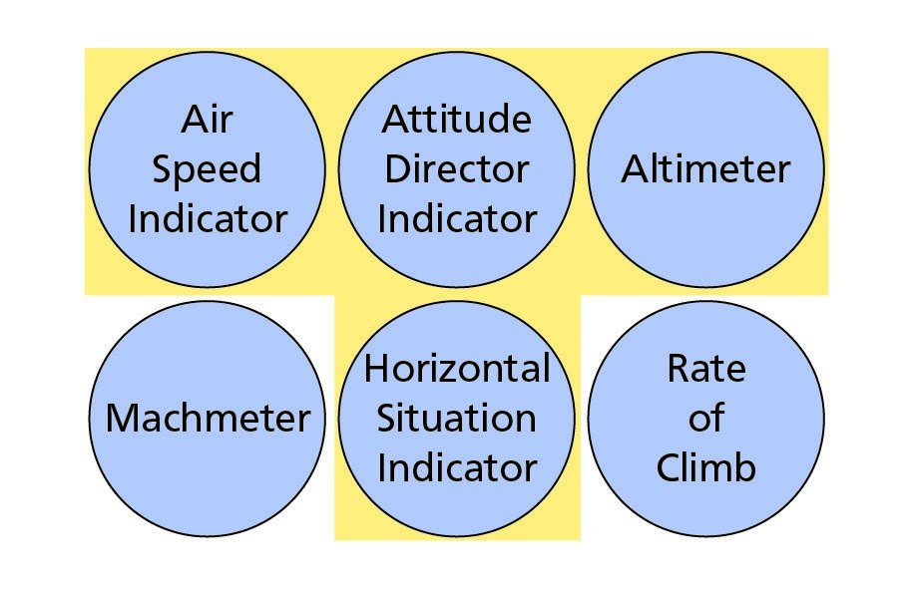

*Figure 14.2 The standard ‘T’*

#### Digital Display and the Compass

The conventional compass card gives a better picture of the aircraft orientation. A digital readout for heading makes it more difficult to determine such factors as the shortest way to turn onto a new heading however it is ideal for the display of quantitative information.

#### Combination of Analogue and Digital Displays

It is practicable to combine both digital information and analogue information in a single instrument, as seen in *Figure 14.3,* in which the thousands and hundreds of feet are displayed digitally. The hundreds of feet are also shown by a single pointer. The use of a single moving pointer against a fixed scale will give a much better mental picture to the pilot when approaching the end of the scale, i.e. approaching the ground. This form of display is also excellent for showing small changes such as when levelling off or departing inadvertently from the selected altitude.

#### Glass Cockpit Display

Basic presentation is maintained to some extent in the modern ‘glass cockpit’, in which the instruments are displayed on a Cathode Ray Tube (CRT). The attitude may be presented in the traditional way but other items, such as speed and altitude, may be displayed on moving tape displays, with a conventional compass card, or as a digital display readout. *(Figure 14.4).*

**14**

**Man and Machine**

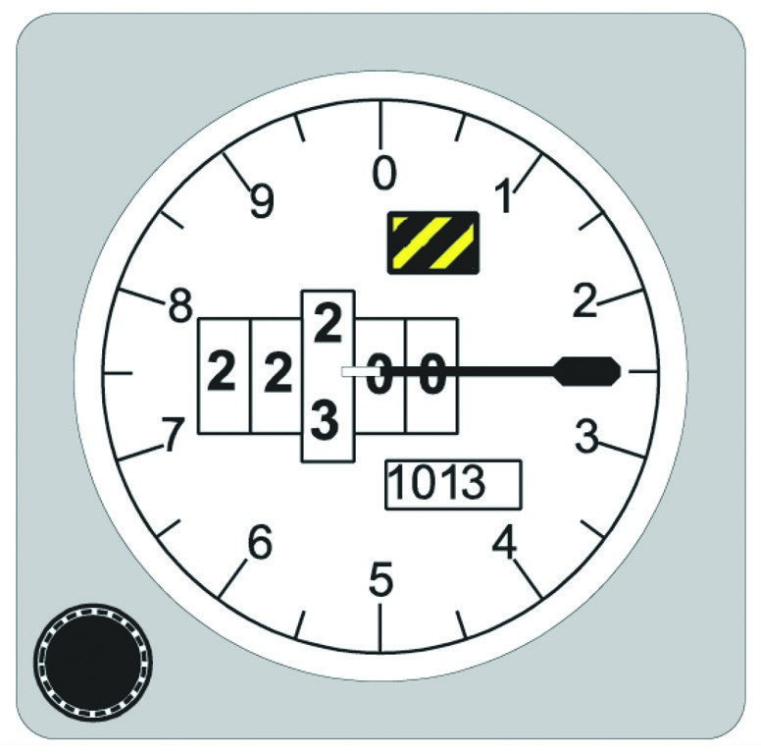

*Figure 14.3 Combination of analogue and digital*

*Figure 14.4*

*A ‘Glass Cockpit’ flight display using tapes*

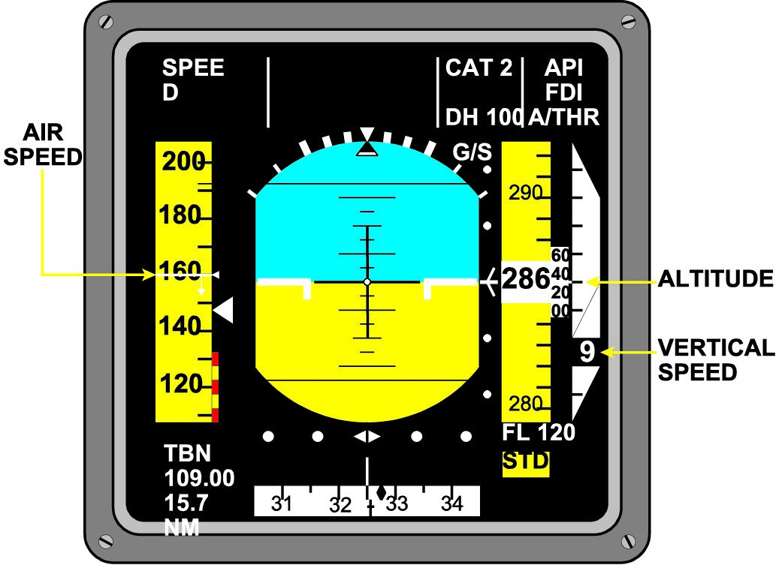

#### Tapes and a Perception of Rolling

The use of tapes does present some problems in the climb and descent. If we maintain the convention of having the high figures at the top of the presentation then during a climb, with a decreasing speed and an increasing altitude, there may be a perception of the aircraft rolling.

Other displays have the higher values at the bottom of the displays. As there is no industrywide standard for presentation of information it is possible, on transfer of aircraft type, to have presentations working in opposite senses to which the pilot has become familiar. Such a state of affairs is plainly undesirable and a recipe for possible errors.

#### Head Up Displays

A promising development for future displays is the Head Up Display **(HUD).** In this system the information required by the pilot is projected on a translucent screen between the pilots and the forward flightscreen window. As the display is projected at infinity it enables the pilot to view the outside world through the display. It has been in use for many years in military aircraft and is now being incorporated into commercial aircraft.

The greatest success is in the presentation of ILS information on the windscreen, when information from the ILS equipment is processed by a computer to show a constantly changing picture of runway data as the procedure is flown. Although there is no requirement for a change of eye focus for the pilot, there is still the need for the transfer of attention.

#### Voice Presentation

An alternative method of presenting information is the use of a recorded voice message. This technique has been developed in some experimental aircraft but has not been adopted for normal commercial aircraft. The voice has been found distracting and after a time tends to be ignored. Voice information has only found a major use in the Ground Proximity Warning System (GPWS) and Traffic Collision Avoidance System (TCAS) systems.

### Hardware - Engine Instruments

#### General

As the information from the engine instruments is as relevant to the pilot as that from the flight instruments, it is important to ensure that these instruments are not only easy to read but as far as possible unambiguous. The instruments in each column should all relate to only one engine, and the instruments in each row should show the same information (RPM, TIT, torque) as shown in *Figure 14.5.*

**Man and Machine**

**14**

This enables the operator to spot immediately any discrepancy on any instrument and identify the engine concerned in the minimum time. In an ideal layout the columns of instruments will be aligned with the appropriate power lever, all No 1 engine instruments being above No 1 power lever and so on. Another aid to rapid identification of a problem is to rotate the instruments so that all needles are aligned, vertically or horizontally, in normal cruise flight. ***Primary and Secondary Instruments***

As well as the primary engine instrument a number of instruments are required to display secondary information. There are a number of different possible configurations, two of which are shown in *Figure 14.6.*

There are advantages and disadvantages to each layout. The ideal layout could have a bank of instruments below the primary instruments but cockpit space may not allow this. In *Figure 14.6* the layout at **A.** might be preferable but this type of layout could only be used with an even engined aircraft and could not be used with a three engined aeroplane. As the purpose of these instruments is to warn of possible problems, and guide the pilot to the correct identification of the engine concerned, there is a great deal of research needed to identify the best layout for each aircraft type.

*Figure 14.5*

*An ideal engine instrument layout*

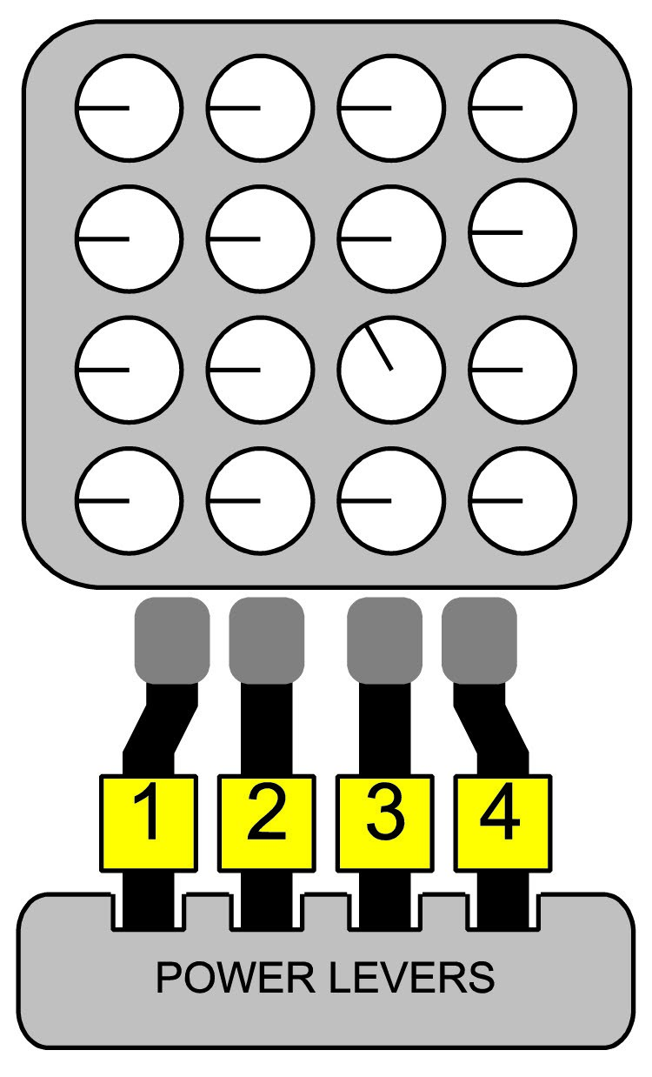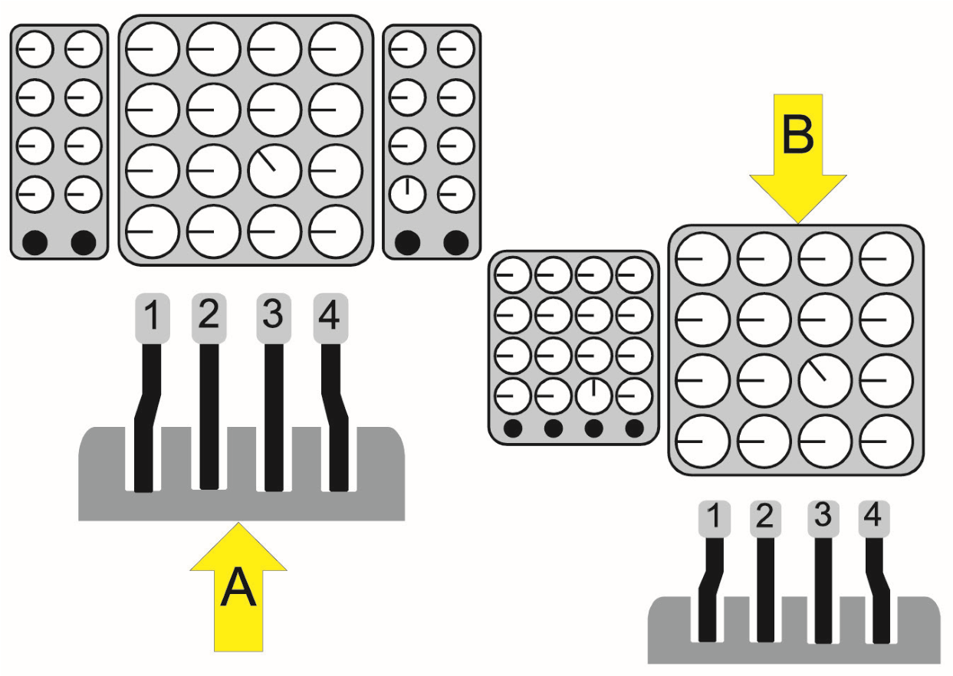

*Figure 14.6 Possible engine instrument layouts*

**14**

**Man and Machine**

#### Cockpit Lighting

All instruments need a lighting system to enable readings to be noted in all light conditions. On conventional dials there is a choice of internal lighting on each instrument or external lights to illuminate a group. In most cockpits there is a mixture of both internal and external lights. In the glass cockpit display the brilliance control will act as an adjusting mechanism to cater for varying light conditions. Once set, the screen brilliance may be automatically retained by an ambient light sensor fitted in the cockpit.

What is essential is an adjustment system that allows for both the state of natural light and individual preference. All lighting systems should avoid harsh shadows and reflected glare.

There has been a tendency in modern civil flying to use higher brightness levels on the flight deck. Research has indicated that on long night flights, fatigue and drowsiness seem to be less with higher brightness levels. With age visual acuity decreases, and older pilots require a higher brightness level.

Should there be a possibility of thunderstorms or lightning, cockpit lights should be turned fully up to reduce, as far as possible, the ‘blinding’ effect of flashes.

### Hardware - Controls

#### Basic Considerations

Displays enable information to be passed from the aircraft to the pilot - controls enable instructions to be passed from the pilot to the aircraft. There are certain basic considerations which govern the way controls should be designed and arranged.

**Man and Machine**

**14**

* **Standardization**

Most importantly, controls should be standardized in their location and sense of use from one aircraft to another, and between different aircraft types. For example, to operate a manual valve, rotation should be:

* Clockwise to close
* Anti- clockwise to open
* **Frequency of use**

Controls should be located such that they are within an easy reach envelope of all designed users of the aircraft. Controls that are used frequently or for protracted periods should be located so that they do not require an awkward or fatiguing posture of the pilot.

* **Sequence of use**

Controls that are frequently used in a given order should be laid out so that the sequence of use is represented in the layout of the controls. As well as convenience, the layout itself acts as a prompt for the pilot.

* **Importance**

Important controls must be located in easily reached and unobstructed positions.

* **Visual/Tactile dissimilarity**

Switches and knobs that control different functions should not look or feel the same thus reducing the chances of inadvertent operation.

* **Symbolism**

Controls, if possible, should be designed to contain some reference to their function. Thus undercarriage levers can be shaped like a wheel and flap levers can resemble a cross section of a flap.

* **Control/Display compatibility**

Controls should be located such that they maintain some spatial logic with the display that they are associated with. For example the columns of engine instruments should be aligned with their relevant power levers. *(See Figure 14.5 and Figure 14.6).*

* **Control loading**

The force required to operate any control should not only be within that which can be exerted by the target population of pilots but should be harmonized with the forces required by other related controls. For example, a control column will be difficult to use if it requires a large force to control roll but only light force to control pitch.

* **Prevention of inadvertent use**

Controls should be designed to minimize the chances of inadvertent operation. Where this could be dangerous, the control should be fitted with a guard.

* **Control position and present demand**

The position of the control should indicate the selected function. In some modern cockpits the conventional column has been replaced by a sidestick. Both pilots’ sidesticks should move in unison so that, on change of operator the pilot taking control will know the already selected position.

**14**

**Man and Machine**

* **Simultaneous use**

Those controls requiring simultaneous use, such as the throttle and trim controls, should be located to enable this to take place.

Great progress is being made to meet all of the above requirements but even today there are problems with some aircraft designs. Some are merely a nuisance but others should not be tolerated. Some examples of problems will be found in Chapter 16 dealing with reports submitted by pilots.

#### Warnings

It is essential that all warnings should be ‘attention getting’ without being startling. As well as attracting attention the warning should inform the pilot of what is wrong and if possible; guide the pilot to the correct actions. The **alerting** function for all important failures should be fulfilled by an **audio** warning. This is mandatory if the pilot is required to assume control.

Even the most conspicuous visual warnings rely on head and gaze orientation. In a more extreme example, the use of any visual warning is rendered useless if the pilots should be asleep. The ideal warning system is to have a single audio warning to alert the pilot to a failure and to direct his attention to a single central warning panel that announces the nature of the problem with a suitable illuminated caption.

It is vital that warning systems be reliable, that is they respond to all genuine problems, but do not generate false alarms. Early GPWS systems were well known for generating spurious warnings and it has been suggested that CFIT accidents have been caused by pilots (used to hearing spurious warnings) ignoring genuine alarms.

### Software

#### Checklists and Manuals - Introduction

The importance of good design in checklists is fundamental to the safe operation of aircraft. Aircrew must be afforded rapid accessibility to accurate information in manuals and checklists. There is plainly a requirement for crews to be sufficiently familiar with their documentation so that they know where to find relevant information in the quickest possible time.

***Checklists - Main Requirements*** The main requirements for checklists are:

* Unambiguous.
* Easy to read.
* Kept to a manageable size for easy use on the flight deck.
* Fullest use is made of good cross-referenced indexing and colour coding of pages by topic.
* Division of pages with protruding thumb locators.
* Amount of information presented is relevant to the needs of the pilot.
* Presented in easily understood language.
* Text:
* Size should be kept well above the minimum required for bare legibility since it may have to be read in poor lighting conditions by a crew that already has a high workload.

**Man and Machine**

**14**

* Type face should maximise legibility.
* A mix of upper and lower case together with bold and italics should be *used with care to maximise clarity and emphasis.*

**Note: UPPER CASE** text and the use of italics may be useful in conveying emphasis but neither of these are as fast to read as normal text.

THUS LONG MESSAGES, IN UPPER CASE, SUCH AS THIS, SHOULD BE AVOIDED SINCE WORD SHAPE WHICH ACTS AS A CLUE IN READING, MAY BE LOST.

#### Use of Colour

Colour is a preferable way of categorizing information and giving importance to different sections of text, but the legibility of different text/background may well vary under varying light conditions. For example red text on a white background may become effectively invisible under red light.

#### Checklists - Design Usage

The maximum benefit is obtained from checklists when the pilot adheres to the designed procedure. If the checklist calls for a challenge and response, then this is the way it should be used.

#### Checklists - Sources of Errors

Common problems are listed below:

* A major source of error in using routine checklists is that they may be responded to **automatically** rather than **diligently.** It is tempting for pilots to regard a rapid dismissal of checklist items as indicative of their skill and familiarity with the aircraft, but, if checklists are dealt with in this automatic way, it is very easy for individuals to see what they expect to see rather than what is there. Pilots must be aware of this tendency and devote particular care to this aspect of checklist action.
* The progress of the checklist is interrupted by an external event, (radio call for example), when items may be omitted, or
* Simply because a pilot, using his thumb as a marker, adjusts his grip on the checklist and items may be missed.

### Hardware and Automation

#### Introduction

Since about 70% of all accidents in aviation are attributed to human error it is understandable that companies are looking for ways and means to eliminate the human element as far as it is safely possible. Thus automation is on the march and is a fact of life. However, with it comes a number of new problems.

Before the advent of computers into civil aviation, cockpits were inevitably complex because every sensor in the aircraft was connected to its own display on the flight deck and the value of the parameter was displayed constantly. The major changes that automation has allowed are:

**14**

**Man and Machine**

* The computer is able to receive information from many sources and integrate all data into a single comprehensive display

and

* The computer can be selective with regard to the amount and type of information that is displayed at any one time.

Possibly the best example of integration of information is in the navigation or horizontal situation display found in advanced flight decks. Information from ground radio aids, the aircraft’s inertial platform, weather and ground mapping radars, is integrated to present the pilot with a picture of the aircraft’s situation in the horizontal plane.

This overall picture not only releases the pilot from the requirement to integrate the information himself, but frees him/her from other tasks such as calculating ETAs or finding wind velocities.

#### Some Basic Concepts of Automation

Before we look at the advantages and disadvantages of automation it is necessary to understand some of the basic concepts of automation.

Automation is to assist rather than replace the pilot, leaving him/her to make higher level decisions. The pilot must at all times remain in control of the automation and be aware of what it is doing.

#### Automation

Automation in aviation is a system or part of a system, which when activated, effects a predetermined sequence of actions autonomously in a limited period of time. Under normal conditions, the pilot has no control over it and cannot deactivate it. Generally automation is embedded in the execution chain of a system (cabin pressurization/cabin temperature control).

#### Protection Automation

Protection Automation is an automatic action which is triggered as a safety limit is passed. It cannot be disengaged by the pilot. (stick shaker/flap load relief/some alarms).

#### Support System

Support System is system displaying processed or diagnostic information that can be instantly used by the pilot (EICAS/Flight Director).

#### Glass Cockpit

Glass Cockpit is a cockpit design characterised by computer-generated visual displays the minimum of which is a Primary Flight Display (PFD) and a Navigation Display (ND). The term is sometimes incorrectly used when referring to an aircraft equipped with screens reproducing standard instruments.

#### Advantages of Automation

* **Crew input** is **decreased** thereby reducing the chances of human error.

**Man and Machine**

**14**

* **Technical reliability**. A large number of automated systems are equipped with two and even three computers thus improving redundancy levels dramatically.
* **Cost savings** and increased productivity due to greater technical reliability.
* The choice of modes has considerably reduced the amount of space needed for instrument display. This has led to a **decrease in the size of cockpits.**
* **Cuts** crew **workload** and thus affords the crew more time for decision making. Although this is generally true, there continues to be discussion over this topic. Whereas physically workload is certainly decreased, mental workload may be increased depending upon the experience of the individual or his/her attitude towards automation. Furthermore there is evidence that automation tends to force pilots from the normal low workload suddenly to an unexpectedly and extremely high workload when the system fails.
* Provides a **smoother and more accurate control** of the aircraft than can be achieved by humans.
* **Greater choice of options** for the display of information.
* Increased **safety**.

#### Disadvantages of Automation

* **Boredom leading to a loss of situational awareness.** The highly automated flight deck and extended range operations have developed concurrently. This means that the cruise stage of the flight, where the pilot has little to do, may continue for over 12 hours. This can create problems, not only of boredom and hypovigilance but of loss of handling skills.

Boredom also leads to a reduced monitoring of the environment and **reduced situational awareness.**

A bored crew may be **tempted to experiment with systems** on the flight deck. In one serious incident the crew attempted to discover how certain aspects of the auto-throttle operated and in the process disabled the engine management system to the extent that fan blades were shed by an engine. The fan blades pierced the fuselage and a passenger was lost through the hole.

There have been many suggestions made to cope with boredom. One of the simplest devices is the fitting of a button which must be pressed every five minutes if no other pilot activity is detected. If the crew should fall asleep then failure to press the button will trigger an aural warning.

An airline has now installed a more sophisticated system whereby, if nothing has been picked up by the CVR for 10 minutes, a steady light illuminates in the cockpit. After 15 minutes the warning light flashes and after 20 minutes an audible warning sounds both in the cockpit and Galley indicating that a member of the Cabin Crew must visit the cockpit.

**14**

**Man and Machine**

The aircraft of the future needs to be designed with a flight deck that is not only safe, comfortable and efficient but also provides the occupants with the stimulation and interest necessary to maintain alertness.

* **Greater delays** between the **performance** of the crew and its **ultimate effect.** For example, an incorrect entry of a waypoint may not become apparent until hours later. The Air New Zealand DC-10 crash into Mount Erebus is a classic example. In this case the incorrect waypoint was entered into the computer by ground personnel.
* **Automation complacency** is an over-reliance on automation and the classic symptom of which is passive monitoring. This is the tendency of aircrew to “leave it up to the computer to sort out” and to accept in blind belief that automation is the more capable of monitoring the flight path and of finding solutions. Continued, active and deliberate monitoring of the systems is an absolute necessity.

There is a danger that the pilot may come to regard the aircraft as infallible, and able to cope with impossible situations. It is no use, for example, to be flying an unstallable aircraft if the pilot has placed it at low level and low airspeed, with no energy available to fly away from the problem. The automation of the aircraft does not absolve the pilot from operating in a way that complies with the basic requirements for safe flight.

* **Blinkered concentration** is the possibility of becoming so involved in a single readout that situational awareness is lost. Always remember that a readout that causes consternation can, in 99% of the cases, be cross-checked with alternate instruments.
* **Confusion.** Automation is capable of collating an enormous amount of information and displaying this information on one screen. Manufactures and designers tend to fall into the marketing trap of producing systems which will give more information to the crew than their competitors. The result can be a multi-facet readout that, far from making life simpler for the crew, tends to confuse with the sheer volume of information displayed on one screen.
* The modern flight deck computer will automatically display the current aircraft status tailored to the pilot’s activity and the phase of the flight. This will certainly reduce the pilot workload but there is the possibility of the pilot remaining unaware of important information when solving an **unusual and unexpected problem.**
* The displays are so easy to use that they make it difficult, when they fail, for the pilot to **use his/her traditional skills** at basic instrument flying, and this might be especially true of younger pilots who do not have any depth of experience on more basic aircraft.
* The **older pilot** may have a **mistrust** of the new computers and increase his workload considerably with unnecessary checking on the information received.
* The **complex systems** which drive the modern pilot/equipment interface **cannot be understood** by pilots to the same extent that more basic systems could. This problem arises partly as a result of the complexity of the system, and partly as a result of the ‘need to know’ mechanized teaching methods. It is said that the commonest expressions heard on the modern flight deck are ‘What’s it doing now?’ or ‘I’ve never seen that before’.

**Man and Machine**

**14**

* **Mode Error.** Since the automatic flight controls and engine management systems can be set up in so many modes, it is possible for the pilot to believe that the aircraft is programmed to carry out one function when it is, in fact, performing another.

It is vitally important for the pilots of such aircraft to maintain an accurate knowledge of the aircraft status by including the mode representation as a central part of their scan. It is equally important that designers ensure that mode information is prominently and centrally displayed.

An example of Mode Error occurred in 1979. A DC-10 was climbing to cruise altitude. The crew was unaware that they had programmed the autopilot for vertical speed hold instead of airspeed hold mode, as was intended. Maintaining a constant rate of ascent the airspeed decayed to such a point that the aircraft entered the stall buffet. This was identified as vibration in number 3 engine, which was subsequently shut down. The aircraft then stalled, rolled to its right and lost 11000 ft before recovery was achieved.

* **Manual control.** Whenever the pilot is not “in the loop”, he or she is often **not mentally prepared** to take over the controls and fly the aircraft in the event of an automatic system failure. In addition, failures are less frequent but also are less predictable and are much quicker and more intense that before (e.g. a sudden reversion to manual control).
* Although the **signal** received by the computer may be of **poor quality**, this information is **not** normally passed to the **flight crew**.
* **Difficulties with crew coordination and communication.**  This is due to the following factors:
* Each member has access to an ever-expanding data base and individual access to commands. However, this flexibility can be dangerous unless concerted effort to coordinate and inform the other pilot of their intentions and actions.
* The co-pilot tends to move less leading to a possible further loss of body language communication.
* Information tends to be abbreviated. The number of acronyms is so high that the less frequent ones tend to be ignored or confused with familiar acronyms.
* Digital reports tend to be so detailed that crew can lose a great deal of time reading through them when prompt action might be necessary.
* **Difficulty in changing plans.** Data entry is lengthy and very prone to errors. Pilots tend to get involved in time-consuming changes to programmed parameters (with the associated loss of situational awareness) whereas manual override on the flight path would have been the best way to ensure flight safety. Two classic examples of this, which have been the cause of many accidents, is on final approach with a runway change or a change of direction in the hold prior to approach. ***Irony of Automation***

Computers do those things that pilots already know how to do well, much better that pilots. But computers do not know how to do those things that a pilot would like to do well.

**14**

**Man and Machine**

In essence, the irony is that pilots are to oversee an automated system, which they do poorly, and take over when there are abnormal conditions, which they may not be very good at either.

#### Adaption to Automation

Adherence to a number of basic principles will go a long way towards adaption to automation, the most important of which are:

* Fly the aircraft.
* Take your time. Nothing has changed. You are still flying the aircraft albeit via a computer. Adaption can be a slow process so give yourself a chance to make the beginner’s mistakes.
* Don’t get so involved in either reading the reports or entering data that you lose situational awareness or forget that you are flying an aeroplane.
* Always try and fly with a pilot who is experienced until you are confident.
* Beware boredom and hypovigilance! Keep “in the loop” and be alert.
* Input data only when you have plenty of time. Even while doing so, stop every 15 seconds or so to have a good look round and to keep your situational awareness.
* Double-check your data entries and get your crew member to check them again independently.
* Keep in contact with the rest of the crew and keep them current in what you are doing.
* If you do not understand a displayed piece of information, double-check it. It could be wrong.
* Take any opportunity to take extra simulator training.

#### Automation - Summary

Aircraft automation is gaining ground and is here to stay. It is a tool and, as we have seen, it is far from a panacea. Certainly it has gone a long way to solving many of the traditional problems but, in its wake, brings those of its own.

As any tool, its effectiveness depends on the user. It should be handled in the correct way and with an awareness of its weaknesses and dangers. Used badly it can lead to catastrophic results but handled well it becomes a major contributor to flight safety.

### Intelligent Flight Decks

There is no precise line that divides the ‘automated’ from the ‘intelligent’, but the problem solving and data evaluation of which modern computers are capable would merit the use of terms such as ‘pilot’s associate’ and ‘electronic crew member’. There are however three main human factors issues that may be identified:

* How much autonomy should be given to the machine? Should the computer be allowed to evaluate information, make decisions, and execute them without reference to the pilot? Or should it remain in an advisory role, presenting suggestions to the pilot to assist him in making the necessary decisions? For example, should an aircraft fitted with a GPWS take automatic climb action on receipt of a terrain warning?

**Man and Machine**

**14**

* As machines become more complex they evaluate greater quantities of possibly ‘noisy’ data. Any increase in this ‘noisy’ data will lead to an increase in ‘probabilistic’ solutions. Present aircraft displays do not give the pilot any estimate of the **reliability of the data displayed** they simply display the machine’s best guess.
* The computer uses information from both its internal inertial system and ground based fixing aids. However, the pilot is given the same display regardless of whether the aircraft ‘knows’ that good data is being received from all sources or whether the computer ‘knows’ that it is receiving information, for example, from two poor cross-cuts, distant VORs or an inertial system that has been drifting for a number of hours.
* Pilots must have an appropriate level of trust in their equipment since under-trust can lead to unnecessary workload and over-trust has obvious dangers. Modern equipment is normally very reliable and the perceived reliability will determine the amount of trust that pilots have in the equipment. Another factor for consideration is that the modern display may be so compelling that it generates more trust than it actually deserves.

### Colour Displays

Where colour is used to indicate a change of state, for example, from ‘ALT (altitude) capture’ (blue) to ‘ALT hold’ (green), the colour change should be accompanied by a change of caption or location. The change of colour by itself is not normally sufficient to ensure that the crew will notice the difference.

### System Active and Latent Failures/Errors

#### Introduction

The human contribution to the failures with modern technological systems can be divided into two types: Active and Latent Failures. The distinction between the two is:

* who made the error and/or
* how long these errors take to appear

#### Active Failures/Errors

Active errors/failures are committed at the human-system interface (i.e. in the cockpit, in the cabin or at the Air Traffic Controllers desk) and have an immediate effect. We have already discussed a number of these (Action Slip, Environmental Capture etc.).

#### Latent Errors/Failures

Latent errors/failures are normally the results of decisions taken by designers, manufacturers and senior management. These people are usually a long way removed from the immediate system. However the consequences of their actions or decisions which have been dormant - perhaps for a long time - may have sudden and disastrous results. An example of latent failure was the Mount Erebus crash where an aircraft database had an unnoticed waypoint error of 2°W. This was sufficient for the aircraft to hit a mountain in poor visibility. Rushed or incomplete preparation is another example of latent failure.

**14**

**Man and Machine**

### System Tolerance

**Sod’s Law states: If something can go wrong, it will.**

An example of Sod’s Law is:

**Murphy’s Law which states: If a system can be operated incorrectly, sooner or later it will be.**

#### Error Tolerance

Aviation systems, whether aircraft, organizational or procedural must be **error-tolerant.** This ensures that no error has serious implications to the overall safety or conduct of the system. An example of this would be an automatic system that prevents an aircraft moving outside its flight envelope regardless of the orders the pilot enters through the controls.

#### Protected and Vulnerable Systems

Systems must also be designed to contain their own intrinsic protection. A system is considered vulnerable if one error is allowed to affect the whole system. *Figure 14.7* illustrates the concept. A brick taken out from the “protected” wall will leave the main structure still standing however, in the case of the “vulnerable” wall, its whole function will be affected.

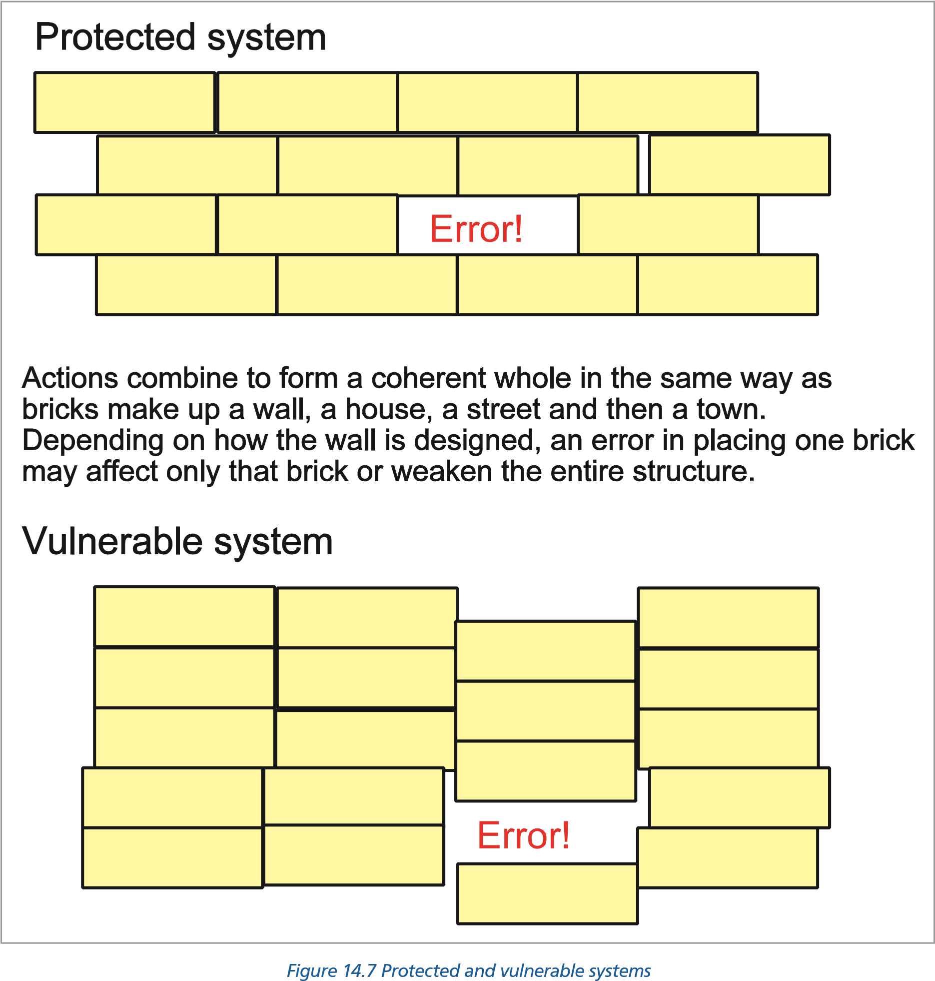

### Design-induced Errors

These errors are those made by aircrew as a direct result of poor or faulty design of any part of the aircraft. The philosophy which will underpin all future EASA design efforts - especially those in the field of avionics and automation - will be based upon:

**Man and Machine**

**14**

**Detectability Tolerance Recoverability**

Systems will be expected to detect errors made by aircrew, tolerate them and, as far as is possible, to recover from these errors.

### *Questions*

#### Questions

1. **A pilot is reading a checklist. In what way is this reference to the SHELL Concept ?**
   1. S - L
   2. H - L
   3. L - S
   4. H - E
2. **What percentage of the appropriate population are anthropometric data table measurements taken from?**
   1. 80%, i.e. the tenth to the ninetieth percentile, using contour, dynamic and static data
   2. 90%, i.e. the fifth to the ninety-fifth percentile, using contour, dynamic and static data
   3. 50%, i.e. the twenty-fifth to the seventy-fifth percentile, using contour, dynamic and static data
   4. None of the above
3. **What is the most common checklist error?**
   1. Action slip

**14**

**Questions**

* 1. Too many capital letters are used
  2. Responded to automatically
  3. Missing items

1. **What is the purpose of the lumbar support?**
   1. To allow the most comfortable position for the spine and higher neck bones
   2. To allow the most comfortable position for the spine and shoulder bones
   3. To allow the most comfortable position for the spine
   4. To produce an even pressure of the discs by allowing the lower spine to curve naturally
2. **What are the essential characteristics of a cockpit warning?**
   1. It should have the best attention-getting qualities as possible
   2. It should be attention-getting but not alarming
   3. It should have attention-getting qualities which do not compromise a clear indiction to the pilot of the faulty component/system
   4. Must not dazzle or possibly compromise the crew’s night vision
3. **What is the most important feature of flight deck design?**
   1. Escape and emergency exits should be clear of obstructions
   2. The design eye point must be clearly marked
   3. Important controls must be located in easily reached and unobstructed positions
   4. Controls and indicators should be standardized

### *Questions*

1. **What will the pilot lose sight of on the approach if seated below the Design Eye Point?**
   1. Some of the undershoot
   2. Some of the overshoot
   3. Peripheral objects especially at night
   4. The sight view
2. **What instrument is best for showing small change?**
   1. A digital display
   2. An analogue display
   3. A mixed digital/analogue display
   4. Ultra/high-precision gyro instrument
3. **What colour should the ‘Alert’ warning be on a CRT?**
   1. Bright red and flashing
   2. Steady Red
   3. Flashing yellow/amber
   4. Steady yellow

**Questions**

**14**

1. **Which pitot/static instrument is most likely to be misread?**
   1. The ASI at night illuminated by a red light
   2. The ASI at night illuminated by low intensity white light
   3. The three point altimeter
   4. The four point altimeter
2. **A manually operated valve should be opened by:**
   1. turning it clockwise
   2. turning it anticlockwise
   3. turning either way
   4. depends on the system it operates
3. **The three types of anthropometric measurements are:**
   1. static, design, contour
   2. contour, design, dynamic
   3. static, dynamic, contour
   4. static, dynamic, design
4. **In the Shell Model L stands for:**
   1. latent errors
   2. long-term errors
   3. lengthy errors
   4. liveware

### *Questions*

1. **System Tolerance can be subdivided into:**
   1. protected and semi-protected systems
   2. protected and endangered systems
   3. protected and vulnerable systems
   4. protected and quasi-protected systems
2. **A flashing red warning light on a CRT normally indicates:**
   1. there is a fault in a critical system
   2. emergency
   3. alert
   4. danger
3. **Automation Complacency is:**
   1. overconfidence in the handling capability of the pilot
   2. overconfidence in the handling capability of the pilot of computers
   3. overreliance on automation
   4. the blind belief in automation
4. **Mode error is associated with:**
   1. automation

**14**

**Questions**

* 1. hardware
  2. INS
  3. software

1. **A danger of automation is that:**
   1. there can be greater delays between the performance of the crew and its ultimate effect
   2. delays between the performance of the crew and its ultimate effect are shortened
   3. delays between the performance of the crew and its ultimate effect are not appreciated
   4. delays between the performance of the crew and its ultimate effect have no effect
2. **Automation:**
   1. helps with unusual and unexpected situations
   2. may result in a pilot being unaware of important information when dealing with an unusual and unexpected situation
   3. increases reaction time when dealing with unusual and unexpected situations
   4. decreases reaction time when dealing with unusual and unexpected situations
3. **Automation can result in:**
   1. lack of information being passed between crew members
   2. too much information being passed between crew members
   3. confused information being passed between crew members
   4. too much detailed information being passed between crew members

***Questions***

**Questions**

**14**

### *Answers*

**14**

**Answers**

#### Answers

|  |  |  |  |  |  |  |  |  |  |  |  |
| --- | --- | --- | --- | --- | --- | --- | --- | --- | --- | --- | --- |
| 1 | 2 | 3 | 4 | 5 | 6 | 7 | 8 | 9 | 10 | 11 | 12 |
| c | b | c | d | b | b | a | c | b | c | b | c |
| 13 | 14 | 15 | 16 | 17 | 18 | 19 | 20 |
| d | c | b | c | a | a | b | a |

Chapter

## **15** Decision Making and Risk

Introduction. . . . . . . . . . . . . . . . . . . . . . . . . . . . . . . . . . . . . . . . . . . . .297

The Mechanics of Decision Making . . . . . . . . . . . . . . . . . . . . . . . . . . . . . . . .298

Standard Operating Procedures . . . . . . . . . . . . . . . . . . . . . . . . . . . . . . . . . .301

Errors, Sources and Limits in the Decision-making Process. . . . . . . . . . . . . . . . . . . .302

Personality Traits and Effective Crew Decision Making. . . . . . . . . . . . . . . . . . . . . .303

Judgement Concept . . . . . . . . . . . . . . . . . . . . . . . . . . . . . . . . . . . . . . . .303

Commitment . . . . . . . . . . . . . . . . . . . . . . . . . . . . . . . . . . . . . . . . . . . .303

Questions . . . . . . . . . . . . . . . . . . . . . . . . . . . . . . . . . . . . . . . . . . . . . .304

Answers . . . . . . . . . . . . . . . . . . . . . . . . . . . . . . . . . . . . . . . . . . . . . . .308

**15**

**Decision Making and Risk**

### Introduction

**“Making a decision is committing to a course of action”**

The most important human factor of any flight is the decision making process of the crew. Sound decisions will lead to a safe and successful outcome to the task whereas bad decisions may lead to disaster. Decision making brings together many factors which have already been studied individually during this course. Thus this most important topic deserves special consideration.

The difference between “deciding” and “decision making” is, whereas “deciding” may be arbitrary or based on an emotion, “decision making” is the step-by-step scientific process which is followed in order to reach a balanced and factual decision sometimes known as the **Judgement Concept.** “Deciding” will not be discussed in this chapter.

A decision must be made each time there are several possible ways of achieving a given end. The choice will depend on:

* The aim to be achieved.
* The personal preference of the decision maker.

The aim of decision making is normally unambiguous however, the personal preference of options to achieve that aim will be influenced by a host of variables, such as the personality and biases of the decision maker, the stakes involved, perception, stress, emotion, training, past experience, motivation, commercial factors - to name but a few. However, it is possible to identify certain common factors that influence decision making regardless of the circumstances.

**Decision Making and Risk**

**15**

Fortunately the human being has a number of positive capabilities in the decision-making mechanism:

* The ability to make decisions very quickly if involved in a “skill” which is well learned and highly automated.
* The capability to be creative.
* The capacity to be innovative.
* The aptitude to cope with novel situations. The human will (currently) consistently out- perform a machine in this area.

We must remember **that the commander of the aircraft is ultimately responsible for any decision made in the cockpit.**

### The Mechanics of Decision Making

It is possible to expand on the British Airways DODAR concept (see *page 331*) to include a number of important considerations.

**15**

**Decision Making and Risk**

|  |  |
| --- | --- |
| **Steps** | **Key Points** |
| Diagnose and Define objective | Identify the most important/urgent problem  Specify the aim or objective Assess the time available |
| Collect information | Collect information from every available source Obtain inputs from other members of the crew |
| Risk assessment | Assess risk |
| Develop options | Think through every option to its logical conclusion |
| Evaluate options | Weigh and compare options |
| Decide | Select the best option and decide |
| Assign tasks | Assign tasks to the whole crew |
| Implement decision | Supervise and monitor the execution of the decision |
| Consequences | Monitor and evaluate consequences |
| Review and Feedback | Review whether the situation remains the same and that the decision is still valid Return to step 1 |

***Diagnosis and Definition of the Objective***

#### Time Assessment

The value of the decision largely depends on how deeply the situation is understood. An accurate assessment often requires perception of a large number of cues - radar pictures, weather forecasts, visual topographical features, fuel consumption, engine status, airport capabilities, and so forth. These cues, in turn, must be interpreted against a knowledge base in the long-term memory to accurately construct a mental model and diagnosis of the real situation.

Faulty diagnosis, and thereby setting out to solve the wrong problem, may be avoided by ensuring that confirmation of the diagnosis is obtained from other members of the crew at this early stage. Should the pilot be by himself/herself, this initial diagnosis of the problem must be deliberately and calmly double-checked.

Definition of the objective must be crystal clear. Once the crew are certain that the diagnosis is correct, the objective normally is self-evident.

A decision is “good” if it can be implemented within the time available. Contrary to popular belief, it is unusual in flight that time dictates a very quick decision. Certainly, a rapid solution to an emergency on take-off or landing, or if the aircraft is flying close to the ground, is essential. However, on most other occasions, a crew can make time in the air. There are many options open to enable this to be done.

Some of these could be:

* An approach can be converted into an overshoot.
* The aircraft can be put into a hold while the problem is assessed and solved.
* Take-off may be delayed.
* Speed can always be reduced.
* Diversion is nearly always an option.

In spite of the possibility of an error of commission, **the only effective solution when pilots expect to be short of time, is to prepare the decision in advance.**

**Remember: Thorough flight preparation plus briefings before each high risk phase of flight provide the best guarantee against making decisions when under the pressure of time.**

**Decision Making and Risk**

**15**

Commercial considerations, such as fuel costs may encourage a pilot to self-impose a time restriction. Although it is easy enough from the classroom to view these as of small importance viz a viz safety, commercial considerations can put considerable pressure on aircrew and thereby colour their decisions. ***Collect Information***

Every source of information must be utilized. Other members of the crew must always be included as one of the most important of these sources. The Commander’s perception of the situation may well differ from that of the crew. If this is the case, and the crew is included as early as possible, in the decision-making process, the consequent discussion and analysis is almost certain to pre-empt a faulty diagnosis.

#### Assess Risk

Due to the dynamics of the situation (particularly the speed of the aircraft), an action emanating from a decision is frequently irreversible - thus risk is involved.

In assessing risk, both the amount and the probability of that risk must be considered. Unfortunately experiments have found that humans are not skilled at assessing the probability of different outcomes and their resulting risks. A person will tend to overestimate the frequency of a very rare, but beneficial/positive, occurrence. This bias explains why gambling and lotteries are pursued - because the low probability payoffs are perceived as occurring more frequently than they, in fact, do.

On the other hand, peoples’ estimates of the frequency of unpleasant/negative events differ. Highly available or well-published events are overestimated (fatal aircraft accidents) whereas less salient events are greatly underestimated. (Airprox incidents, non-fatal accidents or the risk of contracting lung cancer through smoking).

#### Categories of Risk

The pilot can be exposed to 2 types of risk:

* **External or Objective Risk**

External risk is the risk of an accident in the current situation, if no changes are made to the flight path or the operation of systems.

* **Internal or Subjective Risk**

Internal risk is the risk which reflects the inability of the crew to implement a solution due to lack of know-how or insufficient time to apply their know-how. It should be noted that the internal risk increases linearly as the deadline for making and implementing the decision approaches.

A **Risk Factor** can be defined as anything that is likely to increase the likelihood of an accident occurring. ***Develop Options***

Assuming that the assessed situation is identified as a problem that requires some action, the pilot must then generate plausible alternative courses of action such as:

* Should the approach be continued?

**15**

**Decision Making and Risk**

* Is it better to go into a hold to give more time to gain further information?
* Should the aircraft return to base?
* Should the aircraft divert?

#### Evaluate Options

Each proposed course of action may have a different anticipated set of possible outcomes. All of these outcomes will have potential **values** associated with them (or costs, which may be termed as negative values). An evaluation of each outcome, together with its entailed risk assessment, is then made.

#### Decide

The Commander’s choice of options, or decision, should be that which produces the most value and the least cost. The option chosen should also lead to the most favourable expected outcome and which has the least risk. Sometimes it is not possible to have both and a compromise must, on occasions, be made.

A decision could be, of course, to delay an action until current information is confirmed or until additional data is obtained. Having made his/her decision, a good Commander will explain the reasons for the choice to the rest of the crew.

One further aspect of decision making and risk is important. Sometimes there is a choice of only two actions, one a risk and the other a sure thing. Man tends to make his decision dependant upon whether the problem is framed as a choice between two gains or two losses. People are biased to choose the risky loss rather than the certain loss, even when the expected loss resulting from the former is greater.

Consider the pilot who must choose, for example, between turning back in the face of potentially bad weather (with the certainty of disappointing passengers and, perhaps, personal embarrassment), or continuing on (with the chance of getting through safely and on time but also with a chance of suffering a major disaster). The choice is clearly between two negatives: a sure loss against an uncertain possibility of a disaster. Research has found that people have a bias to favour the risky choice. Many, many pilots and passengers have died as a result of this bias (**“press-on-itis”**).

Interestingly, this risk-seeking tendency is reversed when the choice is framed as one between gains. Here the sure thing alternative is favoured.

The really important point is that if our pilot **could have framed his choice differently** as a choice between two gains (the certainty of saving lives by turning back versus the possibility of not disappointing the passengers by continuing), he/she would have been biased to make the wiser decision. ***Assign Tasks***

Workload is shared amongst the crew by the assigning of tasks. It should not be forgotten that tasks may also be assigned to outside agencies (traffic information or diversion/holding of other aircraft by ATC). ***Implement Decision***

The Commander of the aircraft is responsible for supervising and monitoring the implementation of his/her decision.

#### Consequences

**Decision Making and Risk**

**15**

If the decision has been correct, the outcome of its implementation should be the Commander’s original objective. If not, then either the decision is incorrect or the situation has changed.

#### Review and Feedback

The situation is constantly changing in the air. Review of actions by the flight crew is fundamental and it should be ongoing. If the situation has changed, then the Commander should check whether the outcome of his/her decision is still valid - if it is no longer valid, the whole process starts again from the beginning. Thus the **real** situation is thereby continually monitored.

### Standard Operating Procedures

Rule-based Behaviour is one of the things that makes aviation as safe as it is today. Wherever possible, laws, procedures, vital actions and checklists are produced for the crews to follow. This, in itself, reduces the amount of decision making that crews have to carry out.

Errors can occur at the interface between liveware and software as it is very easy for individuals to misinterpret the content of checklists, manuals, maps, charts and airport guides. In order to try to minimize these errors, Standard Operating Procedures have been introduced and, if strictly adhered to, should be successful in reducing the number of mistakes.

One disadvantage is, however, that SOPs cannot be published for every possible situation.

They are aimed at establishing a pattern of behaviour that becomes habitual. As most airlines employ the practice of standardizing equipment and procedures, it is possible for the operating habits learned on one aircraft mark or type, to be carried over to another.

The standardization and training will allow routine tasks to be performed with less attention and effort. Design carry-over will also minimize confusion and reduce training time and costs.

SOPs should be shared by crew members and modified/updated to maintain synergy. **Errors, Sources and Limits in the Decision-making Process**

The Decision-making process is prone to human error and may be limited by outside factors.

#### Errors

* **Confirmation Bias**

See Chapter 8. The best method to avoid this error is to deliberately look for information that will falsify the hypothesis rather than confirm it.

* **Probability**

The pilot will be heavily influenced by the probability of an occurrence. For example a bang heard on take-off could be a tyre burst, a bird strike, or an engine failure. A burst tyre is the most probable cause of a loud noise at this stage. Thus pilots may automatically carry out the initial drills for that event.

* **Saliency**

People often tend to focus attention most heavily on those cues that are physically salient (loud, bright, recent, centrally visible, easy to interpret). Thus vital non-salient information may be overlooked.

**15**

**Decision Making and Risk**

* **Overconfidence**

An overconfidence either of personal skill or decision-making ability has been the direct cause of many bad airborne decisions. A good aviator, however experienced, is the first to admit that there is always much to learn. Overconfidence breeds **complacency**. Hand-inhand with complacency is the loss of motivation to practise or learn. Performance can only deteriorate. This is sometimes known as the **“Deterioration Effect”**. The higher accident rate for general aviation pilots with between 1 000 and 3 000 flying hours, compared with those less experienced, is often explained by this effect.

* **Fatigue/Overload**

Both fatigue and overload will seriously affect decision making.

* **Denial**

A common aspect of human attitude when exposed to risk is that of denial. This can typically manifest itself as one of the following behavioural patterns:

* Procrastination “I’ll continue to fly on for a little longer and then decide”.
* Rationalization “It’ll all work out just fine”.
* Hope and desires “It’s bound to clear on the other side of these hills”.
* Refusal to admit “It’s not like that and anyway it can’t happen to me”.
* Status and reputation “I’m just not going to be beaten”.
* Refusal to review “It worked last time in roughly the same situation”.

Each of the above examples is a form of denial. It is a refusal to accept, admit, confront, change or decide and has been the cause of many accidents. It is fundamental that, in order for a good decision to be reached, the ***REAL*** situation is analysed, confronted and assessed.

#### Limitations

* **Attention**

Human attention is limited or may be “funnelled” (perhaps due to stress) and thus input of information may be significantly curtailed.

* **Stress**

As we have already seen, stress can have a dramatic effect on both the human body and mind. Decisions made under stress are rarely of high quality.

* **Lack of experience**

Lack of experience will certainly slow down the decision-making process since diagnosis of the true situation will be slower than that of a skilled or an experienced pilot who will be able to rapidly correlate information from a number of sources because of the typical pattern that has been observed in the past.

In the same way, extensive familiarity with patterns of symptoms produced by particular aircraft malfunctions will allow the experienced pilot to rapidly interpret the overall situation from a potentially large number of cues indicating their individual status.

**Decision Making and Risk**

**15**

**Personality Traits and Effective Crew Decision Making**

The most important personality trait for effective crew decision making is **stability**.

### Judgement Concept

It can be summarized that judgement, risk assessment and the consequential decision made in the air is based upon the:

* Pilot
* Aircraft
* Environmental conditions
* Time available

### Commitment

Commitment refers to the degree of commitment to a solution when making a decision and which represents the “point of no return”.

### *Questions*

#### Questions

1. **What are the categories of risk?**
   1. Objective/Sudden and Subjective/Gradual
   2. Sudden/Impromptu and Gradual/Planned
   3. External/Objective and Internal/Subjective
   4. Impromptu/Objective and Planned/Subjective
2. **The Commander is ultimately responsible for all decisions made in the cockpit.**
   1. True
   2. False
3. **There is no difference between “deciding” and “decision making”.**
   1. True
   2. False
4. **A decision is “good” when:**
   1. it can be implemented within the available time
   2. time is not an issue. The decision must be correct

**15**

**Questions**

* 1. time can be an issue but the correct perception is the important factor
  2. when other members of the crew agree

1. **Preparation is essential for good decision making when time is an issue.**
   1. True
   2. False
2. **One of the possible problems of preparation is:**
   1. action slip
   2. confirmation bias
   3. error of commission
   4. environment capture
3. **A person will tend to overestimate the frequency of:**
   1. a common but negative occurrence
   2. a common but beneficial occurrence
   3. a rare but beneficial occurrence
   4. a rare but negative occurrence
4. **Negative events tend to be overestimated when:**
   1. they are well published
   2. obvious
   3. under published
   4. the results are unclear

### *Questions*

1. **The risk of an Airprox is normally:**
   1. overestimated
   2. underestimated
   3. discounted
   4. accurately assessed
2. **Evaluation of options in the decision-making process involves:**
   1. positive and negative considerations
   2. values and costs
   3. planned and impromptu considerations
   4. assigning tasks
3. **People tend to be biased to make a:**
   1. risky loss rather than a certain loss even if the expected loss from the former is greater
   2. risky loss rather than a certain loss even if the expected loss from the former is less
   3. risky loss rather than a certain loss even if the expected loss from the latter is greater
   4. risky loss rather than a certain loss even if the expected loss from the latter is far greater
4. **“Press-on-itis” is a:**

**Questions**

**15**

* 1. common dilemma faced by all pilots
  2. is only experienced by skilled pilots
  3. only happens to inexperienced pilots
  4. is rarely faced by good pilots

1. **The co-pilot is responsible for monitoring the implementation of the Commander’s decision.**
   1. True
   2. False
2. **People tend to focus on salient cues.**
   1. True
   2. False
3. **Fatigue/overload:**
   1. sometimes affects decision making
   2. rarely affects decision making
   3. never affects decision making
   4. always affects decision making
4. **In the decision-making process, what should follow “review and feedback”?**
   1. Assign tasks
   2. Decide
   3. Risk assessment
   4. Diagnose and define objective

### *Questions*

1. **Man is extremely capable of accurate risk assessment.**
   1. True
   2. False
2. **Input from the crew is an important factor in the decision-making process.**
   1. True

**15**

**Questions**

* 1. False

1. **Lack of experience will have the following effect on the decision-making process:**
   1. will speed it up (leaping in at the deep end)
   2. slow it down
   3. have no effect
   4. disrupt the process
2. **The decision process should include the crew.**
   1. True
   2. False

***Questions***

**Questions**

**15**

### *Answers*

**15**

**Answers**

#### Answers

|  |  |  |  |  |  |  |  |  |  |  |  |
| --- | --- | --- | --- | --- | --- | --- | --- | --- | --- | --- | --- |
| 1 | 2 | 3 | 4 | 5 | 6 | 7 | 8 | 9 | 10 | 11 | 12 |
| c | a | b | a | a | c | c | a | b | b | a | a |
| 13 | 14 | 15 | 16 | 17 | 18 | 19 | 20 |
| b | a | d | d | b | a | b | a |

Chapter

## **16** Human Factors Incident Reporting

Incident Reporting . . . . . . . . . . . . . . . . . . . . . . . . . . . . . . . . . . . . . . . . .311

Aeronautical Information Circulars . . . . . . . . . . . . . . . . . . . . . . . . . . . . . . . .316

Staines Trident Accident 1972 . . . . . . . . . . . . . . . . . . . . . . . . . . . . . . . . . . .316

**16**

**Human Factors Incident Reporting**

### Incident Reporting *Introduction*

It was first calculated in 1940 that three out of four aircraft accidents are due to what has been called human failure of one kind or another. This figure was confirmed by the International Air Transport Association (IATA) thirty five years later. During the year that IATA was publishing its figures (1977) two aircraft collided at Tenerife with a cost of 583 lives and about £100 million, creating the greatest disaster in aviation history and resulting entirely from a series of human factor deficiencies. Today it is calculated that over 70% of all civilian aircraft accidents are the result of human error of some kind.

#### Reporting Schemes

In an effort to publicise the human factor in aviation accidents, various reporting schemes have been established which allow not only pilots but other agencies, such as Air Traffic Controllers, to report **anonymously** incidents in which human factors have been a contributing, if not sole, cause.

The first scheme was established by NASA in 1976 and was called The Confidential Aviation Safety Reporting System (ASRS). This recognized, for the first time, that it is unrealistic to expect to obtain adequate information for analysis of human behaviour and lapses in human performance while, at the same time, holding the threat of punitive action against those making the reports. This change of attitude was justified by the accumulation in the first ten years of operation, of a data bank of more than 52 000 reports. During 1985 alone, 9280 reports reached the ASRS offices at NASA, the majority from airline pilots.

Some six years after the ASRS programme was set up a similar scheme, the Confidential Human Factors Incident Reporting Programme (CHIRP) was initiated in the UK. Canada and Australia have similar schemes.

**Human Factors Incident Reporting**

**16**

#### The CHIRP Programme

The CHIRP programme allows civilian pilots and other crew members to submit confidential reports to the Royal Air Force Institute of Aviation Medicine. Reports are issued at regular intervals in the bulletin ‘Feedback’ which is readily available to all in the aviation world.

Selected extracts from CHIRP reports are reproduced below and other examples will be used during the lesson periods. The scope of the reports are wide and cover all facets of operating aircraft, crew fatigue, poorly designed equipment, communication problems and interpersonal relationships.

#### CHIRP Report 1 (Cockpit Design)

*‘For the third time, I was caught by variations of switch position on our F27s. During the after start checks, the F/O put the water-methanol switches on instead of the pitot heaters. On some aircraft these switch positions are exchanged. As full power was achieved, I was surprised to hear water-methanol flow cutting in (my own taxi checks having failed to spot the ergonomically induced error)....I know that others have made this error several times, though not usually reaching the take-off stage.’* ***CHIRP Report 2 (Cockpit Design)***

*‘On intermediate approach, while moving his hand from the VHF frequency selector switch on the central pedestal to the heading select knob on the glare shield, the captain’s right knuckle contacted the go-around button on the left thrust lever - with the expected result.’*

#### CHIRP Report 3 (Cockpit Design)

*‘......while I set the QFE and promptly commenced the descent to 2000 ft QFE.... At 2000 ft my co-pilot said ‘You’ve gone below 2000 ft.’ I replied that I had not, but then saw that my altimeter was set on 1030 mb and not the correct QFE of 1020 mb. Consider Figure 16.1 below which is drawn to actual size. The altimeters are viewed from a distance of some 50 cm, while the instrument panel is acknowledged to suffer from shake. The individual helicopters are fitted with altimeters of types A and C, or B and C. As the pilots fly from either seat, a pilot may find himself using an instrument of any type. It seems that most of my colleagues have difficulty in seeing and setting the correct pressures.*

**16**

**Human Factors Incident Reporting**

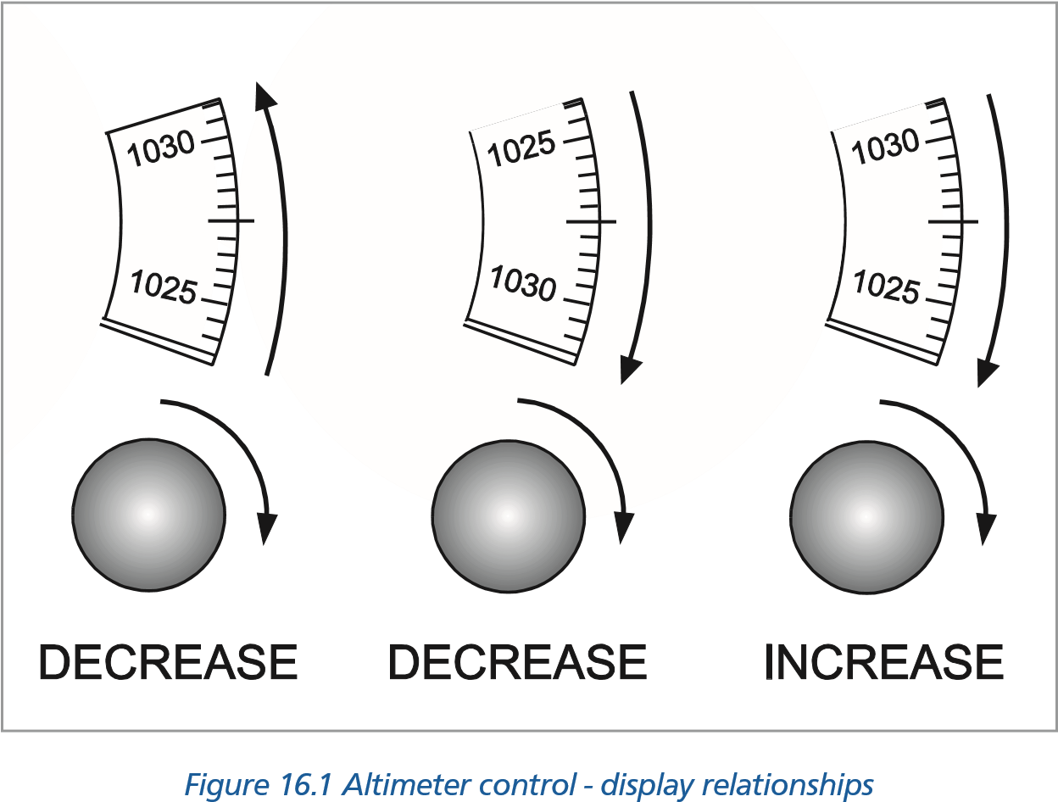

#### CHIRP Report 4 (Status and Role)

*The twin prop commuter aircraft was commanded by a pilot who was also a senior manager in the airline and known to be somewhat irascible. The first officer was junior in the company and still in his probation period. It was the end of an already long day, and the captain was plainly annoyed when the company operations asked for a further flight, but he reluctantly undertook it. During the approach at end of this leg, the first officer went through the approach checks but received no response at all from the captain. Rather than question or challenge the captain, the first officer sat tight and let the captain get on with it. The aircraft flew into the ground short of the runway because the first officer did nothing to intervene. It transpired that the captain had failed to respond to the checks not because he was in a bad mood but because he had died during the approach.* ***CHIRP Report 5 (Risky Shift)***

*‘Following about two weeks of IMC in an Aberdeen winter both of us (Co and myself) were gripped by an overwhelming desire to SEE something other than white mist. Between rigs, with cloud base at destination known to be at 200 ft. No problem, but IMC at the time. Tell FO to set Rad Alt bug at 100 ft - set the Radar on 5 miles scale and tell me if any hard bits show up. I then start a descent to regain VMC. Still no sign of the sea at 200 ft. Keep on going down slowly. Radar screen still clear. Keep descending, well below limits but have to actually get to SEE again, and after all this is the North Sea where men are men, etc etc. We actually level out at 75 ft, but still IMC but can see the waves below. No problem as you never come across 75 ft waves. Decca playing up and became engrossed in navigation problem, radio calls, and an intermittent engine “ANTI-ICE” caption.*

*Co-pilot suddenly points to radar screen and says “What’s that?”. Large blob on bottom of screen (i.e. about ten feet in front of us). Haul back on stick - haul up on collective - heart stopping few seconds waiting for massive lump of machinery to appear in front of us. Needless to say we missed it - whatever* it was - *didn’t even see it; bet we gave them a fright though.*

#### CHIRP Report 6 (Sleep and Fatigue)

*The aircraft left base as an evening flight delayed about 45 minutes for some of the usual reasons. Scheduled to wait in Greece for some three hours so as not to arrive back before the end of the night curfew. Departure for return flight arranged so as to be in the queue early enough to be actually landing as close as possible to scheduled landing time of arrival.*

*On first calling Gatwick approach, it was number 8 to land, gradually descending in the hold as others left the stack. During the second hold, the aircraft descended on autopilot to FL 070 and the handling pilot opened the throttles (no auto-throttle) to maintain holding speed inbound to the fix. He woke up again almost two miles beyond the fix where he should have turned.*

#### CHIRP Report 7 (Sleep and Fatigue, Chapter 10)

*‘The previous day I operated a flight of 13 hr 45 min duty, 10 hrs flying. Arrived back at base at approximately 0815 local time having departed at 1810 the previous evening. Our local regulations are that for flights departing between 6.00am and 6.00pm - 13.45 duty. For flights scheduled to depart 6.00pm to 6.00am - 12 hours duty. By changing the departure to 1755 it thus becomes a DAYLIGHT flight! The next night I was rostered for a flight leaving base at 1.00am and five hours flight time. Very little sleep during the day due to poor facilities and thin curtains. During the flight I informed the F/O and S/O that I wanted 10 minutes rest - eyes shut. I opened my eyes 3 MINS later to find both the F/O and S/O sound asleep! Had I fallen asleep the results could have been disastrous.* ***CHIRP Report 8 (Divided Attention)***

**Human Factors Incident Reporting**

**16**

*‘A nice day - no weather problems and a fully serviceable a/c. At rotate on the previous sector I noticed an amber leading edge flap warning light flash on for a second. This is normally caused by a slightly misaligned proximity switch.*

*On the next take-off, with the F/O flying, I watched the flap warning light carefully for a recurrence of the fault. After rotate the F/O called for ‘gear up’ and I reached for the Flap Lever. The F/O called out, I realized what I was doing and slipped the Flap Lever back into the detent.*

*I thanked the F/O and my lucky stars and vowed never again to allow minor fault diagnosis to distract me from the task in hand.* ***CHIRP Report 9 (Expectation)***

*‘........ we were now right on departure time so I glanced at the fuel gauges, “saw” what I expected to see and signed the Tech Log and Ships Papers.*

*At the top of the climb a fuel check revealed a large discrepancy and a check of the Tech Log showed that I had signed for 6000 kg although the Ships Papers showed 8000 kg as requested. We reduced to economy cruise speed and a detailed fuel check showed that we could reach ‘A’ with fuel to divert to ‘B’ plus reserve. The weather at ‘A’ and ‘B’ was improving and ATC reported no delays into ‘A’ so I decided to continue. We arrived on stand at ‘A’ with diversion and reserve fuel plus about 130 kg.*

#### CHIRP Report 10 (Cockpit Design)

*Taxiing out from dispersal we had reached the point in the check list for “Flap Selection”. The captain confirmed flap to go to take off so I put my left hand down, grasped the knob and pushed downwards. Its travel felt remarkably smooth, so I looked down to find I had actually closed the No 2 HP cock shutting the engine down. The top of the flap lever and the HP cock are immediately next to each other.*

*Only a small incident and not much more than highly embarrassing but it might have been different if we had been on the approach.* ***CHIRP Report 11 (Automated Controls)***

*Throughout the descent we all assumed the Auto Throttle System (ATS) was engaged. Although we all checked the correct speeds were set ‘in the window’ we ALL missed the fact that the ATS was not engaged. Having captured the Localizer and levelling off at 4500 ft to capture the Glideslope the speed was allowed, inadvertently, to drop 10 - 15 kt BELOW MIN SPEED! On noticing the speed I applied Max thrust and prevented the aircraft from stalling.*

*I know of 2 other similar cases concerning different crews and told to me confidentially. It’s apparent, to me, that we rely rather heavily on the autothrottle system and it only takes the assumption that ATS is engaged and a distraction on the flight deck to set up a potentially dangerous situation.*

#### CHIRP Report 13 (Flying and Health)

*On the climb to FL80 I suddenly started to feel unwell, with stomach pains and an urgent desire to defecate. It soon became obvious that I was suffering from an attack of diarrhoea. To divert back to ********* to go to the toilet would have incurred serious commercial penalties and, no doubt, very little sympathy from the company’s management. I therefore decided to persevere and continue to *****. Fortunately the weather was good and I was able to complete a straight in, visual approach. During the second half of the flight the quality of my flying had deteriorated significantly, and my pre-landing checks consisted of little more than checking “Three green lights and brakes off,” before closing the throttles and landing. I made it to the toilet, just in time, and was able to continue the rest of my night’s flying without incident.*

**16**

**Human Factors Incident Reporting**

*Most of my commercial flying has been single crew and it is a type of flying I have always enjoyed. Pilot incapacitation is something I have always considered as so remote a possibility in someone of my age, that I have previously ignored it, confining it to pilots with “dicky tickers” who are nearing retirement. However, the sort of incapacitation that I suffered in this incident had a markedly adverse effect on the safety of the flight, and it has called into question, in my own mind, the whole desirability of operating public transport flights, single crew.*

#### CHIRP Report 14 (Flying and Health)

*I was flying the aircraft back to Luton at the end of a long and frustrating day where I’d been on duty for approximately 13 hours.*

*The Captain was a heavy smoker and the flight deck had been occupied for most of the sector by a third person who also smoked heavily. During the intermediate approach phase I’d noticed that my instrument flying was a little sloppy. I conducted a visual final approach in almost perfect, calm conditions. During the approach I had the greatest difficulty in maintaining a reasonable glide path on the VASIS and also in maintaining the centreline. My response to deviations were late and sluggish. My landing was poor and well off the runway centreline.*

*After long deliberations I can only reach the conclusion that, as a non-smoker, I had been adversely affected by the smoking to the extent that my ability and judgement had been seriously impaired.*

#### CHIRP Report 15 (Personality)

Two senior Captains flying a medium sized passenger aircraft returning to the UK.

*Other Captain’s leg, ex-fighter pilot, never forgot it. Also training Captain and always trying to catch out co-capt, always had superior equipment, watch, calculator etc. On arrival I passed him the weather with the comment “You won’t like it”. The weather was poor with strong cross winds.*

*At the marker we were badly placed and too high, I suggested “Full power for overshoot”. He said “Negative”, closed the throttles, increased flap and continued with the landing. We hit first on port main wheel and wing tip, then I heard the crunch as port engine struck the ground. He called for full power but I held throttles tightly closed knowing the aircraft was structurally damaged. Further damage occurred before we came to a halt.*

*My mistake was not being more forceful when it was quite obvious that a safe landing was impossible. His subsequent attitude was that if I had obeyed his instructions and given him full power he would have been able to take off again.*

#### CHIRP Report 16 (Visual Illusions)

*In the descent to our destination airfield at night the weather being reported good, we requested a visual LH circuit to R/W 29. Whilst attempting to keep the runway in sight, unreported stratus was encountered over the sea. The aircraft descended to beneath the cloud and the R/W looked for to the left. The GPWS triggered but positive action was not taken because the surface of the sea could be seen and looked OK. This caused us to misread our altimeters and mistake* 200 *feet QFE for* 1200 *feet QFE. We were still some way from the airfield and heading for rising ground. Fortunately we realized our mistake and rapidly climbed to a safe height.*

**Human Factors Incident Reporting**

**16**

#### CHIRP Report 17 (Illusions)

*In the cruise, VMC on top in bright sunshine, blade flash through the front rotor system onto the flight deck caused a feeling of unease and tension. After about 45 minutes I left the flight deck and obtained a baseball cap from my nav bag and returned to the flight deck, the symptoms immediately began to subside and disappeared totally within 10 minutes.*

*This problems has occurred before when I didn’t have a cap available and the problem continued until I either descended below cloud or completed the flight.*

The above reports have been selected from CHIRPs reports over the last ten years. For a fuller review of these reports your instructor will have available all the reports issued over that period. Many of the incidents reported have happened to very senior, experienced pilots. It is not only inexperienced pilots who make human errors. Anyone, when they are tired, under stress, unwell or simply not paying attention can make mistakes.

**DON’T LET IT BE YOU!**

### Aeronautical Information Circulars

#### Introduction

From time to time the Civil Aviation Authority issues Aeronautical Information Circulars (AlCs). If the CAA should change the requirements then an amendment will be issued during your course.

It is the responsibility of the individual pilot to check with current national AlCs on a regular basis.

### Staines Trident Accident 1972

#### A Case Study

This tragic accident incorporates a number of human factor aspects. Among these are personal relationships, personal conflict, health, stress, ergonomics, design, crew cooperation, non standard procedures and cockpit warnings. Perhaps the reader is able to identify others. ***Background - the Organizational Environment in BEA at the Time of the Accident***

At the time of the accident there were several disputes ongoing involving the pilots in BEA (British European Airways). Firstly, the Training First Officers were ‘working to rule’ in demand for better pay and conditions in line with their extra training responsibilities. These Senior First Officers were responsible for training new recruits in the Flight Engineer’s (P3) position. As they were working to rule they were refusing to undertake these duties, so many of the new pilots recruited by BEA were not checked out in this position and as a result they could not actually act as a crew member on a revenue-earning flight in the P3 position.

**16**

**Human Factors Incident Reporting**

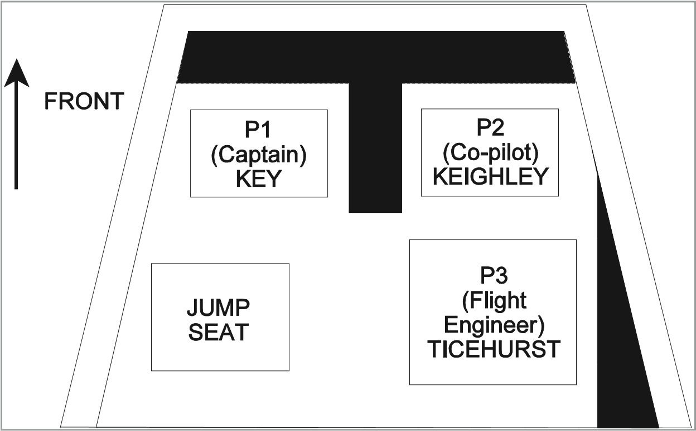

*Schematic of the Trident Flight Deck*

Jeremy Keighley was one of these pilots. He had less than 250 hours on type and was only qualified in the P2 position (the Training Captains were not working to rule). Simon Ticehurst was also a relatively inexperienced pilot but he had about 1500 hours and was qualified to fly in both the P2 and the P3 position. As a result, Ticehurst, although the most experienced of the co- pilots, was flying in the Flight Engineer’s position. This was quite normal at this time.

In an attempt to circumvent the problems of the industrial dispute involving the training of First Officers, BEA were rostering crews in such a way as to avoid giving in to their demands. It also needs to be noted that at the time of the accident there was a huge increase in the demand for air travel. As a result, airlines could not actually train new pilots quickly enough, hence many aircraft were being crewed by relatively inexperienced pilots in the P2 and P3 position.

To add to BEA’s misery, on the following day (a Monday) there was scheduled a worldwide strike of all pilots affiliated to the Association of Airline Pilots (the British Association of Airline Pilots is the UK body). This caused a massive increase in the number of people flying on that Sunday in an attempt to avoid the effects of the dispute. In the UK all BALPA pilots would be on strike. However, many pilots in the UK belong to GAPAN (the Guild of Air Pilots and Air Navigators). GAPAN was opposed to taking industrial action, and the relationships between BALPA and GAPAN members in BEA at the time were distinctly ‘cool’.

#### The People

Captain Stanley Key was in charge of the flight. He was a staunch GAPAN member and was totally opposed to the decision to strike on the following day. He was extremely experienced, both as a pilot on the Trident and as a Training Captain. Key could best be described as an ‘old fashioned’ pilot. Ex-RAF, he was equipped with the ‘right stuff’. He flew that aircraft ‘by the book’ and was extremely intolerant of anyone who didn’t get everything absolutely correct. He also had a temper. His explosions were famous throughout BEA (which involved violent verbal outbursts, massive increases in blood pressure and a marked change in facial colour). His outbursts when supervising trainee pilots were well known throughout the company. Unbeknownst to anyone at the time of the accident, Key was also suffering from arteriosclerosis. Many of the arteries in his heart had actually narrowed to around 50% of their normal width. This had not shown up on his annual ECG as these were conducted at rest. Stress ECGs which would have shown up such a defect were not being used by the regulatory authority as trial had shown that they produced too many false positive results. At the time of the accident, Captain Key’s life expectancy was already quite short (being measured in months rather than years).

**Human Factors Incident Reporting**

**16**

Jeremy Keighley was a Junior Second Officer in BEA and was very inexperienced, both as a pilot as a whole and on the Trident aircraft. He was one of the pilots who was a victim of the industrial dispute and was only qualified to fly in the P2 position. He had still to complete his training as a Flight Engineer. He was shy and retiring and was not prone to coming forward with his opinions. During his training he had been criticised as being slow to react and lacking initiative. His reports suggested that he would need careful, patient coaching to get the best out of him and should not be pressured during his training. Keighley also shared a house with another Junior Second Officer who had recently flown with Key and had been subject to one of his outbursts when he made a mistake on the flight deck during the flight.

Simon Ticehurst was occupying the Flight Engineer’s (P3) position for the flight. He had 1000 flying hours to his name, 750 of which were on Tridents. He was described as a very capable and thoroughly reliable young pilot.

#### The Trident Aircraft

The Trident had several ‘interesting’ design characteristics that were probably implicated in the sequence of events leading to the accident. Perhaps the most critical of these was a tendency to ‘deep stall’.

It was a three-engine aircraft, with all the engines mounted in a group around the tail. While this had aerodynamic advantages (it allowed for a very ‘clean’, aerodynamically-efficient wing and it also reduced the tendency of the aircraft to ‘swing’ during take-off should it lose an engine) this configuration also allowed the possibility of a deep stall. As the aircraft approaches the stall it flies with an increasingly nose-up attitude. Deep stalls occur when the turbulent air from the wings enters the engine air intakes causing the engines to flame out. Most aircraft also drop nose first after the stall, allowing them to gain flying speed and ‘fly out’ of the problem. Not so the Trident. The Trident dropped tail down. These characteristics made recovery absolutely impossible as all the aerodynamic control surfaces were ineffective due to the lack of airspeed. With turbulent air in the engine air intakes it was also impossible to restart the engines. The prototype Trident had been lost in just these circumstances, killing all of the flight test crew on board.

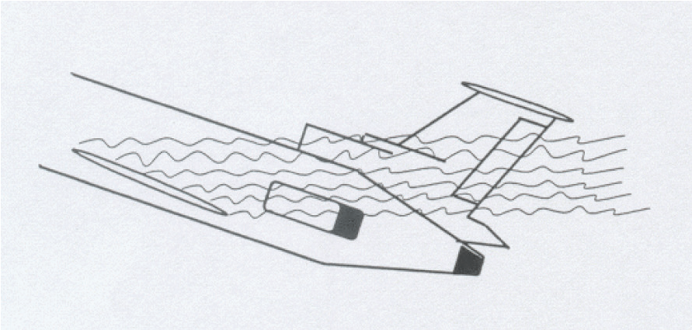

**STALL**

**Engine intakes within turbulent flow - engines flame out**

**16**

**Human Factors Incident Reporting**

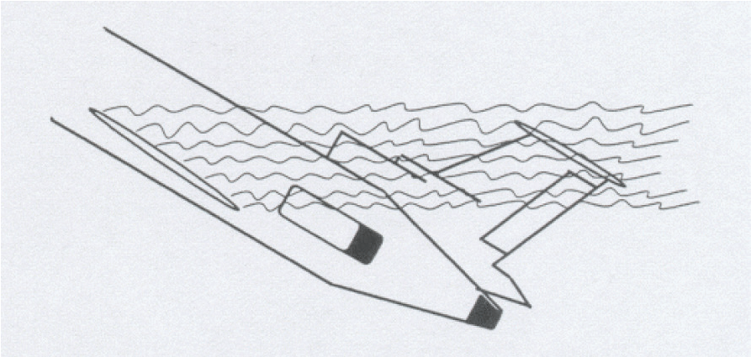

**DEEP STALL**

**Engine intakes and stabilizer within turbulent flow - engines flame out and aircraft is uncontrollable and irrecoverable.**

In an attempt to avoid the aircraft entering a deep stall, the Trident was equipped with a stick pusher system which activated when the aircraft approached the aerodynamic stall. The stick push system was a pneumatic system that operated on the pilots’ control columns pushing the nose of the aircraft down if the crew failed to respond to the stall warnings. Pressure in the stick push system could be ‘dumped’ by pulling a lever on the Captain’s side of the central pedestal. A small amber light illuminated in the case of a lack of pressure in the stick-push system. This was located on the pedestal near the levers controlling the flaps and droops.

The Trident also had a very efficient wing optimized for high speed flight. Unfortunately, it was not so efficient at low speeds, so for take-off and landing it was equipped with flaps (on the trailing edge) and droops (on the leading edge). Flaps were normally retracted at about 185 kt but the droops (also known as ‘slats’) could not be retracted below about 225 kt. Below 225 kt the Trident’s ‘clean’ wing could not produce enough lift to keep the aircraft in the air (i.e. it would enter a stall). Both the flaps and droops produced a great deal of low speed lift but they also produced a lot of drag.

The flaps and droops were controlled by two (almost identical) levers located on the co-pilot’s side of the pedestal. If the flaps and droops were deployed as a safety measure, the droops could not be retracted unless the flaps had first been fully retracted. Unfortunately, as flaps were normally retracted at about 185 kt, the droop lever was effectively unguarded between this speed and droop retraction speed (at 225 kt). Above 250 kt the droops could not be extended as the air pressure would be so great as to rip them from the wing. In an attempt to guard against retracting the droops below 225 kt or leaving them extended about 250 kt, there was an amber ‘droops out of position’ warning light in the cockpit. Unfortunately it did not actually tell you if the droops were retracted when they should be extended or *vice versa*. It just told you that they were not in the correct position for the indicated airspeed. This amber light was located next to the warning light advising the crew of a lack of pneumatic pressure in the stick push system. ***The Run-up to the Flight***

During the months before the flight there had been various flight safety bulletins promulgated throughout BEA advising pilots that it was totally unacceptable to perform flapless take-offs in the Trident (using only the droops). Several pilots were known to do this, as although it increased rotation speed at take-off, a far better climb performance could be attained. Unfortunately, as a result of the design of the Trident’s cockpit and ingrained habits, on several occasions after performing a flapless take-off, as normal flap retraction speed was approached, the Captain still called for flaps, at which point the First Officer immediately retracted the droops! On all occasions the Flight Engineer had noticed and reversed the droop travel before the aircraft fell out of the sky.

Furthermore, several days before the fateful flight the aircraft they were using underwent routine maintenance. During this maintenance visit the stick pusher system was overhauled. Unfortunately on reassembly the mechanic left out a small lock washer. This has the effect of very occasionally letting the pneumatic pressure in the system drop for a fraction of a second before recovering its normal pressure.

**Human Factors Incident Reporting**

**16**

#### The Day of the Flight

Sunday 18 June 1972 was a typical British summer flying day; wet and windy with poor(ish) visibility. In the hours before the flight there was a great deal of pressure on the check-in staff, baggage handlers and everyone at Heathrow due to the number of passengers flying that day in an attempt to avoid the consequences of the strike on the following day. In the hour or so before the flight Captain Key was speaking at a pilots’ meeting in an attempt to persuade his colleagues not to strike on the following day. He failed. Unfortunately, another pilot made some sort of comment to him just after the meeting about his lack of success, at which point Key had one of his famous explosions, turning all the colours of the rainbow and entering into a full and frank (if one sided) discussion of the situation with this other pilot. Keighly and Ticehurst were close by and witnessed the tirade.

Immediately after this outburst Key seemed to be in some discomfort. The problem seemed to be centred around his chest. It now seems likely that at this point he had a minor heart attack. ***The Flight***

While loading the aircraft there were a few problems. At the last moment space had to be found for a crew of a Vanguard freighter so that it could be brought back from Brussels before the strike. This put a little extra pressure on the crew at the last moment as they had to redo the passenger manifest and all the weight and balance calculations. However, the Trident pushed back from the gate approximately on time and began the taxi out.

From this point onwards a great deal of what happened is supposition. The aircraft was only equipped with a rudimentary Flight Data Recorder. There was no Cockpit Voice Recorder so many of the actions and thoughts of the crew are unknown.

During the taxi out there seemed to be a problem. It is likely that the warning light on the stick pusher system kept illuminating as the aircraft bounced over the ridges in the taxiway. As a result the line-up of the aircraft on the runway was delayed. However, eventually the decision was made to line up and take off.

The take-off run was normal, with rotation at 139 kt and unstick at 145 kt. The gear was almost immediately retracted and the V2 (single engined) safety speed was passed at 152 kt. At 170 kt the autopilot was engaged. Unfortunately, slightly the wrong speed was set in the autopilot box. It should actually have been 177 kt, but even at this reduced climb speed there was still a safety margin (although somewhat reduced.) Captain Key was a stickler for procedures. However, it was noted that the autopilot was engaged very early and Key’s radio transmissions were terse and non-standard. Ninety seconds after commencing the take-off run was ‘noise abatement’ time, which required the pilots to throttle back the engines so as not to disturb the residents local to Heathrow. At this point the engines were throttled back as required. The flaps were also retracted, as was normal. By now, because of the reduced thrust from the engines, a turbulent day and an incorrect target speed being set in the autopilot, the aircraft was having difficulty maintaining its speed in the climb.

At times the climb speed dropped to about 157 kt, 20 kt below target. No one seemed to notice. It was suggested that as a result of the combination of Key’s general attitude and his specific demeanour as a result of this outburst and Keighly’s quiet, retiring nature and his general lack of confidence, the latter was disinclined to mention this. Key also may have been distracted by his chest pains. However, the climb continued.

For some reason that will never be established, around this time the droop lever was operated, retracting them. It was likely that Keighley did this as it was on his side of the cockpit. One theory is that the stick push warning light illuminated and that this was mistaken for the ‘droop out of position’ light. Another theory was that Key was so distracted by his chest pains that he associated the low airspeed with flap drag and either retracted what he thought was the flaps himself or asked Keighley to do it. Nevertheless, the droops were retracted while the aircraft was only flying at about 162 kt. The Trident entered the stall regime.

**16**

**Human Factors Incident Reporting**

Shortly after the droops retracted, the stall warning went off and the stick push system operated, pushing the aircraft’s nose down to regain flying speed. This would have automatically disconnected the autopilot and triggered a whole series of warnings in the cockpit (stall warning; autopilot disconnect; master warning; and the stick push operating). Sometime around this point Key had another, larger, heart attack where his heart muscle actually separated due to the blood pressure in a ruptured arteriole. He may not have been incapacitated but he would certainly have been in great pain. As the nose dropped, one of the pilots pulled back on the column in an attempt to hold the aircraft level. It stabilized at around 177 kt in a slight descent. No attempt was made to redeploy either the flaps or the droops. The climb was then reinitiated by pulling back on the column. The stall warning and stick push operated for a second time. Again the crew attempted to hold the aircraft level instead of diving the aircraft, applying power and deploying the high lift devices. The third time the stick push system operated it was overridden by dumping the pressure in the system (remember that the crew may have thought that it was faulty as a result of the previous warnings). It is likely that Key did this as the override was on his side of the centre pedestal. By now airspeed had increased to around 193 kt as a result of being in a shallow dive but for some reason the aircraft was reestablished back into the climb once again. Airspeed decayed to about 175 kt and it entered the stall, followed shortly after by adopting a 60° nose-up attitude (as the Trident was prone to do in these circumstances). This led to the aircraft entering a deep stall from which there was no recovery. The aircraft’s altitude at this point was 1275 feet (AGL) and it was travelling at no more than 54 kt. The Trident fell out of the sky in a flat spin, crashing next to the A30 near Staines Reservoir. All 118 passengers and crew on board were killed in the impact.

#### Some Thoughts

**Was the system designed for minimum risk?** It can be argued that the Trident was a fundamentally unsafe design as it had an inbuilt capacity to lapse naturally into a dangerous, irrecoverable situation (the deep stall).

**Were appropriate automatic safety features installed in the aircraft and implemented in the correct manner?** For example the stick push? It can be argued that the lack of a speed lock on the droops was an automatic safety device that should have been present. There is nothing worse than an unreliable safety device that gives out false warnings. This leads operators to mistrust these systems and potentially be inclined to ignore or override them.

**Were the warning systems implemented in an appropriate way?** Consideration of the position of warning lights on the stick push system and the ‘droops out of position’ warning etc. What about the cacophony of warnings and alerts when the aircraft began to stall? Should these have been better prioritized?

**Human Factors Incident Reporting**

**16**

**Were there appropriate procedures in place?** The lowest level of system fix to be employed only when all the above cannot be used. Were there appropriate procedures for the selection and training of aircrew? Was the procedure to circumvent the industrial dispute one which promoted safety? Was it appropriate to use an inexperienced P2 and P3 on a flight? Should Keighley have been ‘selected out’ in the training process? Should Key have been selected as a Training Captain? What about the inspection procedures in the maintenance hangar?

If possible, each factor in the accident should be assessed as being either **causative** or **contributory**. A causative factor is an item in the accident chain, which if it were removed would have stopped the accident from happening. A contributory factor is one which, from knowledge of the human operator, ‘would not have helped’. This is not an easy thing to do but can be informative if you need to prioritize actions.

*With thanks to Dr Don Harris, Human Factors Group, College of Aeronautics, Cranfield University*

**16**

**Human Factors Incident Reporting**

Chapter

## **17** Introduction to Crew Resource Management

Introduction. . . . . . . . . . . . . . . . . . . . . . . . . . . . . . . . . . . . . . . . . . . . .325

Communication . . . . . . . . . . . . . . . . . . . . . . . . . . . . . . . . . . . . . . . . . . .325

Hearing Versus Listening . . . . . . . . . . . . . . . . . . . . . . . . . . . . . . . . . . . . . .326

Question Types . . . . . . . . . . . . . . . . . . . . . . . . . . . . . . . . . . . . . . . . . . .327

Methods of Communication . . . . . . . . . . . . . . . . . . . . . . . . . . . . . . . . . . . .327

Communication Styles . . . . . . . . . . . . . . . . . . . . . . . . . . . . . . . . . . . . . . .328

Overload. . . . . . . . . . . . . . . . . . . . . . . . . . . . . . . . . . . . . . . . . . . . . . .329

Situational Awareness and Mental Models . . . . . . . . . . . . . . . . . . . . . . . . . . . .329

Decision Making . . . . . . . . . . . . . . . . . . . . . . . . . . . . . . . . . . . . . . . . . .330

Personality. . . . . . . . . . . . . . . . . . . . . . . . . . . . . . . . . . . . . . . . . . . . . .331

Where We Focus Our Attention . . . . . . . . . . . . . . . . . . . . . . . . . . . . . . . . . .332

How We Acquire Information . . . . . . . . . . . . . . . . . . . . . . . . . . . . . . . . . . .333

How We Make Decisions . . . . . . . . . . . . . . . . . . . . . . . . . . . . . . . . . . . . . .334

How People Live . . . . . . . . . . . . . . . . . . . . . . . . . . . . . . . . . . . . . . . . . .334

Behaviour . . . . . . . . . . . . . . . . . . . . . . . . . . . . . . . . . . . . . . . . . . . . . .335

Modes of Behaviour . . . . . . . . . . . . . . . . . . . . . . . . . . . . . . . . . . . . . . . .335

Team Skill . . . . . . . . . . . . . . . . . . . . . . . . . . . . . . . . . . . . . . . . . . . . . .336

**17**

**Introduction to Crew Resource Management**

### Introduction

These notes have been designed to increase your awareness of human factors. Crew Resource Management (CRM) has been developed to improve teamwork. Debate has therefore occurred regarding its relevance to the student who is operating as a single pilot. Should it be delayed until the start of a pilot’s multi-crew career?

Having worked through these notes you may recognize that many of the concepts behind CRM are extremely applicable to this early stage of training. This is because CRM is fundamentally a ‘life skill’ applicable to all situations, professional and social. Moreover, it should be viewed as an integral and essential part of your course and your personal development.

Remember, as with all skills, CRM needs effort and practice for improvement and because of this it has to be introduced as early as possible in your career and then developed alongside your flying skills.

This introduction is split into 4 main areas with a summary in the form of Team Skill Requirements:

* Introduction and Communication.
* Situational Awareness.
* Decision Making.
* Personality, Behaviour and Feedback.
* Summary Team Skills.

In 1978 a United Airlines aircraft experienced an undercarriage problem on the approach to Portland, Oregon. The Captain placed the aircraft in a hold close to the airport to consider the situation. After forty minutes the fault had been resolved and yet after a further twentyfour minutes the aircraft, still in the hold and perfectly serviceable, only a few miles from the airport, ran out of fuel and crashed with loss of life.

**Introduction to Crew Resource Management**

**17**

This accident triggered United Airlines to move aviation into a new era in which the above and many other accidents were finally investigated fully. This deep investigation into the human factors contributing to the accidents had to be given time and substantial financial support to achieve results and from this CRM was eventually born.

Pilot error was no longer taken at face value as the cause of the accident and research into human factors and the development of aviation CRM courses and training began.

### Communication

During this period a number of areas are examined relating to the actual transfer of information and indeed the way that information is transmitted.

#### Effective Communication

**There is a strong tendency for a person transmitting information to assume that it is unambiguous and will be received exactly as intended.**

The exercise in one-way communication, in which only the transmitter is allowed to speak, highlights that this is not the case.

With the one-way limitation the successful completion of the exercise varies considerably for a variety of reasons. The need for concise communication and the ability of the transmitter to recognize the difficulties of perception at the “receiver’s end” and then adapt to the situation being the major factors.

However, the main point that should have been appreciated from this simple exercise is the need of the receiver to question and summarize the transmitter’s intention or need. In the second “two- way” communication exercise, in which this could occur, you will have noted that the information transfer was much more effective and that accurate completion of the exercise was achievable even though the test itself was harder.

As effective communication, both in the aircraft and air to ground, is fundamental for the safe operation of aircraft, many points from this session should be recognized and remembered.

The main points are:

* Effective communication must be two-way. This allows for the transmitter’s intention to be clarified when necessary. (Hence the need for reading back information on the radio, the importance of questioning when unsure and the need to create an atmosphere in which questioning/thinking is encouraged).
* The need for concise communication using language appropriate to the receiver’s background; the use of flying terms which assist concise communication between pilots will have little meaning to someone who is not familiar with those flying terms.
* The recognition that even two-way communication is imperfect and that error can occur which leads back to “questioning” if unsure.

**17**

**Introduction to Crew Resource Management**

### Hearing Versus Listening

So far we have concentrated on the role of the transmitter in the process of communication. However, the role of the receiver is just as important.

Whilst hearing is the physical process of collecting sound transmitted, listening involves the understanding process of interpreting that sound. **Listening is therefore an active process and requires concentration!** The flight deck of an aircraft is a noisy environment and one in which there are many distractions from the operation of the aircraft to the administration of the crew.

To encourage listening the transmitter should:

* Keep the transmissions short as the receiver’s attention will reduce with time. Large quantities of information should be transferred in parts with the receiver being invited to respond or question in between.
* Try hard to ensure that the receiver’s attention is not elsewhere; there is little point in asking for flap operation when the receiver is busy on the radio! You are unlikely to achieve the desired response in this case. Similarly in-depth, theoretical discussions between instructor and student should take place in a quiet room on the ground, not when the student is airborne, working hard!

A person receiving information should:

* Appreciate that he must listen carefully to the transmitter; this is a definite two-way process in which the listener’s role is as important as that of the transmitter.
* Ask for clarification when in need of more information, and continually review/check information received.

**REMEMBER.......WHEN UNSURE ASK!**

**THE AIM IS TO ACHIEVE THE SAME MENTAL MODEL BY GOOD COMMUNICATION!**

### Question Types

The question type determines the type of response. You should therefore have an awareness of question types, their advantages, disadvantages and appropriateness to the situation.

Three types of question are considered to be the most important:

#### Closed Question

A question in which the receiver’s response is limited to “yes”, “no” or a word or two by the way that the question is asked. The closed question allows for rapid transfer of specific information or the checking of understanding of information, which can be appropriate in high workload situations. However, closed questions do not fully use the potential of the person being questioned. Constant use of closed questions can break down open and effective communication and in particular, aspects of teamwork.

#### Open Question

**Introduction to Crew Resource Management**

**17**

A question which is phrased to elicit information from, or initiate discussion with, the receiver. It encourages open and effective communication and this in turn will encourage teamwork. It may not be appropriate during periods of high workload when time is limited and specific, rapid transfer of information is desirable.

#### Leading Question

A leading question is one in which the required answer is in the question.

The words “isn’t it” are often present in this form of question - the classic student leading question is during mutual flying.......”That is Witney down there... Isn’t it?”

**If you ever use or hear a leading question, a loss of situational awareness may have occurred. This must be addressed.... alarm bells need to RING!**

### Methods of Communication

Although we naturally transmit information in a number of different ways, we are generally unaware of exactly how we do it. We know that in normal face-to-face situations the greatest proportion of information is transmitted through body language with a much smaller percentage being transferred by the words themselves.

We need to be conscious of how we normally transmit information if we are to communicate effectively when the situation changes on the flight deck. The physical location of two pilots side by side, a flight engineer behind the pilots or perhaps a flight attendant, situated at best in the pilot’s peripheral vision restricts communication. The result is that for effective communication to take place the balance between body language, the way we say the words and the words themselves must change.

Therefore in the flight deck situation we note that the body language which we naturally use has greatly reduced effectiveness and that the words themselves now become more important.

In consequence, on the flight deck we must:

* Convey concerns through words and through an assertive style (the way we say the words), and not use body language which will probably be missed.
* Concentrate on the choice of words we use. Now the words need to carry much more information and therefore must be more concise.

In addition flight attendants, dispatchers, ground engineers and others whom you may encounter on the flight deck can, because of their different training and backgrounds, interpret your turned back as negative body language. Try to show them you are interested and listening through the way you speak to them, and if you can, turn around so that you are at least partly facing them.

### Communication Styles

Four communication styles are discussed and, of these, two are positive whilst two are negative forms of communication. ***Supportive Style***

**17**

**Introduction to Crew Resource Management**

Here the receiver or transmitter is trying to be receptive to the other person’s needs, feelings or priorities but without putting themselves down or losing sight of the task.

It is often used:

* As an initial helpful prod between pilots.
* To help calm down an agitated person so that the problem can then be addressed.

#### Assertive Style

The principle here is to convey your needs (for example speed 140 kt --flaps to half) for the task without “putting down” others.

An assertive statement/request clearly states your requirements and explains why and is an essential communication style on the flight deck.

#### Aggressive Style

An aggressive communication style focuses solely on the task or perhaps personal needs of the speaker without any concern for the other crew members. It is a very negative form of communication because it degrades teamwork and inhibits open communication. In extreme cases this will lead to team breakdown.

#### Submissive Style

A communication style in which the transmitter has little regard for his own needs or even for the task. A submissive communication style will lead to inefficient teamwork and increase the workload on others.

Do not forget that someone who is sick may become submissive even though they may normally be an excellent team member (on the ground and in the air), and that this situation must be addressed.

### Overload

When someone becomes overloaded, he/she is no longer able to process information, not able to operate an aircraft or indeed learn effectively! Therefore it is extremely important that the situation is resolved quickly if a pilot is not to become overloaded; this is often achieved by reducing his workload to a point where he can become effective once again.

Although this overload situation is more likely to occur with those of less experience (who need more capacity to fly and operate the aircraft), it can and does happen to the most experienced of crews. This is a particular problem when capacity is reduced through illness, stress or any one of a multitude of other outside factors. If you become overloaded at any time during your flying career you must admit it to yourself and tell someone (instructor, “mutual” student or fellow crew member) so that he can help you reduce your workload.

In the case of a learning exercise, when safely on the ground, the instructor will often be able to identify ways of reducing or reorganizing your workload, which will help you in the future. Importantly, if you notice someone becoming overloaded reduce his workload, at least temporarily, if you can. Please note that it is quite usual for the ability to listen to be lost when someone is overloaded and so you may have to gain his attention by changing the way you address him (“Captain”, rather than “Jeff”) or touching him.

**Introduction to Crew Resource Management**

**17**

Finally, remember that if you are ill or highly stressed you should not fly as your capacity is already reduced and you are at much greater risk of becoming overloaded!

### Situational Awareness and Mental Models

Pilots combine large quantities of information from a variety of sources to make a mental model or picture of what they believe to be reality. A pilot with good situational awareness will have worked hard to assimilate this varied information, and will have developed a mental model which reflects reality.

Factors affecting the creation of a mental “model” include:

* **Experience**  What we know, have heard or read.
* **Expectation** What we expect to happen through experience or expectation.
* **Briefing** Training to expect a situation.

A pilot relies on situational awareness to operate an aircraft safely. Situational awareness is however prone to error when an incorrect model is created. This can have fatal results!

**Look** outfor:

* Clues to the loss of situational awareness.
* The situation where confusion/concern exists.
* The time when leading questions are asked.
* The occasion when different sources and information disagree.
* The tendency to ignore or distort incoming information.
* That time when your mind becomes focused on one area to the detriment of others.

**Respond** by:

* Accepting that you may have lost situational awareness.
* Looking for disaffirmation and by collecting varied information which proves loss of situational awareness.
* Using all resources to create a new “mental model”.

Try to **Prevent** by:

**17**

**Introduction to Crew Resource Management**

* Keeping ahead of the aircraft. From the start of your aviation career make it a habit to work hard collecting information and constantly monitoring to create an accurate mental model.
* Recognizing that your perception and work activity is likely to fall during night flights or if you are ill/stressed and counter by working hard at maintaining situational awareness.
* Sharing your mental model with your instructor/mutual student or other crew members. It is unlikely that two crew members will have the same incorrect mental model and therefore constant communication to check and share models is vital.

### Decision Making

Although we constantly make decisions during our day to day life there was no formal tuition as to how to do this in the aviation system. Because of this, two main ways of making decisions have been developed and these are intended to assist airborne decision making:

* Standard Operating Procedures **(SOPs)**. For predictable (often technical) problems, a number of experts will have considered the malfunctions (for example, an engine fire - hydraulic failure - landing gear malfunction) for a considerable length of time and decided upon the best possible solution/course of action.
* For more complex, unpredictable problems a Standard Operating Procedure may not be possible and then a structured approach to decision making is required. British Airways have developed and use a system known as **“DODAR”.**

|  |  |  |
| --- | --- | --- |
| **D**IAGNOSIS - | | Identify the most important / urgent problem. Remember there may be more than one problem and that the most obvious may not be the most serious. Use time and the crew to your advantage. |
| **O**PTIONS | - | Consider all the information available and define the options and consequences of each possible course of action. Discuss the possibilities with the crew! |
| **D**ECIDE | - | The final decision is made by the captain after considering the options and consequences of the possible courses of action. If new information or a flaw in the plan becomes apparent, the decisions made should be questioned. |
| **A**SSIGN | - | Assign tasks to all concerned and use this to share workload - in the case of a training aircraft include the student in the decision and don’t forget that the cabin crew, ATC etc. are also there and available to give assistance. |
| **R**EVIEW | - | Continually ask “Have we missed something, has the situation changed?” In other words continually monitor the situation. |

Remember that although DODAR has five steps it is fundamentally a loop process. Not only did the decision making exercise show you the benefit of a structured decision making process (DODAR), it also highlighted the complimentary need for other human factors skills and good questioning technique.

### Personality

The physical act of picking up a pen and using it shows that we all have a left or right handed personal preference.

**Introduction to Crew Resource Management**

**17**

We discussed that:

* This preference may be stronger in some than in others.
* Many can use their other hand if necessary, but that it will initially be less effective and can cause stress.
* Practise with the other hand leads to improved efficiency.

#### Personality is Psychological Preference

We looked at four opposite pairs of psychological preference that were identified through research based upon the work of Jung and an American mother and daughter team, Myers and Briggs.

The overall purpose of the discussion was to increase your awareness of the differences and to ensure that you realize that:

* These psychological preferences do actually exist and that no preference is right or indeed wrong.
* Each psychological preference has its own strengths and its own weaknesses, and that a weakness can be recognized and combatted.
* With tolerance, a combination of individuals with very different personality preferences would increase team potential.

### Where We Focus Our Attention

#### Extraversion

These people prefer to focus on the outer world of **people** and **things.**

They normally prefer:

**17**

**Introduction to Crew Resource Management**

* to communicate orally rather than writing.
* to learn through experience.

and like ......

* variety and action.

On the flight deck they:

* readily communicate orally which increases good crew situation awareness.

but they ......

* need to recognize the introvert’s requirement for quiet to concentrate and formulate ideas.

#### Introversion

These people prefer to **focus on** the inner world of **ideas** and **thoughts.**

They normally:

* prefer to work in quiet surroundings and without interruptions.
* prefer to think and reflect before acting (reading through notes, consolidating concepts) in relation to training; for them, thorough preparation is very important.

On the flight deck they:

* tend to think before they act.
* continually need to recognize the importance of transferring their thoughts/mental model to other crew members by oral communication.

### How We Acquire Information

#### Sensing

These people readily accept and like to work with individual **facts.**

They normally:

* are realistic and practical.
* are careful with detail.
* like established, structured ways of doing things (for example SOPs/checklists).
* are good at remembering and working with a large number of individual facts on the flight deck.

**Introduction to Crew Resource Management**

**17**

* like to collect factual information.
* prefer to work in a structured way.
* can be expected to oversimplify and could miss the “Big Picture”.

#### Intuitive

These people prefer to go beyond individual facts to find connections, meanings and overall patterns.

They:

* tend to ask “why”.
* look for the overall “picture”.
* normally dislike repetition.
* see new possibilities and methods, and value imagination and inspiration.

On the flight deck they:

* ask why, and look for the big picture which aids their situational awareness.
* can become overloaded with large quantities of factual information.
* should remember to recognize the sensing types’ need for structure.

### How We Make Decisions

#### Thinking

These people tend to make decisions **objectively.**

They tend to be:

* logical and objective.
* analytical.
* task orientated.

On the flight deck they:

* tend to be good at making sound decisions. but
* should remember and appreciate another person’s point of view and feelings.

#### Feeling

These people tend to make decisions based on **person** centred values.

They tend to be:

* appreciative, tactful and sympathetic, valuing harmony.

On the flight deck they:

**17**

**Introduction to Crew Resource Management**

* will work towards harmony. but
* need to recognize the importance of the task.

### How People Live *Judging*

These people like to live in a planned and orderly way.

They:

* prefer to regulate and control their life.
* like structure in their day and tend to be punctual.
* like organizing and planning.

On the flight deck they:

* prefer the operation to run to plan and dislike changes. • like to make decisions but
* once reaching a decision do not tend to reflect and review.

#### Perceiving

These people like to live in a flexible, spontaneous way.

They:

* are flexible and spontaneous by nature.
* prefer to keep their options open, continuing to gather information.
* seek to understand life rather than control it.

On the flight deck they tend to:

* adapt to changing situations readily.
* be less affected by delays and departures from standard.
* delay making a decision and keep looking for further information.
* review decisions taken.

### Behaviour

Although people have a relatively constant personality, it is our behaviour that determines how others perceive us. It is important to remember that ....

We **choose** our behaviour!!!

Pilots are constantly meeting fellow crew members (flight deck and rear crew), company and airport representatives and passengers for the first time. A bad first impression can take a lot of time and effort to undo, therefore, make a habit of considering your behaviour before you meet people.

**Introduction to Crew Resource Management**

**17**

### Modes of Behaviour

Remember the modes of behaviour that are available to you:

#### “Parent, Adult and Child Modes”

Also remember that by staying in “Adult Mode” you can avoid **reacting** to inappropriate behaviour.

To achieve effective behaviour try to:

* Focus on the outcome of your meeting.
* Listen to each other and use reflective statements to show the “agitated” person that you are listening.
* Talk about the issues, avoid personalities and the word “YOU”.
* Remember that the aim is to achieve mutual understanding.

#### Feedback

Feedback is defined as “useful information provided for improvement of performance or correction of error”. It not only rests at the centre of a pilot’s training, but continues throughout his / her aviation career. It should also be recognized as a useful life skill. However, people often shy away from giving feedback and feel uncomfortable receiving it. Like many other human factors topics giving and receiving feedback **well** is a skill which requires thought and practice.

When giving feedback consider:

* **WHY** are you giving it - ensure that it is to encourage change and develop - not to vent your frustration!
* **WHAT** are you going to discuss - check the facts and confirm your interpretation/perception of the events.
* **HOW** you are going to deal with the issues to be raised - ensure that you focus on the issues and not the individual. Look for, and encourage, open but directed discussion.
* **WHEN** is the most appropriate time - a quiet moment after the flight is sure to be better than when working hard in the air!

When receiving feedback:

* Listen carefully and check your understanding of the problem.
* Try not to be defensive (for everyone has room to learn) and work hard to remain in the “Adult Mode” - focus on the issues for you may “learn something”!

**17**

**Introduction to Crew Resource Management**

* Acknowledge the giver’s effort for it may have been a difficult decision to come forward and instigate the discussion.

#### Teamwork

Crew Resource Management aims to improve teamwork through improving human factors skills in all areas. The NASA Team Skills shown on the next pages are particularly related to the multicrew flight deck environment and are used by British Airways in debriefing CRM aspects of LOFT and simulator exercises.

Use your time to improve your CRM skills, reap the benefits of improved learning and remember CRM is fundamentally about **flight safety**.

### Team Skill

#### Briefing

* sets open tone, call for questions
* team concept (“we”) encourages participation
* covers valid safety and operational issues
* includes cabin crew in team
* states how “SOP” deviations will be handled
* addresses crew roles and division of labour
* sets automation guidelines; PF & PNF duties

#### Inquiry, Advocacy and Assertiveness

* crew members speak up with appropriate persistence until there is some resolution
* all are encouraged to state recommendations
* each seeks information, asks questions, and tests assumptions
* flight automation questioned to verify situation ***Feedback (Crew Self-critique)***
* crew provides information to “self-correct”
* provided at appropriate times
* covers both positive and negative performance
* feedback given tactfully, accepted non-defensively
* blame avoided, what is right - **not** “who is right” ***Communications/Decisions***
* participation in decision process encouraged
* “bottom lines” established
* big picture shared with all, including cabin crew and others
* decisions clearly stated and acknowledged ***Leadership/Followership/Tasks***

**Introduction to Crew Resource Management**

**17**

* balance between authority and assertiveness
* climate appropriate to situation (e.g. social tasks during low work load, not in high load/ sterile below 10 000 ft !)
* acts decisively when situation requires
* shows desire for most effective operation
* uses all available resources
* recognizes demands imposed by automation

#### Interpersonal Relations/Climate

* tone of flight deck is friendly, relaxed, supportive
* adapts to other crew members’ personalities
* recognizes effects of stress, fatigue and overload in self and in others ***Preparations/Plans/Vigilance***
* crew “stays ahead of aircraft”, monitors developments (WX, ATC, TIME, FUEL, ETC.) and anticipates required action
* maintains situational awareness
* “model” of what is happening shared with crew
* ensures cockpit and cabin crew are aware of plans
* conflicts, doubts, “warnings” resolved quickly
* time allowed to programme the automatic systems

#### Workload/Avoids Distractions

* work distribution communicated and acknowledged
* crew efficiency is maximised

**17**

**Introduction to Crew Resource Management**

* reports overload in self and in others
* secondary tasks (passenger needs, company communications, etc.) prioritized to deal with primary flight duties
* recognizes distractions of automation, disengages if necessary

Chapter

## **18** Specimen Questions

Questions - Paper 1 . . . . . . . . . . . . . . . . . . . . . . . . . . . . . . . . . . . . . . . .341

Questions - Paper 2 . . . . . . . . . . . . . . . . . . . . . . . . . . . . . . . . . . . . . . . .346

Questions - Paper 3 . . . . . . . . . . . . . . . . . . . . . . . . . . . . . . . . . . . . . . . .351

Questions - Paper 4 . . . . . . . . . . . . . . . . . . . . . . . . . . . . . . . . . . . . . . . .356

Questions - Paper 5 . . . . . . . . . . . . . . . . . . . . . . . . . . . . . . . . . . . . . . . .361

Questions - Paper 6 . . . . . . . . . . . . . . . . . . . . . . . . . . . . . . . . . . . . . . . .366

Answers to Specimen Papers. . . . . . . . . . . . . . . . . . . . . . . . . . . . . . . . . . . .372

Revision Questions . . . . . . . . . . . . . . . . . . . . . . . . . . . . . . . . . . . . . . . . .374

Answers to Revision Questions. . . . . . . . . . . . . . . . . . . . . . . . . . . . . . . . . . .422

Specimen Examination Paper . . . . . . . . . . . . . . . . . . . . . . . . . . . . . . . . . . .424

Answers to Specimen Examination Paper . . . . . . . . . . . . . . . . . . . . . . . . . . . . .436

Explanations to Specimen Examination Paper . . . . . . . . . . . . . . . . . . . . . . . . . .436

**18**

**Specimen Questions**

### Questions - Paper 1

1. **The composition of the atmosphere from sea level to about 70 000 ft retains proportions of:**
   1. 50% Nitrogen, 40% Oxygen, 10% other gases
   2. 78% Oxygen, 21% Nitrogen, 1% other gases
   3. 78% Nitrogen, 21% Oxygen, 1% other gases
   4. 76% Nitrogen, 14% Oxygen, 10% other gases
2. **Oxygen is required by the human body to:**
   1. clear the blood of impurities produced in the body
   2. derive energy from food by oxidation
   3. produce carbon dioxide to maintain the correct acidity of the blood
   4. to ensure the conversion of fats and proteins to carbohydrates required for tissue regeneration

**3 Gas exchange between the air and blood takes place:**

1. through the mucous lining of the trachea and bronchi
2. between the interior of the alveoli and the capillaries on the alveoli walls
3. from the whole surface of the lungs via the fluid in the thoracic cavity
4. by means of the Pulmonary artery, linking the lungs directly to the heart
5. **Oxygen is transported in the blood:**
   1. dissolved in the blood plasma

**Specimen Questions**

**18**

* 1. in chemical combination with haemoglobin in the white blood cells
  2. as microscopic bubbles linked to blood platelets
  3. in combination with haemoglobin in the red blood cells

1. **An individual who is short of oxygen may try to compensate by increasing the rate and depth of breathing. This process is called:**
   1. hypoxic compensation
   2. presbycusis
   3. hyperventilation
   4. carbonic dysrhythmia
2. **A free running circadian rhythm exhibits a periodicity of about:**
   1. 23 hours
   2. 24 hours
   3. 25 hours
   4. 26 hours
3. **Constantly seeking information to anticipate situations and to take the right decisions:**
   1. can be dangerous, as it may distract attention from flying the aircraft
   2. is impossible for pilots as they can only absorb a limited amount of information at any one time
   3. enables maintenance of situational awareness
   4. always carries the risk of constructing a false mental model
4. **Safety in commercial air transport:**
   1. is better than road safety, but not as good as rail safety
   2. though effective, lagging behind road and rail safety
   3. increasing each year, due to the increasing automation of modern aircraft
   4. better than road safety and rail safety
5. **‘Slow wave’ sleep occurs:**
   1. during low voltage high frequency delta brain wave activity
   2. sleep stages 3 and 4
   3. as an individual first starts to fall asleep
   4. during the dreaming stage of REM sleep
6. **Strengthening and organizing the human memory when learning new tasks is believed to occur in:**
   1. REM sleep
   2. slow wave sleep
   3. sleep stages 3 and 4
   4. stages 1 and 2 sleep
7. **The most common form of amnesia affects:**
   1. episodic memory
   2. short-term or working memory

**18**

**Specimen Questions**

* 1. semantic memory
  2. echoic and iconic memory

1. **The time of useful consciousness for a pilot, undertaking moderate activity, when exposed to progressive decompression at 20 000 ft is:**
   1. 30 minutes
   2. 5 minutes
   3. 12 seconds
   4. 2 to 3 minutes
2. **Required oxygen for an individual experiencing a moderate workload at 37 000 ft can be provided by breathing:**
   1. 100% oxygen under pressure
   2. an oxygen/air mixture
   3. 100% oxygen
   4. a mixture of oxygen and helium to balance the partial pressure in the lungs
3. **The General Adaptation Syndrome has in sequence the following phases:**
   1. alarm phase – denial phase – acceptance phase
   2. alarm phase – resistance phase – exhaustion phase
   3. stressor – resistance phase – adaptation phase
   4. resistance phase – exhaustion phase – recovery phase
4. **With a large aircraft maintaining a standard 3° approach to a runway, the touchdown point will be:**
   1. at the visual aiming point
   2. further into the runway than the visual aiming point
   3. short or long from the visual aiming point depending on the runway slope
   4. short of the visual aiming point
5. **‘Risky shift’ is:**
   1. a flight or task undertaken at a time when the body’s circadian rhythms are at their lowest point of efficiency
   2. the process by which the central decision maker will ignore any information which does not fit the mental model created by the situation
   3. the tendency of a group of individuals to accept a higher risk than any individual member of the group
   4. the natural tendency of the human mind to blame outside agencies for any errors made in an emergency situation
6. **The eye datum or design eye position in the cockpit is established:**
   1. so that the pilot can maintain an adequate view of all the important displays inside, and of the world outside with minimum head or body movements
   2. to enable the pilot to see all his flight instruments within minimum scan movements of the head
   3. at the centre of the artificial horizon or flight director indicator

**Specimen Questions**

**18**

* 1. to determine the eventual size of the flight deck and where the window frames will be positioned so as to give minimum interference to the pilot’s field of view

1. **The most dangerous characteristic of a false mental model is that:**
   1. it will mainly occur under conditions of low arousal
   2. it will mainly occur under conditions of stress
   3. it is extremely resistant to change
   4. it will always be modified to meet the expectations of the individual
2. **Which of the following is NOT one of the 5 hazardous attitudes?**
   1. Macho
   2. Anti-authority
   3. Impulsivity
   4. Domination
3. **To facilitate and reduce the time taken to access information in long-term memory, it is necessary to:**
   1. learn to store information in a logical way
   2. mentally rehearse information before it is needed
   3. structure the information as much as possible before committing it to memory
   4. avoid pointlessly activating information, which we know will soon be needed
4. **If a stimulus is expected and the response prepared; when an unexpected stimulus is received:**
   1. the prepared response is likely to be carried out
   2. the mind will ‘freeze’ and will require a reminder a reminder from its data store before actioning the new demand
   3. the prepared response will be transferred to the long-term memory store
   4. the mind will ‘switch off’ and ignore the unexpected stimulus
5. **The area on the retina where the optic nerve receives all the information from the light sensitive cells of the retina is:**
   1. the blind spot
   2. the fovea
   3. the rod/cone intersection point
   4. the most sensitive part of the retina with the highest visual acuity
6. **The eye can adjust to changing light intensities by varying the diameter of the pupil. This can change the intensity of the light falling on the retina by a factor of:**
   1. 10:1
   2. 2:1
   3. 5:1
   4. 20:1
7. **Following a flight that transits numerous time zones, the associated shifting of Zeitgebers helps resynchronization to the new local time at the average rate of:**
   1. 2.5 hours per day

**18**

**Specimen Questions**

* 1. 1.5 hours per day
  2. 4 hours per day
  3. 1 hour per day if the flight has been westward and 2 hours per day if the flight has been eastward

1. **A man is considered to be obese if his Body Mass Index (BMI) is over:**
   1. 18
   2. 25
   3. 22
   4. 30
2. **Divided attention:**
   1. is a fallacy, a pilot can only concentrate on one thing at a time
   2. makes it possible to detect abnormal values for flight parameters even though they are not the pilot’s immediate concern
   3. makes it possible to increase the number of simultaneously managed tasks in safety
   4. makes it possible to carry out several cognitive processes at the same time
3. **The human body can tolerate short duration acceleration forces of up to 45g:**
   1. in the vertical axis
   2. in the fore and aft axis
   3. in the lateral axis
   4. when suitable anti-g straining techniques are employed
4. **Barotrauma of the cranial sinuses is most likely to occur:**
   1. during the descent
   2. among elderly passengers
   3. in the climb
   4. in persons with a history of cardiovascular problems
5. **Motor programmes:**
   1. are stored as working rules in long-term memory
   2. require conscious thought to engage

**Specimen Questions**

**18**

* 1. can be retained for only a few minutes
  2. the behavioural sub routines

1. **During visual scanning the eye movements should be:**
   1. large and frequent
   2. small and infrequent
   3. small and frequent
   4. large and infrequent

### Questions - Paper 2

1. **The ‘time of useful consciousness’ for an individual experiencing rapid decompression at an altitude of 30 000 ft is:**
   1. 45 – 75 seconds
   2. 30 minutes
   3. 1 - 2 minutes
   4. 12 seconds
2. **During scanning of both the instruments and the exterior, the approximate duration of a saccade is:**
   1. 0.1 seconds
   2. 1/3 second
   3. 1.0 second
   4. variable, depending on the angular difference between the two objects to be scanned
3. **Rule-based behaviours are stored in the brain:** 
   1. as sets of rules in long-term memory
   2. as ‘bits’ in the working memory
   3. as conditioned responses in motor programmes
   4. as rule-giving automatic linkage between the semantic and working memories

**18**

**Specimen Questions**

1. **The cabin pressure in commercial pressurized aircraft is normally maintained at an equivalent atmospheric pressure:**
   1. always equivalent to sea level
   2. normally not exceeding 2000 to 3000 ft
   3. normally not exceeding 6000 to 8000 ft
   4. normally not exceeding 10 000 to 12 000 ft
2. **‘Environment capture’ is the process whereby:**
   1. the pilot becomes fixated on the outside environment and neglects to monitor the instruments in the cockpit
   2. the pilot keeps ‘head in cockpit’ to an extreme degree and may therefore miss vital cues from the external environment
   3. the pilot is unable to allocate priorities between the exterior and interior environments causing confusion and the possibility of mistakes
   4. the fact of being at a particular stage of flight may cause an automatic response to checks when the actions have not actually been completed
3. **At altitude the necessary oxygen requirements may be provided for normal respiration by an oxygen/air mix up to:**
   1. 30 800 ft
   2. 40 000 ft
   3. 24 000 ft
   4. 33 700 ft
4. **The partial pressures of various gases in the alveoli differs from those in atmospheric air because:** 
   1. chest muscles and diaphragm raise the lung pressure to above atmospheric pressure
   2. there is a significant increase of carbon dioxide and water vapour in the alveoli
   3. oxygen is removed at a higher rate from alveolar air than carbon dioxide replaces it
   4. the venturi effect of air passing through the trachea and bronchi causes a reduction of pressure in the alveoli
5. **In respiration the functions of the nasal passages are to:**
   1. enable the detection of possible noxious gases and trigger the body’s defences
   2. trap harmful particles and bacteria in their mucous membranes so that they will not pass into the very delicate lung tissue
   3. filter, warm and humidify air drawn in during inspiration
   4. sample the air to enable the respiratory mechanism to adjust the rate and depth of breathing
6. **Any individual who has been scuba diving should avoid flying:**
   1. within 36 hours of the last dive
   2. within 24 hours or 48 hours if a depth of 30 ft has been exceeded
   3. only after consultation with a doctor if a depth of 30 ft has been exceeded

**Specimen Questions**

**18**

* 1. within 12 hours, or 24 hours if a depth of 30 ft has been exceeded

1. **The major factor in the general population which predisposes an individual to heart attack is:**
   1. family history
   2. smoking
   3. the amount of saturated fats in the diet
   4. hypertension (high blood pressure)
2. **Loss of hearing due to damage or defects in the eardrum or auditory ossicles is:**
   1. presbycusis
   2. noise induced hearing loss (NIHL)
   3. conductive deafness
   4. middle ear disconnection
3. **The common illusion created by linear acceleration or deceleration is:**
   1. a false banking sensation due to disturbance in the endolymph of the inner ear
   2. a combined pitch up and banking sensation
   3. a feeling of pitch up when the aircraft decelerates causing an automatic attempt to push the nose of the aircraft down
   4. a pitch up feeling when the aircraft accelerates
4. **What means can be used to combat human error?**
   1. Reducing error-prone mechanisms
   2. Improving the way in which error is taken into account in training
   3. Sanctions against the initiators of errors
   4. Improving recovery from error and its consequences The combination of correct statements is:
   5. 3 and 4
   6. 1 and 2
   7. 2, 3, and 4
   8. 1, 2 and 4
5. **A system can be said to be tolerant of error when:**
   1. its safety system is too subject to error
   2. its safety system has taken into account all statistically probable errors
   3. the consequence of error will not seriously jeopardize safety
   4. latent errors do not entail serious consequences for safety
6. **The physiological responses to high levels of stress are:**
   1. fear, anxiety, depression
   2. sweating, dryness of the mouth, breathing difficulties
   3. indecision, inattention, withdrawal
   4. temporary mental confusion, restlessness

**18**

**Specimen Questions**

1. **The term ‘atmospheric perspective’ in aviation means:**
   1. a change in the attitude of the aircraft could lead to misinterpretation of the runway length
   2. the tendency for objects to become indistinct with distance
   3. the tendency of objects of certain colours to remain in view for longer periods during differing light conditions
   4. the presence of a sloping cloud bank may be mistaken for a horizon, causing a pilot who is flying VMC to bank the aircraft to align it with the cloud bank
2. **The ‘fight or flight’ response occurs when:**
   1. a normal non-aggressive person suffers stress as result of shock, turns pale, trembles and chooses to flee rather than fight
   2. in anger a person becomes red in the face, aggressive and chooses to fight rather than flee
   3. the sympathetic nervous system provides an individual with the resources to cope with a new and sudden source of stress
   4. the parasympathetic nervous system provides extra resources for an individual to cope with a new and sudden source of stress
3. **The working memory is limited in its capacity to store unrelated items. The number of such items that may be stored with full attention is:**
   1. 7 + 2
   2. 7
   3. 5 + 2
   4. 4
4. **If information in the working memory is not rehearsed it will be lost in:**
   1. 1 to 2 minutes
   2. 8 to 12 seconds
   3. 5 to 10 minutes
   4. 10 to 20 seconds
5. **Anthropometry is:**
   1. the study of human behaviour in response to stress
   2. the study of sleep patterns and circadian rhythms
   3. the study of the relationship between man and his working environment
   4. the study of human measurement
6. **In the event of a rapid decompression, the venturi effect of the airflow passing the fuselage may lead to:**
   1. a restriction of vision due to the sudden pressure drop causing water vapour to condense in the cabin
   2. the cabin altitude being at a higher altitude than the aircraft altitude
   3. a sudden rise in the skin temperature of the fuselage with the danger of igniting any fuel spillage
   4. a decrease in the rate at which the cabin depressurizes as the aircraft speed increases
7. **The generally accepted model for the acquisition of expertise or skill comprises three stages:**
   1. cognitive, associative and automatic

**Specimen Questions**

**18**

* 1. cognitive, associative and expert
  2. associative, automatic and expert
  3. automatic, cognitive and expert

1. **According to Rasmussen’s activity model, errors are of the following type in skillbased mode:**
   1. routine errors
   2. errors of technical knowledge
   3. handling errors
   4. creative errors
2. **Stress may be defined as:**
   1. a poorly controlled emotion which leads to a reduction in capabilities
   2. a psychological phenomenon which affects only fragile personalities
   3. a normal phenomenon that enables an individual to adapt to situations encountered
   4. a human reaction which individuals must manage to eliminate
3. **Which behaviour is most likely to promote a constructive solution to interpersonal conflicts?**
   1. responding with logical counter arguments.
   2. steadfastly maintaining one’s own point of view
   3. active listening
   4. surrendering one’s own point of view
4. **The speed of any learning process can be increased by:**
   1. gradually increasing the psychological pressure on the students
   2. punishing the learner for unsuccessful trials
   3. reinforcing successful trials
   4. reinforcing errors made during the learning process
5. **Decision making in emergency situations requires primarily:**
   1. speed of reaction
   2. the distribution of tasks and crew coordination
   3. strong situational awareness
   4. the whole crew to focus on the immediate problem
6. **Sinuses in the skull are required to:**
   1. act as a reservoir for those fluids necessary to maintain the mucous membranes of the respiratory system in a healthy state
   2. provide a system that allows any sudden pressure changes to be over the whole skull

**18**

**Specimen Questions**

* 1. act as a drain system to allow cranial fluids to maintain correct pressure during altitude changes
  2. to make the skull lighter and the voice resonant

1. **The red blood cells are produced in the body by:**
   1. the bone marrow
   2. the spleen when triggered by hormone secretion
   3. the liver and pancreas
   4. the liver and spleen
2. **On the retina of the eye, the rod cells are:**
   1. used primarily during daylight
   2. highly sensitive to colour changes
   3. sensitive to much lower light levels than the cone cells
   4. concentrated in the area of the fovea

### Questions - Paper 3

1. **The part of the retina with the highest visual acuity is:**
   1. the optic nerve entry point
   2. the fovea
   3. the retinal optical focus point
   4. the rod/cone balance point
2. **The effect on an individual of smoking 20 cigarettes a day is to increase the experienced altitude by:**
   1. 2 to 3000 ft
   2. 5 to 6000 ft
   3. a factor of about 20% of the ambient pressure
   4. 5 to 800 ft
3. **Small amounts of carbon monoxide present in the air causes:**
   1. an improvement in the ability of the blood to carry oxygen
   2. a reduction in oxygen carrying capacity of the blood due to its blocking action on the diffusion of oxygen through the walls of the alveoli
   3. a tarring and blackening of the lungs leading to a reduced ability to allow gas passage across the lung surface
   4. a reduction in oxygen carrying capacity of the blood due to the much greater affinity of haemoglobin to carbon monoxide than to oxygen

**Specimen Questions**

**18**

1. **Breathing 100% oxygen will supply sufficient oxygen for normal respiration up to an altitude of:**
   1. 24 000 ft
   2. 33 700 ft
   3. 10 000 ft
   4. 40 000 ft
2. **The effect of an increasing altitude on the gastrointestinal tract may cause stretching of the small bowel if gas is present. This possibility may be reduced by:**
   1. limiting the amounts of liquids taken during the flight to sufficient to relieve dryness of the mouth
   2. following a lifestyle which leads to regular bowel movement
   3. avoiding before flight the foodstuffs that cause the production of intestinal gases
   4. taking mild antacid tablets when the problem first arises
3. **One of the classes of effects of stress is cognitive stress. Cognitive effects can be identified as:**
   1. forgetfulness, lack of concentration, difficulty in ‘switching off’
   2. sleep disorders, increased heart rate and dry mouth
   3. sweating, mental block, disassociation
   4. fatigue, apathy, anxiety
4. **The composition of the atmosphere at sea level is 78% nitrogen, 21% oxygen, 1% other gases. These proportions will:**
   1. remain constant up to the tropopause
   2. remain constant up to about 70 000 ft
   3. vary as the aircraft climbs
   4. remain constant to about 20 000 ft when the proportion of oxygen will reduce considerably as more of the oxygen will be converted to ozone
5. **The capacity of the working memory may be expanded by:**
   1. constant repetition of the material
   2. ‘chunking’ the material
   3. immediate transfer of the material to the long-term memory
   4. practice of the use of mnemonics as memory aids
6. **Professional languages have certain characteristics. They:**
   1. use a limited vocabulary (a maximum of about 500 words)
   2. are rich and adapted to the context which sometimes leads to ambiguities
   3. have technical characteristics allowing them to have a strong syntax 4. have a context which provides meaning and reduces the risk of ambiguities The correct statement(s) is/are?
   4. 4
   5. 1 and 3
   6. 2 and 3

**18**

**Specimen Questions**

* 1. 1 and 4

1. **Discussing private matters in the cockpit:**
   1. decreases the captain’s role in leadership
   2. should be avoided in flight
   3. can improve team spirit
   4. is appropriate at any stage of the flight
2. **Co-action is a mode of coordination that involves:**
   1. working in parallel to achieve individual objectives with independent and unrelated aims
   2. sustained cooperation on actions and the formulation of commitments concerning flight situations
   3. working in parallel to achieve one common objective, with independent but specified aims
   4. the application of procedural knowledge in the conduct of specific actions
3. **A pilot suffering from decompression sickness should:**
   1. descend to a lower level where the symptoms will disappear and continue the flight at this or a lower level
   2. decrease the cabin pressure to relieve the symptoms
   3. continue the flight at a lower altitude and carry out exercises to relieve pain in the affected site
   4. land as soon as possible and seek medical assistance
4. **A pilot can improve the probability of detecting other aircraft by:**
   1. minimizing the duration of eye rests and making as many eye movements as possible
   2. moving the head frequently to alter the apparent motion of any distant object
   3. maximizing the time spent looking in each sector to allow the maximum chance of detecting movement
   4. maintaining as far as possible a lookout ahead of the aircraft and relying on peripheral vision to detect any movement from the side
5. **The temperature range of a flight deck to be comfortable should be:**
   1. 15°C to 30°C with a relative humidity of 40 - 60%
   2. 10°C to 25°C with a relative humidity of 20 - 30%
   3. 15°C to 30°C with a relative humidity of 70 - 80%
   4. 30°C to 40°C with a relative humidity of 30 - 40%
6. **Confirmation bias:**
   1. tends to make the pilot accept information that confirms his diagnosis of a situation and reject information that does not fit into his theory
   2. makes the pilot look for the most probable solution to a problem to avoid using the full checklist
   3. will cause the pilot to believe in a particular solution if the other crew members agree with him
   4. is the reinforcement of any idea by any past experience of a similar problem
7. **The four primary flight instruments arranged in the standard ‘T’ consists of:**

**Specimen Questions**

**18**

* 1. ASI, AH/FDI, ALT, T’SLIP
  2. ASI, AH/FDI, DI/RMI, RMI
  3. ASI, AH/FDI, ALT, DI/HIS
  4. ASI, ALT, DI/HIS, RMI

1. **The sunglasses used by a pilot should have a luminance transmittance of:**
   1. 50 to 60%
   2. 10 to 15%
   3. 20 to 40%
   4. 5 to 8%
2. **The time of useful consciousness when suffering an explosive decompression at**

**40 000 ft is:**

* 1. 1 minute
  2. 2 to 3 minutes
  3. 45 to 75 seconds
  4. about 15 to 20 seconds

1. **The greatest source of incapacitation in flight is:**
   1. motion sickness
   2. heart attack or circulatory problems
   3. acute gastroenteritis
   4. spatial disorientation
2. **The heart muscle requires its own blood supply. This is provided by:**
   1. the pulmonary artery
   2. direct diffusion from the interior of the heart
   3. the aortic arch
   4. the coronary arteries
3. **Raised blood pressure (hypertension) is the main risk factor in the development of:**
   1. strokes
   2. angina
   3. coronary infarcts
   4. ferric haemoglobin poisoning
4. **A man is considered to be overweight if his Body Mass Index (BMI) is over:**
   1. 20
   2. 25
   3. 30
   4. 35
5. **Physical stimuli received by the sensory organs may be stored for a brief period of time after the input has ceased. The visual and auditory sensory stores are:**
   1. visual – echoic memory lasting about 0.5 to 1 second. auditory – iconic memory lasting up to 7 seconds
   2. auditory – echoic lasting 2 to 8 seconds. visual – iconic lasting 0.5 to 1 second
   3. visual – iconic lasting 2 to 8 seconds auditory – echoic lasting 0.5 to 1 second
   4. visual – iconic lasting 3 to 4 seconds. auditory – echoic about 3 to 8 seconds

**18**

**Specimen Questions**

1. **Thinking on human reliability is changing. Which of the following statements is correct?**
   1. Human errors are now considered as being inherent to the cognitive functions of humans and are generally inescapable
   2. Human errors can be avoided. They will however extend one’s knowledge and extreme vigilance
   3. The individual view of safety has gradually replaced the systemic view
   4. It is believed that it will be possible to eliminate all errors in the future
2. **How would one interpret the following statement; ‘one cannot avoid communication’?**
   1. Every situation requires communication
   2. One can not influence one’s own communications
   3. Being silent or inactive are also non-verbal behaviour patterns that are meaningful
   4. Differences in language or culture may prevent any meaningful communication
3. **Information in the short-term memory:**
   1. is not affected by the arrival of new information
   2. is only retained for 2 to 3 minutes
   3. can be retained for long periods
   4. must be actively rehearsed to ensure long-term retention
4. **The permanent denial of a flying licence will be the result of the pilot suffering from:**
   1. depression
   2. anxiety and phobic states
   3. obsessional disorders
   4. schizophrenia or manic depression
5. **A function of the vestibular apparatus is to:**
   1. assist in maintaining spatial orientation
   2. control motion sickness
   3. maintain visual orientation
   4. enhance hearing ability, especially at high frequencies

**Specimen Questions**

**18**

1. **The amount of stress experienced with a particular task is dependent on:**
   1. the actual demand and the actual ability
   2. the perceived demand and the actual ability
   3. the actual demand and the perceived ability
   4. the perceived demand and the perceived ability
2. **An excessive noise level would increase reaction and performance:**
   1. during periods of low arousal
   2. during periods of high arousal
   3. never
   4. during periods of boredom or fatigue

### Questions - Paper 4

1. **An individual who has consumed a moderate amount of alcohol prior to sleep is likely to have:**
   1. a longer sleep
   2. less REM sleep
   3. more slow wave sleep
   4. more REM sleep
2. **If a pilot’s seat is set too low on the approach, the effect would be to:**
   1. obscure the overshoot
   2. obscure the flight instruments
   3. obscure the undershoot
   4. all of the above
3. **In the late stages of an approach, ground proximity is judged by:**
   1. colour and contrast of ground features
   2. position of the aircraft nose relative to the horizon
   3. texture and relative speed of ground features
   4. position of the aircraft nose relative to the visual aiming point
4. **Which of the following graphs represents the relationship between arousal and performance?**

**18**

**Specimen Questions**

* 1. Inverted “U”
  2. “U” shaped
  3. Straight line rising at 45° angle
  4. Straight line descending at 45° angle

1. **An individual’s performance is adversely affected by:**
   1. high arousal state
   2. low arousal state
   3. neither high nor low arousal state
   4. both high and low arousal states
2. **Following a sudden decompression at 30 000 ft, the time of useful consciousness would be:**
   1. 2 minutes
   2. 1 to 2 minutes
   3. 12 seconds
   4. 4 to 5 minutes
3. **A motor programme is:**
   1. one that is based on knowledge and experience
   2. the way that a checklist is actioned
   3. one that requires conscious thought throughout its action
   4. one that is learned by practice and repetition and which may be executed without conscious thought
4. **The main factor in the focusing of the human eye is:**
   1. the cornea
   2. the lens
   3. the iris
   4. the internal fluid in the eyeball
5. **Which of the following statements is correct?**
   1. Poor communications are of little significance in incidents and accidents
   2. Coding communication behaviour improves flight safety
   3. Interpersonal communications have little significance in the modern cockpit as all situations are covered by manuals
   4. Problems in the personal relations between crew members hamper their communication process
6. **In decision making the decision of an average group member is usually:**
   1. worse than the group decision
   2. better than the group decision
   3. the same as the group decision
   4. excluded from the group decision
7. **Referring to the Body Mass Index, a man weighing 81 kg who is 175 cm tall would be:**
   1. considered to be within the normal weight range

**Specimen Questions**

**18**

* 1. considered to be overweight
  2. considered to be obese
  3. considered to be underweight

1. **Once an individual has made a decision regarding a situation, he is most likely to:**
   1. give too much weight to information that tends to confirm the original decision
   2. give equal weight to information that confirms or contradicts that decision
   3. give insufficient weight to information that confirms the original decision
   4. give too much weight to information that goes against the original decision
2. **An individual’s body temperature will be at its lowest at:**
   1. 0900 body time
   2. 2300 body time
   3. 0500 body time
   4. 1100 body time
3. **Hypertension is:**
   1. a high level of stress
   2. low blood pressure
   3. a high workload
   4. high blood pressure
4. **A pilot suffering disorientation should:**
   1. rely on the vestibular apparatus
   2. rely on his somatosensory system (‘seat of the pants’)
   3. line up with a visual reference (e.g. horizon)
   4. re-erect the flight instruments
5. **An individual with an introverted personality is likely to be:**
   1. cautious
   2. sociable
   3. uninhibited
   4. outgoing
6. **During a general briefing at the preflight stage the captain should emphasize:**
   1. the complete delegation of all duties
   2. the importance of crew coordination
   3. the priority of departing on schedule
   4. the avoidance of inadequate handling of controls
7. **Mental training is helpful in improving flying skills:**
   1. mainly for student pilots
   2. mainly for pilots undertaking instructional duties
   3. at all levels of flying experience
   4. only when the student has reached a certain level of flying experience
8. **The response by the receiver to the sender by confirming the reception of the message is:**

**18**

**Specimen Questions**

* 1. synchronization
  2. redundancy
  3. transference
  4. feedback

1. **The group of small bones (the ossicles) in the ear:**
   1. transmit air vibrations from the outer ear to the middle ear
   2. convert vibrations in the inner ear to small electric currents for detection by the auditory nerve
   3. convert air vibrations to vibrations in the liquid of the cochlea
   4. transmit vibrations of the ear drum to the semicircular canals of the inner ear
2. **Gastroenteritis would prevent an individual from flying as a crew member:**
   1. always
   2. possibly, if severe
   3. if not treated by an aviation specialist doctor
   4. never
3. **An ideal leader would be:**
   1. goal directed and person directed
   2. goal directed only
   3. person directed only
   4. neither goal nor person directed, but moderate and accommodating
4. **The severity of noise induced hearing loss (NIHL) is determined by:**
   1. the volume of noise experienced
   2. the duration of high noise levels experienced
   3. a breakdown in the conducting system of the ear
   4. the volume and duration of the noise experienced
5. **Which of the following diseases causes the greatest number of deaths each year?**
   1. Bubonic plague
   2. Malaria
   3. AIDS
   4. Smallpox
6. **The time elapsed before flying as crew or passenger after diving using compressed air if a depth of over 30 ft has been exceeded is:**
   1. 48 hours
   2. 12 hours
   3. 24 hours
   4. no limitation
7. **The major contribution to our perception of orientation is:**
   1. the visual sense

**Specimen Questions**

**18**

* 1. the vestibular apparatus
  2. our previous experience
  3. the somatosensory system

1. **An authoritarian individual tends to be:**
   1. a weak leader and bad underling
   2. a forceful leader and a good underling
   3. a forceful leader and a submissive underling
   4. a weak leader but a good underling
2. **If an individual is awakened after a short sleep, then the next period of sleep will:**
   1. be a normal sleep pattern
   2. contain a higher than normal amount of REM sleep
   3. contain a greater proportion of slow wave sleep
   4. contain more stages one and two sleep
3. **Human behaviour is determined by which of the following?**
   1. Biological characteristics, social environment and cultural influences
   2. Biological characteristics
   3. The social environment
   4. Cultural influences and heredity
4. **What are the various means which allow for better detection of errors?**

1. Improvement of the man-machine interface.

* 1. Development of systems for checking the consistency of situations.
  2. Compliance with crossover redundant procedures on the part of crews. 4 Adaptation of visual alarms for all systems.

**18**

**Specimen Questions**

The correct statements are:

* 1. 1 and 3
  2. 2, 3 and 4
  3. 1, 2 and 3
  4. 3 and 4

### Questions - Paper 5

1. **With regard to communication in cockpits, which of the following statements is correct?**
   1. Communication is always sufficiently automated to enable an activity with a high workload element to be carried out at the same time
   2. Communication uses resources, thus limiting resources allocated to work in progress
   3. Communication is only effective if messages are kept short and sufficiently precise to limit their number
   4. All the characteristics of communication, namely output, duration, precision, clarity, etc. are stable and are not much affected changes in workload
2. **The term ‘attitudes’ is used to describe:**
   1. the predisposition for acting in a particular manner
   2. a synonym for ability
   3. a synonym for behaviour
   4. the conditions necessary for carrying out an activity
3. **Stress management is:**
   1. the effect on an individual in a managerial, or other responsible, position of the pressures of that job
   2. the stress upon an employee caused by the pressures imposed by the management or his superiors at work

**Specimen Questions**

**18**

* 1. the process by which individuals adopt systems to assist in coping with stress
  2. the use of a process, such as relaxation techniques, to remove the stress source

1. **Individuals are more likely to comply with a decision made by a person who they perceive as:**
   1. larger than they are
   2. of a higher status
   3. having a better education than themselves
   4. being of a greater age
2. **A pilot who is diagnosed as having an alcohol problem can:**
   1. continue to fly as an operating pilot whilst he receives treatment
   2. never fly again as an operating pilot
   3. fly as a pilot only if he is supervised by another pilot
   4. return to flying duties after a suitable course of treatment is complete
3. **Risky shift is:**
   1. the tendency for extroverts to take more risks than introverts
   2. the tendency for military pilots to take more risks than civilian pilots
   3. the tendency of a group to make a more risky decision than the average individual within the group
   4. the tendency for individuals to take more risky decisions when transferred to a different aircraft type
4. **Very high ambition and a need for achievement:**
   1. meets the requirement for stress resistance
   2. disturbs the climate of cooperation
   3. always promotes effective teamwork
   4. makes it easier for an individual to cope with personal failures
5. **Reducing alcohol in an individual’s blood:**
   1. is only achieved by the passage of time
   2. can be accelerated by the use of coffee or other drinks containing caffeine
   3. is more rapid when the individual is a regular alcohol user
   4. can be speeded up by the use of medication
6. **Long or short sightedness is normally caused by:**
   1. distortion of the cornea
   2. the shape of the whole eyeball
   3. distortion of the lens
   4. a malfunction of the iris
7. **Barotrauma caused by the inability of the eustachian tube to equalize external and internal pressure in the descent will lead to a pressure difference between the outside air and:**
   1. the inner ear

**18**

**Specimen Questions**

* 1. the vestibular apparatus
  2. the middle ear
  3. the cochlea

1. **‘Environment capture’ may lead to:**
   1. errors of rule-based behaviour
   2. errors of knowledge based behaviour
   3. errors of semantic memory
   4. errors of skill-based behaviour
2. **A runway that slopes downwards when approaching may induce the pilot to:**
   1. land long into the runway
   2. make a shallow approach
   3. land short
   4. go around
3. **When a pilot has no external visual references, a deceleration in straight and level flight can give the impression of:**
   1. the nose of the aircraft pitching up
   2. the nose of the aircraft pitching down
   3. a sudden height loss
   4. a banking of the aircraft
4. **Episodic memory is:**
   1. a memory of events, held in short-term memory
   2. a memory of information, held in short-term memory
   3. a memory of information, held in long-term memory
   4. a memory of events, held in long-term memory
5. **The use of alcohol, drugs or tobacco to counter the effects of stress is an example of:**
   1. action coping
   2. cognitive coping
   3. symptom directed coping
   4. biofeedback technique
6. **A cockpit warning of an emergency should:**
   1. startle to gain attention
   2. illuminate a flashing red light
   3. make a noise symptomatic of the problem
   4. be attention getting without being startling
7. **In processing information an attentional mechanism is required because:**
   1. working memory has a limited capacity
   2. processing capacity is limited
   3. echoic and iconic memories have a very short retention time
   4. it will activate a selection from episodic or semantic memory

**Specimen Questions**

**18**

1. **The function of slow wave sleep is believed to be:**
   1. a period of rest to allow restoration of the body tissues
   2. a period to rest and refresh the mind
   3. a period when vivid dreams can take place
   4. helpful in the learning process especially if a new or difficult procedures have been learned during the day
2. **A pilot is rostered for the following duty period:**

**Awake 0700 UTC Depart 1000 UTC**

**Leg time 10 hours**

**Local time UTC + 7 hours**

**Off duty 24 hours**

**Next leg 10 hours**

**The best rest pattern for time on the ground would be:**

* 1. keep in time with UTC during stop for sleep times and nap for 2 - 3 hours before call
  2. do not sleep until 8 - 9 hours before call
  3. stay awake for 2 - 3 hours after landing, sleep for 3 - 4 hours then stay awake until 8 hours before call
  4. after 1 hours unwind time sleep for 8 hours then ensure 3 - 4 hours sleep prior

to call

1. **The iconic memory is the visual store of the short-term memory. It will hold information for:**
   1. 5 to 8 seconds
   2. 0.5 to 1 minute
   3. 10 to 15 seconds
   4. 0.5 to 1 second
2. **Oxygen is carried in the blood:**
   1. in combination with haemoglobin in the white blood cells
   2. dissolved in the plasma
   3. as microscopic bubbles attached to blood platelets
   4. within the red blood cells
3. **Anthropomorphic data table measurements should be taken from:**
   1. a large selection of the general population static and dynamic measurements
   2. a specific population using static measurements
   3. a large selection of the general population using static measurements
   4. a specific population using dynamic and static measurements
4. **Situational insomnia is:**
   1. an inability to sleep in normal favourable conditions
   2. a condition which may be eased by taking many short naps

**18**

**Specimen Questions**

* 1. an inability to sleep due to circadian dysrhythmia
  2. an inability to sleep due to environmental noise

1. **Sleep apnoea:**
   1. occurs more often in older individuals
   2. occurs when an individual cannot prevent falling asleep even when in sleep credit
   3. most often occurs during REM sleep
   4. is a cessation of breathing whilst asleep
2. **If colours are used in a cockpit display, yellow should signify:** 
   1. it is acceptable to proceed to the next stage of a process
   2. advisory information
   3. non-critical functions
   4. an alert
3. **In standardized controls a handle used to open a valve should:**
   1. always rotate in an anticlockwise direction
   2. only rotate anticlockwise if placed on an overhead panel
   3. rotate clockwise if used from the left hand seat and anticlockwise if used from the right hand seat

d. always rotate clockwise

1. **‘Body language’ on the flight deck should:**
   1. not be used
   2. be restricted to non-aggressive facial expressions
   3. used to supplement oral communication
   4. never used to touch an individual
2. **A circular instrument with a fixed pointer and a moving scale is:**
   1. an analogue display
   2. ideal for displaying range information
   3. ideal for displaying bearing information
   4. a digital display instrument
3. **A pilot is permitted to use bifocal contact lenses:**

**Specimen Questions**

**18**

* 1. only during the cruise stage of the flight
  2. never when flying
  3. only when a pair of bifocal spectacles are carried for emergency use
  4. only when flying in daylight hours in VMC conditions

1. **Donating blood by an operating flight deck crew member is:**
   1. permitted, subject to at least 24 hours elapsing before one’s next flight
   2. not permitted for aircrew who are actively flying
   3. only permitted within 12 hours of one’s next flight when cleared by a qualified aviation doctor
   4. allowable with no restrictions on subsequent flying

### Questions - Paper 6

1. **Hyperventilation:**
   1. is unlikely below 2000 ft
   2. is likely to result in death if not corrected
   3. may be caused by having too little carbon dioxide in the blood
   4. can result from an inadequate partial pressure of oxygen
2. **Following the donation of bone marrow a pilot may not operate an aircraft for:**
   1. 72 hours
   2. 48 hours
   3. 24 hours
   4. 12 hours
3. **The bronchi:**
   1. split from the trachea to the left and right lungs
   2. are easily damaged during rapid decompression
   3. are thin sacs which allow the passage of gases from the lungs to the blood
   4. connect the middle ear to the nose/throat to allow pressure equalization during climb and descent
4. **On the retina of the eye, the rod cells are:**
   1. used primarily during daylight

**18**

**Specimen Questions**

* 1. highly sensitive to colour changes particularly those at the blue end of the spectrum
  2. sensitive to much lower light levels than the cone cells
  3. concentrated in the area of the fovea

1. **Light levels at high altitude may be considered dangerous because:**
   1. they cause the pupil to contract thereby reducing peripheral vision
   2. they will cause excessive glare in the windscreen reflections
   3. the associated closing of the iris will tend to focus the light onto the optic nerve
   4. they contain more high energy blue and ultra violet light
2. **Long sightedness is normally caused by:**
   1. the eyeball being shorter than normal
   2. the retina being too concave
   3. the eyeball being longer than normal
   4. the retina being too convex
3. **The most obvious sign of an individual suffering from carbon monoxide poisoning**

**is:**

* 1. muscular impairment
  2. cyanosis of the lips and fingernails
  3. sensory loss, particularly tunnelling of vision
  4. cherry-red lips and flushed cheeks

1. **Decompression sickness is caused by:**
   1. lack of oxygen at high cabin altitudes
   2. the presence of carbon monoxide from leaking exhausts
   3. nitrogen bubbles coming out of solution in the blood to form bubbles in the body tissues
   4. overbreathing, thereby exceeding the breathing rate needed to maintain the correct amount of carbon dioxide in the blood
2. **When on a collision course with an aircraft on a reciprocal track, the apparent size of the approaching aircraft:**
   1. does not change
   2. increases only slowly and moves only slowly across the windscreen
   3. is easier to detect if the pilot continually moves his/her head
   4. increases very rapidly just prior to impact
3. **The body’s internal biological clocks take longer to adjust to local time when flying:**
   1. East
   2. West
   3. North
   4. South
4. **A blocked Eustachian tube:**
   1. can cause severe pain in the descent

**Specimen Questions**

**18**

* 1. is not a problem when flying in a modern pressurized aircraft
  2. normally only causes severe pain during the climb
  3. can cause problems with balancing the pressures of the inner ear and the outside air

1. **A function of the vestibular apparatus is to:**
   1. enhance hearing ability, especially at high frequencies
   2. control motion sickness
   3. maintain spatial awareness
   4. maintain visual orientation
2. **The permanent denial of a flying licence will be the result of a pilot suffering from:**
   1. anxiety and phobic states
   2. schizophrenia and manic depression
   3. obsessional disorders
   4. depression
3. **A trained pilot, observing an aircraft accident, will, in comparison to a lay observer:**
   1. have a much better recollection of the events
   2. be a reliable expert witness at any accident inquiry
   3. have stronger expectations about likely set of events
   4. automatically discount any any previous accident experience
4. **During visual glide slope maintenance the pilot selects an aiming point on the runway. He will know he is maintaining the correct path if:**
   1. the texture flow is parallel to the point and the visual angle between the point and the horizon remains constant
   2. there is no texture flow in the vicinity of the point and the visual angle remains constant
   3. the texture flow is away from the point and the visual angle remains constant
   4. the texture flow is towards the aiming point and the visual angle remains constant
5. **The amount of stress experienced with a particular task is dependent on:**
   1. the actual demands of the task and the pilot’s perception of his ability
   2. the perceived demands of the task and the pilot’s actual ability
   3. the actual demands of the task and the pilot’s actual ability
   4. the perceived demands of the task and the pilot’s perception of his ability
6. **The alerting system for an important system failure should be fulfilled by:**
   1. an audio warning
   2. a flashing red light
   3. a large dolls eye indicator
   4. a steady bright red light
7. **The cycle of REM sleep and stages 1 to 4 sleep occurs:**

**18**

**Specimen Questions**

* 1. about every hour
  2. about every 90 minutes with REM sleep and slow wave sleep equally balanced in each cycle
  3. about every 90 minutes with the majority of REM sleep taking place in the early cycles
  4. about every 90 minutes with the majority of slow wave sleep taking place in the first two cycles

1. **One of the problems encountered when using a routine checklist is:**
   1. the use of coloured pages to highlight emergency information is rendered useless in low light conditions
   2. the use of mixed upper and lower case characters makes the checklist difficult to read in turbulent conditions
   3. too much information in the lists removes the need for pilots to know their immediate actions
   4. individual responses may become automatic rather than diligent
2. **Situational awareness may well be inhibited by the introduction of:**
   1. computer generated checklists
   2. ‘intelligent’ flight decks
   3. prerecorded voice warnings
   4. moving tape displays
3. **The elapsed time to be allowed before flying, when one has been diving using compressed air to a depth of 20 feet, is:**
   1. no restriction
   2. 12 hours
   3. 24 hours
   4. 36 hours
4. **During visual search the duration of an eye movement/rest cycle (saccade) is:**
   1. 1 second
   2. 0.2 seconds
   3. 0.33 seconds
   4. 0.75 seconds
5. **The normal reaction time for a simple response to a single stimulus is about:**
   1. 1 second
   2. 0.5 second
   3. 0.2 seconds
   4. 0.75 seconds
6. **With no visual references outside the cockpit the human eye will normally adjust to a focal length of:**
   1. infinity

**Specimen Questions**

**18**

* 1. less than 2 metres
  2. about 5 metres
  3. a few centimetres

1. **The greatest source of incapacitation in flight is:**
   1. acute gastroenteritis
   2. angina
   3. malaria
   4. heart attack
2. **Presbycusis is:**
   1. the deterioration of hearing as the result of the normal aging process
   2. loss of hearing due to excessive noise levels
   3. deterioration of vision due to the normal aging process
   4. deterioration in vision due to the formation of cataracts in the cornea
3. **Low blood pressure (hypotension) can have the following harmful effect:**
   1. it can increase the chances of developing a stroke
   2. it can be a major factor in the development of a heart attack
   3. it can reduce the ability of an individual to withstand high positive g-forces
   4. it encourages the formation of cholesterol within the blood
4. **At sea level the percentage of oxygen within the alveoli of the lungs is about:**
   1. 78%
   2. 40%
   3. 21%
   4. 14%
5. **In communications one ‘bit’ is the quantity of information which.**
   1. can be contained in one sentence
   2. can be transmitted by verbal communication only
   3. reduces the uncertainty of the receiver by 50%
   4. can be transferred by non-verbal communication only

**18**

**Specimen Questions**

1. **The term ‘synergy’ is the state:**
   1. where the individual performance exceeds the performance of the group
   2. where the group performance exceeds the sum of the individual performances
   3. where the group performance is dependent on the leadership style of individuals within the group
   4. of increase in reasoning power when extra oxygen is supplied at a time of emergency

**Specimen Questions**

**18**

### *Answers*

#### Answers to Specimen Papers

##### HPMC1

|  |  |  |  |  |  |  |  |  |  |  |  |
| --- | --- | --- | --- | --- | --- | --- | --- | --- | --- | --- | --- |
| 1 | 2 | 3 | 4 | 5 | 6 | 7 | 8 | 9 | 10 | 11 | 12 |
| c | b | b | d | c | c | c | d | b | a | a | b |
|  |  |  |  |  |  |  |  |  |  |  |  |
| 13 | 14 | 15 | 16 | 17 | 18 | 19 | 20 | 21 | 22 | 23 | 24 |
| c | b | d | c | a | c | d | b | a | a | c | b |
| 25 | 26 | 27 | 28 | 29 | 30 |
| d | b | b | a | d | c |

##### HPMC2

**18**

**Answers to Specimen Questions**

|  |  |  |  |  |  |  |  |  |  |  |  |
| --- | --- | --- | --- | --- | --- | --- | --- | --- | --- | --- | --- |
| 1 | 2 | 3 | 4 | 5 | 6 | 7 | 8 | 9 | 10 | 11 | 12 |
| c | b | a | c | d | d | b | c | d | a | c | d |
|  |  |  |  |  |  |  |  |  |  |  |  |
| 13 | 14 | 15 | 16 | 17 | 18 | 19 | 20 | 21 | 22 | 23 | 24 |
| d | c | b | b | c | a | d | d | b | a | a | c |
| 25 | 26 | 27 | 28 | 29 | 30 |
| c | c | b | d | a | c |

##### HPMC3

|  |  |  |  |  |  |  |  |  |  |  |  |
| --- | --- | --- | --- | --- | --- | --- | --- | --- | --- | --- | --- |
| 1 | 2 | 3 | 4 | 5 | 6 | 7 | 8 | 9 | 10 | 11 | 12 |
| b | b | d | d | c | a | b | b | d | c | c | d |
|  |  |  |  |  |  |  |  |  |  |  |  |
| 13 | 14 | 15 | 16 | 17 | 18 | 19 | 20 | 21 | 22 | 23 | 24 |
| a | a | a | c | b | d | c | d | b | a | a | c |
| 25 | 26 | 27 | 28 | 29 | 30 |
| c | d | d | a | d | c |

##### HPMC4

|  |  |  |  |  |  |  |  |  |  |  |  |
| --- | --- | --- | --- | --- | --- | --- | --- | --- | --- | --- | --- |
| 1 | 2 | 3 | 4 | 5 | 6 | 7 | 8 | 9 | 10 | 11 | 12 |
| b | c | c | a | d | b | d | a | d | a | b | a |
|  |  |  |  |  |  |  |  |  |  |  |  |
| 13 | 14 | 15 | 16 | 17 | 18 | 19 | 20 | 21 | 22 | 23 | 24 |
| c | d | c | a | b | c | d | c | a | a | d | b |
| 25 | 26 | 27 | 28 | 29 | 30 |
| c | a | c | b | a | c |

### *Answers*

#### HPMC5

**Answers to Specimen Questions**

**18**

|  |  |  |  |  |  |  |  |  |  |  |  |
| --- | --- | --- | --- | --- | --- | --- | --- | --- | --- | --- | --- |
| 1 | 2 | 3 | 4 | 5 | 6 | 7 | 8 | 9 | 10 | 11 | 12 |
| b | a | c | b | d | c | b | a | b | c | d | a |
|  |  |  |  |  |  |  |  |  |  |  |  |
| 13 | 14 | 15 | 16 | 17 | 18 | 19 | 20 | 21 | 22 | 23 | 24 |
| b | d | c | d | b | a | c | d | d | d | c | d |
| 25 | 26 | 27 | 28 | 29 | 30 |
| b | a | c | a | b | a |

#### HPMC6

|  |  |  |  |  |  |  |  |  |  |  |  |
| --- | --- | --- | --- | --- | --- | --- | --- | --- | --- | --- | --- |
| 1 | 2 | 3 | 4 | 5 | 6 | 7 | 8 | 9 | 10 | 11 | 12 |
| c | b | a | c | d | a | d | c | d | a | a | c |
|  |  |  |  |  |  |  |  |  |  |  |  |
| 13 | 14 | 15 | 16 | 17 | 18 | 19 | 20 | 21 | 22 | 23 | 24 |
| b | c | c | d | a | d | d | b | b | c | c | b |
| 25 | 26 | 27 | 28 | 29 | 30 |
| a | a | c | d | c | b |

#### Revision Questions

1. **Which instrument, which was introduced in the 1980s, led to the greatest reduction of accidents?**
   1. SSR
   2. DME
   3. GPWS
   4. TCAS
2. **Accidents are caused by lack of:**
   1. good judgment
   2. safe maintenance of aircraft
   3. interpersonal relations
   4. physical and mental skills
3. **Who is responsible for Air Safety?**
   1. Aircrew and Groundcrew
   2. Aircrew, Groundcrew and Management
   3. Everyone involved
   4. Aircrew only
4. **Human factors have been statistically proved to contribute approximately:**

**18**

**Specimen Questions**

* 1. 50% of aircraft accidents
  2. 70% of aircraft accidents
  3. 90% of aircraft accidents
  4. have not played a significant role in aircraft accidents

1. **Having given blood a pilot should see a doctor because of the increased susceptibility to:**
   1. hypoxia
   2. low blood pressure
   3. hyperventilation
   4. DCS
2. **The body get its energy from:**
   1. **minerals**
   2. **carbohydrates**
   3. **protein**
   4. **vitamins**
   5. 1 & 4 only
   6. 2 & 3 only
   7. 1, 2 & 4
   8. 3 & 4 only
3. **Haemoglobin is:**
   1. dissolved in the blood
   2. in red blood cells
   3. in white cells of the blood
   4. in the platelets
4. **A pilot should consult an aviation medicine specialist before donating blood because:**
   1. donation may lead to a rise in blood pressure (hypertension)
   2. donation may lead to a lowering of blood pressure (hypotension)
   3. donation may lead to a reduced tolerance of altitude
   4. donation may lead to a lowering of the body temperature causing unpredictable sleepiness
5. **With a pulse rate of 72 beats a minute and a stroke volume of 70 ml, what is the cardiac output?**
   1. 8 litres a minute
   2. 6 litres a minute
   3. 5 litres a minute
   4. 7 litres a minute
6. **Having donated blood aircrew should:**
   1. rest supine for at least 1 hour, drink plenty of fluids and not fly for 48 hours

**Specimen Questions**

**18**

* 1. rest supine for about 15 - 20 minutes, drink plenty of fluids and not fly for 24 hours
  2. aircrew are prohibited from donating blood
  3. aircrew are not encouraged to give blood

1. **Blood from the pulmonary artery is?**
   1. Rich in oxygen and low in carbon dioxide
   2. Rich in oxygen and rich in carbon dioxide
   3. Low in oxygen and low in carbon dioxide
   4. Low in oxygen and rich in carbon dioxide
2. **Smoking reduces the blood’s ability to carry oxygen because:**
   1. the inspiratory tract becomes obstructed
   2. CO2 takes a larger lung volume
   3. haemoglobin has a greater affinity for CO
   4. CO gets trapped in the alveoli and restricts internal respiration
3. **A person is suffering from anaemia when:**
   1. lacking haemoglobin
   2. lacking platelets
   3. lacking blood plasma
   4. lacking white bloods cells
4. **The average heart beat is:**
   1. 30 - 50 beats a minute
   2. 70 - 80 beats a minute
   3. 90 - 95 beats a minute
   4. 100-110 beats a minute
5. **When blood pressure is measured during an aviation medical examination, the pressure is:**
   1. the venous pressure
   2. the pressure of O2 in the blood
   3. the pressure in all of the blood vessels, being representative of the pressure over the whole body
   4. arterial pressure in the upper arm, being equivalent to that of the heart
6. **If someone is hyperventilating, the blood contains too much:**
   1. acid
   2. alkaline
   3. CO2
   4. haemoglobin
7. **What is the carcinogenic substance in cigarettes that can modify cells and cause cancer?**
   1. Tar

**18**

**Specimen Questions**

* 1. Nicotine
  2. Carbon monoxide
  3. Lead

1. **As a result of hyperventilation the blood becomes:**
   1. more acid
   2. more alkaline
   3. more saturated with CO2
   4. less saturated with oxygen
2. **The blood of the pulmonary artery is:**
   1. rich in oxygen and lacking in CO2
   2. rich in oxygen and rich in CO2
   3. lacking in oxygen and rich in CO2
   4. lacking in oxygen and lacking in CO2
3. **The oxygen-carrying capacity of a smoker who smokes 20 to 30 cigarettes a day is reduced by approximately:**
   1. 8 – 10%
   2. 12 – 18%
   3. 20 – 25%
   4. 0.2 – 2%
4. **The effects of carbon monoxide:**
   1. increases with altitude
   2. decreases with altitude
   3. increases with increase of density
   4. decreases with pressure loss
5. **What happens to the systolic blood pressure if peripheral resistance is increased?**
   1. Systolic blood pressure rises
   2. Systolic blood pressure decreases
   3. Systolic blood pressure is unaffected
   4. Systolic blood pressure initially decreases and then increases
6. **The walls of the capillaries of the lungs are permeable to:**
   1. vitamins
   2. proteins
   3. gases
   4. red blood cells
7. **An increase in the pulse rate can be caused by:**
   1. **stress and fear**

**Specimen Questions**

**18**

* 1. **vitamin D**
  2. **physical exercise**
  3. **shortage of oxygen in the early stages of hypoxia**
  4. 1, 2, 3 and 4
  5. 1, 3 and 4
  6. 2, 3 and 4
  7. 1, 2 and 4

1. **What is the main factor concerning smoking that reduces the red bloods cells’ capability to carry oxygen?**
   1. Nicotine
   2. Tar
   3. Carbon monoxide
   4. Carbon dioxide
2. **The rate of breathing is controlled by:**
   1. the amount of CO2 in the blood
   2. partial pressure
   3. differential of concentration levels
   4. the heart rate
3. **The pressoreceptors have signalled low blood pressure. The body’s response is to:**
   1. **increase rate of breathing**
   2. **increase cardiac output**
   3. **increase heart rate**
   4. **relax of the blood vessels**
   5. **decrease heart rate**
   6. **tighten of the blood vessels**
   7. 1, 2, 3 and 4
   8. 2, 3 and 6
   9. 4 and 5 only
   10. 1, 3 and 4
4. **Circulation of the blood is for:**
   1. **transportation of oxygen to the cells of the body**
   2. **withdrawal of the waste products from the cells**
   3. **convey nutrients to the cells**
   4. 1 and 2
   5. 2 and 3
   6. 1 and 3
   7. 1, 2 and 3
5. **Which is the following actions is the most efficient to accelerate the release of Carbon Monoxide from the blood?**
   1. Inhalation of pressurised oxygen

**18**

**Specimen Questions**

* 1. Inhalation of a mixture of unpressurized oxygen and air
  2. Inhalation of pressurised carbon dioxide
  3. Inhalation of a mixture of unpressurized carbon dioxide and air

1. **Blood pressure depends on the:**
   1. resistance and the efficiency of the cells
   2. cardiac input and the resistance of the capillaries
   3. cell output and the thinness of the blood
   4. cardiac output and the resistance of the capillaries
2. **Which of the following is correct concerning O**2 **and blood?**
   1. Arterial blood is darker than venous blood
   2. Blood plasma is oxygenated at the heart
   3. Diffusion of oxygen from the alveoli to the blood is not dependent on the partial pressure
   4. Diffusion from the blood to the cells is dependent on the partial pressure of oxygen (diffusion at both tissue and alveolar levels is related to partial pressure)
3. **DCS is caused by:**
   1. oxygen coming out of solution
   2. carbon dioxide coming out of solution
   3. nitrogen coming out of solution
   4. carbon monoxide coming out of solution
4. **What law governs the oxygen transfer at the alveoli?**
   1. Boyle’s
   2. Charles’
   3. Henry’s
   4. Gas Diffusion Law – Fick’s Law
5. **Which of the following symptoms marks the beginning of hyperventilation?**
   1. Slow heart beat
   2. Cyanosis
   3. Dizzy feeling
   4. Slow rate of breath
6. **Which of the following is true with respect to the cause of DCS:**
   1. altitudes above 18 000 ft in an unpressurized aircraft
   2. altitudes above 5000 ft
   3. climbing at more than 500 ft/min to altitude greater than 18 000 ft
   4. temperatures greater than 24°C at altitudes of over 2000 ft
7. **Dalton’s Law is associated with:**
   1. DCS
   2. Bends
   3. Creeps
   4. hypoxia

**Specimen Questions**

**18**

1. **Carbon Monoxide:**
   1. can have a severe affect on a pilot’s abilities when receiving exposure for a relatively short period of time
   2. does not have an effect when the body becomes used to the gas over a long period of time
   3. has no effect on the human body
   4. is not toxic
2. **What is the normal tidal volume?**
   1. 750 ml
   2. 500 ml
   3. 150 ml
   4. 250 ml
3. **The contents of exhaled air contains:**
   1. less water vapour than the inhaled air
   2. more nitrogen than the inhaled air
   3. more oxygen than the inhaled air
   4. more CO2 than the inhaled air
4. **Boyle’s Law has a role to play in:**
   1. hypoxia with increased altitude
   2. DCS
   3. gastrointestinal tract barotrauma
   4. night vision
5. **A pilot suffering from hyperventilation during final approach in poor weather can combat the effects by:**
   1. going on 100% oxygen and go around
   2. landing regardless of the weather
   3. regulating depth and rate of breathing
   4. declaring a Mayday
6. **What chemical substance in tobacco causes addiction?**
   1. Tar and nicotine
   2. Tar and carbon monoxide
   3. Nicotine and carbon monoxide
   4. Nicotine
7. **The composition of the atmosphere at 21 000 ft is approximately:**
   1. 78% He, 21% 02 and 1% CO
   2. 78% He, 21% 02 and 0.003% CO2 + traces
   3. 78% N, 21% 02 and 1% CO2 + traces

**18**

**Specimen Questions**

* 1. 78% N, 21% 02 and 1% CO + traces

1. **Which of the following factors decrease resistance to DCS?**
   1. **Body height**
   2. **Scuba diving**
   3. **Obesity**
   4. **Age**
   5. 1, 2 and 4
   6. 3 and 4
   7. 1, 2 and 3
   8. 2, 3 and 4
2. **Among the symptoms of hypoxia are:**
   1. **impaired judgment**
   2. **fast and heavy breathing**
   3. **impairment of vision**
   4. **muscular impairment**
   5. 1 & 3
   6. 1, 3 and 4
   7. 1, 2 and 4
   8. 1, 2, 3 and 4
3. **A few hours after landing a pilot feels pain in his/her joints. The correct action is:**
   1. take exercise which will cause the pain to disappear
   2. take physiotherapy
   3. see an aviation medical specialist as soon as possible
   4. ignore it since is probably due to common after-effect of height
4. **TUC following loss of pressurization at 35 000 ft is:**
   1. 3 - 4 minutes
   2. 5 minutes upwards
   3. 30 - 60 seconds
   4. 10 - 15 seconds
5. **Which of the following statements, if any, are correct?**
   1. **Euphoria is a possible result of hypoxia**
   2. **Euphoria can lead to degraded decisions in flight**
   3. 1 & 2
   4. 1 only
   5. 2 only
   6. Neither
6. **Which of the following are defined in the ICAO Standard Atmosphere?**
   1. **Pressure**
   2. **Temperature**

**Specimen Questions**

**18**

* 1. **Density**
  2. **Humidity**
  3. 1, 2 & 4
  4. 1 & 2
  5. 2, 3 & 4
  6. 1, 2 & 3

1. **100% oxygen without pressure can be used up to:**
   1. 50 000 ft
   2. 40 000 ft
   3. 60 000 ft
   4. 70 000 ft
2. **Which of the following statements are correct?: DCS can be avoided by:**
   1. **staying below 18 000 ft**
   2. **maintaining cabin pressure below 8000 ft**
   3. **breathing 100% oxygen 30 minutes prior to and during flight**
   4. **exercising before and during flight**
   5. all correct
   6. 1, 2 & 3 correct
   7. all wrong
   8. 2, 3 & 4 correct
3. **At what altitude is pressure half that at MSL:**
   1. 8000 ft
   2. 10 000 ft
   3. 18 000 ft
   4. 36 000 ft
4. **On expiration there is:**
   1. higher CO2 content than on intake
   2. more oxygen content than on intake
   3. less water vapour content than on intake
   4. the same CO2 content as on intake
5. **The Critical Zone of hypoxia begins at:**
   1. 18 000 ft
   2. 20 000 ft
   3. 23 000 ft
   4. 3600 ft
6. **TUC is dependent upon:**
   1. **rate of decompression**
   2. **altitude of the occurrence**

**18**

**Specimen Questions**

* 1. **type of aircraft**
  2. **activity of the pilot**
  3. **personal health**
  4. 1, 2 & 3
  5. all of the above
  6. all except 3
  7. 2, 3 & 5

1. **Under normal conditions which gas diffuses from the blood to the alveoli?**
   1. Oxygen
   2. Carbon dioxide
   3. Carbon monoxide
   4. Nitrogen
2. **Under normal conditions, external respiration is a subconscious process that occurs at a rate of:**
   1. 20 to 30 breaths/min, averaging 25 breaths/minute
   2. 30 to 40 breaths/min, averaging 35 breaths/minute
   3. 15 to 25 breaths/min, averaging 20 breaths/minute
   4. 12 to 20 breaths/min, averaging 16 breaths/minute
3. **A person who smokes is:**
   1. **more likely to develop coronary heart disease**
   2. **has an increased physiological altitude**
   3. **more likely to develop lung cancer**
   4. 3 only
   5. 1 & 2 only
   6. 1 & 3 only
   7. 1, 2 & 3
4. **At what height does the Critical Zone of hypoxia end?**
   1. 38 000 ft
   2. 23 000 ft
   3. 18 000 ft
   4. 20 000 ft
5. **In an ascent, where is the greatest pressure differential?**
   1. 0 - 5000 ft
   2. 5000 - 10 000 ft
   3. 10 000 - 15 000 ft
   4. 40 000 - 45 000 ft
6. **Short-term memory impairment occurs at what height?**
   1. 8000 ft

**Specimen Questions**

**18**

* 1. 12 000 ft
  2. 15 000 ft
  3. 18 000 ft

1. **Concerning hypoxia, why is it more hazardous if flying solo?**
   1. The effects are increased
   2. It is difficult to recognize the first symptoms of hypoxia for a pilot in initial training
   3. It is more difficult to manage the oxygen systems on your own
   4. There is no one to take control once the symptoms of hypoxia appear
2. **DCS symptoms can occur:**
   1. when flying from an area if high pressure to an area of low pressure in an unpressurized aircraft
   2. when cabin pressure surges below 18 000 ft
   3. following loss of cabin pressure at altitudes higher than 18 000 ft
   4. emergency descent following decompression below 10 000 ft
3. **You have been scuba diving below 10 m. When can you next fly:**
   1. after 12 hours
   2. after 24 hours
   3. after 48 hours
   4. whenever you wish
4. **As the body ascends, the partial pressure of oxygen within the lungs:**
   1. decreases at a rate of 3 times the atmospheric rate
   2. decreases at the same rate as that of the atmosphere
   3. stays the same
   4. increases
5. **The following are features of hypoxia:**
   1. **blue discolouration of the lips and fingernails**
   2. **shortness of breath and light-headedness**
   3. **flatulence**
   4. **impaired night vision**
   5. 2, 3 and 4 are correct
   6. 1, 2 and 4 are correct
   7. 1, 3 and 4 are correct
   8. 1, 2 and 3 are correct
6. **TUC at 25 000 with moderate activity and rapid decompression is approximately:**
   1. 2 minutes
   2. 30 seconds to 5 minutes
   3. 2.5 minutes to 6 minutes
   4. 5 to 10 minutes
7. **Hyperventilation can cause:**

**18**

**Specimen Questions**

* 1. too much oxygen to the brain
  2. spasms in the muscles and possible unconsciousness
  3. bluish tinge under the nails of the fingers and the lobes of the ears
  4. a feeling of euphoria

1. **The partial pressure of carbon dioxide in the lungs is:**
   1. lower than the partial pressure of CO2 in the atmosphere
   2. higher than the pressure of CO2 in the blood
   3. lower than the pressure of CO2 in the blood
   4. almost equal to the pressure of CO2 in the atmosphere
2. **Which Law is relevant to DCS?**
   1. Boyle’s Law
   2. Henry’s Law
   3. The Combined Gas Law
   4. Dalton’s Law
3. **How much air is inhaled and exhaled in one breath?**
   1. 70 ml
   2. 150 ml
   3. 350 ml
   4. 500 ml
4. **If you are suffering from hyperventilation, what should you do?**
   1. close your eyes and relax
   2. breathe 100% oxygen
   3. talk through the procedure out loud and simultaneously control rate and depth of breathing
   4. make an immediate landing
5. **Hyperventilation can, after a long period of time, lead to unconsciousness due to:**
   1. high level of carbon dioxide due to hypoxia
   2. low partial pressure of oxygen to the brain
   3. the body compensates for low partial pressure of oxygen
   4. prolonged anxiety/stress
6. **A pilot who is hyperventilating for a prolonged period of time may become unconscious. Hyperventilation is likely to occur when:**
   1. the pilot is stressed or anxious
   2. there is an excess of carbon dioxide in the blood due to hypoxia
   3. flying a tight turn
   4. there is an increased blood flow to the brain
7. **Hyperventilation is likely to occur as a result of:**
   1. the body attempting to compensate for a drop in partial oxygen pressure

**Specimen Questions**

**18**

* 1. an accelerated heart frequency caused by an increase in blood pressure
  2. overbreathing, leading to too much carbon dioxide in the blood
  3. a reduction of partial oxygen pressure to the brain

1. **What can cause hypoxia?**
   1. Anaemia
   2. High intake of nitrogen
   3. High solar radiation
   4. The lower percentage of oxygen at height
2. **What is the percentage of oxygen at 18 000 ft?**
   1. 5%
   2. 10%
   3. 7%
   4. 21%
3. **One of the results of DCS is the “Chokes”. The chokes causes problems in the:**
   1. joints
   2. lungs
   3. brain
   4. heart
4. **If suffering from Hypoxia you should:**
   1. **descent to below 10 000 ft**
   2. **climb above 10 000 ft**
   3. **go onto 100% oxygen**
   4. **reduce activity**
   5. 1 only
   6. 1, 3 & 4
   7. 4 only
   8. 2, 3 & 4
5. **Which of the following is a correct statement with regards to carbon monoxide?**
   1. Breathing pure oxygen reduces the effects of carbon monoxide
   2. Haemoglobin has an affinity to carbon monoxide over oxygen of 5 times
   3. Carbon monoxide poisoning can result from nicotine
   4. Carbon monoxide increases the altitude at which hypoxia is experienced
6. **Flight for pilots following scuba diving, using compressed air, to a depth of 10 m is**

**……………**

* 1. forbidden
  2. not advisable due to risk of hypoxia
  3. is acceptable if you stay below 38 000 ft
  4. acceptable as long as you take exercise before flying

1. **Which of the following can cause hypoxia?**

**18**

**Specimen Questions**

* 1. **Ascent to altitudes over 10 000 ft**
  2. **Failure of the oxygen system**
  3. **Rapid decompression above 10 000 ft**
  4. All 3
  5. 1 and 2 only
  6. 2 and 3 only
  7. 1 and 3 only

1. **Bubbles in the lungs cause:**
   1. leans
   2. bends
   3. pain in the joints
   4. chokes
2. **Which of the following equals the sum total of the volume of the lungs?**
   1. **Tidal volume**
   2. **Inspiratory reserve volume**
   3. **Expiratory reserve volume**
   4. **Reserve volume**
   5. 1 and 2
   6. 2 and 3
   7. 1, 2 and 3
   8. 1, 2, 3 and 4
3. **Hypoxic Hypoxia:**
   1. can occur at any altitude
   2. only occurs at altitudes over approximately 10 000 ft in the case of a healthy individual
   3. is caused by the inability of the blood to carry sufficient oxygen
   4. is not affected by smoking
4. **One of the outcomes of rapid decompression is:**
   1. regression
   2. a collapse of the middle ear
   3. cyanosis
   4. fogging/misting
5. **Hypoxia:**
   1. has no effect on cardiac output
   2. causes cardiac output to decrease
   3. causes cardiac output to increase
   4. causes a small decrease in cardiac output initially and at approximately

15 000 ft cardiac output remains steady

1. **Hypoxia is caused by:**
   1. **a decrease in the saturation of oxygen in the blood due to intake of carbon monoxide**

**Specimen Questions**

**18**

* 1. **an inability of the body to metabolize oxygen**
  2. **the effects of gz due to inertia and pooling of the blood**
  3. **low partial pressure of oxygen at high altitudes without supplemental oxygen**
  4. 1 and 2 only
  5. 4 only
  6. 1, 2, 3 and 4
  7. 1 & 4 only

1. **Which gas diffuses from the blood to the lungs during external respiration?**
   1. Nitrogen
   2. Air
   3. Carbon dioxide
   4. Nitrogen
2. **Generally a healthy person can compensate for the lack of oxygen with altitude up to:**
   1. 15 000 ft
   2. 20 000 ft
   3. 10 000 – 12 000 ft
   4. 10 000 ft
3. **When flying at 8000 ft a male passenger is observed to be hyperventilating.**
   1. He should be treated for hypoxia because without treatment he may die
   2. He should be treated for hypoxia since this is the safest course of action
   3. Hyperventilation may be assumed and the patient should be so treated
   4. He should be treated for hypoxia since both hyperventilation and hypoxia demand similar treatment
4. **TUC for progressive decompression at 30 000 ft is:**
   1. 1 - 2 minutes
   2. 3 - 5 minutes
   3. 5 - 10 minutes
   4. 15 - 20 minutes
5. **Which is the odd one out?**
   1. The Bends
   2. The Creeps
   3. The Chokes
   4. The Leans
6. **The ossicles (the malleus, incus and stapes) are situated in:**
   1. the inner ear
   2. middle ear

**18**

**Specimen Questions**

* 1. outer ear
  2. semicircular canals

1. **Vertigo causes the illusion when flying of:**
   1. flying straight while in a spin
   2. climbing while turning
   3. a tumbling or turning sensation associated sometimes with dizziness
   4. descending with a decrease of speed
2. **While turning the aircraft the pilots moves his/her head. What effect might the pilot be exposed to:**
   1. Coriolis Effect
   2. Somatogravic Effect
   3. Flicker Effect
   4. Oculogravic Effect
3. **On initiating recovery from a spin, the pilot may have a strong sensation of turning:**
   1. in a direction opposite to that of the spin
   2. in a direction the same as the spin
   3. slowly upwards
   4. quickly upwards
4. **If a pilot picks up a pen from the floor of the cockpit while in a turn, he/she may suffer from:**
   1. Coriolis effect
   2. Hypoxic hypoxia
   3. Barotrauma
   4. Pressure vertigo
5. **Presbycusis causes loss of:**
   1. high tones
   2. low tones
   3. both high tones and low tones equally
   4. ear drum sensitivity
6. **What would be the effect if in a tight turn one bends down to pick up a pencil?**
   1. Coriolis effect
   2. Barotrauma
   3. Vertigo
   4. Inversion illusion
7. **To prevent Vertigo in flight one should:**
   1. use the Valsalva manoeuvre

**Specimen Questions**

**18**

* 1. look to one side while turning
  2. avoid moving one’s head whilst turning
  3. breathe deeply, but control frequency of breathing

1. **Presbycusis is loss of hearing due to age and which effects:**
   1. high tones first
   2. low tones first
   3. medium tones first
   4. the whole spectrum of tones at the same time
2. **What detects hearing?**
   1. Cochlea
   2. Semicircular canals
   3. Saccules
   4. Pinna
3. **Excessive wax in the ear is classed as:**
   1. NIHL
   2. conductive deafness
   3. presbycusis
   4. physical deafness
4. **Disorientation is most likely to occur when:**
   1. **flying IMC**
   2. **the pilot is distracted (using FMS for example)**
   3. **flying from IMC to VMC**
   4. **the pilot is unwell or fatigued**
   5. 1, 2 and 3
   6. 1, 2, 3 and 4
   7. 1, 2 and 4
   8. 2, 3 & 4
5. **Perceptual conflict between the vestibular apparatus and the visual sensory inputs:**
   1. **can occur when flying IMC and may be compelling**
   2. **can cause attitude misinformation**
   3. **may occur when taking off bank following a sustained turn**
   4. **can occur when decelerating**
   5. 1, 2 and 3
   6. 2, 3 and 4
   7. 1, 3 and 4
   8. 1, 2, 3 and 4
6. **What actions should a pilot take if suffering from vertigo?**

**18**

**Specimen Questions**

* 1. **Check and cross-check the aircraft instruments**
  2. **Accept and ignore illusions**
  3. **Keep head movements to a minimum**
  4. **Believe the aircraft instruments**
  5. 1, 2 and 3
  6. 2, 3 and 4
  7. 1, 3 and 4
  8. 1, 2, 3 and 4

1. **What is a stereotype and involuntary reaction to a stimulation?**
   1. Data control
   2. A reflex
   3. Stimulation control
   4. Automatic stimulation
2. **What is a stereotyped and involuntary reaction to a stimulus?**
   1. Data control
   2. A reflex
   3. Stimulation control
   4. Automatic stimulation
3. **Which of the following will result from a conflict between visual input and the vestibular apparatus?**
   1. **A sense of turning when you are not**
   2. **A sense of a light moving outside the aircraft**
   3. **A sense of flying too fast towards the bright lights of a runway**
   4. **A sense of tumbling in a turn**
   5. 1 and 4 only
   6. 2, 3 and 4
   7. 1 only
   8. 3 and 4 only
4. **How many semi-circular canals are contained in the ear?**
   1. 1
   2. 2
   3. 3
   4. 4
5. **Vertigo can be associated with:**
   1. the Coriolis effect
   2. autokinesis
   3. sweating
   4. shivering

**Specimen Questions**

**18**

1. **Hearing through bone conduction:**
   1. bypasses the inner ear
   2. bypasses the outer ear
   3. bypasses outer and the middle ear
   4. is no different from the normal hearing process
2. **With regards to the harmful effects of intensive noise on human performance:**
   1. high frequency causes more harm than low frequency
   2. low frequency causes more harm than high frequency
   3. medium frequency causes more harm than high frequency
   4. frequency is not important
3. **Ordinarily, levels of noise:**
   1. increase the number of human errors but do not reduce the speed at which work is done
   2. increase the number of human errors and reduce the speed at which work is done
   3. decrease the number of human errors but do not reduce the speed at which work is done
   4. decrease the number of human errors and reduce the speed at which work is done
4. **The amount of light entering the eye is controlled by:**
   1. the central nervous system
   2. the peripheral nervous system
   3. the autonomic (vegetative) nervous system
   4. the secondary nervous system
5. **When turning in IMC, head movements should be kept to a minimum to prevent:**
   1. autokinesis
   2. the oculogyral illusion
   3. vertigo
   4. Coriolis effect
6. **Spatial disorientation is when:**
   1. the pilot’s seat harness is too tight not allowing the pilot to sense the aircraft’s attitude changes
   2. there is a mismatch between the information received from the vestibular apparatus and the instruments
   3. the pilot is ignoring illusions
   4. information from the vestibular apparatus is ignored

**18**

**Specimen Questions**

1. **Disorientation is more likely when the pilot is:**
   1. **flying in IMC**
   2. **frequently changing between inside and outside references**
   3. **flying from IMC into VMC**
   4. **approaching over still water at night**
   5. 1, 2 & 3 only are correct
   6. 1, 2 & 4 only are correct
   7. 1, 2, 3 & 4 are correct
   8. 1 only is correct
2. **A sensation of tumbling and dizziness when a pilot makes movement of his/her head during a tight turn are symptoms of:**
   1. the Oculogyral effect
   2. flicker vertigo
   3. pilot’s vertigo
   4. nystagmus
3. **When a pilot looks at a near object, the:**
   1. lens flattens
   2. pupil becomes smaller
   3. cornea becomes more curved
   4. cornea changes shape
4. **Which light sensitive cells of the eye are used for night vision?**
   1. Cones
   2. Rods
   3. Cones and rods
   4. None of the above
5. **Sunglasses:**
   1. **Supply protection for UV and IR**
   2. **Should possess reasonable luminance**
   3. **Absorb color**
   4. **Straighten the light beams**
6. **With reference to the following, which are true regarding flash blindness in a thunderstorm with lightning?**
   1. **Turn up the cockpit lights**
   2. **Look inside the cockpit**
   3. **Wear sunglasses**
   4. **Wear face blinds or use face curtains if installed**
   5. 1 and 2
   6. 1, 2 and 3
   7. All are correct
   8. 3 and 4
7. **Vitamin A and possibly vitamins B & C are chemical factors and essential to good night vision?**

**Specimen Questions**

**18**

* 1. **Vitamin deficiency may decrease night vision performance**
  2. **An excess intake of vitamins A will improve night vision performance significantly**
  3. **Pilots should be careful to take a balanced diet containing sufficient vitamin**

**A**

* 1. **Vitamin deficiency may decrease visual acuity in photopic vision but not in scotopic vision**
  2. All are correct
  3. 1 & 3 are false. 2 & 4 are correct
  4. 1, 2 & 3 are correct. 4 is false
  5. 1 & 3 are correct. 2 & 4 are false

1. **Sunglasses with variable transmission light sensitive Photochromic lenses:**
   1. can be disadvantageous when used in the cockpit due to their dependence on

UV light which is screened by the cockpit glass

* 1. are advantageous for pilots
  2. are generally forbidden for use in flight
  3. are ideal as long as they are polarized

1. **In the indifferent zone altitude band, night vision is affected:**
   1. up to 3000 m
   2. 3000 m - 5000 m
   3. 5000 m - 7000 m
   4. up to 5000 m
2. **The eye can adjust to:**
   1. high levels of illumination in 10 minutes and darkness in 30 minutes
   2. high levels of illumination in 10 seconds and darkness in 30 minutes
   3. high levels of illumination in 30 minutes and darkness in 10 minutes
   4. high levels of illumination in 30 minutes and darkness in 10 seconds
3. **When the visual image is focused in front of the retina the condition is:**
   1. **Myopia**
   2. **Hypermetropia**
   3. **Presbycusis**
   4. **astigmatism**
4. **A person suffering from glaucoma will have:**
   1. cloudiness of the lens
   2. cloudiness of the cornea
   3. increased pressure of the eye
   4. colour blindness
5. **The function of the retina is to:**
   1. convert light images into meaningful information
   2. transport electrical impulses to the brain
   3. convert light signals into electrical impulses

**18**

**Specimen Questions**

* 1. convert light signals into chemical impulses

1. **Night flying at 10 000 ft you find that your acuity decreases. What can you do about it to improve your acuity?**
   1. Use your peripheral vision b.
   2. Go onto oxygen
   3. Turn up the instrument lights
   4. Switch on or turn up the cabin heat
2. Glaucoma is caused by:
   1. excess pressure within the eye
   2. a clouding of the lens
   3. damage to the cornea
   4. damage to the retina
3. **Good quality sunglasses provide:**
   1. the ability to react to varying light levels automatically
   2. good luminance characteristics, avoidance of glare and harsh shadows, protection against UV and IR and equal absorption of colours
   3. for the pilot’s individual needs
   4. no distortion of aircraft windscreens
4. **The part of the retina which has the highest visual acuity is:**
   1. the optic nerve entry point
   2. the retinal optic focus point
   3. the fovea
   4. the outer sections of the retina
5. **How many muscles control the eye?**
   1. **2**
   2. **3**
   3. **4**
   4. **6**
6. **The rods and cones of the eye converts light energy to:**
   1. electrical nerve signals
   2. chemical nerve signals
   3. chemical and motor nerve signals
   4. chemical and sensory nerve signals
7. **Which of the following does not affect the photo-sensitive cells of the eye?**
   1. **Rapid acceleration**
   2. **High speed flight**
   3. **Toxic influence (smoking, alcohol, carbon monoxide etc.**

**Specimen Questions**

**18**

* 1. **Lack of oxygen**
  2. 1, 2, 3 and 4
  3. 1 & 2 only
  4. 2 only
  5. 1, 3 & 4 only

1. **What is essential for seeing colour?**
   1. **Correct light levels**
   2. **Time to adjust**
   3. **Looking 15° to one side of the object**
   4. **No white lights**
   5. 1 only
   6. 1 & 2 only
   7. 1, 2 and 4 only
   8. 3 only
2. **Depth perception when objects are close (less than 1 metre) is achieved by:**
   1. visual memory
   2. binocular vision
   3. the blind spot on the retina
   4. comparison of object sizes
3. **As light decreases, the colour sensitivity of the eye:**
   1. increases
   2. decreases
   3. is not affected
   4. magnified
4. **The retina:**
   1. receives electromagnetic energy and, through photochemical reactions, coverts it into photochemical signals
   2. receives light and, through electrical reactions, coverts it into electrical signals
   3. receives light and, through electromagnetic reactions, coverts it into photochemical signals
   4. receives light signals and, through photochemical reactions, coverts them into chemical signals in the form of pulses
5. **Accommodation is triggered by:**
   1. The secondary nervous system
   2. The peripheral nervous system
   3. The central nervous system
   4. The autonomic (vegetative) nervous system
6. **Scotopic vision is vision via the:**

**18**

**Specimen Questions**

* 1. Cones
  2. Rods
  3. Cones and the rods
  4. Cornea and the lens

1. **What part or parts of the eye is/are responsible for night vision?**
   1. The cones
   2. The rods
   3. The rods and cones
   4. The cornea
2. **When being affected by the Flicker Effect, the pilot should:**
   1. turn off the strobe lights
   2. dim the cockpit lights
   3. switch the autopilot on
   4. fly straight and level and avoiding the turning of the head
3. **What is the worse type of incapacitation on finals?**
   1. Sudden
   2. Severe
   3. Intensive
   4. Gradual
4. **The most dangerous type of incapacitation is:**
   1. acute
   2. rapid
   3. insidious
   4. none of the above
5. **The metabolism of alcohol is:**
   1. influenced by time
   2. accelerated by drinking coffee
   3. quicker when the body gets used to alcohol
   4. improved by the use of easy-to-get medication
6. **Should a pilot fly with a bad cold he/she could suffer from:**
   1. chokes
   2. bends
   3. sinus pain
   4. blurred vision
7. **If a pilot in an unpressurized aircraft suffers from severe flatulence in flight. He/she should:**
   1. climb
   2. descend
   3. pressure breathe oxygen
   4. descend rapidly and seek medical advice

**Specimen Questions**

**18**

1. **If a pilot experiences negative acceleration (-gz) what is the effect on the pilot’s inertia?**
   1. In transverse to the right
   2. In transverse to the left
   3. Downwards and vertical
   4. Upwards and vertical
2. **Even with a small ingestion of alcohol:**
   1. the brain will be stimulated thereby increasing the resistance to hypoxia
   2. the brain functions will be increased thereby increasing performance at high altitudes
   3. the pilot will remain unaffected
   4. the pilot will be more susceptible to hypoxia
3. **Which of the following are correct?**
   1. **Scuba diving imposes no restriction on flying**
   2. **Use of some medication can affect flying**
   3. **One should drink sufficient water during flight to prevent dehydration**
   4. **Diet does not have an effect on health**
   5. 2 & 3
   6. 1, 2 & 3
   7. 2, 3 & 4
   8. 1, 2, 3 & 4
4. **Greyout can result from g-forces greater than:**
   1. +3g y
   2. +3g z
   3. -3g z
   4. +3g x
5. **What is the blood alcohol concentration associated with a highly significant increase in errors associated with both experienced and inexperienced pilots even in a simple aircraft?**
   1. 20 milligrams per 100 millilitres
   2. 40 milligrams per 100 millilitres
   3. 60 milligrams per 100 millilitres
   4. 80 milligrams per 100 millilitres
6. **JAR-OPS specifies a maximum blood alcohol limit. What is it?**
   1. 20 milligrams per 100 millilitres
   2. 40 milligrams per 100 millilitres
   3. 60 milligrams per 100 millilitres
   4. 80 milligrams per 100 millilitres
7. **Pain in the cavities of the skull which accompanies a change of altitude is known as:**
   1. staggers
   2. bends
   3. barotrauma

**18**

**Specimen Questions**

* 1. creeps

1. **With regard to alcohol:**
   1. it does not effect performance
   2. even a small amount will effect performance
   3. drinking coffee with alcohol reduces the effects
   4. it effects orthodox sleep
2. **A passenger complains of an inflated stomach at 8000 ft. What action would you advised the passenger to take?**
   1. **Unbuckle the seat belt and rub the stomach**
   2. **Avoid eating food with fermentation qualities and/or carbonated drinks**
   3. **Stand up and expel the gases from the intestines**
   4. **Drink large amounts of water**
   5. 1 & 4
   6. 2 & 4
   7. 4 only
   8. 1, 2 & 3
3. **If you switch on the anti-collision light in IMC, what are the likely effects?**
   1. Depth perception increases
   2. You can suffer from dizziness and disorientation
   3. You can suffer from colour illusion
   4. Binocular vision is affected
4. **While carrying out a spin in an aircraft the pilot will experience:**
   1. angular acceleration
   2. radial acceleration
   3. negative acceleration
   4. static acceleration
5. **Most ozone is found in the:**
   1. thermosphere
   2. ionosphere
   3. stratosphere
   4. troposphere
6. **You suffer pain in an ear on a descent. You should:**
   1. put one hand over the effected ear
   2. level off and, if necessary, climb to the level where it first occurred
   3. increase the rate of descent
   4. keep the head still and continue descending at a slower rate
7. **The metabolism of alcohol:**
   1. is affected by time
   2. can be affected by caffeine
   3. is reduced by readily available drugs
   4. does not occur in the human body
8. **If feeling unwell before a flight should you:**
   1. **take over-the-counter medicine and consult an aviation specialist doctor at the return of the flight**
   2. **assess your own fitness and, if necessary, consult an aviation specialist doctor.**
   3. **if in any doubt about your fitness, not fly**
   4. **turn the cockpit temperature down and drink water before you are thirsty to avoid dehydration**
   5. 2 and 3 only
   6. 1 only
   7. 2, 3 and 4
   8. 3 and 4 only
9. **What is the first symptom of high radial acceleration?**
   1. Grey out
   2. Unconsciousness
   3. Redout
   4. Blackout
10. **What are the physiological systems which are involved with motion sickness?**
    1. **Auditory**
    2. **Vestibular**
    3. **Visual**
    4. **Proprioceptive**
    5. **Gastrointestinal**
    6. 2, 3 & 4
    7. 1, 3 & 5
    8. 1, 2 & 5
    9. 2, 3, 4 & 5
11. **In tropical regions you should:**
    1. ensure you put ice into all cold drinks
    2. drink only from sealed containers
    3. eat raw vegetables whenever possible
    4. ensure you eat unpeeled fruit because of possible vitamin loss
12. **Which of the following are among the symptoms of otic barotrauma in one or both ears?**
    1. Noise
    2. Increase of pressure in the ear causing pain
    3. Dizziness
    4. The bends

**18**

**Specimen Questions**

1. **To avoid hypoglycaemia:**
   1. a pilot should not eat a meal
   2. a pilot should not eat sugar or sweets
   3. a pilot should eat regularly and ensure a balanced diet
   4. a pilot should eat peanuts because they produce high energy levels
2. **Alcohol is a:**
   1. peripheral nervous system stimulant
   2. central nervous system stimulant
   3. central nervous system depressant
   4. vegetative system stimulant
3. **The Flicker Effect:**
   1. rarely causes spatial disorientation in pilots
   2. is one of the main causes of spatial disorientation in pilots
   3. can result in severe degradation of visual adaption
   4. can result in severe degradation of sensory adaption
4. **Ozone in a pressurized cabin can be eliminated by:**
   1. spraying detergents
   2. climbing to an altitude above 45 000 ft
   3. avoiding flights above the equator
   4. using ozone converters
5. **The first effect on the human being subjected to gradual exposure of high positive radial acceleration is:**
   1. loss of consciousness
   2. black out
   3. red out
   4. grey out
6. **What is the order of symptoms that can be expected due to sustained positive g-forces:**
   1. unconsciousness, blackout, greyout, and tunnel vision
   2. unconsciousness, greyout, blackout and tunnel vision
   3. blackout, greyout, tunnel vision and unconsciousness
   4. greyout, tunnel vision, blackout and unconsciousness
7. **Concerning barotrauma which of the following statements is true?**
   1. Barotrauma is associated with a sink rate which is greater than the ability of the body to balance its internal pressures
   2. Barotrauma is caused by pressure differentials between the ambient pressure and the gases in the cavities of the body
   3. Barotrauma is more likely to happen in the ascent than the descent

**Specimen Questions**

**18**

* 1. Barotrauma is caused by a decrease in altitude associated with an increase in the partial pressure of oxygen

1. **Anxiety affects:**
   1. **judgement**
   2. **attention**
   3. **memory**
   4. **concentration**
   5. 1 & 2 only
   6. 1 only
   7. 1, 2 & 4
   8. all
2. **Hypothermia causes a:**
   1. decrease in the demand for oxygen
   2. increase in the demand for oxygen and eventually lends to unconsciousness
   3. increase in the demand for oxygen
   4. none of the above
3. **Which, if any, of the following is/are true?**
   1. **Psychosomatic refers to the interrelationship of mind and body**
   2. **Psychosomatic refers to a psychological reaction to an outside stimulus causing physiological change/changes**
   3. **Psychosomatic problems are not common among the pilot community due to the high standard of selection**
   4. **Psychosomatic problems can be cured by counselling**
   5. 1 and 3
   6. None are correct
   7. 3 and 4
   8. 1 and 2
4. **With reference to humidity:**
   1. **40 - 60% is optimal**
   2. **cabin humidity is normally 5% - 15%**
   3. **dehydration will affect crew performance**
   4. **humidity has no effect on crew performance**
   5. 1 & 4 are correct
   6. 1, 2 and 3 are correct
   7. 2 & 4 are correct
   8. only 3 is correct
5. **Above and below what body temperatures will there be there be a degradation of mental and physical capabilities?**

**18**

**Specimen Questions**

* 1. Above 38°C Below 35°C
  2. Above 36°C Below 35°C
  3. Above 38°C Below 27°C
  4. Above 36°C Below 25°C

1. **When faced with a problem a pilot should:**
   1. take as much time as he/she needs within the available time to make up his/ her mind
   2. make up his/her mind as quickly as possible to give as much spare time as possible
   3. make up his/her mind before consulting other crew members
   4. wait until the last minute to make up his/her mind
2. **Which of the following statements are correct:**
   1. **Psychosomatic stress causes physiological symptoms to have psychological effects**
   2. **Psychosomatic stress hardly affects aviation because of good crew selection procedures**
   3. 1 & 2
   4. neither
   5. 1 only
   6. 2 only
3. Stressors are:
   1. External factors only
   2. Internal factors only
   3. Both external and internal factors
   4. Neither external nor internal factors
4. Performance can be increased by:
   1. Putting a student pilot under stress
   2. A moderate amount of stress
   3. No stress at all if possible
   4. ignoring stress as all good pilots leave stress on the ground
5. The sequence of GAS is:
   1. Alarm resistance exhaustion
   2. Resistance exhaustion alarm
   3. Alarm flight exhaustion
   4. Exhaustion resistance alarm
6. **A person suffering from extreme cold will stop shivering and thereafter become colder and colder when the internal body falls to about:**
   1. 20°C

**Specimen Questions**

**18**

* 1. 25°C
  2. 30°C
  3. 35°C

1. **At height cockpit humidity can be between:**
   1. 20 - 25 %
   2. 40 - 60 %
   3. 30 - 60%
   4. 5 - 15 %
2. **Tuned resonance of the body parts, distressing the individual can be caused by:**
   1. acceleration along the horizontal flight path
   2. resonance between 150 - 250 Hz
   3. resonance between 16 - 18 GHz
   4. resonance between 1 - 100 Hz
3. **If in a state of stress which is impossible to overcome, the pilot will be in a state of:**
   1. eustress
   2. hypertension
   3. distress
   4. regression
4. **What will happen to the body when in situations of extreme heat?**
   1. **Shivering**
   2. **Vasoconstriction of the exterior blood vessels**
   3. **Sweating**
   4. **Vasodilation of the exterior blood vessels**
   5. 1, 2, 3 and 4
   6. 2 and 3 only
   7. 1 and 2 only
   8. 3 and 4 only
5. **A person that is exposed to extreme or prolonged stress factors can perceive:**
   1. distress
   2. eustress
   3. coping stress
   4. stressors
6. **What is the relationship between stress and performance when plotted on a graph?**
   1. The relationship is linear
   2. The relationship is exponential

**18**

**Specimen Questions**

* 1. There is no relationship
  2. The relationship is in the shape of an inverted U

1. **What is the relationship between stress and fatigue?**
   1. No stress and no fatigue is good
   2. All stress and fatigue is good
   3. Stress can be good, fatigue is always bad
   4. No stress and some fatigue is good
2. The body loses water via:
   1. The skin, lungs and kidneys
   2. The skin
   3. The skin, lungs and liver
   4. The skin, liver and kidneys
3. **Extreme cold may be associated with:**
   1. aggression
   2. aggression and anxiety
   3. anxiety
   4. contentment or apathy
4. **According to the “General Adaptation Syndrome” which of the following statement/s is/are correct?**
   1. **During the alarm phase adrenalin will cause a large release of glucose into the blood, a raised heartbeat and blood pressure plus an increase in the rate and depth of breathing**
   2. **During the resistance phase the parasympathetic system releases cortisol helping in the conversion of fat into sugar**
   3. **During the exhaustion phase the body has to be given time to eliminate the waste products which have been generated excessively**
   4. 1 & 2 only are correct
   5. 2 & 3 only are correct
   6. 1, 2 & 3 are correct
   7. only 1 is correct
5. **An individual’s perception of stress:**
   1. depends on the current situation only
   2. is the objective evaluation of a situation and the perceived ability to cope with

it

* 1. is the subjective evaluation of a situation and the perceived ability to cope with it
  2. depends on the individual’s arousal

1. **Which of the following alternatives is an example of “Negative Habit Transfer” or “Habit Reversion”?**

**Specimen Questions**

**18**

* 1. A pilot who is very experienced on one type of aircraft in which the fuel control is selected forward for the ON position may select this control to the incorrect position when flying a new aircraft in which the ON position is selected to the rear
  2. Predicting ATC instructions
  3. Turning the aircraft in one direction when intending to turn it in the opposite direction
  4. Missing out an item in a checklist

1. **Stress management strategies normally involve:**
   1. only the prevention of stress
   2. only the removal of stress
   3. the use of drugs
   4. the prevention and the removal of stress
2. **What is the duration of short-term memory (working memory)?**
   1. 1 – 2 hours
   2. 1 – 2 days
   3. 1 – 2 months
   4. 10 – 20 seconds
3. **If the sensory threshold is increased:**
   1. selectivity is increased
   2. selectivity is decreased
   3. sensitivity is reduced
   4. sensitivity is increased
4. **Which of the following is correct?**
   1. Hearing is the most important sense for man
   2. The kinestatic channel is the most important channel in flying
   3. 70% of information processed by man enters the visual channel
   4. 40% of information processed by man enters the visual channel
5. **The learning process can be facilitated by:**
   1. reinforcing successful endeavours
   2. punishing errors
   3. increasing psychological pressure on the student
   4. encouraging the student to make mistakes
6. Motor programmes:
   1. are stored as rules in the long-term memory
   2. are behavioural subroutines
   3. require conscious thought to engage
   4. are natural reactions

**18**

**Specimen Questions**

**18**

**Specimen Questions**

1. **What error rate can be expected to be given reasonable training?**
   1. 1 in 100 000
   2. 1 in 10 000
   3. 1 in 1000
   4. 1 in 100
2. **What human error rate is considered to be the norm?**
   1. 1 in 10
   2. 1 in 100
   3. 1 in 1000
   4. 1 in 10 000
3. **If you have an incorrect mental model, it is:**
   1. **easy to change**
   2. **easy to comprehend**
   3. **easy to recognise**
   4. **resistance to correction**
   5. 1, 2 and 3
   6. 2 & 3 only
   7. 4 only
   8. 1 only
4. **Which of the following can you do simultaneously without mutually affecting the other?**
   1. Manually maintaining straight and level flight and solving a complex problem
   2. Reading and listening attentively
   3. Talking and entering frequencies into the working memory
   4. Talking and solving a complex problem
5. **Age:**
   1. generally decreases a pilot’s performance
   2. generally increases a pilot’s performance
   3. generally has little effect on a pilot’s performance since it is compensated for by experience
   4. generally increases performance until approximately the age of 32 and therefore generally decreases performance
6. **Errors that occur during a highly automated action may result from:**
   1. **capture of a poor action subprogramme**
   2. **a mistake in the decision-making process**
   3. **implication of a poor rule**
   4. **an action mode error**
   5. 2, 3 and 4

**Specimen Questions**

**18**

* 1. 1 and 4
  2. 3 and 4
  3. 2 & 4

1. **Which statement concerning LTM is true?**
   1. **Information is stored as episodic and semantic memory**
   2. **The period of time for which information is retained is limited by the frequency with which it is used**
   3. **It is never influenced by our expectations of what should have happened**
   4. **Pre-activation of necessary knowledge will allow reduction in access time**
   5. 1 and 4 are correct
   6. 2 & 4 are correct
   7. 2, 3 & 4 are correct
   8. 1 & 2 are correct
2. **The thinking concerning human error has changed recently to:**
   1. human error is inherent and inescapable
   2. it has been accepted that human error will always be made but can be decreased by training and technology
   3. error can be eliminated completely in the future
   4. human error can be avoided through vigilance and expansion of knowledge
3. **Overlearning:**
   1. improves the chance of recall and makes the performance of a task more resistance to stress and is an important concept of aviation training
   2. is a process which is discouraged in the aviation training as it may lead to

“regression” in times of acute stress

* 1. is a process in training which is usually adopted in order to pass complicated concepts to a recipient of limited capabilities
  2. is the process whereby information is layered and linked with previously learned facts and is an important tool to improve short-term memory

1. **Environmental capture is:**
   1. **obtaining environmental skills**
   2. **performing a skill in an environment commonly flown in, even if it is incorrect to do so**
   3. **the performance of a skill previously learnt in a different aircraft even f it incorrect to do so**
   4. **the way behaviour changes in different social situations**
   5. 1 & 2 are correct
   6. all are correct
   7. 1 only
   8. 2 & 3 are correct
2. **With regard to automation of behaviour and the attention mechanism:**
   1. the less behaviour is automated, the less attention is required and the more resources are available

**18**

**Specimen Questions**

* 1. the more behaviour is automated, the more attention is required and the more resources are available
  2. the more behaviour is automated, the more attention is required and the less resources are available
  3. the more behaviour is automated, the less attention is required and the more resources are available

1. **Mental models of the world are based on:**
   1. past experiences and sensory information
   2. past experiences only
   3. past experiences and motor programmes (skills)
   4. only sensory information
2. **A pilot becomes skilled when he/she:**
   1. **trains or practises regularly**
   2. **knows how to manage him/herself**
   3. **possesses all the knowledge associated with his/her aircraft**
   4. **knows how to keep resources in reserve for coping with the unexpected**
   5. 1, 2 and 4 are correct
   6. all are correct
   7. 1 & 2 only are correct
   8. 2, 3 and 4 are correct
3. **Mental models are based:**
   1. entirely on past experiences
   2. past experiences and motor programmes
   3. sensory information only
   4. past experiences and sensory information received
4. **Once a mental model is constructed, there is a tendency to give:**
   1. undue weight to information that contradicts the model
   2. equal weight to information that contradicts and confirms the mental model c frequent alterations to the mental model

d. undue weight to information that confirms the model

1. **Motor programmes save resources and therefore attention, however they may result in:**
   1. errors in selecting the correct plan of action
   2. errors in decision making
   3. routine errors
   4. mistakes
2. **Mental rehearsal is useful for:**
   1. all pilots
   2. instructor pilots only

**Specimen Questions**

**18**

* 1. only for pilots with a specific level of experience
  2. student pilots only

1. **Which of the following statements are correct?**
   1. **The first information determines how subsequent information will be evaluated**
   2. **If an individual has made up his/her mind, contradictory information may not receive the attention it needs**
   3. **With increasing stress, attention tends to become limited and reduce the flow of information to the central decision maker**
   4. 1, 2 & 3 are correct
   5. 2 & 3 only are correct
   6. 1 & 2 only are correct
   7. 1 & 3 only are correct
2. **When problem solving, what determines the transition from rule-based activities to knowledge-based activities?**
   1. Knowledge of rules that apply for the problem
   2. Unsuitability of automated actions
   3. Unsuitability of known rules for the problem posed
   4. Lack of knowledge of the rules
3. **Which of the following are included in Maslow’s Hierarchy of Needs:**
   1. **self-fulfilment through expression of capacities and talents**
   2. **self-esteem through self respect**
   3. **safety through avoidance of danger**
   4. **achievement through group efforts 5. self-esteem through a job**
   5. all of the above
   6. 1, 2 & 4 only
   7. 1 & 5 only
   8. 1, 3 & 5 only
4. **When do we change from rule-based behaviour to knowledge-based behaviour?**
   1. When we choose to do so
   2. When we do not know the rules
   3. When rules do not apply
   4. When we become highly experienced
5. **Which of the following can be said to be true?**
   1. Motivation can substitute for a lack of knowledge
   2. Motivation is only a psychological phenomenon
   3. Motivation can lead to trying to attain an unrealistic goal which will cause stress and which will lead to a reduction in performance

**18**

**Specimen Questions**

* 1. Motivation is only intrinsic

1. **Very high ambition and drive for success can lead to:**
   1. conflict in the cockpit
   2. improved performance
   3. a “laissez-faire” cockpit situation
   4. improved cohesion and mutual consideration
2. **With respect to Maslow’s Hierarchy of Needs (1943) he expounded that:**
   1. motives lower in the hierarchy are aroused first and must be satisfied first
   2. motives higher in the hierarchy are aroused first and must be satisfied first
   3. motives in the middle of the hierarchy are aroused first and must be satisfied first
   4. any level may be aroused and there is no significance as to which must be satisfied first
3. **With respect to the subcutaneous pressure receptors, they sense:**
   1. the condition of the body
   2. spatial orientation of the body
   3. pressure on the body indicating true vertical
   4. environmental conditions
4. **A pilot is accustomed to a runway with a width of 27 m and lands on an unfamiliar runway with a width of 42 m. The pilot will tend to:**
   1. fly a too high an approach and overshoot
   2. fly a too low an approach and overshoot
   3. fly a too high an approach and undershoot
   4. fly a too low an approach and undershoot
5. **The Gestalt Theory relates to:**
   1. motivation
   2. perception and organization
   3. personality traits
   4. faults and slips
6. **When staring at an isolated light at night, the light may appear to:**
   1. vary in size
   2. move
   3. vary in colour
   4. vary in intensity
7. **Illusions that pilots experience in conditions of fog, snow or mist are that:**
   1. objects appear further away than they really are
   2. objects appear closer than they really are
   3. objects appear to move slower than they really do
   4. objects appear to move faster than they really do

**Specimen Questions**

**18**

1. **Cognitive illusions are caused by:**
   1. poor interpretation of cockpit instruments
   2. lack of external reference points
   3. conflict between different senses
   4. erroneous mental model resulting from a misinterpretation of sensory inputs
2. **What should you do if disorientated at night:**
   1. ignore your instruments
   2. look at the horizon
   3. descend
   4. rely on your instruments
3. **Where are the pressoreceptors located?**
   1. In the heart
   2. In the skin
   3. In the carotid sinus
   4. In the intestines
4. **The illusion that the aircraft is taxiing too fast can be caused by:**
   1. snow and a tailwind
   2. snow and a tail wind
   3. rain and a headwind
   4. a unaccustomed high distance of the cockpit from the ground
5. **Errors in the judgment of height on an approach are more likely over:**
   1. snow
   2. mountains
   3. jungle
   4. rough seas
6. **To cure autokinesis:**
   1. first focus on the light with the right eye and then the left
   2. shake the head and turn down the cockpit lights
   3. look at the light out of the corner of your eye
   4. look for other references inside and outside the cockpit and use peripheral vision
7. **The seat-of-the-pants sensation emanates from receptors in the:**
   1. utricles and saccules
   2. semicircular canals
   3. muscles and joints sensitive to the movement and position of the body
   4. skin
8. **What is the illusion when an aircraft is flying in fog, snow or haze?**
   1. Objects appear to be further away than they actually are
   2. Objects appear to be closer than they actually are

**18**

**Specimen Questions**

* 1. Objects appear to move faster than they actually are
  2. Objects appear to be larger than they actually are

1. **What is the normal illusion for a pilot undertaking an approach on an up-sloping runway?**
   1. The aircraft is too high
   2. The aircraft is too low
   3. The aircraft is too fast
   4. The aircraft is too slow
2. **On an approach at night in rain onto a runway with approach lighting it is it not unusual for the approach to appear:**
   1. slower than it actually is
   2. faster than it actually is
   3. normal
   4. curved
3. **Flying by the “seat of one’s pants”:**
   1. gives a feeling of coming up and out of your seat
   2. is not reliable and does not indicate spatial orientation
   3. is reliable and indicates spatial orientation
   4. is not reliable and indicates spatial orientation
4. **Input for orientation is through:**
   1. **eyes**
   2. **utricles and saccules**
   3. **semicircular canals**
   4. **seat-of-the-pants receptors**
   5. 2 & 3 only
   6. 3 & 4 only
   7. 1, 2 & 4 only
   8. 1, 2, 3 & 4
5. **1. Paradoxic sleep refreshes the brain, memory and body.**

**2. Paradoxic sleep decreases during the night?**

Which is correct?

* 1. 1 & 2
  2. 1 only
  3. 2 only
  4. Neither

1. **Which of the following statements are correct? Hypovigilance is increased by:**
   1. **lack of stimulation**
   2. **tiredness**
   3. **monotony**
   4. **stress**

**Specimen Questions**

**18**

* 1. 1, 2 & 3
  2. 1, 2 & 4
  3. 1 & 3
  4. 1 & 4

1. **Which of the following are correct with regard to circadian dysrhythmia?**
   1. **The effects are worse when travelling from East to West**
   2. **The effects are worse when travelling from West to East**
   3. **Varies little between individuals**
   4. **Varies substantially between individuals**
   5. 2 & 4 only
   6. 2 & 3 only
   7. 2 only
   8. 1, 3 and 4 only
2. **The characteristics of paradoxic sleep are:**
   1. **refreshes body and muscle tone**
   2. **REM**
   3. **decreases during the night**
   4. **brain activity similar to that of being awake**
   5. all are correct
   6. 1, 2 & 3
   7. 2 & 4
   8. 1 & 2
3. **A pilot flies to Moscow (2 hours ahead of home time) with a 4 day stopover. After 3 days his/her circadian rhythm corresponds to:**
   1. local time
   2. home time
   3. Central Europe time
   4. UTC
4. **What is the maximum number of sleep “credits” for the normal person?**
   1. 24
   2. 48
   3. 16
   4. 72
5. **What would disrupt the biological clock?**
   1. **A night flight from New York to Amsterdam**
   2. **A day flight from Amsterdam to New York**
   3. **A day flight from Amsterdam to Johannesburg**
   4. **A poor night’s sleep**
   5. 1, 2 and 3 are correct
   6. 1 and 2 only are correct
   7. 1, 2, 3 and 4
   8. 1, 2 & 4 only
6. **What characterizes a self-centred cockpit?**

**18**

**Specimen Questions**

* 1. Autocratic Captain assures a synergistic cockpit
  2. Crew member tends to do their own jobs independently without keeping other informed
  3. A synergistic cockpit
  4. A non-synergistic cockpit in which the Captain tends to be authoritarian

1. **Attitude is:**
   1. a synonym of behaviour
   2. a genetic predisposition to be biased either positively or negatively
   3. acting and thinking subjectively
   4. How a person responds to another person, situation or organization either positively or negatively
2. **Personality is based on:**
   1. none of the above
   2. 1, 2, and 4
   3. all of the above
   4. 2, 3 and 4
   5. **heredity**
   6. **childhood**
   7. **upbringing**
   8. **experience**
3. **During the preflight brief the aircraft commander should:**
   1. Delegate all duties to all crew members for the entire flight
   2. Emphasize that he/she is in charge
   3. Emphasize areas requiring good crew coordination
   4. Ensure all points are coverted for the flight to avoid repetition in the cockpit
4. **Attitude is:**
   1. Part of personality and cannot be changed in an adult
   2. A person’s response to a situation, person or object
   3. The same as behaviour
   4. Stable and cannot be changed in an adult
5. **Leadership qualities should include:**
   1. 1,2,3 and 4
   2. 1 and 2 only
   3. 2 only
   4. 3 and 4 only
   5. **A dominant style**
   6. **Laissez-faire**
   7. **Technical competency**
   8. **Good communications**
6. **During the cruise, the Captain of an aircraft starts to smoke a cigarette. The copilot is a non-smoker and asks him to stop. The Captain ignores his request saying “That’s your problem”. What should the co-pilot do about the situation?**

**Specimen Questions**

**18**

* 1. He should call one of the cabin crew and ask him/her to arbitrate
  2. He should argue with the Captain pointing out the potential dangers
  3. He must accept his Captain’s behaviour since it is the Captain who is responsible
  4. He should stop discussion and return to the issue during the debrief at the end of the flight

1. **What characteristics are most frequently and least appropriately displayed by a copilot when under command of a highly autocratic Captain?**
   1. **Self assertion**
   2. **Scapegoat feeling**
   3. **Delayed reactions to observed discrepancies**
   4. **Disengagement**
   5. 2, 3 and 4 are correct
   6. 1, 3 and 4 are correct
   7. 3 and 4 are correct
   8. 1 and 2 are correct
2. **Which of the following statements is correct?**
   1. Personality is easily changed
   2. Attitudes do not change in the long term
   3. Behaviour is the outward result of personality and attitude
   4. Attitude is the outward result of behaviour and personality
3. **Which of the following statements regarding interpersonal interactions are correct?**
   1. **If the sender believes that the receiver is competent, he/she tends to reduce the verbal redundancy of his/her sentence**
   2. **If the interlocutor is of non-native tongue, the sender will use more difficult words so as to optimise understanding**
   3. **If the sender believes that the receiver does not understand, he/she will simplify the contents of the sentence**
   4. **By making checklists simpler, for crews that know each other, this is the root cause of interpersonal conflict**
   5. 1 & 2 are only correct
   6. 1 & 3 are only correct
   7. 2 & 4 are only correct
   8. 3 & 4 are only correct **265.**
4. **Metacommunications:**
   1. are of no importance in the cockpit
   2. are shortcuts
   3. are barriers to intra-conflict
   4. complement verbal communications
5. **What is not a useful element of good feedback?**
   1. Tailor to the individual
   2. Enable response and discussion
   3. Specifically target each individual’s failings

**18**

**Specimen Questions**

* 1. Should be understood by all

1. **What constitutes effective communications?**
   1. Speaking in a variety of mother tongues
   2. Using different context which would be understood by the receiver
   3. Considering cultural differences
   4. Using commonly understood context, language and metacommunications
2. **What is the main purpose of preflight briefings?**
   1. To allow the Captain to assert his/her authority
   2. To allow individual crew member to prepare their own responses to likely or problematic events
   3. They form general information about the flight but they contain no specific reference to likely or problematic events
   4. They form information about the flight and allocate responsibilities and reactions to likely or problematic events
3. **Pilots should:**
   1. have a good command of the English language
   2. have at least a limited English vocabulary
   3. be able to understand key words and phases only since these are sufficient to sufficiently impart meaning
   4. be able to have a command of a local language since this is sufficient and legal in an emergency
4. **To resolve conflict you should:**
   1. **actively listen**
   2. **talk on an emotional level**
   3. **be aware of prejudice**
   4. **the leader should not offer his/her thoughts at the start**
   5. 1, 2, 3 and 4
   6. 1 & 2 only
   7. 2, 3 and 4
   8. 1 & 3 only
5. **Which of the following elements of communications is most likely to lead to misunderstanding?**
   1. Coding and decoding a message
   2. The Receiver’s mood
   3. Expectation (what you expect to hear)
   4. The Sender’s nationality
6. **Choose is/are the correct statement/s with regards to communications:**
   1. **if the transmitter considers the recipient competent, he/she cuts down the verbal redundancy of sentences**
   2. **if the transmitter considers the recipient incompetent, sentences tend to be simplified**
   3. **if the interlocutor is a non-native language, the transmitter will emphasize points by using more complicated sentences to optimize understanding**

**Specimen Questions**

**18**

* 1. **crew who know each other well tend to simplify checklists when conflict takes place**
  2. 1 and 3 are correct
  3. 1 only is correct
  4. 2 and 4 are correct
  5. 1 and 2 are correct

1. **In communication which element shows that information has been received and understood?**
   1. Encoding
   2. Decoding
   3. Feedback
   4. Synchronization
2. **With regards to anticipation, which of the following would most likely to result in the occurrence of a hazardous situation?**
   1. Mishearing the contents of an air traffic controller’s non-standard clearance when a standard procedure was anticipated
   2. Anticipation of a checklist
   3. Anticipation of weather
   4. Anticipation of a longer flight time than expected
3. **Which of the following represent a solution to conflict?**
   1. **Seeking arbitration**
   2. **Active listening**
   3. **Moving the conversation onto an emotional level**
   4. **Awareness of cultural differences**
   5. 1, 2 and 3
   6. 3 and 4 only
   7. 2 only
   8. 1, 2 and 4
4. **Which of the following statements are correct with reference to automation?**
   1. Automation increases situational awareness
   2. Enables the pilot to respond to unusual situations better since there is no need to monitor automatics
   3. Reduces pilot’s attention since they can be out of the loop
   4. Saves time
5. **Co-action is a form of cooperation that involves:**
   1. working in parallel towards a common goal
   2. working in parallel towards separate goals
   3. working independently
   4. duplicating actions **278.**

**18**

**Specimen Questions**

1. **A latent error:**
   1. **will show itself in time**
   2. **will not be foreseen by programmers**
   3. **lies dormant**
   4. **only becomes apparent under certain conditions**
   5. **will easily be recognized by operators**
   6. 1, 4 & 5
   7. 1, 2, 3, & 4
   8. 3 only
   9. 1, 3, 4 & 5
2. **Murphy’s Law states that:**
   1. even if a system can be designed correctly, it will always be misused
   2. if a system can be operated incorrectly, sooner or later it will be
   3. if a system can be operated incorrectly it should be guarded
   4. if a system can be operated incorrectly it should be backed up by a second system
3. **The alerting system for an important system failure should be:**
   1. a flashing visual signal - preferably red
   2. a doll’s eye indicator
   3. an audio warning
   4. a steady visual signal - preferably red
4. **Between which components of the SHELL Concept would create a mismatch when reading a 3 point altimeter?**
   1. L and E
   2. L and S
   3. L and L
   4. L and H
5. **The introduction of automation and improvements in glass cockpit designs:**
   1. can sometimes be detrimental to performance as some systems provide poor quality feedback to pilots
   2. give better communications in the cockpit, as pilots have more time to communicate
   3. improves man/machine interface due to artificial intelligence in modern FMS
   4. almost completely remove the need to communicate with ATC
6. **What would be the priority aim in the design of man/machine interface in combating the occurrence of human error?**
   1. To eliminate latent errors
   2. To minimize the consequences of the appearance or non-appearance of errors with respect to safety
   3. To systematically analyse the occurrences of errors to improve the future design of systems and ergonomics

**Specimen Questions**

**18**

* 1. To generate clear warnings and alerts

1. **Between which stage will a human error be induced in the interface of a warning system?**
   1. L – H
   2. E – L
   3. L – S
   4. L – L
2. **Checklists are most important when:**
   1. flying an aircraft which you have flown many times before
   2. flying an aircraft with which you are not familiar and when under stress
   3. conducting a long flight
   4. flying an aircraft in which you are current
3. **Errors resulting from a bad indexing system in a checklist or manual are related to a mismatch between:**
   1. software to hardware
   2. liveware to software
   3. liveware to environment
   4. liveware to liveware
4. **Which of the following are performed better by man than machine?**
   1. **Waiting for an infrequent phenomenon**
   2. **Detection of unusual conditions such as smell or noise**
   3. **Qualitative decision making 4. Monitoring of systems**
   4. 1, 2, 3 and 4
   5. 2 and 3 only
   6. 2 only
   7. 3 and 4 only
5. **SOPs in the cockpit must:**
   1. only be tailored to the type of aircraft regardless of current MCC procedures
   2. follow implicitly the manufacturer’s suggestions and not reflect the operator’s cockpit procedures
   3. be shared by the members of the crew and modified/updated so as to maintain as much synergy as possible
   4. be tailored to the individual pilot’s needs and requirements
6. **The term ‘complacency’ means:**
   1. **To query and double-check possible solutions**
   2. **Synergy between the co-pilot and the commander emanating from CRM procedures**
   3. **Physiological problems resulting from the fear of flying**
   4. **Unjustified self-confidence resulting in careless negligence**

**18**

**Specimen Questions**

1. **One of the negative aspects of automation is:**
   1. It can lead to complacency of the aircrew
   2. Pilots tend to be overloaded when trying to monitor the equipment
   3. Crews become less experienced because the ease of control
   4. Pilots tend to disregard the equipment
2. With reference to decision making, it is:
   1. An automatic function
   2. Conscious and voluntary after assessing the options
   3. An arbitrary decision
   4. A systematic and analytical process
3. **An efficient flight deck crew is one which:**
   1. respect each other’s decision and views
   2. is a constituted crew
   3. respect each other’s political and religious persuasions
   4. is laissez-faire
4. **Confirmation bias of the decision-making process is:**
   1. to ignore information which indicates that a hypothesis or decision is poor
   2. not to seek information which confirms the decision
   3. not to look for information which would reassure the correct decision
   4. to look for facts that confirm expectations before making a decision

**Specimen Questions**

**18**

### *Answers*

**18**

**Answers to Specimen Questions**

#### Answers to Revision Questions

|  |  |  |  |  |  |  |  |  |  |  |  |
| --- | --- | --- | --- | --- | --- | --- | --- | --- | --- | --- | --- |
| 1 | 2 | 3 | 4 | 5 | 6 | 7 | 8 | 9 | 10 | 11 | 12 |
| c | a | c | b | a | b | b | c | c | b | d | c |
|  |  |  |  |  |  |  |  |  |  |  |  |
| 13 | 14 | 15 | 16 | 17 | 18 | 19 | 20 | 21 | 22 | 23 | 24 |
| a | b | d | a | a | b | c | a | a | a | c | b |
|  |  |  |  |  |  |  |  |  |  |  |  |
| 25 | 26 | 27 | 28 | 29 | 30 | 31 | 32 | 33 | 34 | 35 | 36 |
| c | a | b | d | a | d | d | c | d | c | a | d |
|  |  |  |  |  |  |  |  |  |  |  |  |
| 37 | 38 | 39 | 40 | 41 | 42 | 43 | 44 | 45 | 46 | 47 | 48 |
| a | b | d | c | c | d | c | d | d | c | c | a |
|  |  |  |  |  |  |  |  |  |  |  |  |
| 49 | 50 | 51 | 52 | 53 | 54 | 55 | 56 | 57 | 58 | 59 | 60 |
| d | b | b | c | a | b | c | b | d | d | b | a |
|  |  |  |  |  |  |  |  |  |  |  |  |
| 61 | 62 | 63 | 64 | 65 | 66 | 67 | 68 | 69 | 70 | 71 | 72 |
| b | b | c | b | b | b | a | b | c | b | d | c |
|  |  |  |  |  |  |  |  |  |  |  |  |
| 73 | 74 | 75 | 76 | 77 | 78 | 79 | 80 | 81 | 82 | 83 | 84 |
| b | a | a | a | d | b | b | a | b | a | d | d |
|  |  |  |  |  |  |  |  |  |  |  |  |
| 85 | 86 | 87 | 88 | 89 | 90 | 91 | 92 | 93 | 94 | 95 | 96 |
| a | d | c | c | c | c | c | a | d | b | c | a |
|  |  |  |  |  |  |  |  |  |  |  |  |
| 97 | 98 | 99 | 100 | 101 | 102 | 103 | 104 | 105 | 106 | 107 | 108 |
| a | a | a | a | c | a | a | b | c | d | d | b |
|  |  |  |  |  |  |  |  |  |  |  |  |
| 109 | 110 | 111 | 112 | 113 | 114 | 115 | 116 | 117 | 118 | 119 | 120 |
| b | a | c | a | c | a | a | c | d | b | b | c |
|  |  |  |  |  |  |  |  |  |  |  |  |
| 121 | 122 | 123 | 124 | 125 | 126 | 127 | 128 | 129 | 130 | 131 | 132 |
| b | b | b | a | d | c | a | b | a | c | c | b |
|  |  |  |  |  |  |  |  |  |  |  |  |
| 133 | 134 | 135 | 136 | 137 | 138 | 139 | 140 | 141 | 142 | 143 | 144 |
| a | d | c | d | a | c | a | b | b | b | d | b |
|  |  |  |  |  |  |  |  |  |  |  |  |
| 145 | 146 | 147 | 148 | 149 | 150 | 151 | 152 | 153 | 154 | 155 | 156 |
| b | a | d | c | a | c | b | d | d | a | b | b |
|  |  |  |  |  |  |  |  |  |  |  |  |
| 157 | 158 | 159 | 160 | 161 | 162 | 163 | 164 | 165 | 166 | 167 | 168 |
| a | c | b | d | b | b | c | b | a | a | a | a |
|  |  |  |  |  |  |  |  |  |  |  |  |
| 169 | 170 | 171 | 172 | 173 | 174 | 175 | 176 | 177 | 178 | 179 | 180 |
| b | b | c | c | a | d | d | d | b | d | b | d |
|  |  |  |  |  |  |  |  |  |  |  |  |
| 181 | 182 | 183 | 184 | 185 | 186 | 187 | 188 | 189 | 190 | 191 | 192 |
| b | a | a | b | c | b | a | d | d | d | c | d |
|  |  |  |  |  |  |  |  |  |  |  |  |
| 193 | 194 | 195 | 196 | 197 | 198 | 199 | 200 | 201 | 202 | 203 | 204 |
| a | d | c | a | d | c | c | a | d | d | c | c |

### *Answers*

**Answers to Specimen Questions**

**18**

|  |  |  |  |  |  |  |  |  |  |  |  |
| --- | --- | --- | --- | --- | --- | --- | --- | --- | --- | --- | --- |
| 205 | 206 | 207 | 208 | 209 | 210 | 211 | 212 | 213 | 214 | 215 | 216 |
| a | b | c | b | c | a | c | b | d | b | a | d |
|  |  |  |  |  |  |  |  |  |  |  |  |
| 217 | 218 | 219 | 220 | 221 | 222 | 223 | 224 | 225 | 226 | 227 | 228 |
| d | a | a | d | d | c | a | a | c | d | c | c |
|  |  |  |  |  |  |  |  |  |  |  |  |
| 229 | 230 | 231 | 232 | 233 | 234 | 235 | 236 | 237 | 238 | 239 | 240 |
| a | a | b | a | b | b | a | d | d | c | c | a |
|  |  |  |  |  |  |  |  |  |  |  |  |
| 241 | 242 | 243 | 244 | 245 | 246 | 247 | 248 | 249 | 250 | 251 | 252 |
| d | c | a | a | b | b | d | d | a | a | c | a |
|  |  |  |  |  |  |  |  |  |  |  |  |
| 253 | 254 | 255 | 256 | 257 | 258 | 259 | 260 | 261 | 262 | 263 | 264 |
| c | b | b | d | c | c | b | d | d | a | c | b |
|  |  |  |  |  |  |  |  |  |  |  |  |
| 265 | 266 | 267 | 268 | 269 | 270 | 271 | 272 | 273 | 274 | 275 | 276 |
| d | c | d | d | a | d | c | d | c | a | d | c |
|  |  |  |  |  |  |  |  |  |  |  |  |
| 277 | 278 | 279 | 280 | 281 | 282 | 283 | 284 | 285 | 286 | 287 | 288 |
| a | b | b | c | d | a | c | a | b | b | b | c |
| 289 | 290 | 291 | 292 | 293 |
| d | a | d | a | a |

#### Specimen Examination Paper

1. **Which of the following statements is correct? The cones of the eye:**
   1. detect colour and are more sensitive to low light levels and to movement than the rods
   2. detect colour and are less sensitive to low light levels but more sensitive to movement than the rods
   3. detect colour and are less sensitive to low light levels and to movement than the rods
   4. detect colour and are more sensitive to low light levels but less sensitive to movement than the rods
2. **The semicircular canals react to:**
   1. linear acceleration
   2. heat
   3. temperature
   4. angular acceleration
3. **Paradoxical sleep refreshes the:**
   1. body and cell tissues
   2. mind and body
   3. homeoneural systems of the body only
   4. brain and memory
4. **With what is “Mode Error” associated?**

**18**

**Specimen Questions**

* 1. Leadership
  2. Motivation
  3. Automation
  4. Homeostasis

1. **The brain controls breathing rate based upon the:**
   1. the amount of oxygen required at the capillaries
   2. the acidity of the blood
   3. pulse rate
   4. sweat glands
2. **Why is it essential to ensure that the combustion heater is serviceable in an aircraft?**
   1. To prevent carbon dioxide poisoning and possible fire
   2. To prevent carbon dioxide poisoning, possible fire or explosion
   3. To prevent carbon dioxide poisoning
   4. To prevent carbon monoxide poisoning
3. **Short-term memory (Working Memory) can be improved through:**
   1. practice and retrieval
   2. chunking and association
   3. rehearsal and practice
   4. rehearsal and retrieval
4. **The systolic pressure is higher than the diastolic pressure and the normal reading for a healthy person is 120/80. High blood pressure can lead to strokes.**
   1. True
   2. The above is false as the diastolic pressure is higher than the systolic pressure
   3. The above is false as the normal reading is 250/90
   4. The above is false since high blood pressure can lead to heart attacks
5. **The factor which most increases the risk of coronary heart disease is:**
   1. family history
   2. lack of exercise
   3. obesity
   4. smoking
6. **Tidal volume is the volume of air:**
   1. remaining in the lungs after the most forceful expiration
   2. that can still be exhaled by forceful expiration after the normal tidal expiration
   3. that can still be inhaled over and beyond the normal breath
   4. inhaled and exhaled with each normal breath
7. **If you have an incorrect mental model, it is:**
   1. **easy to change**
   2. **easy to comprehend**
   3. **easy to recognize 4. resistant to correction**

**Specimen Questions**

**18**

* 1. 1, 2 & 4 only are correct
  2. 4 only is correct
  3. 2 & 3 only are correct
  4. 1 only is correct

1. **Approximately ..............% of all accidents are caused by human factors:**
   1. 50
   2. 95
   3. 20
   4. 70
2. **Linear acceleration may give a false impression of a:**
   1. climb
   2. descent
   3. turn
   4. spin
3. **The altitudes in the standard atmosphere that pressure will be ¾, ½, and ¼ of MSL pressure, will be approximately:**
   1. 20 000 ft 10 000 ft 5000 ft
   2. 5000 ft 10 000 ft 20 000 ft
   3. 36 000 ft 18 000 ft 8000 ft
   4. 8000 ft 18 000 ft 36 000 ft
4. **The law that states “providing the temperature is constant, the volume of gas is inversely proportional to its pressure” is:**
   1. the Combined Gas Law
   2. Henry’s Law
   3. Dalton’s Law
   4. Boyle’s Law
5. **The Time of Useful Consciousness at 35 000 ft is:** 
   1. 15 to 30 seconds
   2. 25 to 30 seconds
   3. 30 to 90 seconds
   4. 20 to 40 seconds
6. **When suffering from hypoxic hypoxia short-term memory impairment starts at approximately:**
   1. 10 000 ft
   2. 12 000 ft
   3. 14 000 ft
   4. 16 000 ft
7. **DCS is normally associated with ascent to altitudes over:**
   1. 10 000 ft

**18**

**Specimen Questions**

* 1. 25 000 ft
  2. 33 700 ft
  3. 40 000 ft

1. **A free running circadian rhythm exhibits a periodicity of approximately:**
   1. 23 hours
   2. 24 hours
   3. 25 hours
   4. 26 hours
2. **Messages are sent through the nervous systems by ...................... means.**
   1. Chemical and hormonal
   2. Electrical and chemical
   3. Electrical and hormonal
   4. Chemical only
3. **What is the relationship between personality, attitude and behaviour?**
   1. Behaviour is the outward result of personality and attitude
   2. Personality is the outward result of behaviour and attitude
   3. Attitude is the outward result of personality and behaviour
   4. There is no relationship. Personality is derived from genes whereas behaviour and attitude are learnt
4. **The nose:**
   1. warms, dries and filters the air
   2. cools, dries and filters the air
   3. cools, moistens and filters the air
   4. warm, moistens and filters the air
5. **Rain on the windscreen at night tends to lead to:**
   1. too steep an approach and the threshold appears to be more distant than it is in fact
   2. too shallow an approach and the threshold appears to be more distant than it is in fact
   3. too steep an approach and the threshold appears to be closer than it is in fact
   4. too shallow an approach and the threshold appears to be closer than it is in fact
6. **One of the causes of Noise Induced Hearing Loss (NIHL) is:**
   1. long exposure to levels of noise in excess of 90 dB
   2. age
   3. a blow to the head with subsequent damage to the ossicles
   4. hypertension
7. **The vestibular apparatus consists of the:**

**Specimen Questions**

**18**

* 1. cochlea and the auditory nerve
  2. eustachian tube and the semicircular canals
  3. semicircular canals and the otoliths
  4. eustachian tube and the pinna

1. **The ‘leans’ or somatogyral illusion can be caused by:**
   1. entering a turn too quickly
   2. bunting the aircraft
   3. levelling or reducing bank following a prolonged turn
   4. a carrier take-off
2. **To overcome disorientation in IMC conditions it is advised to:**
   1. look out at the horizon
   2. believe the instruments
   3. keep the head as still as possible
   4. get relief from lookout duties
3. **Our primary source of spatial orientation is:**
   1. sight
   2. the ears
   3. the cortex
   4. the cerebellum
4. **Co-action is a form of cooperation that can be defined as:**
   1. working in parallel towards a common goal.
   2. working in parallel towards separate goals.
   3. working independently.
   4. duplicating actions.
5. **When moving from high to low levels of light the Cones detect ................... and adapt in approximately ................... whereas the Rods detect .................. and adapt in approximately ...........................**
   1. black and white 7 minutes colour 30 minutes
   2. black and white 30 minutes colour 7 minutes
   3. colour 7 minutes black and white 30 minutes
   4. colour 30 minutes black and white 7 minutes
6. **Which of the following statements is true?**
   1. Circadian Dysrhythmia is usually worse when travelling from West to East and
      1. day’s recovery is required for every 1 hour of Circadian Dysrhythmia
   2. Circadian Dysrhythmia is usually worse when travelling from East to West and
      1. day’s recovery is required for every 90 minutes of Circadian Dysrhythmia
   3. Circadian Dysrhythmia is usually worse when travelling from West to East and
      1. day’s recovery is required for every 12 hours of Circadian Dysrhythmia
   4. Circadian Dysrhythmia is usually worse when travelling from West to East and

2 day’s recovery is required for every 1 hour of Circadian Dysrhythmia

1. **Among the factors which affect night vision are:**

**18**

**Specimen Questions**

* 1. age, cabin altitudes above 8000 ft, age, smoking and alcohol
  2. age, cabin altitudes above 8000 ft, age, smoking and lack of vitamin C
  3. age, cabin altitudes above 8000 ft, age, smoking and lack of vitamin D
  4. age, cabin altitudes above 8000 ft, age, smoking and lack of vitamin B

1. **The twin objectives of Human Performance are:**
   1. knowledge of the limitations of the body and their significance in aviation
   2. flight safety and self-awareness
   3. the safety and efficiency of the operation and the well-being of the individual
   4. physical fitness and good decision making
2. **Haemoglobin is manufactured mainly in the:**
   1. liver
   2. heart
   3. bone marrow
   4. capillaries
3. **Which of the following statements is correct?**
   1. automation always improves situational awareness
   2. it has been shown that approximately 80% of all communications is achieved by metacommunications
   3. the Black Hole Effect generally leads to a steep approach
   4. a mix of status and role is the best way to constitute a flight crew
4. **Normal cabin pressure is:**
   1. 10 000 ft
   2. 5000 ft
   3. 3000 ft - 4000 ft
   4. 6000 ft - 8000 ft
5. **To be restorative a nap must last for at least:**
   1. 5 minutes
   2. 20 minutes
   3. 1 hour
   4. 2 hours
6. **The function of the eustachian tube is to:**
   1. equalize the pressure between the outer and middle ear
   2. equalize the pressure between the outer and inner ear
   3. equalize the pressure between the inner and middle ear
   4. equalize the pressure between the tympanum and the inner ear
7. **If you wear contact lenses while flying, you must also:**
   1. inform the company aviation medical specialist of your condition
   2. make sure that they are correctly oiled, cleaned and maintained
   3. take a spare pair of contact lenses with you and ensure they are immediately available

**Specimen Questions**

**18**

* 1. take a pair of ordinary corrective spectacles with you and have them immediately available

1. **Generally the most common cause of accidents to aircraft is:**
   1. CFIT
   2. MAYDY
   3. RADA
   4. EMERG
2. **Iconic memory lasts for approximately:**
   1. 0.5 - 1.0 second
   2. 2 - 8 seconds
   3. 10 - 20 seconds
   4. Normally over 20 seconds
3. **Stimuli must be of a certain strength for the receptors to pick them up. This is called:**
   1. sensory threshold
   2. sensory filter
   3. sensory strength
   4. sensory volume
4. **The main limitation of the Central Decision Maker is:**
   1. it is dual channelled processing
   2. it is single channelled processing
   3. it is slow
   4. it multi-channelled processing
5. **The Cocktail Party Effect is an example of:**
   1. selective attention
   2. divided attention
   3. selective communication
   4. divided communication
6. **A latent error:**

**1 will show itself in time**

* 1. **will not be foreseen by programmers**
  2. **lies dormant.**
  3. **only becomes apparent under certain conditions 5 will easily be recognized programmers**
  4. 1, 2, 3 & 4 only are correct
  5. only 3 is correct
  6. 1, 3, 4 & 5 only are correct

**18**

**Specimen Questions**

* 1. 1, 4 & 5 only are correct

1. **What 2 factors will bring a person temporarily from the Automatic phase stage of a motor programme into the Associative stage?**
   1. Fatigue and stress
   2. Lack of practice and stress
   3. Loss of situational awareness and fear
   4. Anxiety and fatigue
2. **What are the 3 reactions of the GAS Syndrome?**
   1. Alarm, Resistance and Exhaustion
   2. Alert, Resistance and Exhaustion
   3. Temporal, Cognitive and Resultant
   4. Psychological, Psychosomatic and Somatic
3. **A smoker travelling in a non-pressurised aircraft to a height of over 10 000 ft will suffer from:**
   1. hypoxic hypoxia only
   2. anaemic hypoxia only
   3. anaemic and hypoxic hypoxia
   4. the Coriolis effect
4. **With a pulse rate of 72 beats a minute and a stroke volume of 70 ml, what is the cardiac output?**
   1. 8 litres a minute
   2. 6 litres a minute
   3. 5 litres a minute
   4. 7 litres a minute
5. **What are the physiological systems which are involved with motion sickness?**
   1. **Auditory**
   2. **Vestibular**
   3. **Visual**
   4. **Proprioceptive 5. Gastrointestinal**
   5. 2, 3 & 4
   6. 1, 3 & 5
   7. 1, 2 & 5
   8. 2, 3, 4 & 5
6. **Anxiety affects:**
   1. **judgement**
   2. **attention**
   3. **memory**
   4. **concentration**

**Specimen Questions**

**18**

* 1. 1 & 2 only
  2. 1 only
  3. 1, 2 & 4
  4. all

1. **Which, if any, of the following statements is/are true?**
   1. **Psychosomatic refers to the interrelationships of mind and body**
   2. **Psychosomatic refers to a psychological reaction to an outside stimulus causing physiological change/changes**
   3. **Psychosomatic problems are not common among the pilot community due to the high standard of selection**
   4. **Psychosomatic problems can be cured by counselling**
   5. 1 and 3
   6. None are correct
   7. 3 and 4
   8. 1 and 2
2. **If the sensory threshold is increased:**
   1. selectivity is increased
   2. selectivity is decreased
   3. sensitivity is reduced
   4. sensitivity is increased
3. **If you have an incorrect mental model, it is:**
   1. **easy to change**
   2. **easy to comprehend**
   3. **easy recognize 4. resistance to correction**
   4. 1, 2 and 3
   5. 2 & 3 only
   6. 4 only
   7. 1 only
4. **Overlearning:**
   1. improves the chance of recall and makes the performance of a task more resistance to stress and is an important concept of aviation training
   2. is a process which is discouraged in aviation training as it may lead to

“Regression” in times of acute stress

* 1. is a process in training which is usually adopted in order to pass complicated concepts to a recipient of limited capabilities
  2. is the process whereby information is layered and linked with previously learned facts and is an important tool to improve short-term memory

1. **What happens to the Systolic blood pressure if peripheral resistance is increased?**
   1. Systolic blood pressure rises

**18**

**Specimen Questions**

* 1. Systolic blood pressure decreases
  2. Systolic blood pressure is unaffected
  3. Systolic blood pressure initially decreases and then increases

1. **The pressoreceptors have signalled low blood pressure. The body’s response is to:**
   1. **increase rate of breathing**
   2. **increase cardiac output**
   3. **increase heart rate**
   4. **relax the blood vessels**
   5. **decrease heart rate 6. tighten the blood vessels**
   6. 1, 2, 3 and 4
   7. 2, 3 and 6
   8. 4 and 5 only
   9. 1, 3 and 4
2. **On expiration there is:**
   1. higher CO2 content than on intake
   2. more oxygen content than on intake
   3. less water vapour content than on intake
   4. the same CO2 content as on intake
3. **TUC is dependent upon:**
   1. **rate of decompression**
   2. **altitude of the occurrence**
   3. **type of aircraft**
   4. **activity of the pilot**
   5. **personal health**
   6. 1, 2 & 3 only are correct
   7. all of the above are correct
   8. all are correct except 3 which is incorrect
   9. 2, 3 & 5 only are correct
4. **Hearing through bone conduction:**
   1. bypasses the inner ear
   2. bypasses the outer ear
   3. bypasses outer and the middle ear
   4. is no different from the normal hearing process
5. **What is the ideal personality for a pilot?**
   1. G + P +
   2. A team player
   3. Stable Extrovert
   4. Synergistic

**Specimen Questions**

**18**

1. **Disorientation is more likely when the pilot is:**
   1. **flying in IMC**
   2. **frequently changing between inside and outside references**
   3. **flying from IMC into VMC**
   4. **approaching over still water at night**
   5. 1, 2 & 3 only are correct
   6. 1, 2 & 4 only are correct
   7. 1, 2, 3 & 4 are correct
   8. 1 only is correct
2. **A pilot becomes skilled when he/she:**
   1. **trains or practises regularly**
   2. **knows how to manage him/herself**
   3. **possesses all the knowledge associated with his/her aircraft**
   4. **knows how to keep resources in reserve for coping with the unexpected**
   5. 1, 2 and 4 are correct
   6. all are correct
   7. 1 & 2 only are correct
   8. 2, 3 and 4 are correct
3. **Once a mental model is constructed, there is a tendency to give:**
   1. undue weight to information that contradicts the model
   2. equal weight to information that contradicts and confirms the mental model c frequent alterations to the mental model

d. undue weight to information that confirms the model

1. **A pilot inputting information from an altimeter can be expressed in terms of the SHELL Concept as:**

**18**

**Specimen Questions**

* 1. L - H
  2. S - L
  3. P - R
  4. H - E

**Specimen Questions**

**18**

### *Answers*

#### Answers to Specimen Examination Paper

**18**

**Answers to Specimen Questions**

|  |  |  |  |  |  |  |  |  |  |  |  |
| --- | --- | --- | --- | --- | --- | --- | --- | --- | --- | --- | --- |
| 1 | 2 | 3 | 4 | 5 | 6 | 7 | 8 | 9 | 10 | 11 | 12 |
| c | d | d | c | b | d | b | a | a | d | b | d |
|  |  |  |  |  |  |  |  |  |  |  |  |
| 13 | 14 | 15 | 16 | 17 | 18 | 19 | 20 | 21 | 22 | 23 | 24 |
| a | d | d | c | b | b | c | b | a | d | d | a |
|  |  |  |  |  |  |  |  |  |  |  |  |
| 25 | 26 | 27 | 28 | 29 | 30 | 31 | 32 | 33 | 34 | 35 | 36 |
| c | c | b | a | a | c | b | a | c | c | b | d |
|  |  |  |  |  |  |  |  |  |  |  |  |
| 37 | 38 | 39 | 40 | 41 | 42 | 43 | 44 | 45 | 46 | 47 | 48 |
| b | a | d | a | a | a | b | a | a | b | d | c |
|  |  |  |  |  |  |  |  |  |  |  |  |
| 49 | 50 | 51 | 52 | 53 | 54 | 55 | 56 | 57 | 58 | 59 | 60 |
| c | a | d | d | c | c | a | a | b | a | c | c |
| 61 | 62 | 63 | 64 | 65 |
| c | b | a | d | a |

#### Explanations to Specimen Examination Paper

23. This is because the lights of the runway are magnified by the raindrops so that the runway lights appear to be closer than they really are. This may lead the pilot to believe the aircraft’s groundspeed has suddenly increased.

44. The Cocktail Party Effect selects your attention for you.

1. For example: fear (psychological) is caused by outside stimulus triggers, through the GAS Syndrome, adrenaline, which causes increased blood pressure and rate of breathing, dilation of the bronchi etc. (physiological).
2. Someone suffering from Conductive Deafness, for example, has a heightened sensory threshold and so is less sensitive to sound.

56. If there is a narrowing of the arteries or veins then blood pressure will increase.

61. G + P + is ‘Interactive Style’ and quite different from personality.

65. Liveware to Hardware.

Chapter

## **19** Glossary

Glossary of Terms . . . . . . . . . . . . . . . . . . . . . . . . . . . . . . . . . . . . . . . . . 439

**19**

**Glossary**

### Glossary of Terms

This glossary of terms is issued as a reference for some of the words and phases associated with the subject of Human Performance and Limitations. It is intended to act as a quick reference for those students who are not familiar with some of the technical terms used in the subject.

***Accommodation:*** The changing of the shape of the lens of the eye, through the ciliary muscles, to achieve the final focusing onto the retina.

***Acuity:*** It is the ability to discriminate at varying distances. An individual with an acuity of 20/20 vision should be able to see at 20 feet that which the so-called normal person is capable of seeing at this range

***Adrenaline:*** A stress hormone which causes a massive release of sugar reserves from the liver and prompts the body into certain actions aimed primarily to assist survival.

***Alveoli:*** The final division in the lungs; very fine sac-like structures where blood in the alveolar capillaries is brought into very close proximity with oxygen molecules. Under the effect of a pressure gradient, oxygen diffuses across the capillary membrane from the alveolar sac into the blood.

***Anaemia:*** This occurs when cells of the various tissues are deprived of oxygen through insufficient haemoglobin or red blood cells.

***Angina:*** The pain developing in the chest, or sometimes the neck, shoulder or arms, which is caused by a narrowing of the coronary arteries carrying blood to the heart muscle. The narrowing or gradual blockage of the coronary arteries results in insufficient blood reaching the muscle and the effect is to deprive part of the muscular pump of oxygen when demands are placed on it by exertion or emotion.

**Glossary**

**19**

***Anthropometry:*** The study of human measurement.

***Anxiety:*** A state of apprehension, tension and worry. It can also be a vague feeling of danger and foreboding.

***Aorta:*** The main artery leaving the heart’s left ventricle before dividing into smaller arteries to carry the oxygenated blood around the body.

***Arousal:*** The measure of the human being’s readiness to respond. It can be said to be the general activation of the physiological systems.

***Attention:*** Attention is the deliberate devotion of the cognitive resources to a specific item.

***Atrium:*** The left and right atria (auricles) are the upper chambers of the heart. The right atrium collects venous blood (deoxygenated) and passes it to the right ventricle from where it is pumped into the lungs to receive oxygen. The left atrium collects the oxygenated blood from the lungs and passes it to the left ventricle from where it can be passed around the body to the various tissues.

***Audiogram:*** This instrument measures hearing.

***Autokinesis:*** This occurs in the dark when a static light may appear to move after being stared at for several seconds.

***Autonomic Nervous System:*** The nervous system controlling many of the functions essential to life, such as respiration, arterial pressure gastrointestinal motility, urinary output, sweating, body temperature and the General Adaption Syndrome (sometimes known as the Fight or Flight Response) over which we normally have no conscious control.

***Barotrauma:*** Pain caused by the expansion and contraction, due to outside pressure changes of air trapped in the cavities of the body, notably within the intestines, middle ear, sinuses or teeth. Barotrauma can cause discomfort or extreme pain sufficient to interfere with the operation of the aircraft.

***Bends:*** Experienced during decompression sickness when nitrogen bubbles affect the joints causing pain.

***Blind Spot:*** The site on the retina where the optic nerve enters the eyeball. Having no light sensitive cells in this area, any image on this section of the retina will not be detected.

***Blood Pressure:*** Blood pressure as measured in mm Hg at a medical examination is given as two figures e.g. 120/80. The first (highest) figure is the systolic pressure which is the pressure at systole when the left ventricle is contracting to send the oxygenated blood around the body to the various tissues. The lower figure is the diastolic pressure which is the constant pressure in the system even when the heart is not contracting.

***Body Mass Index (BMI):*** A measure of any excess fatty tissue in the body. The Body Mass Index relates height to weight by the formula:

***BMI*** **= weight in kilogrammes ÷ (height in metres)²**

**19**

**Glossary**

***Bronchus:*** A division in the respiratory system. Air drawn into the nose and mouth is passed first through the trachea, which then divides into two large airways, the left and right bronchi. The bronchi carry the air into the left and right lungs before they divide into smaller airways eventually terminating in the alveoli.

***Capillary:*** The smallest division of the blood circulation system. They are very thin walled blood vessels in which oxygen is in close proximity to the tissues and unlatches from haemoglobin. The oxygen molecules diffuse down a pressure dependant gradient across the cell walls into the respiring tissues. Carbon dioxide and water is picked up in exchange, and the capillary blood passes on into the veins.

***Carbonic Acid:*** Carbon dioxide is produced in the tissues as the result of the oxidation of foodstuffs to provide energy. This carbon dioxide is carried in the blood in solution but largely in chemical combination as carbonic acid.

***Cardiac Arrest:*** State in which the heart ceases to pump blood around the body.

***Central Vision:*** Vision at the fovea. Only at this part of the retina is vision 20/20 or 6/6.

***Cerebellum:*** Second and smaller division of the brain. Responsible for receiving information from all nerve endings including the semicircular canals in the inner ear.

***Cerebrum:*** A part of the forebrain which contains the cells that perform the functions of memory, learning and other higher mental powers.

***Chokes:*** The difficulty in breathing experienced as a result of decompression sickness.

***CH(F)IRP:*** Confidential Human Factors Incident Reporting Programme is a scheme which enables all Civilian Aircrew and Air Traffic Control personnel to report their errors in complete confidence to the RAF Institute of Aviation Medicine. The CH(F)IRP scheme was initiated and sponsored by the Civil Aviation Authority.

***Ciliary Muscles:***  The ciliary muscles push and pull the lens of the eye to achieve the final focusing. See also Accommodation above.

***Circadian Rhythms:*** Many physiological processes in the body exhibit regular rhythmic fluctuations, and they occur whether one is asleep or is kept awake. These rhythms are controlled not by reactions to the external environment but internally. The most common rhythms exhibited by man and other organisms have periodicities of, or about, 24 hours. These rhythms are termed “circadian rhythms”, from the Latin “circa” - about and “dies” - day.

***Circadian Dysrhythmia:*** Disruption of the circadian rhythms (see above).

***Co-action:*** Working in parallel to a common goal.

***Cochlea:*** That part of the inner ear concerned with hearing. Vibrations in the air, sounds, are passed to the eardrum causing it to vibrate. This vibration is passed across the middle ear by a series of small bones to the fluid-filled cochlea of the inner ear. The cochlea contains a sensitive membrane which responds to vibrations and generates the nerve impulses which the brain interprets as sounds.

***Conductive Deafness:*** See Hearing Loss.

***Cones:*** Light sensitive cells situated on the retina at the back of the eye which are sensitive to colour. These cells convert light into nerve impulses that travel up the optic nerve to the brain where the visual picture is built up.

**Glossary**

**19**

***Confirmation Bias:*** In decision making, once a decision is made, there is a natural tendency to stay with that decision. Here a subject will often take a small piece of information and use it to “confirm” the process that is already in place even to the extent of ignoring other more compelling evidence suggesting a flaw in the plan.

***Coriolis Effect:*** An illusion of a change in the turn rate due to a sudden movement of the head.

***Cornea:*** A transparent focusing layer at the front of the eyeball.

***Coronary Thrombosis:*** See Heart Attack.

***Cortex:*** That part of the brain which receives impulses from the auditory nerve and translates them into sound patterns.

***Cortisol (Cortisone):*** Substance released during 2nd phase of General Adaption Syndrome to convert fats to sugar thus prolonging body mobilisation in face of perceived stress/threat.

***Cyanosis:*** The development of a blue colour in those parts of the body in which the blood supply is close to the surface, the lips or under the fingernails, caused by a lack of oxygen in the blood and a consequent shortage of oxyhaemoglobin. Cyanosis is one of the signs of Hypoxia.

***Diaphragm:*** A muscular and tendinous sheet separating the thorax and abdomen. Movement of the diaphragm helps to reduce the pressure in the chest, drawing air into the lungs. In the process of breathing out the diaphragm is relaxed.

***Diffusion:*** The movement of particles from regions of high concentration to regions of lower concentrations.

***ECG:*** Electrocardiogram, a device for measuring the synchronisation of the brain’s electrical impulses with the beating of the heart (pulse rate).

***EEG:*** Electroencephalogram, a device to measure the electrical activity of the brain.

***EMG:*** Electromyogram, used to measure the electrical activity associated with the contraction and relaxation of muscles.

***Endolymph:*** The fluid which fills the inner ear and in particular the three semicircular canals which are used to detect angular movement and provide balance cues for the brain.

***Electrolytes:*** Electrolyte is a chemical capable of carrying or conducting an electrical charge in solution. The body relies on the presence of electrolytes to carry nerve impulses and to maintain cell metabolism.

***EOG:*** Electroculogram, a device to measure eye movement using electrodes attached to the outer corners of the eyes.

***Episodic Memory:***  A part of long-term memory storing episodes/events in our lives.

***Ergonomics:*** The principle of design which ensures that the job required should be fitted to the man rather than the man to the job.

**19**

**Glossary**

***Expiratory Reserve Volume:*** The amount of air that can be still exhaled by forceful expiration after the end of the normal tidal expiration.

***Faults:*** A category of errors. The action satisfies the operator’s intent, but the intent itself was incorrect.

***Fight or Flight:*** See Automatic Nervous System.

***Formication:*** A creeping sensation felt on the skin as a result/symptom of hypoxia.

***Fovea:*** That part of the retina, composed only of cones, which is the most central part of the retina. only at the fovea is there 6/6 or 20/20 vision. It is the area of highest visual acuity and away from the fovea the acuity declines rapidly.

***General Adaption Syndrome (GAS):*** the term used to describe the mechanism by which an individual reacts to an outside perceived threat.

***Gestalt Theory:*** From the German word gestalt meaning “shape”. This theory of learning proposes that any individual’s understanding of the world results from sorting out and combining multiple cues perceived in the environment until a “coherent whole” appears that is acceptable according to the individual’s standards as regards the world.

***Glaucoma:*** A disease of the eye which causes a pressure rise of the liquid within the eye. Glaucoma can cause severe pain and even blindness. Glaucoma exists in two forms: Acute and Chronic.

***Habituation:***  A term for Sensory Adaption. It is also sometimes used when referring to Environmental Capture (an error brought upon by habit).

***Haemoglobin:*** Haemoglobin is made up of a combination of protein and a chemical called heme which has an atom of iron contained in the middle of the molecule. It is found in the red blood cells and has the property of uniting with oxygen in a reversible manner to form oxyhaemoglobin. The combination will release the oxygen again to a gas mixture which contains little, or no, oxygen. Haemoglobin has a much greater affinity for CO (carbon monoxide) than for oxygen, therefore the presence of carbon monoxide in the air will cause a reduction in the amount of oxygen that may be carried in the blood.

***Hearing Loss:*** Caused by a number of factors. A breakdown of the eardrum/ossicles system is Conductive Deafness. The loss of some hearing as the natural consequence of growing old is known as Presbycusis. Hearing loss caused by damage to the sensitive membrane in the cochlea by the intensity and duration of loud noises is called “Noise Induced Hearing Loss”(NIHL).

***Heart Attack:*** Also known as Myocardial Infarction. The blockage of one of the coronary arteries, usually by a clot, will deprive some of the heart muscle of an oxygen supply. The effects are dramatic, often with severe chest pain, collapse, and sometimes complete cessation of the heart. (See also Infarct).

***Homeostasis:*** The process of the body maintaining physiological equilibrium through organs and internal control mechanisms in spite of varying external conditions.

***Hydrostatic Variation:*** The difference of the blood pressure in the legs and lower body and the blood pressure at the heart.

**Glossary**

**19**

***Hypermetropia:*** Long sightedness. A shorter than normal eye results in the image being formed behind the retina. Images of close objects will become blurred.

***Hypertension:*** High blood pressure.

***Hyperventilation:*** Overbreathing, causing changes in the acid/base balance of the body. Can be caused not only by Hypoxia but also by anxiety, motion sickness, vibration, heat, high ‘g’ or shock.

***Hypoglycaemia:*** Low sugar content of the blood normally caused by fasting or not eating regularly.

***Hypovigilance:*** Sleep patterns showing on an EEG during human activity.

***Hypoxia:*** Inadequate oxygen supply. In mild cases the symptoms may hardly be noticed but as the hypoxia increases the symptoms become more severe, leading in some cases to unconsciousness and even death.

***Iconic memory:*** The visual sensory store. Physical stimuli which are received by the sensory receptors (e.g. eyes, ears etc.) can be stored for a brief period of time after the input has ceased. The iconic memory only lasts for about 0.5 to one second but it does enable us to retain information for a brief period of time until we have sufficient spare processing capacity to deal with the new input.

***Infarct: (Infarction):*** The death of a portion of a tissue or organ due to the failure of the blood supply. Hence the death of part of the heart muscle due to a failure of some of the coronary artery supply is also known as a “coronary infarction”.

***Insomnia:*** Inability to gain sufficient sleep. Divided into Clinical Insomnia and Situational Insomnia.

***Inspiratory Reserve Volume:*** The extra volume of air that can be inhaled over and beyond the normal tidal volume.

***Leans:*** Experienced when the vestibular apparatus of the ear has given an incorrect assessment of attitude leading to the senses of the pilot giving, for example, a “banking sensation” when the visual picture will tell him that he is “straight and level”.

***Long Sightedness:*** See hypermetropia.

***Mental Schemas:*** Mental representations of categories of objects, events and people.

***Mesopic Vision:***  Vision through the functioning of both the rods and cones.

***Metabolism:*** The chemical processes in a living organism producing energy and growth.

***Metacommunications:*** The term that covers communication in its complete sense embracing everything from body language / facial expression to simple voice communication to enable a transfer of information to take place.

**19**

**Glossary**

***Microsleeps:*** Very short periods of sleep lasting from a fraction of second to two to three seconds.

***Myopia:*** Short sightedness. A longer than normal eye results in image forming in front of the retina. If accommodation cannot overcome this then distant objects will be out of focus.

***Narcolepsy:*** The tendency of an individual to fall asleep even when in sleep credit can even occur when driving or flying. Narcolepsy is a recognized disorder and is clearly undesirable in any aircrew.

***Neuron:*** A nerve cell

***NIHL:*** See Hearing Loss.

***Oculogravic Illusion:*** Visually apparent movement of a forward object that is actually in a fixed position relative to the observer due to the displacement of the otoliths.

***Orthodox sleep:*** Another term for slow wave sleep.

***Ossicles:*** The small bones in the middle ear which transmit the vibration of the eardrum to the cochlea of the inner ear.

***Paradoxical Sleep:*** Another term for REM Sleep for although the person is certainly asleep the brain activity is very similar to that of someone who is fully awake.

***Parasympathetic Nervous System:*** See Autonomic Nervous System.

***Percept:*** The immediate interpretation of the information in the sensory store. It is not necessarily a complete representation of the information.

***Perception:*** The active process through which people use knowledge and understanding of the world to interpret sensations as meaningful experiences.

***Peripheral Vision:*** Vision emanating away from the fovea and from the rods cell receptors of the eye.

***Photopic Vision:*** Vision through the functioning of the cone light-sensitive cells of the eye.

***Presbycusis:*** See Hearing loss.

***Presbyopia:***  A form of long sightedness caused by the lens of the eye losing its elasticity with age. The loss of elasticity means that the lens can no longer accommodate fully and will result in close objects becoming blurred. A common condition in those more than 45 years of age, but easily corrected with a weak convex lens.

***Psychosomatic:*** Refers to a psychological reaction to an outside stimulus causing physiological changes or changes. It refers to the interrelationships of the mind and body.

***Pulmonary:*** Referring to the lungs. Hence the pulmonary artery takes blood from the heart to the lungs and the pulmonary vein carries oxygenated blood from the lungs back to the heart.

***Regression:***  A symptom of stress in which correct actions are forgotten and substituted for procedures learnt in the past.

**Glossary**

**19**

***REM:*** (Rapid Eye Movements) A term used in sleep studies to define a stage of sleep. In REM sleep the EEG becomes irregular and the EOG shows the eyes rapidly darting back and forth whilst the EMG shows the muscles to be relaxed. It is suggested that during REM sleep the memory is strengthened and organized. Sometimes referred to as Paradoxical Sleep.

***Residual Volume:*** The volume of air remaining in the lungs even after the most forceful expiration.

***Retina:*** A light-sensitive screen on the inside of the eye to which images are focused. The retina has light sensitive cells, rods and cones, which convert the image into nerve impulses which are interpreted by the brain.

***Rods:*** Light-sensitive cells on the retina. They are sensitive to lower levels of light than the cones and are not sensitive to colour. To adapt completely to dark conditions will take the rods about 30 minutes and their adaption can be destroyed by even a transitory bright light.

***Saccade:*** The eye cannot be moved continuously and smoothly when searching for a target, but moves in jerks, known as saccades, with rests between them. The external world is sampled only during the resting periods. An eye movement/rest cycle takes about one third of a second, which means that the amount of the external world that can be examined in detail is strictly limited.

***Scotopic Vision:*** Vision through the functioning of the rod light-sensitive cells of the eye.

***Semantic Memory:*** A part of long-term memory storing information as to general knowledge of the world.

***Semicircular canals:*** The organs of the inner ear set in three planes at right angles to each other, which detect angular acceleration.

***Skill:*** is an organized and coordinated pattern of activity. It may be physical, social, linguistic or intellectual.

***Slips:*** A category of errors. Slips do not satisfy the operator’s intent although the intent was correct.

***Somatosensory system:*** Pressure and position nerve receptors distributed throughout the body that provide information, for example, on the orientation of the seat on which we sit. The somatosensory system along with the vestibular apparatus and our vision enables us to maintain an image of our spatial orientation.

***Somnambulism:*** Sleep walking.

***Somniloquism:*** Talking in one’s sleep.

***Staggers:*** Experienced when suffering from decompression sickness as nitrogen bubbles affect the blood supply to the brain causing the sufferer to lose some mental and body control functions.

***Stapes (or Stirrup):*** The inner bone of the ossicles.

***Stroboscopic Effect:*** A flickering effect of light and in aviation is often caused by a propellor or, in the case of a helicopter, the rotor blade turning and cutting the sunlight.

**19**

**Glossary**

***Stereopsis:*** The ability to judge depth visually due to the principle that near objects produce images on each retina that are more different from one another than distant objects.

***Stroke:*** A term used to describe the effects of a blockage of one of the arteries to the brain. The disruption of blood flow, and therefore oxygen supply to that part of the brain, will cause a failure in the ability of the brain to control a particular part of the body. Depending on the site affected, the results could be paralysis, loss of speech, loss of control of facial expression.

***Subcutaneous:*** An adjective meaning below or under the skin.

***Sympathetic Nervous System:*** See Autonomic Nervous System.

***Synapse:*** The connection between two neurons.

***Syncope:*** Fainting through a fall in blood pressure.

***Tidal Volume:*** The volume of air inhaled and exhaled with each normal breath.

***Time of Useful Consciousness (TUC):*** The amount of time an individual is able to perform useful flying duties in an environment of inadequate oxygen.

***Thrombus:*** A clot of blood which can stop blood flow to any organ. If the blockage is in one of the coronary arteries then a heart attack can result or if in an artery to the brain then the result will be a stroke.

***Trachea:*** The main airway leading from the nose/mouth into the chest cavity. It is a cartilage reinforced tube which divides into two bronchi which deliver air to the left and right lungs.

***Ventricles:*** The two largest and most muscular divisions of the heart. The left ventricle, when it contracts, sends the blood around the body. The right ventricle passes blood from the heart to the lungs to be recharged with oxygen.

***Vestibular Apparatus:*** The combination of the semicircular canals and the otoliths. The function of the vestibular apparatus is to provide data to the brain that enables it both to maintain a model of spatial orientation and to control other systems that need this information.

***Visual Cortex:*** That part of the brain which receives the electrical charges from the optic nerve of the eye.

**Glossary**

**19**

***Visual Field:*** comprises both the central and peripheral vision.

***Visual Perception Cascade:*** The reaction time from visual input, brain reaction, perception to recognition. In perfect conditions this takes approximately 1 second.

***Vigilance (state of):*** The degree of activation of the central nervous system. This can vary from deep sleep to extreme alertness.

**19**

**Glossary**

Chapter

# 20 Index

**20**

**Index**

**A**

Ability . . . . . . . . . . . . . . . . . . . . . . . . . . . . 232

Accommodation . . . . . . . . . . . . . . . . . . . . . 76

Acetone . . . . . . . . . . . . . . . . . . . . . . . . . . . 98 Action coping . . . . . . . . . . . . . . . . . . . . . . 137

Action Slip . . . . . . . . . . . . . . . . . . . . . . . . . 157

Active Failures/Errors . . . . . . . . . . . . . . . . 288

Active Listening . . . . . . . . . . . . . . . . . . . . 260

Adrenaline . . . . . . . . . . . . . . . . . . . . . . . . . 19

Aerodontalgia . . . . . . . . . . . . . . . . . . . . . . 95 Aiming Point . . . . . . . . . . . . . . . . . . . . . . . 191

Alarm Reaction . . . . . . . . . . . . . . . . . . . . . 126 Alcohol . . . . . . . . . . . . . . . . . . . . . . . . . . . 103***,*** 45

Allergy Treatments . . . . . . . . . . . . . . . . . . 113

Altitude . . . . . . . . . . . . . . . . . . . . . . . . . . . . 45

Alveoli . . . . . . . . . . . . . . . . . . . . . . . . . . . . . 38 Ambiguous . . . . . . . . . . . . . . . . . . . . . . . . 171

Amnesia . . . . . . . . . . . . . . . . . . . . . . . . . . 156

Anaemia . . . . . . . . . . . . . . . . . . . . . . . . . . . 24

Anaemic Hypoxia . . . . . . . . . . . . . . . . . 26***,*** 46

Anaesthetics . . . . . . . . . . . . . . . . . . . . . . . 113

Analgesics . . . . . . . . . . . . . . . . . . . . . . . . . 114

Analogue Standard “T” Display . . . . . . . 275

Angina . . . . . . . . . . . . . . . . . . . . . . . . . . . . 23

Angular acceleration . . . . . . . . . . . . . . . . . 91

ANS . . . . . . . . . . . . . . . . . . . . . . . . . . . . . . . 59 Antacids . . . . . . . . . . . . . . . . . . . . . . . . . . 113

Anti-authority . . . . . . . . . . . . . . . . . . . . . . 265

Anti-icing fluid . . . . . . . . . . . . . . . . . . . . . . 97 Anxiety . . . . . . . . . . . . . . . . . . . . . . . . . . . . 47***,*** 134***,*** 229

Anxiety States . . . . . . . . . . . . . . . . . . . . . . 107

Aorta . . . . . . . . . . . . . . . . . . . . . . . . . . . . . . 21 Apnoea . . . . . . . . . . . . . . . . . . . . . . . . . . . 216

Appetite Suppressants . . . . . . . . . . . . . . . . 99 Association . . . . . . . . . . . . . . . . . . . . . . . . 154

Associative Phase . . . . . . . . . . . . . . . . . . . 156

Atmospheric Perspective . . . . . . . . . . . . ***,*** 153

Atrium . . . . . . . . . . . . . . . . . . . . . . . . . . . . . 20

Attitude . . . . . . . . . . . . . . . . . . . . . . . . . . 228

Audible Range . . . . . . . . . . . . . . . . . . . . . . 62

Auditory Canal . . . . . . . . . . . . . . . . . . . . . . 60 Authoritarian - Obedience Style . . . . . . . 239

Autocratic Cockpit . . . . . . . . . . . . . . . . . . 243

Autokinesis . . . . . . . . . . . . . . . . . . . . . . . . 188

Automatic phase . . . . . . . . . . . . . . . . . . . 156

Automation . . . . . . . . . . . . . . . . . . . . . . . 282

Autonomic (Vegetative) Nervous System . 59

**B**

**Index**

**20**

Back Ache . . . . . . . . . . . . . . . . . . . . . . . . . . 98

Baggage . . . . . . . . . . . . . . . . . . . . . . . . . . . 98

Barotrauma . . . . . . . . . . . . . . . . . . . . . . . . 94

Barotrauma of the Teeth . . . . . . . . . . . . . . 95

Behaviour . . . . . . . . . . . . . . . . . . . . . . . . . 228

Behavioural Effects . . . . . . . . . . . . . . . . . 136

Bends . . . . . . . . . . . . . . . . . . . . . . . . . . . . . 50

Bereavement . . . . . . . . . . . . . . . . . . . . . . 132

Bifocal . . . . . . . . . . . . . . . . . . . . . . . . . . . . . 83

Bipolar Disorder . . . . . . . . . . . . . . . . . . . . 106

Black Hole Effect . . . . . . . . . . . . . . . . . . . 191

Blackout . . . . . . . . . . . . . . . . . . . . . . . . . . . 92

Blind Spot . . . . . . . . . . . . . . . . . . . . . . . . . . 79

Blood Donation . . . . . . . . . . . . . . . . . . . . . 29

Blood Pressure . . . . . . . . . . . . . . . . . . . . . . 26

Blood Transfer . . . . . . . . . . . . . . . . . . . . . 108

BMI . . . . . . . . . . . . . . . . . . . . . . . . . . . . . . . 98

Body Language . . . . . . . . . . . . . . . . . . . . 258

Body Mass Index . . . . . . . . . . . . . . . . . . . . 98

Body Temperature . . . . . . . . . . . . . . . . . . 206

Bone Marrow . . . . . . . . . . . . . . . . . . . . . . . 20

Bottom-up . . . . . . . . . . . . . . . . . . . . . . . . 148

Boyle’s Law . . . . . . . . . . . . . . . . . . . . . . . . 40

Brain . . . . . . . . . . . . . . . . . . . . . . . . . . . . . . 50

Break Point . . . . . . . . . . . . . . . . . . . . . . . . 135

Briefings . . . . . . . . . . . . . . . . . . . . . . . . . . 263

Bronchi . . . . . . . . . . . . . . . . . . . . . . . . . . . . 38

**C**

Caffeine. . . . . . . . . . . . . . . . . . . . . . . . . . . 105

Capillaries . . . . . . . . . . . . . . . . . . . . . . . . . . 21

Carbohydrates . . . . . . . . . . . . . . . . . . . . . . 21

Carbon Dioxide . . . . . . . . . . . . . . . . . . . . . 21

Carbonic Acid . . . . . . . . . . . . . . . . . . . . . . . 21

Carbon Monoxide . . . . . . . . . . . . . . . . 25***,*** 46

Central Decision Maker . . . . . . . . . . . . . . 156

Central Vision . . . . . . . . . . . . . . . . . . . . . . . 77

Channel . . . . . . . . . . . . . . . . . . . . . . . . . . . 254

CHIRP . . . . . . . . . . . . . . . . . . . . . . . . . . . . 311

Chokes. . . . . . . . . . . . . . . . . . . . . . . . . . . . . 50

Chronic Fatigue . . . . . . . . . . . . . . . . . . . . 217

Chronic stress . . . . . . . . . . . . . . . . . . . . . . 136

Chronobiology . . . . . . . . . . . . . . . . . . . . . 205

Ciliary Muscles . . . . . . . . . . . . . . . . . . . . . . 76

Circadian Disrhythmia . . . . . . . . . . . . . . . 212

Circadian Rhythms . . . . . . . . . . . . . . . . . . 205

Clearing the Ears . . . . . . . . . . . . . . . . . . . . 95 Closed Question . . . . . . . . . . . . . . . . . . . . 256***,*** 327 CNS . . . . . . . . . . . . . . . . . . . . . . . . . . . . . . . 59 Co-action . . . . . . . . . . . . . . . . . . . . . . . . . . 263

Cochlea . . . . . . . . . . . . . . . . . . . . . . . . . . . . 61 Cockpit Seats . . . . . . . . . . . . . . . . . . . . . . 274

Cocktail Party Effect . . . . . . . . . . . . . . . . . 150

Cognitive Effects . . . . . . . . . . . . . . . . . . . 136

Cognitive Phase . . . . . . . . . . . . . . . . . . . . 156

Cognitive Stress . . . . . . . . . . . . . . . . . . . . 132

Cognitive Synchronization . . . . . . . . . . . . 264

Cohesion . . . . . . . . . . . . . . . . . . . . . . . . . . 234 Cold . . . . . . . . . . . . . . . . . . . . . . . . . . . . . . . 49***,*** 128

Colds . . . . . . . . . . . . . . . . . . . . . . . . . . . . . 113

Collision . . . . . . . . . . . . . . . . . . . . . . . . . . . 194

Colour Blindness . . . . . . . . . . . . . . . . . . . . . 84 Communications . . . . . . . . . . . . . . . . . . . 237***,*** 253

Complacency . . . . . . . . . . . . . . . . . . . . . . 302

Concave Lens . . . . . . . . . . . . . . . . . . . . . . . 81 Conceptually-driven Processing. . . . . . . . 148

Conceptual Model . . . . . . . . . . . . . . . . . . 273

Cones . . . . . . . . . . . . . . . . . . . . . . . . . . . . . 76 Confirmation Bias . . . . . . . . . . . . . . . . . . . 136***,*** 171***,*** 302

Conformity . . . . . . . . . . . . . . . . . . . . . . . . 234

Contaminated Foodstuffs . . . . . . . . . . . . 101

Context . . . . . . . . . . . . . . . . . . . . . . . . . . . 254

Control Loading . . . . . . . . . . . . . . . . . . . . 280

Convergency . . . . . . . . . . . . . . . . . . . . . . . 153

Convex Lens . . . . . . . . . . . . . . . . . . . . . . . . 81

Cooperation . . . . . . . . . . . . . . . . . . . . . . . 237

Coordination . . . . . . . . . . . . . . . . . . . . . . 237

Coriolis Effect . . . . . . . . . . . . . . . . . . . . . . . 67

Cornea . . . . . . . . . . . . . . . . . . . . . . . . . . . . 75 Counselling Techniques . . . . . . . . . . . . . . 139

Country Club Management Style . . . . . . 239

Creeps . . . . . . . . . . . . . . . . . . . . . . . . . . . . . 50 Crew Resource Management . . . . . . . . 138***,***

237

CRM. . . . . . . . . . . . . . . . . . . . . . . . . . . . . 138***,***

237 Culture . . . . . . . . . . . . . . . . . . . . . . . . . . . 258***,*** 261

Cyanosis . . . . . . . . . . . . . . . . . . . . . . . . . . . 44

**D**

Dark Adaptation . . . . . . . . . . . . . . . . . . . . 78 Data-driven Processing . . . . . . . . . . . . . . 148

DCS . . . . . . . . . . . . . . . . . . . . . . . . . . . . . . . 49

Decibels . . . . . . . . . . . . . . . . . . . . . . . . . . . . 62 Decoder . . . . . . . . . . . . . . . . . . . . . . . . . . 255

Decompression Sickness . . . . . . . . . . . . . . 49 Departure from the Rules . . . . . . . . . . . . 170

**20**

**Index**

Design Eye Position . . . . . . . . . . . . . . . . . 274

Deterioration Effect . . . . . . . . . . . . . . . . . 302

Diabetes . . . . . . . . . . . . . . . . . . . . . . . . . . 109

Diaphragm . . . . . . . . . . . . . . . . . . . . . . . . . 37 Diarrhoea Controllers . . . . . . . . . . . . . . . 113

Diastolic Pressure . . . . . . . . . . . . . . . . . . . . 26

Diffusion . . . . . . . . . . . . . . . . . . . . . . . . . . . 21 Digital Display . . . . . . . . . . . . . . . . . . . . . . 276

Dimensions of Personality . . . . . . . . . . . . 229

Diving . . . . . . . . . . . . . . . . . . . . . . . . . . . . . 50 DODAR . . . . . . . . . . . . . . . . . . . . . . . . . . . 330

Domestic Stress . . . . . . . . . . . . . . . . . . . . 132

Downsloping Runways . . . . . . . . . . . . . . 190

Drugs . . . . . . . . . . . . . . . . . . . . . . . . . . . . . . 45 **E**

Ear . . . . . . . . . . . . . . . . . . . . . . . . . . . . . . . . 60

Echoic Memory . . . . . . . . . . . . . . . . . . . . . 149

Environment . . . . . . . . . . . . . . . . . . . . . . . 273

Environmental Capture . . . . . . . . . . . . . . 157

Epilepsy . . . . . . . . . . . . . . . . . . . . . . . . . . . 102

Episodic memory . . . . . . . . . . . . . . . . . . . 154

EPT . . . . . . . . . . . . . . . . . . . . . . . . . . . . . . . 47 Error Chain . . . . . . . . . . . . . . . . . . . . . . . . 160

Error Generation . . . . . . . . . . . . . . . . . . . 160 Error of Commission . . . . . . . . . . . . . . . . . 158***,*** 170***,*** 171

Error Tolerance . . . . . . . . . . . . . . . . . . . . . 288

Escalation of Conflict. . . . . . . . . . . . . . . . 260

Excessive Wax . . . . . . . . . . . . . . . . . . . . . . . 62

Exercise . . . . . . . . . . . . . . . . . . . . . . . . . . . . 45

Exhaust gases . . . . . . . . . . . . . . . . . . . . . . . 98 Exhaustion . . . . . . . . . . . . . . . . . . . . . . . . 127

Expectation . . . . . . . . . . . . . . . . . . . . . . . 155

Expiratory Reserve Volume . . . . . . . . . . . . 38

Explicit Question . . . . . . . . . . . . . . . . . . . 256

External Respiration . . . . . . . . . . . . . . . . . . 37 External Risk . . . . . . . . . . . . . . . . . . . . . . . 300

Extreme Cold Stress . . . . . . . . . . . . . . . . . 131

Extreme Heat Stress . . . . . . . . . . . . . . . . . 130

Extroversion . . . . . . . . . . . . . . . . . . . . . . . 229

Eye Datum . . . . . . . . . . . . . . . . . . . . . . . . 274 **F**

Faints . . . . . . . . . . . . . . . . . . . . . . . . . . . . . 102

Fatigue . . . . . . . . . . . . . . . . . . . . . . . . . . . 217

Fats . . . . . . . . . . . . . . . . . . . . . . . . . . . . . . . 21 Faults . . . . . . . . . . . . . . . . . . . . . . . . . . . . . 160

Feedback. . . . . . . . . . . . . . . . . . . . . . . . . . 158***,***

261 Feeling . . . . . . . . . . . . . . . . . . . . . . . . . . . 334 Fick’s Law . . . . . . . . . . . . . . . . . . . . . . . . 21***,***41 Filters of Perception . . . . . . . . . . . . . . . . . 152

Fire Extinguishing agents. . . . . . . . . . . . . . 97

Fits . . . . . . . . . . . . . . . . . . . . . . . . . . . . . . . 102

Five Point Harness . . . . . . . . . . . . . . . . . . . 94 Fog/Pollution and low visibility . . . . . . . . 197

Food Poisoning . . . . . . . . . . . . . . . . . . . . . 101

Formal Training . . . . . . . . . . . . . . . . . . . . 193

Formication. . . . . . . . . . . . . . . . . . . . . . . . . 44

Fovea . . . . . . . . . . . . . . . . . . . . . . . . . . . . . . 77 Frequency of Use . . . . . . . . . . . . . . . . . . . 279

Fuels . . . . . . . . . . . . . . . . . . . . . . . . . . . . . . 97

**G**

Galactic Radiation . . . . . . . . . . . . . . . . . . 111

GAS . . . . . . . . . . . . . . . . . . . . . . . . . . . . . . . 60 Gastroenteritis . . . . . . . . . . . . . . . . . . . . . 101

Gastrointestinal Barotrauma . . . . . . . . . . . 96 Gestalt Theory . . . . . . . . . . . . . . . . . . . . . 186

Glass Cockpit . . . . . . . . . . . . . . . . . . . . . . 283

Glass Cockpit Display . . . . . . . . . . . . . . . . 276

Glaucoma . . . . . . . . . . . . . . . . . . . . . . . . . . 83

G-LOC . . . . . . . . . . . . . . . . . . . . . . . . . . . . . 92 Goal Directed Style: G . . . . . . . . . . . . . . . 231

GPWS . . . . . . . . . . . . . . . . . . . . . . . . . . . . 287

Graveyard Spin . . . . . . . . . . . . . . . . . . . . . . 66

Greying Out . . . . . . . . . . . . . . . . . . . . . . . . 92

Group Duration . . . . . . . . . . . . . . . . . . . . 236

Groupthink . . . . . . . . . . . . . . . . . . . . . . . . 232

**H**

Habituation . . . . . . . . . . . . . . . . . . . . . . . 149***,*** 157

Haemoglobin . . . . . . . . . . . . . . . . . . . . . . . 19

Hardware . . . . . . . . . . . . . . . . . . . . . . . . . 273

Hay Fever . . . . . . . . . . . . . . . . . . . . . . . . . 113

Head Up Display . . . . . . . . . . . . . . . . . . . . 276

Healthy Diets . . . . . . . . . . . . . . . . . . . . . . 100

Heat . . . . . . . . . . . . . . . . . . . . . . . . . . . . . . 47

Henry’s Law . . . . . . . . . . . . . . . . . . . . . . . . 41

Hepatitis . . . . . . . . . . . . . . . . . . . . . . . . . . 108

Hepatitis A . . . . . . . . . . . . . . . . . . . . . . . . 108

Hepatitis B . . . . . . . . . . . . . . . . . . . . . . . . 108

Hepatitis C . . . . . . . . . . . . . . . . . . . . . . . . 109

High Arousal . . . . . . . . . . . . . . . . . . . . . . . 125

High Arousal overload . . . . . . . . . . . . . . . 151

High G-forces . . . . . . . . . . . . . . . . . . . . . . . 47

High Light Levels . . . . . . . . . . . . . . . . . . . . 80 Holding . . . . . . . . . . . . . . . . . . . . . . . . . . . 189

Homeostasis . . . . . . . . . . . . . . . . . . . . . . . 123

Hot or Cold Sensations . . . . . . . . . . . . . . . 48

Human Reliability . . . . . . . . . . . . . . . . . . . 159 Hydrophobia . . . . . . . . . . . . . . . . . . . . . . 110

**Index**

**20**

Hydrostatic variation . . . . . . . . . . . . . . . . . 91

Hyoscine . . . . . . . . . . . . . . . . . . . . . . . . . . . 68

Hypertension . . . . . . . . . . . . . . . . . . . . . . . 27

Hypertext . . . . . . . . . . . . . . . . . . . . . . . . . 257

Hypoglycaemia . . . . . . . . . . . . . . . . . . . . . 100

Hypotension . . . . . . . . . . . . . . . . . . . . . . . . 28 Hypovigilance . . . . . . . . . . . . . . . . . . . . . . 284

Hypoxia . . . . . . . . . . . . . . . . . . . . . . . . . . . . 49

**I**

Iconic Memory . . . . . . . . . . . . . . . . . . . . . 149

Implicit Questions . . . . . . . . . . . . . . . . . . 255

Impoverished Management Style . . . . . . 239

Impulsive . . . . . . . . . . . . . . . . . . . . . . . . . . 265

Inadvertent Speed Loss . . . . . . . . . . . . . . 191

Increased Heart Rate . . . . . . . . . . . . . . . . . 48 Influenza . . . . . . . . . . . . . . . . . . . . . . . . . . 113

Inquiry . . . . . . . . . . . . . . . . . . . . . . . . . . . . 260

Insects . . . . . . . . . . . . . . . . . . . . . . . . . . . . 110

Insidious . . . . . . . . . . . . . . . . . . . . . . . . . . 101

Insight . . . . . . . . . . . . . . . . . . . . . . . . . . . . 161

Insomnia . . . . . . . . . . . . . . . . . . . . . . . . . . 216

Inspiratory Reserve Volume . . . . . . . . . . . . 38

Interactive Processing . . . . . . . . . . . . . . . 148

Interactive Style . . . . . . . . . . . . . . . . . . . . 231

Intercostal Muscles . . . . . . . . . . . . . . . . . . . 37

Internal Respiration . . . . . . . . . . . . . . . . . . 21 Internal Risk . . . . . . . . . . . . . . . . . . . . . . . 300

Inter-personal Differences . . . . . . . . . . . . 260

Interviewing Techniques . . . . . . . . . . . . . 229

Intuitive . . . . . . . . . . . . . . . . . . . . . . . . . . . 333

Invulnerable . . . . . . . . . . . . . . . . . . . . . . . 265

Iris . . . . . . . . . . . . . . . . . . . . . . . . . . . . . . . . 75 **J**

Jet Lag . . . . . . . . . . . . . . . . . . . . . . . . . . . . 212

Joints . . . . . . . . . . . . . . . . . . . . . . . . . . . . . . 50 Judgement Concept . . . . . . . . . . . . . . . . . 297

Judging . . . . . . . . . . . . . . . . . . . . . . . . . . . 334

**K**

Kinaesthetic Effect. . . . . . . . . . . . . . . . . . 193

Kraft Illusion . . . . . . . . . . . . . . . . . . . . . . . 191 **L**

Laisser-Faire Cockpit . . . . . . . . . . . . . . . . . 243

LCB . . . . . . . . . . . . . . . . . . . . . . . . . . . . . . 194

Leadership . . . . . . . . . . . . . . . . . . . . . . . . 238

Leading Question . . . . . . . . . . . . . . . . . . . 255

Leans . . . . . . . . . . . . . . . . . . . . . . . . . . . . . . 65

Lens . . . . . . . . . . . . . . . . . . . . . . . . . . . . . . . 76 Line of Constant Bearing . . . . . . . . . . . . . 194 Line-oriented Flying Training . . . . . . . . . . 237

Liveware . . . . . . . . . . . . . . . . . . . . . . . . . . 273

LOFT . . . . . . . . . . . . . . . . . . . . . . . . . . . . . 237

Long Duration Negative G . . . . . . . . . . . . . 92 Long-term Fatigue . . . . . . . . . . . . . . . . . . 217

Losing Weight. . . . . . . . . . . . . . . . . . . . . . . 99

Loss of Consciousness . . . . . . . . . . . . . . . . 48 Low arousal . . . . . . . . . . . . . . . . . . . . . . . 124

Low Humidity . . . . . . . . . . . . . . . . . . . . . . 130

Lubricants . . . . . . . . . . . . . . . . . . . . . . . . . . 97

Lungs . . . . . . . . . . . . . . . . . . . . . . . . . . . . . . 97

**M**

Malaria . . . . . . . . . . . . . . . . . . . . . . . . . . . 107

Manic Depression . . . . . . . . . . . . . . . . . . . 106

Manual Control . . . . . . . . . . . . . . . . . . . . 285

Manuals . . . . . . . . . . . . . . . . . . . . . . . . . . 281

Meatus . . . . . . . . . . . . . . . . . . . . . . . . . . . . 60 Melatonin . . . . . . . . . . . . . . . . . . . . . . . . . 217

Mental block . . . . . . . . . . . . . . . . . . . . . . . 136

Message . . . . . . . . . . . . . . . . . . . . . . . . . . 254

Metacommunication . . . . . . . . . . . . . . . . 261

Middle of the Road Style . . . . . . . . . . . . . 239

Minerals . . . . . . . . . . . . . . . . . . . . . . . . . . 101

Minimum Safe Altitude . . . . . . . . . . . . . . . 46 Mis-communication . . . . . . . . . . . . . . . . . 262

Model of Human Needs . . . . . . . . . . . . . 174

Motion Sickness . . . . . . . . . . . . . . . . . . . . . 47 Motivation . . . . . . . . . . . . . . . . . . . . . . . . 173

Motor Programmes . . . . . . . . . . . . . . . . . 154

MSA . . . . . . . . . . . . . . . . . . . . . . . . . . . . . . . 46

Myocardial Infarction . . . . . . . . . . . . . . . . 23

Myopia . . . . . . . . . . . . . . . . . . . . . . . . . . . . 81

**N**

Naps . . . . . . . . . . . . . . . . . . . . . . . . . . . . . 211

Narcolepsy . . . . . . . . . . . . . . . . . . . . . . . . 216

Nasal Decongestants . . . . . . . . . . . . . . . . 113 Nervous system . . . . . . . . . . . . . . . . . . . . . 59 neurons . . . . . . . . . . . . . . . . . . . . . . . . . . . . 59

Nicotine. . . . . . . . . . . . . . . . . . . . . . . . . . . . 26

NIHL . . . . . . . . . . . . . . . . . . . . . . . . . . . . . . 63 Noise . . . . . . . . . . . . . . . . . . . . . . . . . . . . . 129

Noise Induced Hearing Loss . . . . . . . . . . . 63 Non-Declarative Knowledge . . . . . . . . . . 157

Non-verbal Communications . . . . . . . . . . 258

**O**

Obedience . . . . . . . . . . . . . . . . . . . . . . . . 235

Obesity . . . . . . . . . . . . . . . . . . . . . . . . . 99***,*** 47 Objective Risk . . . . . . . . . . . . . . . . . . . . . . 300

Obscuration . . . . . . . . . . . . . . . . . . . . . . . 153 Obsessional Disorders . . . . . . . . . . . . . . . 107

**20**

**Index**

Oculogravic Illusion . . . . . . . . . . . . . . . . . 198

Oculogyral Illusion . . . . . . . . . . . . . . . . . . 198

Omissions . . . . . . . . . . . . . . . . . . . . . . . . . 161

Open Question . . . . . . . . . . . . . . . . . . . . . 327

Open questions . . . . . . . . . . . . . . . . . . . . 255

Optic Nerve . . . . . . . . . . . . . . . . . . . . . . . . 76 Optimal Arousal Level . . . . . . . . . . . . . . . 125

Organisational Stress . . . . . . . . . . . . . . . . 134

Orthodox Sleep . . . . . . . . . . . . . . . . . . . . 209

Ossicles . . . . . . . . . . . . . . . . . . . . . . . . . . . . 60

Otoliths . . . . . . . . . . . . . . . . . . . . . . . . . . . . 64

Over-confidence . . . . . . . . . . . . . . . . . . . . 302

Ozone . . . . . . . . . . . . . . . . . . . . . . . . . . . . . 98

**P**

Paper Bag . . . . . . . . . . . . . . . . . . . . . . . . . . 48 Paradoxical Sleep . . . . . . . . . . . . . . . . . . . 209

Parasites . . . . . . . . . . . . . . . . . . . . . . . . . . 110

Parasympathic Branch . . . . . . . . . . . . . . . 126

Passive Monitoring . . . . . . . . . . . . . . . . . . 284

Paul Watzlawick . . . . . . . . . . . . . . . . . . . . 253 Perception . . . . . . . . . . . . . . . . . . . . . . . . . 124***,*** 152

Peripheral Nervous System . . . . . . . . . . . . 59

Peripheral Vision . . . . . . . . . . . . . . . . . . . . 76 Personality . . . . . . . . . . . . . . . . . . . . . . . . 228

Personality Questionnaires . . . . . . . . . . . 229

Person Directed Style: P . . . . . . . . . . . . . . 231

Persuasion . . . . . . . . . . . . . . . . . . . . . . . . . 235

Phobic States . . . . . . . . . . . . . . . . . . . . . . 107

Photopic Vision . . . . . . . . . . . . . . . . . . . . . . 76

Pilot Error . . . . . . . . . . . . . . . . . . . . . . . . . . . 3

Pinna . . . . . . . . . . . . . . . . . . . . . . . . . . . . . . 60

Plasma . . . . . . . . . . . . . . . . . . . . . . . . . . . . . 19

Plaster Casts . . . . . . . . . . . . . . . . . . . . . . . . 97

Platelets . . . . . . . . . . . . . . . . . . . . . . . . . . . 19

PNS . . . . . . . . . . . . . . . . . . . . . . . . . . . . . . . 59 Point of no Return . . . . . . . . . . . . . . . . . . 303

Post Descent Collapse . . . . . . . . . . . . . . . . 50 Preferred Personality . . . . . . . . . . . . . . . . 230

Presbycusis . . . . . . . . . . . . . . . . . . . . . . . . . 63

Presbyopia . . . . . . . . . . . . . . . . . . . . . . . . . 82 Press-on-itis . . . . . . . . . . . . . . . . . . . . . . . . 301

Pressoreceptors . . . . . . . . . . . . . . . . . . . . . 28

Pressure Breathing . . . . . . . . . . . . . . . . 42***,*** 47

Pressure Vertigo . . . . . . . . . . . . . . . . . . . . . 95

Procrastination . . . . . . . . . . . . . . . . . . . . . 302

Propellants . . . . . . . . . . . . . . . . . . . . . . . . . 97

Proprioceptors . . . . . . . . . . . . . . . . . . . . . 197

Protected Systems . . . . . . . . . . . . . . . . . . 288

Protection Automation . . . . . . . . . . . . . . 283 Proteins . . . . . . . . . . . . . . . . . . . . . . . . . . . . 21 Psychological Reaction . . . . . . . . . . . . . . . 127

Pulmonary Artery . . . . . . . . . . . . . . . . . . . . 22

Pulmonary Embolism . . . . . . . . . . . . . . . . . 29

Pulmonary System . . . . . . . . . . . . . . . . . . . 19

Pulmonary Vein . . . . . . . . . . . . . . . . . . . . . 22

Pupil . . . . . . . . . . . . . . . . . . . . . . . . . . . . . . 75

**Q**

Qualitative Overload . . . . . . . . . . . . . . . . 151

**R**

Rabies . . . . . . . . . . . . . . . . . . . . . . . . . . . . 110

Radial (Centripetal) Acceleration . . . . . . . 91 Rain on the Windscreen . . . . . . . . . . . . . 196

Rebound Effect . . . . . . . . . . . . . . . . . . . . 210

Receiver . . . . . . . . . . . . . . . . . . . . . . . . . . . 254

Red Blood Cells . . . . . . . . . . . . . . . . . . . . . . 19

Redout . . . . . . . . . . . . . . . . . . . . . . . . . . . . 92 Redundant Actions . . . . . . . . . . . . . . . . . 263

Reference Eye Point . . . . . . . . . . . . . . . . . 274

Refusal to Admit . . . . . . . . . . . . . . . . . . . 302

Regression . . . . . . . . . . . . . . . . . . . . . . . . 136

Relative Humidity . . . . . . . . . . . . . . . . . . . . 40 Relative Movement . . . . . . . . . . . . . . . . . 186

Relaxation Techniques . . . . . . . . . . . . . . . 138

REM . . . . . . . . . . . . . . . . . . . . . . . . . . . . . . 209

Repetition . . . . . . . . . . . . . . . . . . . . . . . . . 155

Resigned . . . . . . . . . . . . . . . . . . . . . . . . . . 265

Resistance . . . . . . . . . . . . . . . . . . . . . . . . . 126

Respiratory System . . . . . . . . . . . . . . . . . . . 50 Response . . . . . . . . . . . . . . . . . . . . . . . . . . 158

Response Error . . . . . . . . . . . . . . . . . . . . . 171

Response Times . . . . . . . . . . . . . . . . . . . . 159

Retina . . . . . . . . . . . . . . . . . . . . . . . . . . . . . 76 Retinal Size . . . . . . . . . . . . . . . . . . . . . . . . 153

Risk Factor . . . . . . . . . . . . . . . . . . . . . . . . 300

Risky Shift . . . . . . . . . . . . . . . . . . . . . . . . . 235

Rods . . . . . . . . . . . . . . . . . . . . . . . . . . . . . . 76 Role . . . . . . . . . . . . . . . . . . . . . . . . . . . . . . 233

Role and Norm . . . . . . . . . . . . . . . . . . . . . 236

Rule-based Behaviour . . . . . . . . . . . . . . . 169

Runway Lights . . . . . . . . . . . . . . . . . . . . . 197

**S**

Saccade . . . . . . . . . . . . . . . . . . . . . . . . . . . 195

Saccules . . . . . . . . . . . . . . . . . . . . . . . . . . . . 64 Safety . . . . . . . . . . . . . . . . . . . . . . . . . . . . 283

Scanning Technique . . . . . . . . . . . . . . . . . 195

Schizophrenia . . . . . . . . . . . . . . . . . . . . . . 106

Scotopic Vision . . . . . . . . . . . . . . . . . . . . . . 76

Seat-of-the-pants . . . . . . . . . . . . . . . . . . . 197 Selective Attention . . . . . . . . . . . . . . . . . . 150

**Index**

**20**

Sensing . . . . . . . . . . . . . . . . . . . . . . . . . . . 333

Sensory Adaption . . . . . . . . . . . . . . . . . . . 149

Sensory Threshold . . . . . . . . . . . . . . . . . . 149

Shock . . . . . . . . . . . . . . . . . . . . . . . . . . . . . . 47 Short Stop-over . . . . . . . . . . . . . . . . . . . . 213

Short-term Fatigue . . . . . . . . . . . . . . . . . . 217

Short-term Memory . . . . . . . . . . . . . . . . . 153

Sinus Barotrauma . . . . . . . . . . . . . . . . . . . . 95 Skill-based Behaviour . . . . . . . . . . . . . . . . 169

Skin . . . . . . . . . . . . . . . . . . . . . . . . . . . . . . . 50 Sleep Credit Limit . . . . . . . . . . . . . . . . . . . 207

Sleep Debit . . . . . . . . . . . . . . . . . . . . . . . . 208

Sleep Hygiene . . . . . . . . . . . . . . . . . . . . . . 215

Sleep Stages . . . . . . . . . . . . . . . . . . . . . . . 208

Sleepwalking . . . . . . . . . . . . . . . . . . . . . . 216

Slow Wave Sleep . . . . . . . . . . . . . . . . . . . 209

Smoking . . . . . . . . . . . . . . . . . . . . . . . . . . . 26

Snow Coverage. . . . . . . . . . . . . . . . . . . . . 197

Software . . . . . . . . . . . . . . . . . . . . . . . . . . 273

Solar Radiation . . . . . . . . . . . . . . . . . . . . . 112

Somatogravic Illusion . . . . . . . . . . . . . . . . 187

Somatogyral Illusion . . . . . . . . . . . . . . . . . . 65 Somnambulism . . . . . . . . . . . . . . . . . . . . . 216

SOPs . . . . . . . . . . . . . . . . . . . . . . . . . . . . . 301

Source . . . . . . . . . . . . . . . . . . . . . . . . . . . . 254

Spasms . . . . . . . . . . . . . . . . . . . . . . . . . . . . 48 Spatial Orientation . . . . . . . . . . . . . . . . . . 197

Staggers . . . . . . . . . . . . . . . . . . . . . . . . . . . 50 Standardisation . . . . . . . . . . . . . . . . . . . . 275

Standardization . . . . . . . . . . . . . . . . . . . . 279

Standard Operating Procedures . . . . . . . 301

Standard “T” Display . . . . . . . . . . . . . . . . 275 Status . . . . . . . . . . . . . . . . . . . . . . . . . . . . 233***,*** 235

Stereopsis . . . . . . . . . . . . . . . . . . . . . . . . . . 80

Stimulants . . . . . . . . . . . . . . . . . . . . . . . . . 113

Stress Factor . . . . . . . . . . . . . . . . . . . . . . . 123

Stressor . . . . . . . . . . . . . . . . . . . . . . . . . . . 123

Strokes . . . . . . . . . . . . . . . . . . . . . . . . . . . . 27 Subjective Risk . . . . . . . . . . . . . . . . . . . . . 300 Submarining . . . . . . . . . . . . . . . . . . . . . . . . 94***,*** 274

Sunglasses . . . . . . . . . . . . . . . . . . . . . . . . . . 80 Support System . . . . . . . . . . . . . . . . . . . . 283

Sweating . . . . . . . . . . . . . . . . . . . . . . . . . . . 60 Sympathetic Branch . . . . . . . . . . . . . . . . . 126

Symptom Directed Coping . . . . . . . . . . . 137

Synapse . . . . . . . . . . . . . . . . . . . . . . . . . . . . 59

Syncope . . . . . . . . . . . . . . . . . . . . . . . . . . . . 29 Synergistic Cockpit . . . . . . . . . . . . . . . . . . 243 Synergy . . . . . . . . . . . . . . . . . . . . . . . . . . . 264

Systolic Pressure . . . . . . . . . . . . . . . . . . . . . 26

**T**

Tar . . . . . . . . . . . . . . . . . . . . . . . . . . . . . . . . 26 Teamwork . . . . . . . . . . . . . . . . . . . . . . . . . 265

Temporal Synchronization . . . . . . . . . . . . 264

Tetanus . . . . . . . . . . . . . . . . . . . . . . . . . . . 108

Texture and Texture Flow . . . . . . . . . . . . 191

Thrombus . . . . . . . . . . . . . . . . . . . . . . . . . . 29

Time . . . . . . . . . . . . . . . . . . . . . . . . . . . . . . 45

Top-down . . . . . . . . . . . . . . . . . . . . . . . . . 148

Trachea . . . . . . . . . . . . . . . . . . . . . . . . . . . . 38 Tranquillisers . . . . . . . . . . . . . . . . . . . . . . . 113

Transmeridian Desynchronisation . . . . . . 212

Travelling Eastwards. . . . . . . . . . . . . . . . . 213

Tuberculosis . . . . . . . . . . . . . . . . . . . . . . . 107

Tunnel Vision . . . . . . . . . . . . . . . . . . . . . . . 44

Turpentine . . . . . . . . . . . . . . . . . . . . . . . . . 98

Tympanum . . . . . . . . . . . . . . . . . . . . . . . . . 60

**U**

Upsloping Runways . . . . . . . . . . . . . . . . . 190

Utricles . . . . . . . . . . . . . . . . . . . . . . . . . . . . 64

**V**

Valsalva Manoeuvre . . . . . . . . . . . . . . . . . . 95

Vasoconstriction . . . . . . . . . . . . . . . . . . . . . 19

**20**

**Index**

Vasodilation . . . . . . . . . . . . . . . . . . . . . . . . 19 Vectional False Horizons . . . . . . . . . . . . . 187

Ventricles . . . . . . . . . . . . . . . . . . . . . . . . . . 20

Ventricular Fibrillation . . . . . . . . . . . . . . . . 23

Venturi Effect . . . . . . . . . . . . . . . . . . . . . . . 49 Verbal Communications . . . . . . . . . . . . . . 258

Vertical Separation . . . . . . . . . . . . . . . . . . 189

Vertigo . . . . . . . . . . . . . . . . . . . . . . . . . . . . 66 Vibration . . . . . . . . . . . . . . . . . . . . . . . . . . . 47***,*** 129

Vigilance . . . . . . . . . . . . . . . . . . . . . . . . . . 218

Visual Angle . . . . . . . . . . . . . . . . . . . . . . . 189

Visual Field . . . . . . . . . . . . . . . . . . . . . . . . . 77 Visual/Tactile Dissimilarity . . . . . . . . . . . . 279

Vitamins . . . . . . . . . . . . . . . . . . . . . . . . . . 100

Voice Presentation . . . . . . . . . . . . . . . . . . 277

Vulnerable Systems . . . . . . . . . . . . . . . . . 288

**W**

Water Vapour . . . . . . . . . . . . . . . . . . . . . . . 21

Whiteout . . . . . . . . . . . . . . . . . . . . . . . . . . 197

Width of Runways . . . . . . . . . . . . . . . . . . 190

**Y**

Yellow Fever . . . . . . . . . . . . . . . . . . . . . . . 108

**Z**

Zeitgebers . . . . . . . . . . . . . . . . . . . . . . . . . 205